Sales & purchase orders and invoices — ERP UI design standard
Document types and order-to-invoice flow, field conventions, combined-vs-per-line calculation logic, multi-ledger additional charges, the Additional Settings side panel, further and withholding tax handling on both sides of the ledger, and general ledger posting — as used across SAP S/4HANA, Oracle Fusion Cloud, and Microsoft Dynamics 365

1. Scope — four document types, one architecture
This standard covers the four commercial documents every ERP carries, on both sides of the ledger:
Document | Role | Posts to GL? | Typically created from
Sales order (SO) | Commitment to sell — prices, quantities, terms agreed with a customer | No — backlog / commitment only | Quotation, or blank
Sales invoice (SI) | Bills the customer; the financial document | Yes — AR, revenue, output taxes | One or more SOs, or blank (§4)
Purchase order (PO) | Commitment to buy from a supplier | No — encumbrance optional | Requisition, or blank
Purchase invoice (PI) | Records the supplier’s bill | Yes — inventory/expense, input tax, AP | One or more POs, or blank (§4)
All four share the same screen architecture. Across SAP (S/4HANA Fiori “Create Sales Order/Invoice”, “Manage Purchase Orders/Supplier Invoices”), Oracle Fusion Cloud (Order Management, Receivables, Procurement, Payables), and Microsoft Dynamics 365 (Business Central and Finance & Operations), the entry screen follows the same three-zone layout, regardless of vendor:
- Header / master data block — document number, dates, and the partner, billing, shipping and transport details that apply to the whole document.
- Line-item grid — one row per product/service, with quantity, rate, and the calculation columns that can be either document-wide or line-specific.
- Totals / tax summary panel — subtotal down to net payable, always positioned bottom-right or in a collapsible side panel, and always re-derived live as the grid changes.
A fourth, on-demand zone — the right-hand Additional Settings slide-over (§7) — holds every toggle that governs how the document calculates, following SAP Fiori’s settings drawer, Oracle Redwood’s drawer pattern, and Dynamics 365’s side pane. Orders and invoices share the grid, charges, scopes and settings behaviour described in §5–§8; what invoices add is GL posting (§11) and the ability to be generated from orders (§4). The mockups throughout are original layouts built to the conventions described here, not screenshots of any vendor’s proprietary interface.

2. Field catalogue

2.1 Customer / partner fields
Field | Purpose | SAP term | Oracle term | Dynamics 365 term
Sold-to party | Primary customer on the document | Sold-to Party | Bill-to Customer | Customer / Bill-to Customer
Ship-to party | Delivery/receiving customer | Ship-to Party | Ship-to Customer | Ship-to Customer
Customer reference | Buyer’s own PO number | Customer Reference / PO Number | Customer PO | Your Reference
Tax registration no. | VAT / GST / sales-tax ID — also drives further tax (§8) | Tax Number | Taxpayer ID | Tax Registration Number
Payment terms | Due-date calculation | Terms of Payment | Payment Terms | Payment Terms
Price list / group | Which price book applies | Customer Pricing Procedure | Price List | Customer Price Group
Salesperson / office | Attribution and reporting | Sales Employee / Sales Office | Salesperson | Salesperson Code

2.2 Transport / shipping fields
Field | Purpose | SAP term | Oracle term | Dynamics 365 term
Mode of transport | Road / rail / air / sea | Shipping Type | Shipping Method | Mode of Delivery
Vehicle / transport doc. no. | LR, GR, bill of lading | Bill of Lading Number | Bill of Lading | Way Bill Number
Transporter / carrier | Third-party logistics provider | Forwarding Agent | Carrier | Shipping Agent
Freight terms | Who bears freight cost | Incoterms | Freight Terms | Delivery Terms
Place of supply | Tax jurisdiction for the sale | Tax Jurisdiction Code | Ship-from/Ship-to Tax Jurisdiction | Tax Area
Dispatch / delivery date | Scheduling and goods issue | Goods Issue Date | Requested Ship Date | Shipping Date

2.3 Line item and calculation fields
Field | Purpose | SAP term | Oracle term | Dynamics 365 term
Item / material | Product or service sold | Material | Item | Item Number
Order ref | Source order of the line, when invoice was created from orders (§4) | Reference Document | Source Order | Order No.
Quantity | Units sold | Quantity | Quantity | Quantity
Rate / unit price | Price per unit | Price | Unit Selling Price | Unit Price
Amount | Qty × Rate, before adjustments | Net Value | Extended Amount | Line Amount
Discount % / value | Item-level price reduction | Pricing Condition (Discount) | Discount | Line Discount
Add. charges | Line’s share of every Per-item additional charge (§6) | Item Condition (freight etc.) | Charges | Charges Code / Auto Charge
Tax code / rate | GST, VAT, or sales-tax rate | Tax Code | Tax Rate Code | Item Sales Tax Group
Net amount | Line total after its own discount and tax allocation | Net Value | Extended Price | Net Amount

2.4 Sales ↔ purchase mirror
Purchase documents reuse the whole catalogue with the partner roles and tax directions mirrored — the screen layout does not change:
Sales document | Purchase counterpart
Customer (sold-to / ship-to) | Supplier / vendor (order-from; deliver-to our warehouse)
Customer reference (their PO on our SO) | Our PO number (quoted on the supplier’s invoice)
Salesperson / sales office | Buyer / purchasing officer
Price list / customer group | Supplier price list / purchase contract
Sales tax payable (output tax) | Input sales tax receivable (recoverable)
Withholding tax receivable (customer withheld from us) | Withholding tax payable (we withhold from the supplier)
Charge recovered income (freight, labour billed on) | Landed cost absorbed into item cost, or purchase expense

3. Header, customer and transport block
All three vendors keep this block as static, document-wide data entered once at the top of the screen — it never repeats per line and is not subject to the combined/per-line scopes described in Section 5. The same block serves orders and invoices; on the purchase side the partner fields flip per §2.4.
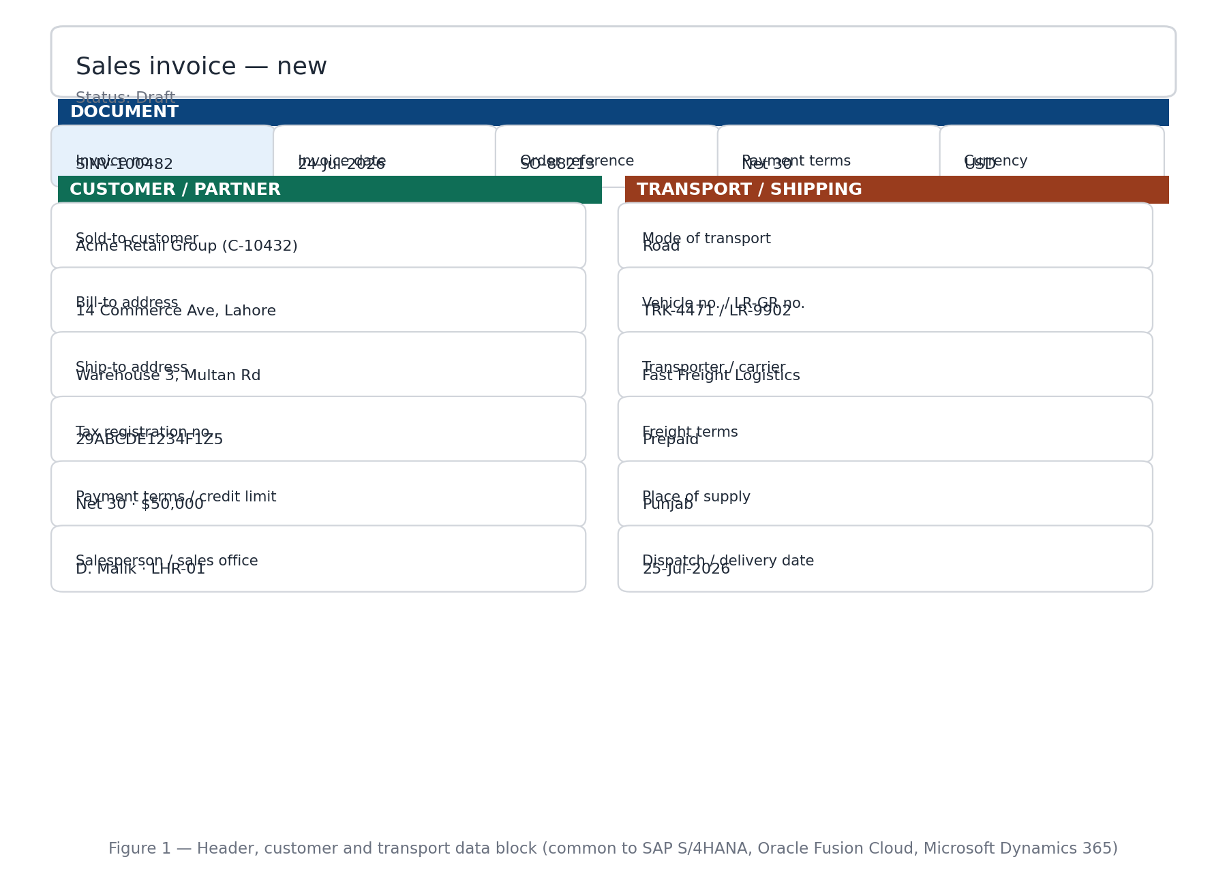
Figure 1 — header, customer and transport data block.

4. Creating an invoice — from orders, or blank

4.1 The source choice
Invoice creation opens with a single decision, presented as two options: load from orders, or start blank. A sales invoice loads from the customer’s open sales orders; a purchase invoice loads from the supplier’s open purchase orders — the flow is identical (SAP “Create with Reference” / billing due list, Oracle “Create Invoice from Orders” / invoice matching, Dynamics 365 “Get Shipment/Receipt Lines”). A blank invoice has no order link: every line is typed by hand, and the Order ref column of §5.1 simply never appears.

4.2 The order picker
Choosing “from orders” requires the partner first — the partner locks the list. The picker then shows only that partner’s orders that are open or partially invoiced, in the same currency and tax jurisdiction; fully-invoiced and closed orders appear greyed and unselectable. Multiple orders can be ticked into one invoice. Expanding an order exposes its lines with four figures each — ordered, already invoiced, balance, and an editable this-invoice quantity capped at the balance (or at delivered-not-yet-invoiced when delivery-based billing is enforced; on the purchase side, at received-not-yet-invoiced for 3-way PO–receipt–invoice matching). Partial loading is therefore per line, not just per order.
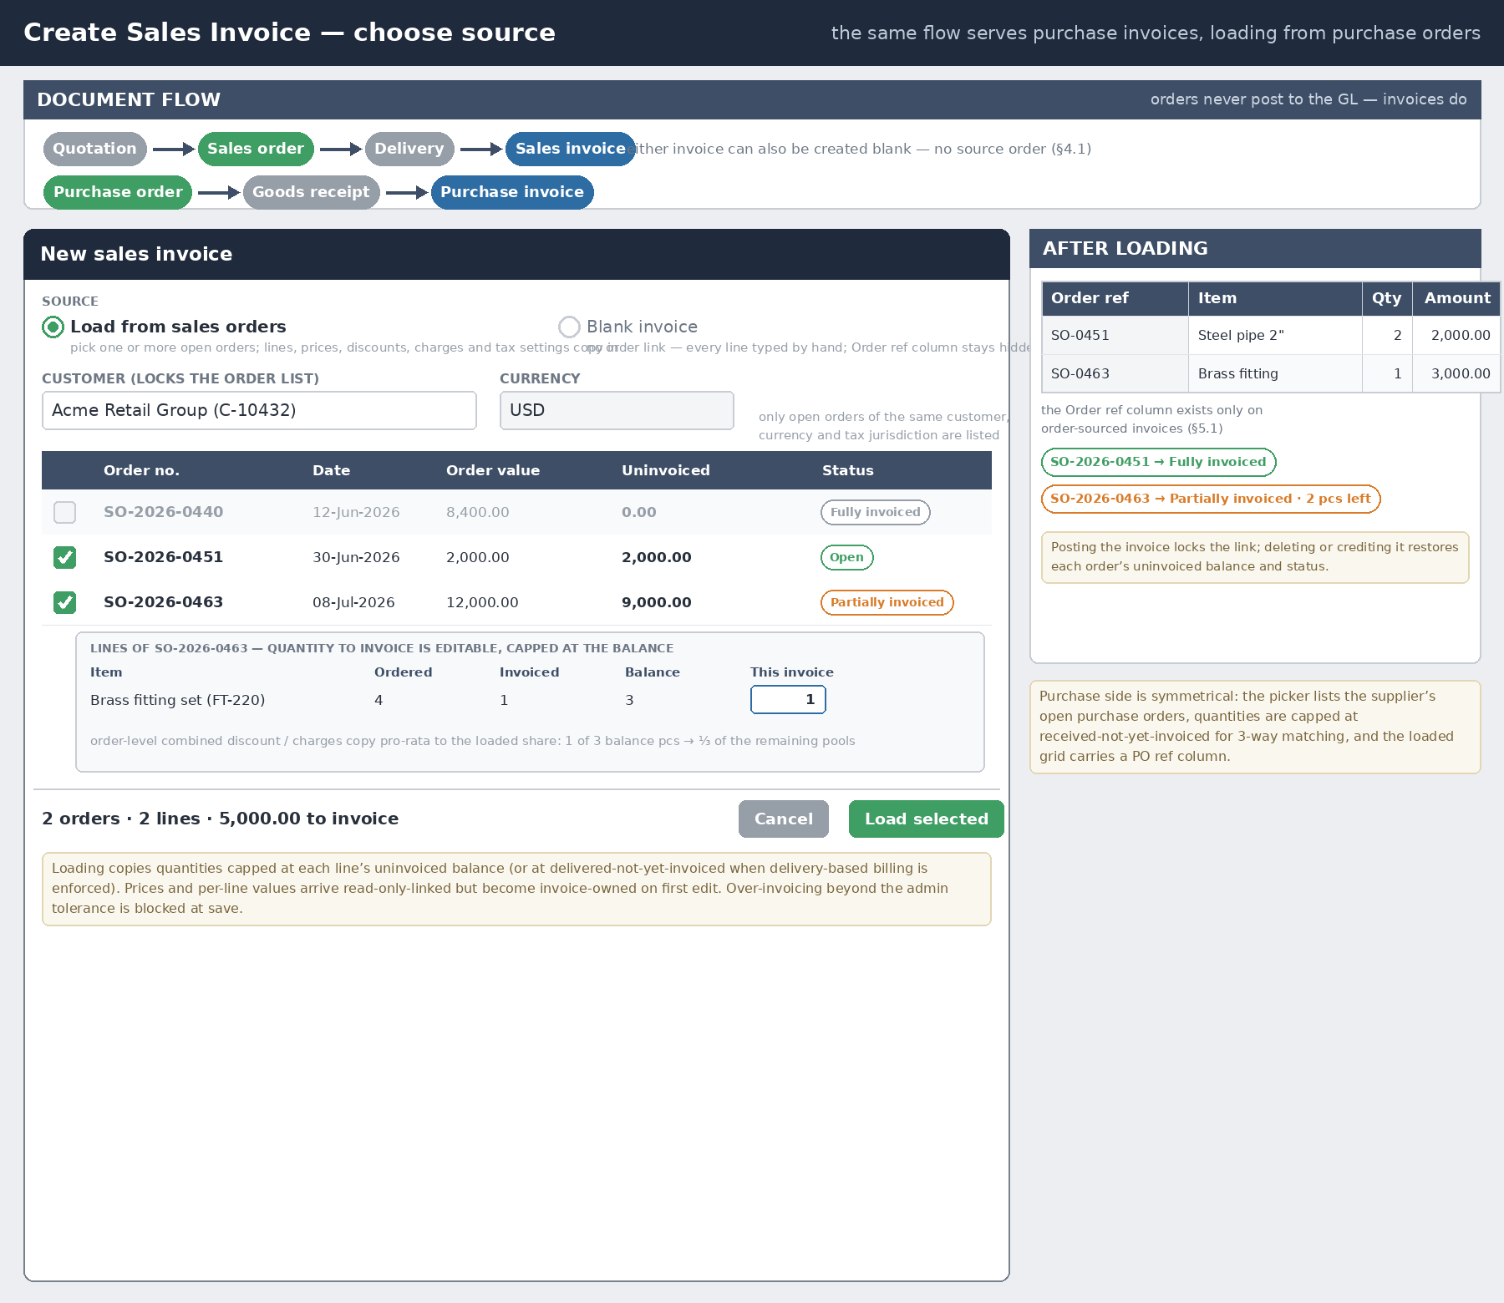
Figure 2 — the create-from-orders picker: one full order and one partial line loading into a single invoice; the same picker serves purchase invoices.

4.3 What loading copies
- Lines, quantities (as selected), rates, per-line discounts and per-line tax codes copy from the order and remain linked read-only until first edited — editing makes the value invoice-owned, and a subtle marker shows it now deviates from the order.
- Order-level Combined values — a combined discount, combined billed charges — copy pro-rata to the loaded share of the order (load one third of an order’s balance and one third of its remaining combined pools arrive). Per-item charges copy the shares belonging to the loaded lines and quantities.
- Tax settings (Apply further, Apply withholding, per-line tax scope) copy from the order but are re-evaluated against the partner’s current registration status at invoice date (§8).
- Lines from several orders sit in one grid; the Order ref column identifies each line’s source, and an optional per-order subtotal grouping can be switched on in Columns & fields (§7).

4.4 Status and linkage
Posting the invoice writes back to every source order: each loaded line’s invoiced quantity increases, and the order’s status moves Open → Partially invoiced → Fully invoiced. Over-invoicing beyond the administrator tolerance (§11.2) is blocked at save. Deleting a draft invoice — or posting a credit note against a posted one — restores the balances and reopens the orders. A blank invoice touches no order and carries no Order ref column.

5. The combined-vs-per-line scopes, and how columns follow them
The one design decision that most separates a basic form from an ERP-grade one is how Discount, Additional charges, and Tax are applied. Each of the three sections gets an explicit choice between two scopes:
- Combined — one percentage or flat value is entered once and applies to the whole document. No line carries its own discount, charge share, or tax rate; the line-item grid stays clean, with only Amount and no extra columns.
- Per line / Per item — each line can carry its own value. For Discount and for each additional charge this splits further into Auto-split (a single pool is entered once, then divided across lines pro-rata by value, by quantity, or by weight, shown read-only) or Manual (a distinct value is typed against every line). Tax is always manual when set to per line — there is no meaningful “auto-split” for a tax rate, since different products can legitimately sit in different tax brackets.
Additional charges is not one global toggle: scope is chosen per charge inside the charges form (§6) — Freight can be Combined while Labour is Per item on the same document. The grid reacts to the set of charges as a whole: the moment at least one charge is Per item, the Add. charges column exists; when every charge is Combined, it does not. The same appear/disappear logic drives the Order ref column of §4 — present exactly when the invoice was created from orders.

5.1 Column visibility rules
Section / document state | Extra column shown | Editable?
Discount — Combined | none | —
Discount — Per line / Auto-split | Discount (computed) | No — read-only
Discount — Per line / Manual | Disc % / Disc value | Yes, per line
Add. charges — every charge Combined | none | —
Add. charges — ≥1 charge Per item, all Auto-split | Add. charges (computed Σ of shares) | No — cell click opens a read-only breakdown
Add. charges — ≥1 charge Per item / Manual | Add. charges | Via the breakdown editor — the cell lists each per-item charge for that line
Tax — Combined | none | —
Tax — Per line (always manual) | Tax % | Yes, per line
Invoice created from ≥1 order (§4) | Order ref (+ optional per-order subtotals) | No — informational link
Invoice created blank | Order ref hidden | —
The Net amount column is itself conditional: it is shown when Discount is Per line and/or at least one billed charge is Per item (there is a real per-line adjustment worth displaying), and hidden when everything is Combined, since it would just duplicate the Amount column.

5.2 Dynamic behaviour of the columns
- Columns mount and unmount instantly when a scope changes — no page reload — and the remaining columns reflow to reabsorb the width. Nothing is left behind as a dead, always-zero column.
- Hidden does not mean deleted: values typed under Per line / Manual are retained in memory when the section is flipped back to Combined, and restored intact if it is flipped again before saving. Only saving the document discards them.
- Flipping Per line → Combined seeds the combined field from the rollup total, never resets it to zero.
- Read-only computed columns (auto-split shares, rollups, Order ref) render in grey cells; hovering shows the formula or the source order behind the figure (e.g. “60.00 × 1,800.00 / 4,650.00”).
- Because several charges can be Per item at once, one Add. charges cell holds the sum of that line’s shares across all per-item charges — freight, labour, loading, unloading and so on. Clicking the cell opens a breakdown popover naming each charge, its method, and its share; charges that are Combined or expense-only are listed there as “not in column” so the user can always reconcile the figure.
- Every visibility change triggers the full recalculation chain (subtotal → discount → charge splits → tax bases → taxes → net payable) so the totals panel is never stale.
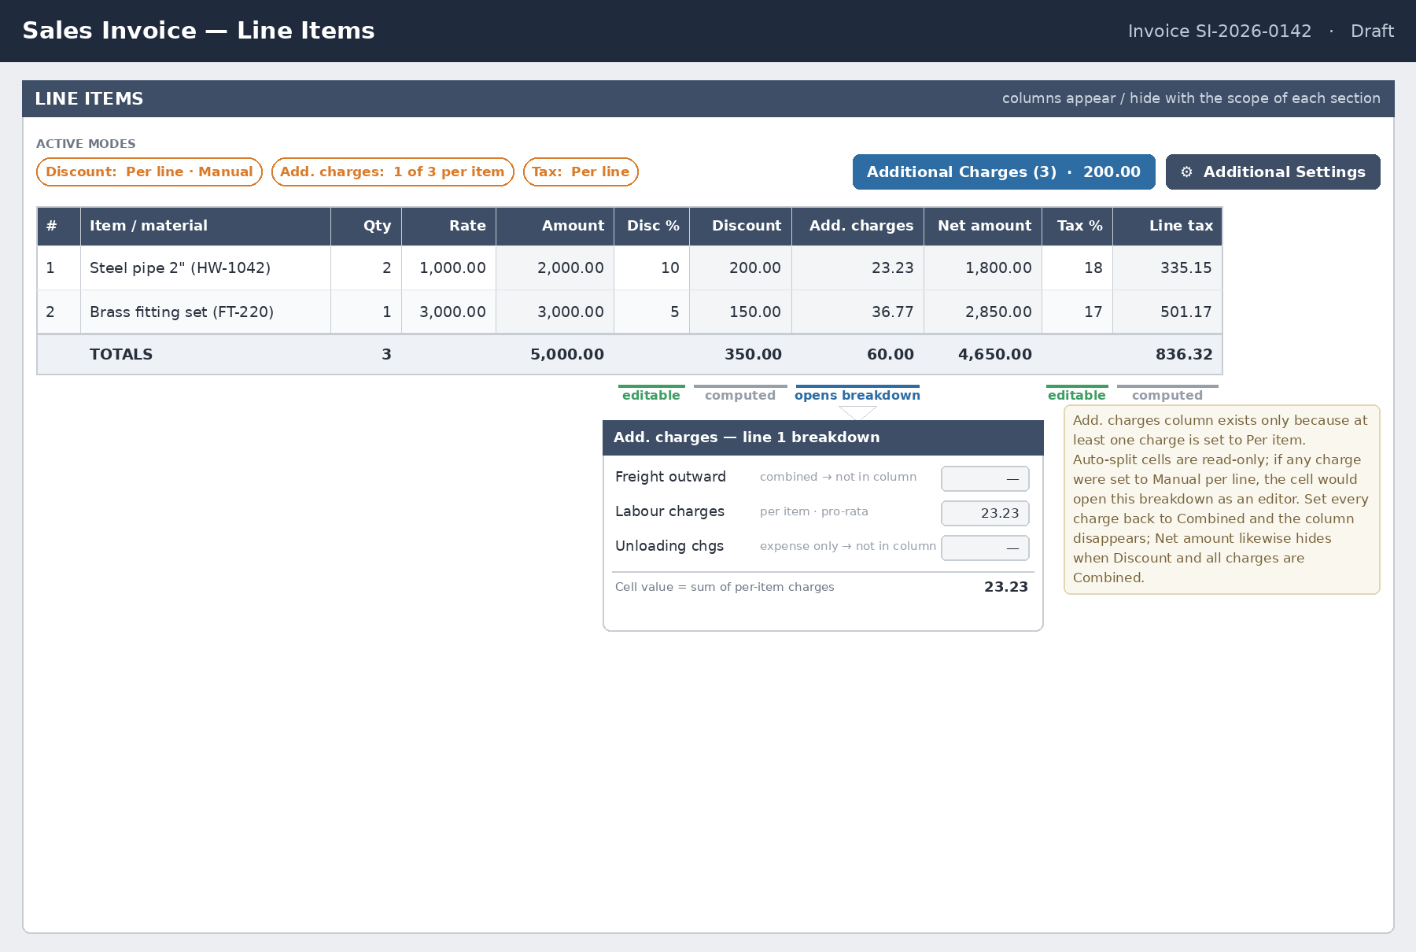
Figure 3 — line-item grid of a blank-created invoice (no Order ref column). The Add. charges column exists only because one charge (Labour) is Per item; its cell opens the breakdown shown.

6. Additional charges — replacing the single Freight field
A single “Freight” box cannot represent how documents are actually charged: freight, labour, loading, unloading, packing and insurance are separate expenses, hit different ledgers, and are treated differently for tax. This standard therefore replaces the Freight field with an Additional Charges facility, matching SAP header/item pricing conditions, Oracle Charges, and Dynamics 365 charges codes / auto-charges. It applies to orders and invoices alike; charges defined on an order flow to the invoice per §4.3.

6.1 The charges form
The grid toolbar carries a button labelled with a live summary — “Additional Charges (3) · 200.00”. Clicking it opens the charges form (Figure 4). Each row of the form is one charge and carries five decisions:
- Charge type — picked from the chart of accounts, filtered to expense/income ledgers flagged “chargeable on sales” (or “on purchases”). The ledger, not free text, is the identity of the charge — it is what the GL posting in Section 11 will use.
- Amount — the document-level value of the charge (a % of subtotal entry mode is a permissible convenience; it resolves to a value).
- Scope — Combined or Per item, per charge (§6.2).
- Treatment — bill on the document, absorb into item values, or expense ledger only (§6.3).
- Tax bases — independent switches for sales tax, withholding tax and extra tax (§6.4); further tax follows the sales-tax base automatically.
Rows are unlimited; the form foots to a total, split into billed and expense-only portions.
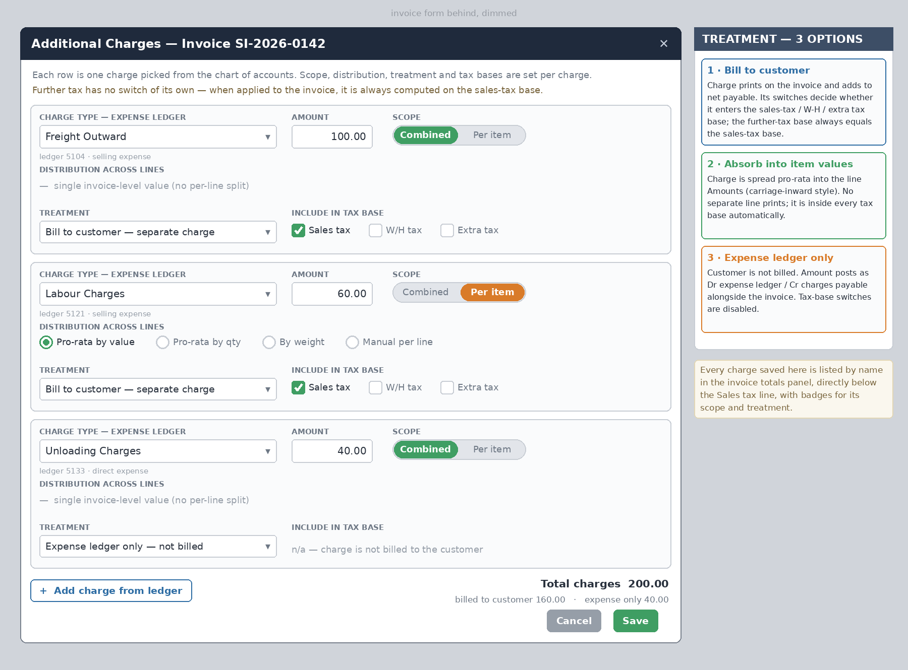
Figure 4 — the Additional Charges form; three charges from three ledgers, each with its own scope, treatment and tax bases.

6.2 Scope and distribution, per charge
A Combined charge is one document-level figure — it never touches the grid. A Per-item charge is distributed across lines by one of four methods: pro-rata by line value (default), pro-rata by quantity, by weight, or manual per line. The first three are auto-split — the user enters one pool and the system divides it, read-only; manual exposes an input per line inside the breakdown editor.
Whenever at least one charge is Per item, the grid materialises the Add. charges column described in §5. Its cell value is the sum of that line’s shares of every per-item charge; the breakdown popover itemises them. Rounding residuals from any auto-split are forced onto the last line so the column always foots exactly to the pool.

6.3 Treatment — three ways a charge can flow
- 1. Bill on the document (separate charge). On a sales invoice the charge prints and adds to net payable — the classic “freight recovered” pattern; on a purchase invoice it is the supplier’s own charge line, adding to what we owe. Its tax-base switches (§6.4) decide which tax calculations it enters.
- 2. Absorb into item values. The amount is spread pro-rata by line value into the line Amounts themselves before discount and tax. No separate charge line prints, and because the value now sits inside the goods value it is inherently inside every tax base — the switches are moot and disabled. On the purchase side this is literal carriage inward / landed cost: the charge capitalises into item cost. The totals panel still lists the charge as a memo row (“included in item values”) so the audit trail survives.
- 3. Expense ledger only. The counterparty is not billed at all — the business absorbs the cost. Nothing is added to any tax base or to net payable; instead, saving the document also posts Dr the chosen expense ledger / Cr Charges payable (accrued), so the cost is captured the moment it is incurred. Tax-base switches are disabled for such a charge.

6.4 Tax-base switches, per charge and per tax type
For every billed charge — Combined or Per item alike — independent switches decide whether it enters the sales-tax, withholding-tax and extra-tax calculations. A business can legitimately put freight inside the sales-tax base while keeping it out of the withholding-tax base, since the two are governed by different rules; and it can tax freight but not labour. Further tax deliberately has no switch of its own: by definition it is calculated on the same value as sales tax, so a charge inside the sales-tax base is automatically inside the further-tax base (§8). The document-level formulas therefore read:
Sales-tax base = Subtotal − Discount + Σ (billed charges whose Sales-tax switch is On)
Further-tax base = Sales-tax base — always; no separate switch
W/H-tax base = Subtotal − Discount + Σ (billed charges whose W/H switch is On)
Extra-tax base = Subtotal − Discount + Σ (billed charges whose Extra switch is On)
When Tax is Per line, the same switches operate line by line: a Per-item charge contributes its own per-line share to each line’s base, and a Combined billed charge with the switch On is spread pro-rata by line value into the line bases (it still prints as one document-level figure). Withholding tax, where applied, is always calculated on the document-level base — never per line, and never compounded on top of sales tax.

6.5 Presentation in the totals panel
Every charge saved in the form — regardless of scope or treatment — is itemised by name in the totals panel, directly below the Sales tax line (Figure 6). Billed charges carry badges for scope and bases and add into net payable; absorbed charges appear as grey memo rows (their value already sits inside Subtotal); expense-only charges appear greyed with “not billed” and are excluded from net payable. Nothing that was entered in the charges form is ever invisible on the face of the document.

7. The Additional Settings side panel
All configuration toggles move off the form surface into a right-hand slide-over, opened by the Additional Settings button on the grid toolbar. The document dims behind it; totals stay live. Compact chips above the grid (“Discount: Per line · Manual”, “Add. charges: 1 of 3 per item”, “Tax: Per line”) mirror the active modes so the operator never has to open the panel just to know the state.
Inside, the settings are grouped into four sections that behave as a strict accordion:
- 1 · Discount — Combined / Per line scope, and Auto-split vs Manual method.
- 2 · Additional charges — default scope for new charges, default distribution method, default tax bases, and the “Manage charges” entry into the form of §6.1.
- 3 · Taxes — the Apply further tax and Apply withholding tax switches for this document (§8), their rates, the per-line tax toggle, and which extra taxes are in play.
- 4 · Columns & fields — optional grid columns (including per-order subtotals on order-sourced invoices) and the transport/logistics block.
Accordion rules: sections expand and collapse on click, and exactly one section is open at a time — expanding any section automatically collapses the one that was open. Collapsed section headers always display a live one-line summary of their current values (“Per line · Manual”, “Further: Off · W/H: Off”), so a collapsed section hides controls, never information. The panel remembers which section was last open per user. The panel governs this document; the defaults it starts from are the administrator’s Invoice Settings in Section 11.
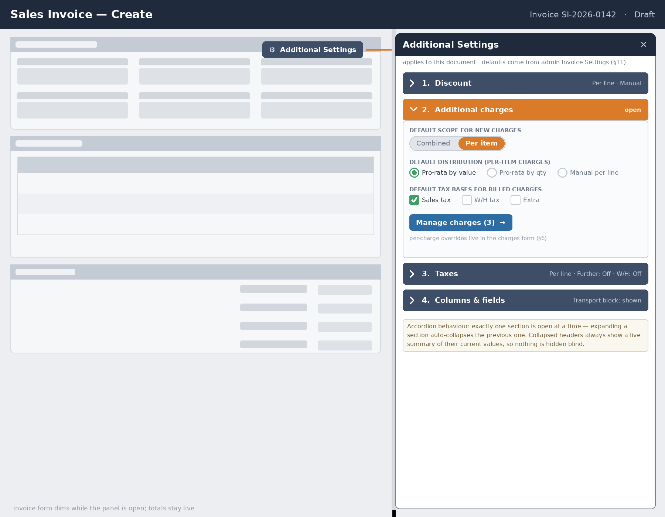
Figure 5 — the Additional Settings slide-over. Section 2 is open; opening any other section collapses it.

8. Further tax and withholding tax — apply, or not
Two levies routinely sit on top of sales tax, and both are decided per document, not hard-coded:
- Further tax — an output-side surcharge some jurisdictions levy on supplies to unregistered buyers (for example the 3% further tax under Pakistan’s Sales Tax Act). The invoice carries an Apply further tax switch in the Taxes section (§7). When On, Further tax = further rate × the sales-tax base — by definition it is calculated on the same value as sales tax, which is why §6.4 gives it no base switches of its own. The switch defaults from the customer’s tax-registration status (§2.1): unregistered → On, registered → Off, always overridable. It applies to sales documents only — there is no further tax on purchases.
- Withholding tax — an income-tax deduction at source, with an Apply withholding tax switch per document and a mirrored treatment on the two sides. On a sales invoice the customer is the withholding agent: they retain W/H% of the base and pay the remainder, and the seller books the retained amount as Withholding tax receivable — an advance-tax asset, not an expense. On a purchase invoice the business itself is the agent: it retains W/H% from the supplier and books Withholding tax payable — a liability to deposit with the tax authority — while the supplier is paid net. The base follows the §6.4 W/H formula (jurisdictions differ on taxable-value vs gross bases; the base definition is configurable in §11.2, and this document’s examples use the taxable value). Withholding is never compounded on sales tax and never split per line.
When a switch is Off, the corresponding totals row shows 0.00 greyed (or is hidden by §11.3 visibility) and nothing posts. Section 11’s examples show both switches Off (Example B), further tax applied to an unregistered customer (Example A), and withholding on the purchase side (Example C).

9. Totals and tax summary panel
The summary panel is where every Combined-mode value lives, alongside the pool inputs for auto-split — pro-rata still starts from one entered figure. Whichever sections are in Per line/Manual mode become read-only rollups here instead of inputs, so the printed total always reconciles to the sum of the visible line items. The fixed ordering is: Subtotal → Total discount → Taxable value → Sales tax → the itemised additional charges (§6.5) → Further tax (if applied) → Withholding tax (if applied) → extra taxes (as visible) → Net payable.
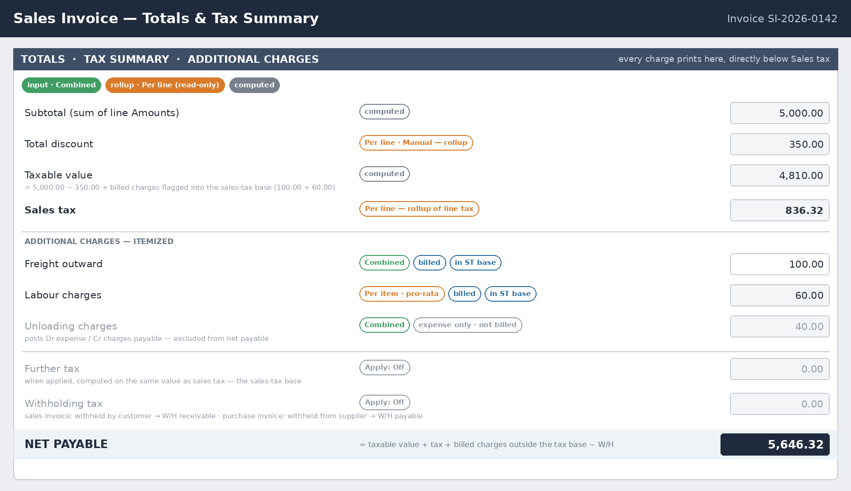
Figure 6 — totals panel. Sales tax first, then every additional charge by name; further and withholding tax follow, here both switched Off.

10. Worked example — a sales invoice
Two line items on a blank-created sales invoice. Discount = Per line / Manual; Tax = Per line / Manual; Apply further tax = Off and Apply withholding tax = Off (registered customer — Example A in §11 shows them On). Three charges: Freight outward 100.00 (Combined, billed, in ST base), Labour 60.00 (Per item, pro-rata by value, billed, in ST base), Unloading 40.00 (Combined, expense ledger only). Labour’s pool splits over the post-discount line values (1,800.00 and 2,850.00 of 4,650.00) as 23.23 and 36.77:
Line | Qty × Rate | Amount | Discount | Add. chg | Net amount | Tax base | Tax % | Line tax
A | 2 × 1,000 | 2,000.00 | 10% → 200.00 | 23.23 | 1,800.00 | 1,861.94 | 18% | 335.15
B | 1 × 3,000 | 3,000.00 | 5% → 150.00 | 36.77 | 2,850.00 | 2,948.06 | 17% | 501.17
Each line’s tax base = Net amount + its own Add. charges share + its pro-rata slice of Combined billed charges flagged into the sales-tax base (Freight 100.00 splits 38.71 / 61.29). Check: 1,800.00 + 23.23 + 38.71 = 1,861.94 and 2,850.00 + 36.77 + 61.29 = 2,948.06.
Subtotal = 5,000.00; total discount = 350.00; taxable value = 4,650.00 + 100.00 + 60.00 = 4,810.00; total sales tax = 836.32; further tax = 0.00 (not applied); withholding = 0.00 (not applied); net payable = 4,810.00 + 836.32 = 5,646.32. Unloading (40.00) appears in the totals panel as expense-only, adds nothing to payable, and posts Dr Unloading expense / Cr Charges payable (§11.2). Rounding residuals of every split are forced onto the last line so the invoice foots exactly.

11. Invoice settings (administrator) — defaults, tolerances and visibility
Charges and top-up taxes sit in an odd spot: some tax authorities and business policies want a charge taxed along with the goods, others don’t; further tax depends on who the buyer is; withholding depends on which side of the transaction you stand. Rather than hard-coding answers, all three vendors expose this as configuration — SAP via pricing-procedure condition types, Oracle via tax-rule determinants, Dynamics 365 via charges code and tax group setup — not as something re-decided from scratch on every document.

11.1 Charge ledger defaults
One row per chargeable ledger, seeding the charges form of §6.1: the default treatment, and the default state of the tax-base switches for when the charge is billed. Each switch is independent, and every default remains overridable per charge, per document, in the form itself.

11.2 Tax application defaults and order tolerances
Default Apply further tax (Off, auto-On for unregistered customers), default Apply withholding tax per partner class, the rates for each, the withholding base definition (taxable value or gross), and the over-invoicing tolerance used by §4.4 all live here as document defaults.

11.3 Form field visibility
A second group of switches controls which fields and toggles even appear on the day-to-day creation form — most businesses use only a subset, and hiding the rest keeps data-entry staff from being confronted with options that don’t apply to them:
- Create-from-orders picker / per-line discount toggle / Additional Charges button / per-line tax toggle — hiding one removes the control entirely and forces its behaviour (no order sourcing; Combined only; a no-charges document).
- Withholding / further / extra tax fields — many businesses only ever deal with one or two of these; hiding the rest declutters the totals panel and the Taxes accordion section alike.
- Transport / logistics block — relevant mainly to businesses that ship physical goods; service-only businesses can hide it.
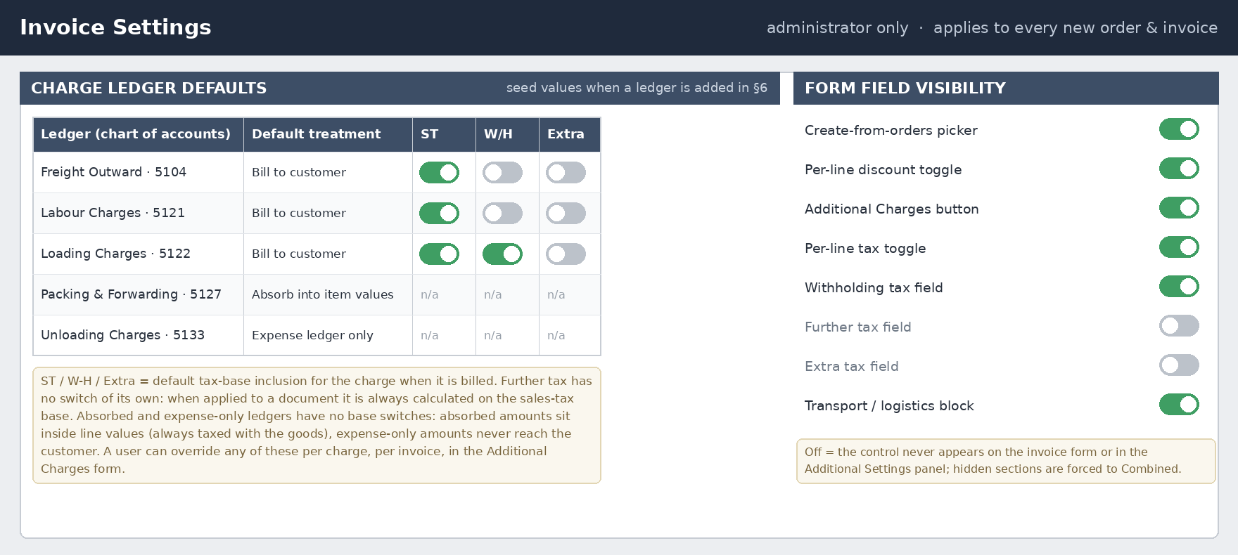
Figure 7 — administrator Invoice Settings; set once, inherited by every order and invoice and by the Additional Settings panel.

12. General ledger posting
Orders never post; invoices do. The creation screen only decides how numbers are calculated and displayed — what posts is a separate mapping, but it follows directly from the scope and treatment choices made in Sections 5, 6, 8 and 11:
- Combined mode always posts one aggregated line per natural GL account — one Discount line, one line per charge ledger, one Sales Tax Payable line — regardless of how many document lines fed into it.
- Per line / Per item mode can post multiple lines against the same natural account type when lines map to different sub-accounts — most commonly a different revenue account per item category, or a different Sales Tax Payable sub-account per tax rate/code (this split is what tax-return reporting actually needs; a single “Sales Tax Payable” account can’t tell an auditor how much was collected at 18% versus 17%).
- A billed charge credits the recovery/income account paired with its ledger (“Freight recovered”, “Labour charges recovered”) — separate from product revenue, since it is usually a pass-through of a cost rather than margin-bearing sales. On a purchase invoice the mirror applies: a supplier-billed charge debits cost, an absorbed charge capitalises into inventory (landed cost).
- An absorbed charge posts nowhere separately: its value is inside the revenue lines (sales) or the inventory/expense lines (purchase), because it was folded into the line Amounts before posting. The memo row in the totals panel is the only place it remains visible, which is precisely why that row exists.
- An expense-only charge posts Dr its expense ledger / Cr Charges payable (accrued) together with the invoice; the payable clears when the transporter’s or contractor’s bill is settled.
- Discount is booked as a contra-revenue debit (a “Sales Discount/Allowances” account), not netted silently into revenue, so gross sales and total discounts both remain visible on the P&L.
- Further tax, when applied, is credited to Further tax payable — kept as its own code even where it files on the same statutory return as sales tax, so the return can be populated line by line.
- Withholding tax is two-sided (§8): on sales, the amount the customer withholds is a debit to Withholding Tax Receivable (an advance-tax asset the seller later offsets against its own income tax); on purchases, the amount withheld from the supplier is a credit to Withholding Tax Payable until deposited with the authority. It is never an expense in either direction.
- Sales tax mirrors too: output tax on a sales invoice credits Sales tax payable; input tax on a purchase invoice debits Input sales tax receivable (recoverable against output tax).

12.1 Example A — sales invoice, fully Combined, further and withholding applied
Unregistered customer, so Apply further tax = On (3%); Apply withholding tax = On (3%). Subtotal 55,000.00 · Discount 18% = 9,900.00 · Charges: Freight 20,000.00 (billed, ST base On), Loading 2,000.00 (billed, ST base Off), Unloading 1,000.00 (expense only) · Sales-tax base = 45,100.00 + 20,000.00 = 65,100.00 · Sales tax 18% = 11,718.00 · Further tax 3% on the same base = 1,953.00 · W/H tax 3% (every charge’s W/H switch is Off, so on 45,100.00) = 1,353.00 · Net payable = 65,100.00 + 2,000.00 + 11,718.00 + 1,953.00 − 1,353.00 = 79,418.00.
GL account | Debit | Credit
Accounts receivable | 79,418.00
Withholding tax receivable | 1,353.00
Sales discount / allowances | 9,900.00
Unloading charges (expense) | 1,000.00
Sales revenue |  | 55,000.00
Freight recovered |  | 20,000.00
Loading charges recovered |  | 2,000.00
Sales tax payable |  | 11,718.00
Further tax payable |  | 1,953.00
Charges payable — unloading |  | 1,000.00
Totals: debits 91,671.00 = credits 91,671.00. One line per account — this is the entire posting regardless of how many products were on the invoice. Further tax rides the sales-tax base exactly; Loading is billed but outside that base, so it reaches AR without touching either tax; Unloading never reaches AR at all.

12.2 Example B — the Section 10 sales invoice, two revenue categories
Line A posts to Hardware Sales, line B to Fittings Sales; tax splits by rate code; Freight and Labour are billed into the ST base; Unloading is expense-only; Apply further and Apply withholding are both Off.
GL account | Debit | Credit
Accounts receivable | 5,646.32
Sales discount / allowances | 350.00
Unloading charges (expense) | 40.00
Hardware sales revenue |  | 2,000.00
Fittings sales revenue |  | 3,000.00
Freight recovered |  | 100.00
Labour charges recovered |  | 60.00
Sales tax payable — 18% code |  | 335.15
Sales tax payable — 17% code |  | 501.17
Charges payable — unloading |  | 40.00
Totals: debits 6,036.32 = credits 6,036.32. Per line mode changes which sub-accounts receive the revenue and tax — it does not change the accounting model itself. Had Freight instead been set to Absorb into item values, the line Amounts would have become 2,040.00 and 3,060.00 (100.00 spread 40 / 60 by line value), the Freight recovered line would vanish, and gross revenue would carry the 100.00 — with the totals-panel memo row as the only remaining trace.

12.3 Example C — purchase invoice from a PO, withholding on the supplier
A purchase invoice loaded from a purchase order (§4): goods 50,000.00, supplier’s freight 1,000.00 set to Absorb into item values — literal carriage inward, so inventory cost is 51,000.00 and the ST base is the same 51,000.00. Input sales tax 18% = 9,180.00; invoice gross 60,180.00. Apply withholding tax = On at 4% of the taxable value = 2,040.00, withheld from the supplier; further tax does not apply to purchases (§8).
GL account | Debit | Credit
Inventory (goods incl. absorbed freight) | 51,000.00
Input sales tax receivable | 9,180.00
Accounts payable — supplier (net) |  | 58,140.00
Withholding tax payable |  | 2,040.00
Totals: debits 60,180.00 = credits 60,180.00. The mirror of §12.1 is exact: input tax is a receivable where output tax was a payable, and withholding flips from an asset (customer withheld from us) to a liability (we withhold from the supplier, then deposit it). The supplier is paid 58,140.00; the 2,040.00 goes to the tax authority against the supplier’s income tax.

13. Design checklist
- Header/partner/transport fields are entered once and never repeat per line; the same block serves sales and purchase documents with roles mirrored (§2.4).
- Invoice creation always offers two sources — load from open orders (multi-select, per-line partial quantities capped at the uninvoiced or received balance) or start blank; loading copies lines, prices, discounts, charges and tax settings, prorating order-level pools to the loaded share.
- Order-sourced invoices carry the Order ref column and write back invoiced quantities and status (Open → Partially → Fully invoiced); deleting or crediting restores balances; blank invoices carry no link and no column.
- Discount and Tax each get an independent Combined / Per line toggle; Additional charges get a scope per charge — never gate one section on another.
- Grid columns appear only for the sections actually in Per line / Per item mode — no dead, always-zero columns; the Add. charges column is the per-line sum of all per-item charges, with a breakdown popover to reconcile it.
- Every additional charge is picked from a chart-of-accounts ledger and carries its own scope, distribution, treatment (bill / absorb / expense-only) and tax-base switches; on purchases, absorb = carriage inward into item cost.
- Every charge — billed, absorbed or expense-only — is itemised in the totals panel directly below the Sales tax line.
- Apply further tax and Apply withholding tax are per-document switches: further tax is always computed on the sales-tax base (no base switches of its own) and exists on sales only; withholding books as a receivable on sales and a payable on purchases, never as an expense.
- All configuration lives in the right-hand Additional Settings slide-over: four accordion sections, exactly one open at a time, collapsed headers showing live value summaries.
- Switching a section from Per line/Manual back to Combined seeds the combined field from the rollup total, never resets it to zero; manual values are retained until save.
- Administrator Invoice Settings hold per-ledger charge defaults, tax application defaults and rates, over-invoicing tolerance, and field visibility; documents inherit them and may override per document.
- Recalculate the full chain — subtotal → discount → charge splits → tax bases → taxes → net payable — on every edit, and force rounding residuals onto the last line so the printed document always foots correctly.

