# Lab Manual

**Step1:** Open link

[**https://www.way2automation.com/**](https://www.way2automation.com/)

**Step2**:

Hover your mouse on “All courses”, then to “Selenium” and click on “Selenium in Javahttps://www.way2automation.com/https://www.way2automation.com/”

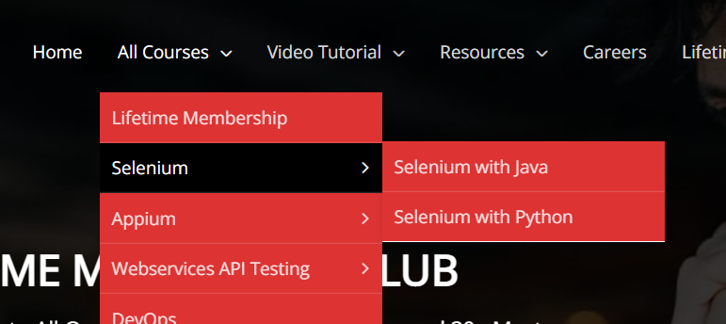

**Step3**:

Now go to <https://www.way2automation.com/way2auto_jquery/frames-and-windows.php>

And Click on “Frames And Windows”.

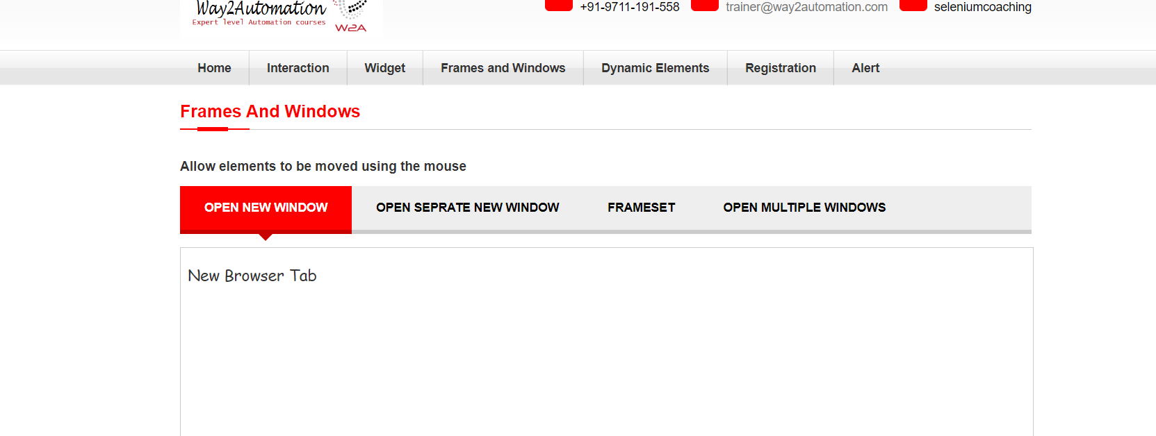

**Step4**:

Handle all four cases.

**Step5**:

Go to

<https://sso.teachable.com/secure/673/identity/login>

Click on Signup create account and go to home page.