**Lab Manual 6**

**TestNG**

**Question 1**

Go to:

<https://www.globalsqa.com/angularJs-protractor/BankingProject>

Explore the website.

Test Cases for customer login are 3

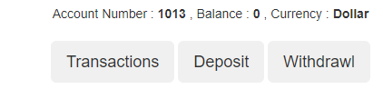

Test Cases for Manager login are 3

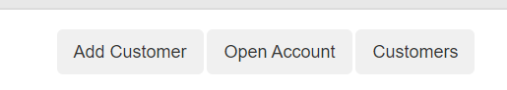

1. Do manager login and then add customer.
2. Open customer’s account.
3. Go to Customer login.
4. Deposit cash more than 5000 and the withdraw 2000.
5. Set the starting/ending date and time. And get transactions data. (List)
6. Reset the transactions and logout.
7. Again, do manager login and delete the customer you are working on.