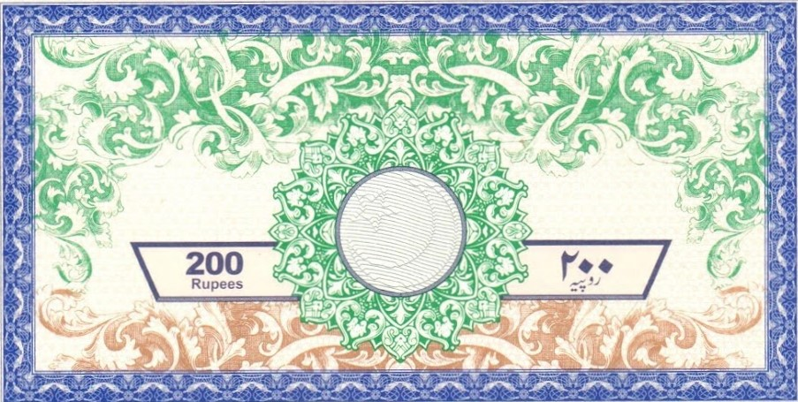
Sale of Property Agreement

This Sale of Property Agreement is made and entered into on {{Date}} by and between:
{{SellerName}} , residing at {{SellerAddress}} (hereinafter referred to as "Seller"),
and
{{BuyerName}} residing at {{BuyerAddress}} (hereinafter referred to as "Buyer").

Whereas, Seller is the legal owner of the property located at {{AddressofProperty}} described as {{DescriptionofProperty}} , hereinafter referred to as the "Property";

Whereas, Buyer desires to purchase the Property from Seller and Seller agrees to sell the Property to Buyer under the terms and conditions set forth herein;
Now, therefore, in consideration of the mutual covenants contained herein and other good and valuable consideration, the receipt and sufficiency of which are hereby acknowledged, the parties agree as follows:
1. Purchase Price:
The purchase price for the Property shall be {{PurchasePrice}} which shall be paid as follows: [Specify payment terms, such as down payment, installments, or lump sum].

2. Closing Date:
The closing of this transaction shall take place on or before {{ClosingDate}} at a location agreed upon by both parties.
3. Terms and Condition of Property:
Seller shall convey the Property to Buyer with a clear and marketable title. Seller represents that there are no encumbrances, liens, or adverse claims against the Property except as disclosed herein. Buyer acknowledges that the Property is sold in its current condition and agrees to accept it {{TermsandConditionofProperty}}
4. Closing Costs:
Buyer and Seller shall each bear their respective closing costs, including but not limited to attorney fees, title search fees, transfer taxes, and recording fees.
5. Inspection:
Buyer shall have the right to conduct inspections of the Property at their own expense within {{InspectionNumberOfDays}} days from the effective date of this Agreement. Any defects discovered during the inspection period shall be disclosed to Seller, who may choose to remedy the defects or negotiate a reduction in purchase price.
6. Default:
In the event of default by either party, the non-defaulting party shall have the right to pursue all remedies available at law or in equity.
7. Governing Law:
This Agreement shall be governed by and construed in accordance with the laws of [State/Country].
8. Entire Agreement:
This Agreement contains the entire agreement between the parties and supersedes all prior and contemporaneous agreements, representations, and understandings.
9. Witnesses:
This Agreement may be executed in counterparts, each of which shall be deemed an original but all of which together shall constitute one and the same instrument.

IN WITNESS WHEREOF, the parties have executed this Agreement as of the date first above written.

SELLER: {{SellerWitness}}
Signature:
BUYER: {{BuyerWitness}}
Signature:
Date: {{Date}}

