**Quote That Includes**

Overall Details of the EATON 150 VCP W40 1200 AMP Switch that we offer on the following quotation are:

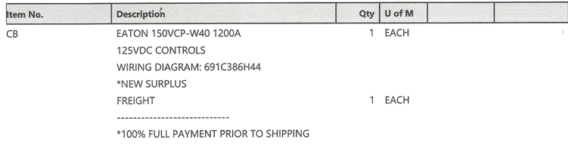

Product Name: 150VCP W40 Switch

# General Information:

# This is a 15 kV RMS rated electrical equipment, designed for industrial and high-voltage applications. It is manufactured in the USA and features a range of operational and safety specifications tailored to meet rigorous industry standards.

# Key Features:

# Maximum Voltage: 15 kV RMS

# Interruption Capacity: 104 kA Peak

# Control Voltage Range: 125 VDC/AC

# Power Frequency: 60 Hz

# Continuous Current: 1200A

# Technical Specifications:

# Lightning Impulse Withstand Voltage: 95 kV Peak

# Short-Circuit Current: 50%

# Operating Time: 2 Sec for Trip

# Weight 375 lbs.

# Color: Grey

# WIRING DIAGRAM 691C386H44

# Image:

