Contact Diary

Tourist Guide

FINAL YEAR PROJECT

SESSION 2015-2017

MASTER’S OF COMPUTER SCIENCE



BS(CS)SUBMITTED BY:

Muhammad Asif Mehmood IUB1572212

Muhammad Salman Mehmood IUB1572220

Muhammad Awais IUB1572232

DEPARTMENT OF COMPUTER SCIENCE

ISLAMIA UNIVERSITY OF BAHWALPUR, BAHAWALNAGAR CAMPUS

|  |  |  |  |  |  |
| --- | --- | --- | --- | --- | --- |
| Type (Nature of project) | | | [ ] **D**evelopment [ ] **R**esearch [ ] **R**&**D** | | |
| Area of specialization | | |  | | |
| **Project Group Members** | | | | | |
| Sr.# | Reg. # | Student Name | | Email ID | *Signature |
| (i) | IUB1572212 | Muhammad Asif Mehmood | | asifchiub@gmail.com |  |
| (ii) | IUB1572220 | Muhammad Salman Mehmood | | salmanmehmoodiub@gmail.com |  |
| (iii) | IUB1572232 | Muhammad Awais | | awaisch569@gmail.com |  |

**Table of Contents**

**Chapter 1: Introduction………………………………………. 5**

1. Introduction……………………………………………………………… 6

1.1 Objective…………………………………………………………………………………………….. 7

1.2 Problem statement……………………………………………………… 7

1.3 Assumption and Constraints…………………………………………… 7

1.4 scop…………………………………………………………………….. 7

Chapter 2:Requirements analysis……………………………………….

2.1 Stake Holders…………………………………………………………. 9

2.2 Requirements elicition…………………………………………………. 9

2.2.1 Functional Requirments………………………………………………. 9

2.2.2 Non functional Requirements…………………………………………. 10

2.3Use case description……………………………………………………... 11

2.3.1Use Cases design and activity diagram………………………………... 11

00UCAd00 Login…………………………………………………………… 11

01UCAd01 Check request of user…………………………………………… 13

02UCAd02 Send tour plan of user to hotel manager……………………… . 15

03UCAd03 Receive room detail from hotel manager………………………. 17

04UCAd04 Send response of user request………………………………….. 19

04 UCAd05 Cancel request of user………………………………………….. 21

05UCAd06 Show the ticket's booking……………………………………… 23

06UCAd07 Cancel the ticket's booking……………………………………… 25

07UCAd08 Add new packages………………………………………………. 27

08 UCAd09 Edit any previous package………………………………………. 29

09 UCAd10 Change system profile……………………………………………. 31

10UCAd11 Logout……………………………………………………………. 33

11UC User01 Registration………………………………………………………. 35

12.UC User02 Visit site………………………………………………………….. 37

13UC User03 send tour plan to admin………………………………………......... 39

14UC User04 Receive response of plan from admin................................................ 41

15 UC User05 Request for report format ………………………………………….. 43

16UC User06 Cancel plan of trip…………………………………………………… 45

17 UC User07 Logout……………………………………………………………….. 47

18UC HM01 Receive user plan by admin…………………………………………… 49

19UC HM02 Send room detail………………………………………………………. 51

**Chapter 3:System Design…………………………………………………………… 52**

3.1 class diagram……………………………………………………………………… 53

**Chapter4:System Testing……………………………………………………………. 54**

4.1 Test Cases………………………………………………………………………… 55

4.1.1 Tourist signup…………………………………………………………………… 55

4.1.2 Tourist login………………………………………………………………………. 56

4.1.3 Tourist booking……………………………………………………………………. 57

4.1.4 Admin login……………………………………………………………………….. 58

4.1.5 View tour request………………………………………………………………… 59

4.1.6 Admin add hotels………………………………………………………………… 60

4.1.7 Admin add city…………………………………………………………………… 61

4.1.8 Admin add new admin…………………………………………………………… 62

4.2 Unit Testing………………………………………………………………………… 63

**Chapter 5:Conclusion…………………………………………………………………. 64**

5.1 Problem faced and lesson learned…………………………………………………... 65

5.2 Project summary…………………………………………………………………….. 66

5.3 Future work…............................................................................................................... 67

5.4 screen shot…………………………………………………………………………… 68

**Chapter 01**

**Introduction**

**Software Requirement Specification (SRS)**

1. **Introduction:**

The purpose of this project is to provide the complete information about the package available for a tour and routes detail. Admin design tour packages covering a wide range of tourist attractions at different prices to attract diverse target segments.This website is also helpful for Hotels that available in relevant cities, in which Hotel Manager add there packages for tourist.

In first User open the site for travel user get registration form through menu, every user must enter user name and password in registration form and this user name and password is used for login after registration. Admin show packages with different categories with different payment. There are two types of user,

First the user visits the site and enters the place and route detail from where to where he wishes to travel.

User also provides the date as when he would like to travel. Then user sends these details to admin of system. Admin receives the mail and contact with Hotel manager of the city where and where user wants to stay during tour. After that admin reverse back to the user along with the quotation. If the customers agree for any one of the quotation, he can reply back along with agreed quotation. Then the admin will take down all the details of the user and add user will send a confirmation message to the user in which admin tell to user,id and password that user use to login into the system and view his/her profile.

A second type of user visits the site and views all packages on site. Different categories of packages are available on site with different payment. Packages for one person, family, and friends and for student packages all are provide onsite to viewable with vehicle and route detail. Admin show Package specification, payment, and also concession for some specific package. User decides any package, and sends detail to admin of system, admin check that mail, contact with hotel manager and reverts back to the user along with the quotation. Admin will add new package and new routes. This Product is user friendly and helps in finding the vehicle sooner rather than wandering manually.

* 1. **Objective:**

1. This project is aimed to developing an online Tourist Guide system.  The proposed system is a web based application and maintains a centralized repository of all related information.
2. The system allows one to easily access the relevant information and make necessary travel arrangements. Users can decide about places and routes they want to visit and make bookings online for travel and accommodate.
3. The purpose is to design a system using which one can perform all operations related to traveling and sightseeing
4. SRS document consist of simple explanation about the system and its features.

**1.2 Problem Statement**

Pakistan is a country where in a few holiday, you can enjoy a lot. The problem is that we although having many websites but they offer different kind of services. The customers are enjoying a lot but there is a lack of relationship between travel agency and customers and hence we are establishing that relationship by caring and serving all customers in the same manner that we wish to be served.

**1.3Assumptions & constraints:**

1. User have an active internet connection to access and view the website
2. User runs an operating system which supports internet browsing.

Our website will not be violating any internet ethnic or culture rules and won’t be blocked by the telecom companies

**1.4 Scope:**

In this subsection: Admin can make use of it for saving user detail in database. Admin can use it for managing their location, hotel, vehicles details. This application can easily implement under various situations. Admin can add new features as when he require. Reusability of this application is also possible.

**Chapter 2: Requirements Analysis**

**2.1Stakeholders list (Actors):**

* Admin
* User
* Hotel manager

**2.2Requirements elicitation:**

**2.2.1 Functional requirements:**

* Login
* Registration
* Show detail about places
* Provide various packages
* Routes information
* Ticket reservation
* Add new packages
* Facility of stay

**2.2.2 Non-functional requirements:**

* **Robustness:**

The entire system includes every function which is always help to the system to work correctly and strongly in all conditions.

* **Reliability:**

The system has the ability to work all the time without failures apart from network failure. The user can have the faith on the system. The authorities will keep the privacy of all user in a proper manner.

* **Portability:**

Portability As mentioned earlier the system is working on the official website of the travel and tourist. Therefore if a user uses different operating system (Linux, Windows) or different web browser, after logging into the system, the system will show the all features in it.

* **Modularity:**

Modularity The system mainly consists of many parts. SMS indicating part is the largest part of all. In that section the system interact with the indicating device. Ultimately however the system manages to combine all parts of the system & work as a large system.

* **Maintainability:**

Ability of this system to be retained in its original form, and to be restored so that forms in case of failure.

* **Availability:**

Our system provides the availability of 24/7 hours.

* **Security:**

In our system only admin has the authority to change the system. User can only view the system he cannot make change to the system.

* 1. **Use case descriptions:**

|  |  |
| --- | --- |
| **Use Case** | **Description** |
| Login | Admin, user and Hotel manager login to system |
| Check request of user | Admin check the request of user(tourist) |
| Send tour of user to hotel manager | Admin contact with hotel management and send mail of user plan |
| Receive room detail to hotel manager | Admin receive response to hotel manager which show room detail etc, |
| Send response of user | Admin send response to user hotel room, vehicle detail |
| Cancel user request | Admin cancel the user request, request may be invalid |
| Show the ticket’s booking | Admin Show ticket book for tour |
| Cancel the ticket booking | Admin will cancel the ticket booking of user |
| Add new packages | Admin will add new package |
| Remove and edit previous package | Admin will edit and remove previous package |
| Change system profile | Admin change the profile of system |
| Registration | User will register by form |
| User send plan of trip to admin | User send plan of trip with route detail to admin |
| User Visit site | User can visit site, view differ packages with route detail and price method |
| Receive response of plan from admin | User receive response of plan from admin |
| Request report format | Report format user want receive response in this format |
| User cancel plan of trip | User can cancel plan of trip, if user doesn’t interest for tour |
| Hotel manager receive tour plan by admin | Hotel manager will receive tour plan of user by admin |
| Send Room detail | Room detail ,room no, room id, room facilities |
| Logout | Admin ,user leave the site by logout |

* + 1. **Use case design and activity diagram:**

**1. Use Cases**

**Main login use case scenario**

Use Case ID: UCActor00

Name: Login



Description:

This is the main use case & lets the every actor (Admin, user, Hotel manager) will be login by email id and password for perform different task on system.

Actor: Admin

Precondition:

1. Internet connection must available
2. Actor must have a valid e-mail id and password
3. Actor will open the login view

Flow of events:

1. Actor will enter the e-mail id
2. Actor will enter the password
3. Actor will login into the system

System response & exception:

1. E1:Invalid e-mail and password
2. R3: login successfully

Post-condition:

1. The Actor will see the main page where he/she can now perform different tasks



Use Case ID: UCAd01

Name: Check request of user



Description:

This use case lets the administrator check the request of users after login the site.

Actor: Admin

Precondition:

1. Login
2. Request must available on the system.

Flow of events:

1. Admin will login
2. Admin will open the request
3. Admin will check the request

System response & exception:

1. E1:login successfully
2. E:Internet connection error

Post-condition:

1. The admin prepare report for user tour by contact with hotel manager.



Use Case ID: UCAd02

Name: send tour plan of user to Hotel manager



Description:

This use case lets the administrator send tour plan of user to hotel manager.

Actor: Admin

Precondition:

1. Internet connection must available
2. Login

Flow of events:

1. Admin will login by email id and password
2. Admin will send tour plan of user to hotel manager

System response & exception:

1. E2:Sending failed
2. R2:Sending tour plan successfully

Post-condition:

1. Hotel manager receive tour plan of user from admin



Use Case ID: UCAd03

Name: Receive rooms detail from Hotel manager



Description:

This use case lets the administrator receive rooms detail from hotel manager in which Hotel manager send all detail related to room price, room number. For large family tour hotel manager manage more than one room.

Precondition:

1. Internet connection must available
2. Login

Flow of events:

1. Admin will login by email id and password
2. Receive room detail from Hotel manager

System response & exception:

1. E1:email id or password invalid
2. R2:Receive room detail

Post-condition:

1. Admin will send response of user request



Use Case ID: UCAd04

Name: Send response of user request



Description:

This use case lets the administrator response the request of users and sends all information about vehicle, rooms and related all detail of tour plan that is receive by Hotel manager.

Actor: Admin

Precondition:

1. Login

Flow of events:

1. Admin will login by email id and password
2. Admin will send response of user request

System response & exception:

1. 1-R2 Sending response successfully

Post-condition:

1. The admin check's another requests available on the system



Use Case ID: UCAd05

Name: Cancel request of user



Description:

This use case lets the administrator cancel the request of users due to the rooms in Hotel are not free or user want the visit to abroad country.

Actor: Admin

Precondition:

1. Request must available on system

Flow of events

1. Admin will check the request of user
2. Admin will cancel the request because request not valid

System response & exception:

1. Internet connection error

Post-condition:

1. The admin check's another requests available on the system.



Use Case ID: UCAd06

Name: Show the ticket(s) booking



Description:

This use case lets the administrator show the ticket to the user for trip

Actor: Admin

Precondition:

1. Admin must have valid user name and id
2. Admin must already sent response of user about his/her tour plan

Flow of events:

1. Admin will Login
2. Admin view the request of user
3. Admin verify the request of user
4. Admin will show ticket to user

System response & exception:

1. E3: Request(s) already show ticket to user.

Post-condition:

1. The admin check's another requests available on the system

.



Use Case ID: UCAd07

Name: Cancel the ticket(s) booking



Description: This use case lets the administrator cancel the ticket booking of user for trip because of any reason and send feedback in which show reason.

Actor: Admin

Precondition:

1. Admin must have valid user name and id
2. Any reason available for canceling ticket booking

Flow of events:

1. Admin will Login by e-mail and id
2. Admin will cancel ticket due to any reason
3. Admin will Send feedback to user in which he/she tell the reason of canceling request

System response & exception

1. R2 Cancel ticket successfully
2. E1 invalid name or password

Post-condition:

1. The admin must check's another requests.



Use Case ID: UCAd08

Name: Add new packages



Description: This use case lets the administrator add new packages. In packages admin show all routes of new package and its payment. In a little packages admin manage less payment, for heavy packages manage heavy payment. For students packages admin give discount.

Actor: Admin

Precondition:

1. Admin must have valid user name and id
2. Admin must have new package

Flow of events:

1. Admin will add new routes
2. Admin show stay points for long tour
3. Admin will manage price according to package

System response & exception

1. E1: Internet connection error

Post-condition:

1. Admin will post new packages for user view



Use Case ID: UCAd09

Name: Edit any previous packages



Description:

In this use case admin will edit any previous packages by adding new routes or add new stay points for long travel. If admin will add new routes in previous package he/she also change price of package. if admin want to give any discount in previous package then he/she will show discount in it.

Actor: Admin

Precondition:

1. Admin must have valid user name and id
2. Admin must have any idea to edit packages

Flow of events:

1. Admin will login by user name and id
2. Admin will View the packages
3. Admin will edit packages by adding new routes, price, discount etc.

System response & exception:

1. R4:package edit successfully
2. E:Internet connection error

Post-condition:

1. Admin Post new packages for user view



Use Case ID: UCAd-10

Name: Change system profile



Description:

In this use case admin edit or change system profile. Admin changes picture, color and design of profile.

Actor: Admin

Precondition:

1. Admin must have valid user name and id

Flow of events:

1. Admin will login by user name and id
2. Admin will edit system profile
3. Admin will change profile,colour and design of system

System response & exception:

1. R3: profile picture change successfully

Post-condition:

1. System appear with new profile



Use Case ID: UCAd-11

Name: Logout



Description:

In this use case Admin will check the whole system.Admin will logout after perform different task related to package or user’s request, response etc.

Actor: Admin

Precondition:

1. Internet connection must available
2. System must in running form

Flow of events:

1. Admin will check the whole system
2. Admin will perform different task on system
3. Admin will logout

System response & exception:

1. E: Internet connection error

Post-condition:

1. Login page appear after logout



Use Case ID: UC User-01

Name: Registration



Description:

In this use case user open the site by registration form, in registration form he/she fill out all required fields. User must enter email id and password in form and this email id and password he/she will use for login. In Registration form also check validity by system

Actor: User

Precondition:

1. Internet connection must available

Flow of events:

1. User will open site
2. User Fill out registration form
3. User will registered into the system

System response & exception

1. R2:Register successfully
2. E2:Must fill out all field in registration form

Post-condition:

1. User view whole system



Use Case ID: UC User-02

Name: Visit site



Description:

In this use case user can see all information and updates of site, see all packages which helps the user to decide any tour plan. if user want to send request for tour then he/she will must register by fill out registration form.

Actor: User

Precondition:

1. System must in running form
2. Internet connection must available

Flow of events:

1. User will visit site
2. User view all tour packages

System response & exception:

1. E: Internet connection error

Post-condition:

1. User will leave the site



Use Case ID: UC User-03

Name: Send tour plan to admin



Description:

In this use case user send tour plan, which show full detail of trip, he can also defines the routes of own interest for tour plan.

Actor: User

Precondition:

1. Internet connection must available
2. Login

Flow of events:

1. User will login by user name and id
2. User will view all packages
3. User will define a tour plan
4. User will Send tour plan

System response & exception:

1. R3: Send tour plan successfully
2. E: Internet connection error

Post-condition:

1. User visit the site or logout



Use Case ID: UC User-04

Name: Receive response of tour plan from admin



Description:

In this use case user receive response of tour plan from admin by document, in which admin sends hotel, vehicles and other details of tour plan.

Actor: User

Precondition:

1. Internet connection must available
2. User must have valid user name and id

Flow of events:

1. User will login by user name and id
2. User will Receive response of tour plan from admin

System response & exception

1. R2: Receive response successfully

2. E: internet connection error

Post-condition:

1. User will leave the site



Use Case ID: UC User-05

Name: Request for report format



Description:

In this use case user send request for report format to admin, in which user want to wish to receive response from admin side.

Actor: User

Precondition:

1. Internet connection available
2. Login

Flow of events:

1. User will login by user name and id
2. User will send request to admin for report format

System response & exception

1. E: internet connection error

Post-condition:

1. User wait for response from admin side



Use Case ID: UC User-06

Name: Cancel plan of trip



Description:

In this use case user cancel the plan of trip, he doesn’t have interest of plan, so cancel the plan of trip and send feedback to admin in which he defined reason of cancel request.

Actor: User

Precondition:

1. Internet connection must available
2. Login
3. User must have any reason for cancel his/her plan

Flow of events:

1. User will login by user name and id
2. User will cancel the plane of trip that he/she already sent.

System response & exception:

1. R2:cancel plane of trip successfully
2. E: internet connection error

Post-condition:

1. User have been leaving the site



.

Use Case ID: UC User-07

Name: Logout



Description:

In this use case user want to logout, after send plan of trip & receive the response from admin, before the logout maybe he just visit the site or just see the packages to decide any tour plan.

Actor: User

Precondition:

1. Internet connection available
2. System must in running form

Flow of events:

1. User will send request to admin for tour
2. User will logout

System response & exception

1. R4: logout
2. E: internet connection error

Post-condition:

1. Login page appear after logout



.

Use Case ID: UC HM-01

Name: Receive user plan by Admin



Description:

In this use case hotel manager receive user plan by admin for sending room detail to admin because admin responsible of sending response to user.

Actor: Hotel manager

Precondition:

1. Internet connection must available
2. System must in running form
3. Login

Flow of events:

1. Hotel manager will login by email id and password
2. Hotel manager will view admin requests
3. Hotel manager will receive tour plan of user by admin

System response & exception:

1. E1:Invalid user name and id
2. E3:Internet connection error
3. Receive tour plan by admin successfully

Post-condition:

1. Hotel manager will send room detail to admin



Use Case ID: UC HM-03

Name: Send room detail



Description:

In this use case hotel manager send room details to admin in which he tell about room for user stay.

Actor: Hotel manager

Precondition:

1. Internet connection must available
2. Login

Flow of events:

1. Hotel manager will login by email id and password
2. Hotel manager will send room details to admin

System response & exception

1. R4: sending successfully
2. E2: Internet connection error

Post condition:

1. Admin can view the hotel manager response.



**Chapter 3: System Design**

**3.1Class Diagram**



**Chapter 4: System Testing.**

**4.1 Test cases**

**Tourist Sign Up:**

|  |  |
| --- | --- |
| Test Suite ID | TS001 |
| Test Case ID | TC001 |
| Test Case Summary | Enter Email Id and Password and Sign Up the system. |
| Related Requirement | RS001 |
| Prerequisites | Every user has its own Email Id and Password. |
| Test Procedure | 1. User ID 2. Password |
| Expected Result | 1. After enter Email Id and Password user can Sign-Up. |
| Actual Result | 1. After Sing Up user can login. |
| Status | Pass |
| Executed By | Asif |
| Created By | Asif |
| Date of Creation | 08-02-2017 |
| Date of Execution | 09-03-2017 |
| Test Environment | 1. OS: Windows 10 2. Browser: Google Chrome |

**Tourist login:**

|  |  |
| --- | --- |
| Test Suite ID | TS002 |
| Test Case ID | TC002 |
| Test Case Summary | Enter valid Email Id and Password and login the system. |
| Related Requirement | RS001 |
| Prerequisites | Tourist has its own Email Id and Password. System in the running position. |
| Test Procedure | 1. User ID 2. Password |
| Expected Result | If tourist Enter valid Email Id and password, User will be login otherwise error message will be displayed. |
| Actual Result | Tourist login after enter valid email ID and password. |
| Status | Pass |
| Executed By | Salman |
| Created By | Salman |
| Date of Creation | 07-02-2017 |
| Date of Execution | 13-03-2017 |
| Test Environment | 1. OS: Windows 10 2. Browser: Google Chrome |

**Tourist booking:**

|  |  |
| --- | --- |
| Test Suite ID | TS003 |
| Test Case ID | TC003 |
| Test Case Summary | Select tour package and view profile. |
| Prerequisites | System on the running position, default on the home page. |
| Test Procedure | 1. Go on the tour package 2. Select Tour package. |
| Expected Result | A new page in table form display, that consist all booking record with all information. |
| Actual Result | Records also display for his required requirement. |
| Status | Pass |
| Executed By | Awais |
| Created By | Awais |
| Date of Creation | 01-03-2017 |
| Date of Execution | 17-03-2017 |
| Test Environment | 1. OS: Windows 10 2. Browser: Google Chrome |

**Admin login:**

|  |  |
| --- | --- |
| Test Suite ID | TS004 |
| Test Case ID | TC004 |
| Test Case Summary | Enter valid Email Id and Password and login the system. |
| Related Requirement | RS004 |
| Prerequisites | Tourist has its own Email Id and Password. System in the running position. |
| Test Procedure | 1. Email ID 2. Password |
| Expected Result | If admin Enter valid Email Id and password, admin will be login otherwise error message will be displayed. |
| Actual Result | Admin login successfully and checked whole site. |
| Status | 100% |
| Executed By | Asif |
| Created By | Asif |
| Date of Creation | 19-02-2017 |
| Date of Execution | 06-03-2017 |
| Test Environment | 1. OS: Windows 10 2. Browser: Google Chrome |

**View Tour Request:**

|  |  |
| --- | --- |
| Test Suite ID | TS005 |
| Test Case ID | TC005 |
| Test Case Summary | Admin check the request of users after login the site |
| Related Requirement | RS004 |
| Prerequisites | System in the running position and tourist request available. |
| Test Procedure | 1. Valid User ID 2. Check Package request of users |
| Expected Result | Invalid Request(if out of Pakistan) |
| Actual Result | 1. Check request of authorize person and send response to user. |
| Status | Pass |
| Executed By | Salman |
| Created By | Salman |
| Date of Creation | 23-03-2017 |
| Date of Execution | 31-03-2017 |
| Test Environment | 1. OS: Windows 10 2. Browser: Google Chrome |

**Admin add hotels:**

|  |  |
| --- | --- |
| Test Suite ID | TS006 |
| Test Case ID | TC006 |
| Test Case Summary | Admin add the hotels with hotel details. |
| Prerequisites | System on the running position default on the home page, and hotels request are available with valid details. |
| Test Procedure | 1. Check hotels request 2. Add hotels with hotel name, location, manager name, email id with contact no 3. Updates and delete any hotel. |
| Expected Result | New hotel will display with all record related to hotel. |
| Actual Result | Hotels record is displayed and any updating/deleting hotel also displayed. |
| Status | Pass |
| Executed By | Awais |
| Created By | Awais |
| Date of Creation | 25-03-2017 |
| Date of Execution | 14-04-2017 |
| Test Environment | 1. OS: Windows 10 2. Browser: Google Chrome |

**Admin add city:**

|  |  |
| --- | --- |
| Test Suite ID | TS007 |
| Test Case ID | TC007 |
| Test Case Summary | In this case admin can add and update new city. |
| Prerequisites | System on the running position, admin will be login. |
| Test Procedure | 1. Add new city. 2. Select any Delete/ Update/ Insert record. 3. Perform his activity. 4. Save new updating record. |
| Expected Result | After add or update new city the new updated page will appear of new record. |
| Actual Result | Admin edit records successfully so this module is also successfully tested. Admin ADD, Update and Delete any type of city. |
| Status | Pass |
| Executed By | Asif |
| Created By | Asif |
| Date of Creation | 12-04-2017 |
| Date of Execution | 25-04-2017 |
| Test Environment | 1. OS: Windows 10 2. Browser: Google Chrome |

**Admin add new admin:**

|  |  |
| --- | --- |
| Test Suite ID | TS008 |
| Test Case ID | TC008 |
| Test Case Summary | Admin add new admin’s with admin details. |
| Prerequisites | System on the running position, default on the home. |
| Test Procedure | 1. Admin add new admin 2. Add new admin name 3. Add new admin email id with password 4. Add new admin contact no |
| Expected Result | Invalid admin email id or password. |
| Actual Result | New admin will login the admin panel successfully. |
| Status | Pass |
| Executed By | Salman |
| Created By | Salman |
| Date of Creation | 16-05-2017 |
| Date of Execution | 28-05-2017 |
| Test Environment | 1. OS: Windows 10 2. Browser: Google Chrome |

**4.2 Unit Testing:**

In unit testing we test all modules individually. We also test all modules in our project.

**Login**

In login modules users login for his site first they insert correct ID and password and then they get login. So in this system all is well, Admin login successfully after insert the correct information. Our login system, modules is correct and working is also preferable.

**Registration**

User’s registration module working is well and all record submitted correct and successfully added. This is the main important modules because all users entered his data with the help of registration. Validation rules are also satisfied. Email must be fully and consist of (@, ., ….) and if any mistake and any character is require data not submitted successfully and error message were followed.

And in the same way if any field is empty also show error message and say you must fill all fields. So these all validations are full fill in this registration phase.

**Admin**

Admin is authorized for add, update and delete packages or add new hotels and delete any hotel details with hotel name, location and manager information,

**User**.

User is login after signup the site. User visits the site and views the all tour packages to select any desire package. In package he viewed the hotel record with fully description of stay,

**Hotel manager.**

Hotel manager login by email id and correct password. Hotel manager send the hotel details to admin of user request.

**Chapter 5: conclusion**

**Conclusion:**

# Initially in SRS we describe the introduction the system introduction define the whole system, scope and purpose also define in SRS, define the specific requirement, functional requirement, production functions etc, in use case diagram and activity diagram we define the flow of events.

**5.1 Problems faced and lessons learned:**

In this project we face a lot of problems. Some are mentioned there.

1. The basic and main problem is that we choose PHP & Bootstrap for develop this project and we are not fully know about this we face lot of problems for lean this, so in this way we not perform more extra work, we spend a most of time to leaned PHP so in this way very short time left for develop this project.
2. We all group members belongs to different cities we faced coordination problem as well.
3. In PHP upload picture method is very difficult we face many type of problems in this. Spend most time for this module and then we successfully achieve it.
   1. **Project Summary:**



**5.3 Future Work:**

In the present time this system has limited functionality. So our scope is to improve this system. We like to increase its performance like that, Admin start more than one tourism management system at a time, and handle these records. In present time is functionality just for visit site in Pakistan’s cities only, but in the future our project provides the facility to visits the out of Pakistan sites.

Our scope is also to get views to users and with the help of increasing the functionality of project.

We also establish this system in other countries we like to do with online. So in this way some more improvements is require for establish these enhancement in this project. We get more information and then add more enhancement with the passage of time.

In future we make its android app and use image processing technique to increase its functionality.

Screen Shots.

* 1. Home page

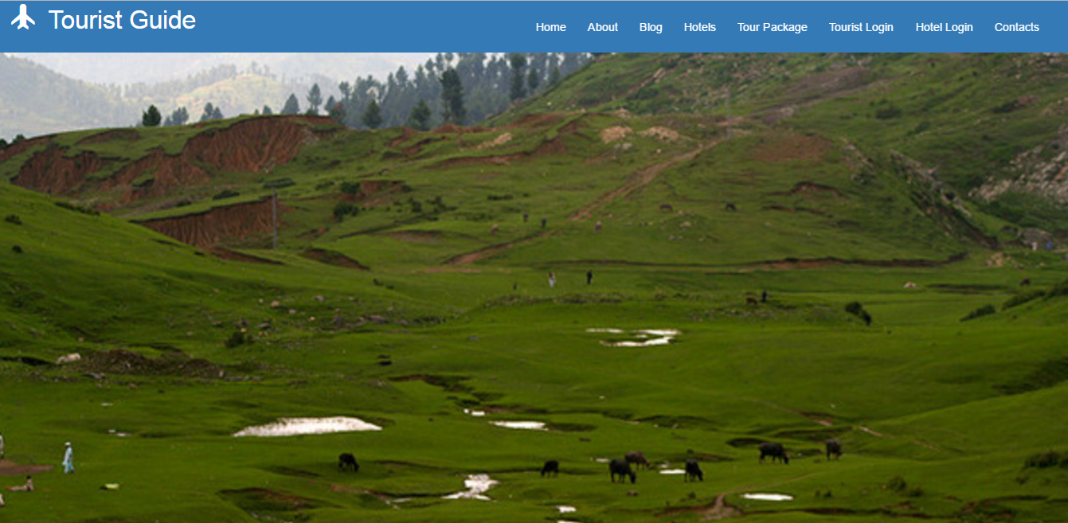

2.Hotel sign-up

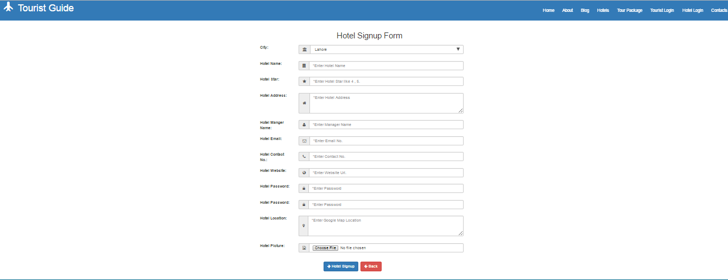

3.Hotels

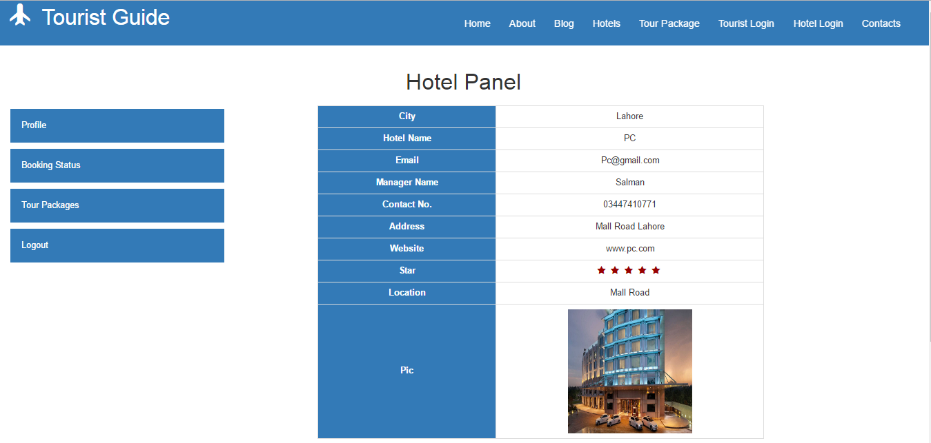

4.Packages

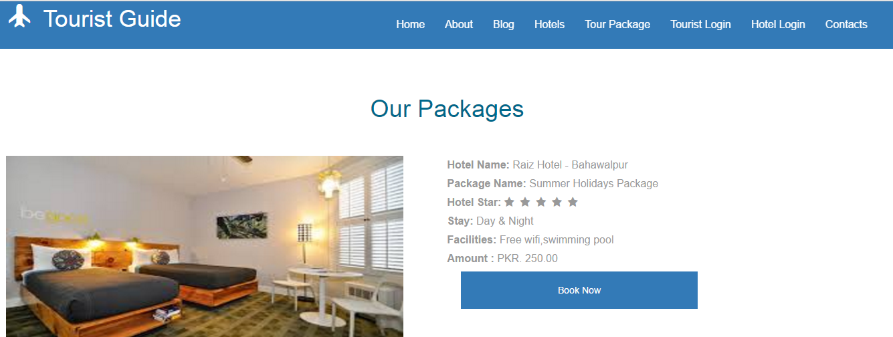

5.Tourist sign-up

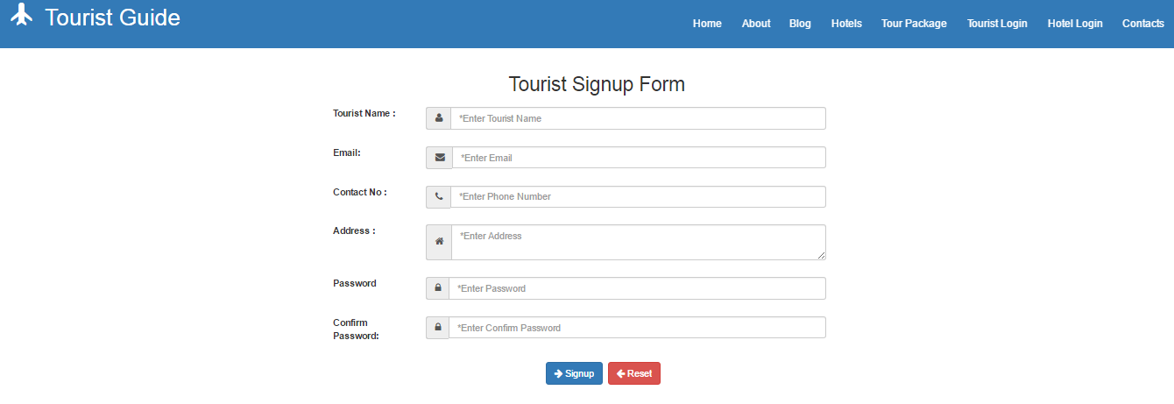

6.Database

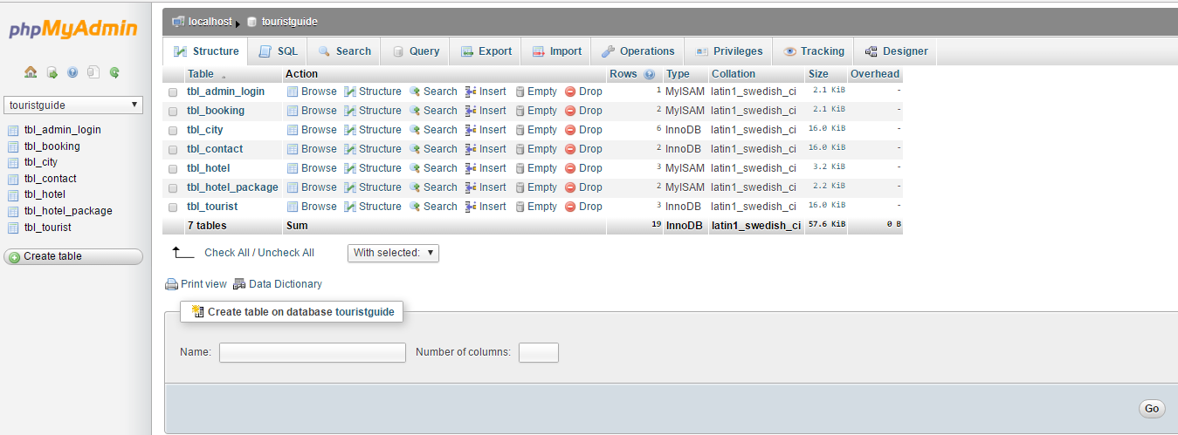

7.Admin table

