**DATABASE SYSTEMS LAB PROJECT**

**PROJECT:**

FIT-ME GYM

**MEMBER 1:**

MUHAMMAD ABDULLAH AKRAM I190513

**MEMBER 2:**

ABDUL AHAD I190405

**MEMBER 3:**

Umair Afzal I190517

**MEMBER 4:**

ABDUL MANNAN CHUGHTAI I190611

**SECTION:**

CS-E

**DATE:**

16th June, 2021

**RESUBMITTED ON:**

19th June, 2021

# ERD

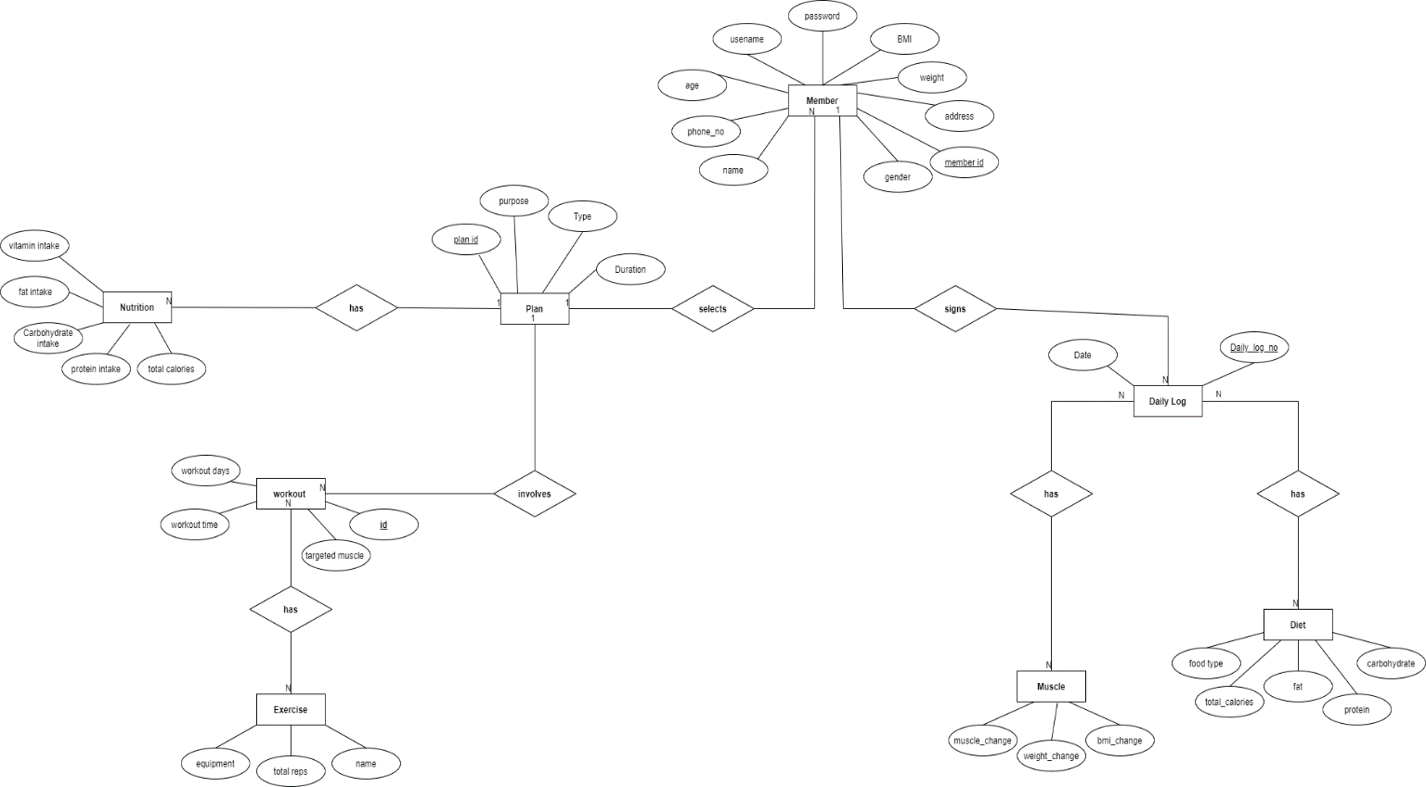

There are total of **8 tables** in the ERD with the relationship and attributes mentioned above.

* Member
* Plan
* Nutrition
* Workout
* Exercise
* Daily Log
* Muscle
* Diet

# Table Description

First of all we have a Member’s table where all the info related to member of gym is stored and has a many to one relationship with Plan table. This Plan table stores the duration, purpose and type of plan. In turn it is connected to workout table with a one to many relationship. This table stores information about workload of exercises, which are stored in Exercise table connected as a many to many. The plan table is also connected to Nutrition table which tells about a suitable diet to achieve your desired goal. This nutrition table stores info about fat intake, protein intake, and total calories in a one to many relationship. Member table is also connected to a daily log table with a one to many relationship and it stores information about daily progress of the member. This log table stores info in two other tables, Muscle table which stores progress about muscle growth and BMI changes and is introduced in a many to many relationship. The other table is Diet table which asks the user for the meals he consumed in the entire day, from which we can calculate the carbohydrate, fats, and calories intake. This table is has also a many to many relationship with Daily log.

# **SCHEMA**

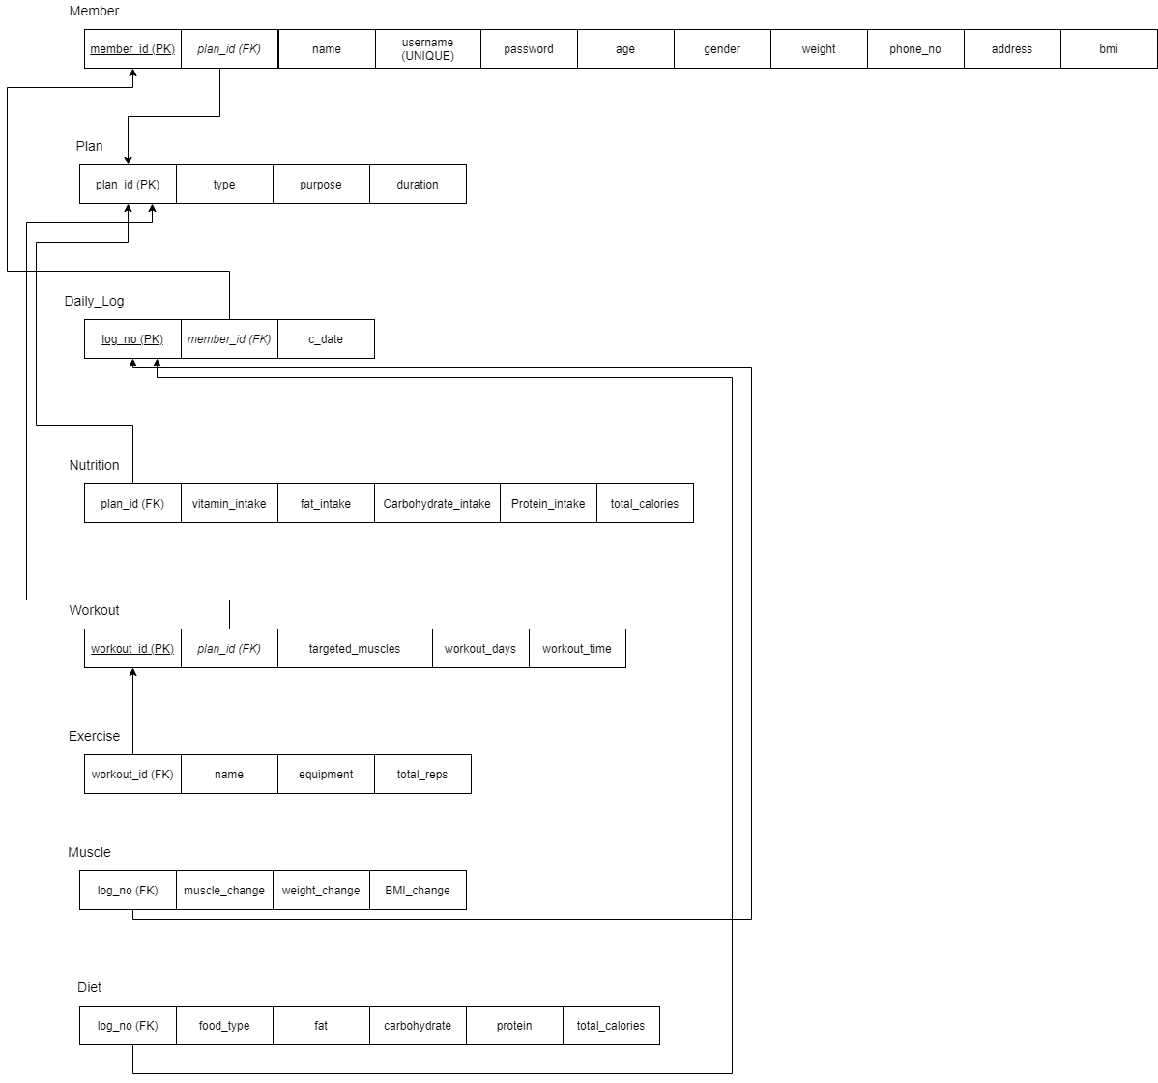

# HTML INTERFACE

**Welcome Page**



LOGIN PAGE

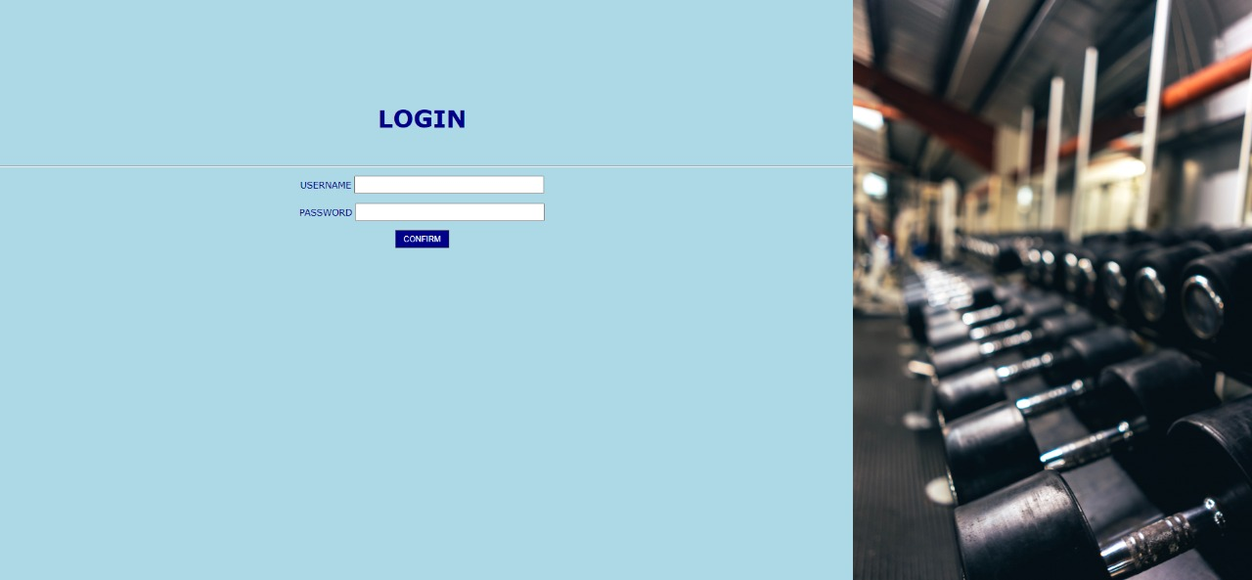

New User Registration

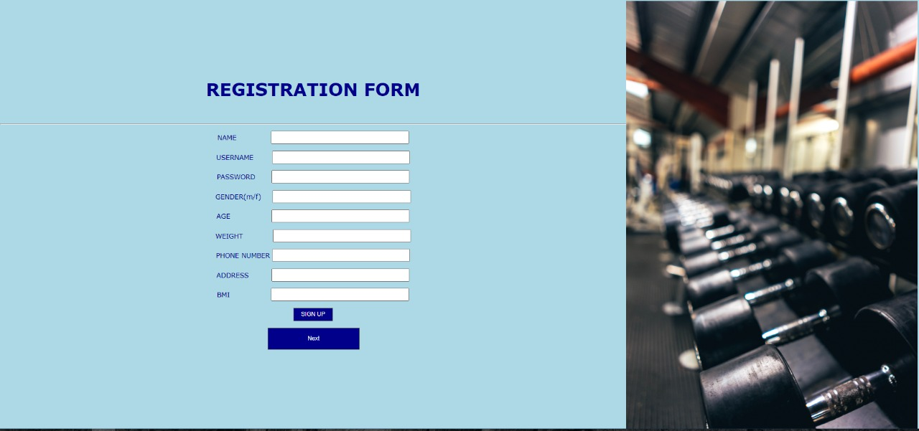

OPTIONS PAGE

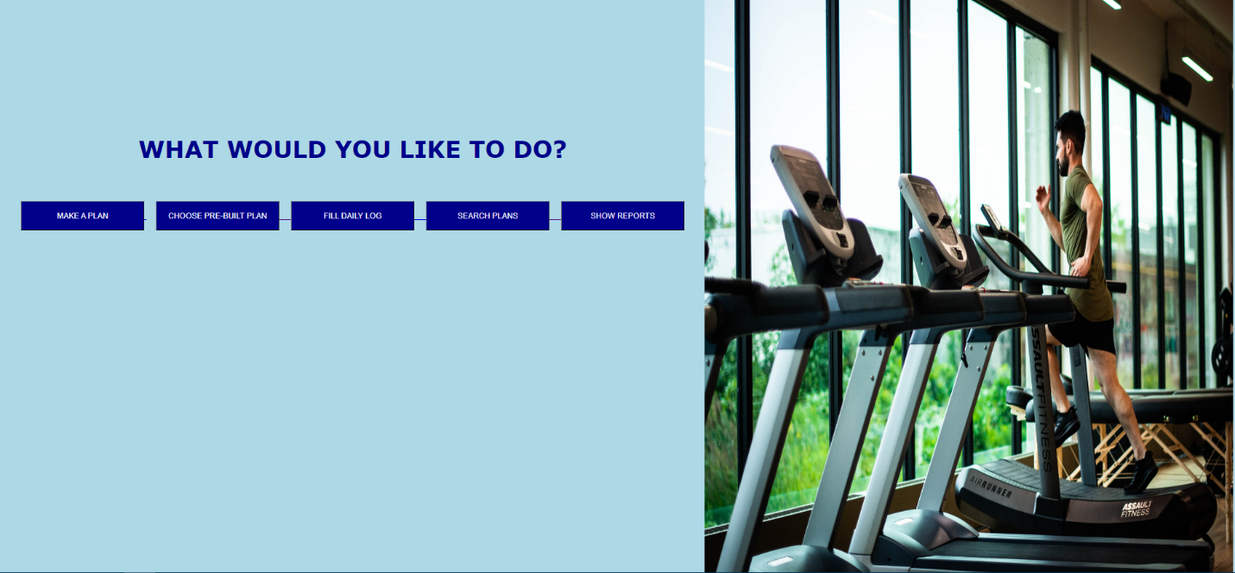

AVAILABLE PANS

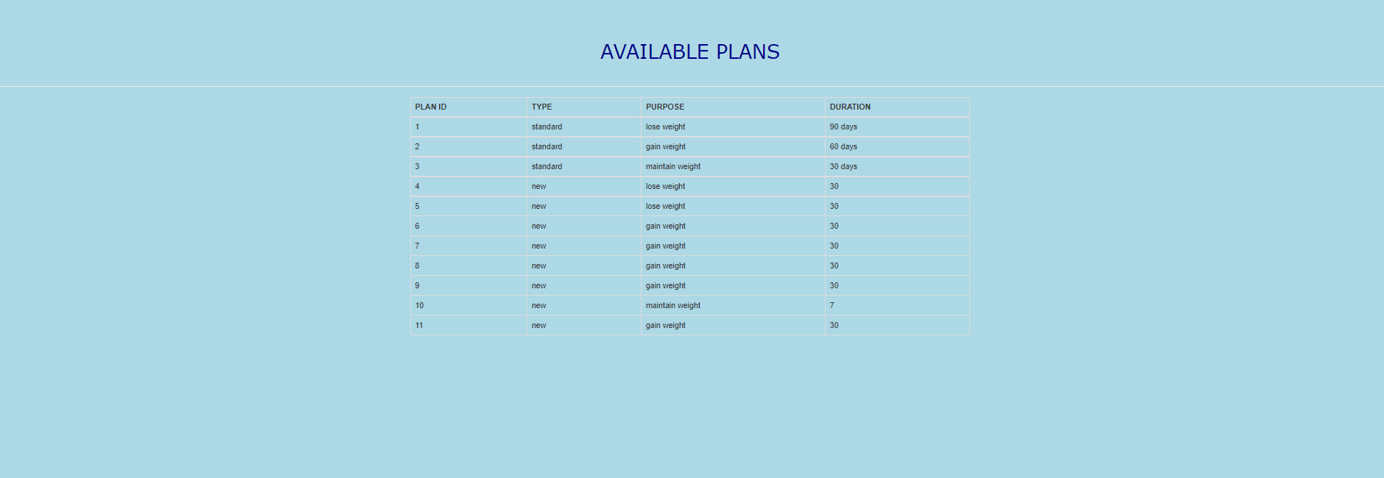

PRE-BUILT PLANS

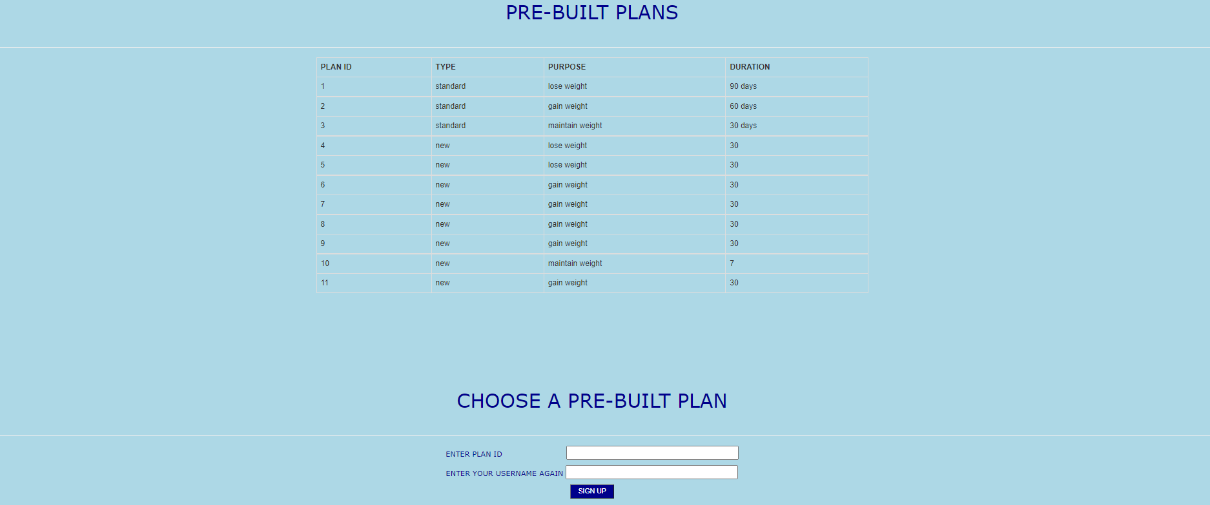

CUSTOM PLAN

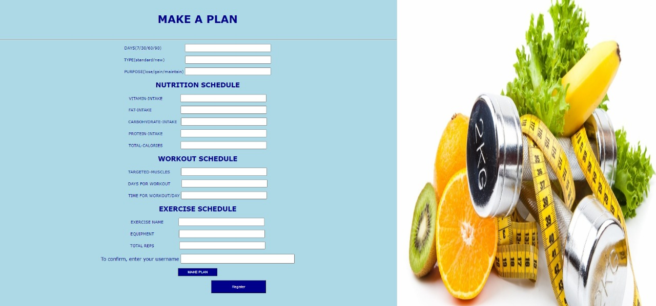

DAILY LOG

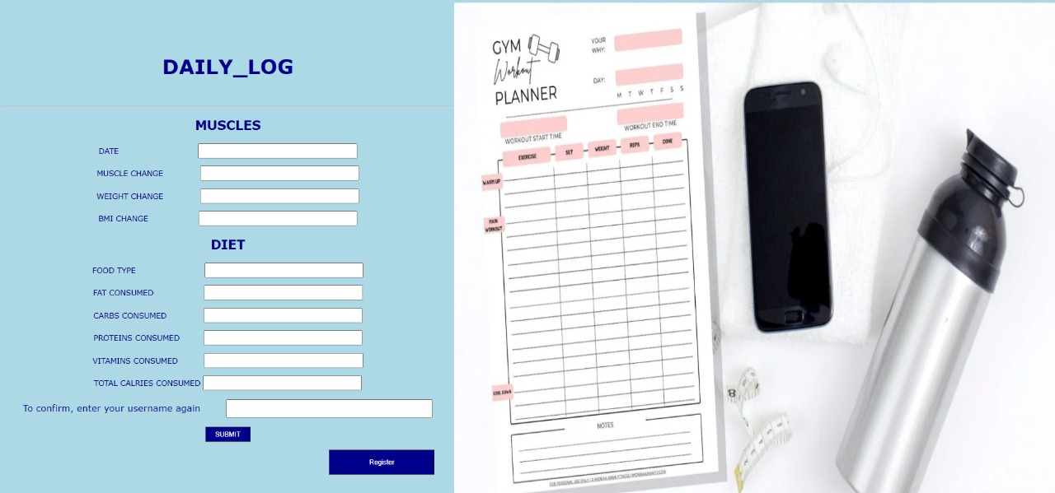

REPORTS

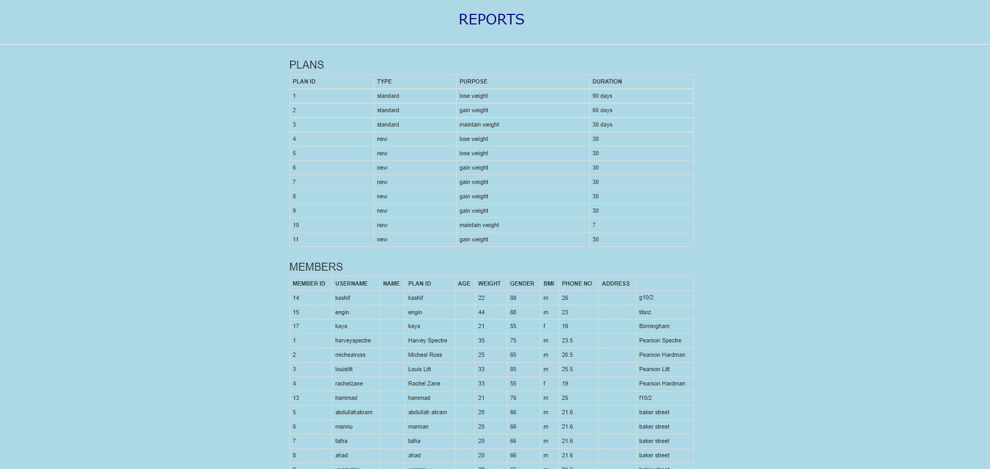

# REPORTS FROM SQL DEVELOPER

MEMBER TABLE REPORT

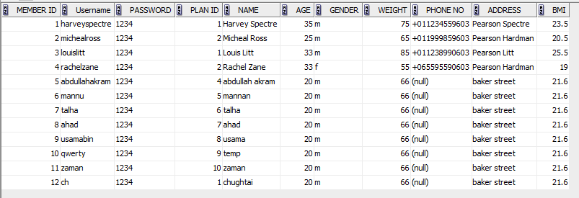

DIET TABLE REPORT

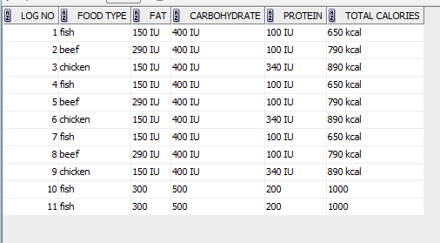

WORKOUT TABLE REPORT

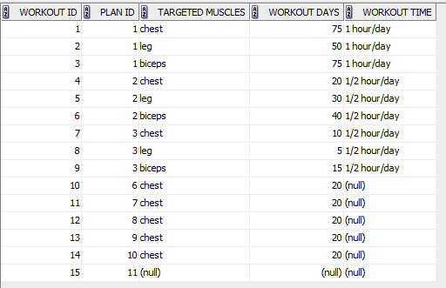

# WEBSITE DESCRIPTION

First of all we have the welcome page where we give user options to login if he is already a user and register if not. The user on registration page fills in his info and gets registered and after either of steps we go to the next page i.e. Choose options page. Here we have five options:

## Make a Plan

Here user makes a new plan.

## Choose a Pre-Built Plan

Here user choses a pre-built plan by another user or trainers.

## Fill Daily Log

Here user fills his daily log.

## Search Plans

Here user can look for plans already available.

## Show Reports

Here we can see all the reports of all tables.

# BONUS

We have used bootstrap to show reports and pre-built plans.