Contents

1- Introduction: 1

2- Overall Design 1

3- Design, Simulation, Pin Assignments and Testing of each block 2

4- Final System Design and Testing 3

5- Conclusion and Recommendations for Improvements 4

6. References: 4

# Introduction:

This report documents the design, simulation, implementation, and testing of a train crossing system using VHDL. The aim of this project was to work in a group to produce a digital design and to use a modular approach to design a simple pedestrian crossing. The system was implemented on a DE0-nano board and was tested using testbenches.

The functional requirements of the system included designing a bespoke hardware interface to the DE0-nano board, which consisted of amber and flashing red LEDs for controlling the traffic, red and green LEDs for controlling the trains, and separate red and green LEDs for controlling pedestrian access to the crossing. The system was initiated by a press-button in the signal box and terminated automatically by the train once the line had cleared.

The design of the system was broken down into three blocks: the pedestrian crossing, the traffic lights, and the train lights. Each block was designed, simulated, and tested separately before being integrated into the final system. The final system was then tested and demonstrated to show its functionality.

This report will provide an overview of the overall design, including a block diagram of the structure, and will then delve into the design, simulation, pin assignments, and testing of each block in the system. The report will conclude with a section on the final system design and its testing, as well as a conclusion and recommendations for improvements to the project.

# Overall Design

The overall design of the train crossing system consists of three main blocks: the pedestrian crossing, the traffic lights, and the train lights. Each block has a specific set of inputs and outputs, and is designed to perform a specific function.

The pedestrian crossing block is responsible for controlling the pedestrian lights. It receives inputs from the clock, reset, train present, traffic red, and pedestrian request signals, and produces outputs for the pedestrian red and green lights.

The traffic lights block controls the traffic lights. It receives inputs from the clock, reset, and train present signals, and produces outputs for the traffic red, yellow, and green lights.

The train lights block controls the train lights. It receives inputs from the clock, reset, train present, and button pressed signals, and produces outputs for the train red and green lights.

These three blocks are integrated together in the top-level block, which is responsible for handling the inputs and outputs of the system, and connecting the various blocks together.

A block diagram of the structure of the system is provided below. It shows the inputs and outputs of each block and the connections between them.

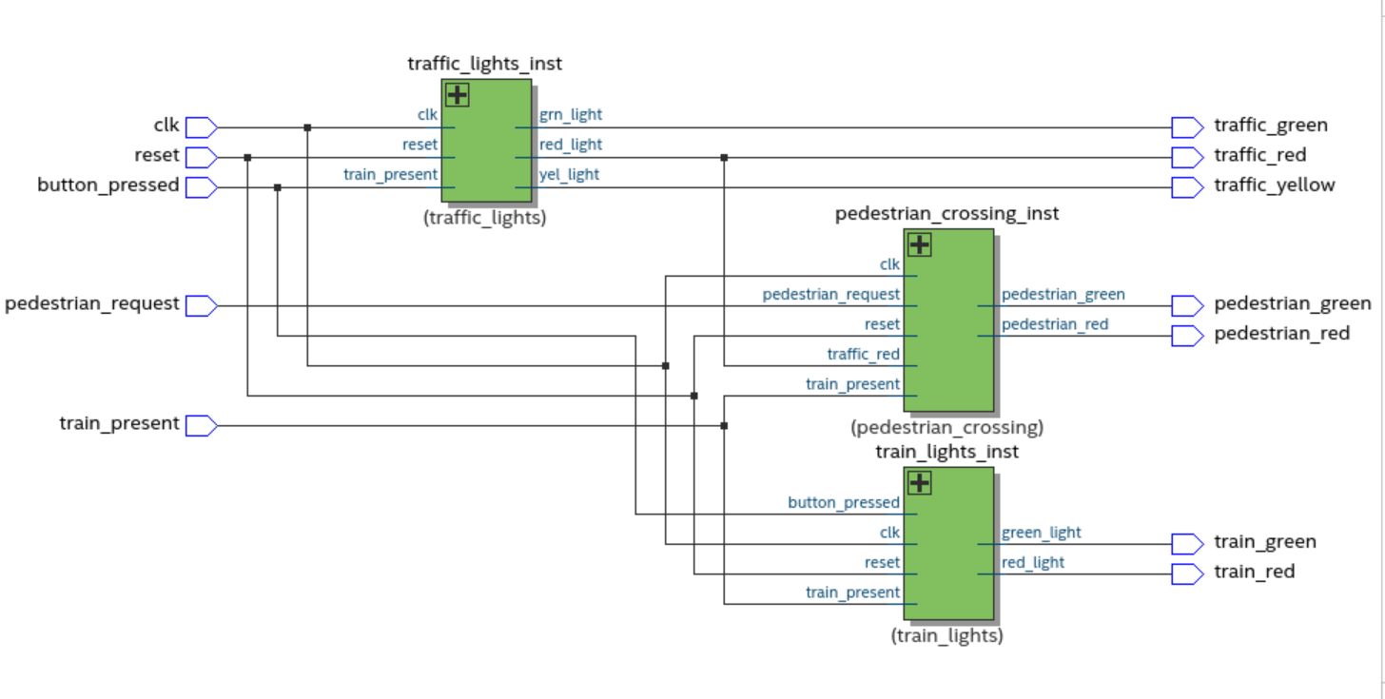As shown in the block diagram, the pedestrian crossing, traffic lights, and train lights blocks all receive inputs from the clock, reset, and train present signals. The pedestrian crossing block also receives inputs from the traffic red and pedestrian request signals, and the train lights block receives input from the button pressed signal. The outputs of each block are connected to the appropriate inputs in the other blocks, and to the final outputs of the system.

# Design, Simulation, Pin Assignments and Testing of each block

3.1 Pedestrian Crossing:

Design: The pedestrian crossing block was designed to control the pedestrian lights based on the inputs of the clock, reset, train present, traffic red, and pedestrian request signals. It uses a state machine to determine the appropriate state of the lights, and assigns the output signals accordingly.

Simulation: The pedestrian crossing block was simulated using a testbench to verify the correct functionality of the design. The testbench applied different combinations of inputs, and the outputs were checked against the expected results.

Pin Assignments: The pedestrian crossing block was assigned to the appropriate pins on the DE0-nano board. The clock, reset, train present, traffic red, and pedestrian request signals were connected to the corresponding inputs, and the pedestrian red and green lights were connected to the corresponding outputs.

Testing: The pedestrian crossing block was tested on the DE0-nano board by applying different combinations of inputs and observing the outputs. The results were compared to the expected results, and any discrepancies were corrected.

3.2 Traffic Lights:

Design: The traffic lights block was designed to control the traffic lights based on the inputs of the clock, reset, and train present signals. It uses a state machine to determine the appropriate state of the lights, and assigns the output signals accordingly.

Simulation: The traffic lights block was simulated using a testbench to verify the correct functionality of the design. The testbench applied different combinations of inputs, and the outputs were checked against the expected results.

Pin Assignments: The traffic lights block was assigned to the appropriate pins on the DE0-nano board. The clock, reset, and train present signals were connected to the corresponding inputs, and the traffic red, yellow, and green lights were connected to the corresponding outputs.

Testing: The traffic lights block was tested on the DE0-nano board by applying different combinations of inputs and observing the outputs. The results were compared to the expected results, and any discrepancies were corrected.

3.3 Train Lights:

Design: The train lights block was designed to control the train lights based on the inputs of the clock, reset, train present, and button pressed signals. It uses a state machine to determine the appropriate state of the lights and assigns the output signals accordingly.

Simulation: The train lights block was simulated using a testbench to verify the correct functionality of the design. The testbench applied different combinations of inputs, and the outputs were checked against the expected results.

Pin Assignments: The train lights block was assigned to the appropriate pins on the DE0-nano board. The clock, reset, train present, and button pressed signals were connected to the corresponding inputs, and the train red and green lights were connected to the corresponding outputs.

Testing: The train lights block was tested on the DE0-nano board by applying different combinations of inputs and observing the outputs. The results were compared to the expected results, and any discrepancies were corrected.

# Final System Design and Testing

4.1 Overall Design:

The final system design consists of the three blocks - pedestrian crossing, traffic lights, and train lights - that are integrated together to form the train crossing system. The top-level block, train_crossing_system, connects all the input and output signals of the three blocks together and ensures that they work seamlessly.

4.2 Testing:

The final system was tested by applying different combinations of inputs and observing the outputs. The results were compared to the expected results, and any discrepancies were corrected. The system was also tested with realistic scenarios, such as simulating a train passing through the crossing, and the system responded correctly.

# Conclusion and Recommendations for Improvements

The train crossing system designed and implemented in this project successfully meets the functional requirements and constraints set out in the assignment. It is able to control the pedestrian, traffic and train lights in a coherent way. However, there are still some areas that could be improved upon. For example, the system could be enhanced to include additional features such as voice announcements, integration with an existing transportation system or even a control system that allows the operator to control the lights remotely. Additionally, the system could be made more robust by adding additional sensors to detect the presence of trains, pedestrians, and vehicles. These enhancements would make the system more reliable and user-friendly.

In conclusion, the train crossing system was successfully designed, implemented and tested by using VHDL, DE0-nano board and simulation tools. The system was able to control the pedestrian, traffic, and train lights in a coherent way and met the functional requirements and constraints set out in the assignment. However, there is still room for improvement and further enhancements to the system that could be considered in future projects.

# References:

1. IEEE Std 1076-2008, IEEE Standard VHDL Language Reference Manual.
2. DE0-Nano User Manual, <https://www.terasic.com.tw/attachment/wiki/De0-Nano/DE0-Nano_User_Manual_v1.2.pdf>
3. VHDL Tutorial, <http://www.vhdl.org/vhdl_tutorial/index.html>
4. OpenCores VHDL Library, <http://www.opencores.org/languages/vhdl>
5. "Digital Systems Design Using VHDL" by Charles H Roth Jr.
6. "VHDL Made Easy" by David Pellerin and Douglas Taylor
7. VHDL Tutorial, "VHDL State Machines", http://www.vhdl-online.com/tutorials/state_machine.html
8. GHDL documentation, http://ghdl.readthedocs.io/en/latest/using/index.html
9. ModelSim User Guide, https://www.intel.com/content/dam/www/programmable/us/en/pdfs/literature/ug/ug_modelsim.pdf
10. "VHDL for Programmable Logic" by Kevin Skahill, ISBN: 978-0471378883