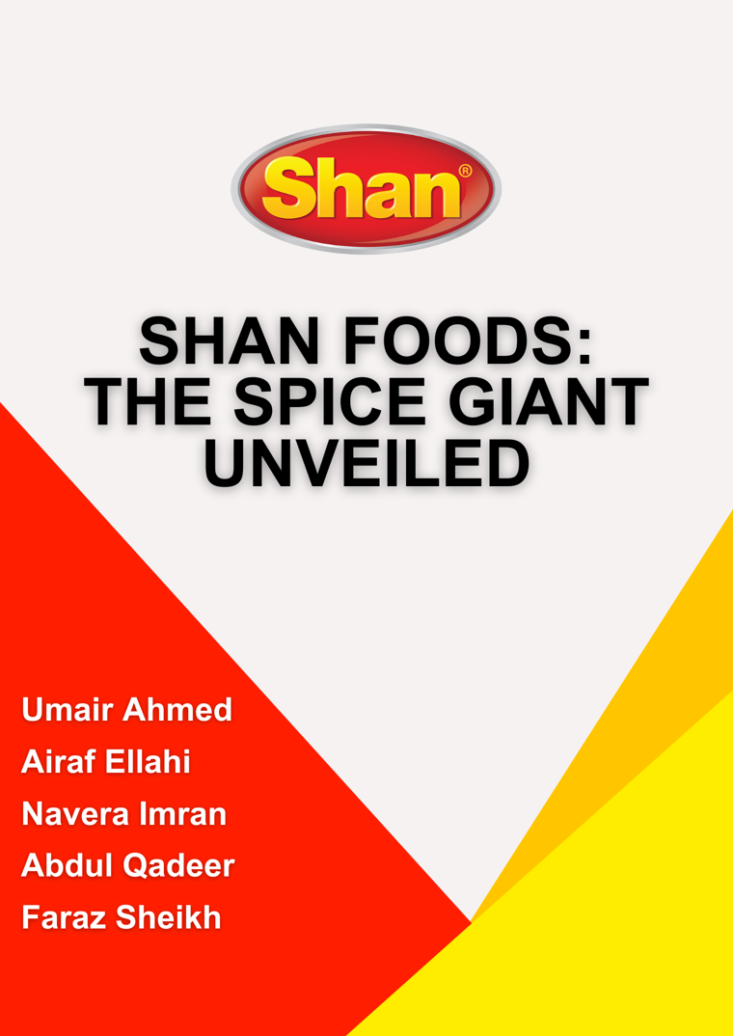
Contents
A Journey of Spice and Success: The Story of Shan Foods 5
Introduction: Shan Foods 6
Overview of Shan Foods: 6
Interview with Mr. Baneen: Manager of International Marketing: 6
Mr. Baneen's Experience at Shan Foods: 6
Vision of Shan Foods: 7
Mission Statement: 7
Objective: 7
Certifications: 7
Why we want to study this brand: 8
Product Portfolio: Shan Foods 9
Shan Brand: 9
Shoop Brand: 10
Shan Brand Current Status in the Market and Brand Positioning Elements: 11
Current Status in the Market: 11
Brand Positioning: 13
External Factors: 14
Competitive Environment: 14
Target Market: 15
Consumers Viewpoint: 15
Benefits: 15
Values & Personality: 15
Reason to Believe: 16
Discriminators: 16
Root Strengths: 16
Pricing Strategy at Shan Foods: 17
Premium Pricing for International Markets: 17
Mitigating Price Increases Amid Inflation: 17
Differentiation in Pricing Structure: 17
Strategic Pricing Decisions: 18
Conclusion: 18
Distribution Strategy of Shan Foods: 18
Selection of Distributors: 18
Role of Distributors: 19
Importance of Distribution: 19
International Expansion and Mainstream Retail Channels: 19
Maintaining Distributor Relationships: 19
Conclusion: 20
Promotional Strategy of Shan Foods 20
Digital Promotion: 20
Influencer Marketing: 20
Taste Trials and Product Sampling: 21
Product Positioning and Targeted Campaigns: 21
Diversified Product Portfolio for Younger Audiences: 21
Navigating Market Challenges: Shan Foods' Adaptive Approach 21
Conclusion: 22
Competitive Landscape Analysis: Shan Foods in International and Local Market: 22
Positioning and Market Leadership: 23
Perceptual Mapping and Consumer Perception: 23
Conclusion: 23
Change Shan Foods Wants: 24
Approach: 24
Assessment of Current Data Practices: 24
Investment in Data Infrastructure: 24
Training and Upskilling: 24
Establishment of Key Metrics: 24
Adoption of Advanced Analytics: 24
Benefits: 25
Informed Decision-Making: 25
Improved Operational Efficiency: 25
Enhanced Customer Understanding: 25
Global Expansion Opportunities: 25
Competitive Advantage: 25

A Journey of Spice and Success: The Story of Shan Foods

The journey of Shan Foods' impressive success began in 1981 when the dreams of one man turned into reality. Mr. Sikander Sultan, the Chairman of Shan Foods (Pvt.) Ltd, was a visionary entrepreneur, a compassionate humanist, and a devoted philanthropist. With humble beginnings, he started the spice business from a small single-room operation.
Initially, the recipe mixes were shared within family circles. However, their popularity quickly grew beyond, captivating not only acquaintances but also reaching a wider consumer base. With increasing demand, the company thrived, leading Mr. Sultan to introduce his own brand, "SHAN," which marked a significant moment in Shan's journey.
Since then, Shan has expanded globally, reaching over 70 countries across five continents. Alongside its global reach, Shan Foods has diversified its product range to meet various tastes and preferences. With a strong focus on quality, innovation, and customer satisfaction, Shan has become a trusted household name known for culinary excellence.
Driven by a passion for enriching lives through food, Shan Foods continues to succeed, guided by the enduring principles set by its founder, Mr. Sikander Sultan.

Introduction: Shan Foods

Overview of Shan Foods:
Shan Foods stands out in the global culinary landscape due to its unparalleled quality and distinctive flavors. The company's dedication to maintaining the same high standards in every product has earned it a loyal customer base worldwide. From its humble beginnings, Shan has expanded its reach to over 70 countries across 5 continents, catering to the diverse tastes of consumers.

Interview with Mr. Baneen: Manager of International Marketing:
Representing Shan Foods in this report is Mr. Baneen, the Manager of International Marketing at Shan Foods, where he shared insights into the company's evolution, strategic initiatives, Pricing strategy, Distribution Strategy, Promotional Strategy and Competition. With over 2 years of experience at Shan, Mr. Baneen elaborated on Shan's venture into international markets and its introduction of frozen food products like lasagna and pasta to cater to global preferences.

Mr. Baneen's Experience at Shan Foods:
Mr. Baneen's extensive experience sheds light on Shan's commitment to quality and innovation. As the manager overseeing international marketing, he spearheads efforts to maintain Shan's reputation for excellence while exploring new avenues for growth. His firsthand knowledge underscores Shan's dedication to meeting the highest standards, evident in its major global certifications for quality management and food safety.

Vision of Shan Foods:
The vision of Shan Foods is “To become an iconic culinary brand enjoyed on every table every day across the world”. This vision drives the company's Research & Development efforts, where a team of experts collaborates with the Board of Directors to create innovative food products. With a modern R&D lab equipped with advanced facilities, Shan continuously explores new ideas and strives to develop trending prototype food products, ensuring its place as a leader in the global food industry.

Mission Statement:
Shan Foods mission is “To provide our consumers with supreme standards of product quality, safety and consistency”. This mission serves as the company’s guiding principle, shaping every aspect of its operations as they strive to exceed customer expectations and set industry benchmarks.

Objective:
“Our overarching objective is to establish our Quality Operations as the gold standard within the industry. We are committed to upholding the highest levels of quality assurance across all stages of production, from research and development to packaging and distribution”. By steadfastly pursuing these objectives, Shan Foods aims to not only meet but exceed the expectations of our consumers, stakeholders, and partners, ensuring long-term success and sustainable growth for the company.

Certifications:
Shan Foods proudly holds major local and global certifications, including:
1. ISO 9001:2015
Quality Management System.
2. FSMS 22000
Food Safety Management System.
3. BRC Global Standard For Food Safety
British Retail Consortium Issue.

4. SANHA Halal Certification
South African National Halal Authority.

5. JAKIM Halal Certification
Jabatan Kemajuan Islam Malaysia.

6. PSQCA Product Certifications
All Mandatory Food Products.

7. SEDEX
Supplier Ethical Data Exchange.

8. FDA
Facility Registration.

9. ISO 45001:2018
Health Safety.

10. ISO 14001:2015
Environmental Safety.

Why we want to study this brand:
Studying the Shan Foods brand presents a compelling opportunity to delve into the intricacies of a globally recognized culinary enterprise. Shan Foods has carved a distinctive niche in the food industry, characterized by its unwavering commitment to quality, innovation, and authenticity. By studying this brand, we gain valuable insights into the dynamics of product development, market expansion, and consumer engagement strategies in the food sector. Moreover, Shan Foods' journey from a humble family-owned business to a powerhouse brand with a presence in over 70 countries offers invaluable lessons in entrepreneurship, leadership, and global expansion strategies. Furthermore, the company's focus on sustainability, social responsibility, and ethical business practices provides fertile ground for exploring the intersection of business success and societal impact.

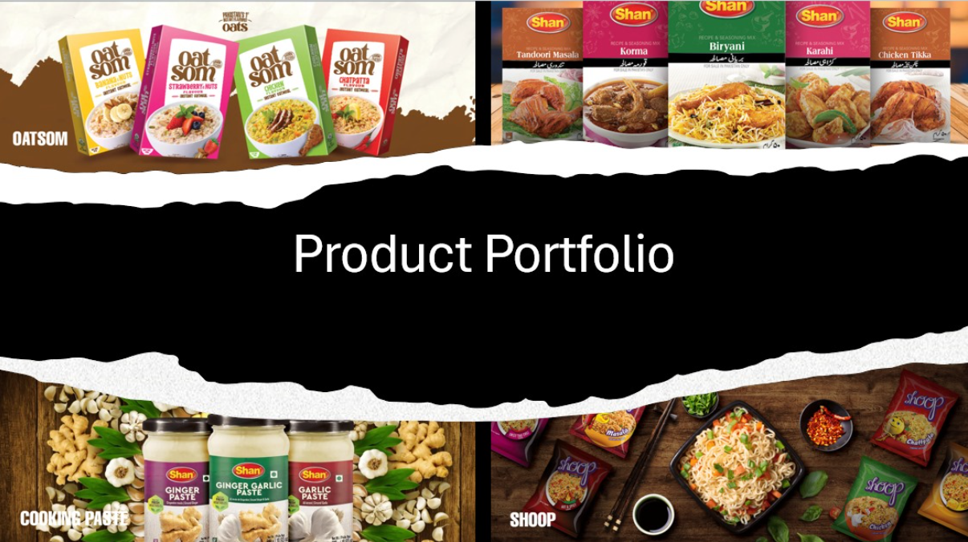
Product Portfolio: Shan Foods

Shan Brand:
- Cooking Sauces
- Rice Range
- Lentils
- Frozen Foods
- Recipe Mixes
- Plain Spices
- Salt
- Cooking Paste
- Accompaniments
- Desserts

Shoop Brand:
- Instant Noodles
- Korean Ramen

Oatsom Brand:
- Everyday Oats

BRANDS | Shan | Shoop | Oatsom
PRODUCTS +VARIETY | Cooking Sauces – Tikka Masala Sauce, Butter Chicken Sauce, etc.  Rice Range– Basmati Rice, Long Grain Rice, etc.  Lentils – Masoor Dal, Moong Dal, etc.  Frozen Foods – Frozen Samosas, Parathas, etc.  Recipe Mixes – Biryani Mix, Nihari Mix, etc.  Plain Spices – Cumin Powder, Coriander Powder, etc.  Salt – Iodized Salt, Rock Salt, etc.  Cooking Paste – Garlic Paste, Ginger Paste, etc.  Accompaniments –Mango Pickle, Mixed Pickle, etc.  Desserts –Kheer Mix, Gulab Jamun Mix, etc. | Instant Noodles – Chicken Flavor Noodles, Masala Flavor Noodles, Chatpata Flavor Noodles.  Korean Ramen Noodles - Cheese Flavor Ramen, Carbonara Flavor Ramen, Chili Blast Flavor Noodles. | Everyday Oats-  Strawberry and Nuts Flavor, Banana and Nuts Flavor, Chicken Flavor, Chatpata Flavor.

Shan Brand Current Status in the Market and Brand Positioning Elements:

Current Status in the Market:
Spices Industry of Pakistan worth of PKR 24 Billion Annual Business, according to the statistics provided by SMEDA 2020-2024. This industry can be further divided into two categories, with respect to the sources being known/unknown.
- Branded/Packed Spices (Market Share 40%, Business Volume PKR 8 Billion)
- Unbranded/Loose Spices (Market Share 60%, Business Volume PKR 10-15 Billion)
The Unbranded Industry wins a larger volume of sales than the Branded spices manufacturers, but this Unbranded Spices Industry is showing decreasing trends due to the rapid changes in consumer behavior, maybe due to globalization, (according to PGA). This can be considered as an opportunity for the branded spices producer to increase their market shares. Unbranded players operate in the market through independent, self-owned businesses and they don’t run their products under any label.
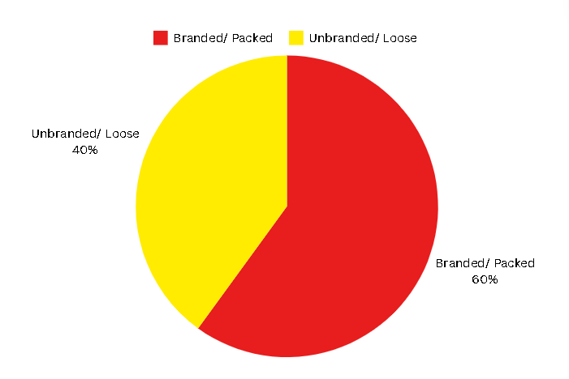
In the small list of Branded Manufacturer, some of the major known shareholders are Shan, National, Mehran, Chef’s Pride etc. Competition is rising now as new players are also entering this market, including Habib, Rivaayat (Kitchen Secrets) etc. The price levels of the branded packed spices are almost 30% more than unbranded spices.

Major Shareholder of the Packaged Spices Market:

- National foods
- Shan Foods

Other Shareholders with smaller Market Share:

- Chef’s Pride
- Mehran Foods
- Ahmed Foods
- Habib Foods
- Zaiqa Foods
- Kitchen Secrets (Rivaayat)
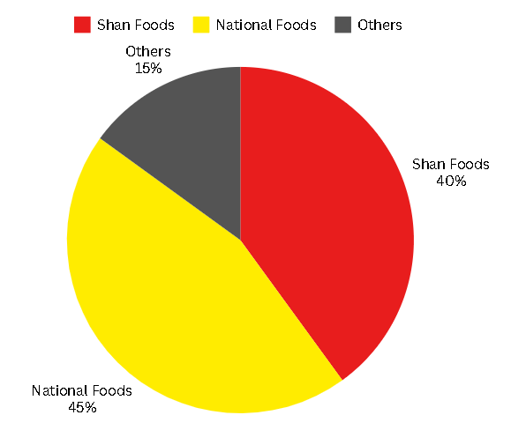
This data shows that Shan Foods is second to National Foods but the Market shares of both the brands are very close in volume.
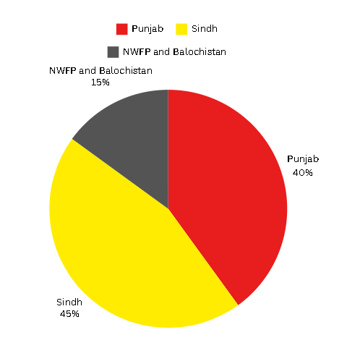
The regional share percentage of the total of Shan’s annual business volume is shown in figure below:
Shan sales distribution network is divided into four zones. According to the Sales Statistics from internal or Primary Data Sources, the total growth decreased in Karachi and South Regions, whereas Central and North regions gained percentage growth.

Brand Positioning:
Shan delivers premium quality food products, with taste, aroma and color of the meal prepared with it, it provides cooking convenience, and delights the consumers’ five senses. In simple words, Shan enriches the food experience.

External Factors:

Competitive Environment:
Shan’s Competitive environment consists of two types of competitions.
- Primary competitors: Selling similar product ranges and categories.
This category comprises of all packaged spice producers with similar cuisine recipe ranges. Shan holds a market share of 40% amongst them. The list of these competitors is in the Current Status in the Market section.
- Secondary Competitors: Selling Alternates and Substitutes
This category comprises of all unbranded/loose spice sellers, Restaurants serving similar cuisines as in the product range of Shan. Example, Student Biryani, Karachi Haleem and other restaurants that offer same dishes as the recipe mixes.

This category also consists of alternate product providers which may satisfy the need (need to eat) to pursue the brand. Example Ready to Cook, Knorr, Maggie, even Dawn Bread with Blue Band Margarine, etc. Anything that can satisfy the consumers’ need to eat.

BRANDS | National | Shan
Market Share | 45% | 40%
Regional Strength | Nationwide | Karachi and Sindh
Regional Weakness | Not as such | Punjab
Point of difference | First mover advantage, Unique taste | Challenger brand, Unique taste and strong in exports

Target Market:
By attitude, the target market of Shan is the following.
- Women who don’t compromise on premium quality culinary products.
- Women who seek Convenient and reliable cooking solution.
- Women who want to be praised for preparing delicious and healthy food.

By socio-demographics,
- Age 18 – 35.
- Women.
- Housewife, working woman.
- Married, Single.

The target market is simply those who want to be praised for good cooking and keep their family’s taste buds satisfied.

Consumers Viewpoint:

Benefits:
The functional benefit for which Shan is preferred over its competitor is the Unique Taste, Aroma and the Color of the Meal, Consistent Premium Quality and Convenience in cooking.

Values & Personality:
Shan as a brand has a hazy personality, even though it is perceived as one of the most trusted brands of spices. The Brand name is Masculine which should have been feminine as it is a culinary product. Our hunch is that in some part of the consumers subconscious mind there must be an image of Shan as a “Trusted Friend (Guide) for Women”. Shan must tailor their campaigns to use this opportunity and build up a concrete Brand Personality.

Reason to Believe:
Shan is an FMCG brand. Moreover, it is a food Product. Therefore, a simple reason for a consumer to believe in the brand is the consistency of the product attributes. Enriching the food experience every time is the key reason consumer has; to believe in the brand.

Discriminators:
- Unique Taste
- Best selected, premium quality raw materials
- New contemporary packaging
- V Lock Freshness

Root Strengths:
The Root Strengths of Shan is mainly functional differentiators, which is taste. Other differentiators are Higher (Premium) Perceived Quality, and convenience which satisfies the consumers’ spot evaluation of value for money. After more than 25 years in business, Shan is still maintaining these root strengths. According to Mr. Sikander Sultan (CEO, Shan Foods Pvt Ltd), he started with these strengths from a Shop at Jodiya Bazaar, Karachi.
Logo of Shan is also one of the root strengths, as it is perceived as a sign of quality and taste.

Pricing Strategy at Shan Foods:
According to Mr. Baneen, Shan Foods implements a nuanced pricing strategy tailored to both domestic and international markets, leveraging its brand equity and commitment to high-quality products.

Premium Pricing for International Markets:
In international markets, Shan Foods adopts a premium pricing strategy, capitalizing on its brand reputation for quality and authenticity. By positioning itself as a premium offering, Shan Foods can command higher prices, reflecting the perceived value of its products among discerning consumers. This premium pricing strategy is underpinned by the company's unwavering dedication to delivering superior taste experiences, ensuring that consumers are willing to pay a premium for Shan's renowned quality.

Mitigating Price Increases Amid Inflation:
Despite the premium pricing strategy, Shan Foods faces challenges posed by inflation, which necessitates periodic price adjustments. Recent inflationary pressures have prompted price increases across the industry, impacting Shan Foods' pricing strategy both domestically and internationally. While the company endeavors to minimize price hikes through cost-saving measures, such as optimizing operational efficiencies, certain market dynamics may require adjustments to maintain profitability and sustainability.

Differentiation in Pricing Structure:
Shan Foods' pricing structure encompasses various elements, including the net sale to distributors and subsequent pricing decisions made by distributors based on factors such as clearance, taxes, and market conditions. The company's revenue model relies on the volume of sales to distributors, with revenue generated proportional to the quantity sold. However, the ultimate retail price paid by consumers may vary based on additional factors beyond Shan Foods' control, such as distributor markups and regional taxes.

Strategic Pricing Decisions:
Shan Foods' pricing decisions are guided by a strategic balance between maintaining brand integrity, meeting consumer expectations, and navigating market dynamics. The company aims to strike a delicate equilibrium between pricing its products competitively to capture market share while upholding its premium positioning and preserving profitability. Through meticulous market analysis, Shan Foods seeks to identify pricing opportunities and challenges, allowing it to adapt its pricing strategy to evolving market conditions effectively.

Conclusion:
In conclusion, Shan Foods' pricing strategy is multifaceted, encompassing premium pricing for international markets, proactive measures to mitigate inflationary pressures, and strategic differentiation in pricing structures. By aligning pricing decisions with its brand ethos and market realities, Shan Foods aims to sustain its position as a leading provider of high-quality culinary solutions while navigating the complexities of the global food industry landscape.

Distribution Strategy of Shan Foods:
As per Mr. Baneen's insights, Shan Foods implements a meticulous distribution strategy, which starts with the precise selection of distributors and extends to the continuous monitoring of sales data. This strategy also involves fostering strong relationships with channel partners to ensure the broad availability of Shan's products across diverse markets.

Selection of Distributors:
Initially, Shan Foods identifies and evaluates multiple potential distributors, pitching to them and carefully assessing their suitability for partnership. Criteria such as financial stability, existing brand portfolio, market reach, and distributor size are considered before finalizing partnerships. This rigorous selection process ensures that Shan Foods collaborates with distributors who are well-equipped to effectively promote and distribute its products.

Role of Distributors:
Distributors play a crucial role in Shan Foods' distribution network, acting as intermediaries between the brand and retailers. They are responsible for managing product inventory, ensuring timely deliveries, and maintaining product availability in retail outlets. Additionally, distributors are required to share sales data with Shan Foods, allowing the company to monitor stock levels and assess market demand effectively.

Importance of Distribution:
The effectiveness of Shan Foods' distribution strategy is paramount to the brand's success. A strong distribution network ensures that Shan's products are readily accessible to consumers, enhancing brand visibility and driving sales. Conversely, inadequate distribution can lead to product unavailability and hinder market penetration, underscoring the critical role distributors play in Shan Foods' supply chain.

International Expansion and Mainstream Retail Channels:
While Shan Foods initially targeted ethnic retail channels, such as specialty stores catering to specific cultural communities, the brand has expanded into mainstream retail channels in certain markets. This diversification allows Shan to reach a broader consumer base, including mainstream retailers like Tesco and Walmart. However, the brand remains selective in its market expansion efforts, prioritizing markets with significant potential for growth and profitability.

Maintaining Distributor Relationships:
Shan Foods places great emphasis on maintaining strong relationships with its distributors. By offering competitive margins, incentives, and promotional support, Shan incentivizes distributors to prioritize the brand and maintain consistent sales performance. This commitment to partnership and mutual success fosters loyalty among distributors, ensuring long-term collaboration and sustained market presence for Shan Foods.

Conclusion:
In conclusion, Shan Foods' distribution strategy is characterized by meticulous distributor selection, ongoing monitoring of sales data, and proactive relationship management. By aligning distribution efforts with market dynamics and consumer preferences, Shan Foods maximizes product availability and drives growth in both domestic and international markets.

Promotional Strategy of Shan Foods
Mr. Baneen mentioned that Shan Foods implements a multifaceted promotional strategy with a strong focus on digital platforms and influencer marketing to connect with its target audience effectively. This strategy encompasses various components tailored to different markets and consumer segments.

Digital Promotion:
Digital platforms, including social media channels like TikTok, serve as key pillars of Shan Foods' promotional efforts. By leveraging the widespread reach and engagement potential of digital platforms, Shan Foods effectively disseminates brand messages, product information, and promotional campaigns to a vast audience. This approach allows the brand to connect with consumers in real-time, fostering meaningful interactions and driving brand awareness. According to Mr. Baneen Digital and Social Media Marketing has always been the most used promotional tool.

Influencer Marketing:
Influencer marketing plays a pivotal role in Shan Foods' promotional strategy, particularly in international markets. Collaborating with influencers from diverse ethnic backgrounds, Shan Foods effectively taps into niche communities and cultural preferences, thereby expanding its reach and relevance among target audiences. These influencers serve as brand advocates, endorsing Shan's products and reinforcing brand loyalty among their followers.

Taste Trials and Product Sampling:
Shan Foods recognizes the importance of taste trials and product sampling in driving consumer awareness and adoption. By offering consumers the opportunity to try their products, either through in-store demos or sampling campaigns, Shan Foods can create memorable experiences and encourage trial purchases. This helps to build consumer confidence and loyalty towards the brand.

Product Positioning and Targeted Campaigns:
Shan Foods strategically positions its products to cater to specific consumer segments and market preferences. For instance, offerings like Palak Paneer or vegetarian options are tailored to resonate with Indian consumers, aligning with their culinary preferences and cultural traditions. Shan Foods conducts targeted campaigns to promote these products, effectively communicating their unique value propositions and relevance to the target audience.

Diversified Product Portfolio for Younger Audiences:
Shan Foods diversifies its product portfolio to appeal to younger audiences, who are often drawn to convenience and innovation in culinary offerings. In addition to traditional spice mixes, Shan offers a range of sauces, chutneys, and ready-to-use condiments designed to attract younger consumers seeking quick and flavorful meal solutions. This strategic approach ensures that Shan Foods remains relevant and appealing to a broad spectrum of consumers.

Navigating Market Challenges: Shan Foods' Adaptive Approach
Mr. Baneen mentioned that in response to a market challenge, where there was a change of distributor in the market of UAE, Shan Foods demonstrated adaptability and resilience in its promotional strategies. They launched targeted campaigns featuring influencers from diverse ethnic backgrounds, Shan effectively mitigated concerns about brand dominance and reinforced its position in the market. This proactive approach not only sustained brand awareness but also derived increased consumer engagement and loyalty.

Conclusion:
In conclusion, Shan Foods' promotional strategy is characterized by a dynamic mix of digital promotion, influencer marketing, targeted campaigns, and product diversification. By leveraging these components effectively, Shan Foods maintains a strong brand presence, connects with diverse consumer segments, and navigates market challenges with agility and innovation.

Competitive Landscape Analysis: Shan Foods in International and Local Market:
In the International market, Shan Foods faces significant competition from Indian brands, particularly in regions with large South Asian populations such as the UAE. Despite this competition, Shan Foods maintains a strong foothold internationally, outperforming Indian brands in certain markets. For example, in the UAE, Shan Foods has established itself as a dominant player, surpassing Indian competitors in terms of market share and consumer preference.


One of the key factors contributing to Shan Foods' competitive advantage is its ability to cater to diverse taste preferences while maintaining a distinct flavor profile. Shan masalas are known for their bold flavors and slightly spicier taste compared to other brands, appealing to consumers who enjoy robust and flavorful dishes. However, it's important to note that taste preferences vary, and some consumers may prefer the milder taste offered by competing brands such as National masalas.

Positioning and Market Leadership:
Shan Foods holds a formidable position in the Pakistani market, being the leading recipe mix brand. With a wide range of products and a strong brand presence, Shan Foods has established itself as a household name synonymous with quality and authenticity. Moreover, the brand's global expansion efforts have yielded remarkable results, with Shan Foods emerging as the number one recipe mix brand in key markets like the UK and UAE, as per research by Kantar. According to insights from Mr. Baneen, Shan Foods and National Foods emerge as the two major players in the Pakistani market. Mr. Baneen mentioned that it’s a healthy competition but according to the data they have, Shan asserts its dominance over National Foods in the local Pakistani Market.

Perceptual Mapping and Consumer Perception:
Perceptual mapping provides insights into how consumers perceive different brands within the market landscape. In the case of Shan Foods, its positioning on the perceptual map reflects its emphasis on bold flavors and quality ingredients. While Indian brands may offer similar products, Shan Foods distinguishes itself through its robust flavor profiles and widespread popularity, both domestically and internationally. Consumer perception of Shan Foods is shaped by its reputation for authenticity, taste, and versatility, positioning it as a preferred choice for consumers seeking flavorful and convenient culinary solutions.

Conclusion:
In conclusion, Shan Foods navigates a competitive landscape shaped by Indian brands and other international players, leveraging its strengths in flavor, quality, and market leadership to maintain a strong position in the global market. Through strategic positioning, consumer-centric product development, and effective marketing initiatives, Shan Foods continues to uphold its reputation as a trusted provider of authentic Pakistani cuisine, winning the hearts of consumers around the world.

Change Shan Foods Wants:
Shan Foods desires to transition into a more data-oriented organization while concurrently expanding its presence globally.

Approach:

Assessment of Current Data Practices:
Shan Foods should start by assessing its current data practices, including data collection methods, storage systems, and analytical capabilities. This assessment will help identify existing strengths and areas for improvement.

Investment in Data Infrastructure:
The company should allocate resources towards building a robust data infrastructure. This includes implementing data management systems, cloud storage solutions, and analytics platforms to streamline data collection, storage, and analysis processes.

Training and Upskilling:
Shan Foods should invest in training programs to enhance data literacy and analytical skills among its workforce. Employees at all levels should be equipped with the necessary skills to interpret and utilize data effectively in their decision-making processes.

Establishment of Key Metrics:
The company needs to define key performance metrics and KPIs aligned with its business objectives and expansion goals. These metrics could include sales performance, market penetration, customer satisfaction scores, and supply chain efficiency.

Adoption of Advanced Analytics:
Shan Foods should leverage advanced analytics techniques such as predictive modeling, machine learning, and data visualization to extract actionable insights from its data. These insights can inform strategic decisions related to product development, marketing campaigns, and market expansion efforts.

Benefits:

Informed Decision-Making:
By embracing a data-oriented approach, Shan Foods can make more informed and data-driven decisions across all aspects of its business operations. This leads to better strategic planning, resource allocation, and risk management.

Improved Operational Efficiency:
Streamlining data processes and utilizing analytics tools can help Shan Foods identify inefficiencies and optimize its operations. This could result in cost savings, reduced wastage, and enhanced productivity.

Enhanced Customer Understanding:
Analyzing customer data allows Shan Foods to gain deeper insights into consumer preferences, behaviors, and trends. This enables the company to tailor its products and marketing efforts to better meet the needs of its target audience, ultimately driving customer satisfaction and loyalty.

Global Expansion Opportunities:
A data-driven approach provides Shan Foods with valuable insights into potential markets for expansion, including market demand, competitive landscape, and consumer preferences. This enables the company to make informed decisions regarding market entry strategies and resource allocation for international expansion initiatives.

Competitive Advantage:
Embracing data analytics gives Shan Foods a competitive edge in the market by enabling proactive decision-making, agile responses to market changes, and the ability to anticipate and capitalize on emerging trends.

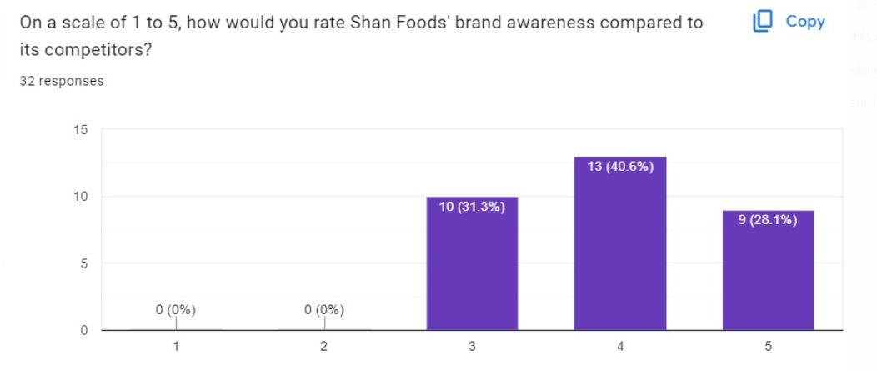
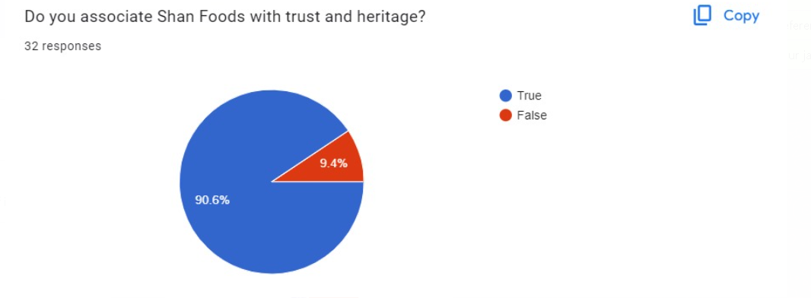
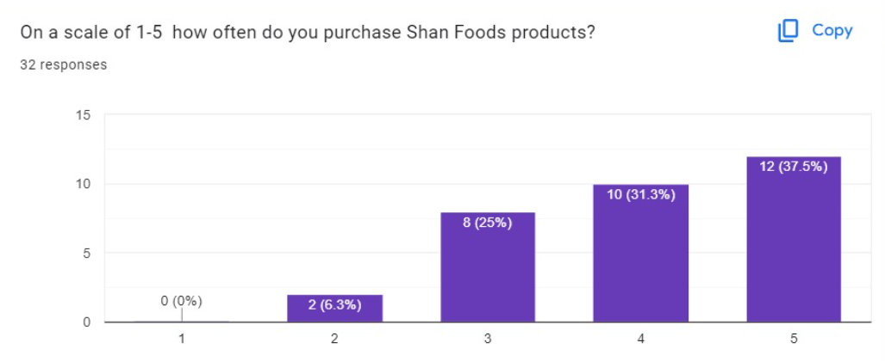



A Survey Conducted:
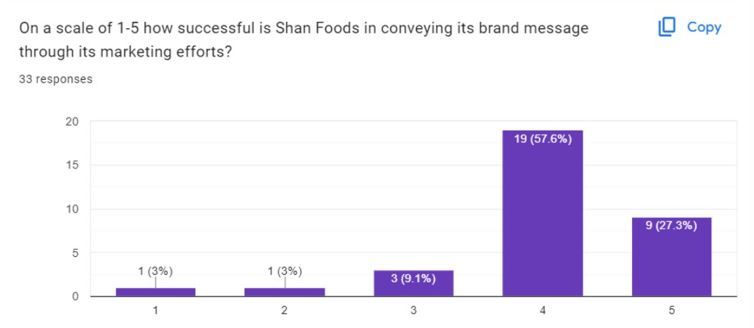



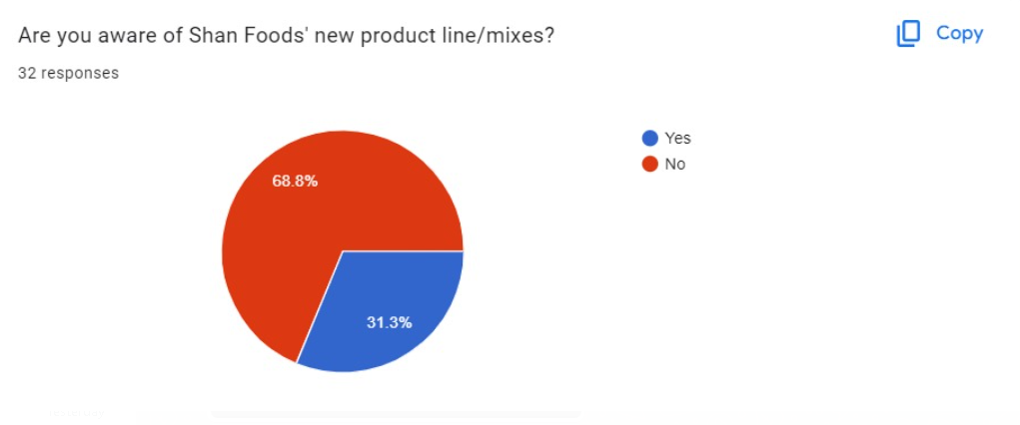
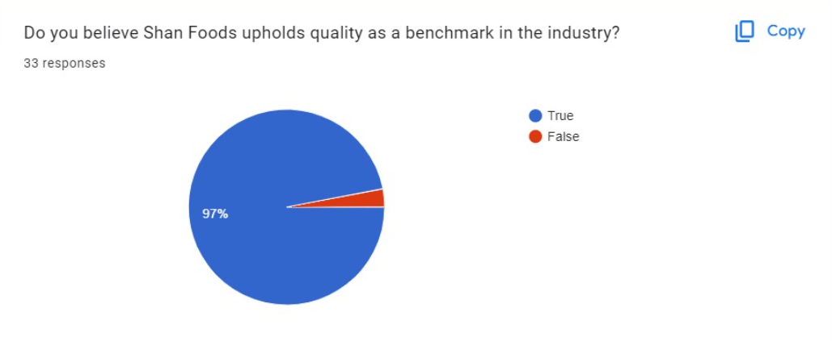


References:

- J. A. Qureshi and N.A. Syed," Branding Agriculture commodity-based industry: the case of spice industry in Pakistan”, Pak. J. Agri., Agril. Engg., Vet. Sci., 2016, 32 (2): 246-257. ISSN 1023-1072
- Andrew, M. 2015. Spicing it up- Exploring Pakistan's spice industry. Dawn News. May-June 2015
- Official Website of Shan Foods, www.shanfoods.com
- saad@shanfoods.com
- Shan Foods. 2017. An Overview of Shan Foods. https://www.shanfoods.com/pk/about-us/.

