PROJECT PROPOSAL
Smart Challan System
Delivering traffic challans to the person who is actually responsible

Item | Details
Student | Muhammad Umair
University | UET Lahore, IDS Department
Course | Generative AI (3-month course), Arfa Karim Technology Incubator
Project type | Final course project
Core topics used | CNN, RNN / LSTM, NLP, relational database

1. Introduction
Traffic challans are issued to enforce road rules, but the way they are delivered has a weakness. In Pakistan, a challan is sent to the registered owner of the vehicle, because the number plate is the only reliable link between a vehicle and a person. The person who actually broke the rule may be a family member, a friend, an employee, or a rental customer.
This project proposes the Smart Challan System: an AI-assisted system that detects a violation, reads the vehicle number plate, finds the owner, and then makes sure the challan finally reaches the person who is responsible, using a confirmed driver identity (CNIC or driving licence).

2. Problem Statement
The current challan process has the following problems:
- The challan message is always sent to the vehicle owner, even when someone else was driving.
- The owner has no simple, official way to say who the real driver was.
- The real offender faces no direct consequence, which reduces the effect of the penalty.
- A camera can capture a number plate, but it cannot reliably identify the driver as a person.
The problem to solve is: how can a challan be sent to the responsible person, when the system can only identify the vehicle and not the driver?

3. Objectives
- Detect a traffic violation automatically from an image or video frame using a CNN.
- Read the vehicle number plate using a CNN plus LSTM text recognition model.
- Find the vehicle and its registered owner from a database using the plate number.
- Send the challan to the correct person: the driver when identified at the scene, or the owner first when the driver is unknown.
- Let the owner name the real driver, either from a saved list of authorised drivers or by entering any CNIC, and let that driver accept or reject.
- Generate a clear challan message in English, Urdu or Roman Urdu using NLP.
- Keep a complete record of every challan, nomination and notification.

4. Proposed Solution
The system identifies the vehicle, not the person, from the camera image. The number plate is the link used to reach the owner. The driver is then identified in one of two ways, so the challan finally reaches the right person.

4.1 Scenario A: Driver identified at the scene
A traffic warden stops the vehicle and scans the driver's licence or CNIC. The system already knows who the driver is, so the challan goes directly to that driver. The owner is not involved.

4.2 Scenario B: Driver not identified (nomination process)
When the vehicle is captured by a camera and nobody is stopped, the process is:
- The system reads the plate and finds the owner, for example Ali.
- Ali receives a challan notice. If he was driving, he pays. If someone else was driving, he names the driver within a fixed number of days (for example 7 days).
- Two ways to name the driver: (a) pick the person from his saved list of authorised drivers, which is quick for family and regular drivers; or (b) enter any person's CNIC, for a friend from another city, a guest or a rental customer. The list is only a shortcut and never limits who can be named.
- The system checks that the person exists in the database and holds a driving licence. If not, the nomination is refused and the challan stays with Ali.
- The system sends an SMS to the phone number stored against that CNIC. Ali cannot choose the number. The named person accepts or rejects.
- If the person accepts, the challan moves to them. If they reject, or do not reply before the deadline, the challan stays with Ali, who may try one more nomination.
Why confirmation is required: this applies to both ways of naming the driver. Without the driver's acceptance, an owner could move a fine onto an innocent person, even a family member who was not driving.

5. System Modules
Module | Technique | What it does
Violation detection | CNN (object detection, e.g. YOLO) | Finds the vehicle and the violation in an image, for example a rider without a helmet.
Number plate recognition | CNN for plate detection + LSTM for text reading (CRNN) | Locates the plate in the image and reads the characters as text.
Database and lookup | SQL Server | Matches the plate to a vehicle and owner, and stores people, challans and nominations.
Responsibility logic | Rule-based workflow | Chooses driver or owner; handles nomination (list or CNIC), licence check, confirmation, deadlines and expiry.
Message generation | NLP (templates or a small language model) | Writes the challan message in English, Urdu or Roman Urdu with the correct details.
Notification | SMS API or simulated SMS | Delivers the message to the responsible person.
User interface | Simple web application | Lets the user upload an image, view the result, and see the challan and message.

6. System Workflow
The figure below shows the full flow of the system, from camera capture to payment and appeal.
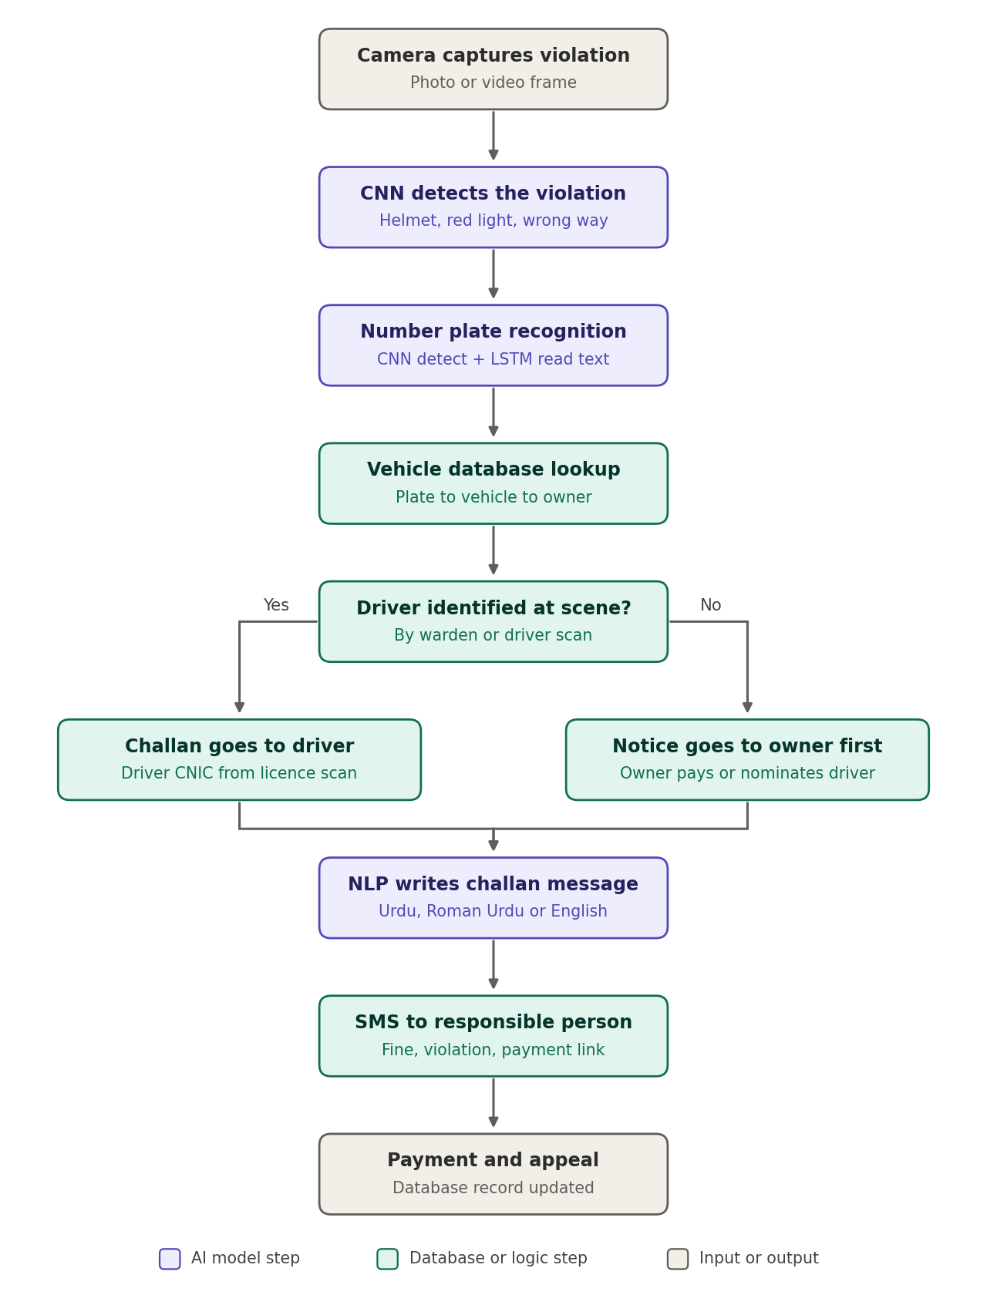
Figure 1: Smart Challan System flow

7. Database Design
The database stores people, vehicles, violation types, challans, nominations and notifications. A single People table is used for owners and drivers, so one person can be both.
Table | Main fields | Purpose
People | person_id, name, cnic, licence_no, phone | All owners and drivers
Vehicles | vehicle_id, plate_number, make, model, colour, owner_id | Links a plate to its owner
ViolationTypes | type_id, name, fine_amount | List of violations and fines
Challans | challan_id, vehicle_id, type_id, evidence_image, location, date_time, status, responsible_person_id, nomination_deadline | One record per violation
AuthorisedDrivers | auth_id, vehicle_id, person_id | Owner's saved list of regular drivers (a shortcut only)
Nominations | nomination_id, challan_id, nominated_person_id, method (list or CNIC), otp, status, created_at | Tracks owner nominations and driver replies
Notifications | notification_id, challan_id, recipient_id, language, message_text, sent_at, delivery_status | Message history
Challan status values: Issued, Nominated, Accepted, Rejected, Expired, Paid.

8. Sample Challan Messages
English (to owner): Challan notice: Vehicle LEA-1234 was recorded riding without a helmet on dd-mm-yyyy. Fine: Rs. 500. If someone else was driving, enter their CNIC within 7 days using the link provided.
Roman Urdu (to owner): Challan notice: Gaari LEA-1234 bagair helmet chalane par record hui. Jurmana: Rs. 500. Agar gaari koi aur chala raha tha to 7 din ke andar uska CNIC link par enter karein.
Confirmation (to nominated driver): Ali ne bataya hai ke LEA-1234 aap chala rahe thay. Challan qabool karne ke liye YES likhein, warna NO likhein.
The fine amount and the dates shown above are sample values for demonstration.

9. Technology Stack
Area | Tools
Programming language | Python (models and logic), C# or Python for the application layer
Deep learning | PyTorch or TensorFlow/Keras; a pretrained YOLO model for detection
Image processing | OpenCV
Plate text recognition | CRNN (CNN + LSTM) model, with an OCR library as a fallback
NLP | Message templates, optionally a small language model for wording and translation
Database | Microsoft SQL Server
Application and interface | Flask or FastAPI backend with a simple web interface
Messaging | SMS API, or a simulated SMS screen for the demonstration

10. Data and Test Scenarios
- Images for plate and violation detection: public number plate and helmet detection datasets (for example from Kaggle or Roboflow Universe), supported by additional Pakistani-style plate images where available.
- People and vehicle records: a dummy database created for the project, with fake names, CNIC numbers, licence numbers, phone numbers and plates. No real NADRA or excise data is used.
- Challan messages: a set of message templates in English, Urdu and Roman Urdu.
- Test scenarios: owner is also the driver; vehicle with five authorised drivers; friend from another city named by CNIC; nominee accepts; nominee rejects; nomination expires with no reply; CNIC not found; nominee has no licence.

11. Scope and Limitations
- The system is a working prototype for demonstration, not a replacement for any government system.
- It uses a dummy database. It does not connect to NADRA or any real vehicle registration records.
- The camera identifies the vehicle only. It does not identify a person from their face.
- The project covers one or two violation types, for example no helmet, so that the system can be completed and tested well.
- SMS delivery may be simulated if a live SMS service is not available.
- Plate reading accuracy depends on image quality, lighting and plate style.

12. Privacy and Ethical Considerations
- Only the data needed for the challan is stored, and access is limited to the system.
- A named person must confirm before a challan moves to them. If there is no confirmation, responsibility stays with the registered owner.
- Every action is recorded, so a challan can be reviewed or appealed.
- Demonstration data is fake, so no real person's information is exposed.

13. Expected Outcomes
- A working system that takes an image, reads the plate, and finds the registered owner.
- A complete nomination and confirmation flow that moves the challan to the responsible person.
- Automatically generated challan messages in more than one language.

14. Future Work
- Connection to real registration and licence systems, with proper authorisation.
- Support for more violations such as red-light crossing, wrong-way driving and overspeeding.
- Real-time video, online payment, a mobile app and an appeal portal.

15. Conclusion
The Smart Challan System addresses a real gap in how challans are delivered. By combining plate recognition, a verified nomination process and automatic message generation, it makes sure the challan reaches the person who is responsible. The project uses CNN, LSTM and NLP in a single practical application and can be completed as a focused, well-tested prototype.

