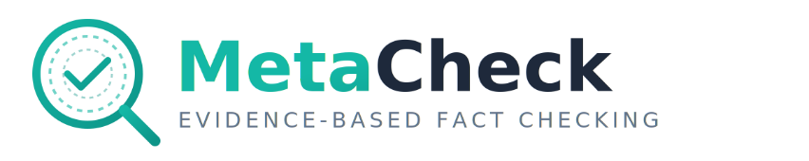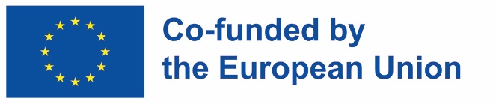

A Tool Developed in the Erasmus+ Metacog Project

MetaCheck Documentation
Complete guide to using MetaCheck for educational fact-checking and media literacy learning
GitHub Link: https://github.com/umairalipathan1980/MetaCheck---An-Evidence-Based-Fact-Checker/tree/main
Developed by: Umair Ali Khan, Senior Researcher, Haaga-Helia University of Applied Sciences, Helsinki. Email: umairali.khan@haaga-helia.fi, LinkedIn: www.linkedin.com/in/uakhan80

Table of Contents
- How to Use
- How It Works
- Understanding Verdicts
- Evidence Sources
- Educational Use

1. How to Use

Overview
MetaCheck is an educational tool that helps students learn fact-checking by comparing their own assessment with AI-generated analysis. The workflow consists of three main steps:
- Your Assessment - Do your own fact-checking first
- AI Analysis - Let AI verify the same claims
- Compare - See how your assessment compares with AI

Step 1: Your Assessment
Why start with your assessment?
By doing your own fact-checking first, you develop critical thinking skills before seeing the AI’s approach. This pedagogical design prevents “answer-seeking” behavior and encourages genuine learning.
How to create your assessment:
- Add Claims Manually
  - Click “+ Add New Claim” button
  - Enter the claim text you want to verify
  - Research the claim using multiple sources
  - Gather evidence and assess credibility
- Determine Your Verdict
  - Choose from: SUPPORTED, REFUTED, INSUFFICIENT_INFORMATION, or CONFLICTING_EVIDENCE
  - Set your confidence level (0.0 to 1.0)
  - Record how many sources you consulted
  - Track time spent on verification
- Write Your Reasoning
  - Explain why you reached your verdict
  - Cite specific sources and evidence
  - Note any assumptions or uncertainties
Guidelines for Assessment:
Refer to the collapsible “How to Assess Claims (Guidelines)” section in the Your Assessment tab, which includes:
- Extract Verifiable Claims: Identify statements that can be proven true or false
- Collect Evidence from Multiple Sources: Use search engines, Wikipedia, fact-checking sites, primary sources
- Evaluate Source Credibility: Consider authority, bias, evidence quality, timeliness
- Choose a Verdict: Based on the evidence strength
- Set Confidence Level: How certain are you about your verdict?
- Write Your Reasoning: Explain your critical thinking process
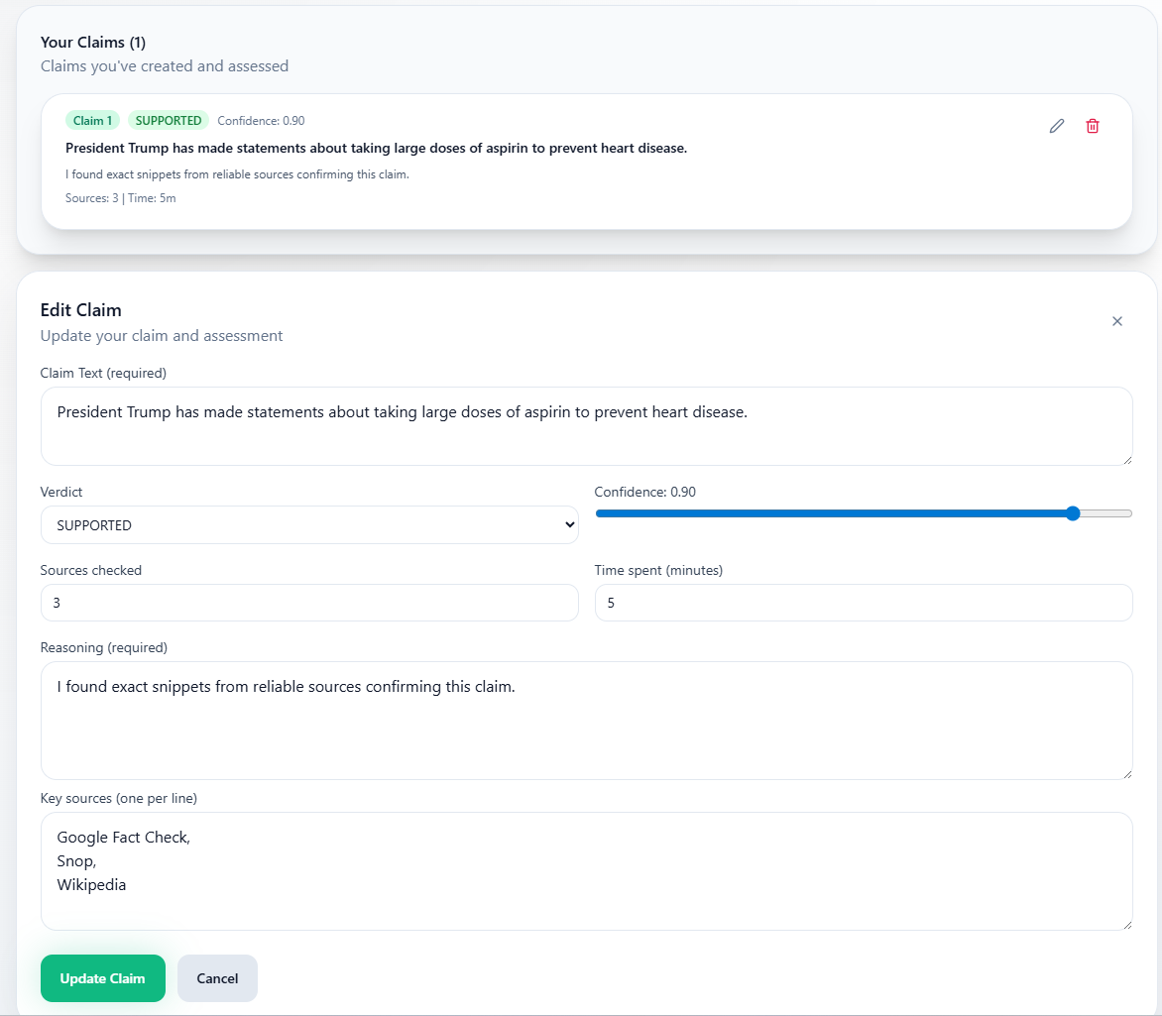
Add your own assessment for a verification task

Step 2: AI Analysis
Automated Verification:
After completing your assessment, you can run AI verification on the same text:
- Input Text: Paste or type the text containing claims
- Extract Claims: AI automatically identifies verifiable claims
- Select Claims: Choose which claims to verify (up to 5)
- Run Verification: AI searches multiple sources and generates verdicts
What AI Does:
- Searches 3 evidence sources in parallel (Web, Wikipedia, Fact Check databases)
- Assigns credibility scores to each source
- Analyzes stance (supports/refutes/neutral)
- Synthesizes a verdict with confidence and justification
- Provides full transparency through metacognitive detail (Comprehensive mode)
Basic vs. Comprehensive Mode:
- Basic: Faster, concise justifications (1-2 sentences)
- Comprehensive: Detailed reasoning, full metacognitive transparency, more sources

Step 3: Compare & Learn
Educational Comparison:
After both assessments are complete:
- View side-by-side comparison of your verdict vs. AI verdict
- See overall summary of your performance
- Review areas for improvement (if any)
- Learn professional fact-checking techniques
What You’ll Learn:
- How professional fact-checkers approach claims
- Source selection strategies
- Evidence synthesis techniques
- Confidence calibration
- Reasoning transparency

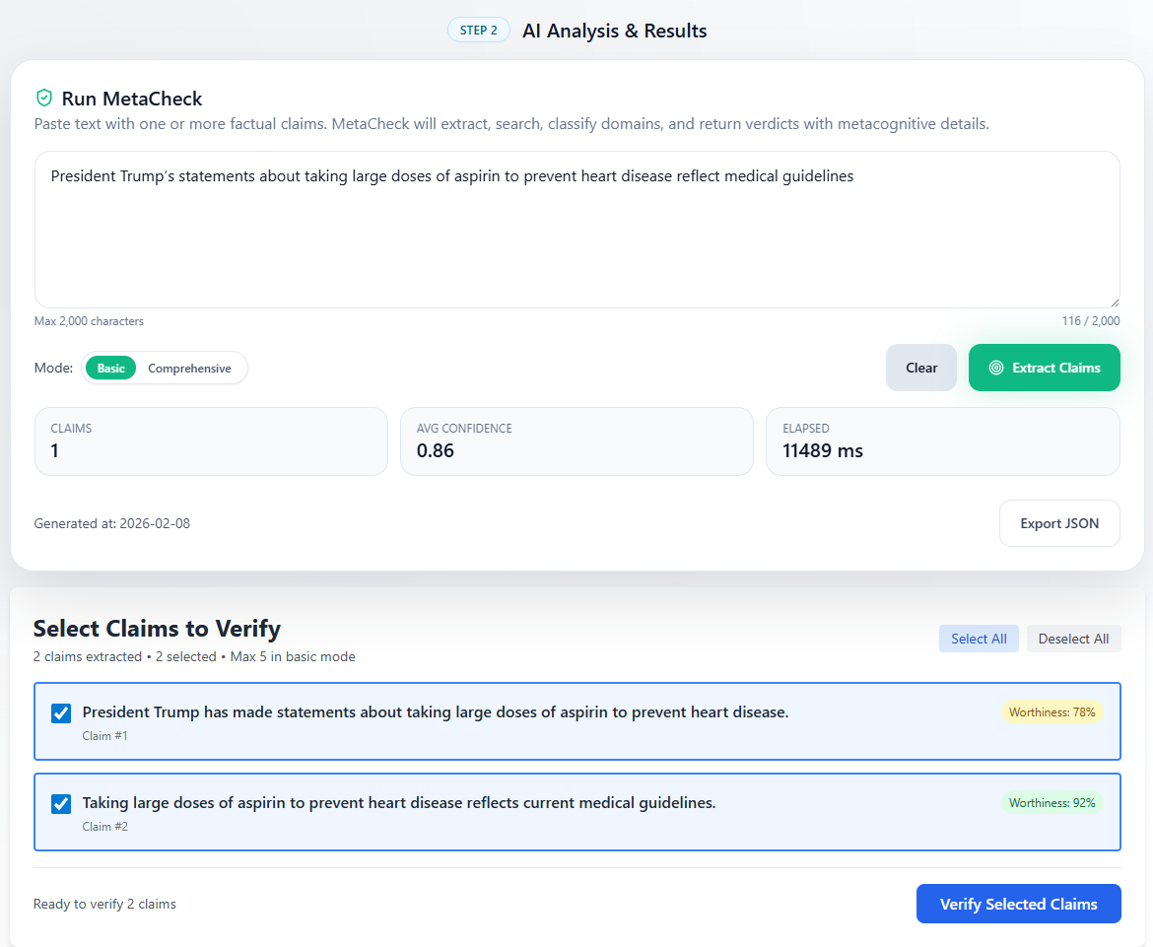
AI assessment (view 1)

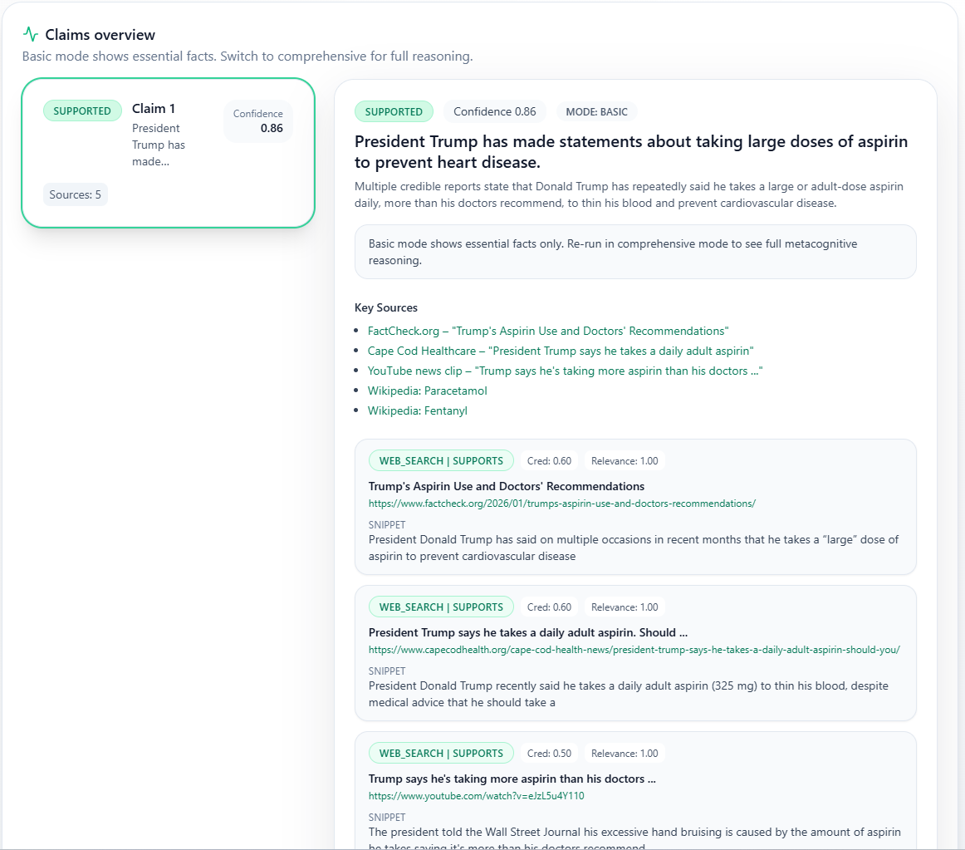
AI assessment (view 2)

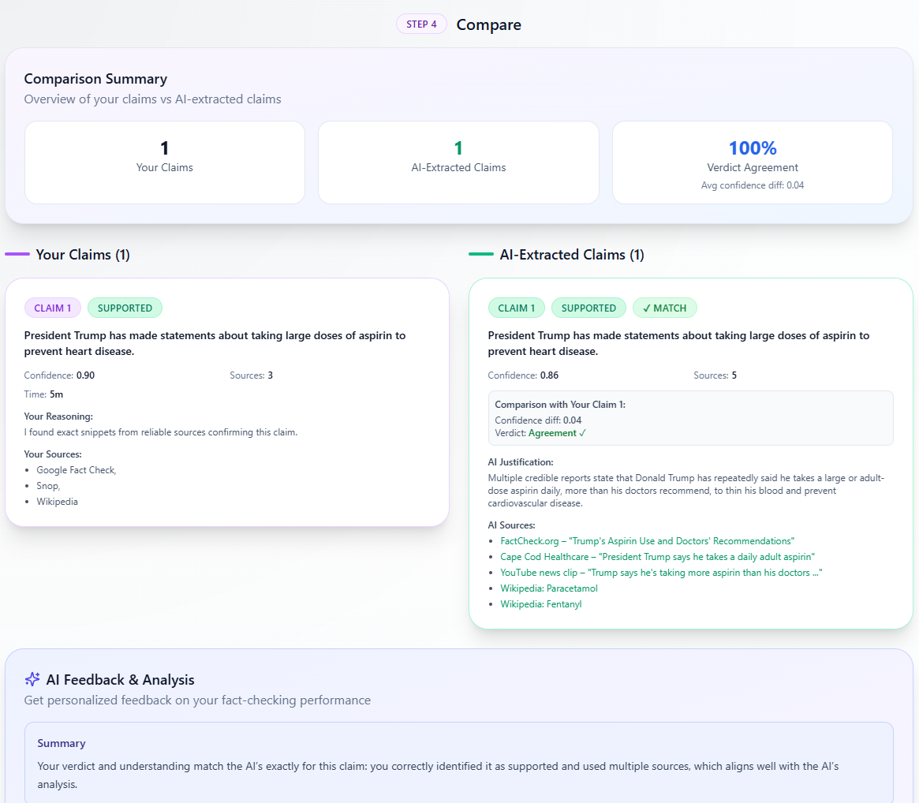
Comparison of user vs. AI assessment with feedback

2. How It Works

MetaCheck Workflow
Educational Workflow:
- Your Assessment → Extract claims, gather evidence, make your own verdict
- AI Verification → AI agents search sources, analyze evidence, generate verdicts
- Compare & Learn → See how your assessment compares with AI and get feedback
Educational Insight: By doing your own fact-checking first, you develop critical thinking skills before seeing the AI’s approach. The comparison helps you learn professional fact-checking techniques.

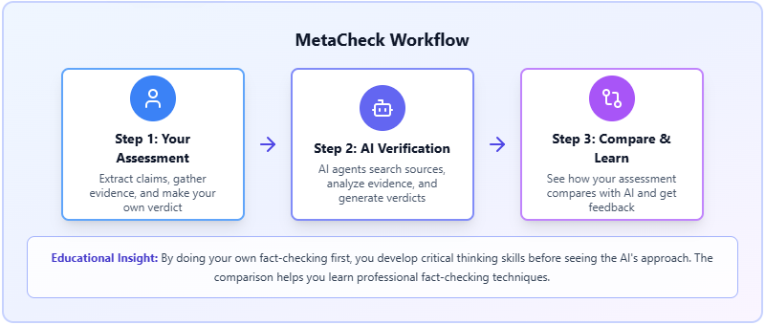

How MetaCheck Works Behind the Scenes
Understanding the technical workflow helps you interpret results and troubleshoot issues. MetaCheck uses an agentic AI architecture with specialized components working together.

Complete Technical Workflow
Step 1: INPUT - User provides text to verify
Step 2: CLAIM EXTRACTION - AI extracts verifiable claims (Claim Extractor Agent)
Step 3: USER SELECTION - User selects claims to verify
Step 4: PARALLEL VERIFICATION AGENTS - System spawns one agent per selected claim (all run simultaneously) - Each agent performs: - Parallel Search: Web 🌐, Wikipedia 📚, Fact Check ✓ - Process Evidence: Credibility scoring + Stance analysis - Verdict: With Confidence + Justification
Step 5: AGGREGATION - Collect all verdicts + evidence
Step 6: FINAL ASSESSMENT - Complete analysis with sources
Technical Implementation: Uses OpenAI Agents SDK with parallel tool execution. Each verification agent is an autonomous AI that orchestrates evidence gathering, analyzes credibility, determines stance, and synthesizes a verdict with full reasoning transparency.

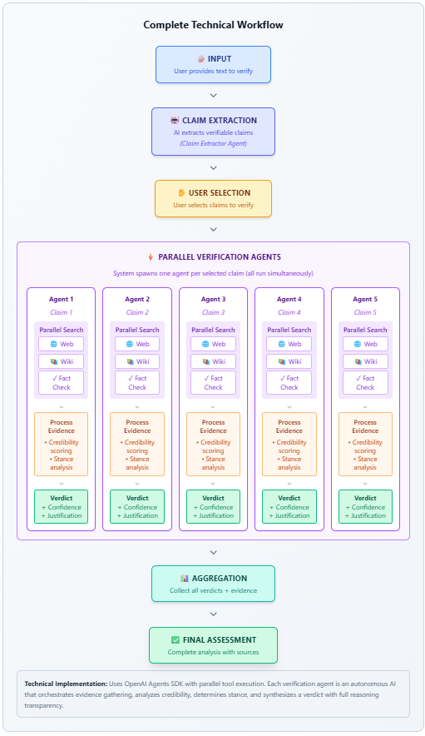
How MetaCheck works behind the scenes

The Verification Pipeline

Phase 1: Claim Extraction
Component: Claim Extractor Agent
What happens: The AI analyzes your input text and identifies statements that are: - Specific and concrete (not vague) - Falsifiable (can be proven true or false) - Require external verification (not common knowledge) - Contain verifiable details (numbers, dates, names, locations)
Output: A list of candidate claims extracted from your text

Phase 2: Claim Selection
Component: User Interface (Manual Selection)
What happens: You review the extracted claims and select which ones you want to verify. This gives you control over what gets fact-checked and helps manage processing time and cost.

Phase 3: Parallel Evidence Gathering
Component: Orchestrator Agent with comprehensive_evidence_tool
What happens: For each selected claim, the system simultaneously searches three sources:
- Tavily Web Search: Finds relevant web pages and snippets
- Wikipedia: Searches encyclopedic articles
- Google Fact Check API: Queries professional fact-checking databases
All three searches run in parallel (simultaneously), significantly reducing processing time.
Output: Combined evidence bundle with snippets, URLs, source types, and preliminary scores

Phase 4: Credibility Classification
Component: Domain Classification (config-based lookup)
What happens: Each web search result is analyzed to determine its credibility: - Domain is extracted from the URL - Domain is matched against a taxonomy (government, academic, news, etc.) - Credibility score is assigned based on category (0.50-0.90)
Note: Wikipedia (0.80) and Fact Check (0.95) have fixed scores. Only web search results use dynamic domain classification.

Phase 5: Stance Analysis
Component: Orchestrator Agent (AI Analysis)
What happens: The AI reads each evidence snippet and determines its stance: - Supports: Evidence confirms or aligns with the claim - Refutes: Evidence contradicts or disproves the claim - Neutral: Evidence is related but doesn’t clearly support or refute - Unclear: Evidence is ambiguous or indirect
For Fact Check sources, the stance is automatically interpreted from ratings. For web and Wikipedia, the AI analyzes the snippet text.

Phase 6: Verdict Synthesis
Component: Orchestrator Agent (Decision Logic)
What happens: The AI synthesizes all evidence and reaches a verdict:
- Calculate total credibility weight for supporting evidence
- Calculate total credibility weight for refuting evidence
- Apply verdict criteria based on weights and thresholds
- Determine confidence score based on evidence quality and quantity
- Generate justification explaining the verdict
- (Comprehensive mode only) Document metacognitive detail with full reasoning transparency
Output: VerificationResult with verdict, confidence, justification, sources, and evidence list

Mode Differences Explained
Aspect | Basic Mode | Comprehensive Mode
Primary Use Case | Quick fact-checking, classroom demos, fast results | Deep learning, understanding reasoning, and educational transparency
Evidence Retrieved | Limited (3 web, 2 wiki, 2 fact-check) | More comprehensive (5 web, 3 wiki, 3 fact-check)
Justification | 1-2 concise sentences explaining the verdict | Detailed paragraph with reasoning and evidence summary
Metacognitive Detail | Not included (empty) | Full transparency: search queries, source assessments, verdict reasoning, AI uncertainties, assumptions
Processing Time | Faster (~10-20 seconds per claim) | Slower (~15-30 seconds per claim)
Max Claims | 5 claims | 5 claims
Best For | Quick demos, time-constrained situations | Educational deep dives, learning AI reasoning, and research
API Cost | Lower (fewer API calls) | Higher (more comprehensive analysis)

Parallelism Architecture
MetaCheck uses two levels of parallelism for optimal performance:
- Agent-Level Parallelism: All selected claims are verified simultaneously (not sequentially)
- Tool-Level Parallelism: Within each agent, all 3 evidence sources are searched in parallel
This architecture significantly reduces total verification time.

3. Understanding Verdicts

Verdict Categories
MetaCheck uses four verdict categories based on evidence strength and consistency:

✅ SUPPORTED
Meaning: The claim is backed by credible evidence from multiple sources.
Criteria: - Supporting evidence significantly outweighs refuting evidence - High credibility sources confirm the claim - Consensus across multiple independent sources - No significant contradictions from reliable sources
Example: “The Eiffel Tower is 330 meters tall” → Multiple authoritative sources (Wikipedia, official websites, encyclopedias) confirm this measurement.
Confidence Interpretation: - 0.8-1.0: Very strong support from many high-quality sources - 0.6-0.7: Moderate support, some gaps or lower-quality sources - 0.5: Borderline, minimal support

❌ REFUTED
Meaning: The claim is contradicted by credible evidence.
Criteria: - Refuting evidence significantly outweighs supporting evidence - High credibility sources contradict the claim - Fact-checkers have rated it false or misleading - Evidence demonstrates the opposite is true
Example: “Vaccines cause autism” → Multiple scientific studies, medical organizations, and fact-checkers have thoroughly debunked this claim.
Confidence Interpretation: - 0.8-1.0: Very strong refutation from authoritative sources - 0.6-0.7: Clear contradiction but from fewer sources - 0.5: Borderline, weak refutation

⚠️ CONFLICTING_EVIDENCE
Meaning: Different credible sources provide contradictory information.
Criteria: - Both supporting and refuting evidence exist in significant amounts - Credible sources disagree with each other - No clear consensus in the evidence - The truth may depend on context, interpretation, or ongoing debate
Example: “Remote work increases productivity” → Some studies show productivity gains, others show productivity losses. The truth varies by industry, role, and measurement methodology.
When to use: - Genuine scientific or expert disagreement - Politically polarized topics with partisan sources - Evolving situations where facts are still being established - Complex claims where “it depends” is the honest answer

❓ INSUFFICIENT_INFORMATION
Meaning: Not enough reliable evidence was found to make a determination.
Criteria: - Very few sources found (or sources have low credibility scores) - Total credibility weight below minimum threshold (typically < 0.7) - Evidence is tangential or doesn’t directly address the claim - Sources are unreliable, outdated, or irrelevant
Example: “John Smith’s bakery in Springfield has the best croissants” → Too specific/local to have authoritative sources. Subjective claim without verifiable evidence.
Common Causes: - Very new events (not yet in databases) - Hyper-local claims (small town events, local businesses) - Obscure historical facts - Claims about non-public figures - Subjective statements (“best”, “most beautiful”)

Confidence Scores
What is confidence?
A numerical score (0.0 to 1.0) indicating how certain the AI is about its verdict.
How it’s calculated:
Confidence is based on: - Evidence quantity: More sources = higher confidence - Evidence quality: Higher credibility sources = higher confidence - Evidence consistency: Agreement among sources = higher confidence - Search success: Successful searches = higher confidence
Interpretation:
- 0.9-1.0: Extremely confident (strong, consistent evidence from many high-quality sources)
- 0.7-0.8: Confident (solid evidence from reliable sources)
- 0.5-0.6: Moderate confidence (some evidence, but gaps or inconsistencies)
- 0.3-0.4: Low confidence (weak evidence, few sources, low quality)
- 0.0-0.2: Very low confidence (almost no evidence, unreliable sources)
Important Notes:
- High confidence does NOT guarantee the verdict is correct (AI can be confidently wrong)
- Low confidence often indicates insufficient evidence, not necessarily that the claim is false
- Confidence reflects evidence strength, not absolute truth

Justification
What is justification?
A human-readable explanation of why the AI reached its verdict. This is the “reasoning” section that explains the evidence and decision process.
Basic Mode Justification: - 1-2 concise sentences - Summarizes the key evidence - States the verdict and primary reason
Comprehensive Mode Justification: - Detailed paragraph - Explains evidence from each source - Discusses evidence weight and credibility - Addresses contradictions or uncertainties - Transparent about reasoning process

Metacognitive Detail (Comprehensive Mode Only)
What is metacognitive detail?
A detailed breakdown of the AI’s reasoning process, showing “thinking out loud” transparency.
What’s included:
- Search Queries Used: Exact queries sent to each evidence source
- Source Assessments: How each source was evaluated for credibility and stance
- Evidence Synthesis: How different pieces of evidence were combined
- Verdict Reasoning: The logical steps that led to the final verdict
- Uncertainties & Assumptions: What the AI is unsure about or had to assume
- Alternative Interpretations: Other ways the evidence could be interpreted
Why is it useful?
- Educational: Students learn how professional fact-checkers think
- Transparency: Users can audit the AI’s reasoning
- Debugging: Helps identify when AI misunderstood something
- Trust: Users can verify the reasoning makes sense

Evidence Sources
Each verdict includes a list of evidence sources with:
- URL: Link to the source
- Title: Title or snippet from the source
- Source Type: web, wikipedia, or factcheck
- Credibility Score: 0.0-1.0 (higher = more trustworthy)
- Stance: supports, refutes, neutral, or unclear
- Domain Category: government, academic, news, etc. (for web sources)

Search Status
Each evidence source also has a search status:
- success: Search ran successfully and found results
- no_results: Search completed but found no matching evidence
- error: Search failed due to API error or network issue
- no_api_key: API key not configured for this source type

Common Verdict Patterns
Pattern 1: Strong Consensus - Verdict: SUPPORTED or REFUTED - Confidence: 0.8-1.0 - All sources agree - High credibility sources
Pattern 2: Weak Evidence - Verdict: INSUFFICIENT_INFORMATION - Confidence: 0.3-0.5 - Few sources found - Low credibility scores
Pattern 3: Genuine Disagreement - Verdict: CONFLICTING_EVIDENCE - Confidence: 0.5-0.7 - Credible sources on both sides - No clear consensus
Pattern 4: Search Failures - Verdict: INSUFFICIENT_INFORMATION - Confidence: 0.0-0.3 - Multiple search errors - No usable evidence retrieved

4. Evidence Sources

Overview of Evidence Sources
MetaCheck searches three types of evidence sources for each claim:
- Web Search (Tavily)
- Wikipedia
- Google Fact Check API
All three sources are queried in parallel (simultaneously) to maximize speed.

1. Web Search (Tavily)
What is Tavily?
Tavily is a search API optimized for AI agents and LLM applications. It provides relevant, high-quality web search results with clean snippets.
How MetaCheck uses it:
- Searches the open web for claim-related content
- Returns relevant snippets and URLs
- Prioritizes authoritative sources
- Filters out low-quality content
Search Depth:
- Basic: Quick search, fewer results
- Advanced: More thorough search, more results (configurable in Settings)
Credibility Scoring:
Web search results are scored based on domain classification:
Domain Category | Credibility Score | Examples
Government | 0.90 | .gov, .mil, official government sites
Academic | 0.85 | .edu, university sites, research institutions
Medical/Health Authority | 0.85 | WHO, CDC, NIH, medical journals
Fact-Checking Organizations | 0.85 | Snopes, FactCheck.org, PolitiFact
Major News (High Reputation) | 0.75 | AP, Reuters, BBC, NYT, WSJ
Major News (Mainstream) | 0.70 | CNN, Fox News, Guardian, etc.
Non-Profit Organizations | 0.70 | .org domains, NGOs
General News/Media | 0.60 | Regional news, smaller outlets
Commercial/Business | 0.55 | .com domains, corporate sites
Unknown/Uncategorized | 0.50 | Domains not in taxonomy
Limitations:
- May miss paywalled content
- Cannot access private databases
- Subject to search API coverage
- Domain classification may not capture all nuances

2. Wikipedia
What is Wikipedia?
Wikipedia is a free online encyclopedia with millions of articles. While not peer-reviewed, it’s generally reliable for factual information and provides good starting points for research.
How MetaCheck uses it:
- Searches Wikipedia articles for claim-related content
- Extracts relevant paragraphs
- Provides context and background information
- Links to original articles for verification
Credibility Score: Fixed at 0.80
Why 0.80? - Wikipedia is generally accurate for mainstream topics - Articles are collaboratively edited and monitored - Citations provide traceability to original sources - Not peer-reviewed, so not as authoritative as academic sources
Strengths: - Comprehensive coverage of many topics - Well-structured, neutral point of view - Frequently updated - Good for historical facts, definitions, basic information
Limitations: - Can be vandalized (though usually quickly corrected) - Not appropriate for highly specialized topics - May lag behind very recent events - Not suitable as a primary source for academic research

3. Google Fact Check API
What is Google Fact Check API?
The Google Fact Check Tools API searches a database of fact-checks from professional fact-checking organizations worldwide.
How MetaCheck uses it:
- Queries the fact-check database for matching claims
- Returns fact-checks from organizations like Snopes, FactCheck.org, PolitiFact
- Includes the fact-checker’s verdict (e.g., “True”, “False”, “Mostly False”)
- Provides claim context and reasoning
Credibility Score: Fixed at 0.95
Why 0.95? - Professional fact-checkers are experts in verification - Rigorous editorial standards - Transparent methodology - Explicitly designed for claim verification
Strengths: - Highest credibility of all sources - Expert analysis with detailed reasoning - Covers popular claims and misinformation - Includes context and explanation
Limitations: - Coverage is limited to claims that fact-checkers have investigated - Typically focuses on viral misinformation and public statements - May not cover obscure or local claims - No results ≠ claim is false (just means not fact-checked yet)

Source Comparison
Aspect | Web Search (Tavily) | Wikipedia | Fact Check API
Credibility | 0.50-0.90 (varies) | 0.80 (fixed) | 0.95 (fixed)
Coverage | Broad (entire web) | Encyclopedic topics | Fact-checked claims only
Freshness | Very current | Usually current | Depends on fact-checkers
Depth | Varies widely | Medium depth | Deep analysis
Expertise | Varies by source | Collaborative | Professional fact-checkers
Best For | Current events, diverse perspectives | Background, definitions, history | Debunked claims, misinformation

Evidence Synthesis
How MetaCheck combines evidence:
- Collect all evidence from all three sources
- Score credibility based on source type and domain
- Determine stance (supports/refutes/neutral) for each piece of evidence
- Calculate weighted evidence (credibility × stance)
- Synthesize verdict based on total evidence weight
- Generate confidence based on quantity, quality, and consistency

Search Status Indicators
Each source search has a status:
Status | Meaning | Implication | Action
success | Search ran successfully and found results | Evidence is usable | None — working as expected
no_results | Search ran but found no matching evidence | This is an absence of evidence, not a system error | None — this is normal for many claims
error | Search failed due to API error, network issue | Evidence may be incomplete. Verdict is based only on sources that succeeded | Try again later or check system status
no_api_key | API key for this source was not configured | That source type was disabled for this run. Verdict is based on remaining sources | System administrator needs to configure API key

Quality Assurance
How to assess evidence quality:
- Check credibility scores: Higher is better (> 0.7 is generally reliable)
- Verify source diversity: Multiple independent sources are better than one
- Review search status: Ensure searches succeeded
- Read justification: Understand how AI interpreted the evidence
- Follow links: Verify AI interpretation by reading original sources
- Check for bias: Consider potential biases in source selection

5. Educational Use

Learning Objectives
MetaCheck is designed to help students develop:
- Critical Thinking: Evaluate claims independently before seeking answers
- Media Literacy: Understand how to assess source credibility
- Research Skills: Learn effective search strategies and source evaluation
- Metacognition: Reflect on their own reasoning process
- AI Literacy: Understand how AI makes decisions and where it can fail

Pedagogical Approach
Compare-and-Contrast Learning:
MetaCheck uses a “Do-it-yourself first, then compare” pedagogy:
- Student completes task independently (no AI guidance)
- AI completes the same task (transparent reasoning)
- Student compares their approach with AI’s approach
- Student reflects on differences and learns from comparison
Why this works:
- Prevents answer-seeking: Students must think first
- Encourages genuine effort: No way to “cheat” by copying AI
- Promotes metacognition: Students see their own thinking vs. expert thinking
- Builds confidence: Students see what they got right
- Identifies gaps: Students see where they can improve

Classroom Use Cases

Use Case 1: Fact-Checking Exercise
Objective: Teach students how to verify claims using multiple sources
Activity: 1. Provide a text with several factual claims (news article, social media post) 2. Students manually fact-check using search engines and databases 3. Students record their findings in MetaCheck 4. Run AI verification on the same text 5. Compare results and discuss differences in class
Discussion Points: - Which sources did students miss? - How did students assess credibility differently than AI? - What search strategies were most effective?

Use Case 2: Misinformation Detection
Objective: Help students identify and debunk common misinformation
Activity: 1. Present a viral claim or conspiracy theory 2. Students research and create their own assessment 3. AI verifies the same claim 4. Compare verdicts and review fact-checker sources 5. Discuss why misinformation spreads despite evidence
Discussion Points: - What makes a source credible? - Why do people believe false claims? - How can we communicate corrections effectively?

Use Case 3: Source Credibility Training
Objective: Teach students to evaluate source reliability
Activity: 1. Students assess a claim with diverse sources (academic, news, blogs, social media) 2. Students assign their own credibility scores to each source 3. Compare with MetaCheck’s domain classification system 4. Discuss agreements and disagreements
Discussion Points: - What makes a source credible? - How should domain (.gov, .edu, .com) influence trust? - When might a “lower credibility” source still be valuable?

Use Case 4: AI Transparency & Limitations
Objective: Help students understand how AI works and where it can fail
Activity: 1. Give students a tricky claim (ambiguous, context-dependent, or nuanced) 2. Students predict how AI will handle it 3. Run verification in Comprehensive mode 4. Analyze metacognitive detail 5. Identify where AI succeeded and where it struggled
Discussion Points: - What can AI do well vs. poorly? - How can we audit AI reasoning? - When should we trust AI vs. human judgment?

Assessment Rubrics
Suggested Grading Criteria for Student Assessments:
Criterion | Poor (0-2) | Satisfactory (3-4) | Excellent (5)
Evidence Quality | Used 0-1 sources, unreliable sources | Used 2-3 sources, mostly credible | Used 3+ diverse, highly credible sources
Source Evaluation | Did not assess credibility | Basic credibility assessment | Thorough credibility analysis with reasoning
Reasoning | Vague or missing justification | Clear reasoning with some evidence | Detailed, logical reasoning citing specific evidence
Verdict Accuracy | Incorrect verdict based on evidence | Reasonable verdict but could be stronger | Well-supported verdict matching evidence
Confidence Calibration | Confidence wildly misaligned with evidence | Confidence somewhat aligned | Confidence well-calibrated to evidence strength

Tips for Instructors
Before using MetaCheck:
- Set expectations: Explain the “do-it-yourself first” approach
- Model the process: Demonstrate a complete assessment as an example
- Provide guidelines: Share the assessment guidelines from the tool
- Discuss credibility: Review the credibility scoring system
- Practice: Start with simple, unambiguous claims
During the activity:
- Encourage thoroughness: Remind students to use multiple sources
- Require documentation: Students should record sources and reasoning
- Allow adequate time: Fact-checking takes time (15-30 min per claim)
- Discourage guessing: Better to say “insufficient information” than guess
- Monitor progress: Check that students are engaging meaningfully
After comparison:
- Facilitate reflection: Have students write about what they learned
- Discuss patterns: Identify common mistakes or successes
- Address surprises: Talk about unexpected differences
- Highlight strengths: Celebrate what students did well
- Identify improvements: Discuss specific areas for growth

Advanced Features for Educators
Settings Configuration (Admin Only):
Instructors can adjust: - Number of claims to verify per run - Number of sources to search - Model choice (faster vs. more accurate) - Search depth (basic vs. advanced) - Timeout settings
Comparison Feedback:
The comparison tab provides: - Overall summary of student performance - Areas for improvement (specific, actionable feedback) - Recognition of what was done well
Export Functionality:
Students and instructors can export: - Complete assessment as JSON - Full verification results - Comparison analysis

Best Practices
For Students:
- Take your time: Thorough fact-checking requires patience
- Use multiple sources: Don’t rely on just one website
- Check credibility: Look for author credentials, publication date, domain
- Be honest about confidence: It’s okay to be uncertain
- Cite specific evidence: Don’t just say “I googled it”
- Document your process: Track sources, time, reasoning
For Instructors:
- Start simple: Use clear, unambiguous claims first
- Scaffold the process: Provide templates or worksheets initially
- Make it collaborative: Have students work in pairs or small groups
- Connect to current events: Use recent news or viral claims
- Emphasize learning over grades: Focus on improvement, not perfection
- Model transparency: Share your own fact-checking process

Common Challenges & Solutions
Challenge 1: Students rush through assessment
Solution: - Require minimum number of sources (3-5) - Have students submit source list before verdict - Track and require minimum time spent - Make assessment a significant portion of grade
Challenge 2: Students copy AI results
Solution: - Require students to submit assessment BEFORE running AI - Use timestamp tracking - Require written reflection on differences - Focus on process, not just final answer
Challenge 3: Disagreement with AI verdict
Solution: - Emphasize that disagreement is okay (AI can be wrong) - Have students defend their position with evidence - Discuss nuances and context the AI may have missed - Use it as a teaching moment about AI limitations
Challenge 4: Students don’t know where to start
Solution: - Provide assessment guidelines (included in tool) - Model the process with an example - Offer search strategy tips - Start with simpler, more straightforward claims

Resources for Further Learning
Fact-Checking Organizations: - FactCheck.org - Snopes - PolitiFact - Full Fact (UK)
Media Literacy Resources: - News Literacy Project - Common Sense Media - NAMLE (National Association for Media Literacy Education)
Source Evaluation Tools: - CRAAP Test (Currency, Relevance, Authority, Accuracy, Purpose) - SIFT Method (Stop, Investigate source, Find better coverage, Trace claims) - Lateral Reading (Stanford approach)

Appendix: Technical Specifications

System Requirements
Backend: - Python 3.12+ - FastAPI framework - OpenAI Agents SDK - Tavily API key - Google Fact Check API key (optional) - Wikipedia API access token (optional)
Frontend: - Node.js 20+ - React 19+ - Vite build tool - Tailwind CSS

API Endpoints
- POST /api/extract - Extract claims from text
- POST /api/verify - Verify selected claims
- POST /api/compare - Compare student vs AI assessment
- GET /api/config/settings - Get current settings
- PUT /api/config/settings - Update settings (admin only)
- POST /api/admin/reload-settings - Reload configuration (admin only)

Authentication
Admin access required for: - Modifying settings - Reloading configuration
Login credentials: - Username: admin - Password: Set in .env file (ADMIN_PASSWORD)

Configuration
Settings can be adjusted in the Settings tab (admin login required):
- Max claims to verify per run: 1-5
- Max claims to extract: 1-10
- Max web search results: 1-5
- Max Wikipedia results: 1-5
- Max fact-check results: 1-5
- Model choice: gpt-5.1, gpt-4.1-mini, or gpt-5-mini
- Tavily search depth: basic or advanced
- Per-claim timeout: seconds to wait before timing out

About MetaCheck
Version: 1.0.0
Developer: Educational AI Research Team
Purpose: MetaCheck is designed as an educational tool to help students learn fact-checking, critical thinking, and media literacy skills through hands-on practice and AI-powered comparison.
License: Educational use
Contact: For questions, issues, or feedback about MetaCheck, please contact your course instructor or system administrator.

This documentation reflects the MetaCheck interface as of the current version. Features and functionality may be updated over time. Always refer to the in-application documentation for the most current information.

