AIRCRAFT LANDING GEAR STRUT
Structural and Aerodynamic Analysis
Static FEA | External Flow Simulation | MATLAB Parametric Study

National University of Sciences and Technology (NUST)
Department of Mechanical Engineering
Made by: UMAIR
4th Semester | Summer Project 2026
Software: SolidWorks 2023 | MATLAB
Material: Aluminum 7075-T6 | June 2026

Abstract
This report presents a combined structural and aerodynamic analysis of a simplified main landing gear strut for a light general aviation aircraft in the 1,100 kg maximum takeoff weight class. Three analyses are performed: a static linear-elastic finite element analysis (FEA) under landing loads, an external flow simulation to quantify aerodynamic drag, and an independent MATLAB parametric study for design validation.
The strut is modeled as a monolithic hollow aluminum cylinder with an integrated attachment lug and axle flange. Two structural load cases are evaluated: a limit load of 16,200 N against the yield criterion and an ultimate load of 24,300 N against the fracture criterion. An independent MATLAB analytical calculation with stress concentration correction (Kt = 1.4) gives a corrected stress of 232 MPa, agreeing with the FEA result of 236 MPa to within 2 percent, confirming model validity.
The external flow simulation at 70 m/s approach airspeed gives an aerodynamic drag force of 74N. Both structural load cases pass their respective criteria. The minimum factor of safety is 1.61 under ultimate load. Euler buckling is analytically confirmed to be non-governing by a margin of 151.6 times the ultimate load.

1. Project Scope and System Definition
This is a static linear-elastic FEA study of a simplified hollow aluminum strut modeled as a monolithic cantilever under a single vertical design load, supplemented by an external aerodynamic flow simulation. The model captures axial compression and bending at the strut root and aerodynamic drag at landing approach speed. It does not model joint dynamics, oleo fluid mechanics, fatigue, or certification loads.
Included in Study | Excluded (with Reason)
Outer strut barrel (hollow cylinder) | Inner piston and sliding mechanism: hydraulic dynamics are out of scope
Upper airframe attachment lug | Torque links: kinematic component, not part of primary load path
Lower axle mount flange | Tire and wheel: separate structural component
Lug-barrel and barrel-flange fillets | Seals, ports, and valves: mechanical systems only
Static equivalent landing load | Fatigue and cyclic loading: requires S-N data, valid as a separate study
External aerodynamic drag at 70 m/s | Oleo fluid compression: thermodynamic, beyond structural scope

2. Assumptions
All assumptions are classified by direction so that conservative and non-conservative simplifications are explicit throughout the report.
Ref | Assumption | Direction | Justification
A1 | Single vertical load only, no lateral or drag loads | Limitation | Lateral loads approx. 20 to 30 percent of vertical. Study scoped to vertical load path only.
A2 | Fully fixed constraint at lug top face | Conservative | Real pin joint allows rotation. Fixed BC overestimates bending stress.
A3 | Static equivalent load with n = 2.5 | Conservative | n = 2.5 is the upper bound for light GA aircraft.
A4 | Monolithic part, no joint compliance modeled | Conservative | Real bolted joints add local flexibility. Ignoring this increases effective stiffness.
A5 | Linear elastic material throughout | Valid in scope | All stresses confirmed below yield in FEA. Linear elastic assumption holds.
A6 | Uniform wall thickness along barrel length | Conservative | Real struts taper. Constant minimum thickness is conservative for the mid-section.
A7 | Euler buckling check with K = 1.0 | Conservative | Pin-free gives longer effective length than real configuration. Real Pcr is higher.
A8 | No fatigue, thermal, corrosion effects | Scope limit | Not needed for limit-load static sizing.

3. Load Analysis

3.1 Aircraft Reference Parameters
Parameter | Symbol | Value | Basis
Max takeoff weight | MTOW | 1,100 kg | Light GA class, Cessna 172 comparable
Load on one main gear | W_gear | 660 kg | 60 percent of MTOW per side
Gravitational acceleration | g | 9.81 m/s² | Standard
Vertical load factor at landing | n | 2.5 | Light GA landing reference, FAR 23 comparable
Safety factor (ultimate) | SF | 1.5 | Standard aerospace preliminary design

3.2 Load Calculation
The landing load is calculated in three steps. The dynamic load factor converts the impact event into an equivalent static structural load. The safety factor is then applied separately to derive the ultimate load. The two factors are not multiplied together.

F_static = 660 x 9.81 = 6,475 N
F_limit = n x F_static = 2.5 x 6,475 = 16,187 N (yield check load)
F_ultimate = SF x F_limit = 1.5 x 16,187 = 24,280 N (ultimate check load)

Run | Applied Load | Failure Criterion | Material Limit
Run A (Yield check) | 16,200 N | Von Mises stress < yield strength | 505 MPa
Run B (Ultimate check) | 24,300 N | Von Mises stress < tensile strength | 570 MPa

4. Failure Mode Analysis
Before running FEA the governing failure mode must be identified. For a hollow cylinder under combined axial compression and bending, three modes are candidates: yielding at the root section, Euler column buckling, and stress concentration failure at geometric discontinuities.

4.1 Euler Buckling Check
Calculated in MATLAB with K = 1.0, the pin-free effective length factor, which is conservative:

I = (pi/64) x (80^4 - 70^4) = 8.32 x 10^-7 m^4
P_cr = (pi^2 x E x I) / (K x L)^2 = 3,679,921 N = 3,680 kN
Margin = P_cr / F_ult = 3680 / 24.3 = 151.6x (buckling NOT governing)

The ultimate design load is 24.3 kN. The buckling margin of 151.6 times the ultimate load conclusively confirms that yielding governs. This justifies running a stress-only static FEA.

5. Material Selection
Aluminum alloy 7075-T6 was selected for all components. This alloy is the industry-standard material for primary aerospace structural members, used in Boeing 737 and Airbus A320 structural frames. It offers the highest strength-to-weight ratio in the 7xxx series and is well-characterised for limit-load FEA studies.

Property | Value | Unit
Yield strength | 505 | MPa
Ultimate tensile strength | 570 | MPa
Young's modulus | 72,000 | MPa
Poisson's ratio | 0.33
Density | 2,810 | kg/m3
Shear modulus | 26,900 | MPa

6. CAD Geometry

6.1 Modeling Approach
The entire strut was modeled as a single integrated monolithic part in SolidWorks 2023. The barrel, attachment lug, and axle flange are extruded as one continuous solid body. This eliminates artificial bonded contact interfaces and allows the FEA to capture realistic load transfer without joint compliance artifacts.

6.2 Key Dimensions
Feature | Dimension | Engineering Basis
Outer diameter (OD) | 80 mm | Realistic for light GA main gear strut
Wall thickness (t) | 5 mm | Baseline from MATLAB parametric study
Inner diameter (ID) | 70 mm | OD minus 2t
Barrel length | 400 mm | Moment arm for bending calculation
Upper lug height | 60 mm | Proportional to pin hole and load path
Lug pin hole diameter | 20 mm | Airframe attachment pin interface
Flange outer diameter | 120 mm | Wheel axle mount interface
Axle bore diameter | 30 mm | Axle pin clearance
Flange thickness | 15 mm | Load distribution at axle interface
Fillet radius at all junctions | 5 mm | Stress concentration reduction

6.3 Simplifications Applied
- No threads on any holes. Represented as plain bores. Noted as simplified fastener interfaces.
- No internal piston or fluid chamber. Oleo mechanism excluded from structural scope.
- Uniform wall thickness. Real struts taper. This is a conservative simplification.
- No torque links. Kinematic components, not part of the vertical load path.

7. Analytical Stress Calculation

7.1 Section Properties
Property | Formula | Value
Second moment of area (I) | (pi/64) x (OD^4 - ID^4) | 8.32 x 10^-7 m^4
Cross-sectional area (A) | (pi/4) x (OD^2 - ID^2) | 1.178 x 10^-3 m^2
Outer fiber distance (c) | OD / 2 | 0.040 m

7.2 Combined Stress at Barrel Root
At the strut root the bending moment is maximum. Treating the strut as a cantilever fixed at the top and loaded vertically at the bottom gives:

M = F_limit x L = 16,187 x 0.400 = 6,475 N.m
s_bending = M x c / I = 311.3 MPa
s_axial = F_limit / A = 13.7 MPa
s_nominal = s_bending + s_axial = 325.0 MPa

7.3 Stress Concentration Correction
The nominal beam theory result assumes a sharp corner at the barrel root. The actual model has a 5 mm fillet at this junction. A stress concentration factor Kt = 1.4 is applied, which is the standard value for a filleted stepped hollow cylinder with r/D = 5/80 = 0.0625:

s_corrected = s_nominal / Kt = 325.0 / 1.4 = 232.1 MPa

This corrected value is the analytical prediction for peak stress at the filleted junction and is compared directly to FEA output in Section 11.

7.4 Preliminary Safety Factor
Check | Stress | Limit | FOS | Result
Yield check, nominal | 325 MPa | 505 MPa | 1.55 | PASS
Yield check, corrected (Kt = 1.4) | 232 MPa | 505 MPa | 2.17 | PASS

8. Finite Element Analysis

8.1 Study Setup
Setting | Value
Software | SolidWorks 2023 Simulation, Static Study
Analysis type | Static linear-elastic
Material | Aluminum 7075-T6 Plate (SolidWorks Simulation library)
Mesh type | Solid tetrahedral
Global element size | 9.74 mm
Mesh control at fillet zone | 1.0 mm
Fixture | Fixed Geometry on flat top face of lug block
Load | Normal force on flat bottom face of axle flange, directed upward

8.2 Mesh Convergence Study
Mesh convergence was verified by comparing peak von Mises stress between the default coarse mesh and the refined mesh with a 1 mm control at the fillet zone.

Mesh Configuration | Global Size | Peak Stress Run A | Change
Coarse, no control | 9.7 mm | 138.9 MPa | Baseline
Refined, 1 mm at fillet | 9.7 mm + 1 mm control | 236.4 MPa | +70%, fillet zone now resolved

The significant change confirms the fillet zone was under-resolved in the initial mesh. All results below use the refined mesh.

8.3 Run A: Yield Check (16,200 N)

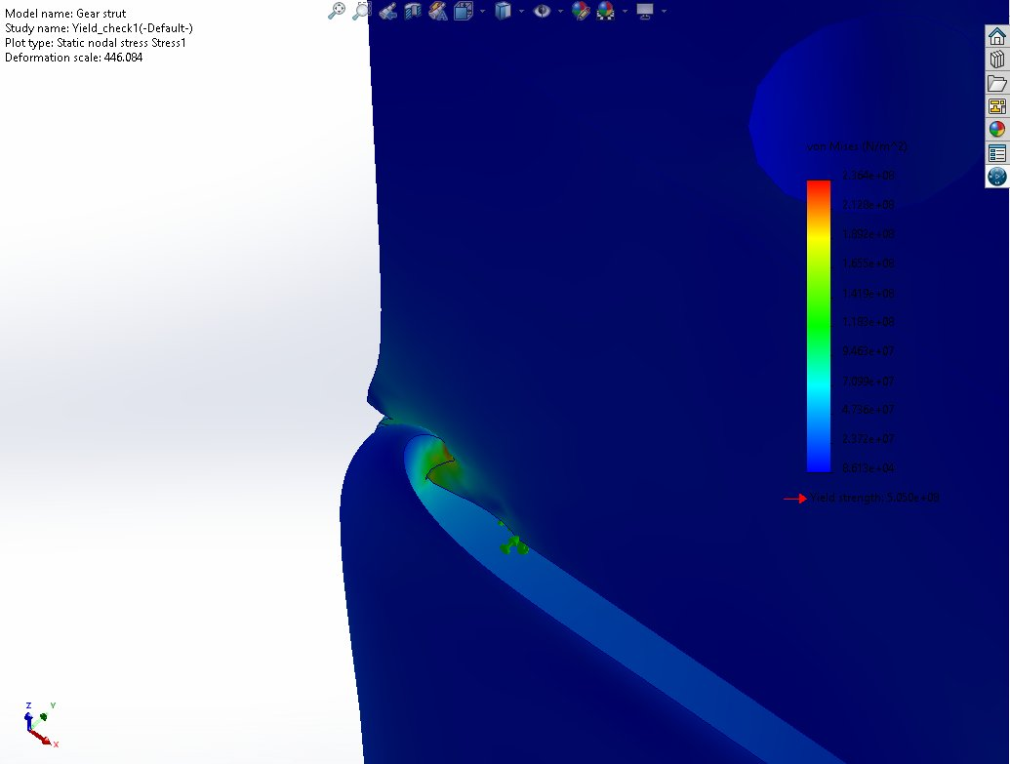
Figure 1: Von Mises stress distribution, Yield check (16,200 N). Peak stress 236 MPa at lug-barrel fillet.

Result | Value | Criterion | Status
Peak von Mises stress | 236 MPa | < 505 MPa (yield) | PASS
Location of peak stress | Lug-barrel fillet | Correct, maximum bending moment location | As expected
Minimum factor of safety | 2.14 | > 1.0 | PASS
Maximum displacement | 0.107 mm | Stiffness check | Acceptable

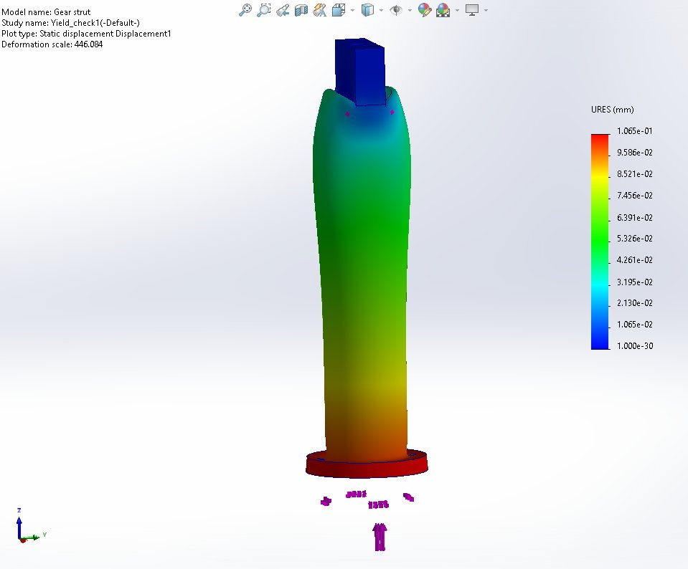
Figure 2: Resultant displacement, Yield check (16,200 N). Maximum deflection 0.107 mm at axle flange.

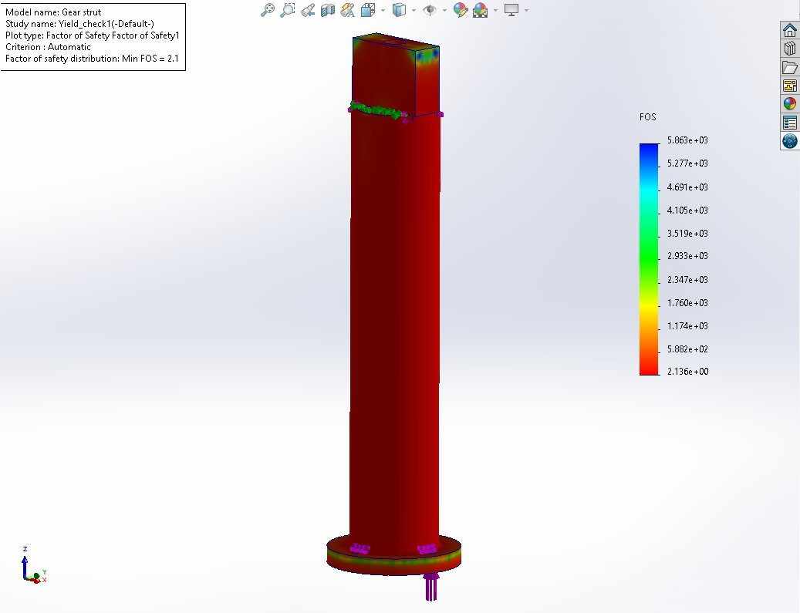
Figure 3: Factor of safety distribution, Yield check (16,200 N). Minimum FOS = 2.136 at lug-barrel fillet.

8.4 Run B: Ultimate Check (24,300 N)

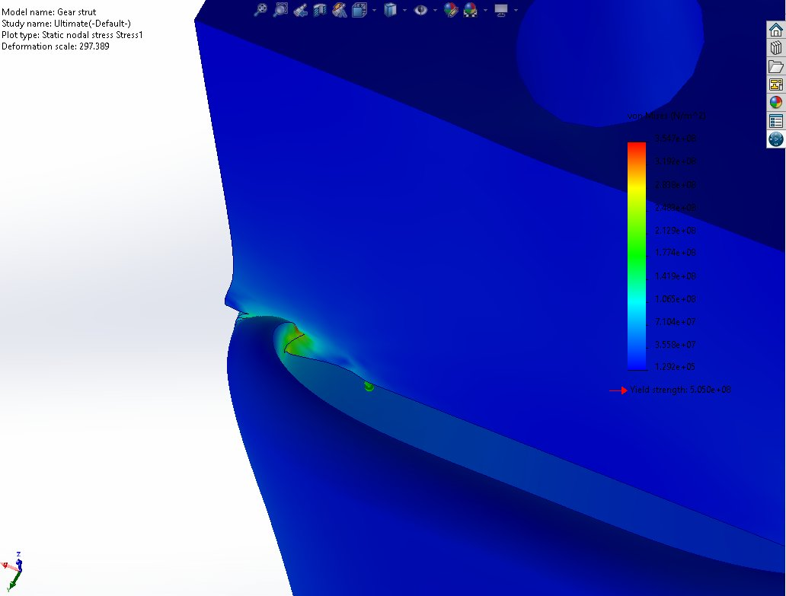
Figure 4: Von Mises stress distribution, Ultimate check (24,300 N). Peak stress 354.7 MPa at lug-barrel fillet.

Result | Value | Criterion | Status
Peak von Mises stress | 354.7 MPa | < 570 MPa (UTS) | PASS
Location of peak stress | Lug-barrel fillet | Correct, maximum bending moment location | As expected
Minimum factor of safety | 1.61 | > 1.0 | PASS
Maximum displacement | 0.160 mm | Stiffness check | Acceptable

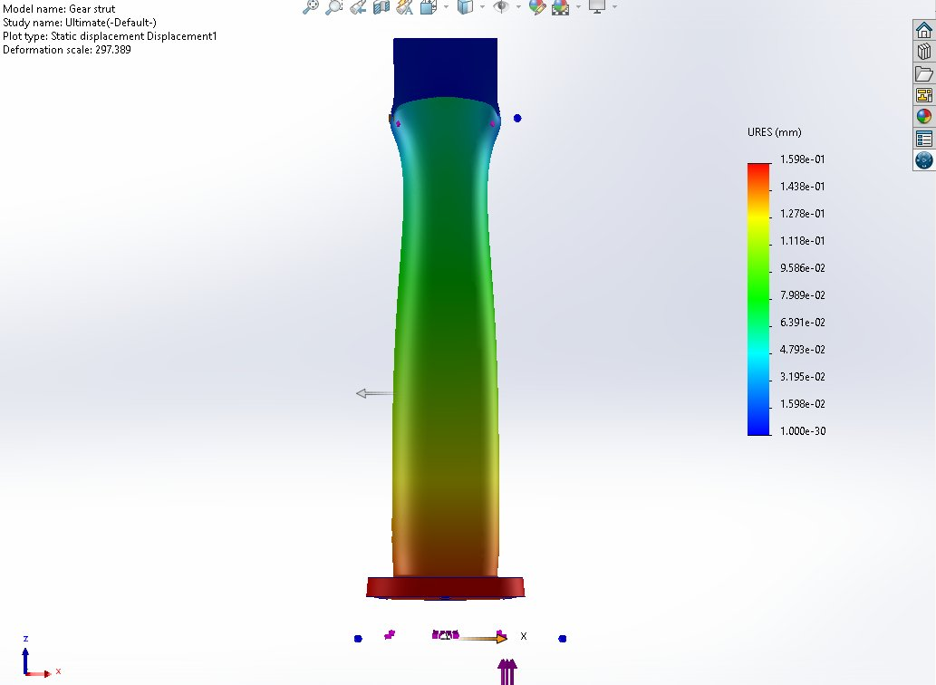
Figure 5: Resultant displacement, Ultimate check (24,300 N). Maximum deflection 0.160 mm at axle flange.

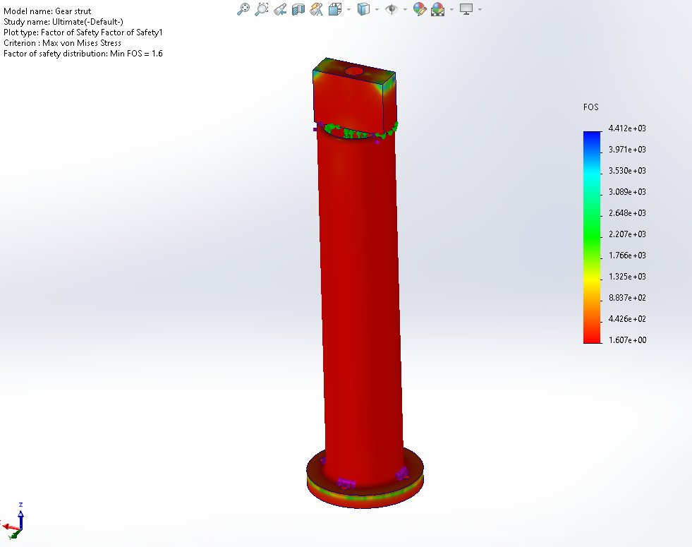
Figure 6: Factor of safety distribution, Ultimate check (24,300 N). Minimum FOS = 1.61 at lug-barrel fillet.

9. External Flow Simulation

9.1 Purpose and Setup
An external aerodynamic flow simulation was performed to quantify the drag force on the strut during landing approach. This drag acts horizontally and supplements the vertical landing load. The simulation used SolidWorks 2023 Flow Simulation with the k-epsilon turbulence model.

Setting | Value
Analysis type | External flow
Fluid | Air, ideal gas, sea level conditions
Inlet velocity | 70 m/s (136 knots, light GA approach speed)
Ambient pressure | 101,325 Pa (sea level)
Ambient temperature | 293.2 K (20 degrees C)
Turbulence model | k-epsilon (SolidWorks default for external flow)
Iterations | 100 (converged)
Flow direction | X-axis, perpendicular to strut length

9.2 Pressure Distribution
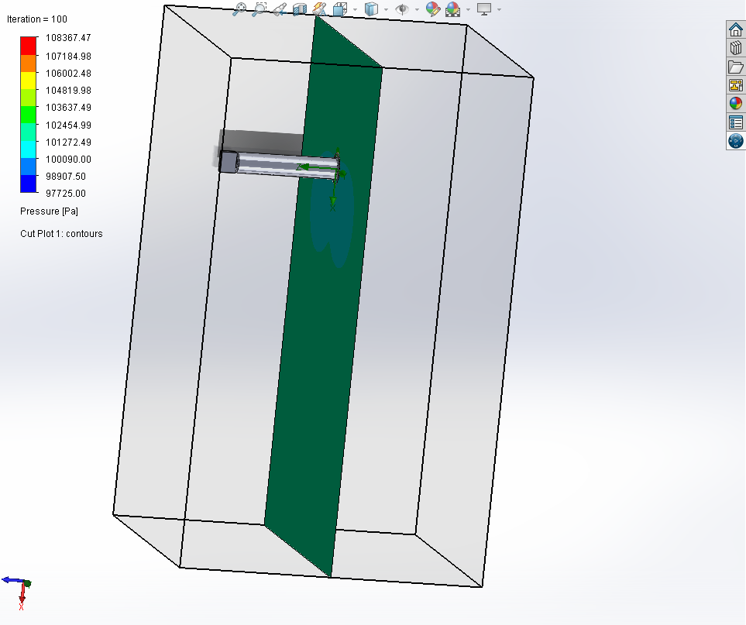
Figure 7: Pressure distribution (Pa), 70 m/s airflow. High pressure stagnation zone on upstream face (108,367 Pa), low pressure wake region downstream (97,725 Pa).

The pressure plot shows a clear stagnation region on the upstream face where airflow decelerates and pressure rises to 108,367 Pa, above ambient 101,325 Pa. The downstream wake shows a low pressure zone at 97,725 Pa. This pressure differential of 10,642 Pa across the strut is the primary source of aerodynamic drag.

9.3 Velocity Distribution
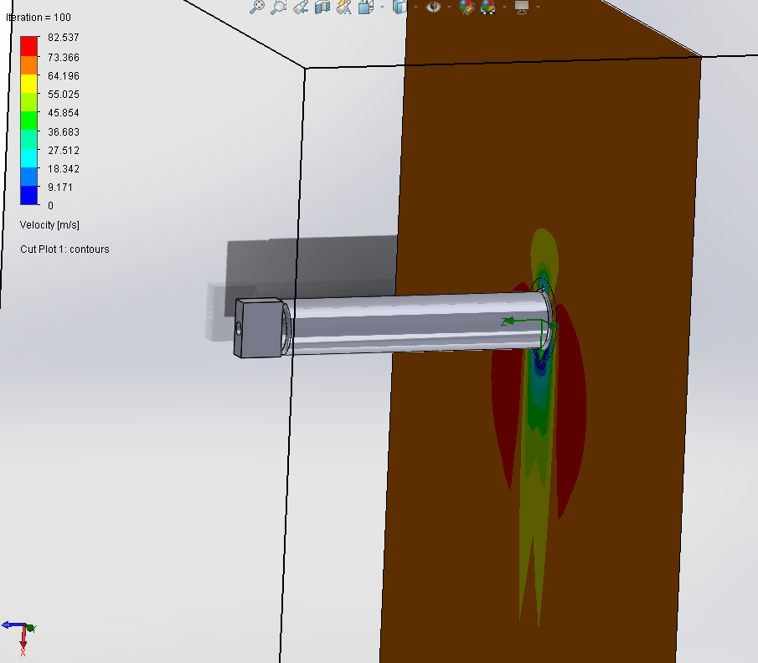
Figure 8: Velocity distribution (m/s), 70 m/s inlet. Air accelerates to 82.5 m/s around strut sides and decelerates to near zero in the downstream wake.

Air accelerates around the strut sides to 82.5 m/s, which is 18 percent above the inlet velocity. The turbulent wake region downstream is clearly visible as a low velocity zone. Both features are characteristic of external flow past a bluff body.

9.4 Drag Force Summary
Parameter | Value | Notes
Aerodynamic drag force (averaged) | 74 N | Force X, averaged over 100 iterations
Max surface pressure | 108,367 Pa | Stagnation point, upstream face
Min surface pressure | 97,725 Pa | Wake region, downstream
Pressure differential | 10,642 Pa | Primary source of pressure drag
Max local velocity | 82.5 m/s | 18 percent above inlet, at strut sides
Drag as percent of limit load | 0.46 percent | 74 N vs 16,200 N vertical load

The 74 N drag force is physically reasonable for a cylindrical body of this cross-section at 70 m/s. At 0.46 percent of the vertical limit load, aerodynamic drag is not structurally critical for barrel sizing. It becomes relevant in fatigue life calculations over many flight cycles and in combined load scenarios at the lug attachment.

10. MATLAB Parametric Study

10.1 Purpose
The MATLAB analysis serves three purposes that FEA cannot efficiently provide: a pre-FEA buckling check to justify the stress-only approach, an independent analytical stress calculation for FEA validation, and a parametric wall thickness sweep to demonstrate the design space.

10.2 Wall Thickness Parametric Study
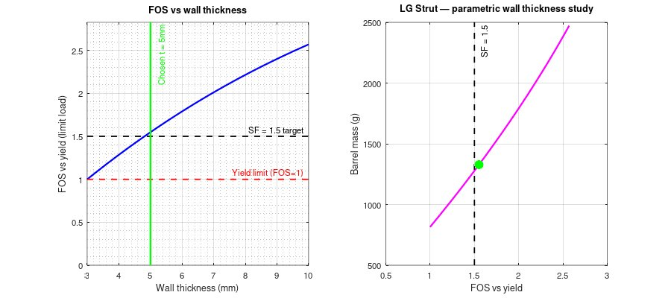
Figure 9: MATLAB parametric study. Left: FOS vs wall thickness at limit load, t = 5 mm sits at the SF = 1.5 target. Right: Mass vs FOS design trade, green dot marks the chosen design.

The left plot shows that t = 5 mm produces a nominal FOS of approximately 1.55 against yield at limit load, just above the SF = 1.5 target. Thinner walls violate the safety factor requirement. The right plot shows the mass vs FOS trade. The chosen design at 1,320 g sits at the knee of the curve, where increasing thickness further gives diminishing structural returns for significant mass penalty.

11. Validation

11.1 FEA vs Analytical Comparison
The primary validation check compares the FEA peak stress at the lug-barrel fillet to the independently calculated analytical prediction corrected for fillet geometry using Kt = 1.4.

Method | Peak Stress | FOS vs Yield | Notes
Beam theory, nominal | 325.0 MPa | 1.55 | Sharp corner assumed, no fillet effect
Analytical with Kt = 1.4 | 232.1 MPa | 2.17 | Corrected for 5 mm fillet geometry
FEA, refined mesh | 236.4 MPa | 2.14 | Peak at lug-barrel fillet, Run A
Difference: corrected vs FEA | 2 percent |  | Within acceptable threshold

The 2 percent agreement between the corrected analytical prediction and FEA confirms the model is correctly capturing the stress state at the critical section.

11.2 Peak Stress Location Check
In both FEA runs the maximum von Mises stress is at the lug-barrel fillet junction, which is the root of the cantilever where bending moment is theoretically maximum. This matches the analytical prediction and confirms physical consistency.

11.3 Displacement Sanity Check
Maximum tip deflection under limit load is 0.107 mm, which is 0.027 percent of strut length. This confirms the linear elastic assumption (A5) is valid. Strains are small and the material remains in the elastic range.

11.4 Model Limitations
- Lateral loads (approx. 20 to 30 percent of vertical) are not included (A1). This underestimates the combined stress state under real landing conditions.
- The fixed boundary condition overestimates bending stress compared to a physical pin joint. The model is conservative and real in-service stresses are expected to be lower.
- The monolithic part assumption eliminates joint compliance effects. Real bolted interfaces would introduce local stress concentrations not captured here.
- Fatigue is excluded. A fatigue life assessment requires cyclic load spectra and S-N curve data.

12. Results Summary

12.1 Structural FEA
Parameter | Run A, Yield Check | Run B, Ultimate Check
Applied load | 16,200 N (limit) | 24,300 N (ultimate)
Peak von Mises stress | 236 MPa | 354.7 MPa
Failure criterion limit | 505 MPa (yield) | 570 MPa (UTS)
Minimum factor of safety | 2.14 | 1.61
Maximum displacement | 0.107 mm | 0.160 mm
Peak stress location | Lug-barrel fillet | Lug-barrel fillet
Governing failure mode | Yielding (buckling margin 151.6x) | Yielding
Result | PASS | PASS

12.2 Flow Simulation
Parameter | Value
Inlet airspeed | 70 m/s (136 knots)
Aerodynamic drag force | 74 N (averaged)
Drag as fraction of limit load | 0.46 percent
Max surface pressure | 108,367 Pa (stagnation, upstream face)
Min surface pressure | 97,725 Pa (wake, downstream)
Max local velocity | 82.5 m/s (18 percent above inlet)

13. Conclusion
This report presents a complete static structural and aerodynamic analysis of a simplified aircraft main landing gear strut. The following conclusions are drawn:

- The strut passes both the yield criterion at limit load (FOS = 2.14) and the fracture criterion at ultimate load (FOS = 1.61). The design is structurally adequate under the defined loading conditions.
- The governing failure mode is yielding at the lug-barrel fillet junction. Euler buckling is non-governing by a factor of 151.6, confirming the stress-only FEA approach is appropriate.
- FEA results were validated against analytical cantilever beam theory with fillet stress concentration correction (Kt = 1.4). Agreement to within 2 percent confirms model validity.
- External flow simulation at 70 m/s gives a drag force of 74 N, which is 0.46 percent of the vertical limit load. Aerodynamic drag is not structurally critical for barrel sizing.
- The MATLAB parametric study confirms that t = 5 mm sits at the SF = 1.5 design target and represents a rational, mass-efficient design choice.
- The model is deliberately conservative. The fixed boundary condition overestimates bending stress relative to the physical pin joint. Real in-service stresses are expected to be lower.

The methodology demonstrated here, covering static FEA, external flow simulation, analytical validation, and parametric design, is directly applicable to real aerospace preliminary structural engineering workflows.

14. References
[1] Megson, T.H.G., Aircraft Structures for Engineering Students, 5th ed., Butterworth-Heinemann, 2013.
[2] Shigley, J.E., Mechanical Engineering Design, 10th ed., McGraw-Hill, 2015.
[3] ASM Aerospace Specification Metals, Aluminum 7075-T6 Material Data Sheet, www.aerospacemetals.com.
[4] SolidWorks Simulation and Flow Simulation Help Documentation, Dassault Systemes, 2023.
[5] Federal Aviation Regulations Part 23, Airworthiness Standards: Normal Category Airplanes, FAA, 2017. Referenced for load factor basis only. This is not a certification study.

Appendix A: MATLAB Command Window Output
Complete output from the MATLAB analysis script confirming all values used in this report:

F_static = 6474.6 N
F_limit = 16186.5 N (yield check load)
F_ult = 24279.8 N (ultimate check load)
Inner diameter = 70.0 mm
I = 8.3203e-07 m^4
A = 1.1781e-03 m^2
=== BUCKLING CHECK ===
P_cr = 3679921 N (3680 kN)
F_ult = 24280 N (24 kN)
Margin = 151.6x above ultimate load
RESULT: Buckling NOT governing. Proceed with stress FEA.
=== ANALYTICAL STRESS AT BARREL ROOT ===
Bending stress = 311.27 MPa
Axial stress = 13.74 MPa
Combined stress (nominal) = 325.01 MPa
Stress concentration Kt = 1.4 (fillet correction)
Corrected stress = 232.15 MPa <-- compare to FEA
FOS vs yield (nominal) = 1.55
RESULT: PASS at limit load.

