AQUALOOP
Virtual Multi-Loop Process Control and Instrumentation System
Technical Report
Sam
Mechanical Engineering
September 2026
Personal project. This is a software-only, simulated implementation. No physical hardware was built or tested for this version.

Table of Contents
1. Introduction
2. Problem Definition and Objectives
3. System Architecture
4. Mathematical Model of the Virtual Plant
5. Instrumentation
6. Control Architecture
7. Disturbances and Fault Injection
8. Simulation Methodology
9. Experiments and Results
10. Performance Analysis
11. Validation and Testing
12. Limitations
13. Industrial Relevance
14. Future Improvements
15. Conclusion
Appendix A: Engineering Assumptions
Appendix B: Reproducing These Results

1. Introduction
This report documents Aqualoop, a software-based process control and instrumentation project built around a simulated water tank with two coupled feedback loops: water level and water temperature. The project started as a physical table-top plant design for a Measurement and Instrumentation and Control Engineering course, built around an ESP32 microcontroller, a DS18B20 temperature probe, a JSN-SR04T ultrasonic level sensor, a YF-S201 flow sensor, and a PWM-driven pump and heater.
I decided not to build that hardware version. Instead I built a virtual implementation of the same process architecture: a plant model that evolves according to real differential equations rather than a predetermined curve, virtual sensors with the kind of imperfections real sensors have, calibration and filtering routines, two feedback controllers tuned from an identified process model, a disturbance and fault injection framework, and an experiment suite that exercises all of it and computes performance metrics from the results.
Nothing physical was built or tested for this version, and nothing in this report claims otherwise. Every number that came out of a simulation run is labeled as simulated data. Where a parameter could not be taken from real hardware, I made an engineering assumption and documented it; the full list is in Appendix A.

2. Problem Definition and Objectives
The original Aqualoop concept called for a physical table-top plant: a reservoir, a pump, a process tank, a gravity drain, a heater, and enough instrumentation to run a temperature control loop and a level control loop at the same time. Building that plant well means working through a set of problems that show up in real process plants at a much larger scale: how to model a nonlinear process, how to deal with sensors that are noisy, biased, delayed or occasionally wrong, how to tune a controller from data instead of guessing at gains, how a fault in one part of a system shows up somewhere else, and how two loops that look independent on paper end up affecting each other through a shared piece of equipment.
For the virtual version I set the following objectives:
- Build a plant model whose temperature and level actually evolve according to differential equations, not a scripted curve
- Give the level and temperature loops a real physical connection to each other, not two independent simulations running side by side
- Model three different virtual sensors with different, appropriate failure characteristics
- Calibrate those sensors and filter their signals the same way I would for real instrumentation
- Implement a PID controller and a PI controller from first principles, including anti-windup and bumpless manual and automatic transfer
- Tune both controllers from an identified process model instead of picking gains by feel
- Build a disturbance and fault injection framework that changes the plant equations while a simulation is running, not one that overlays an annotation on a plot afterward
- Automate the experiments that demonstrate all of the above, and compute performance metrics from the resulting data
- Keep the scope realistic for one person to build and understand completely, without machine learning, model predictive control, an industrial protocol stack, or container orchestration the project does not need

3. System Architecture
The project is organized into six layers, each with a single job. Nothing is in one giant script; a change to the pump curve, for example, only touches tank.py and the tests that cover it.
Aqualoop/
src/
plant/ tank.py, thermal.py, process.py
instrumentation/ temperature_sensor.py, level_sensor.py,
flow_sensor.py, calibration.py, filtering.py
control/ pid.py, pi.py, tuning.py
simulation/ configuration.py, engine.py,
disturbances.py, faults.py
experiments/ experiments.py, runner.py, saving.py
analysis/ metrics.py
tests/ 55 automated tests
scripts/ run_demo.py
data/generated/ experiment CSV output, simulated data
results/figures/ experiment plots
results/reports/ experiment JSON summaries
docs/ this report

plant: the physical model. tank.py holds the level dynamics and the pump curve, thermal.py holds the energy balance, process.py combines the two into one Plant object and applies the dry-run heater interlock.
instrumentation: the three virtual sensors, the calibration routine, and the exponential moving average filter.
control: the PID and PI controllers, and the tuning module that identifies a process model from a step test and computes gains from it.
simulation: configuration.py holds every tunable parameter in one place, engine.py runs the closed-loop, time-stepping simulation, and disturbances.py and faults.py apply changes to the running plant.
experiments: the eleven experiment functions and the shared code that saves their CSV, plot and JSON output.
analysis: the performance metrics module, computed from simulation arrays rather than estimated by eye.
Every layer has automated tests. 55 tests cover the plant physics, the three sensors, the calibration routine, both controllers, the disturbance and fault frameworks, and the closed-loop simulation engine, and all 55 pass.

4. Mathematical Model of the Virtual Plant
Both loops are driven by real differential equations, integrated forward in time with explicit Euler steps (see section 8). Nothing here is a plotted curve fitted to look like a control response; the numbers in section 9 come directly from stepping these equations forward.

4.1 Level Dynamics
The process tank is modeled as a single well-mixed control volume with a gravity drain. The mass balance in terms of height h is:
A dh/dt = Qin - Qout (1)
with a physically meaningful outflow relationship for a submerged, sharp-edged orifice draining under gravity:
Qout = Cd . Ao . sqrt(2 g h) (2)
Qin comes from the inlet pump through a nonlinear command-to-flow curve. I did not assume that a 50% pump command gives 50% of the pump's rated flow. Below a dead zone the pump does not move enough water to matter, which is what a small DC pump with static friction actually does; above the dead zone, flow rises with the command raised to an exponent greater than one, so the pump has to spin up before flow tracks the command closely:
Qin = Qmax . ((u - udead) / (100 - udead))^{gamma} (3)
for command u above udead, and zero otherwise. Table 1 and Table 2 list the tank and pump parameters used.
Table 1. Tank geometry parameters
Parameter | Value | Basis
Tank cross-sectional area, A | 0.045 m2 | Assumption: roughly 21 cm x 21 cm tank
Usable tank height | 0.30 m | Assumption: table-top scale
Outlet orifice area, Ao | 1.2e-6 m2 | Assumption: narrow gravity drain, about 1.2 mm diameter (see section 4.3)
Discharge coefficient, Cd | 0.62 | Standard textbook value for a sharp-edged orifice
Minimum safe level | 0.03 m | Heater interlock threshold

Table 2. Pump parameters
Parameter | Value | Basis
Maximum pump flow | 6.0e-6 m3/s (about 0.36 L/min) | Assumption: small dosing-style pump (see section 4.3)
Dead zone | 8% of command | Assumption: static friction in a small DC pump
Nonlinearity exponent, gamma | 1.25 | Assumption: flow builds slower than command near the low end

4.2 Thermal Dynamics
The tank is also treated as a single well-mixed thermal mass. Starting from an energy balance on a control volume whose mass changes as water flows in and out:
d(m cp T)/dt = rho Qin cp Tin - rho Qout cp T + Qheater - Qloss (4)
and expanding the left side as m cp dT/dt + cp T dm/dt, then substituting the continuity relation dm/dt = rho (Qin - Qout), the rho Qout cp T terms cancel and the balance reduces to:
m cp dT/dt = rho Qin cp (Tin - T) + Qheater - Qloss (5)
which is what the simulation actually integrates, with:
m = rho A h (6)
Qheater = Pheater . (heater command / 100) (7)
Qloss = UA (T - Tambient) (8)
A minimum mass floor prevents the m in the denominator from approaching zero as the tank runs low, and the dry-run heater interlock described in section 3 stops the heater entirely below the minimum safe level, the way a real immersion heater would need a cutout to avoid heating an element with no water around it. Table 3 lists the thermal parameters.
Table 3. Thermal parameters
Parameter | Value | Basis
Water density | 997 kg/m3 | Standard property of water
Specific heat | 4186 J/(kg K) | Standard property of water
Heater power | 180 W | Assumption: small immersion heater
Heat loss coefficient, UA | 0.6 W/K | Assumption: lumped convective loss, lightly insulated tank
Ambient temperature | 25 degC | Assumption
Reservoir temperature | 25 degC | Assumption: same as ambient

4.3 Coupling Between the Two Loops
The rho Qin cp (Tin - T) term in equation 5 is the mechanism that couples the level loop to the temperature loop. When the pump runs harder to hold the level setpoint, more reservoir-temperature water enters the tank, and that shows up directly as a thermal disturbance the PID controller has to reject. This is not two simulations running side by side; a single shared variable, Qin, drives both equations.
Sizing the drain and the pump took a real iteration. My first attempt used a garden-hose-sized drain (about 6 mm diameter) and a pump rated around 3.3 L/min. Holding a steady level against that drain needed a continuous makeup flow whose thermal cost, rho Q cp times a 20 degC rise, worked out to a few kilowatts, far more than a 40 W heater could supply. The heater stayed pinned at 100% and the temperature still settled only a few tenths of a degree above ambient. Water's specific heat is large enough that even a modest continuous flow carries a large thermal cost, and a level loop that needs meaningful continuous throughput to hold its setpoint will dominate a small heater before the heater does anything useful.
The fix was to size the drain and pump around the heater's real capacity rather than the other way round: a roughly 1.2 mm drain orifice and a pump rated around 0.36 L/min, sized so the makeup flow needed to hold a level setpoint stays small enough for a 150-200 W heater to dominate. Experiment 10 in section 9.7 is the direct demonstration of this coupling once the plant was sized correctly: a level setpoint change produces a real, computed dip in temperature with no change to the temperature setpoint or controller.

5. Instrumentation

5.1 Sensor Models
Three virtual sensors stand in for the DS18B20, JSN-SR04T and YF-S201 in the original physical concept. Each has a different noise and failure profile on purpose, the same way a thermistor, an ultrasonic rangefinder and a turbine flow meter fail in different ways in reality. Every sensor converts a true physical quantity into a measured one through the same general steps: scale and bias, additive noise, an optional multi-step delay implemented as a small FIFO buffer, and quantization to a fixed resolution. Table 4 lists the parameters actually used.
Table 4. Virtual sensor parameters
Sensor | Noise (1 std dev) | Resolution | Delay | Other
Temperature | 0.05 degC | 0.0625 degC | 2 steps | DS18B20-style reference
Level | 2.0 mm | 1.0 mm | 1 step | 1% chance per step of an outlier glitch, 12 mm
Flow | 1.0e-7 m3/s | none | 1 step | Reads exactly zero below 3.0e-7 m3/s (turbine stall)

Two sensors get an extra failure mode that would not make sense on the other one. The level sensor has a small chance each step of an outlier glitch, a burst error an ultrasonic rangefinder produces when it catches a reflection off a disturbed water surface. The flow sensor reads exactly zero below a minimum detectable flow, because a turbine flow meter's rotor will not spin fast enough to register a pulse train at very low flow. All three sensors also support being frozen at their last reading or dropping a fraction of readings entirely, both used by the fault injection framework in section 7 rather than being active during normal operation.

5.2 Sensor Calibration
Calibration is a linear fit, measured = slope times reference plus intercept, computed by ordinary least squares against a set of simulated reference values swept across each sensor's working range. This produces SIMULATED CALIBRATION DATA: it comes from the sensor model in this project, not a physical bench, and every calibration output in this project is labeled that way so it is never confused with a real measurement.
Getting a clean calibration result took a second iteration too. The first version read each sensor once per reference point. For a sensor with a multi-step delay, that compares the current reference value against a measurement still lagging the previous reference point, which looks like calibration error but is really just reading the sensor too fast. The fix, matching how a real calibration bench is actually run, is to hold each reference value steady and sample the sensor repeatedly until its delay buffer has settled, then record the last reading. Temperature calibration RMSE dropped from 1.49 degC with the bug to 0.041 degC once fixed, which is close to the sensor's own 0.05 degC noise standard deviation, as it should be. Table 5 shows the calibration result actually used for all three sensors, and Figure 1 shows the temperature calibration.

Table 5. Simulated calibration results, 21 reference points per sensor
Sensor | Slope | Intercept | RMSE | Max abs error | Mean % error
Temperature | 0.9999 | 0.0148 | 0.0414 degC | 0.0751 degC | 0.090%
Level | 0.9974 | 0.000628 | 0.00159 m | 0.00353 m | 1.258%
Flow | 0.9967 | 2.35e-8 | 6.23e-8 m3/s | 1.19e-7 m3/s | 3.580%

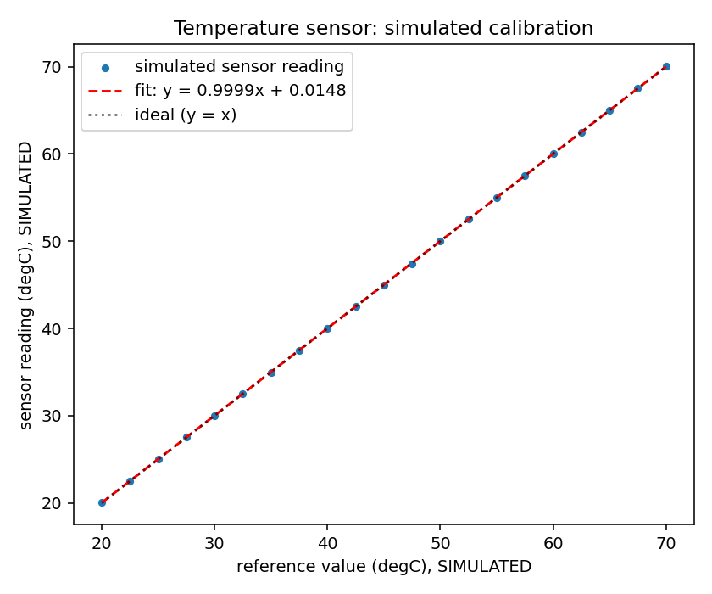
Figure 1. Simulated temperature sensor calibration, with the fitted line and the ideal y = x line for reference.

5.3 Signal Filtering
Both the temperature and level measurements pass through an exponential moving average filter before reaching their controllers:
y[n] = alpha x[n] + (1 - alpha) y[n-1] (9)
A smaller alpha filters harder at the cost of more lag behind the true signal, and that tradeoff is why alpha is a configuration parameter rather than a fixed constant. It also genuinely affects the control loop rather than being cosmetic. The level filter is the clearer example: with the outlier glitch modeled at 30 mm and a lightly-filtered alpha of 0.4, a single glitch produced a proportional-term spike large enough to swing the pump command across most of its range for one sample, visible as sharp, high-frequency spikes in the pump command trace even though the physical level itself stayed smooth (the tank's own capacitance absorbs a one-sample command spike). Reducing the outlier size to 12 mm and the filter alpha to 0.15 brought the pump command down to a level of noise that still tracks real changes but no longer spikes on every glitch. The temperature filter uses alpha = 0.3.

6. Control Architecture

6.1 PID Temperature Controller
The temperature loop uses a discrete PID controller implemented directly rather than pulled from a library, since understanding the anti-windup and derivative handling was one of the objectives in section 2. The controller keeps a running integral and a filtered derivative as state between calls:
u[n] = Kp e[n] + Ki I[n] + Kd D[n] (10)
I[n] = clamp(I[n-1] + e[n] Δt, 0, 100) (11)
D[n] = -(measurement[n] - measurement[n-1]) / Δt, low-pass filtered (12)
where e[n] = setpoint - measurement[n] and clamp(x, lo, hi) restricts x to the actuator's output range. Two design choices are worth stating explicitly rather than leaving implicit in the code.
Anti-windup: the integral term accumulates every step and is then clamped to the actuator's output range (0 to 100%), rather than conditionally deciding whether to accumulate at all. This is simpler to reason about and keeps the integral from ever holding a value larger than the heater could act on by itself. When windup has pushed the integral to its ceiling, a small overshoot past the setpoint starts pulling the integral back down on the very next step rather than needing extra time first to work off banked windup, which is exactly what a unit test in tests/test_control.py checks for.
Derivative on measurement: the derivative term is computed from the change in the filtered measurement, not the change in error, so a setpoint step does not produce an instantaneous spike in the heater command (a derivative kick). The raw derivative also passes through its own first-order low-pass filter (time constant 2 s) before being used, since differentiating a noisy measurement directly would let sensor noise dominate the heater command.
The controller also supports a manual mode that holds a fixed output, used for the open-loop step tests in section 6.3, and bumpless transfer back to automatic mode: the integral term is seeded from the manual output at the moment of the switch so the command does not jump.

6.2 PI Level Controller
The level loop uses a PI controller with no derivative term, built the same way as the PID controller (accumulate the integral, then clamp it to the output range) but without the derivative branch. Two reasons support leaving D out rather than just following convention.
- The ultrasonic level measurement is the noisiest signal in the project, and the occasional outlier glitch described in section 5.1 is exactly the kind of event a derivative term would amplify into a large, spurious pump command swing.
- The level process does not have the kind of lag that derivative action is meant to compensate for. The gravity drain's sqrt(h) outflow relationship already provides natural damping (a higher level drains faster on its own), so the process behaves closer to self-regulating than the thermal loop does, and there is not much for a D term to usefully damp.
This matches standard industrial practice for level control, where PI is the default and PID is the exception rather than the rule, for the same reasons.

6.3 Controller Tuning
Gains were not hand-picked. Both controllers were tuned from an open-loop step test: hold the controller in manual mode, step the actuator command, and record the process variable's response with the other loop running normally underneath (so the identification reflects real operating conditions, including the coupling in section 4.3, not an artificially isolated loop). tuning.py fits a first-order-plus-dead-time (FOPDT) model to that response:
- K, the process gain, is the steady-state change in the response divided by the size of the step
- tau, the time constant, is the time for the response to reach 63.2% of its total change
- theta, the apparent dead time, is the time before the response is first visibly moving
For the temperature loop, stepping the heater command from 20% to 60% identified K = 0.316 degC per percent, tau = 4050 s, theta = 87 s (Figure 2). For the level loop, stepping the pump command from 20% to 40% identified K = 0.00329 m per percent, tau = 3231 s, theta = 88 s.
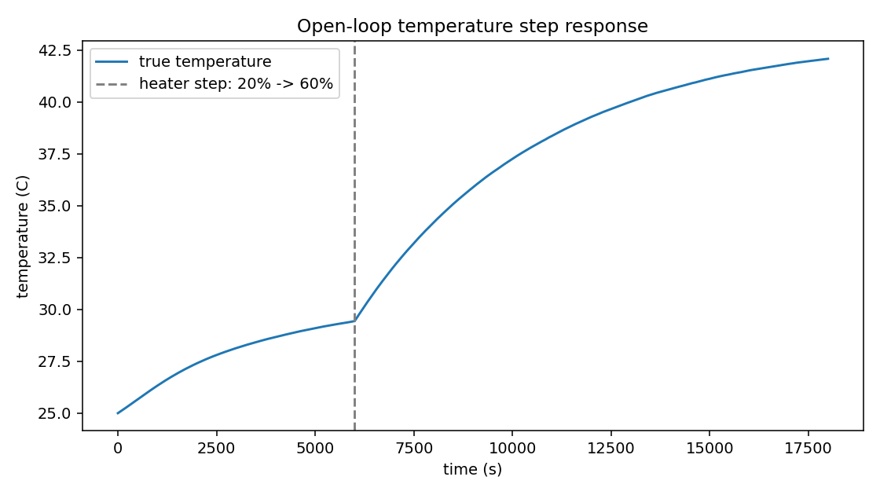
Figure 2. Open-loop temperature step response used to identify the FOPDT model.
I initially computed gains with the classic Ziegler-Nichols open-loop reaction-curve formulas, which divide directly by theta. That produced a derivative gain over 7500, because this plant has almost no real transport delay: the theta a threshold-based estimator picks up on a clean first-order response is mostly an artifact of how slowly such a response leaves its baseline, not a genuine dead time, and dividing by a very small or noisy theta blows the ZN formulas up. I switched to Skogestad's SIMC rule instead:
Kc = (1/K) . tau / (theta + lambda) (13)
Ti = min(tau, 4(theta + lambda)) (14)
where lambda is the desired closed-loop time constant, chosen here as tau/4 for a reasonably brisk but not aggressive response. SIMC stays well behaved as theta shrinks toward zero, which is the regime this plant sits in, and it does not need a precise theta to give sensible gains, only a roughly correct one. The derivative time for the PID controller is set directly from the real instrumentation lag (sensor delay plus filter time constant, about 5 s) rather than from the identified theta, for the same reason: using the inflated reaction-curve theta for Td would give a derivative term far larger than the real lag justifies. Table 6 summarizes both loops.

Table 6. Identified process models and resulting gains
Loop | K | tau (s) | theta (s) | Kp | Ki | Kd
Temperature (PID) | 0.316 degC/% | 4050 | 87 | 11.22 | 0.0027 | 56.10
Level (PI) | 0.00329 m/% | 3231 | 88 | 1095.04 | 0.3389 | n/a

The gains actually in use in configuration.py match these identified values; they were not manually adjusted afterward. Running the identification a second time gives very similar but not bit-for-bit identical FOPDT parameters, because the level loop's pump command during the step test depends on noisy sensor data, which is expected and is discussed further in section 12.

7. Disturbances and Fault Injection
A disturbance is something that happens to the process from the outside. A fault is something wrong with a piece of equipment. Both are implemented the same way: a small object with a start time, a duration and a magnitude, whose apply_on_step method mutates the live plant or sensor objects while it is active, called once per timestep through an on_step hook in the simulation engine. This means a disturbance or fault genuinely changes the equations being integrated for as long as it is active, rather than being an annotation added to a plot afterward.

7.1 Disturbances
Three kinds are implemented, covering both loops:
- ambient_temp_step: the ambient air temperature changes, for example a draft or a door left open near the tank
- inflow_temp_step: the reservoir's water temperature changes, for example a second process drawing from the same reservoir
- extra_outflow: an additional drain flow on top of the normal gravity outlet, for example a small leak or someone drawing water off the tank by hand

7.2 Faults
Eight kinds are implemented:
- sensor_bias, sensor_noise, sensor_dropout, sensor_stuck, targeting a named sensor (temperature, level or flow)
- pump_effectiveness and heater_effectiveness, which scale an actuator's real output below what it was commanded, standing in for a worn pump or a degraded heating element
- extra_heat_loss, which adds to the ambient heat loss coefficient, standing in for lost insulation
- extra_outflow, an uncommanded drain flow, the fault-side equivalent of the disturbance of the same name
The fault and disturbance extra_outflow kinds share the same underlying plant attribute, so a single simulation run should schedule one or the other for that particular effect, not both at once; scheduling both would let the second one silently overwrite the first. This is a real limitation, not a hidden one, and it is listed again in section 12.

8. Simulation Methodology
The simulation engine steps the closed loop forward in discrete time. At each step it reads the plant's true state, generates sensor measurements from it, applies filtering, lets the controllers compute new actuator commands, logs every quantity, and only then advances the plant physics using those commands. This ordering matters: a controller can only act on information a real controller would actually have, the filtered and delayed measurement, not the true state directly.
Both the level and thermal equations are integrated with explicit Euler steps: the next value is the current value plus the rate of change times the timestep. This is appropriate here because both loops' time constants (thousands of seconds, see section 6.3) are far larger than the timestep used (1 s), which keeps the scheme well inside its stability region while staying easy to read and explain. A few sanity checks are enforced directly in the plant code rather than left as an assumption: level is clamped to the physical range of the tank (it cannot go negative or exceed the tank height), and the thermal model's mass term is floored above zero so it cannot divide by a vanishing quantity as the tank runs low.
Sensor noise is generated from a seeded NumPy random generator (numpy.random.default_rng), so passing the same random_seed reproduces an identical run bit for bit; tests/test_engine.py checks this directly. AqualoopConfig().ideal() returns a copy of the configuration with every sensor's noise, bias, resolution, delay and dropout set to zero, the pump's dead zone and nonlinearity switched off, and the simulation mode label set accordingly, which is what section 14 identifies as the next piece to actually show side by side with the realistic mode in a dashboard.

9. Experiments and Results
Eleven experiments were run; each saves its own CSV of logged simulation data, a plot, and a JSON summary of the metrics computed from that run. All data produced by these experiments is simulated.

9.1 Sensor Calibration
Covered in section 5.2 and Table 5. All three sensors show a fitted slope within 0.4% of 1.0 and an intercept close to zero, consistent with sensor models that were configured with a scale of 1.0 and no deliberate bias; the residual error is the sensor's own modeled noise.

9.2 Open-Loop Temperature Response
Covered in section 6.3 and Figure 2. Stepping the heater command from 20% to 60% with the level loop holding 0.15 m identified the FOPDT model used for tuning.

9.3 Closed-Loop Temperature Control
Starting cold at 25 degC with a 45 degC setpoint and the level held at 0.15 m (Figure 3):
- Rise time (10% to 90%): 3536 s
- Overshoot: 8.04%
- Settling time (2% band): 11559 s
- Steady-state error: 0.129 degC
- IAE: 48661, ISE: 455635
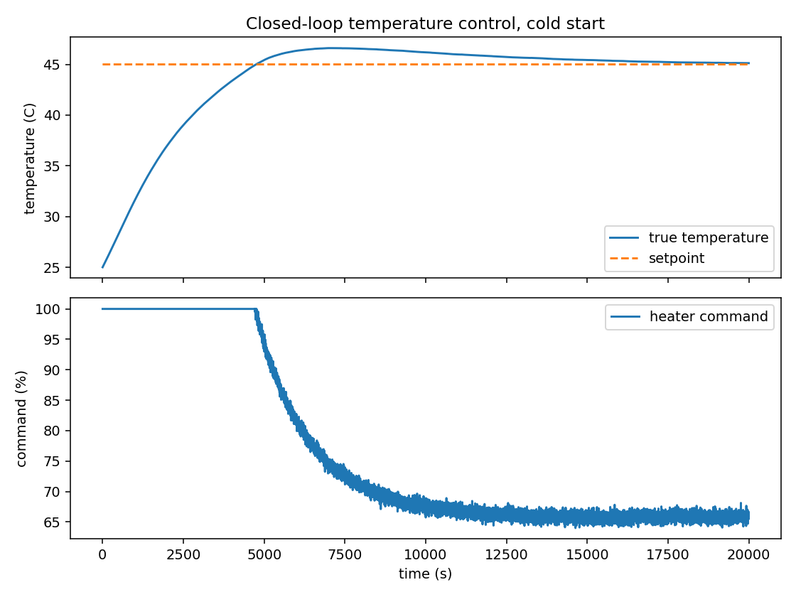
Figure 3. Closed-loop temperature control, cold start.

9.4 Closed-Loop Level Control
Starting at 0.08 m with a setpoint step to 0.20 m (Figure 4):
- Rise time (10% to 90%): 1952 s
- Overshoot: 0%
- Settling time (2% band): 3369 s
- Steady-state error: 1.9 mm
- IAE: 107.2, ISE: 6.27
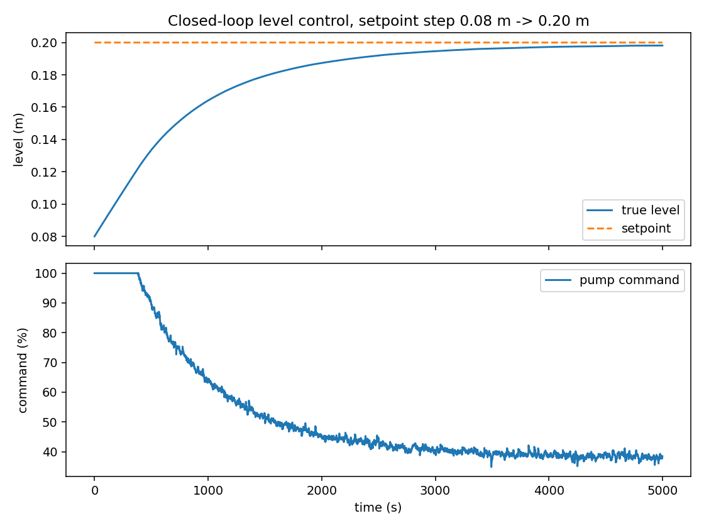
Figure 4. Closed-loop level control, setpoint step.
The level loop shows no overshoot, consistent with the SIMC tuning choice of lambda = tau/4 (a conservative, non-aggressive closed-loop speed) and with the process's own self-regulating behavior described in section 6.2.

9.5 Temperature Disturbance Rejection
With the loop holding 45 degC, the reservoir temperature was stepped 15 degC colder for 2000 s, simulating a cold-water surge (Figure 5):
- Maximum dip: 5.12 degC
- Recovery time after the disturbance ends: 2220 s
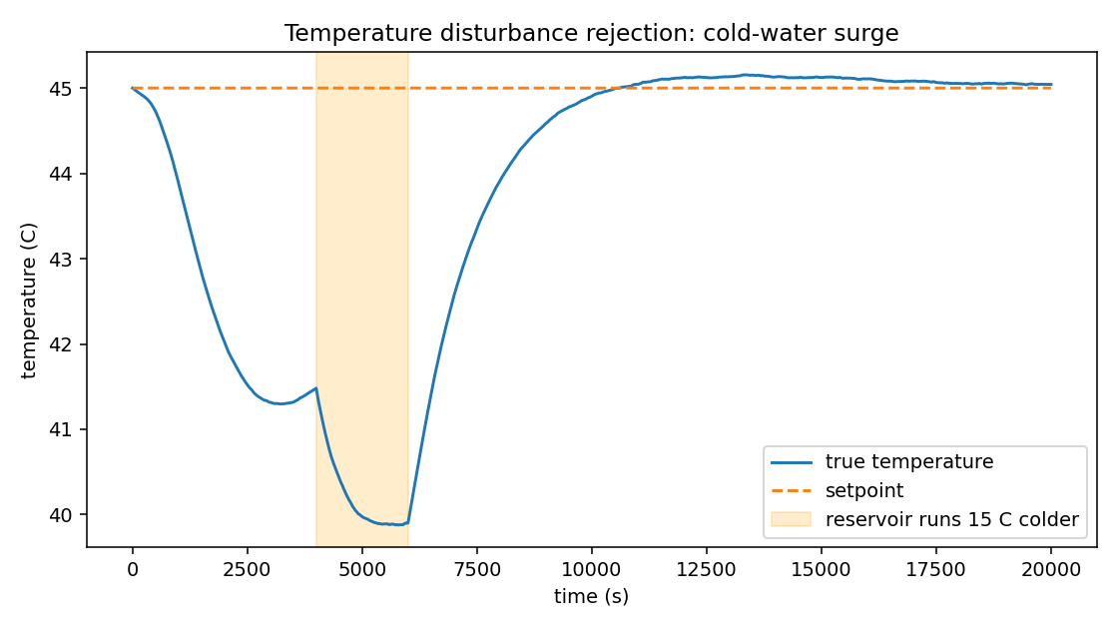
Figure 5. Temperature disturbance rejection, cold-water surge.

9.6 Level Disturbance Rejection
With the loop holding 0.15 m, an extra drain flow of 2.5e-6 m3/s was applied for 800 s, simulating a manual water draw-off (Figure 6):
- Maximum dip: 45.7 mm
- Recovery time after the disturbance ends: 3356 s
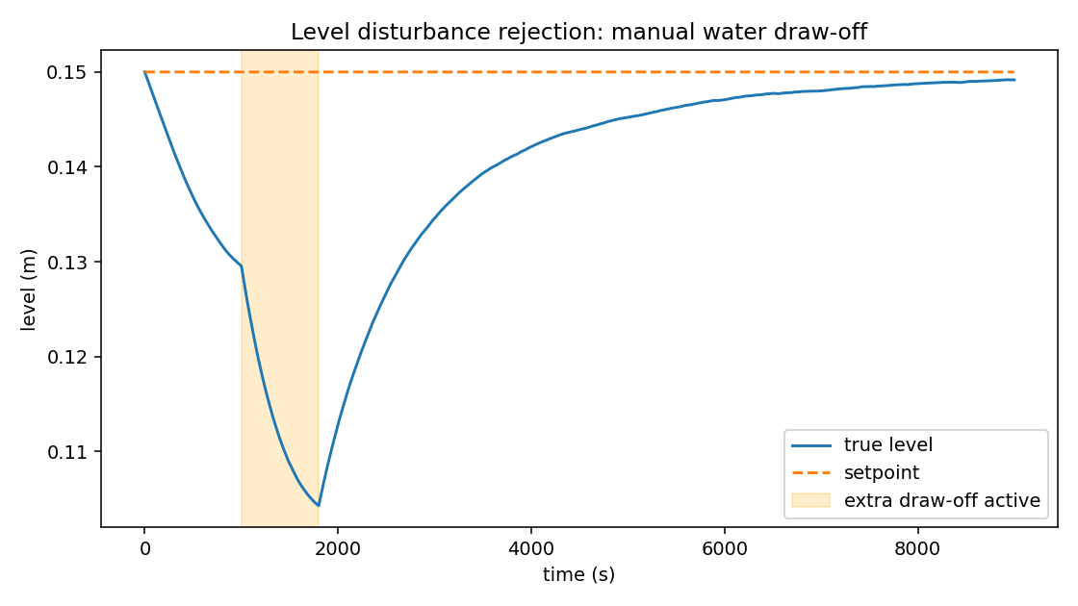
Figure 6. Level disturbance rejection, manual water draw-off.

9.7 Coupled Full-System Operation
This experiment is the direct demonstration of section 4.3's coupling claim. The temperature loop holds a 45 degC setpoint throughout; at t = 7000 s, only the level setpoint changes, stepping from 0.10 m to 0.20 m. Neither the temperature setpoint nor the temperature controller's gains change at any point (Figure 7):
- Temperature immediately before the level setpoint change: 45.14 degC
- Temperature dip caused purely by the level change: 7.05 degC
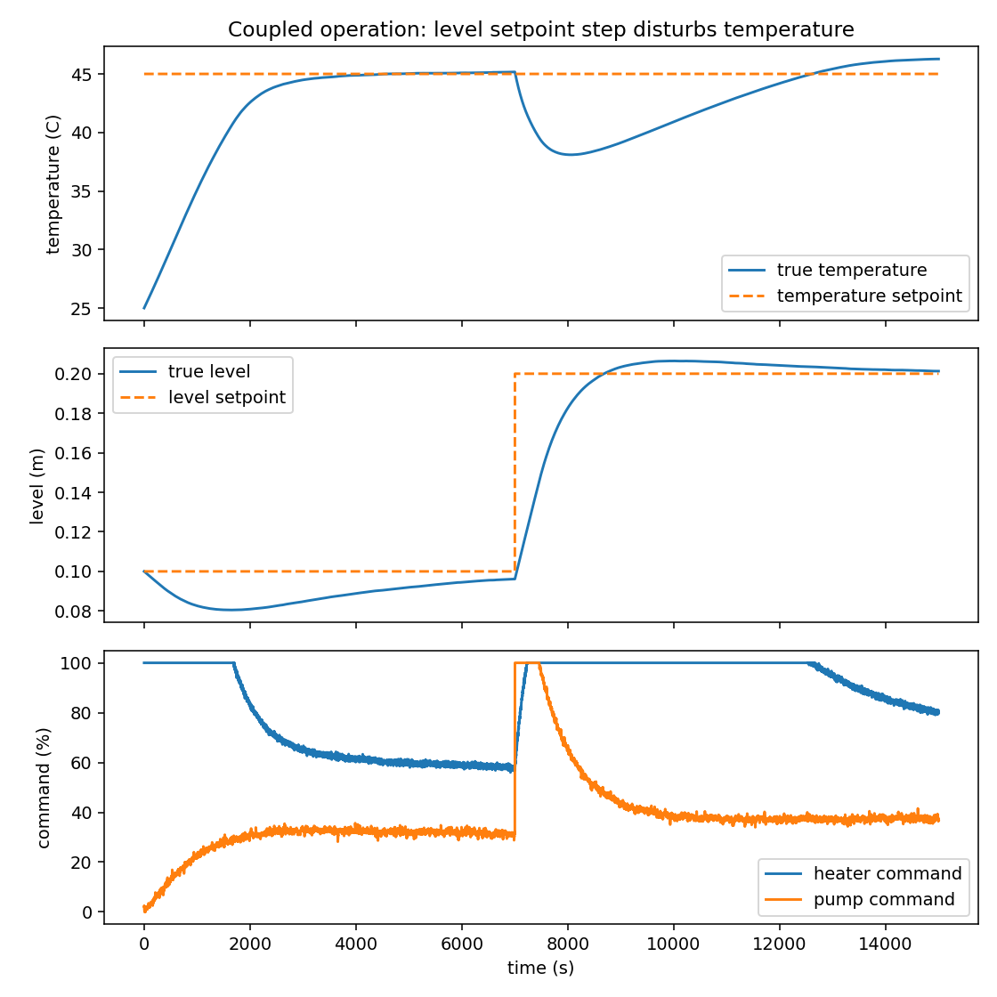
Figure 7. Coupled operation: a level setpoint change alone produces a real temperature dip.
The pump saturates at 100% to move the tank to its new, higher level quickly, and that flow of reservoir-temperature water is what pulls the temperature down. The temperature PID then recovers it over the following few thousand seconds, exactly the pattern described in section 4.3 without any part of it scripted into the experiment.

9.8 Controller Comparison: P, PI and PID
The same plant, the same starting conditions, and the same proportional and derivative gains were used for all three controllers, varying only which terms were enabled (Figure 8, Table 7):
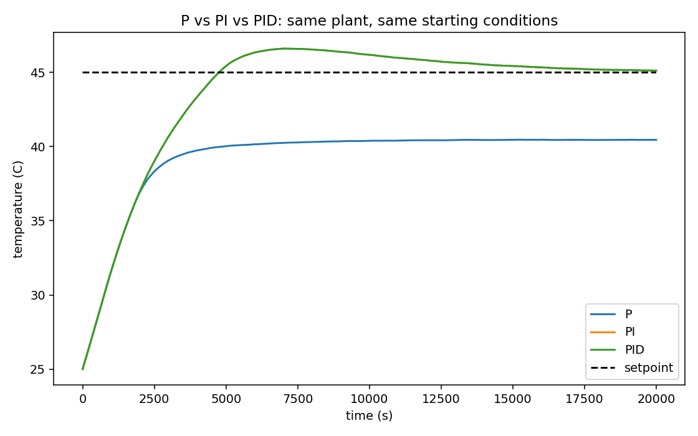
Figure 8. P vs PI vs PID on the temperature loop.
Table 7. Performance metrics, same plant and starting conditions
Controller | Rise time (s) | Overshoot (%) | Settling time (s) | SSE (degC) | IAE
P | n/a | 0.0 | n/a | 4.541 | 113872
PI | 3536 | 8.043 | 11555 | 0.129 | 48661
PID | 3536 | 8.036 | 11559 | 0.129 | 48661

Proportional-only control settles at 40.5 degC and never reaches the 45 degC setpoint or the 2% settling band around it, which is why its rise time and settling time are both undefined rather than zero or large: the response never gets far enough for either to be measured. This is the textbook proportional offset, and it is the direct, quantified reason integral action is in the loop at all. Adding integral action (PI) removes the offset entirely. Adding derivative action on top (PID) changes the response only slightly, overshoot 8.036% against 8.043% for PI alone, which is consistent with this plant having very little real dead time for a derivative term to usefully compensate, as discussed in section 6.3.

10. Performance Analysis
Taken together, the eleven experiments in section 9 exercise every objective set out in section 2. The plant genuinely evolves in time (sections 4, 8), the two loops are coupled through a real, shared physical mechanism rather than by construction (sections 4.3, 9.7), the three sensors fail in different, appropriate ways (section 5.1) and were calibrated the same way real ones would be (section 5.2), both controllers were tuned from identified process data rather than guessed gains (section 6.3), and the disturbance, fault and comparison experiments show the closed loop responding to conditions it was not specifically shaped to handle.
The clearest single result is the controller comparison in section 9.8: it is not just that PID outperforms P, it is a quantified answer to the question of why PI was chosen for level control and PID for temperature, backed by numbers computed from identical starting conditions rather than asserted from control theory alone. The second clearest result is the coupled-operation experiment in section 9.7, which is the specific piece of behavior the whole plant sizing exercise in section 4.3 was aimed at producing: a level-loop event with a real, measurable consequence on the temperature loop, with no part of the temperature side of the experiment touched.
The temperature loop's settling time (about 3.2 hours of simulated time) is a genuine property of the identified model, not a simulation artifact: the water mass in a 0.15 m fill of this tank combined with a 180 W heater and the ambient and inflow heat losses in Table 3 produces a time constant over an hour, and settling to within 2% of a step that size at that time constant takes a few time constants. It highlights that thermal processes are slow compared to, for instance, an electrical control loop, and that simulated time is not the same as the wall-clock time actually spent computing it; every result in this report was generated in well under a second of real computation.

11. Validation and Testing
55 automated tests (pytest) cover:
- Tank level dynamics: the pump curve's dead zone and nonlinearity, the outlet flow relationship, and the level never leaving the tank's physical range
- Thermal dynamics: the heater power relationship, convergence to the analytically predicted steady state with no flow, and the level-to-temperature coupling (more inflow of cooler water measurably lowers temperature)
- The coupled Plant object, including the dry-run heater interlock
- Both controllers: output saturation, anti-windup behavior, manual and automatic mode, bumpless transfer, and (for the PID controller) that acting on the measurement rather than the error avoids a derivative kick on a setpoint step
- All three sensors: noise statistics, bias, resolution quantization, delay, and the stuck-value fault
- Calibration: recovering a known linear relationship exactly when there is no noise, and that the correction step inverts the fit
- The EMA filter: that it reduces noise variance and that a smaller alpha lags a step change more
- The disturbance and fault frameworks: that a disturbance changes the plant and then reverts when its window ends, and that a fault shifts a sensor's reading only while active
- The closed-loop simulation engine: that both loops reach their setpoints from a cold start, that the same random seed reproduces an identical run, and that ideal mode genuinely disables sensor noise
- The performance metrics module, against constructed responses with known analytical answers (for example, a synthetic first-order step whose rise time should equal tau times the natural log of 9)
All 55 pass. Two real bugs were caught and fixed during this process rather than found later: the calibration settling issue described in section 5.2, and an earlier version of the closed-loop temperature test that failed because my first choice of plant parameters (the garden-hose-sized drain described in section 4.3) made the setpoint physically unreachable within the heater's capacity. Both are left in this report as examples of what the test suite and the experiments were actually able to catch, not edited out.
What has not been validated: there is no physical Aqualoop hardware for this version, so nothing here has been checked against a real measurement. What has been checked is internal consistency (the plant obeys its own equations, sanity limits are respected, calibration recovers a known relationship) and known physics (the thermal steady state matches the analytical prediction for the configured parameters). That distinction is kept deliberately explicit throughout this report and in every generated data file, each of which is labeled SIMULATED DATA.

12. Limitations
- No physical hardware exists for this version. Every number in this report is a simulation output, checked against the model's own physics and internal consistency, not against a real measurement.
- The FOPDT identification in section 6.3 is a linear approximation of a plant that is genuinely nonlinear (the sqrt(h) outflow relationship, the pump's dead zone and gamma curve). Gains are tuned around one operating point, 0.15 m and 45 degC, and would likely need re-identifying far from it.
- The identified dead time (theta) for both loops is small and dominated by instrumentation lag rather than a true transport delay, so it is not a precise physical quantity, only good enough for SIMC tuning to stay numerically well behaved, as discussed in section 6.3.
- The exponential moving average filter is a simple first-order filter. A Kalman filter or another model-based observer would likely handle the level sensor's outlier glitches more gracefully than a fixed-alpha average, at the cost of real implementation complexity this project did not take on.
- A disturbance and a fault of the extra_outflow kind cannot be scheduled in the same run without one overwriting the other's effect on the plant, since both act on the same underlying attribute (section 7.2).
- The heater is modeled as responding to a command instantly; a real immersion heating element has some thermal inertia of its own, which is not modeled separately from the water's thermal mass.
- Running the FOPDT identification a second time gives similar but not identical parameters to Table 6, because the level loop's pump command during the step test depends on noisy sensor readings, which feed back into the exact trajectory of the temperature response being identified.

13. Industrial Relevance
This is a small, single-person student project, not an industrial control system, but the concepts it uses are the same ones a real process plant runs on, just at a much smaller scale. The temperature and level are process variables; the heater and pump commands are manipulated variables; the setpoints are what an operator would enter on an HMI. The virtual sensors stand in for transmitters, the calibration routine for the bench work an instrumentation technician actually does before a transmitter goes into service, and the dry-run heater interlock for the kind of safety interlock a real plant would wire directly into hardware rather than trust to software alone. A PID and a PI loop are still the most common control elements in industrial plants by a wide margin, and the reasoning in section 6 for why level control uses PI while temperature control uses PID reflects a real, common industrial default, not something specific to this project. The disturbance and fault framework in section 7 is a small version of what a plant would use to test alarm and interlock logic before commissioning, and the dashboard planned in section 14 is a small analogue of an HMI or SCADA screen. None of this makes the project industrial-grade; it is a way of connecting a student project to the vocabulary and structure of the field it is drawn from.

14. Future Improvements
- A Streamlit dashboard with a process schematic, live charts, and pages for control engineering, instrumentation, experiments, and fault and disturbance testing
- Showing ideal mode and realistic mode side by side, since the configuration already supports it (AqualoopConfig().ideal()) but nothing currently displays the comparison
- Relay-feedback auto-tuning (the Astrom-Hagglund method) as a second tuning route, which identifies an ultimate gain and period directly from a limit cycle rather than from a step test, and would make an interesting comparison against the SIMC gains in Table 6
- A Kalman filter or similar observer for the level signal, to handle the ultrasonic sensor's outlier glitches without trading off as much lag as a larger EMA alpha currently does
- If physical hardware is ever built, comparing real sensor and control data against this model would be the first genuine experimental validation, as opposed to the internal validation described in section 11

15. Conclusion
Aqualoop, in this virtual form, is a coupled level and temperature process with a real dynamic plant model, three virtual sensors with distinct, documented failure modes, calibration and filtering routines, two controllers tuned from identified process data rather than guessed gains, and a disturbance and fault injection framework that changes the plant's actual equations while a simulation runs. Eleven experiments exercise all of it and produce performance numbers computed directly from simulation output, including a controller comparison that quantifies why PI and PID were chosen where they were, and a coupled-operation experiment that demonstrates the project's central engineering claim, that the level and temperature loops are physically connected, as a measured result rather than an assertion.
The plant sizing problem in section 4.3, the tuning-method problem in section 6.3, and the calibration and filtering bugs described in sections 5.2 and 5.3 were all real problems that came up during development and were resolved by going back to the physics and the data rather than by adjusting numbers until a plot looked right. What remains, listed in section 14, is mostly interface work: a dashboard to make the existing simulation interactive, not new physics or control theory the project still needs.

Appendix A: Engineering Assumptions
Every parameter below could not be taken from physical hardware, since none exists for this version, and was instead set to a documented, reasonable value. All are defined in src/simulation/configuration.py.
Parameter | Value | Reasoning
Tank cross-sectional area | 0.045 m2 | Table-top scale, roughly 21 cm x 21 cm
Outlet orifice diameter | about 1.2 mm | Sized so makeup flow stays within the heater's thermal capacity (section 4.3)
Pump maximum flow | 6.0e-6 m3/s (0.36 L/min) | Small dosing-style pump, sized with the outlet (section 4.3)
Pump dead zone | 8% of command | Static friction in a small DC pump
Heater power | 180 W | Small immersion heater, sized against the sink terms in Table 3
Heat loss coefficient | 0.6 W/K | Lumped convective loss, lightly insulated tank
Temperature sensor noise | 0.05 degC std dev | DS18B20-style reference
Level sensor noise | 2.0 mm std dev, 1% outlier chance | Ultrasonic rangefinder-style reference
Flow sensor minimum detectable flow | 3.0e-7 m3/s | Turbine stall at low flow
Derivative filter time constant | 2 s | Damps noise amplification from differentiating a noisy signal
SIMC lambda (both loops) | tau / 4 | Reasonably brisk, non-aggressive closed-loop speed

Appendix B: Reproducing These Results
From the project root:
pip install -r requirements.txt
python3 -m pytest tests/ -q
python3 -m src.experiments.runner
This regenerates every CSV, plot and JSON summary referenced in this report under data/generated/, results/figures/ and results/reports/. Every random draw is seeded (random_seed = 42 by default, in SimulationConfig), so a fresh run reproduces the same numbers for any experiment that does not depend on a second, independent step test's own noisy trajectory (the caveat noted at the end of section 6.3 and in section 12).

