
ROOFTOP RAINWATER HARVESTING SYSTEM
Design Basis, Simulation, and Performance Evaluation

A Preliminary Engineering Design Report
LOCATION | Karachi, Pakistan (multi-station model, adaptable to Lahore, Islamabad, Peshawar, Quetta)
PROJECT TYPE | Mechanical Engineering portfolio project
DELIVERABLES | Excel simulation workbook and this design report
DATE | July 2026

Executive Summary
This report covers the design and simulation of a rooftop rainwater harvesting system for a residential property in Karachi, built around a 365-day water balance model in Excel. The approach is straightforward: track rainfall, tank storage, supply, and shortage day by day for a full year, then use that simulation to answer the two questions every rainwater harvesting design comes down to. How big should the tank be, and is it actually worth building?
For the base case, a 220 m2 metal roof feeding a 5,000 L tank, the system meets about 24% of a six-person household's annual demand and never once overflows. That second part is the interesting bit. It means the tank isn't what's holding the system back, the rainfall is. Karachi only gets around 167 mm of rain a year on average, and most of it lands in a six-week window across July and August. There simply isn't enough water arriving to justify a much larger tank, and the optimization work in Section 5 and the sensitivity analysis in Section 6 both arrive at that same conclusion independently.
Financially, the system pays for itself in roughly seven years and shows a small positive Net Present Value at a 12% discount rate over a 20-year horizon. It's not a spectacular investment, but it's a legitimate one, and the numbers make clear that the same design in a wetter city, Lahore or Islamabad for instance, would perform noticeably better.
 KEY FINDINGS
Annual reliability of 23.9% at the base tank size, climbing above 90% in July and August and dropping close to zero for most of the rest of the year.
A 3,000 L tank captures 98% of the water the system can ever realistically supply. The base-case 5,000 L tank is oversized.
Roof area, rainfall, and collection efficiency each swing reliability by about 9.5 points under a 25% change. Tank capacity moves it by only 0.5 points over the same range.
Simple payback of 7.0 years, IRR of about 13%, and a positive NPV at a 12% discount rate over 20 years.

1. Introduction
Karachi doesn't get much rain, and what little falls arrives squeezed into a short window each year. That's the starting problem behind this project: is a rooftop rainwater harvesting system actually worth building in a city like this, and if so, what size tank makes sense?
Groundwater across much of Karachi runs saline, and municipal supply is unreliable enough that many households already depend on tanker deliveries for part of the year. Rainwater harvesting won't replace that supply outright, but it can take a real bite out of non-potable demand: flushing, laundry, cleaning, irrigation. The appeal is that it's low-tech and mostly passive once it's installed. The hard part is that rainfall doesn't arrive on a schedule. It shows up in short, unpredictable bursts, which means sizing the tank properly calls for a full year-long simulation rather than a rough rule of thumb.
It's worth putting Karachi's climate in context. Lahore, Islamabad, and Peshawar all sit on the edge of the South Asian monsoon belt and see several times Karachi's annual rainfall, while Quetta follows a completely different pattern driven by winter storms from the west. That spread is exactly why the accompanying workbook lets the rainfall station be swapped out with a dropdown. Change the station and the reliability, tank sizing, and economics all update immediately, so the same tool works whether the design is for Karachi or Islamabad.
 PROJECT OBJECTIVES
Build a daily water balance model that properly conserves mass across the full year, no shortcuts.
Identify the tank size that delivers strong reliability without paying for capacity that never gets used.
Work out which design variables actually move the needle on performance, and which ones barely matter.
Check whether the system pays for itself, using payback period, NPV, and IRR.
Package the whole analysis into a workbook and report that another engineer could pick up and verify.

2. System Overview and Methodology
The model works through five linked stages, shown in Figure 1, each living on its own worksheet in the accompanying workbook. Input parameters and the chosen rainfall station feed a 365-day daily simulation, which rolls up into monthly summaries. Those summaries in turn drive a faster, monthly-resolution version of the same balance used for the tank-size sweep and sensitivity tests, and the analysis closes with a 20-year economic evaluation.
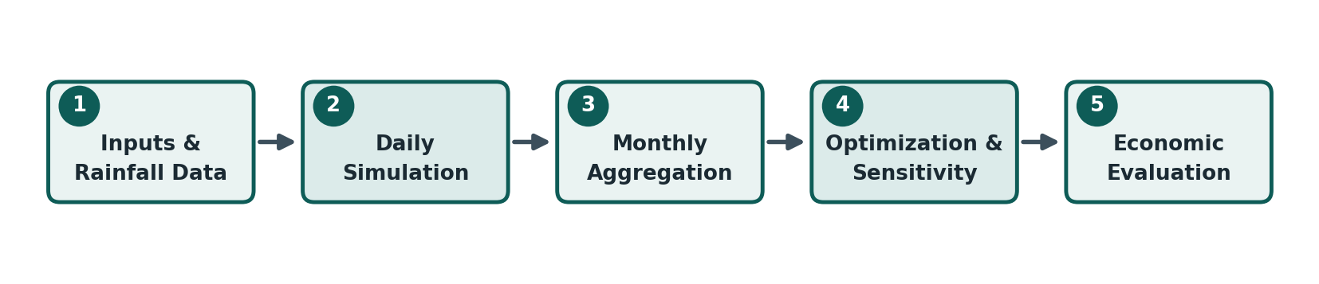
Figure 1: Five-stage analysis workflow, input through economic evaluation.

Two Resolutions of the Same Balance
There are actually two versions of the water balance in this workbook, and it's worth explaining why. The Daily Simulation sheet is the authoritative one. It steps through all 365 days individually and is what every dashboard figure, chart, and monthly total is built from. The Tank Optimization and Sensitivity sheets instead run a lighter monthly version, twelve steps instead of 365, so a full parameter sweep recalculates instantly rather than requiring Solver to churn through 365 rows for every scenario tested. Section 5 checks the monthly approximation against the daily model's annual totals, and the two track closely, which makes sense given that the monthly rainfall figures are themselves just the daily series summed up.

Rainfall Input
Monthly rainfall normals for five Pakistani stations sit in a lookup table, and whichever station is active gets its monthly total spread across a fixed number of rain-days, evenly spaced through the month, each day taking an equal share. Real storms don't behave that evenly (Karachi's monsoon typically shows up as a handful of intense days rather than a steady drizzle), but this keeps the monthly and annual totals accurate while giving a defensible day-to-day shape for a preliminary design. Anyone with an actual daily rainfall record for their station can drop it straight into the Daily Simulation sheet in place of this approximation.
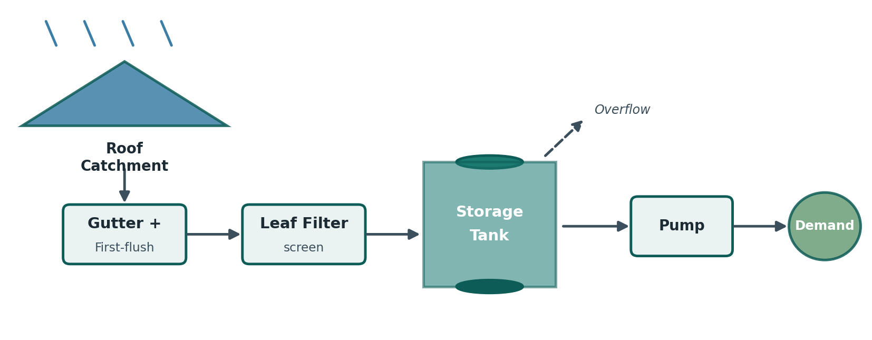
Figure 2: System layout, from roof catchment through to demand.

Workbook Structure
The ten worksheets behind this report are summarized below.
Sheet | What's on it
Dashboard | KPI cards and monthly charts, the one-page view for a reviewer.
Inputs | Every editable parameter, roof, tank, demand, location, cost, bound to named ranges.
Rainfall Data | Monthly normals for five stations plus the derived 365-day daily series.
Daily Simulation | The authoritative day-by-day mass balance across the full year.
Monthly Summary | Daily results rolled up by calendar month, including reliability.
Engineering Calcs | Every governing equation and stated assumption, in one place.
Tank Optimization | Solver setup plus an independent capacity sweep and sizing recommendation.
Sensitivity | One-at-a-time parameter tests and the resulting tornado chart.
Economics | Capital cost, savings, payback, 20-year cash flow, NPV, and IRR.
Charts | The full chart set referenced throughout this report.

3. Design Basis: Equations and Assumptions
Every number this model produces traces back to eleven equations, reproduced below exactly as they appear on the Engineering Calcs worksheet. None of it is particularly advanced, it's mostly careful bookkeeping of volumes in and out of a tank, but getting that bookkeeping right is what makes the simulation trustworthy.
Eq. 1 Collection Volume  V = (P - Dff) x A x 1,000  1 mm of rain over 1 m2 of roof is exactly 1 litre, so mm x m2 gives litres directly, no extra conversion needed. | Eq. 2 Runoff Coefficient  Vrunoff = C x P x A  C accounts for surface wetting and minor ponding losses. Metal roofs run 0.80-0.90, green roofs closer to 0.30-0.50.
Eq. 3 Collection Efficiency  eta = C x eta_filter x eta_convey  Three independent multiplicative losses: runoff, filtration, and conveyance through gutters and pipe. | Eq. 4 Tank Mass Balance  S(t) = MIN[S(t-1)+V-Qs-Qo, Scap]  Conservation of mass for the tank as a control volume. Everything in either leaves or accumulates.
Eq. 5 Water Supplied  Qs(t) = MIN[Qd(t), S(t-1)+V-Sdead]  The tank can only give what's both demanded and physically available above the dead-storage line. | Eq. 6 Overflow  Qo(t) = MAX[S(t-1)+V-Qs-Scap, 0]  Zero unless incoming water would push storage past the tank's capacity.
Eq. 7 Shortage  Qsh(t) = Qd(t) - Qs(t)  Always zero or positive, since supply can never exceed demand by construction. | Eq. 8 Reliability  R = sum(Qs) / sum(Qd)  The share of annual demand actually met, in volume terms, over the whole simulation period.
Eq. 9 Tank Utilization  U = Savg / Scap  Time-averaged storage as a fraction of capacity. Low U all year points to an oversized tank. | Eq. 10 Annual Savings  Savings = sum(Qs) x Tariff  Value of supplied water at the avoided cost of the municipal or tanker water it replaces.
Eq. 11 Simple Payback
Payback = Capital / Net Savings
A first-pass screening number, backed up by the discounted NPV and IRR in Section 7.

Assumptions
A model this size can't avoid simplifying a few things. Below is what's been assumed, and why each one is a fair call for a preliminary design tool rather than a construction-ready specification.
Assumption | Why it holds up
Rainfall is uniform within each rain-day. | Sub-daily records are rarely available this early in design, and a single daily depth doesn't change annual totals.
Monthly rainfall is spread evenly across a fixed number of rain-days. | Approximates real storm clustering without needing a historical daily record. Swappable for observed data later.
Demand stays constant day to day. | Non-potable use (flushing, laundry, cleaning) is far steadier than potable demand, so a flat daily draw is reasonable.
No evaporation losses. | Tanks are assumed closed and covered, standard for this application, so evaporation is negligible against the flows involved.
No leakage from tank or piping. | A properly installed, inspected system shouldn't leak meaningfully; the maintenance budget covers minor repairs.
First-flush diversion removes a fixed depth per rain-day, if enabled. | Simpler than a volume-based diverter, standard practice for early-stage sizing, and the depth is adjustable.
Pump efficiency affects only energy cost, not the water balance. | The balance itself is volume-based; pumping is a downstream energy cost rather than a source of water loss.
Runoff coefficient is held constant year-round. | C does vary slightly with rain intensity and roof wetness in reality, but a constant value is standard at this scale.

4. Results
The numbers below are for the base case: Karachi rainfall, a 220 m2 corrugated metal roof (runoff coefficient 0.85), 95% filter efficiency and 97% conveyance efficiency (78.3% overall collection efficiency), a six-person household drawing 45 L per person daily, and a 5,000 L tank.
Metric | Value
Total annual rainfall (Karachi) | 155 mm
Total water collected | 22,746 L
Total annual demand | 98,550 L
Water supplied | 23,546 L
Overflow | 0 L
Shortage | 75,004 L
Average tank storage | 674 L
Tank utilization | 13.5%
Annual reliability | 23.9%
The headline number is the zero in the overflow row. At this tank size, the system uses every drop it collects and never once spills water it can't store. That's a direct result of Karachi's rainfall being small relative to demand: total annual collection sits at 22,746 L against a demand of 98,550 L, so the tank rarely, if ever, comes close to filling up.
Reliability isn't steady through the year, it swings hard. July and August, the monsoon months, push monthly reliability above 90%, with August alone essentially meeting full demand. Every other month sits below 15%, and March through May contribute close to nothing, with the tank parked at its dead-storage floor for weeks at a stretch. Figure 3 shows this pattern clearly against the monthly rainfall that drives it.
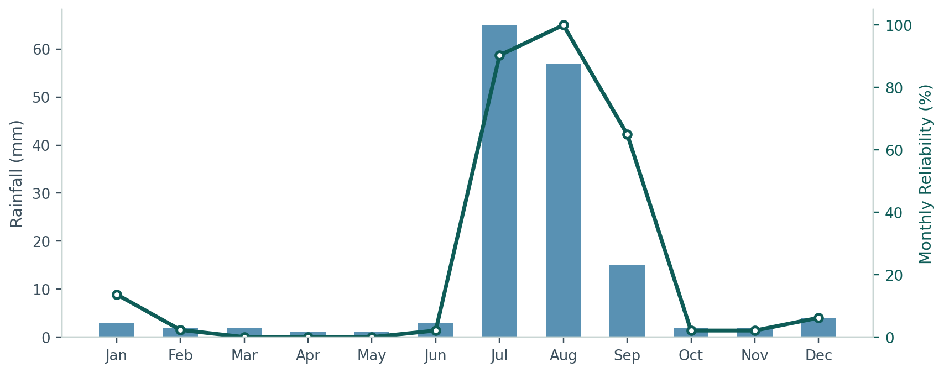
Figure 3: Monthly rainfall against monthly reliability. The system essentially runs on two months of the year.
 READING THIS RESULT
A tank that never overflows isn't automatically a good design decision, it can just mean the tank is bigger than the rainfall justifies. That's exactly what the optimization in Section 5 goes on to test.

5. Tank Size Optimization
Tank capacity was optimized in Excel Solver to maximize annual water supplied, and cross-checked against an independent formula-driven sweep across fifteen candidate sizes from 500 to 20,000 L, built on the monthly approximation so it recalculates instantly rather than needing Solver to iterate.
 HOW IT WAS SOLVED
Objective: maximize Monthly Summary!F18, annual water supplied.
Variable cell: Inputs!C19, tank capacity.
Constraints: capacity between 500 L and 20,000 L (practical residential range).
Method: GRG Nonlinear. The MIN/MAX terms in the daily balance make the response curve non-linear (it climbs, then flattens), which rules out the Simplex LP method.
Tank Size (L) | Est. Annual Supplied (L) | Est. Overflow (L) | Est. Reliability
500 | 22,327 | 3,783 | 22.7%
1,500 | 23,327 | 2,783 | 23.7%
3,000 | 24,827 | 1,283 | 25.2%
4,000 | 25,827 | 283 | 26.2%
5,000 (base case) | 26,110 | 0 | 26.5%
10,000 and above | 26,110 | 0 | 26.5%
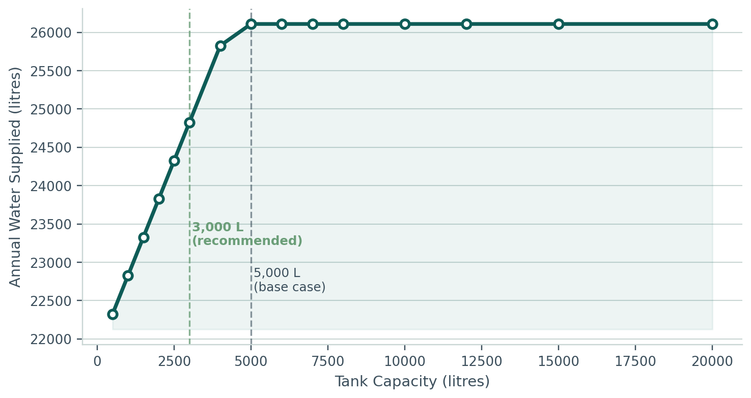
Figure 4: Annual water supplied against tank capacity. Returns flatten hard past 5,000 L.
The curve climbs steadily until about 5,000 L, right where overflow hits zero, and then goes completely flat. Past that point, every extra litre of capacity buys nothing, because there's no rainfall left to fill it. The workbook's recommendation cell flags 3,000 L as the smallest tank that still captures 98% of the maximum achievable supply, a noticeably cheaper option than the base-case 5,000 L input for almost the same performance.
 RECOMMENDATION
For this roof and demand profile in Karachi, a 5,000 L tank is measurably oversized. 3,000 L delivers 98% of the achievable annual supply at a lower capital cost.

6. Sensitivity Analysis
Each parameter below was shifted by 25% up and down from its base value, one at a time, with everything else held fixed, using the same monthly balance as the optimization sweep. The resulting change in annual reliability is what's plotted in Figure 5.
Parameter | Low (-25%) | High (+25%) | Swing (points)
Roof Area | 19.3% | 28.8% | 9.5
Rainfall | 19.3% | 28.8% | 9.5
Collection Efficiency | 19.3% | 28.8% | 9.5
Water Demand | 23.2% | 26.4% | 3.2
Tank Capacity | 26.0% | 26.5% | 0.5
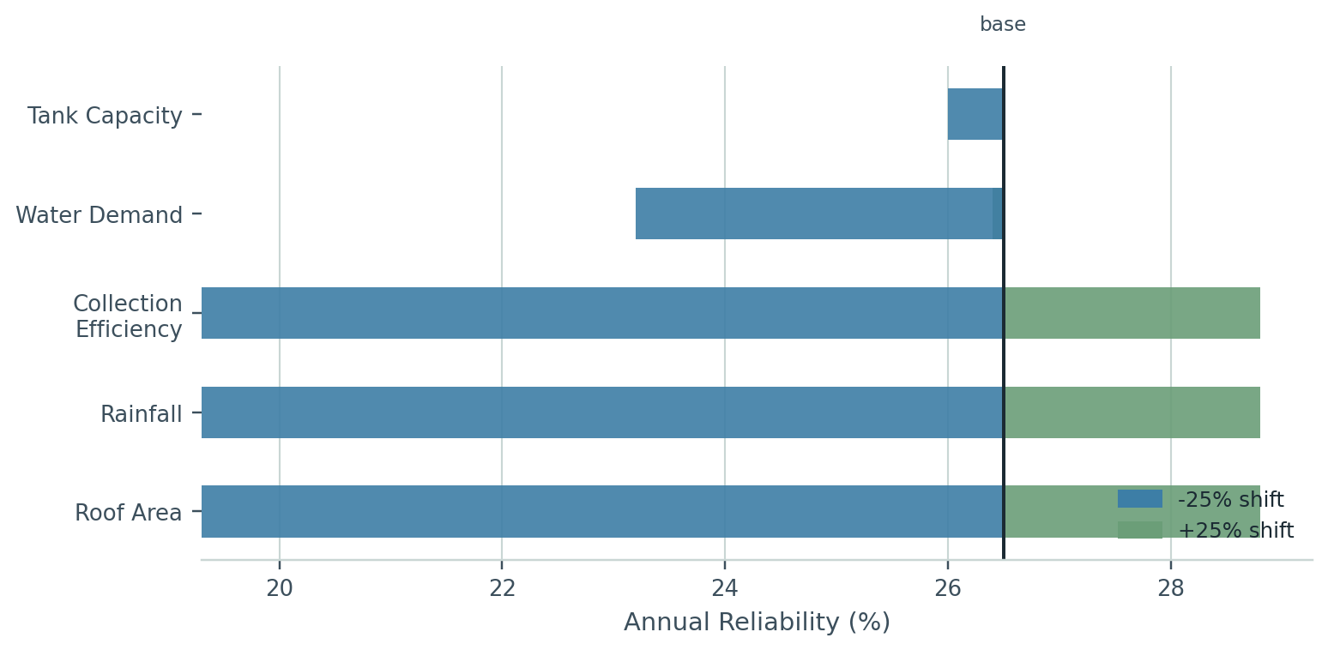
Figure 5: Reliability swing under a 25% change in each parameter.
Roof area, rainfall, and collection efficiency all produce the exact same swing because each one enters the collection equation as a plain multiplier. A 25% change in any of them changes total collection by 25%, and since the system is limited by what it collects rather than by where it stores that water, the change flows almost straight through to reliability. Demand moves the needle less, mostly because supply is already capped by rainfall in most months, so more demand mainly shows up as more shortage rather than less reliability. Tank capacity barely matters at all here, just 0.5 points, which is the clearest possible confirmation of the pattern from Section 5: in Karachi's climate, money is better spent improving what the roof collects than on a bigger tank.

7. Economic Analysis
All costs below are representative 2026 Pakistani market estimates, entered as editable inputs. Anyone using this for an actual purchase decision should swap them for real quotes first.
Item | Value
Tank capital cost | PKR 85,000
Installation (gutters, downpipes, filter, plumbing, labour) | PKR 45,000
Total capital cost (Year 0) | PKR 130,000
Annual maintenance | PKR 6,000 / yr
Annual pump energy (0.37 kW, 0.5 hr/day) | PKR 3,798 / yr
Total annual operating cost | PKR 9,798 / yr
Against a water tariff of PKR 1.20 per litre, the system saves about PKR 28,256 a year in gross water bill offsets, or PKR 18,457 net of operating costs. That puts simple payback at 7.0 years.
 ECONOMICS AT A GLANCE
Simple payback: 7.0 years
Net Present Value at 12% discount, 20-year horizon: approximately PKR 7,866
Internal Rate of Return: approximately 13.0%
Discounting the 20-year stream of net savings against the PKR 130,000 upfront cost gives an IRR just above the 12% discount rate, so the project clears the hurdle, but only by a narrow margin. That's consistent with everything else in this report: the savings side of the equation scales with how much rainfall there is to collect, and Karachi simply doesn't offer much of it. Run the same system through the Islamabad or Lahore rainfall station and both payback and IRR improve, because there's more collectible water behind the same fixed capital cost.

8. Limitations and Where to Take This Next
No model this size gets everything right, and it's worth being upfront about where the simplifications live and what would tighten them up.
Limitation | Possible improvement
Rainfall is a smoothed monthly average, not an observed daily record. | Swap in real PMD daily data where available, and test multiple years to see actual variability, not just a long-run average.
Optimization and sensitivity run on a monthly approximation for speed. | Re-run Solver directly against the full daily model if computation time allows, as a final check.
No evaporation, leakage, or partial first-flush losses beyond the fixed diversion. | Add explicit loss terms if more precision is needed for a construction-ready design.
Demand is held constant through the year. | Model seasonal demand, more irrigation in dry months for example, for a tighter worst-case estimate.
Economic inputs are estimates, with no tariff escalation or subsidy modeling. | Update with real vendor quotes and check for local subsidy programs before any purchase.
Of the improvements above, greywater integration is probably the single highest-value addition, and it isn't in the table because it's less a fix to an existing limitation than a genuinely new idea. Since this report's main finding is that the system is limited by what it collects rather than by storage, adding a second, steadier supply stream from laundry and bathroom greywater would likely do more for dry-season reliability than any amount of extra tank capacity. Beyond that, a low-cost tank-level sensor (an ultrasonic or float sensor on a small microcontroller) would let the simulated storage curve be checked against what the tank is actually doing, and layering in climate projections for the monsoon would help stress-test the design against a wetter or drier future than the historical average assumes.

9. Conclusion
This project built a fully formula-driven, 365-day rainwater harvesting simulation for Karachi, covering rainfall handling, daily mass balance, tank optimization, sensitivity testing, and a full economic evaluation, all inside one auditable spreadsheet. The main finding, that the system is limited by rainfall rather than by storage, showed up independently in both the optimization sweep and the sensitivity analysis, which is exactly the kind of cross-checked result a preliminary design should aim for rather than accept from a single calculation. The base-case 5,000 L tank turned out to be oversized for this roof and demand, with 3,000 L capturing 98% of the achievable supply at a lower cost, and the system as a whole is economically viable but not by a wide margin, at roughly seven years' payback and an IRR just above the discount rate. Because the workbook lets the rainfall station change with a single dropdown, the same analysis can be re-run instantly for Lahore, Islamabad, Peshawar, or Quetta, where a wetter climate would be expected to push the system from rainfall-limited toward storage-limited and shift both the optimal tank size and the economics meaningfully, a claim the workbook is built to test directly rather than just assert.

References
Weather and Climate. "Average Monthly Precipitation, Rainfall, Karachi, Pakistan." weather-and-climate.com, accessed July 2026.
Climates to Travel. "Karachi Climate: Weather by Month." climatestotravel.com, accessed July 2026.
Weather Atlas. "Climate and Monthly Weather Forecast, Karachi, Pakistan." weather-atlas.com, accessed July 2026.
Climate-Data.org. "Karachi Climate (Sindh, Pakistan)." en.climate-data.org, accessed July 2026.
British Standards Institution. BS 8515:2009+A1:2013, Rainwater Harvesting Systems Code of Practice.
United States Environmental Protection Agency. Rainwater Harvesting: Guidance for Homeowners.

Appendix: Base-Case Inputs
Every input below is bound to a named range on the Inputs or Rainfall Data sheet (RoofArea_m2, TankCapacity_L, DailyDemand_L, WaterTariff_PKR_L, and so on), so changing one cell propagates automatically through the entire model without touching a single formula elsewhere.
Parameter | Value
Rainfall station | Karachi
Roof area | 220 m2
Roof material / runoff coefficient | Corrugated metal / 0.85
Filter / conveyance efficiency | 95% / 97%
Overall collection efficiency | 78.3%
Tank capacity / dead storage | 5,000 L / 200 L
Occupants / per-capita demand | 6 people / 45 L per day
Total daily demand | 270 L per day
Water tariff | PKR 1.20 per litre
Discount rate / project life | 12% / 20 years

