DUBAI REAL ESTATE
Market Analyzer
Where to invest, when to buy, and what the risks are. An analysis of 1,800 property sales from January 2023 to September 2026.
Prepared by: Umair Asif
Date: 19 October 2026
Audience: Investment and development managers
Tools: Python (pandas, SciPy, statsmodels), Power BI / HTML dashboard
Mock-data notice: every figure in this report comes from a synthetic dataset created for learning. It does not describe the real Dubai property market. Do not use it for real investment decisions.

1. Executive summary
Question. Which Dubai areas give the best rental return? Are prices still rising? Is off-plan really cheaper than ready?
What we found.
- Yield is highest in the cheapest areas. Ready units in Dubai South earn 7.52% gross and JVC earns 7.11%. Palm Jumeirah earns only 4.19%. The market average is 5.57%.
- Prices are still rising. Comparing Jan–Sep with Jan–Sep, price per sq ft rose 14.0% in 2024, 16.0% in 2025 and 8.5% so far in 2026. The 2025 increase is statistically significant (p < 0.001).
- Off-plan is not a discount. Overall, off-plan looks 6.9% cheaper per sq ft. Inside every one of the nine areas, however, it costs 4.5–13.7% more than ready stock. The overall gap only appears because off-plan is concentrated in low-cost areas.
Recommendation. For an AED 1.5M budget aimed at rental income, buy a ready apartment in JVC. The average price is AED 0.97M, the yield is 7.29%, and the rent is about AED 70,756 a year. This rests on 45 comparable sales, the largest sample of any area in this price range.
Key numbers: 1,800 sales worth AED 6.99B; median price AED 2.62M; average 2,341 AED/sq ft; average time to sell 30.9 days.

2. Business problem and objectives
A Dubai property developer or investment firm must decide where to put capital, when to buy, and whether to buy off-plan or ready. This report answers five questions with transaction data:
- Which areas offer the best gross rental yield, and what does that yield cost in price per sq ft?
- How have prices per sq ft moved since 2023, and is the rise statistically real?
- Are there seasonal patterns, such as Ramadan or summer, that make some months better for buying or selling?
- Is off-plan cheaper than ready once location is held constant?
- Where should an investor with AED 1.5M buy for rental income?
The findings support three decisions: area allocation, the timing of purchases and launches, and the off-plan vs ready mix.

3. Data description
Source: dubai_real_estate_mock.csv, a synthetic dataset. Size: 1,800 rows × 21 columns, one row per sale. Period: 2023-01-02 to 2026-09-30, so 2026 is a partial year (January to September). Currency: AED.
Column | Meaning
transaction_id, date, year, quarter, month | Sale ID and when it happened
ramadan_period | 1 if the sale happened during Ramadan
area | One of 9 communities (e.g. Business Bay, JVC, Palm Jumeirah)
property_type, bedrooms, size_sqft | Apartment / Townhouse / Villa; 0 bedrooms = studio; size 302–10,272 sq ft
status | Ready (1093) or Off-Plan (707)
building_age_years, view | Age of the building (0 = off-plan) and main view
developer, payment_plan | Developer ("Resale" for ready units) and off-plan payment split (e.g. 70/30)
buyer_type | Investor or End-user
sale_price_aed, price_per_sqft_aed | Price paid (AED 0.32M–45.2M) and price ÷ size
days_on_market | Days from listing to sale (2–152)
annual_rent_aed, gross_yield_pct | Rent and rent ÷ price × 100. Ready units only

4. Data cleaning
Each decision below is reflected in data/dubai_real_estate_clean.csv and in the Power Query steps (dashboard/powerbi_kit/power_query.m).
Issue | Before | After | Decision and reason
Rows | 1,800 | 1,800 | No rows removed. There are no duplicate IDs and no duplicate rows.
date stored as text | text | Date | Converted, so time trends and the Date table work.
view blank | 36 | 0 | Replaced with "Unknown". The sale itself is valid.
building_age_years blank | 36 | 36 | Left blank. The value is missing, not zero, and the column is not used in any result.
annual_rent / gross_yield blank | 707 | 707 | Left blank. The 707 blanks are exactly the 707 off-plan units, which have no tenant yet. Filling them would invent yields.
payment_plan "N/A" | 1,093 | relabelled | "N/A" appears only on ready units. It was relabelled "Not applicable (Ready)" so it is not read as missing.
Outliers in price/sq ft (IQR) | 32 | 32 | Kept. All 32 sales above 4,617 AED/sq ft are in Palm Jumeirah. They are real luxury sales, not errors.
Helper columns | – | 4 added | Price Band, Size Band, Ramadan Label (Yes/No) and Year-Quarter, for slicing.

Consistency checks passed: price per sq ft equals price ÷ size within 5 AED, and gross yield equals rent ÷ price within 0.1 percentage points on every ready unit.
Why we avoided imputation. Filling off-plan yields with area medians, or dropping rows with a missing view, would change the averages. It would also mix ready and off-plan economics. Every yield figure in this report uses the 1,093 ready units only.

5. Exploratory analysis

5.1 Market overview
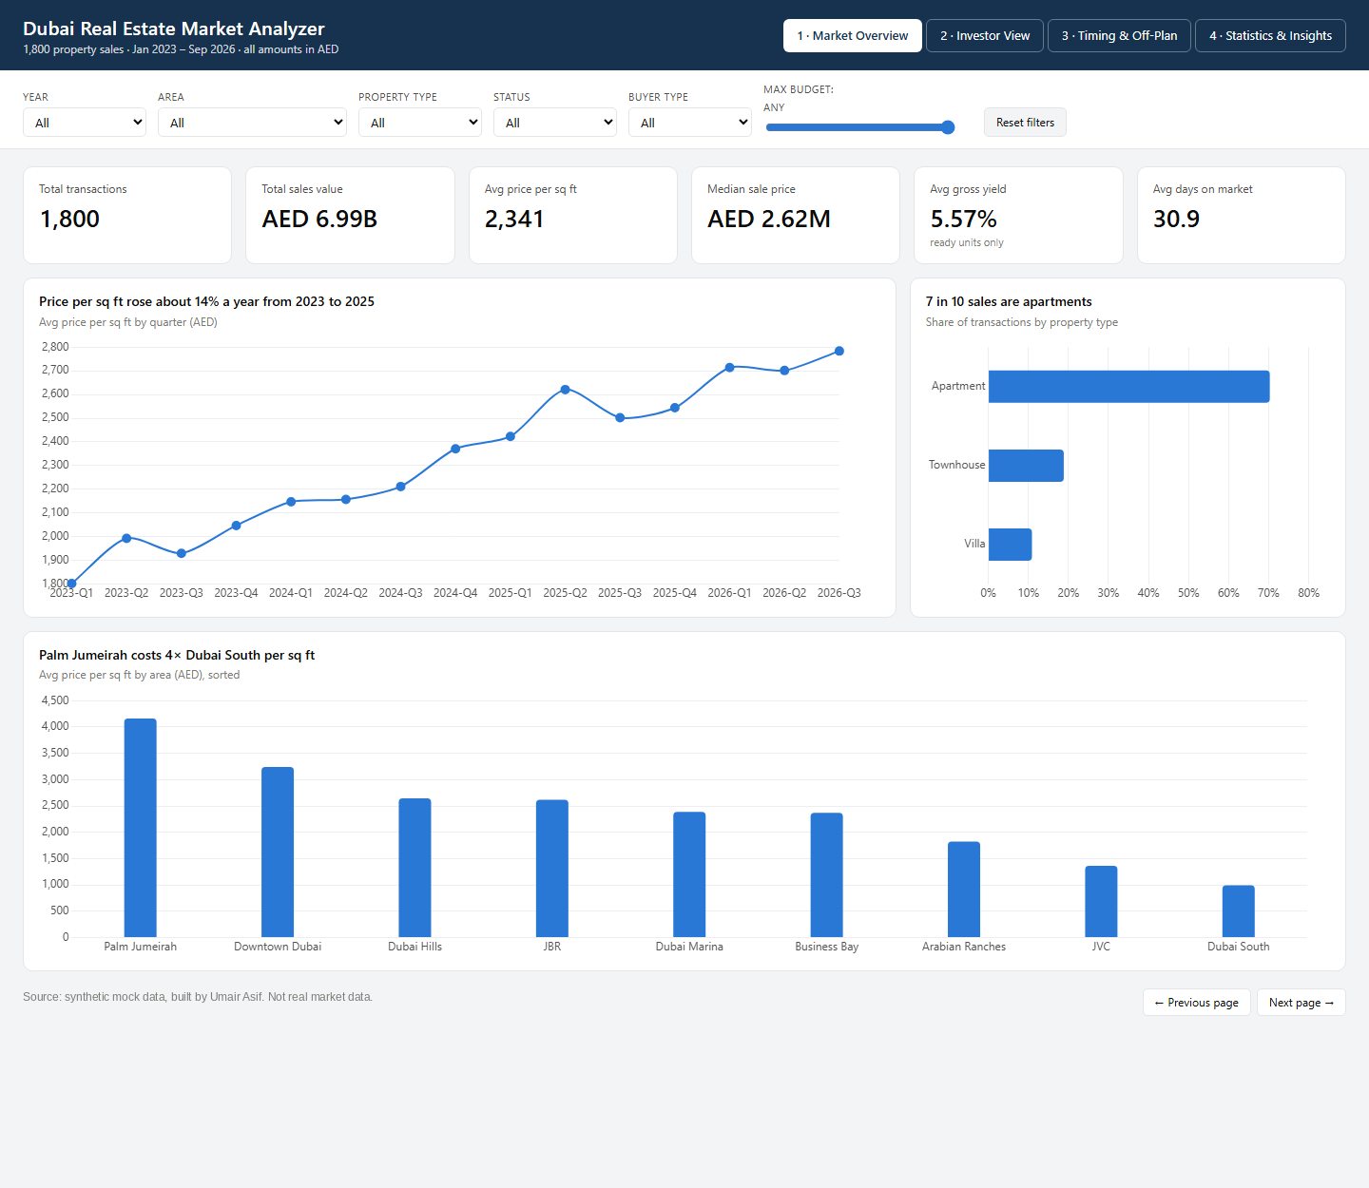
Figure 1. Dashboard page 1: Market overview (no filters)
Takeaway: Price per sq ft climbed from 1,945 AED in 2023 to 2,523 AED in 2025, a 13.9% compound annual rate. Palm Jumeirah (4,162) costs about four times as much per sq ft as Dubai South (995).
Prices are skewed. The mean sale price (AED 3.88M) is 48% above the median (AED 2.62M), because a few large villas pull the mean up. This report therefore uses the median for "typical price" and price per sq ft for comparisons between areas.
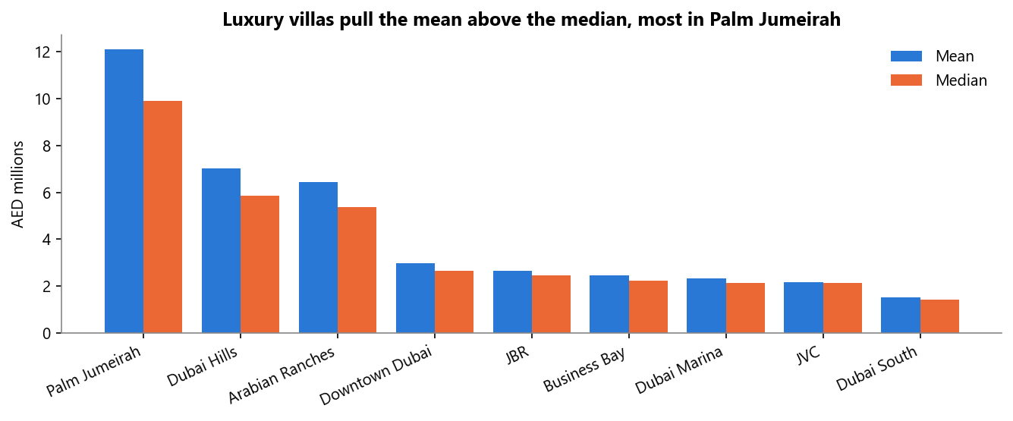
Figure 2. Mean vs median sale price by area
Takeaway: The gap between mean and median is largest in Palm Jumeirah, Dubai Hills and Arabian Ranches, where villas dominate. In apartment areas such as JVC and Marina, mean and median are almost equal.

5.2 Timing and seasonality
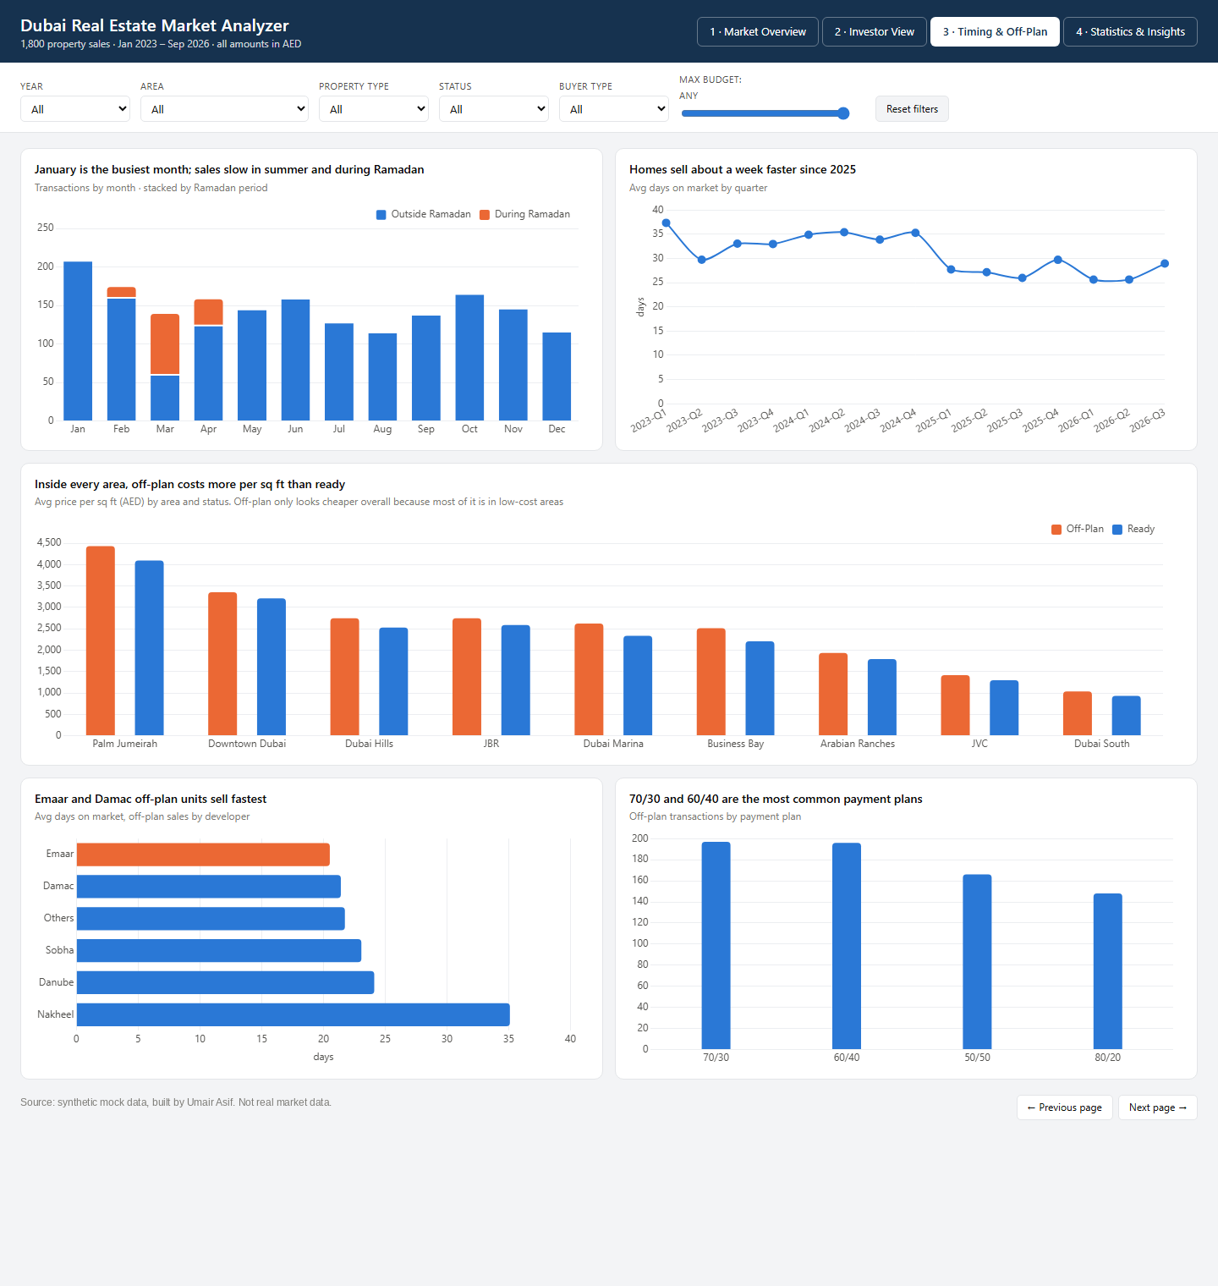
Figure 3. Dashboard page 3: Timing and off-plan
Takeaway: January is the busiest month (209 sales) and August the quietest (116). Q1 has 522 sales vs 384 in Q3. Ramadan runs at 1.07 sales a day vs 1.34 outside it, about 20% slower.
The market got faster. Average days on market fell from 34.9 in 2024 to 27.8 in 2025 and 26.5 in 2026. Among off-plan sellers, Emaar (20.5 days) and Damac (21.4) sell fastest, and Nakheel is slowest (35.1 days, only 11 sales).

5.3 Trap: off-plan vs ready, and the area mix
Area | Off-plan AED/sq ft | Ready AED/sq ft | Off-plan premium | Off-plan share of sales
Arabian Ranches | 1,934 | 1,793 | +7.9% | 20.9%
Business Bay | 2,511 | 2,208 | +13.7% | 53.9%
Downtown Dubai | 3,353 | 3,209 | +4.5% | 21.3%
Dubai Hills Estate | 2,744 | 2,528 | +8.5% | 54.1%
Dubai Marina | 2,620 | 2,333 | +12.3% | 19.6%
Dubai South | 1,037 | 933 | +11.1% | 60.2%
Jumeirah Beach Residence | 2,746 | 2,587 | +6.1% | 18.5%
Jumeirah Village Circle (JVC) | 1,416 | 1,296 | +9.3% | 55.8%
Palm Jumeirah | 4,432 | 4,097 | +8.2% | 19.5%

Takeaway: Off-plan looks 6.9% cheaper overall (2,240 vs 2,406 AED/sq ft). In every area, however, it is more expensive. More than half of all sales in Dubai South, JVC, Business Bay and Dubai Hills are off-plan, and those low-priced areas drag the overall off-plan average down. Always compare within an area.

6. Investor analysis
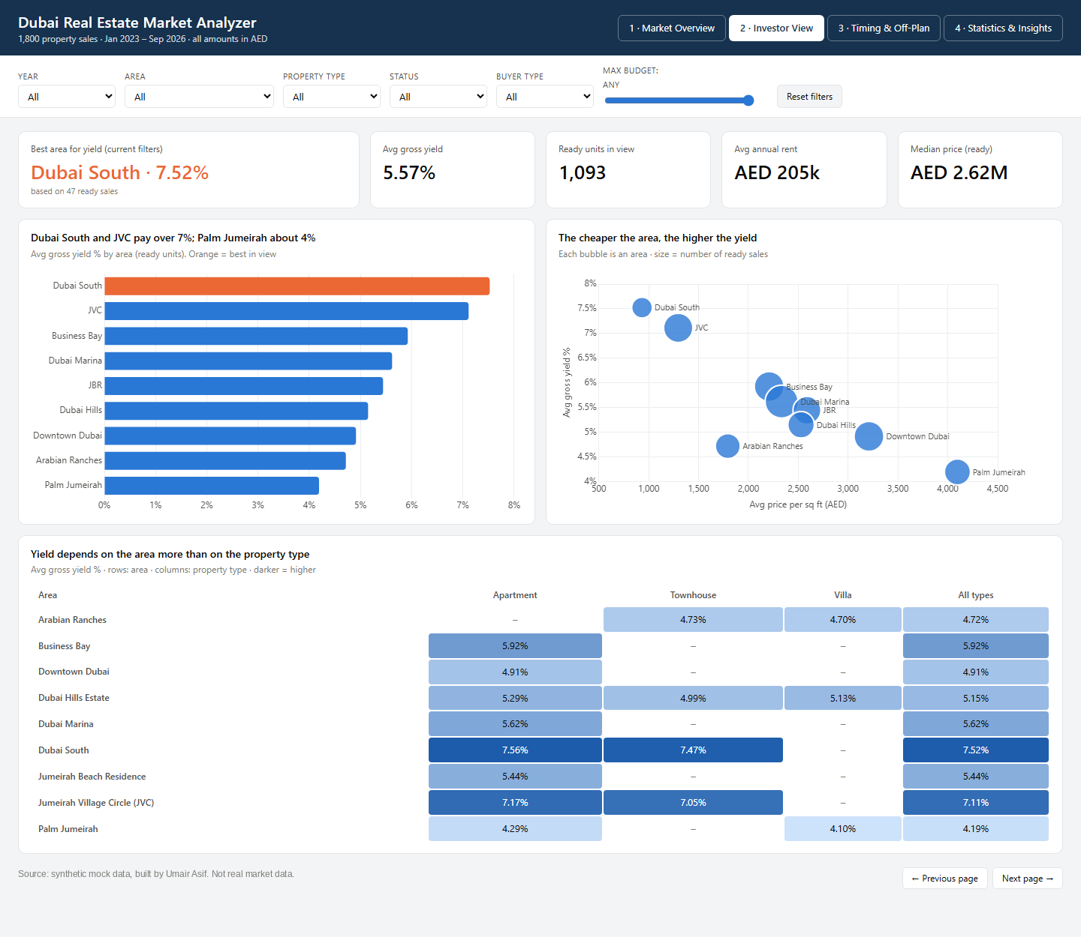
Figure 4. Dashboard page 2: Investor view (ready units)
Takeaway: There is a clear price–yield trade-off. The three cheapest areas per sq ft (Dubai South, JVC, Business Bay) are also the three highest-yielding. The three most expensive (Palm Jumeirah, Downtown, Dubai Hills) are among the lowest. Within each area, property type barely changes the yield.
Area | Avg gross yield (ready)
Dubai South | 7.52%
Jumeirah Village Circle (JVC) | 7.11%
Business Bay | 5.92%
Dubai Marina | 5.62%
Jumeirah Beach Residence | 5.44%
Dubai Hills Estate | 5.15%
Downtown Dubai | 4.91%
Arabian Ranches | 4.72%
Palm Jumeirah | 4.19%

6.1 Recommendation for an AED 1.5M budget
Filter: ready units priced at AED 1.5M or less (only ready units have a rent). Areas with fewer than 10 comparable sales are excluded.
Area | Comparable sales | Avg price | Gross yield | Avg annual rent | Days on market
Dubai South | 28 | AED 0.90M | 7.62% | AED 67,893 | 45.1
Jumeirah Village Circle (JVC) | 45 | AED 0.97M | 7.29% | AED 70,756 | 38.8
Business Bay | 32 | AED 1.15M | 6.20% | AED 70,844 | 31.4
Dubai Marina | 45 | AED 1.10M | 5.91% | AED 64,400 | 42.0
Jumeirah Beach Residence | 17 | AED 1.20M | 5.75% | AED 68,941 | 37.5
Downtown Dubai | 23 | AED 1.28M | 5.34% | AED 67,913 | 44.2

Takeaway: Buy a ready apartment in JVC. It yields 7.29%, about AED 70,756 a year on an average AED 0.97M unit. That leaves around AED 528k of the budget for fees and furnishing. Dubai South yields slightly more (7.62%), but it has fewer comparable sales (28) and the slowest resale (45.1 days). Business Bay (6.20%, 31.4 days) is the central-location option.
A prime-area unit at about 4.5% yield would earn roughly AED 67,500 a year on AED 1.5M. That is less than JVC earns on a unit costing a third less.

7. Statistical analysis

7.1 Sampling distribution and the Central Limit Theorem
We treat the 1,800 sales as the population (mean 2340.8 AED/sq ft, SD 884.3, skew 0.55). From it we drew 1,000 random samples of n = 30 and 1,000 of n = 100, and recorded each sample's mean.
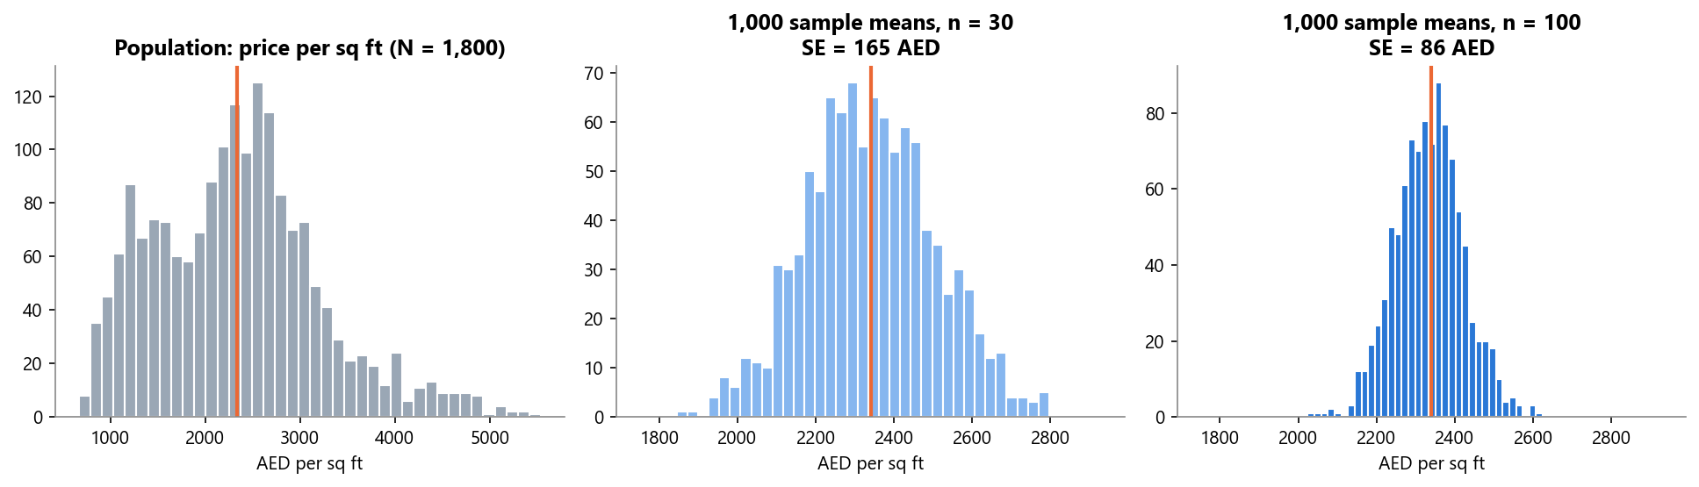
Figure 5. Population (left) and the sampling distribution of the mean for n = 30 and n = 100
 | Mean of sample means | Standard error (observed) | SE theory σ/√n | Skew
n = 30 | 2340.9 | 164.7 | 161.4 | 0.08
n = 100 | 2335.4 | 86.3 | 88.4 | 0.03

Takeaway: The population is skewed (0.55), yet the sample means form a symmetric bell centred on the true mean, as the Central Limit Theorem predicts. Making the sample 3.3× larger roughly halves the standard error (165 → 86), because SE shrinks with √n.

7.2 Confidence intervals (95%)
Area | n | Mean AED/sq ft | 95% CI
Dubai Marina | 245 | 2389.1 | 2340.1 – 2438.1
Business Bay | 319 | 2371.2 | 2326.8 – 2415.6
JVC | 317 | 1363.0 | 1341.2 – 1384.8
Downtown Dubai | 188 | 3239.7 | 3164.1 – 3315.3

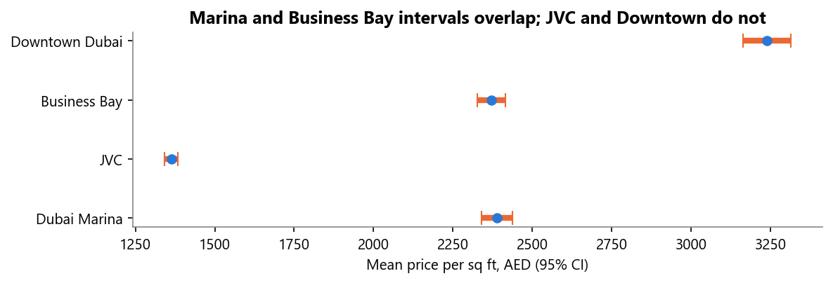
Figure 6. 95% confidence intervals for mean price per sq ft
Takeaway: If we repeated the sampling many times, 95% of intervals built this way would contain the true mean. For Marina, the true mean price is plausibly between 2,340 and 2,438 AED/sq ft. The Marina and Business Bay intervals overlap heavily, which points to no real difference. JVC and Downtown are far apart from each other and from both.

7.3 Hypothesis tests (α = 0.05)
Test | H0 | H1 | Method | Result | p-value | Conclusion
Marina vs Business Bay | Mean price/sq ft is equal | Means differ | Welch two-sample t-test | 2389 vs 2371 AED/sqft, t = 0.535 | 0.593 | Fail to reject H0. No evidence of a price difference.
Ready apartment yield vs overall ready average | Mean = 5.57% | Mean ≠ 5.57% | One-sample t-test | 5.63% vs 5.57% (n=799), t = 1.802 | 0.072 | Fail to reject H0. Apartments yield about the same as the average.
Price across all 9 areas | All area means are equal | At least one differs | One-way ANOVA | F = 952.2 (Kruskal–Wallis agrees) | < 0.001 | Reject H0. Location drives price.
2025 vs 2024, Jan–Sep only | Means are equal | 2025 is higher | Welch t-test, one-sided | 2514 vs 2167 AED/sqft, t = 5.365 | < 0.001 | Reject H0. Prices rose in 2025.
Off-plan vs ready in Business Bay | Means are equal | Means differ | Welch two-sample t-test | 2511 vs 2208 AED/sqft, t = 7.183 | < 0.001 | Reject H0. Off-plan carries a premium.

Note on test 2. Gross yield exists only for ready units. "Ready yield vs the overall average" would therefore compare the average with itself. We tested ready apartments (n = 799) against the overall ready average of 5.57%. That average was calculated first, as the guide asks.
Type I and Type II errors. In the 2025 vs 2024 test, a Type I error would mean concluding that prices rose when they did not. With α = 0.05 that risk is capped at 5%, and the actual p-value is far below it. In the Marina vs Business Bay test, the risk is a Type II error: missing a real difference. The observed effect is tiny (Cohen's d = 0.045). With these sample sizes the test has 84% power to detect a 100 AED/sq ft gap. A difference that large would very likely have been found, so the two areas really do price alike.

7.4 Regression
Model | R² | Key coefficients
1. price ~ size | 0.752 | +AED 2,735 per extra sq ft
2. price ~ size + area + bedrooms + status | 0.91 | Palm Jumeirah +AED 6.67M vs Dubai South; Downtown +AED 3.11M; size +AED 3,075/sq ft; off-plan +AED 333,399; bedrooms -401,636
3. log(price) ~ log(size) + area + bedrooms + status | 0.96 | Size elasticity 0.883; off-plan +10.0%; Palm +341% vs Dubai South

Takeaway: Size alone explains 75% of the variation in price. Adding area, bedrooms and status raises this to 91%. The two biggest coefficients are both location. An otherwise identical home costs about AED 6.67M more in Palm Jumeirah and AED 3.11M more in Downtown than in Dubai South. The negative bedrooms coefficient means that, at the same size, more bedrooms means smaller rooms and a lower price. The log model confirms the off-plan premium of about 10% once area is controlled.
Caveat: the residuals of model 2 grow with price, because luxury sales vary more. The log model (R² = 0.96) handles this better, and it is the one we would use for valuation.

8. Recommendations
- For rental income, allocate to JVC and Dubai South ready stock. They yield 7.11% and 7.52%, against 5.57% for the market. For AED 1.5M, a ready JVC apartment gives about 7.29% (AED 71k a year).
- Treat Palm Jumeirah and Downtown as capital-growth plays, not income plays. Yields are 4.19% and 4.91%, and prices per sq ft are the highest in the city.
- Do not buy off-plan for a "discount". Within the same area, off-plan costs 5–14% more per sq ft. Buy off-plan only for the payment plan (70/30 and 60/40 are most common) or for expected growth before handover.
- Time purchases for Ramadan and late summer, and time sales or launches for Q1. Activity is about 20% lower per day during Ramadan, and August has the fewest sales. That means less competition for buyers. January has the most sales, which suits sellers.
- Expect price growth to slow. Like-for-like growth was +16.0% in 2025 and +8.5% in 2026 so far. Use growth assumptions below 10% in models for 2027.

9. Limitations and next steps
- Synthetic data. The data is mock, so the patterns are built in. The method transfers to real data; the numbers do not.
- 2026 is partial (January to September). All year-on-year comparisons use January to September only.
- Gross yield only. There are no service charges, vacancy or fees, so real net yields would be 1–2 points lower.
- No macro factors. The analysis has no mortgage rates, inflation, population or supply pipeline data.
- Off-plan has no rent, so its yield cannot be compared until handover.
With real data we would add: Dubai Land Department transactions, rent contracts (Ejari), service charges, the supply pipeline by area, and mortgage rates. We would then model net yield and forecast price growth by area.

Appendix

A. Dashboard: Statistics and Insights page
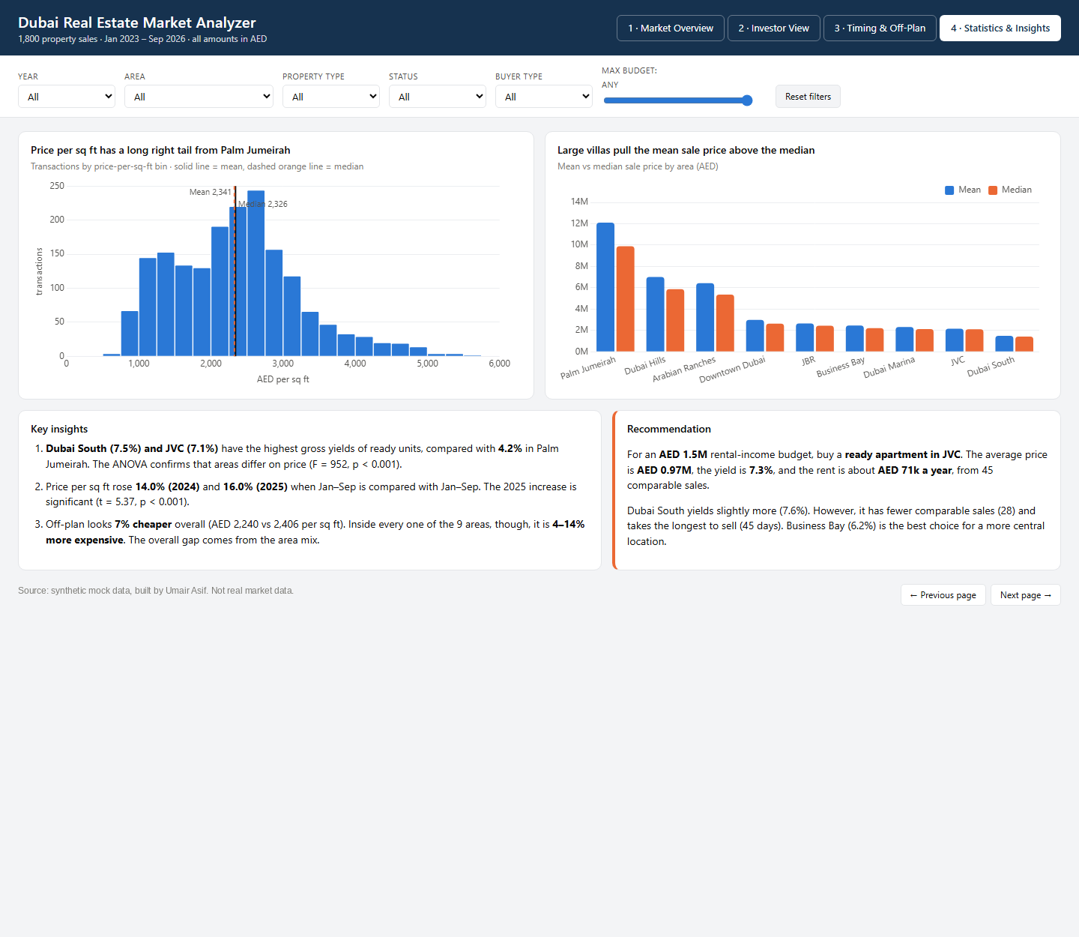
Figure 7. Dashboard page 4
Takeaway: This page summarises the skew in prices, the gap between mean and median, the three key insights and the recommendation.

B. Price-per-sq-ft distribution
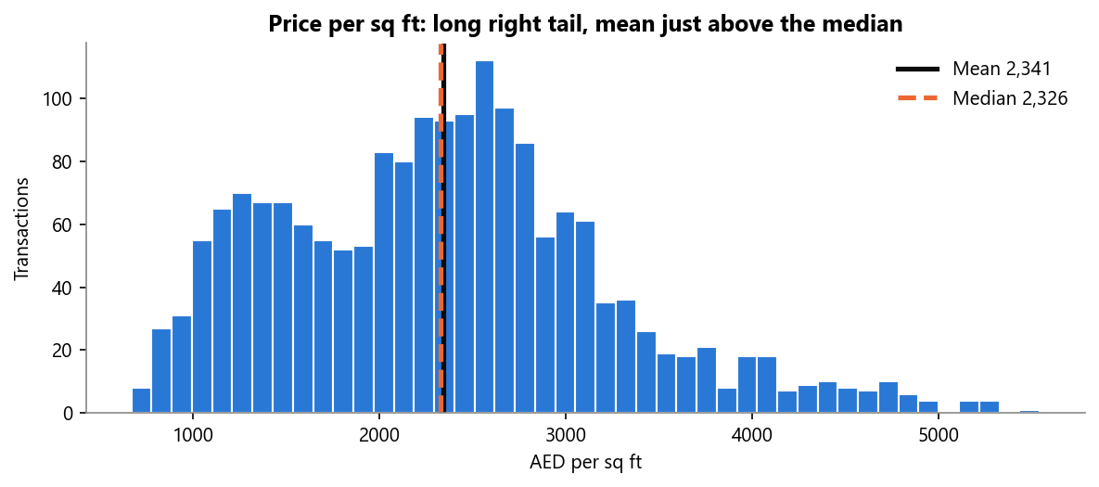
Figure 8. Distribution of price per sq ft
Takeaway: Most sales fall between 1,000 and 3,500 AED/sq ft. The right tail comes from Palm Jumeirah. The mean (2,341) sits just above the median (2,326).

C. Code snippets
# 95% confidence interval
m, se = x.mean(), stats.sem(x)
h = se * stats.t.ppf(0.975, len(x) - 1)
# Welch t-test, 2025 vs 2024 (Jan-Sep)
stats.ttest_ind(y25, y24, equal_var=False, alternative='greater')
# Regression
smf.ols("sale_price_aed ~ size_sqft + C(area) + bedrooms + C(status)", df).fit()

D. Project files
- data/: raw and cleaned CSV
- scripts/analysis.py: cleaning, statistics, figures and dashboard build. scripts/build_report.js builds this report
- dashboard/: interactive HTML dashboard, PNG screenshots, PDF, and powerbi_kit/ (Power Query, DAX, theme, build guide)
- GitHub repository: https://github.com/umairasifofficalll-code/Dubai-Real-Estate-Market-Analyzer

