Stock Market Dashboard Guide
What to add, how to build it in Power BI, and a design to copy
Project: Gulf Market Tracker (fictional DFM, ADX and Tadawul stocks, Jan 2023 to Oct 2026).
Files: stock_prices_mock.csv, stock_info_mock.csv, market_index_mock.csv (merged into one table first).
Tool: Power BI Desktop, with a little Python to prepare the metrics.

What you will build
- A 3-page Power BI dashboard: Market Overview, Risk and Return, and Stock Detail.
- Every page answers a clear question a Gulf investor or fund manager would ask.
- A consistent dark-header, light-body design with green for gains and red for losses.
The data is synthetic. The companies, prices and index are invented. Put a clear note in the footer of every page and in your README.

1. What to add to the dashboard
Start from the questions. If a visual does not help answer one, leave it out.
Page | Main question | Visuals to add
1. Market Overview | How did the market and each sector perform? | 5 KPI cards, indexed price lines, market index trend, total return by stock, sector performance
2. Risk and Return | Which stocks give the best return for the risk? | Risk vs return scatter, metrics table (return, volatility, Sharpe, beta, max drawdown, VaR), correlation matrix, drawdown chart
3. Stock Detail | How has one chosen stock behaved? | Company cards, price with 20 and 50-day averages, return distribution, volume chart, insights text box

Slicers (filters)
- Date range (all pages): use the date column from the stocks table, not a separate calendar.
- Sector and Exchange (pages 1 and 2), and Ticker (page 3).
- Set the slicer style to Dropdown so they stay small. Use Edit interactions so the slicers do not filter visuals that should always show everything.

KPI cards on Page 1
Card | What it shows
Market return % | Change in the market index over the selected dates
Best stock | Ticker with the highest total return
Worst stock | Ticker with the lowest total return
Avg volatility % | Average annualised volatility across the stocks
Total volume | Sum of shares traded

2. How to make it, step by step

Step 1: Prepare the data (Python)
First merge the three files into stocks_merged.csv (drop duplicates, join info on ticker and index on date). Then run this script. It adds moving averages and drawdown, and creates two small tables that Power BI cannot calculate easily: risk metrics and correlations.
import pandas as pd, numpy as np

df = pd.read_csv("stocks_merged.csv", parse_dates=["date"])
df = df.sort_values(["ticker", "date"])

# moving averages and drawdown
df["ma20"] = df.groupby("ticker").close.transform(lambda s: s.rolling(20).mean())
df["ma50"] = df.groupby("ticker").close.transform(lambda s: s.rolling(50).mean())
df["running_max"] = df.groupby("ticker").close.cummax()
df["drawdown_pct"] = (df.close / df.running_max - 1) * 100
df.to_csv("stocks_dashboard.csv", index=False)

# one row of risk metrics per stock
rows = []
for t, g in df.groupby("ticker"):
r = g.daily_return_pct / 100
m = g.index_return_pct / 100
ok = r.notna() & m.notna()
beta = np.cov(r[ok], m[ok])[0, 1] / np.var(m[ok], ddof=1)
rows.append({"ticker": t,
"annual_return_pct": r.mean() * 252 * 100,
"volatility_pct": r.std() * np.sqrt(252) * 100,
"beta": beta,
"max_drawdown_pct": g.drawdown_pct.min(),
"var95_1d_pct": np.percentile(r.dropna(), 5) * 100})
metrics = pd.DataFrame(rows)
metrics["sharpe"] = (metrics.annual_return_pct - 4) / metrics.volatility_pct
metrics.round(2).to_csv("stock_metrics.csv", index=False)

# correlation table in long format (for the matrix)
wide = df.pivot(index="date", columns="ticker", values="daily_return_pct")
corr = (wide.corr().round(2)
.rename_axis(index="ticker_a", columns="ticker_b")
.stack().reset_index(name="correlation"))
corr.to_csv("correlation_long.csv", index=False)

Note: the risk metrics are calculated for the whole period. They will not change when someone moves the date slicer. Say this in a small text note on Page 2, or label the table "Full period".

Step 2: Load and connect the tables in Power BI
- Home > Get data > Text/CSV. Load stocks_dashboard.csv (name it stocks), stock_metrics.csv (metrics) and correlation_long.csv (correlation).
- In Power Query, check types: date = Date, prices and returns = Decimal number, volume = Whole number.
- Model view: create a one-to-many relationship from metrics[ticker] to stocks[ticker]. Leave the correlation table unconnected.
- Rename the file and tables clearly, and hide columns you will not use (such as running_max).

Step 3: Create the DAX measures
Create a new table called _Measures (Enter data, empty) and keep all measures there. Table names below assume stocks and metrics.
Measure | DAX formula
Avg Daily Return % | AVERAGE(stocks[daily_return_pct])
Volatility % | STDEV.S(stocks[daily_return_pct]) * SQRT(252)
Total Volume | SUM(stocks[volume])
Avg Volatility % | AVERAGE(metrics[volatility_pct])
Total Return % | VAR FirstDate = CALCULATE(MIN(stocks[date]), ALLSELECTED(stocks[date])) VAR LastDate = CALCULATE(MAX(stocks[date]), ALLSELECTED(stocks[date])) VAR FirstClose = CALCULATE(MAX(stocks[close]), REMOVEFILTERS(stocks[date]), stocks[date] = FirstDate) VAR LastClose = CALCULATE(MAX(stocks[close]), REMOVEFILTERS(stocks[date]), stocks[date] = LastDate) RETURN DIVIDE(LastClose, FirstClose) - 1
Market Return % | Same as Total Return %, but use MAX(stocks[market_index]) instead of MAX(stocks[close]). The index is the same for every ticker on a date.
Indexed Price | VAR FirstDate = CALCULATE(MIN(stocks[date]), ALLSELECTED(stocks[date])) VAR FirstClose = CALCULATE(MAX(stocks[close]), REMOVEFILTERS(stocks[date]), stocks[date] = FirstDate) RETURN DIVIDE(MAX(stocks[close]), FirstClose) * 100
Best Stock | VAR T = ADDCOLUMNS(VALUES(stocks[ticker]), "@r", [Total Return %]) RETURN MAXX(TOPN(1, T, [@r], DESC), stocks[ticker])
Worst Stock | Same as Best Stock, but use ASC in TOPN.

Where to use them: Total Return % and Indexed Price only make sense in visuals split by ticker (a bar chart or a line with ticker as legend). In a card with many tickers they would mix stocks together. That is why the cards use Best Stock, Worst Stock and Market Return %.

Step 4: Build Page 1 (Market Overview)
- Set the page size to 16:9 (1280 x 720) under Format page > Canvas settings.
- Add the header bar, three slicers and five cards (positions are in Section 4).
- Indexed price: Line chart. X = date, Y = Indexed Price, Legend = ticker. Use a Ticker slicer or Top N filter so only 4 to 5 lines show.
- Market index trend: Area chart. X = date, Y = Max of market_index.
- Total return by stock: Bar chart sorted descending. Y = ticker, X = Total Return %. Use conditional formatting: green above 0, red below 0.
- Sector performance: Bar chart. Y = sector, X = Avg Daily Return %.

Step 5: Build Page 2 (Risk and Return)
- Scatter: X = volatility_pct, Y = annual_return_pct, Details = ticker, Size = Total Volume. Add a constant line at the average to make four quadrants.
- Metrics table: Table visual with ticker, annual_return_pct, volatility_pct, sharpe, beta, max_drawdown_pct, var95_1d_pct. Add data bars or colour scales on Sharpe and max drawdown.
- Correlation matrix: Matrix visual. Rows = ticker_a, Columns = ticker_b, Values = Average of correlation. Format > Cell elements > Background colour (teal gradient from 0 to 1).
- Drawdown chart: Area chart. X = date, Y = Min of drawdown_pct, Legend = ticker (or one selected ticker).

Step 6: Build Page 3 (Stock Detail)
- Ticker slicer set to single select.
- Cards: Sector, Exchange, Last close, P/E ratio, Dividend yield (use the First/Last or Max aggregation on the right field).
- Price chart: Line chart with close, ma20 and ma50 on the Y axis and date on the X axis. Make ma20 amber and ma50 purple, dashed.
- Return distribution: Create a histogram by adding a bin to daily_return_pct (Group > New group > Bin size 0.5) and counting rows.
- Volume: Column chart, X = date, Y = Sum of volume.
- Insights text box: Three lines with real numbers from your analysis, written in plain language.

Step 7: Navigation and polish
- Insert > Buttons > Page navigator to get the three navigation buttons in the header.
- Create bookmarks if you want a Reset filters button.
- Add tooltips and turn on Title for each visual with a message that states the point (for example: Technology and airlines were the most volatile).
- Check every slicer with all three pages open, then export screenshots (File > Export > PDF).

3. Dashboard design (wireframes)
Canvas: 1280 x 720 px (16:9). Placeholders are shown as simple shapes. Use these as your blueprint. Exact positions are listed in Section 4.

Page 1: Market Overview
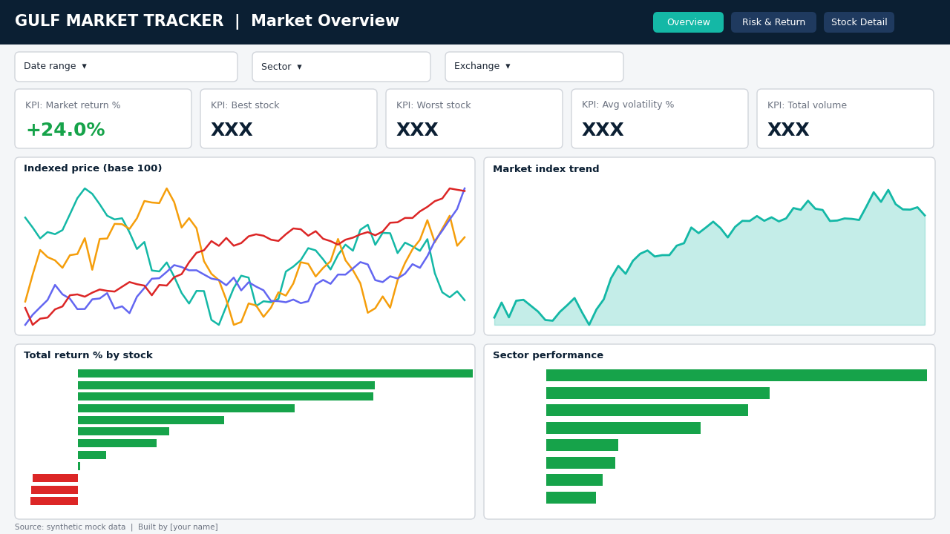

Page 2: Risk and Return
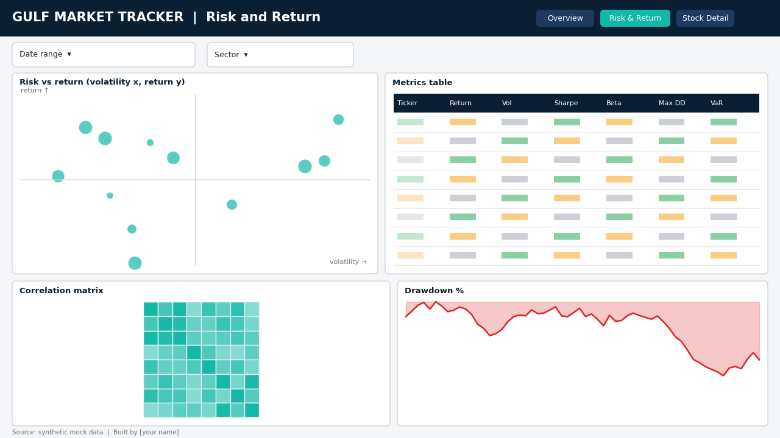

Page 3: Stock Detail
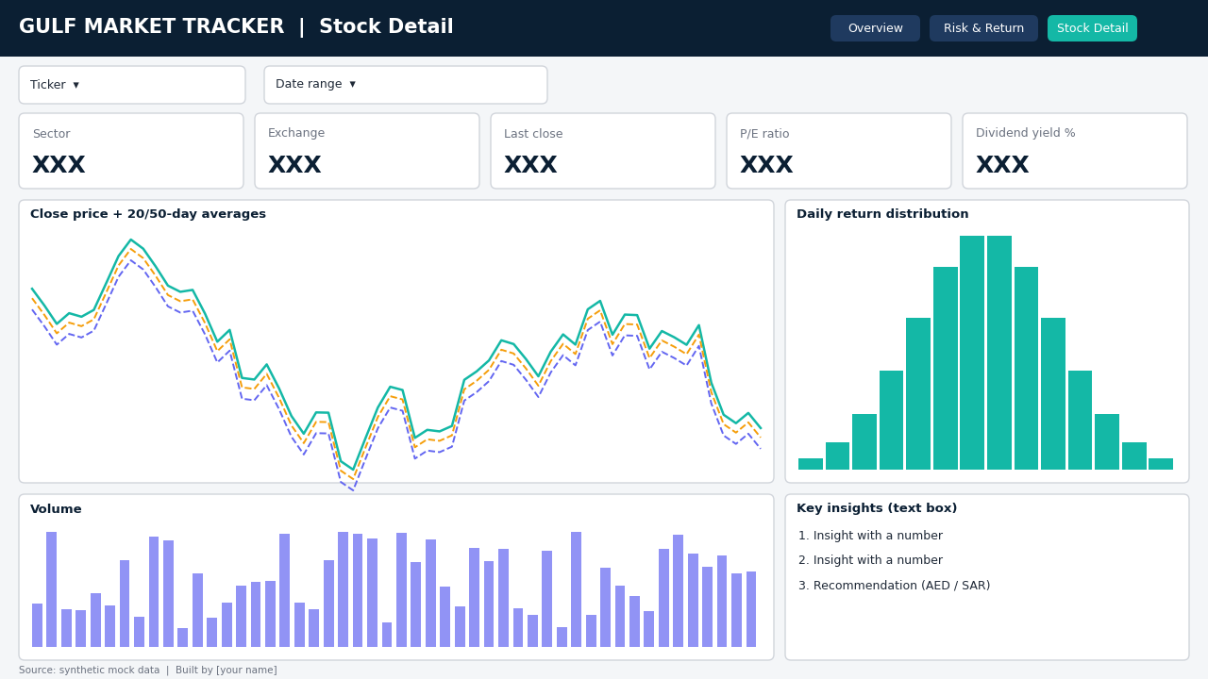

4. Design system and layout coordinates

4.1 Colour palette
Use | Hex code | Name | Swatch
Header and titles | #0B1F33 | Navy
Accent / highlights | #14B8A6 | Teal
Gains / positive | #16A34A | Green
Losses / negative | #DC2626 | Red
Warning / secondary line | #F59E0B | Amber
Page background | #F4F6F8 | Light grey
Cards | #FFFFFF | White
Body text | #1F2937 | Dark grey

4.2 Typography and style rules
- Font: Segoe UI everywhere. Page title 20 pt bold, visual titles 12 pt bold, labels 10 pt, KPI numbers 24 pt bold.
- Cards and charts: white background, thin grey border, rounded corners, 8 px gap between items, 20 px margin around the page.
- Colour logic: green only for gains, red only for losses. Use teal for neutral highlights.
- Always include: a title that states the point, a footer saying the data is synthetic, and your name.
- Keep it clean: at most 4 to 5 colours on any chart, no 3D, no pie charts with more than 5 slices.

4.3 Layout coordinates (x, y, width, height in px)
Use Format > General > Properties > Position and Size in Power BI and type these values.
Page 1: Market Overview
Item | x | y | Width | Height
Header bar | 0 | 0 | 1280 | 60
Slicers: Date, Sector, Exchange | 20 / 340 / 600 | 70 | 300 / 240 / 240 | 40
5 KPI cards | 20, 270, 520, 770, 1020 | 120 | 238 each | 80
Indexed price (line) | 20 | 212 | 620 | 240
Market index (area) | 652 | 212 | 608 | 240
Total return by stock | 20 | 464 | 620 | 236
Sector performance | 652 | 464 | 608 | 236
Footer note | 20 | 704 | 600 | 16

Page 2: Risk and Return
Item | x | y | Width | Height
Slicers: Date, Sector | 20 / 340 | 70 | 300 / 240 | 40
Risk vs return scatter | 20 | 120 | 600 | 330
Metrics table | 632 | 120 | 628 | 330
Correlation matrix | 20 | 462 | 620 | 238
Drawdown chart | 652 | 462 | 608 | 238

Page 3: Stock Detail
Item | x | y | Width | Height
Slicers: Ticker, Date | 20 / 280 | 70 | 240 / 300 | 40
5 company cards | 20, 270, 520, 770, 1020 | 120 | 238 each | 80
Price + averages (line) | 20 | 212 | 800 | 300
Return distribution | 832 | 212 | 428 | 300
Volume (columns) | 20 | 524 | 800 | 176
Insights text box | 832 | 524 | 428 | 176

5. Checklist and tips
- Data merged with no duplicates, and the metrics script run successfully
- Three tables loaded and the metrics to stocks relationship created
- All DAX measures work, and Total Return % is only used in visuals split by ticker
- Three pages built on a 1280 x 720 canvas with consistent colours
- Every visual has a title that states a point, and returns are green or red correctly
- Navigation buttons and slicers tested
- Footer states the data is synthetic
- Screenshots exported and added to your report and GitHub README

Insights to write once it is built
- Which stock gave the best return per unit of risk (highest Sharpe ratio), and which gave the worst?
- Which stocks are aggressive (beta above 1) and which are defensive (beta below 1)?
- How did the market behave in the three stress periods, and which stocks fell the most?
- Which stocks move together most, and how does that affect diversification?
Portfolio tip: put the dashboard link, screenshots and a two-sentence summary in your portfolio and LinkedIn post, and mention that you built it from synthetic data on purpose so it can be shared freely.

