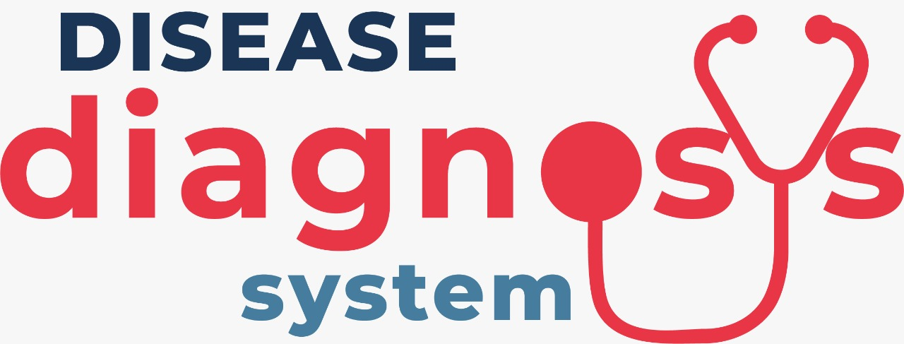
Software Requirements Specification
for
DISEASE DIAGNOSIS SYSTEM
Version 1.0 approved
Prepared by:
Kareema Batool (2018174)
Umair Ayaz Aslam (2018484)
Lalain Aslam Brohi (2018091)

GHULAM ISHAQ KHAN INSTITUTE OF ENGINEERING SCIENCES AND TECHNOLOGY

8th January 2021

Table of Contents
Table of Contents ii
Revision History ii
1. Introduction 1
1.1 Purpose 1
1.2 Document Conventions 1
1.3 Intended Audience and Reading Suggestions 1
1.4 Product Scope 1
1.5 References 2
2. Overall Description 2
2.1 Product Perspective 2
2.2 Product Functions 3
2.3 User Classes and Characteristics 4
2.4 Operating Environment 5
2.5 Design and Implementation Constraints 5
2.6 User Documentation 5
2.7 Assumptions and Dependencies 5
3. Specific Requirements 6
3.1 External Interface Requirements 6
3.1.1 User Interfaces 6
3.1.2 Hardware Interfaces 6
3.1.3 Software Interfaces 6
3.1.4 Communications Interfaces 7
3.2 Functional Requirement 7
3.3 User Requirements……………………………………………………………………...7
4. Other Nonfunctional Requirements 9
4.1 Performance Requirements 9
4.2 Safety Requirements 10
4.3 Security Requirements 10
4.4 Software Quality Attributes 10
4.5 Business Rules 10
5. Other Requirements 11
6. Use Cases 11
Appendix A: Glossary 16
Appendix B: Analysis Models 17
Appendix C: To Be Determined List 17

Revision History
Name | Date | Reason For Changes | Version
Disease Detection System | 4th January 2020 | First Version | 1.0

Introduction

Purpose
The purpose of this document is to state all the requirement specifications for the product which diagnosis diseases by using Machine Learning techniques. A set of classifiers and regressors are trained on a dataset to predict the diseases bases on the symptoms specified by the user. Moreover, it maintains several DBs such as Hospital DB which it uses to display the suitable hospitals on the basis of locality and budget.

Document Conventions
Word | Convention
Database | DB
Distributed Database | DDB
Entity Relationship | ER
Logical Regression | LR
K-Nearest Neighbor | KNN
Random Forest | RF
Multinomial Naibe Bayes | MNB
Support Vector Machine | SVM
Multi-Layer Perceptron Neural Network | MLPNN

Intended Audience and Reading Suggestions
This project is a prototype for system end users, system engineers, system developers, administration, supervisor, system architects, client managers, client engineers, and contract managers. The rest of chapter 1 consists of project scope and references. Chapter 2 further elaborates product perspective, product features, user class and characteristics, operating environment, design and implementation constraints, and assumption dependencies. Moreover, chapter 3 starts by stating the external interface requirements, it then looks into functional requirements. Chapter 4 explains other non-functional requirements and chapter 5 explains other requirements that might or might not exist. Chapter 6 illustrates use cases.

Product Scope
This is a personalized diagnosis software that gets the symptoms from the users and suggests a list of diseases based on the given symptoms using various machine learning classification and regression models. These models have been trained and tested on UCI machine learning repository datasets. For each model, it computes the performance accuracy using different parameters such as cross validation folds. It also maintains various DB of users, hospitals, and diseases. Additionally, it provides a list of hospitals based on the budget and the locality of the user.

References
https://senior.ceng.metu.edu.tr/2016/default/images/portfolio/SRS.pdf

https://lostclouds.com/2Communicate/project/SDS.pdf

https://app.creately.com/diagram/vJxjefwhW86/edit

https://www.modernanalyst.com/Careers/InterviewQuestions/tabid/128/ID/365/What-is-use-case-generalization.aspx#:~:text=In%20the%20context%20of%20use,of%20another%20actor%20(parent).

Overall Description

Product Perspective
The need for this product arose from the ongoing pandemic that has put a lot of burden on the healthcare facilities. This product decreases the need of going out to the hospitals for a specific treatment by diagnosing the disease and suggesting the suitable hospitals from the comfort of your home. This is a self-contained product which comprises of the following components:

    - Hospital:
It is a DB for hospitals that includes hospital name, hospital location, average expenses etc.

    - Disease:
It is a DB that has all the diseases as rows and symptoms as columns. It contains all the values in binary numbers where 0 represents fail (disease not found) and 1 represents hit (disease found).

    - User:
It is a DB that stores the patient name, patient age, gender, contact information, home address, budget, city etc.

    - Machine Learning Techniques:
Classification and regression models such as LR, KNN, RF, MNB, SVM, and MLPNN etc.

    - Preprocessing of data:
- Preprocessing of dataset:
The component that preprocesses the entities present in disease DB.
- Preprocessing of user input:
The component that preprocesses the inputs entered by user.

    - Model Training:
The component that is responsible for training the machine learning techniques specified above.

    - Model Testing:
This component tests the models on 10% of datasets from disease DB.

    - Performance Accuracy Test:
This computes the performance accuracy of each machine learning models using the cross-validation folds and selects the best model amongst all.

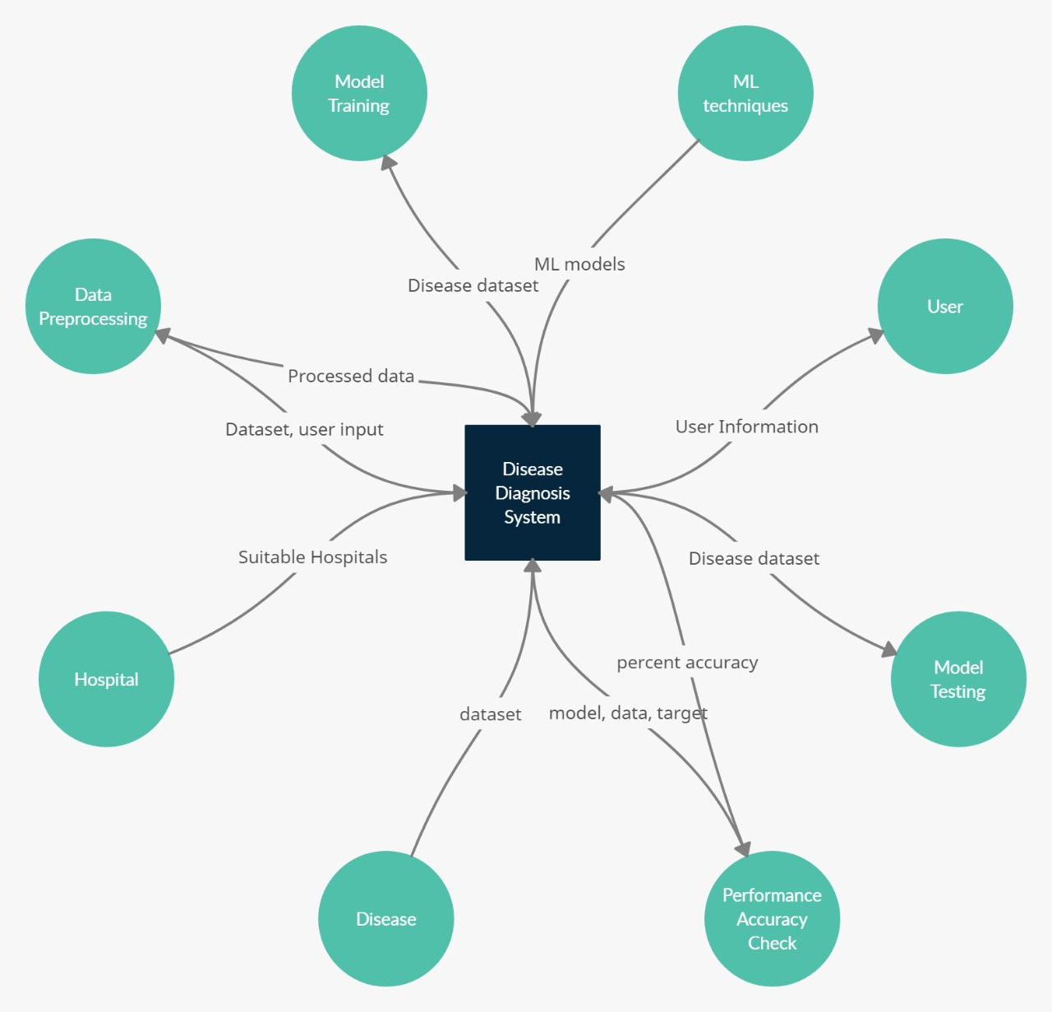
Figure 1.0 Context Diagram

Product Functions
The system is majorly categorized into two interfaces:

    - Patient Interface:
This is an interface designed for patients. Following major functions are implemented for this interface:
- User information: At this point, user will enter all of his/her personal details.
- User Symptoms: Here, the user will enter the symptoms that he/she is experiencing.
- Preprocessing of dataset: The component that preprocesses the entities present in disease DB. The dataset is multiplied which generates different combinations of symptoms. For each of these combinations, a new disease is entered.
- Training the Machine Learning Models: In this part of code, all the machine learning models that are implemented, are trained on 90% of dataset from disease DB.
- Testing the Machine Learning Models: All the models implemented are tested on 10% of dataset from disease DB.
- Performance Accuracy Computation: The performance accuracy of each model is computed using cross-validation.
- Preprocessing of user symptoms: In this segment of code, a lexical analysis is performed to tokenize and lemmatize the symptoms given by users to remove the punctuation marks etc. Moreover, the expansion of this processed symptoms list is done by appending all the synonyms of symptoms in the synonym vector.
- Predicting the diseases: This is one of the most essential segments of the code where the expanded symptom vector is matched to find the related symptoms in Disease DB. For this purpose, each symptom in DB is tokenized and is compared with the expanded symptom vector, and a similarity score is calculated for each of these symptoms. If this score exceeds a threshold value, that symptom qualifies to be a hit. Finally, a trained model takes this symptom vector (in binary values) and displays a list of n possible diseases.
- Suggesting Hospitals: In this part of code, a list of suitable hospitals is displayed that matches the patient’s locality and budget.

    - Admin Interface:
This is for administration that involves the following major functions:
- Modify User DB: In this section, the admin modifies and keeps track of user DB.
- Modify Disease DB: Here, the admin updates the diseases and symptoms in disease DB.
- Modify Hospital DB: In this segment, the admin adds, deletes, or updates the hospital DB.
Activity diagram to be added.

User Classes and Characteristics

    - Patient:
The patients can be classified into following categories:
- COVID Patients:
Patients diagnosed with COVID-19 are given special instructions to stay at home unless absolutely necessary.

- Financially Unstable Patients:
Patients are concerned with the budget.

The patients should be able to do the following functions:
- Enter the symptoms
- Search hospitals based on city
- Search hospitals based on their budget

    - Admin:
The privileged users who have access to DB’s and they can perform the following operations:
- Add/Delete a new disease
- Add/Delete the symptoms of a particular disease
- Add/Delete patient’s information

    - Security Manager:
This component is responsible for security and integration of overall system. It can perform the following operations:
- Authenticate the admin’s username and password
- Authentication of DB’s.

Operating Environment
Operating environment of this system is listed below:
- Distributed DB
- Client-Server System
- Operating System: Windows
- DB: MySQL + Oracle
- Platform: HTML/JavaScript/PHP/CSS
- Development: Anaconda/Spyder/YAML
- Programming Language: Python

Design and Implementation Constraints
- SQL commands for a specified queries or applications
- The DB of hospitals is limited to Pakistan only
- The search based on budget is associated with the average expense of a hospital which may vary to any extent depending upon the treatment.
- The dataset contains around 8835 rows with 489 unique symptoms which might not necessarily cover all the possible diseases.
- All the communication between system and its users is in English Language only.

User Documentation
A detailed video of the system software and its documentation is under development and will be available online.

Assumptions and Dependencies
The operation of this product is based on the following assumptions:
- All the listed hospitals in the DB provide treatment for all the diseases tackled by the product.
- The users of this product are assumed to reside in cities that are present in the DB.
- The hospitals have access to a centralized DB that stores the information of the users.

Specific Requirements

External Interface Requirements

User Interfaces
The DD system’s user interface is divided into two major categories:

      - Patient Interface:
The patient will his/her personal details that will be stored in the user DB. Afterwards, the patient will state his/her symptoms which will be stored in a user file. A list of all possible diseases that a patient can have will be displayed on the interface along with the nearest possible hospital that treats that disease within the allocated patient’s budget.

      - Admin Panel Interface:
Software Uses | Description
HTML | To construct the basic structure of the product’s front-end.
CSS | To stylize the front-end of the product.
JavaScript | It makes the front-end of the product interactive.
MySQL | To create and maintain the DBs used in this product
Spyder | The CLI for Python to construct the backend of the product.
Anaconda | It provides packages and libraries used for the product’s backend.
YAML | The file containing the product’s configuration parameters.
This interface requires the admin to be logged in with a username and a password which grants the admin panel the privileged access to all the DBs. Admin panel can have access to three interfaces where each interface represents three different DBs that are User, Disease, and Hospital.

These interfaces will be developed using HTML, CSS, and JavaScript.

Hardware Interfaces
This product can be accessed via a computing device such as desktop computers, laptops, mobile phones etc. The communication protocol will take place over HTTP.

Software Interfaces
This product has been developed using the following software interfaces:

Communications Interfaces
This product supports all sorts of web browsers on Windows platform. The server diagnoses the diseases of the patient by comparing symptoms that are provided on the client side. The basic communication protocol used between the server and the clients is HTTP.

Functional Requirement
This section of the document highlights the functional requirements of the system. It elaborates on the essential functions being offered by to the stakeholders by the team of developers.

The requirements have been divided into two parts namely, user requirements; that will be available to the customers using the software and administration requirements; given to the administrator handling the backend operations of the system in function.

  - User Requirements

    - Diagnosis based on symptoms

      - Description and Priority
This high priority requirement allows the user to select the symptoms he/she is feeling from a list of symptoms being offered by the system.

      - Stimulus/Response Sequence
User will be given a form to fill, one of the attributes of that form will be for the user to enter the symptoms that apply to them. The dataset is then preprocessed, as in the dataset is multiplied which generates different combinations of symptoms. For each of those combinations, a new disease is entered. A lexical analysis is then performed to tokenize and lemmatize the symptoms given by users to remove the punctuation marks they might have entered as well. Moreover, the expansion of this processed symptoms list is done by appending all the synonyms of symptoms in the synonym vector. Then each symptom in the dataset is tokenized and is compared with the expanded symptom vector, and a similarity score is calculated for each of these symptoms. If this score exceeds a threshold value, that symptom qualifies to be a hit.
The system will then provide a list of up to 10 diseases that correspond with t e entered symptoms.

      - Functional Requirements
- The system must be connected to the diseases database at all times.
- The performance accuracy of each model is computed using cross-validation.
- It must match the symptoms with the diseases database and provide a disease, or list of diseases, depending on the symptoms, with 90% accuracy.
- The machine learning models are trained on 90% of dataset and tested on 10% of dataset of the disease database.

    - Recommendation of hospitals according to budget

      - Description and Priority
This high priority requirement recommends hospitals to users depending on the budget of their expenses that they have entered.
      - Stimulus/Response Sequence
User will be given a form to fill, one of the attributes of that form will be to fill their suitable budget. The system will then match the budget entered to the hospital database and display the list of hospitals that come under the users allocated budget.
      - Functional Requirements
- The system must be connected to the hospital database at all times.
- The system must apply a search query on the hospital database and provides a list of all the hospitals whose expenses match the budget entered by the user.

    - Recommendation of hospitals according to the user’s locality

      - Description and Priority
This medium priority requirement recommends a list of hospitals nearest to the user’s current locality.
      - Stimulus/Response Sequence
The software asks the user to provide their address upon starting. That address is saved in the user’s database. The user is then provided with a list of hospitals in the user’s proximity.
      - Functional Requirements
- The system must be connected to the user and hospital database.
- The system must apply a search query on the user’s address from the user database to the hospitals database and provide a list of hospitals closest to the user’s current locality for easy convenience.

    - Administrator Login

      - Description and Priority
This high priority requirement allows the user to login to the software in order to access the backend of the system.
      - Stimulus/Response Sequence
The administrator will be prompted to enter their username and unique password in order to login to the system. The system will then authenticate the administrator by comparing the username and password currently entered to the existing database and will only be granted access if it finds a match.
      - Functional Requirements
- The system will grant access to the administrator to make modifications to the databases at the backend of the system.
- In the case where the login details did not match with the ones in the existing database the system will prompt the administrator to either enter the details again or to sign-up to the software.

    - Modify Diseases Database
      - Description and Priority
This high priority requirement allows the administrator to access the Diseases database and add/delete/modify the diseases or their symptoms.

      - Stimulus/Response Sequence
The administrator will be able to access the backend of the system which includes the diseases database and add/delete or modify the database according to its symptoms.
      - Functional Requirements
An authenticated administrator must be given access to modify the disease database.

    - Modify Hospital Database
      - Description and Priority
This high priority requirement provides access to the administrator to the hospital database to add/delete/modify hospitals.
      - Stimulus/Response Sequence
The administrator is given full backend access that includes the hospitals database. They will be able to add/delete/modify hospitals and their data in the case that new hospitals are created in the locality or specific hospitals become obsolete.
      - Functional Requirements
The hospitals entered must be located at a reliable address in Pakistan and must be able to treat all diseases listed in the diseases database.

    - Remove User Details

      - Description and Priority
This medium priority requirement enables the user to remove user details from the user database if the user hasn’t used the software for a certain amount of time.
      - Stimulus/Response Sequence
The administrator is provided with access to the user database that contains the details of all the users that previously used the system. They can then remove users from the database if it hasn’t been used by the said user for a prolonged amount of time.
      - Functional Requirements
An authenticated administrator must be given access to modify the user database.

Other Nonfunctional Requirements

Performance Requirements
There is segment of code that performs lexical analysis of the input provided by the user and tokenizes it for later testing which affects the performance in terms of computational complexity. Moreover, the bandwidth of the communication protocol between the server and the clients also affects the performance. If a user enters a city that doesn’t exist in the DB, the search algorithm will go through all the tuples in the Hospital DB and return ‘not found’ that increases the computational time.

Safety Requirements
All the Machine Learning models that are implemented in our product don’t reach a 100% performance accuracy as a result of which a correct diagnosed disease may sometimes not be possible. Since the Hospital is assigned based on the average expenditure of the Hospital and the allocated budget of the user, it is possible that the user budget exceeds the average expenditure of the Hospital that will cause monetary loss to the user.

Security Requirements
- The security and integrity of the entire product is guaranteed by classifying the access into two main categories:
- Privileged Access:
This access is granted only to admin panel that are required to login with authenticated credentials.

- Unprivileged Access:
This access is granted to all the users who are using the product.

- The dataset of diseases and the symptoms used in this product has been taken from a verified source that is UCI Machine Learning Repository.
- This product fulfills all laws and regulations provided by the Federal Government of Pakistan.

Software Quality Attributes
- Availability: This product can be accessed by anyone as long as he/she has a stable internet connection.
- Adaptability: A standby team of three qualified individuals will ensure the continuous support. Moreover, each problem will be overcome by adapting and improvising.
- Maintainability: A standby team of three qualified individuals will be maintaining the product’s DBs and the communication link.
- Portability: This product can be accessed by desktop computer as well as PDA’s such as mobile phones, tablets etc that makes it portable.
- Reliability: This product has been tested by qualified testers to make it more reliable.
- Usability: This product satisfies a maximum number of users needs.

Business Rules
- Administrators and developers can overlook all details and parts of this product.
- Patients can only enter personal information and the symptoms of their disease.
- The security component overlooks the authentication of administration credentials.

Other Requirements
- For the time being, this product is localized. However, this can be internationalized in the near future as it does not contain any regulations.
- The database requirement includes granting access based on different level of authorization.
- All the fields in the product’s DBs are of alphanumeric type.

Use Cases
All the UML use cases of this system are stated below:
- User’s Input:

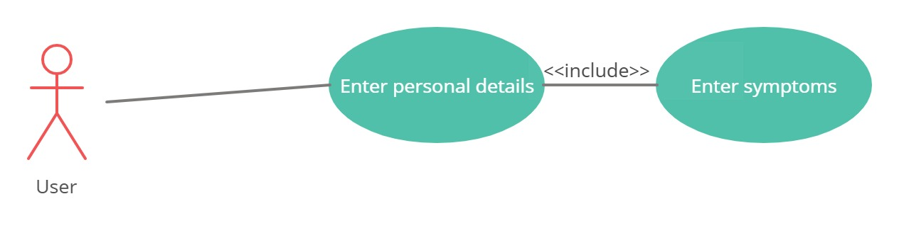

Use Case ID | 1
Use Case | User’s input
Description | The user inserts his/her personal details and symptoms.
Actor | User
Trigger | User clicks on “Enter details” and “Enter symptoms”.
Primary Scenario | User inputs his/her personal information and symptoms that are saved for later processing.
Exceptional Scenario | None

- Training Machine Learning Models:
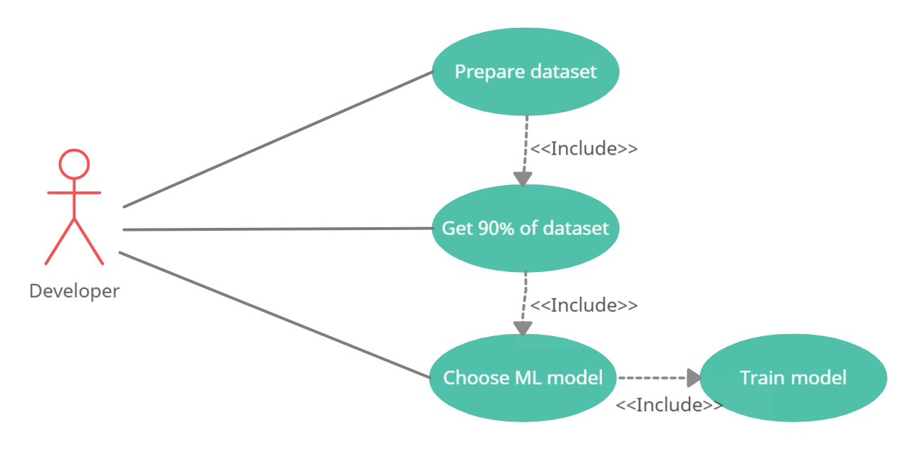

Use Case ID | 2
Use Case | Training machine learning models
Description | A set of models are trained on dataset.
Actor | Developer
Trigger | These models are included using different machine learning libraries and packages.
Primary Scenario | A set of classifiers and regressors get trained on 90% of data from dataset used in code.
Exceptional Scenario | None

- Performance Accuracy Computation:
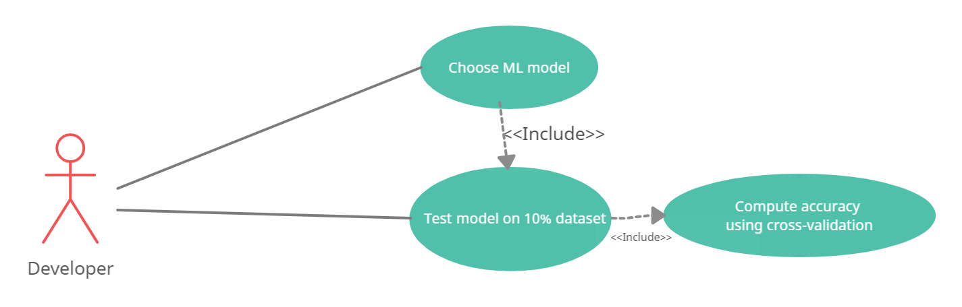

Use Case ID | 3
Use Case | Performance accuracy computation
Description | The performance accuracy of each machine learning model is computed.
Actor | Developer
Trigger | A performance computation metric is included within the code.
Primary Scenario | For each of the models, performance accuracy is computed using cross-validation folds.
Exceptional Scenario | None

- Preprocessing of User Symptoms:
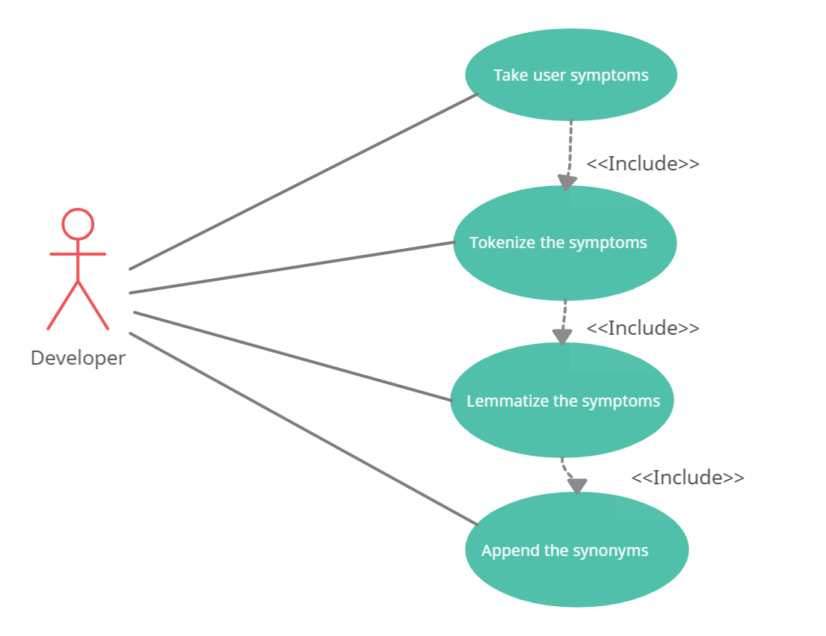

Use Case ID | 4
Use Case | Preprocessing of user symptoms
Description | Symptoms entered by user are tokenized and lemmatize for further processing.
Actor | Developer
Trigger | Functions for tokenization and lemmatization are called within the code.
Primary Scenario | The user entered symptoms are preprocessed to produce a symptom vector for each user.
Exceptional Scenario | None

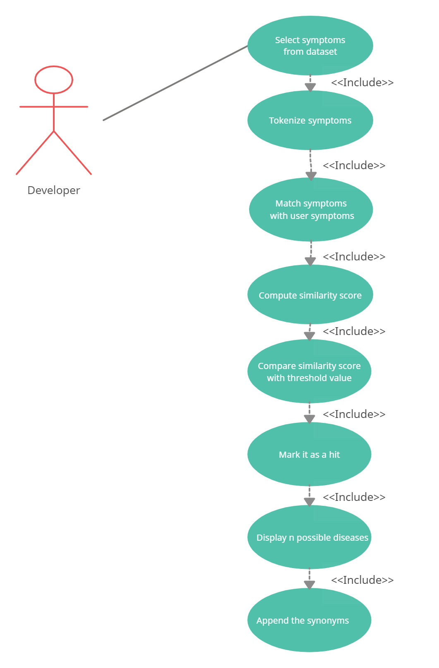
- Disease Prediction:

Use Case ID | 5
Use Case | Disease prediction
Description | A set of possible diseases are predicted based on user entered symptoms.
Actor | Developer
Trigger | A function for predicting diseases is called in the code.
Primary Scenario | The trained models predict a list of diseases based on user symptoms by matching and comparing.
Exceptional Scenario | None

- Suggesting Suitable Hospitals:

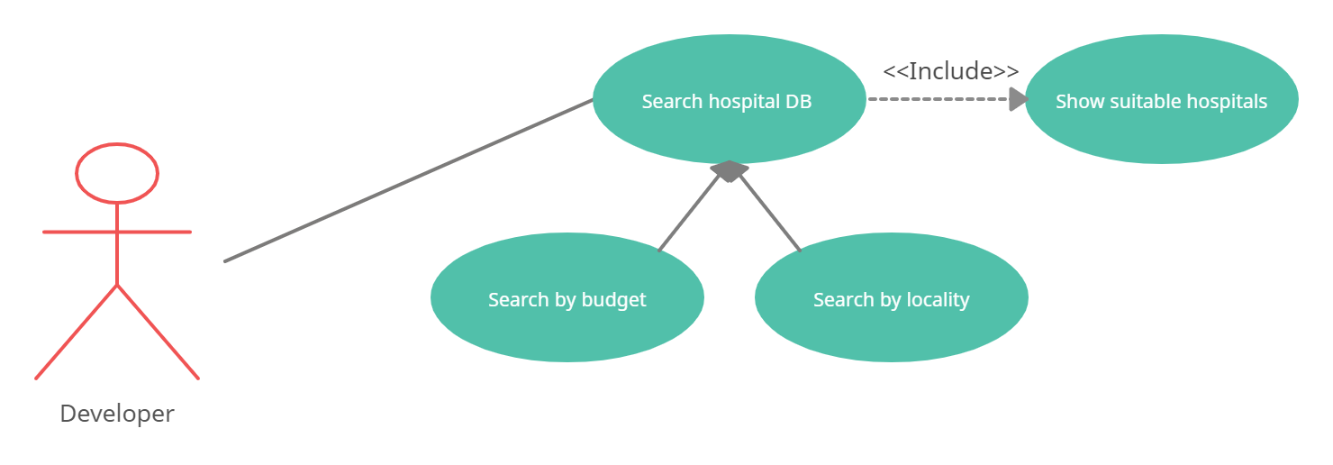

Use Case ID | 6
Use Case | Suggesting suitable hospitals
Description | A list of all suitable hospitals is displayed.
Actor | Developer
Trigger | A query to search all hospitals based on user’s budget and locality is implemented in the code.
Primary Scenario | The hospital DB is searched on the basis of budget and locality and a list of suitable hospitals is displayed.
Exceptional Scenario | None

- Managing Databases:
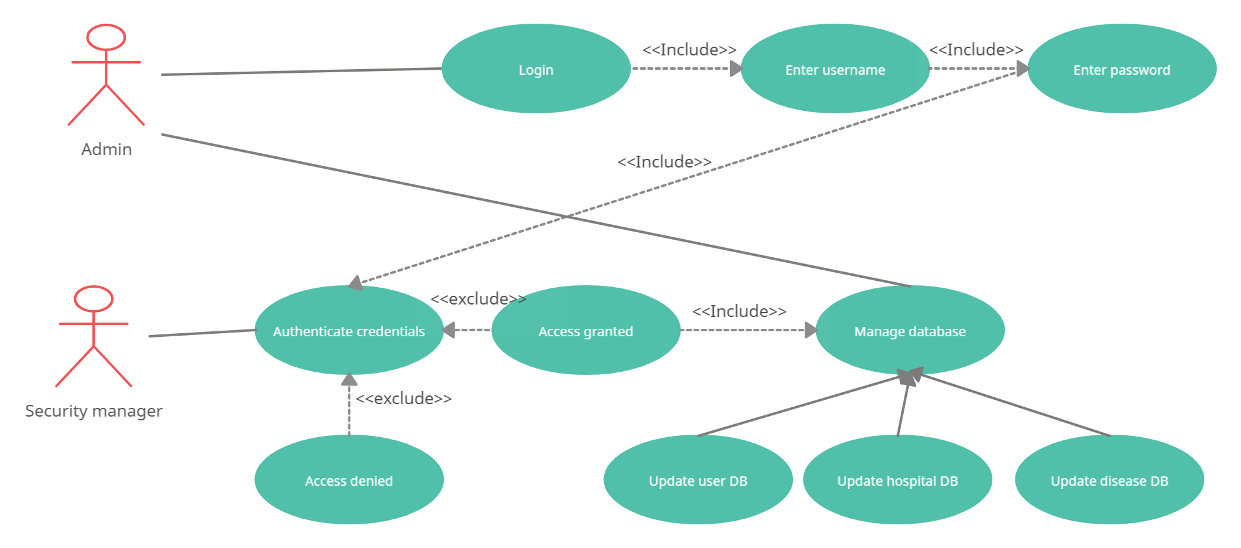

Use Case ID | 7
Use Case | Managing databases
Description | Admin manages all the databases implemented in the product.
Actor | Admin
Trigger | Admin can select three different interfaces to update all three databases.
Primary Scenario | Admin checks and updates databases.
Exceptional Scenario | None

Appendix A: Glossary
Accuracy: A metric for evaluating the Machine Learning models.
Classification: It refers to a predictive model where a target is predicted for each data in dataset.
Cross-validation: It is a resampling procedure used to evaluate Machine Learning models on animated data sample.
Communication Protocol: A system of rules that allows two or more entities to transmit information via any kind of variation of a physical quantity.
Distributed DB: An integrated collection of DBs which is physically distributed across sites in a computer network.
Lexical Analysis: The process of converting the user input into appropriate tokens.
Regression: A statistical method to model the relationship between a dependent target and independent predictor variable with one or more independent variables.

Appendix B: Analysis Models
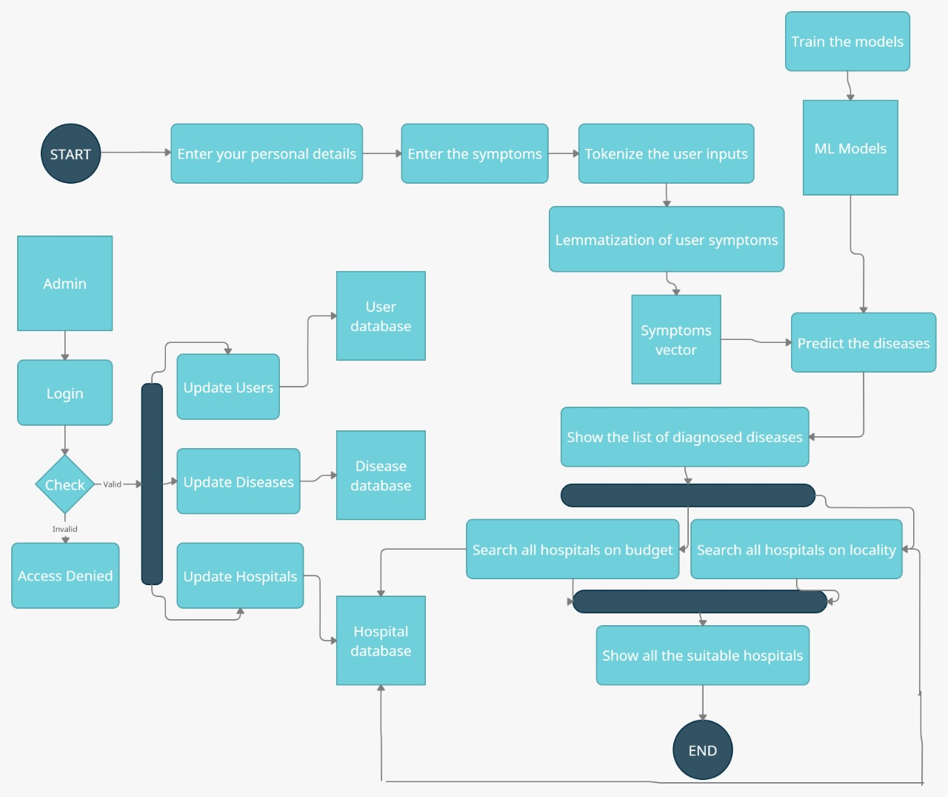
Figure 2 Activity Diagram

Appendix C: To Be Determined List
Not applicable yet.

