ExpenseMate – Software Requirements Specification (SRS)
By:24K-3041 & 24K-3099

Functional Requirements:
- Manage Transaction: The system will allow user to record, update, delete, and view income and expense transactions with fields for id,amount, date and category.
- Budgeting and Alerts: The system must allow users to define monthly budget limits per category or overall, and generate alerts when spending reaches configured thresholds (e.g., 80% or 100%).
- Analytic and visualization: The system must compute category-wise totals and aggregate monthly income vs. expense data to generate visual charts
- CSV import/export: The system must export transaction records to a standard CSV file and parse imported CSV files to bulk-insert transactions into the database.

Non-Functional Requirements:
- Performance: The app must load dashboard, charts, and expense lists instantly under 1 second without lagging.
- Reliability: Your financial entries must save securely. If the app crashes midway, your data won't get lost or corrupted.
- Usability: The layout should be simple enough that anyone can log expenses or check their budget without needing instructions.
- Maintainability: The code must stay organized in clear layers so that new features can be added easily later.

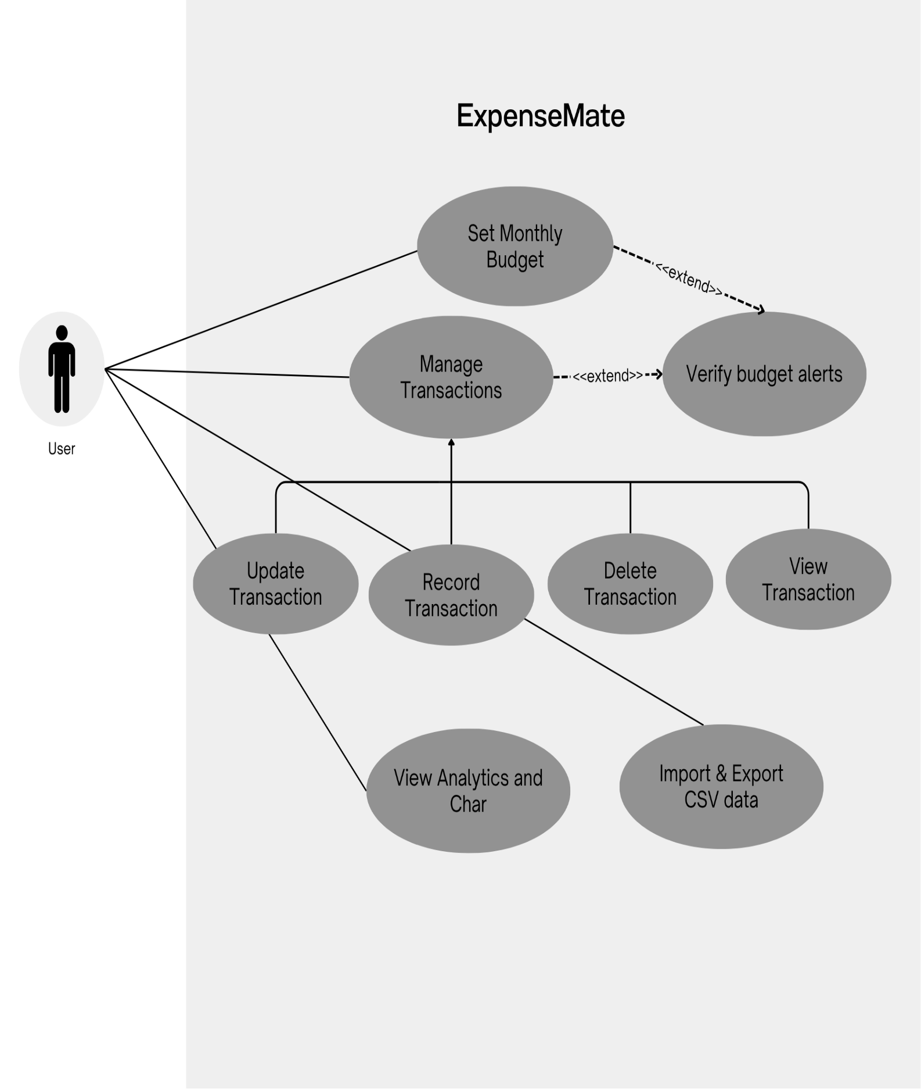
USE CASE DIAGRAM

