Software Design Specification
Vaccination Management System (VMS)

Rumaesa (24k-3099)
Umair Ehtesham (24k-3041)
Ameerah (24k-3113)

Supervisor: Rubab Jaffar
FAST-NUCES Karachi
Definitions, Acronyms and Abbreviations
Term | Description
VMS | Vaccination Management System
SRS | Software Requirements Specification
SDS | Software Design Specification
RBAC | Role-Based Access Control
CNIC | Computerized National Identity Card — unique patient identifier
XAMPP | Local server environment containing Apache and MySQL
NIMS | National Immunization Management System (Pakistan)
ER | Entity Relationship (as in ER Diagram)
PHP | Hypertext Preprocessor — server-side scripting language
OOP | Object-Oriented Programming

1. Introduction
1.1 Purpose of Document
This document describes the software design of the Vaccination Management System (VMS). It is intended for the course instructor (Rubab Jaffar) and teaching assistants for academic evaluation. The design methodology used is Object-Oriented Design (OOD), in which the system is broken down into classes and objects representing real-world entities such as Patient, Vaccine, Appointment, and Report.
1.2 Intended Audience
The primary audience for this document is the course instructor Rubab Jaffar and the teaching assistants of the Software Design and Architecture and Database Systems courses at FAST-NUCES Karachi. The document may also be referenced by the project team during the implementation phase.
1.3 Document Convention
This document uses Times New Roman, size 12 for body text and size 14 bold underlined for section headings. All table text is size 10. Requirements referenced from the SRS are cited using their original tags (e.g., REQ-1, REQ-S2).
1.4 Project Overview
The VMS is a web-based application developed to replace paper-based vaccination registers used in small healthcare clinics. The system supports four core modules: Patient Registration, Vaccine Inventory Control, Dose Scheduling and Tracking, and Certification and Reporting. It is built on PHP 8.1, MySQL, and Bootstrap 5, deployed on a XAMPP local server. Three user roles are supported: Administrator, Healthcare Staff, and Citizen.
1.5 Scope
The VMS will deliver:
- Vaccine inventory management with batch tracking, expiry blocking, and low-stock alerts
- Appointment booking and automatic next-dose date calculation based on vaccine-specific intervals
- PDF vaccination certificate generation upon dose completion
- Admin reports on daily vaccination coverage and expiring stock

The VMS will NOT deliver:
- Integration with any external government database such as NIMS or NADRA
- Payment or billing functionality
- Multi-language support — English only
- A mobile application — web browser access only
- SMS or email appointment reminders

2. Design Considerations
2.1 Assumptions and Dependencies
The following design-level assumptions are made (separate from those already stated in SRS Section 2.7):
- PHP 8.1 sessions will be used to manage authentication state across all pages. No external authentication library is required.
- MySQL foreign key constraints will be used to enforce relational integrity between tables (e.g., an Appointment cannot exist without a valid Patient and Vaccine record).
- Bootstrap 5 grid system will handle responsive layout across desktop and mobile views, removing the need for custom media queries.
- The PDF certificate will be generated server-side using a PHP PDF library. Client-side rendering is not used.
- All date calculations for dose intervals will be performed in PHP using the DateTime class, not in MySQL.
2.2 Risks and Volatile Areas
- Vaccine Interval Logic: The dose interval values (e.g., 21 days for Pfizer) are stored in the database vaccine table. If WHO guidelines change, only the database record needs updating — no code change is required.
- Certificate Layout: The visual design of the PDF certificate is listed in Appendix B of the SRS as a To-Be-Determined item. This section of the design may need revision once the layout is finalized.
- Daily Appointment Capacity: The maximum number of daily appointments per center has no default value yet. The system design must allow this to be configurable.
- Reporting Columns: The exact fields for the Daily Coverage and Expiry reports are TBD. The database schema is designed to accommodate multiple report formats without structural changes.

3. System Architecture
3.1 System Level Architecture
The VMS follows a three-tier client-server architecture. The three tiers are the client browser, the application server, and the database server.

At the top level, three types of users — Administrator, Healthcare Staff, and Citizen — access the system through a web browser (Chrome, Firefox, or Edge). All requests are sent over HTTP/HTTPS to an Apache web server hosted within the XAMPP environment. The Apache server routes requests to the PHP application layer, which processes business logic and communicates with a MySQL database through SQL queries. Responses are returned back to the browser as rendered HTML pages.

There are no external system integrations. The system is fully self-contained with no connection to government databases such as NADRA or NIMS.

Note: An architecture diagram (package/component diagram) should be inserted here showing: Browser -> Apache Server -> PHP Application -> MySQL Database, with three user types connecting to the browser layer.
3.2 Software Architecture
The internal software is organized into three layers:

User Interface Layer: Built using HTML5, CSS3, JavaScript, and Bootstrap 5. This layer contains all web pages visible to the user — dashboards, registration forms, appointment booking pages, and report views. It communicates with the middle tier by submitting HTTP requests (form POSTs and GET requests).

Middle Tier (Business Logic Layer): Built using PHP 8.1. This layer contains all business logic including session management, RBAC checks on every page load, dose interval calculations, stock decrement logic, expiry validation, and PDF certificate generation. It sits between the UI layer and the database.

Data Access Layer: MySQL database managed via phpMyAdmin. This layer stores all persistent data including patient records, vaccine batches, appointments, and user accounts. All data access is done through parameterized SQL queries issued by the middle tier.

Note: A layered architecture diagram should be inserted here showing the three layers stacked vertically with arrows indicating the direction of communication.

4. Design Strategy
The VMS is designed using an Object-Oriented approach. The core entities of the domain — Patient, Vaccine, Appointment, VaccinationCenter, Staff, Certificate, and Stock — are each represented as database tables and correspond to logical classes in the PHP application layer.

Role-Based Access Control (RBAC) is the central security strategy. On every page load, the PHP middle tier checks the session role against the page's required permission level before rendering any content. Citizens cannot access inventory or reporting modules. Healthcare Staff cannot delete records or manage user accounts. Only Administrators have full system access.

For data management, SQL transactions (REQ-S3) are used for any multi-step operation — particularly patient registration and stock decrement during dose recording. This ensures that partial writes do not corrupt the database in the event of a crash.

The UI paradigm follows a consistent navigation principle required by the SRS. A persistent sidebar is present on all staff and admin pages, always displaying the search bar and Register Patient button. Citizens see a simplified dashboard showing only their own appointments and a certificate download button.

For future extensibility, vaccine interval logic and stock thresholds are stored as database values rather than hardcoded constants. This means new vaccine types can be added without any code changes.

5. Detailed System Design
5.1 Database Design
5.1.1 ER Diagram
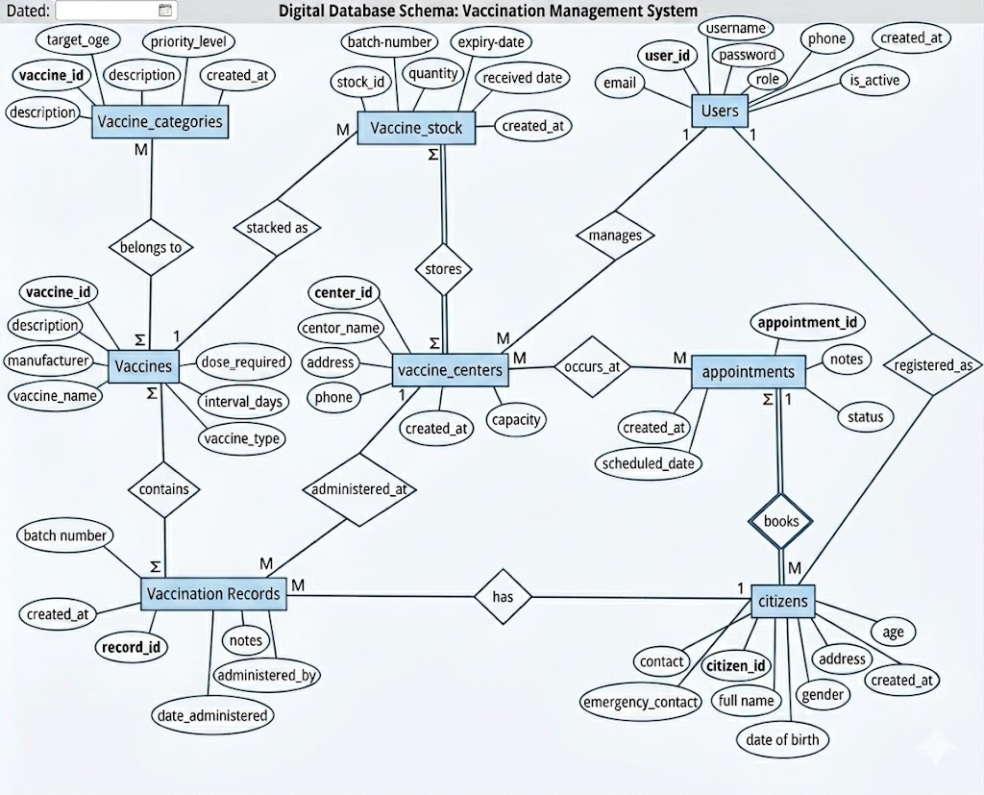

5.1.2 Data Dictionary
5.1.2.1 Patient
Column Name | Description | Type | Length | Nullable | Default | Key
patient_id | Unique patient identifier | INT | 11 | No | — | PK
cnic | National identity number | VARCHAR | 15 | No | — | UNIQUE
name | Full name of patient | VARCHAR | 100 | No | —
age | Age in years | INT | 3 | No | —
gender | M / F / Other | ENUM | — | No | —
phone | Contact number | VARCHAR | 15 | Yes | NULL

5.1.2.2 Vaccine
Column Name | Description | Type | Length | Nullable | Default | Key
vaccine_id | Unique vaccine identifier | INT | 11 | No | — | PK
vaccine_name | Name of vaccine (e.g., Pfizer) | VARCHAR | 100 | No | —
doses_required | Total doses in schedule | INT | 2 | No | —
interval_days | Days required between doses | INT | 3 | No | —

5.1.2.3 Stock
Column Name | Description | Type | Length | Nullable | Default | Key
stock_id | Unique stock record ID | INT | 11 | No | — | PK
vaccine_id | Links to Vaccine table | INT | 11 | No | — | FK
batch_number | Manufacturer batch code | VARCHAR | 50 | No | —
manufacturer | Manufacturer name | VARCHAR | 100 | No | —
expiry_date | Expiry date of batch | DATE | — | No | —
quantity | Current stock count | INT | 6 | No | —

5.1.2.4 Appointment
Column Name | Description | Type | Length | Nullable | Default | Key
appointment_id | Unique appointment ID | INT | 11 | No | — | PK
patient_id | Links to Patient table | INT | 11 | No | — | FK
vaccine_id | Links to Vaccine table | INT | 11 | No | — | FK
center_id | Links to VaccinationCenter | INT | 11 | No | — | FK
staff_id | Links to Staff table | INT | 11 | Yes | NULL | FK
appointment_date | Scheduled appointment date | DATE | — | No | —
status | Pending / Completed / Cancelled | ENUM | — | No | Pending
dose_number | Which dose in schedule (1, 2...) | INT | 2 | No | —
next_dose_date | Auto-calculated next due date | DATE | — | Yes | NULL

5.1.2.5 Staff
Column Name | Description | Type | Length | Nullable | Default | Key
staff_id | Unique staff identifier | INT | 11 | No | — | PK
name | Full name | VARCHAR | 100 | No | —
role | Admin or Healthcare Staff | ENUM | — | No | —
email | Login email address | VARCHAR | 150 | No | — | UNIQUE
password_hash | BCRYPT hashed password | VARCHAR | 255 | No | —
center_id | Assigned vaccination center | INT | 11 | Yes | NULL | FK

5.1.2.6 Certificate
Column Name | Description | Type | Length | Nullable | Default | Key
certificate_id | Unique certificate ID | INT | 11 | No | — | PK
patient_id | Links to Patient table | INT | 11 | No | — | FK
vaccine_id | Links to Vaccine table | INT | 11 | No | — | FK
issue_date | Date certificate was generated | DATE | — | No | —
download_path | File path to generated PDF | VARCHAR | 255 | No | —

5.2 Application Design
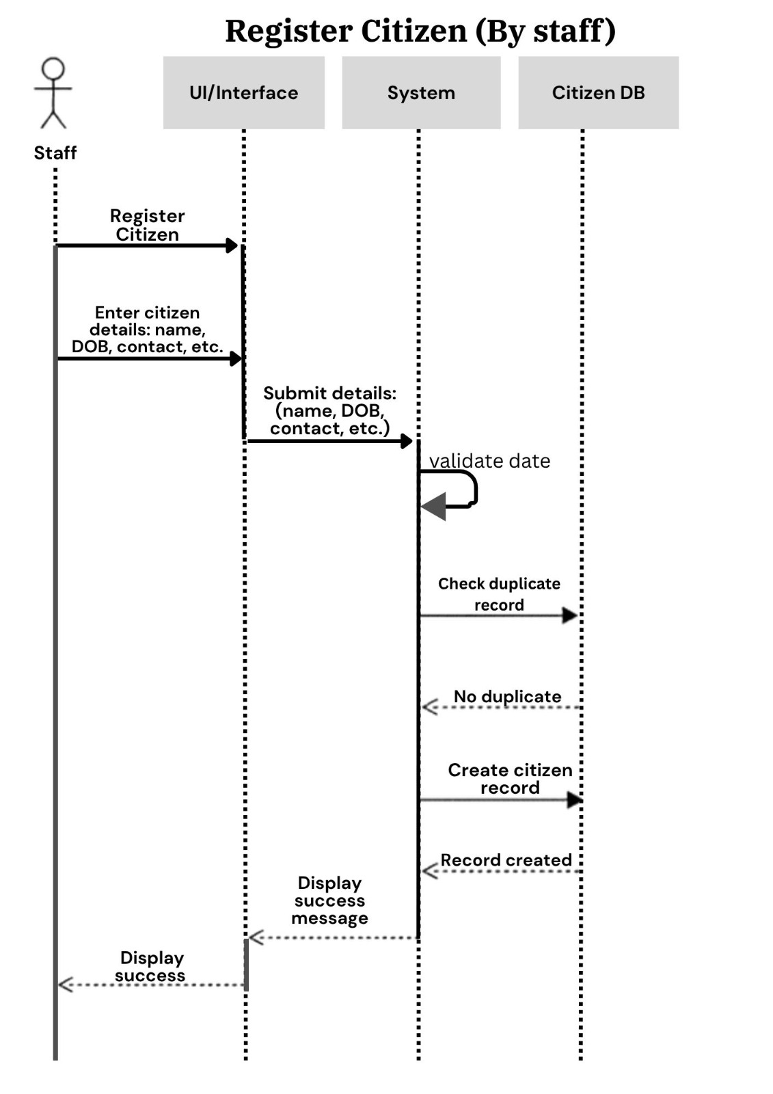
5.2.1 Sequence Diagrams
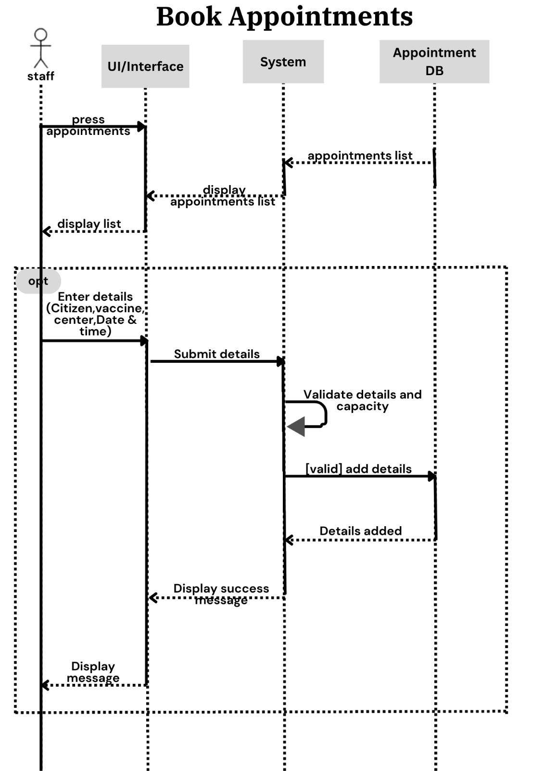
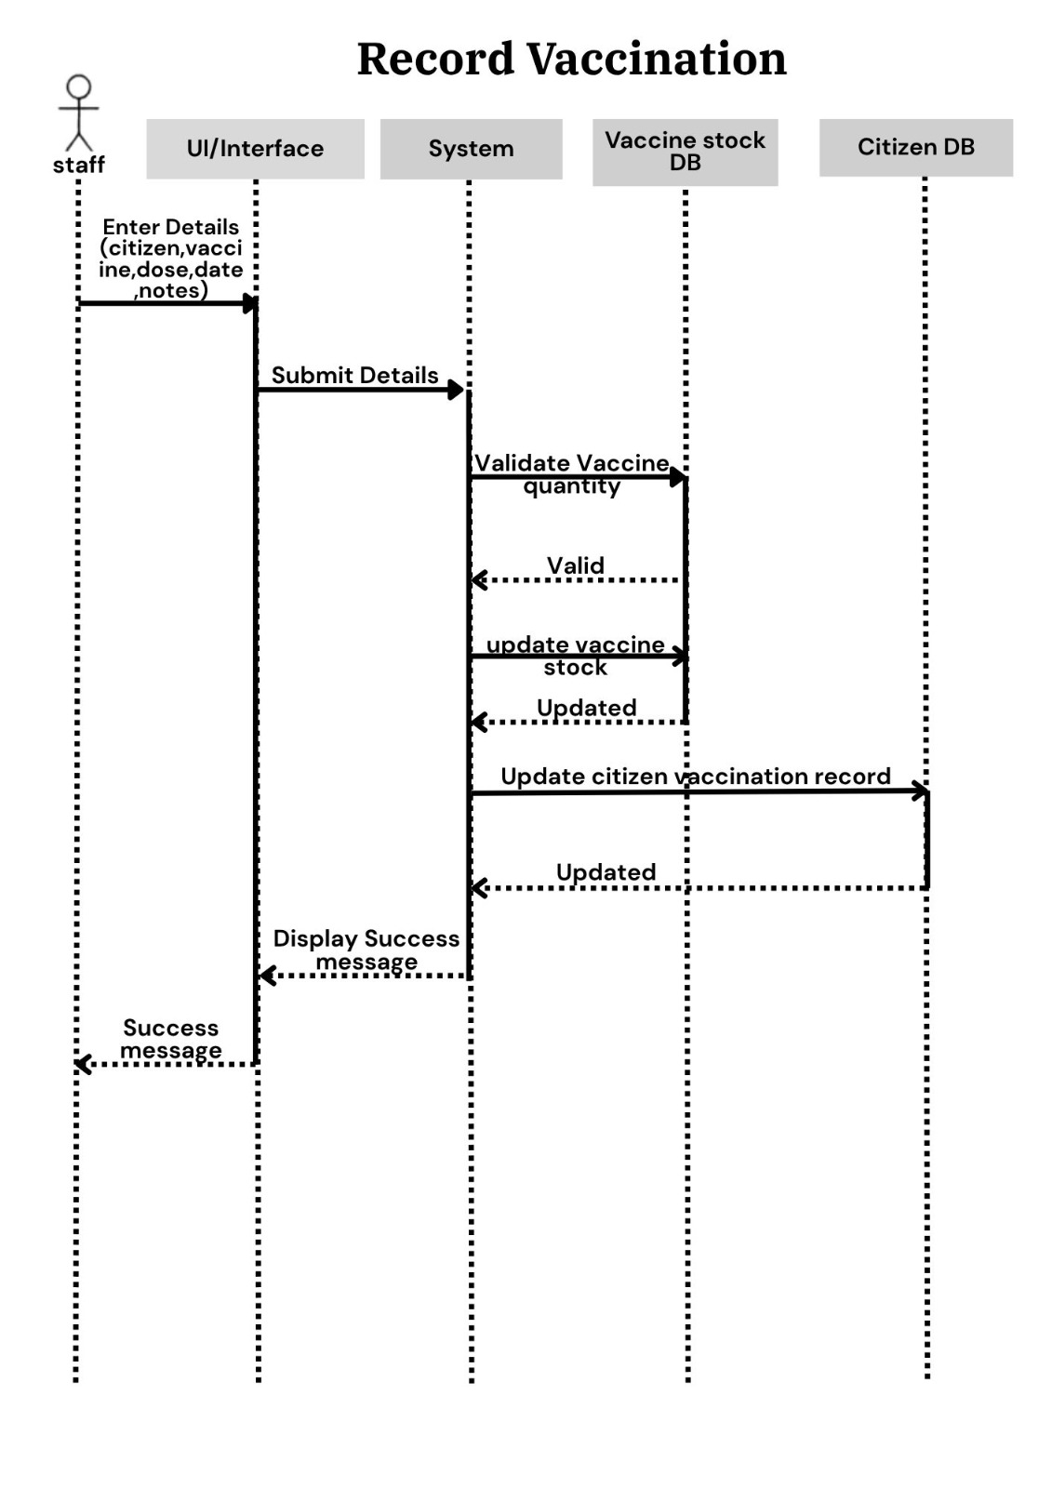
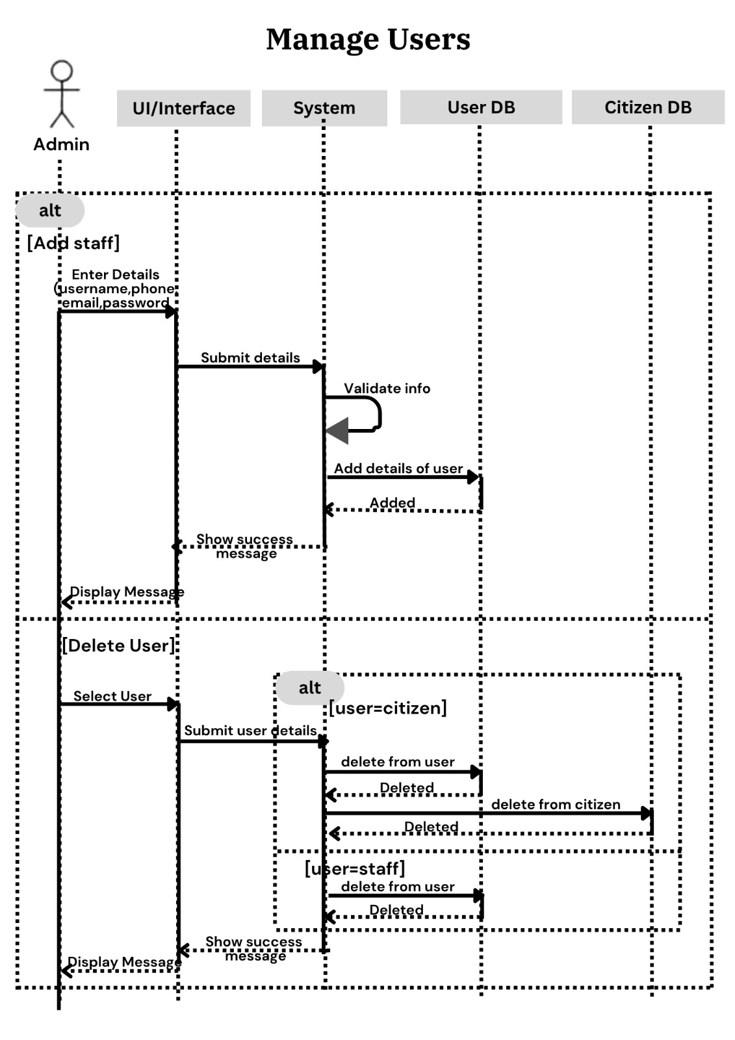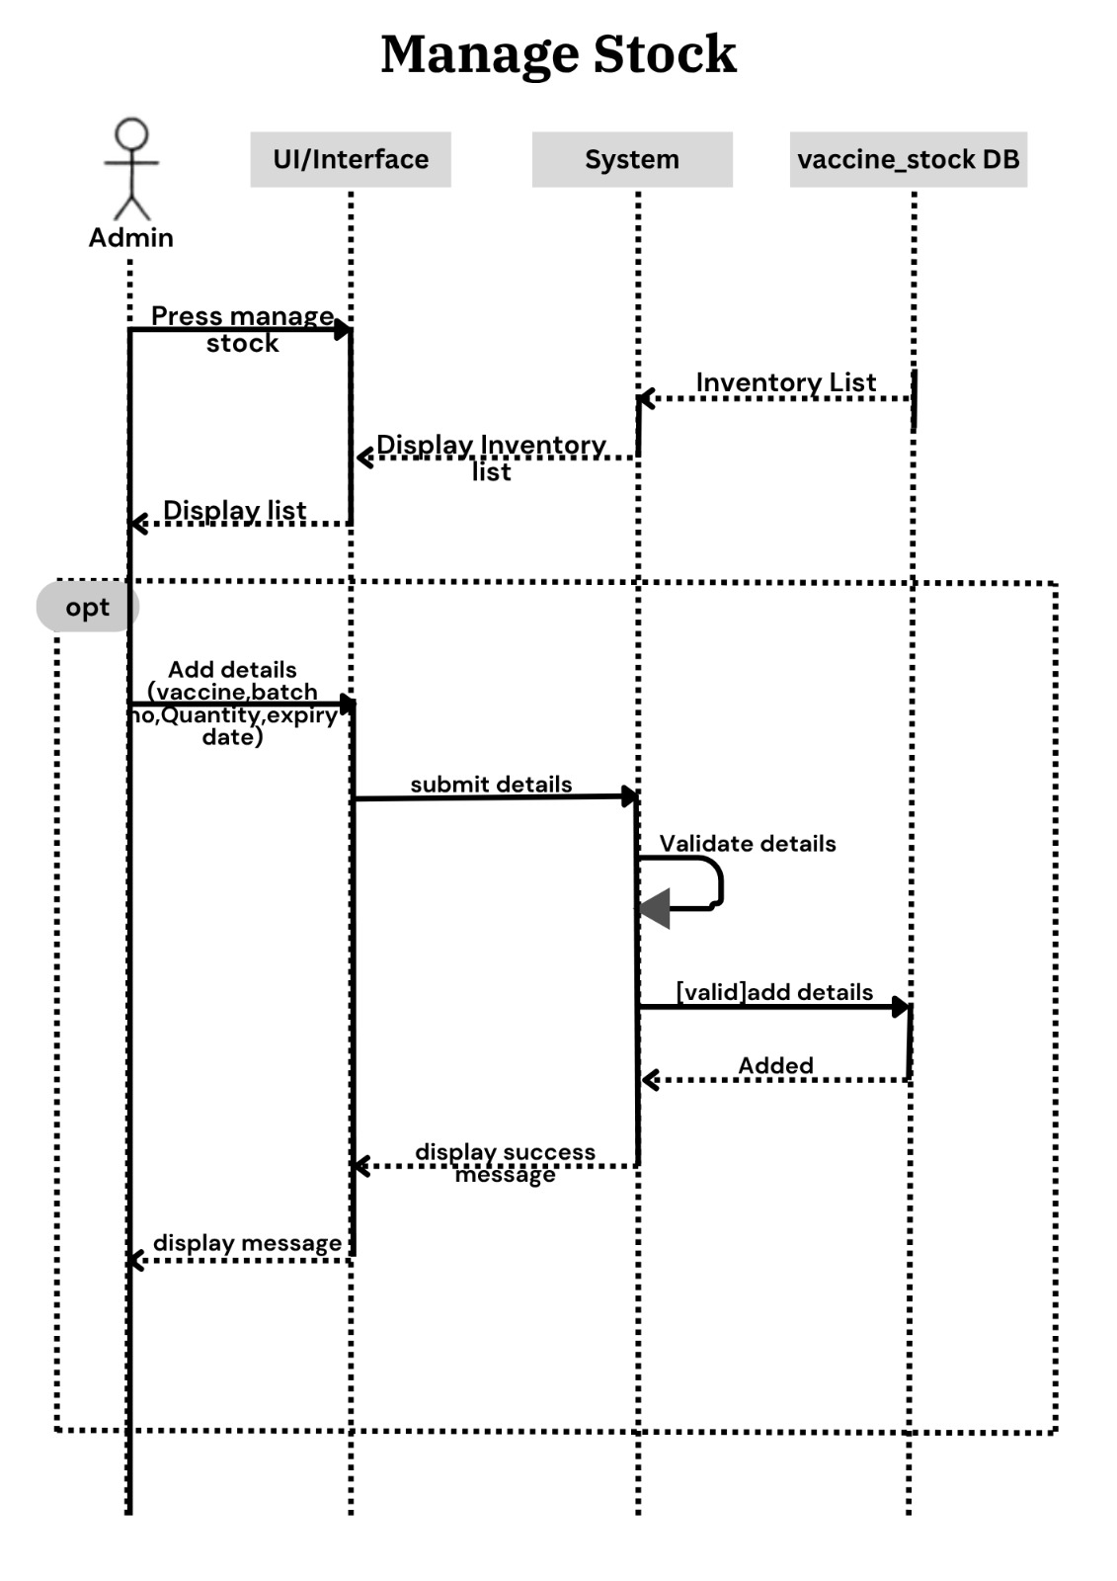
5.2.2 Activity Diagrams
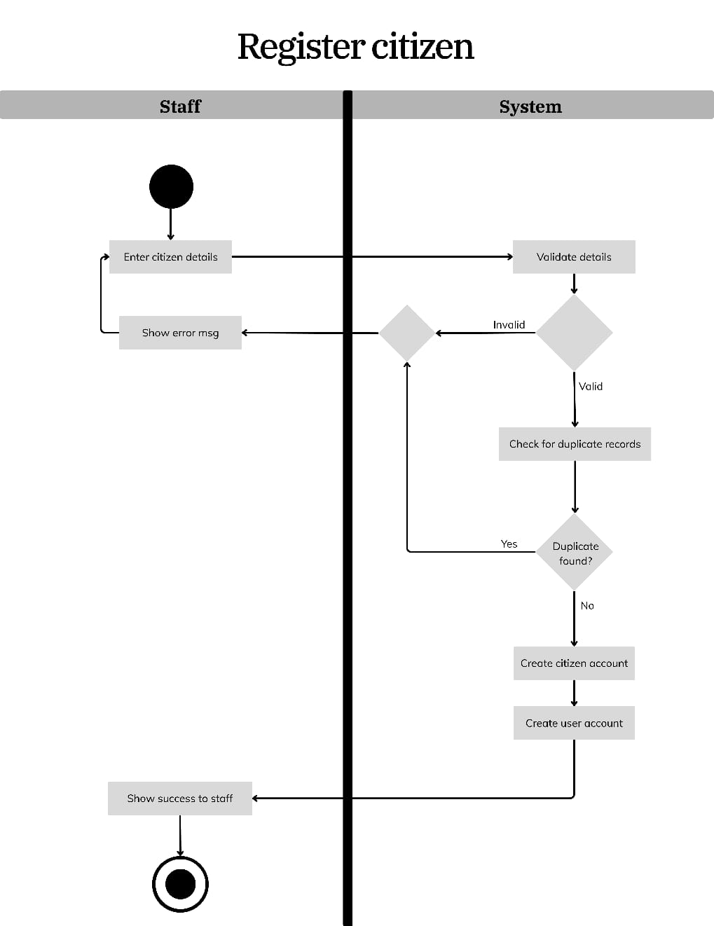
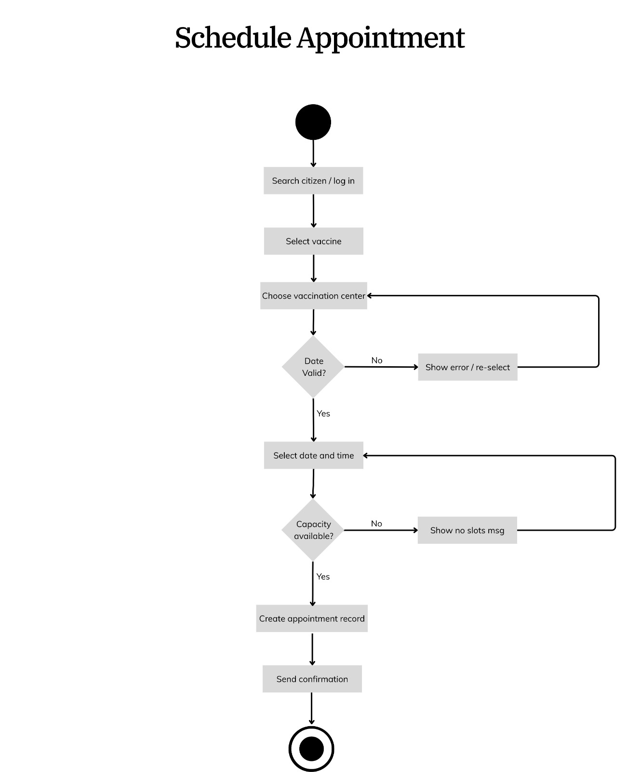

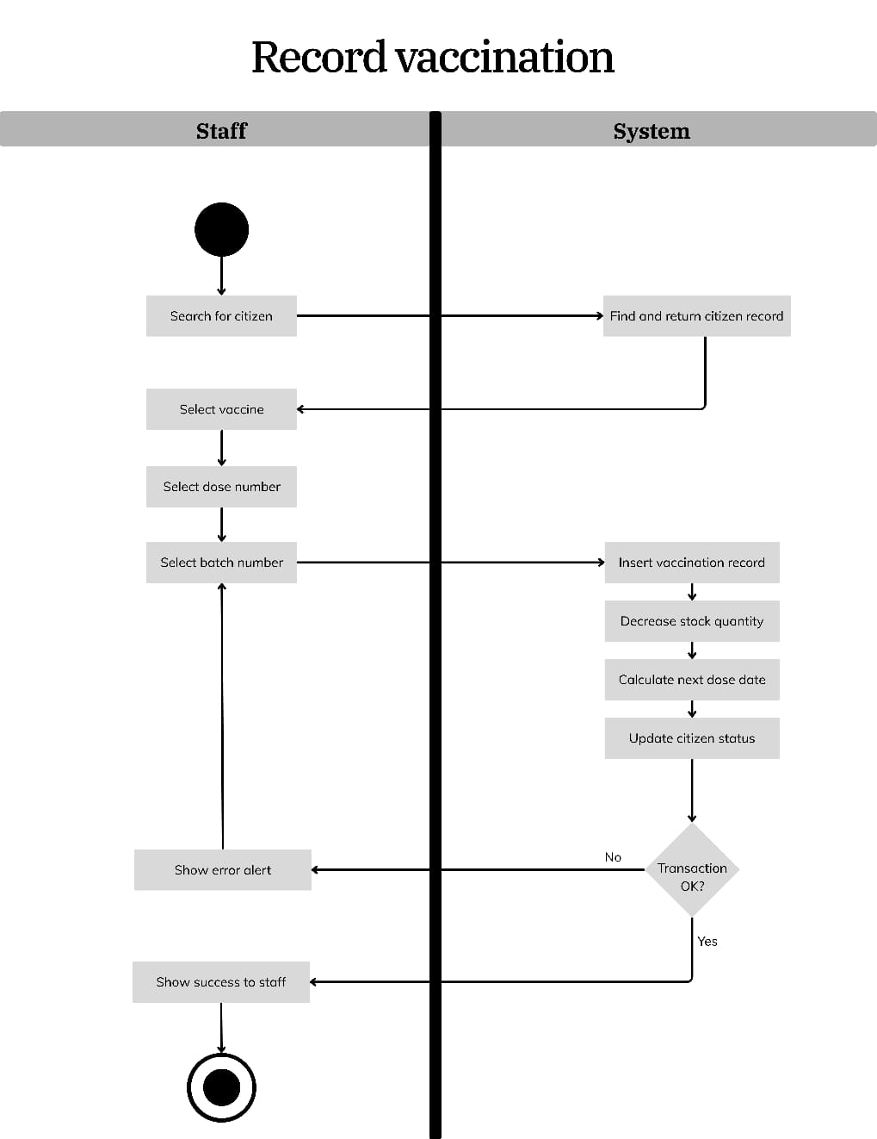
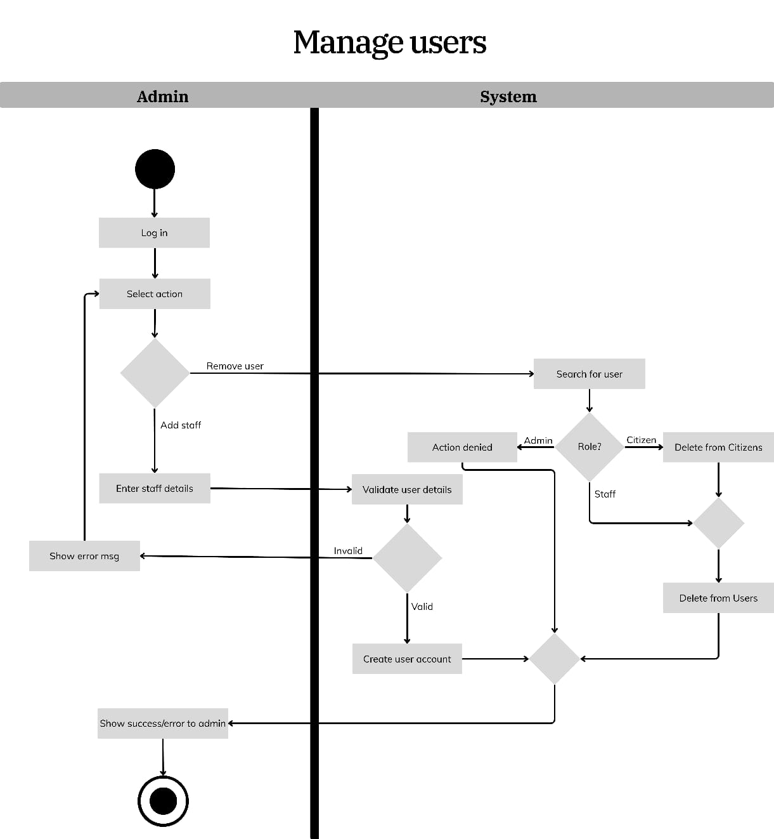
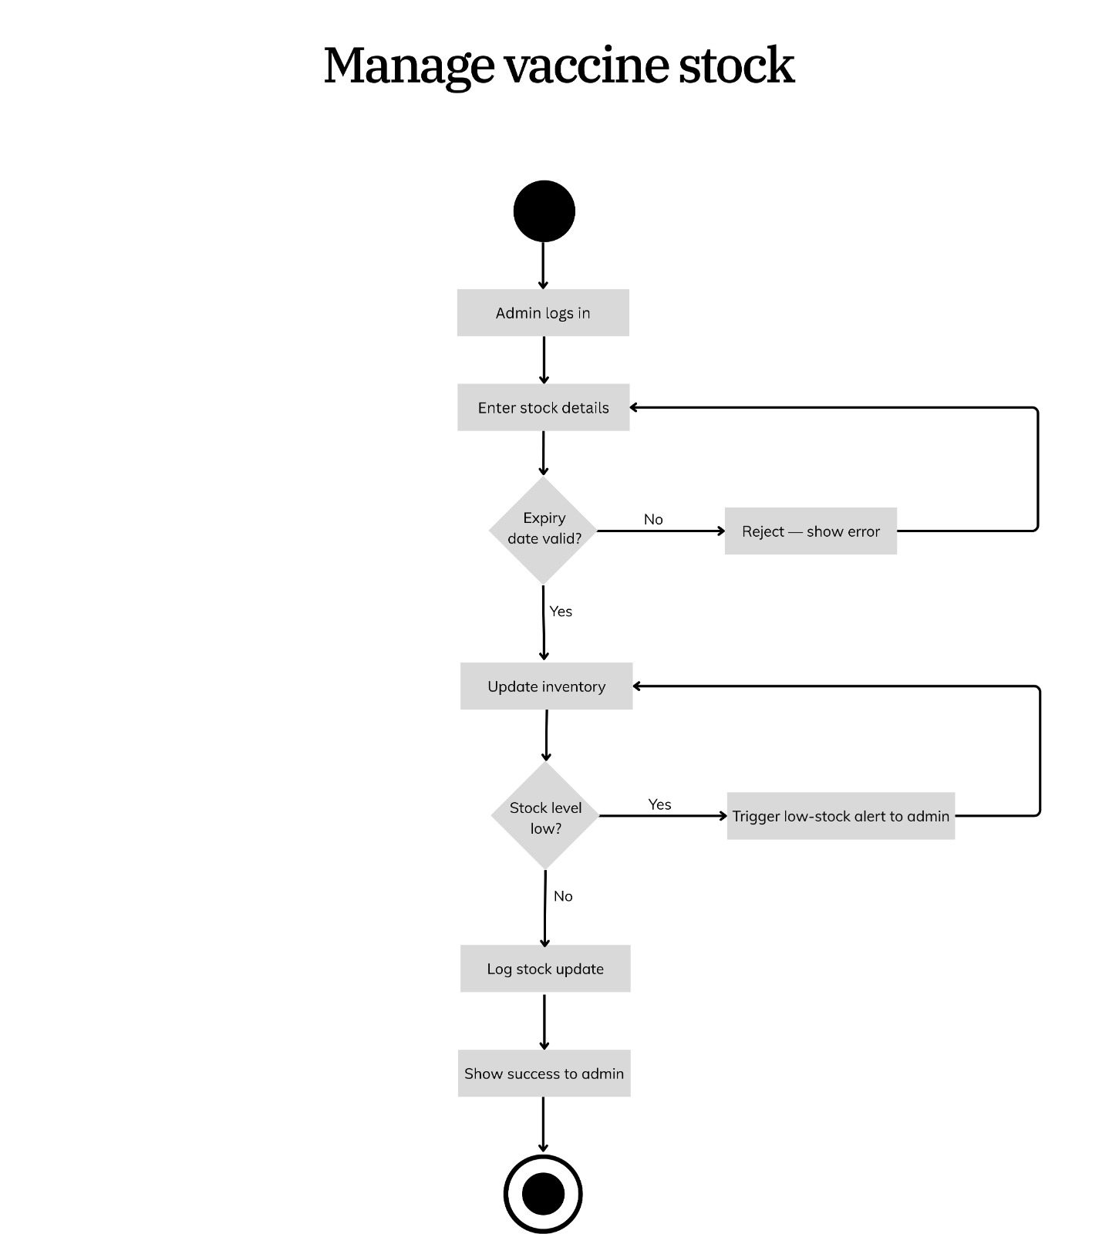

5.2.3 State Diagrams
Insert your state diagrams below. One diagram per key entity with meaningful state transitions is required.

5.2.2.1 Appointment State Diagram
States: Pending -> Completed / Cancelled.
Transitions: An appointment starts in the Pending state when booked. It moves to Completed when a staff member records the dose successfully (all safety checks passed). It moves to Cancelled when the patient does not attend or the staff manually cancels.

[Insert State Diagram for Appointment here]

5.2.2.2 Vaccine Stock State Diagram
States: Sufficient -> Low Stock -> Out of Stock.
Transitions: Stock starts in Sufficient state. When quantity falls below 100 doses, it transitions to Low Stock and triggers a dashboard alert for the Administrator (REQ-6). When quantity reaches 0, it moves to Out of Stock and the batch becomes unavailable for selection. If the administrator adds new stock, it returns to Sufficient.

[Insert State Diagram for Vaccine Stock here]

5.2.2.3 Patient Vaccination Status State Diagram
States: Unvaccinated -> Dose 1 Completed -> Dose 2 Due -> Fully Vaccinated.
Transitions: Patient starts as Unvaccinated. After the first dose appointment is marked Completed, they move to Dose 1 Completed and the system calculates the next dose date (REQ-7). After the next dose date is reached and the second dose is recorded as Completed, they move to Fully Vaccinated and the certificate download button becomes active (BR-2).

[Insert State Diagram for Patient Vaccination Status here]

6. References
- Karl E. Wiegers, Software Requirements Specification Template (1999). Used as the structural guideline for the SRS document.
- Pakistan's National Immunization Management System (NIMS). Referenced for vaccination workflows and CNIC-based identification.
- India's CoWIN Platform. Referenced for appointment booking and digital certificate features.
- WHO Immunization Information Systems Guidelines. Consulted for dose interval standards and vaccination data elements.
- PHP 8.1 Documentation. https://www.php.net/docs.php
- MySQL 8.0 Reference Manual. https://dev.mysql.com/doc/
- Bootstrap 5 Documentation. https://getbootstrap.com/docs/5.0/
- IEEE 830-1998 Standard for Software Requirements Specifications.

7. Appendices
Appendix A: Any additional diagrams, wireframes, or UI mockups that support the design described in this document should be inserted here.

Appendix B: The following items remain To Be Determined and will be finalized during the implementation phase:
- Exact visual layout of the PDF vaccination certificate
- Complete list of supported vaccines and their dose-interval values
- Final column structure of the Daily Coverage and Expiry reports
- Default daily appointment capacity per vaccination center

