Software Requirements
Specification
for
Vaccine Management
System
Version 1.0 approved
Prepared by:
Ameerah 24k-3113
Rumaesa 24k-3099
Umair Ehtesham 24k-3041
FAST-NUCES Karachi
21-04-2026

Table of Contents
Table of Contents
Table of Contents ii
Revision History ii
1. Introduction 6
1.1 Purpose 6
1.2 Document Conventions 6
1.3 Intended Audience and Reading Suggestions 6
1.4 Product Scope 7
1.5 References 7
2. Requirements Engineering Process 8
2.1 Requirements Elicitation 8
2.2 Requirements Analysis 9
2.3 Requirements Specification 9
2.4 Requirements Validation 9
3. Overall Description 9
3.1 Product Perspective 9
3.2 Product Functions 9
3.3 User Classes and Characteristics 10
3.4 Operating Environment 10
3.5 Design and Implementation Constraints 10
3.6 User Documentation 12
3.7 Assumptions and Dependencies 12
4. External Interface Requirements 12
4.1 User Interfaces 12
4.2 Hardware Interfaces 12
4.3 Software Interfaces 12
4.4 Communications Interfaces 12
5. System Features 13
5.1 System Feature 1: Patient Registration and Profile Management 13
5.2 System Feature 2: Vaccine Inventory and Stock Control 13
5.3 System Feature 3: Dose Scheduling and Tracking 14
5.4 System Feature 4: Certification and Reporting 14
6. Other Nonfunctional Requirements 14
6.1 Performance Requirements 14
6.2 Safety Requirements 14
6.3 Security Requirements 15
6.4 Software Quality Attributes 15
6.5 Business Rules 15
7. Other Requirements 15
7.1 Database Requirements 15
7.2 Legal and Regulatory Requirements 16
7.3 Internationalization Requirements 16
Appendix A: Glossary 16
Appendix B: Diagrams and Interaction Matrix 17
Appendix C: To Be Determined List 22
Revision History
Name | Date | Reason for Changes | Version
Ameerah, Rumaesa, Umair | 2026-04-21 | Initial Draft | 1.0

1. Introduction
1.1 Purpose

The purpose of this document is to specify the software requirements for the Vaccination Management System (VMS). The VMS is a centralized web-based solution designed to digitize vaccination records, inventory, and scheduling for small healthcare clinics. This SRS describes the functional and non-functional requirements for Version 1.0 of the software.
1.2 Document Conventions
This document follows the structural standards of the IEEE 830-1998 Software Requirements Specification. The following conventions are used throughout the document to ensure clarity:
- Requirement Identification: All functional and non-functional requirements are assigned a unique tag. Functional requirements in Section 4 use the prefix [REQ-X], while non-functional requirements in Section 5 use category-specific tags such as [REQ-S] for Safety and [REQ-SEC] for Security.
- Prioritization: Requirements are prioritized as High, Medium, or Low. High-priority requirements are those essential to the core "Dose Tracking" and "Stock Management" logic.
- Typographical Cues: * Boldface is used for technical terms, database entities (e.g., Name,ID), and specific system roles.
  - Italics are used for specific error messages or system alerts (e.g., Safety Violation).
- Verification: All requirements are written to be "verifiable" through testing. Quantifiable measures (e.g., 100 doses threshold, 2-second load time) are used where possible to allow for objective evaluation.
1.3 Intended Audience and Reading Suggestions

The intended audience for this SRS is the Course Instructor (Alina Arshad) and Teaching Assistants only. It is designed to demonstrate the structured application of Software Requirements Engineering (SRE) for academic evaluation. Readers should begin with the Overall Description (Section 2) for context before reviewing the specific functional requirements in Section 4.

1.4 Product Scope
The VMS is a conceptual system that provides a computerized alternative to manual paper registers. It supports:
- Citizen/Patient registration.
- Vaccine inventory management and real-time tracking.
- Automatic calculation of next-dose schedules.
- Generation of downloadable vaccination certificates and coverage reports. It does not connect to external government databases or handle financial transactions.
1.5 References
The following documents and resources were used as references during the elicitation of requirements and the design of the Vaccination Management System (VMS):
- Karl E. Wiegers SRS Template (1999): Used as the primary structural guideline for this Software Requirements Specification document.
- CS 2005 Database Systems Project Proposal: The internal project document defining the core database functionalities, including patient registration and stock tracking.
- Vaccination Management System (SRE Proposal): The academic proposal outlining the intended audience, stakeholder elicitation strategy, and project scope for the Software Requirements Engineering course.
- Pakistan’s National Immunization Management System (NIMS): Used as a functional reference for COVID-19 record management and national vaccination workflows.
- India’s CoWIN Platform: Referenced for its appointment booking and digital certification features.
- WHO Immunization Information Systems Guidelines: Consulted for standard medical practices regarding dose intervals and vaccine data management.
- PHP 8.1 and MySQL Documentation: Technical references used to define the implementation constraints for server-side processing and relational database management.
- Bootstrap 5 Framework Documentation: Used as the standard for developing the responsive and modern user interface required for the system.

2. Requirements Engineering Process
The Requirements Engineering (RE) process for the Vaccine Management System consists of four phases: Requirements Elicitation, Requirements Analysis, Requirements Specification, and Requirements Validation.

2.1 Requirements Elicitation
Requirements elicitation was conducted using a survey-based technique through Google Forms. This approach was selected to efficiently collect structured input from multiple stakeholders and to analyze responses quantitatively.

Method Used: Google Forms
A questionnaire was designed and distributed among key stakeholders, including medical students, doctors, and physicians. The responses were automatically recorded in Google Sheets for analysis and interpretation.

Survey Design
The survey included:
- Multiple-choice questions to identify required system features
- Likert scale questions to evaluate importance
- Open-ended questions for additional suggestions

Participants
The survey received a total of 20 responses from stakeholders including students, doctors, and physicians.

Key Findings
- A clear majority of respondents reported difficulty in tracking vaccine availability manually
- Most participants preferred an online appointment booking system
- A large proportion of users required reminder and notification features
- Respondents strongly emphasized the importance of secure patient data handling
- Many users highlighted the need for centralized vaccination record management

Data Analysis
The collected responses were analyzed using Google Sheets. Frequency distribution and trend analysis were used to identify dominant user requirements and common patterns.

Outcome

The survey analysis helped identify key functional and non-functional requirements for the system. A detailed description of these requirements is provided in later sections of this document.

2.2 Requirements Analysis
The collected requirements were analyzed to remove inconsistencies, resolve conflicts, and ensure completeness.

2.3 Requirements Specification
The finalized requirements were documented in this SRS in a structured format.

2.4 Requirements Validation
The requirements were reviewed to ensure they accurately represent stakeholder needs and are feasible for implementation.
3. Overall Description

3.1 Product Perspective
The VMS is a new, self-contained, web-based product. It is an academic project for the Database Systems and SRE courses. The system replaces manual spreadsheets to eliminate data inconsistency and stock mismanagement.

3.2 Product Functions
- Patient Management: Registration and secure storage of personal details.
- Inventory Control: Tracking batch numbers and expiry dates with automated low-stock alerts.
- Vaccination Scheduling: Booking appointments at specific centers and calculating intervals.
- Certification: Generating PDF certificates upon completion of doses.
- Reporting: Instant generation of stock and vaccination history reports.

3.3 User Classes and Characteristics
The Vaccination Management System (VMS) identifies three primary user classes. Each class is differentiated by its access level and the specific tasks it performs within the system.
User Class | Description & Characteristics | Privilege Level
Administrator | Clinic managers or system owners who oversee daily operations. They are expected to have moderate technical expertise. Their main tasks include managing user accounts for staff, updating vaccine types, and monitoring critical stock levels. | High: Full access to all system settings, inventory reports, and user management modules.
Healthcare Staff | Doctors, nurses, or data entry operators who interact with the system throughout the workday. They have basic computer skills. Their primary responsibilities include searching patient history, recording administered doses, and updating appointment statuses. | Medium: Access to patient registration, vaccination records, and scheduling; restricted from administrative settings.
Citizens / Patients | Individuals receiving vaccinations who access the system via the web. This is the largest and most diverse user group with varying levels of technical expertise. They use the system primarily to book appointments and download certificates. | Low: Access is strictly limited to their own personal profiles, appointment booking, and certificate downloads.

3.4 Operating Environment
• Platform: Web application accessible via modern browsers (Chrome, Firefox, Edge).
• Server: Apache Web Server.
• Database: MySQL managed via phpMyAdmin.

2.5 Design and Implementation Constraints
The development and deployment of the Vaccination Management System (VMS) are subject to the following constraints:
Technology Stack Constraints:
    - Back-end: The system must be developed using PHP 8.1 to ensure compatibility with the provided server environment.
    - Front-end: The user interface must utilize HTML5, CSS3, and JavaScript, specifically incorporating the Bootstrap 5 framework to ensure the application is mobile-responsive.
    - Database: Data persistence must be handled strictly through a MySQL relational database managed via phpMyAdmin.
Development Environment Constraints:
  - The project must be developed and tested within the XAMPP local server environment.
  - All code development is restricted to standard text editors, primarily Visual Studio Code.
Hardware and Network Limitations:
    - Connectivity: The system is designed as a web-based application and requires a consistent internet connection to access the centralized database.
    - Browser Compatibility: The application must operate peacefully across updated versions of Chrome, Firefox, and Edge; it is not required to support legacy browsers (e.g., Internet Explorer).
Security and Privacy Constraints:
    - Data Protection: The system must implement password encryption (hashing) for all user accounts to prevent unauthorized access to sensitive medical data.
    - Access Control: A Role-Based Access Control (RBAC) mechanism must be enforced, ensuring that each user is assigned only one role (Admin or Staff) to prevent privilege escalation.
    - Regulatory Compliance: While conceptual, the system design must aim to follow data privacy laws to maintain patient confidentiality.
Operational Constraints:
    - Capacity Limits: Each vaccination center within the system must operate under a defined daily appointment capacity to prevent overbooking.
    - Language: The primary user interface and all generated reports will be provided in English only.
3.6 User Documentation
The system will provide digital instructions and tooltips for staff to handle registration and inventory workflows.
3.7 Assumptions and Dependencies
• The clinic has a reliable internet connection.
• Staff possess basic computer knowledge.
• Vaccine data (doses/intervals) follows standard medical guidelines.
• The database is backed up regularly to prevent data loss.
4. External Interface Requirements
4.1 User Interfaces
• A responsive dashboard built with Bootstrap 5.
• Intuitive navigation using Font Awesome icons.
• Specific forms for registration, stock entry, and appointment booking.
4.2 Hardware Interfaces
The software will run on any standard PC or mobile device with a modern web browser.

4.3 Software Interfaces
• Database: Connects to a MySQL database using SQL queries.
• Server Environment: Developed and tested using XAMPP.
4.4 Communications Interfaces
All communication between the client and server will occur over HTTP/HTTPS protocols.
5. System Features
5.1 System Feature 1: Patient Registration and Profile Management
5.1.1 Description and Priority (High)
This feature allows healthcare staff and citizens to create and maintain digital profiles. This is the foundation of the system, ensuring every vaccination is tied to a verified individual.
5.1.2 Functional Requirements
REQ-1: The system shall allow staff to register new patients using unique identifiers (ID, Name, Age, Gender, and Phone Number).
REQ-2: The system shall permit patients to update their contact information (phone number and address) via a secure login.
REQ-3: The system shall prevent duplicate registrations by validating the unique ID against the existing database.
5.2 System Feature 2: Vaccine Inventory and Stock Control
5.2.1 Description and Priority (High)
This feature tracks the lifecycle of vaccine doses from arrival at the clinic to administration. It aims to eliminate manual errors in stock counting.
5.2.2 Functional Requirements
REQ-4: The system shall record batch numbers, manufacturer names, and expiry dates for all incoming vaccine stock.
REQ-5: The system shall automatically decrement the stock count by one (1) whenever a vaccination dose is marked as "Completed."
REQ-6: The system shall trigger a dashboard alert for the Administrator when the stock of any vaccine type falls below a threshold of 100 doses.

5.3 System Feature 3: Dose Scheduling and Tracking
5.3.1 Description and Priority (High)
This feature manages the timing of vaccinations. It ensures that follow-up doses are not missed and are administered at the correct intervals.
5.3.2 Functional Requirements
REQ-7: The system shall automatically calculate the "Next Dose Due Date" based on the specific interval logic (e.g., 21 days for Pfizer) stored in the vaccine table.
REQ-8: The system shall allow citizens to view available time slots and book appointments at specific clinic centers.
REQ-9: The system shall allow healthcare staff to search for a patient's history using their ID and update the status of an appointment (Pending, Completed, or Cancelled).
5.4 System Feature 4: Certification and Reporting
5.4.1 Description and Priority (Medium)
This feature provides the "output" of the system, allowing for the verification of vaccination status and administrative oversight.
5.4.2 Functional Requirements
REQ-10: The system shall generate a downloadable PDF Vaccination Certificate once a patient has completed the required number of doses.
REQ-11: The system shall provide the Administrator with real-time reports on "Daily Vaccination Coverage" (total doses administered per day).
REQ-12: The system shall generate "Expiry Reports" listing all vaccine batches that will expire within the next 30 days.
6. Other Nonfunctional Requirements
6.1 Performance Requirements
- Response Time: The system shall load the main dashboard and retrieve patient search results (REQ-9) within 2 seconds to ensure clinical efficiency.
- Concurrency: The system must support at least 20 concurrent sessions (staff and citizens) without any degradation in response time or database locking.
- Real-time Updates: Stock level adjustments (REQ-5) must reflect globally across the system immediately (within 1 second) after a vaccination is marked as completed.

6.2 Safety Requirements
REQ-S1 (Expiry Blocking): The system shall programmatically prevent a staff member from selecting a vaccine batch for a patient if the current system date is equal to or later than the Expiry Date recorded in REQ-4.
REQ-S2 (Interval Validation): To ensure patient health safety, the system shall display a "Safety Violation" alert and block the "Complete" status if a staff member tries to record a dose before the Next Dose Due Date calculated in REQ-7 has been reached.
REQ-S3 (Data Persistence): In the event of a browser crash or power failure at the clinic, the database must use SQL Transactions to ensure that no partial patient registration (REQ-1) or incomplete stock decrement (REQ-5) is saved.

6.3 Security Requirements
REQ-SEC1 (Data Encryption): All user passwords must be hashed using the BCRYPT algorithm before being stored in the MySQL database to protect against data breaches.
REQ-SEC2 (Role-Based Access Control - RBAC): * Citizens shall be restricted by the software from accessing the inventory management (REQ-4, REQ-5) and reporting modules (REQ-11, REQ-12).
Healthcare Staff shall be restricted from deleting records or managing user accounts.
REQ-SEC3 (Session Management): The system shall automatically terminate a session after 20 minutes of inactivity to prevent unauthorized access if a clinic terminal is left unattended.

6.4 Software Quality Attributes
- Usability: The system shall follow a "consistent navigation" principle using Bootstrap 5, where the search bar and "Register Patient" button are always visible on the sidebar for Healthcare Staff.
- Reliability: The system shall maintain an uptime of 99.5% during the standard clinic operating hours (9:00 AM to 9:00 PM).
- Robustness: If a user enters an invalid CNIC/ID format (e.g., letters instead of numbers) in REQ-1 or REQ-3, the system shall provide a clear error message: "Invalid ID format. Please use numeric characters only," rather than failing.

6.5 Business Rules
BR-1 (Minimum Stock Alert): The low-stock threshold is fixed at 100 doses. This value can only be modified by a System Administrator with direct database access, not via the standard UI.
BR-2 (Certificate Eligibility): A "Download Certificate" button (REQ-10) shall only become active/visible if the patient's record shows the final dose status as "Completed" for their specific vaccine type.
BR-3 (Single Role Restriction): To maintain accountability, no user profile is permitted to hold both the Administrator and Citizen roles simultaneously.

7. Other Requirements
This section captures specific requirements that do not fit into the functional or non-functional categories but are essential for the system's successful implementation.

7.1 Database Requirements
- Logical Storage: The system shall use a Relational Database Management System (RDBMS), specifically MySQL, to ensure data integrity through foreign key constraints and primary keys.
- Data Retention: The system must be capable of storing at least 50,000 patient records and 100,000 vaccination entries without performance degradation.
- Audit Trail: The database must store a timestamp for every vaccination recorded to track when the data was entered and by which staff member.

7.2 Legal and Regulatory Requirements
- Data Privacy: While this is an academic project, the system design must respect the principle of data minimization—only collecting personal information (CNIC/ID, Age, Phone) necessary for vaccination tracking.
- Academic Compliance: The system must meet all requirements set forth by the National University of Computer & Emerging Sciences for the Database Systems and SRE courses.

7.3 Internationalization Requirements
- Language: The user interface, system alerts, and generated certificates shall be provided in English.
- Date Format: To avoid confusion in medical records, the system shall strictly use the DD/MM/YYYY format for all dates.

Appendix A: Glossary
Defining these terms ensures that the Instructor and TA interpret the requirements exactly as intended.
- Administrator: The user role responsible for managing system settings, staff accounts, and vaccine stock levels.
- Bootstrap 5: A front-end framework used to ensure the VMS is responsive and works on mobile devices.
- ID: The unique identifier for citizens in the system.
- Dose Interval: The minimum required waiting period between the first and second dose of a specific vaccine.
- Healthcare Staff: Users (doctors or nurses) who perform the physical vaccination and update the records in the system.
- NIMS: National Immunization Management System (Reference point for the project).
- RBAC (Role-Based Access Control): A security method that restricts system access to authorized users based on their specific role (Admin, Staff, or Citizen).
- VMS: Vaccination Management System (The name of this project).
- XAMPP: A local server environment containing Apache and MySQL used for developing this project.

Appendix B: Diagrams
- Use-case Description
VMS-UC-01 : Recording Vaccination Dose
Use case Id: |  | VMS-UC-01
Actors: Healthcare Staff (Initiator), Patient/Citizen (Secondary)
Feature: Clinical Data Entry and Dose Tracking (Section 4.3)
Pre-condition: |  | 1. Healthcare Staff is authenticated and logged into the portal.  2. The Patient must be present and registered in the system.  3. Sufficient vaccine inventory must be available in the local database.
Scenarios
Step# | Action |  |  | Software Reaction
1. | Staff searches for the patient using their unique ID. |  |  | System queries the Patients table and displays the profile.
2. | Staff initiates the "Record Vaccination" flow. |  |  | System triggers the Validate Patient include-case to verify eligibility.
3. | Staff confirms the administration of the vaccine dose. |  |  | System creates a new record in the database.
Alternate Scenarios: •1a: Invalid Patient ID: If the search returns no results, the system prompts the staff to navigate to Register Patient Profile.
•2a: Validation Failure: If Validate Patient returns a "Not Eligible" status (e.g., dose interval not met), the system blocks the recording and displays a reason.
•3a: Out of Stock: If the selected vaccine has a quantity of 0, the system displays an error and prevents the "Confirm" action.

Post Conditions 1. The vaccination event is successfully committed to the MySQL database with a timestamp.
2.The specific vaccine batch count is reduced by exactly one (1) unit.
3.The patient's status is updated, potentially enabling the Download Certificate feature.
4.A next-dose reminder/date is generated based on the specific vaccine's interval logic.
Step# | Description
 | Not Applicable
 | Not Applicable
 | Not Applicable
Use Case Cross referenced |  |  | • Includes: UC-11 (Validate Patient), UC-06 (Update Stock).  • Extended by: UC-10 (Managing Critical Stock Alert) if inventory hits the threshold.  • Related: UC-04 (Download Certificate), UC-03 (View Vaccination History).
Figure B.2: Use-Case Description for Vaccination Management System (VMS)

- Use-case Diagram
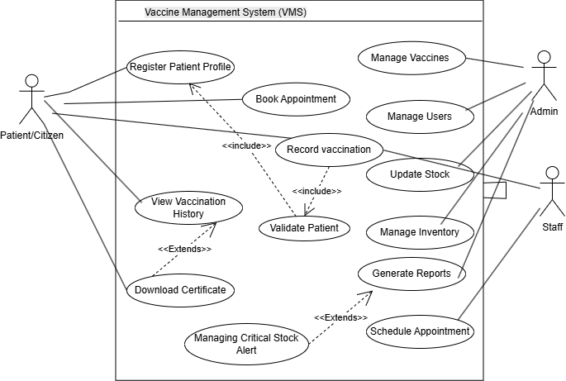
Figure B.2: Use-Case Diagram for Vaccination Management System (VMS)

- Class Diagram
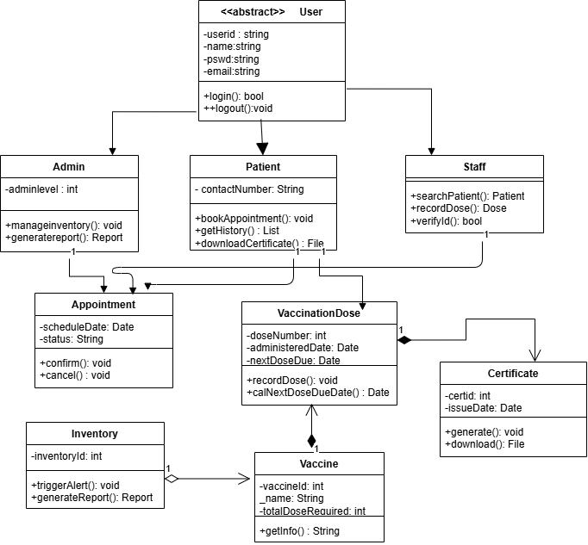
Figure B.3: Class Diagram for Vaccination Management System (VMS)

- Entity-Relationship Diagram
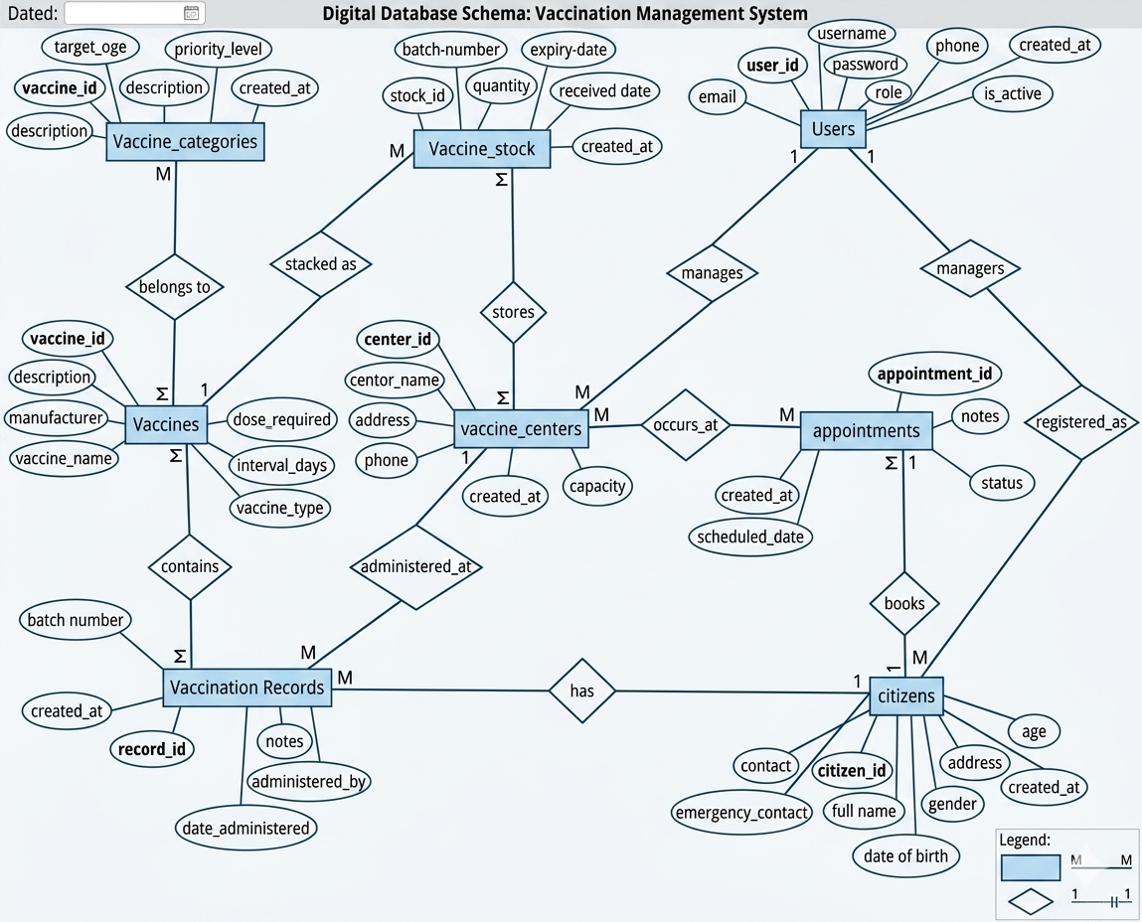
Figure B.4: Entity-Relationship Diagram (ERD) for Vaccination Management System (VMS)

- Interaction Matrix

Requirement Interaction Matrix (0–10–100 Scale)

Scale Meaning
- 0 = No interaction or dependency
- 10 = Moderate interaction
- 100 = Strong interaction / direct dependency
Requirements | REQ-1 | REQ-4 | REQ-5 | REQ-7 | REQ-8 | REQ-9 | REQ-10 | REQ-11
REQ-1 Patient Registration | 100 | 0 | 10 | 10 | 10 | 100 | 10 | 0
REQ-4 Inventory Management | 0 | 100 | 100 | 10 | 0 | 10 | 0 | 100
REQ-5 Stock Decrement | 10 | 100 | 100 | 10 | 0 | 100 | 0 | 100
REQ-7 Dose Scheduling | 10 | 10 | 10 | 100 | 100 | 100 | 10 | 0
REQ-8 Appointment Booking | 10 | 0 | 0 | 100 | 100 | 100 | 0 | 0
REQ-9 Patient Tracking | 100 | 10 | 100 | 100 | 100 | 100 | 100 | 10
REQ-10 Certificate Generation | 10 | 0 | 0 | 10 | 0 | 100 | 100 | 10
REQ-11 Coverage Reports | 0 | 100 | 100 | 0 | 0 | 10 | 10 | 100
Table B.1: Interaction Matrix for Requirements of Vaccine Management System (VMS)

- The interaction matrix shows how strongly system requirements depend on each other.

Strong Interactions (100)
REQ-4 and REQ-5 are strongly connected because inventory updates directly affect stock decrement.
REQ-7, REQ-8, and REQ-9 work closely together for scheduling and patient tracking.
REQ-10 depends heavily on completed vaccination records from REQ-9.
REQ-11 relies on inventory and vaccination data for accurate reporting.

Moderate Interactions (10)
- Patient registration supports scheduling, tracking, and certification.
- Inventory data moderately affects scheduling decisions.

No Interaction (0)
Some modules such as appointment booking and reporting operate independently.
- Overall, patient tracking, scheduling, and inventory management are the most interconnected modules and require careful integration and testing.

Appendix C: To Be Determined List
This is a numbered list of items that are currently unresolved but will be finalized during the coding and implementation phase of your project.
- Vaccination Certificate Layout: The exact visual design and logo placement for the downloadable PDF certificate are yet to be finalized.
- Specific Vaccine Data: The full list of supported vaccines (e.g., Sinopharm, Pfizer, Polio) and their specific dose-interval logic needs to be finalized in the database schema.
- Password Hashing Algorithm: The specific PHP hashing function (e.g., password_hash() with BCRYPT) will be selected during the security implementation.
- Reporting Templates: The exact columns and filters for the "Vaccination Coverage Report" and "Stock Status Report" are to be determined based on final database table structures.
- Center Capacity Logic: The maximum number of daily appointments per center (e.g., 50 or 100) will be configurable but currently has no set default.

