

National University of Computer and Emerging

Sciences



Software for Mobile Devices

(Section A)

Fall 2019

**Instructor:** Mr. Ahmad Shahwaiz

Assignment 2

**Date:** September 8, 2019

**Author:** Abdul Wasey (TA)

**Due Date:** September 13, 2019 (Friday – 11:59 PM)

**Instructions:**

* You are required to do this assignment **individually.**.
* You must do this assignment using Android Studio with Java and XML language. **No template should be used.**
* Please properly comment your code.
* It is highly preferable that you code as per [Android](https://blog.mindorks.com/android-code-style-and-guidelines-d5f80453d5c7) and [Java styling guide](https://github.com/twitter/commons/blob/master/src/java/com/twitter/common/styleguide.md#field-class-and-method-declarations). However, it won’t affect the marking criteria.
* Submit this assignment by **emailing** me your work before deadline. You have to cc the email to your **class instructor** as well.
* Make the project folder inside your local repository directory. Please don’t work outside your repository and then copy files.

**_____________________________________________________________________________________**

**Part 1 (Marks: 10):**

Like in previous assignment(s), use **GitBash** to do all of your Git operations.

For this part:

* Those who don’t have their own repositories will create these as per the instructions in Assignment 1
* You will create Android Studio project named “Assignment 2 - GUI” **inside** your local repository (SMD Assignments)
* You will work only on your own branch e.g. yourname_dev. You will push and commit only in this branch
* There shouldn’t be any push or commits in the **master** and **develop** branches for this assignment
* Upon completing work, you will switch to develop branch and merge your branch’s work in develop branch
* There shouldn’t be anything related to assignment 2 in master branch

**Note:** Now, you have been fairly familiar with Git, so now, you are expected to work properly on Git Bash. Therefore, this part will have **binary** checking.

**Part 2 (Marks: 300):**

For this part, you need to create GUI having different screens using various Android **layouts** and **components**.

* **Screen No: 1 (70)**

**“Sign Up”** will be the first screen that users will see. You must design using this screen using **Constraint Layout**.

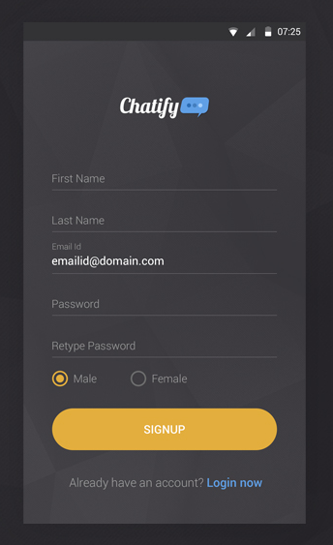**Sample:**

Your design can be different from the sample above but following should be included must:

* All the components shown in the sample

(Text, Password, Email, Radio buttons, etc. Try to add more)

* Logo
* Rounded buttons
* UI should be centered on all the screen sizes
* An exit button in the same row as Sign Up button
* Upon tapping Sign Up, the app should move to the next screen
* Upon tappin exit, the app should be closed
* **Screen No: 2 (75 + (50 + 75 + 15 + 15))**

After tapping Sign Up button, the user should be brought to this screen. This screen would have **Tab Layout that will include three fragments.**

**Tutorial(s)**:

* <https://www.tutlane.com/tutorial/android/android-tabs-with-fragments-and-viewpager>
* <https://www.youtube.com/watch?v=h4HwU_ENXYM>

(Don’t just rely on these, you can follow any guide/tutorial related to fragments and tab layouts. However, you should know **everything** about the code you follow.)

**Sample:**

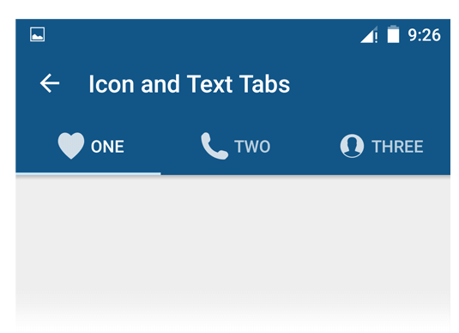Following should be included must:

* Back arrow – Tapping it should return you to previous screen
* Title of the screen: GUI Demo (*Roll Number*)
* Icons in fragment names as shown in sample
* There should be four fragments

Fragments should be named as:

1. Relative Layout
2. Constraint Layout
3. Frame Layout
4. Linear Layout

Each of these fragments should be designed with their titled layouts. E.g. “Linear Layout” fragment would have Linear Layout and as such.

1. **Relative Layout**

**Sample:**

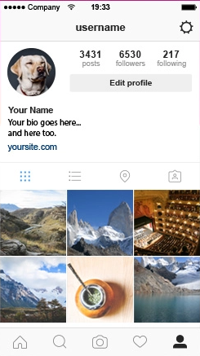You would clone this UI using **Relaive Layout**. Some instructions:

* The bottom navigation bar should be fixed
* Use Grid Layout inside the main layout to display pictures (Ideally, Grid View is used, but for this demo, get handy with Grid Layout)
* Profile pic should be rounded

1. **Constraint Layout**

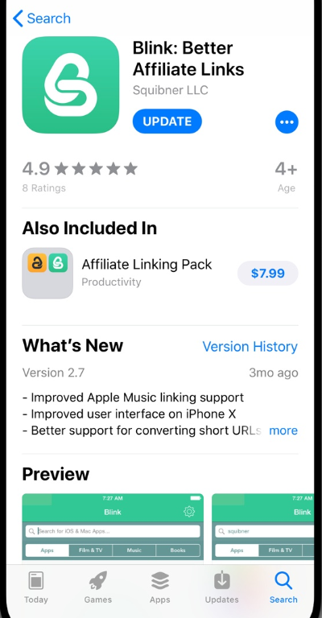**Sample:**

You would clone this UI with **Constraint Layout.** Instructions:

* For the sections: “4.9”, “Also Included In”, “What’s New”, “Preview”, you must use **Card Views** i.e.these rows/sections should be in separate cards
* The picture at the top should be centered unlike in the sample

1. **Frame Layout**
2. **Linear Layout**

For 3 and 4, you are free design any sort of UI using the respective layouts. Please note, that these UI(s) shouldn’t be fairly simple. You should use multiple compenents here as well.

**Guidelines:**

* All of the strings must be in the “strings.xml”
* All the dimensions must be in “dimens.xml”
* All the colors should be in “colors.xml”
* It is essential that you utilize these resources:
  + https://fonts.google.com/specimen/Nunito
  + https://www.flaticon.com/

**Submission Format:**

* **Submit to:** abdulwaseybutt@gmail.com
* **CC:** [ahmadshahwaiz@gmail.com](mailto:ahmadshahwaiz@gmail.com)
* **Subject:** SMD Assignment 2
* **Body:** GitHub link, Zip File

**Note:** As per your instructor, please write **formal submission** emails from now on. You shouldn’t just paste the link and attach files, **instead formally state some context related to the submitted work**, mention the one you are submitting to and give your regards for good practice. Also make your signature by going through from settings menu.

**GitHub:**

* Your Git repo would contain all of the project files except for the build files

To avoid pushing build files to the remote repository:

* + Open the **.gitignore** file in your Android project folder
  + Write “app/build” at the end of the file
  + Save the file

Files mentioned in .gitignore are ignored at the time of pushing, meaning that these don’t get sent to the remote repository

**Zip File:**

* It should be named with your roll number and fullname e.g. **“15L-1234 (Your Name).zip”**
* It would contain two things:
  + APK file ( **Name:** “GUI Demo (15L-1234).apk” – It should be your roll number inside )
  + A folder called **Screenshots** that will have the screenshots of all the screens in your app

**_____________________________________________________________________________________**

**For any issues, please feel free to contact me on Piazza or via email – after trying finding the solution on your own first.**

**Good Luck!**