

**Title:** *One Stop Degree Issuance System*

**Sprint Backlog**

**Group Description:**

*Group # 7*

Ali Umer (21I-0380)

Umair Khalid (21I-0455)

Abdullah Khan (20P-0100)

**Roles:**

Umair Khalid **(Scrum Master and Developer):** Will handle all the coordination of tasks and ensure that the Scrum framework is followed. Another responsibility of the Scrum Master is to facilitate communication and collaboration between team members and the stakeholders. As being a developer in the team, the member is also responsible for the creating and testing of crucial features of this system.

Abdullah Khan  **(Product Owner and Developer):** The Product Owner is responsible for representing the stakeholders to clearly define and present the user requirement with the team. In other words, the Product Owner acts as a bridge between the stakeholders and the team members. Apart for this, as being a developer in the team, this member is also responsible for the creating and testing of crucial features of this system.

Ali Umer **(Developer and Tester):** The developer is responsible for potentially delivering the shippable product increment at the end of each Sprint. One task of this member is to create and test crucial functionalities of this system. A developer and Tester closely collaborate with other members including the Product Owner and Scrum Master to understand the requirements and implement the features effectively.

**Total Number of Sprints: 3**

**Sprint # 1**

**Modules to be Developed**

**Feature Name:** *Submit Degree Issuance Form*

**Story ID: 001**

**User Story:** As a Student, I want to submit my Degree Issuance Form, so that I can request the university administration to start the process of my degree issuance.

Respective Tasks:

1. Implement a Student Login
2. Implement a frontend for degree issuance submission.
3. Create a Form for Degree Issuance.
4. Create backend API endpoint to receive and process degree issuance form data.
5. Validate the submitted Degree Issuance Form.
6. Store Data in the Database Accordingly.

**Feature Name:** *Submit Student Complaint Forms*

**Story ID: 002**

**User Story:** As a Student, I want to fill a Complaint Form, so that I can file my desired complaint to the university administration regarding my degree issuance process.

Respective Tasks:

1. Create a Student Complaint Form.
2. Implement backend to receive and process Student’s Complaint.

**Feature Name:** *Track Activity*

**Story ID: 003**

**User Story:** As a Student, I want to track my Generated Requests, so that I stay updated about my Degree Issuance process.

Respective Tasks:

1. Create a Student Complaint Form.
2. Implement backend to receive and process Student’s Complaint.

**Feature Name:** *Generate Degree*

**Story ID: 004**

**User Story:** As a Student, I want the university administration to generate my degree, so that I can receive my degree on the Degree Issuance Portal.

Respective Tasks:

1. Create a Student Complaint Form.
2. Implement backend to receive and process Student’s Complaint.

**Feature Name:** *Submit Student Data Change Form*

**Story ID: 005**

**User Story:** As a Student, I want to submit my Student’s Data Change Form, so that I provide the university administration with my updated data that has been requested for a change.

Respective Tasks:

1. Create a Student Data Change Form.
2. Implement backend to receive and process Student’s Data Change Form.

**Feature Name:** *Submit Student Feedback*

**Story ID: 006**

**User Story:** As a Student, I want to submit my Feedback Form, so that I can provide my comments regarding the usability of this system.

Respective Tasks:

1. Create a Student Feedback Form.
2. Allow student to view the feedback form.
3. Validate the Given Student Input.
4. Store the Data in the Database.
5. Develop backend functionality to process Student feedback.

**Feature Name:** *Receive Student Notification for Degree Issuance.*

**Story ID: 007**

**User Story:** As an Admin, I want to receive student’s notification for Degree Issuance, so that I can address the student’s request of Degree Issuance related to Finance Department.

Respective Tasks:

1. Set up a system to notify admins when a student submits a request for degree issuance, particularly those that involve the Finance Department.
2. Modify the admin dashboard to display these notifications and allow admins to directly address and resolve each degree issuance request.

**Feature Name:** *Generate Tokens*

**Story ID: 008**

**User Story:** As an Admin, I want to Generate a Token, so that I can assign a unique id and required time for every student’s request.

Respective Tasks:

1. Make a process to generate unique token to suppourt degree issuance requests.
2. These tokens should be generated on every submission of degree issuance form.
3. Now the integration logic of token generation will be integrate with frontend to display tokens to Onestop admin and students.
4. Now test token generation process and its reliablity.

**Feature Name:** *View Requests Log*

**Story ID: 009**

**User Story:** As an Admin, I want to view the Requests Log, so that I can view all the requests received from the students that are either processed, pending or in new state.

Respective tasks:

1. Create a database schema for the backend to manage records of degree issuance requests.
2. Build backend capabilities to fetch and show all requests with their respective statuses.
3. Design a user interface for the Onestop admin to observe and sort requests by status and additional criteria.
4. Conduct tests on the request viewing feature to verify the precision and completeness of the information presented.

**Feature Name:** *Respond to Requests*

**Story ID: 010**

**User Story**: As an Admin, I want to reply to a student’s requests, so that I can inform the student about any objection on their request from the FYP or Finance Department.

Respected tasks:

1. Modify the database to include fields for storing admin responses and any related objections from departments.
2. Update the admin interface to include a response form where admins can write and submit their replies to student requests.
3. Conduct testing to ensure the new functionality works correctly and then deploy the changes to the production environment.

**Feature Name:** *Issue Degree*

**Story ID: 011**

**User Story**: As an Admin, I want to issue a degree, so that I can complete the student’s request for degree issuance and update the processed request list.

Respected Tasks:

1. Create a function to update the student's request status to "issued" once the degree is processed.
2. Add a button or form on the admin panel that allows for issuing degrees and updating the request list.

**Feature Name:** *Update Student Data*

**Story ID: 012**

**User Story**: As an Admin, I want to receive student’s data change request form, so that I can update the student’s data that was previously incorrect.

Respected task:

1. Develop a system on the backend to accept and update student data based on admin approval.
2. Add a form to the admin section of the website where admins can review and approve changes to student data.

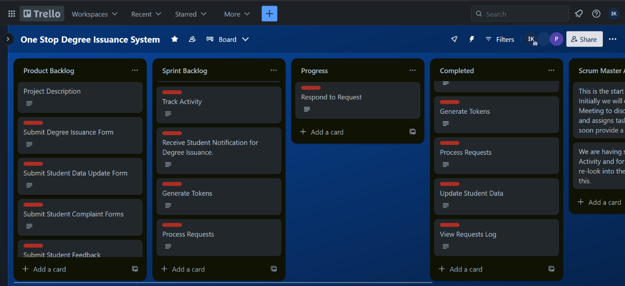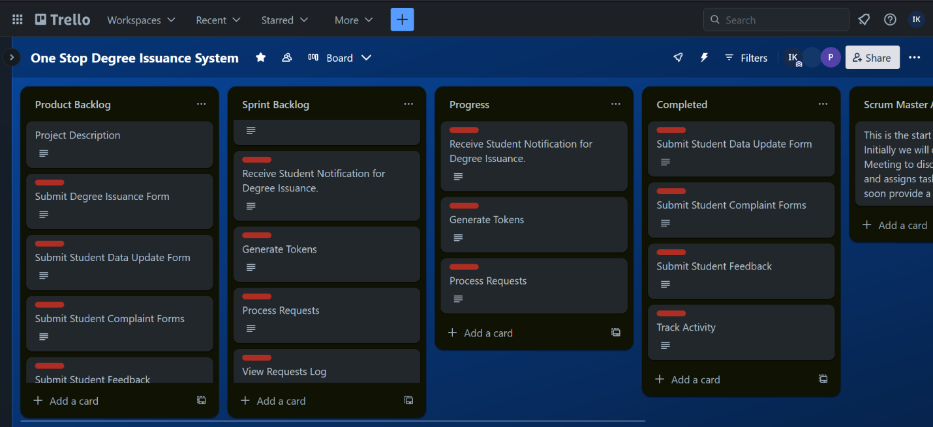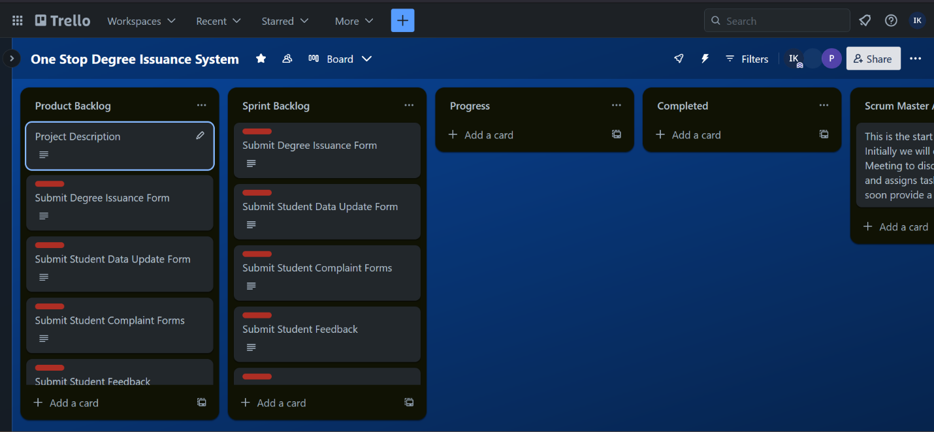

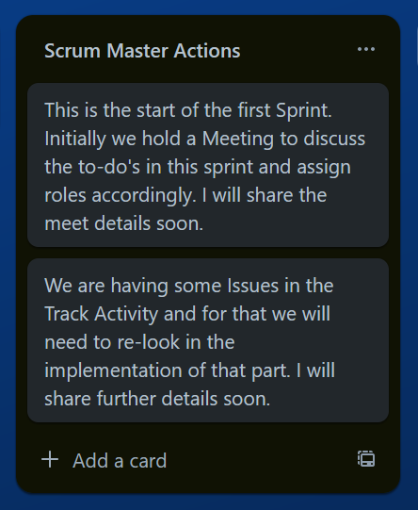

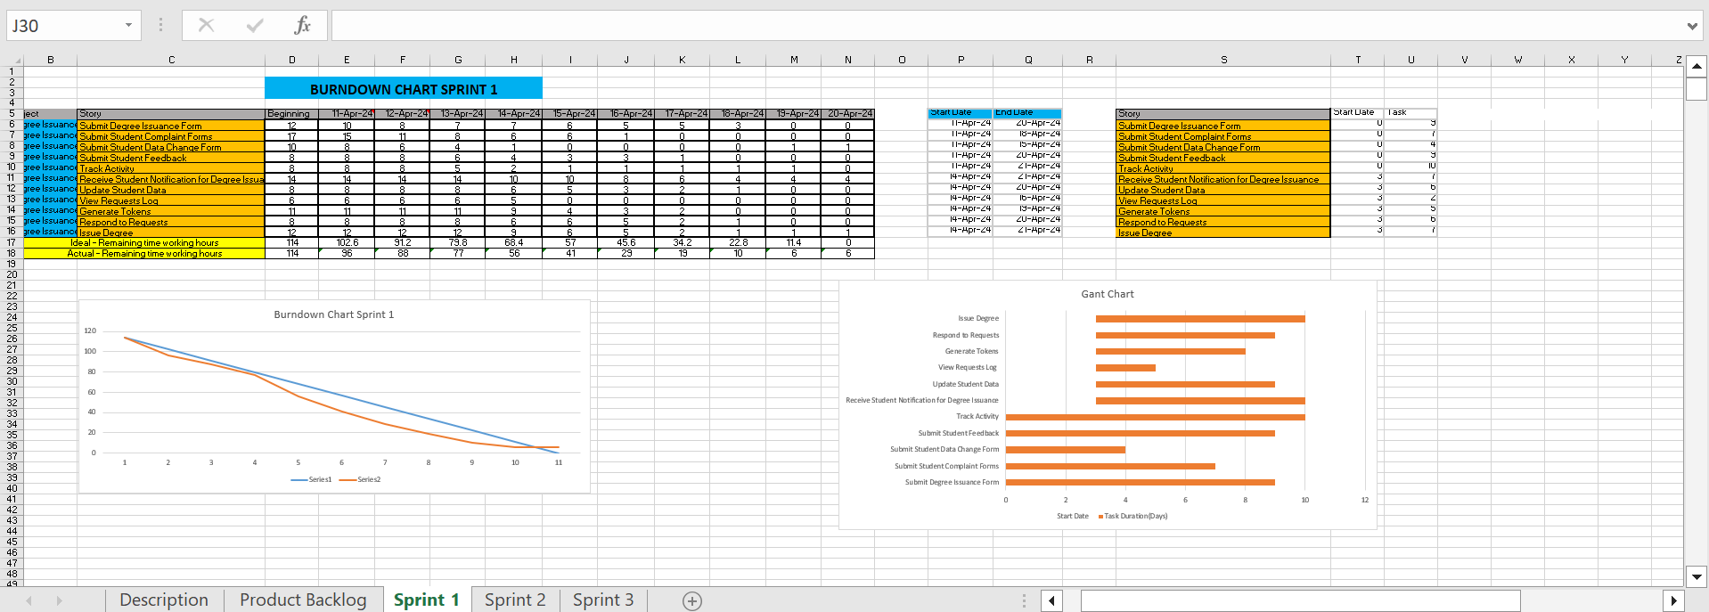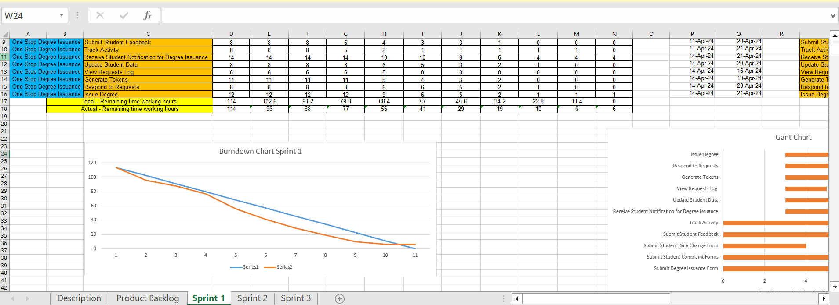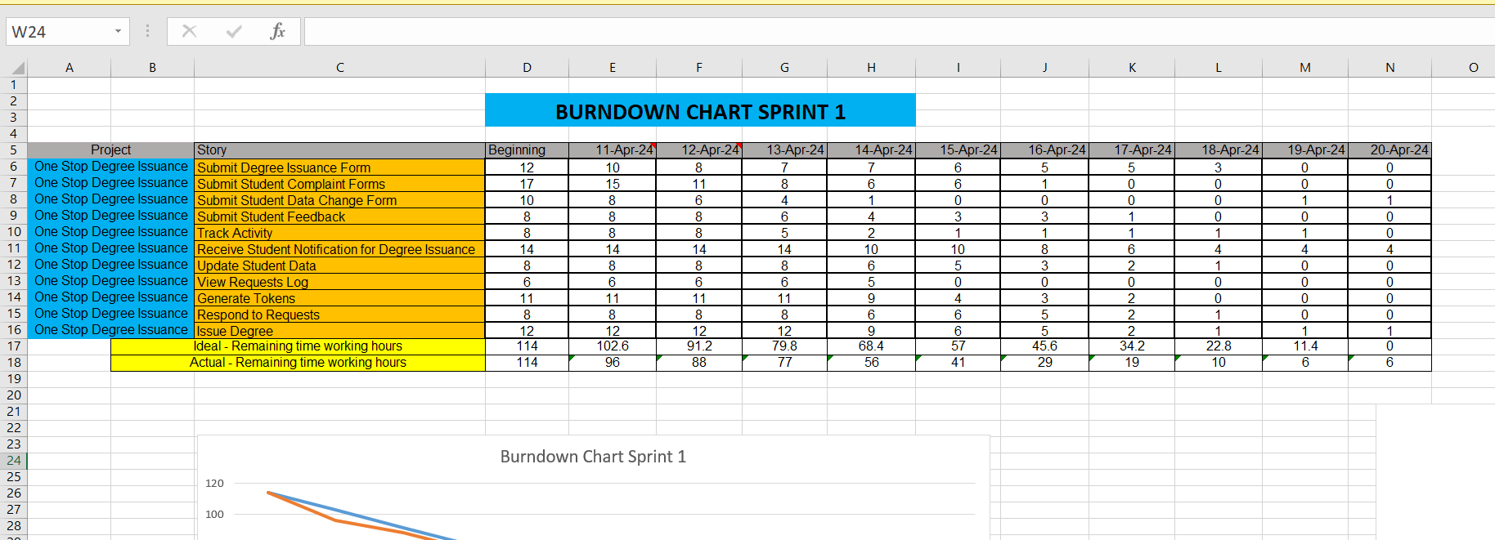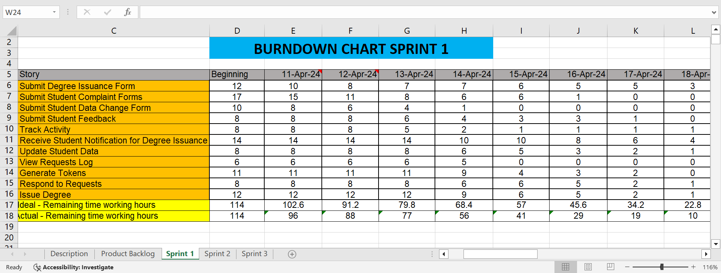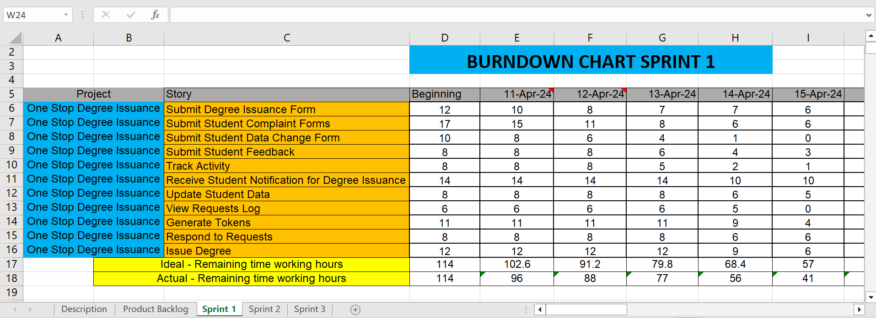

**Sprint # 2**

**Modules to be Developed**

**Feature Name:** *Receive Student Notification for Degree Issuance.*

**Story ID: 013**

**User Story:** As a Member of the FYP Department, I want to receive student’s Notification for Degree Issuance from the administration, so that I can address the student’s request for Degree Issuance related to the Finance Department.

Respected task:

1. Create a system that alerts FYP Department members when a degree issuance request related to the Finance Department is received from the administration.
2. Modify the FYP Department's interface to include these notifications, enabling members to view and respond to each relevant degree issuance request.

**Feature Name:** *Process Request*

**Story ID: 014**

**User Story:** As a Member of the FYP Department, I want to provide my decision regarding the student’s request, so that I can reply back to the student’s request as accepted, rejected or objection.

Respected tasks:

1. Implement a feature in the FYP Department's system that allows members to mark a student's request as accepted, rejected, or with objections.
2. Modify the user interface for FYP Department members to easily provide and submit their decisions on student requests.

**Feature Name:** *Process User Complaints*

**Story ID: 015**

**User Story:** As a Member of the FYP Department, I want to receive student complaints, so that I can resolve the complaints and reply back to the concerned.

Respected tasks:

1. Create a feature where FYP Department members can receive and view student complaints.
2. Implement a system for members to resolve these complaints and communicate the resolutions back to the students.

**Feature Name:** *View Requests Stats*

**Story ID: 016**

**User Story:** As a Member of the FYP Department, I want to View Requests Stats, so that I can analyze the time taken by the FYP committee to process a request.

Respected tasks:

1. Create a dashboard for FYP Department members to view statistics on request processing times.
2. Set up a system to automatically collect and calculate the time taken by the FYP committee to process each request.
3. Incorporate features in the dashboard that allow members to generate and view detailed reports on request processing times.

**Feature Name:** *Generate Ineligible Students List*

**Story ID: 017**

**User Story:** As a Member of the FYP Department, I want to Generate an Ineligible Students List, so that I can notify all the students that are ineligible for Degree Issuance due to issues in their final year project.

Respected tasks:

1. Create a feature that compiles a list of students who are ineligible for degree issuance based on their final year project status.
2. Implement checks within the system to automatically identify students based on specific criteria related to issues in their final year projects.
3. Set up a system to notify the identified ineligible students, explaining the reasons for their ineligibility and any steps for resolution if applicable.

**Feature Name:** *Issue Transcript*

**Story ID: 018**

**User Story**: As an Admin, I want to issue a student’s transcript, so that I can provide the student with his/her transcript containing their department, CGPA, all courses’ grades, duration and photograph.

Respected tasks:

1. Develop a tool that automatically generates transcripts for students, including department, CGPA, all course grades, duration of study, and photograph.
2. Ensure the system integrates seamlessly with the existing database to fetch all the necessary student data accurately.
3. Set up secure printing capabilities and a distribution method to ensure transcripts are delivered securely to students or sent digitally in a secure format.

**Feature Name:** *Notify Complaint Result*

**Story ID: 019**

**User Story:** As an Admin, I want to notify the student of their complaint result, so that I update the student on the outcome of their submitted complaint.

Respected tasks:

1. Create a feature within the administrative platform that allows admins to send notifications about the outcome of complaints to students.
2. Set up automation to update the complaint status in the system once a decision has been made, triggering a notification to the student.
3. Implement functionality for admins to customize the notification message, providing details about the complaint resolution and any further actions the student may need to take.

**Feature Name:** *Receive Student Notification for Degree Issuance*

**Story ID: 020**

**User Story:** As a Member of the Finance Department, I want to receive student’s Notification for Degree Issuance from the administration, so that I can address the student’s request for Degree Issuance related to the Finance Department.

Respected tasks:

1. Develop a feature that alerts Finance Department members when a notification about a degree issuance request is sent from the administration.
2. Customize the notification system to include specific details relevant to the Finance Department, such as financial clearance status or outstanding fees.
3. Create a mechanism for Finance Department members to directly address and update the status of each student's degree issuance request based on financial criteria.

**Feature Name:** *Check Outstanding Dues*

**Story ID: 021**

**User Story:** As a Member of the Finance Department, I want to view students’ fee details, so that I can check whether all the outstanding dues have been paid or not.

Respected Tasks:

1. Create a user interface within the Finance Department's system that allows members to view detailed information about each student's fees, including outstanding dues.
2. Ensure the system integrates with the existing financial database to fetch real-time fee information and updates on payments.
3. Add functionality that allows Finance Department members to search for specific students and filter by payment status to quickly identify those with outstanding dues.

**Feature Name:** *Check Degree Issuance Fee Status*

**Story ID: 022**

**User Story:** As a Member of the Finance Department, I want to check student’s degree issuance fee status, so that I can check whether the student has paid the degree issuance fee or not.

Respected tasks:

1. Create a tool within the Finance Department's system that allows members to specifically check the payment status of the degree issuance fee for each student.
2. Ensure the tool integrates with the university's payment systems to access real-time data on whether students have paid their degree issuance fees.
3. Implement a feature that allows Finance Department members to send notifications to students who have not yet paid their degree issuance fee, reminding them of the outstanding payment.

**Feature Name:** *Process Request*

**Story ID: 023**

**User Story:** As a Member of the Finance Department, I want to provide my decision regarding the student’s request, so that I can reply back to the student’s request as accepted, rejected or objection.

Respected Tasks:

1. Implement a feature that allows Finance Department members to submit their decision on a student's request, categorizing it as accepted, rejected, or with objections.
2. Modify the user interface for the Finance Department to include options for entering and submitting decisions, providing reasons for rejections or objections if applicable.
3. Set up an automated system to notify students of the decision on their requests, detailing the decision and any next steps if their request was not accepted.

**Feature Name:** *Generate Outstanding Dues List*

**Story ID: 024**

**User Story:** As a Member of the Finance Department, I want to Generate an Outstanding Dues List, so that I can notify all the students that are ineligible for Degree Issuance because they have encountered an issue related to the clearance of their remaining dues.

Respected tasks:

1. Create a tool within the Finance Department's system that compiles a list of all students with outstanding dues who are therefore ineligible for degree issuance.
2. Ensure the system automatically integrates and updates payment records to reflect current outstanding balances accurately.

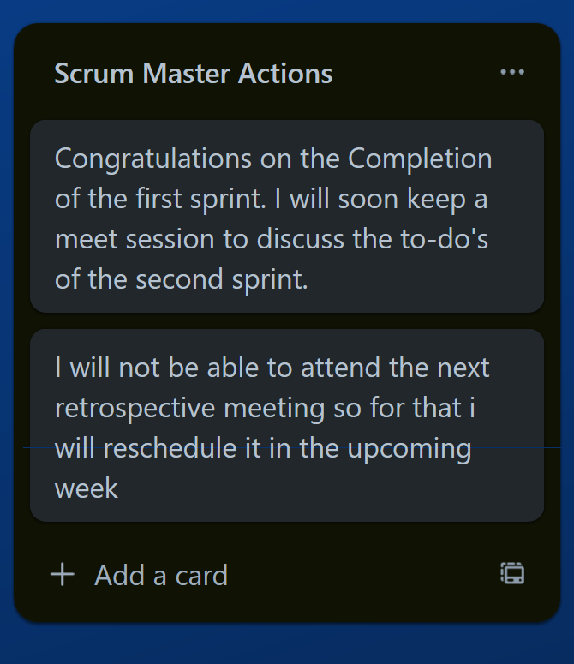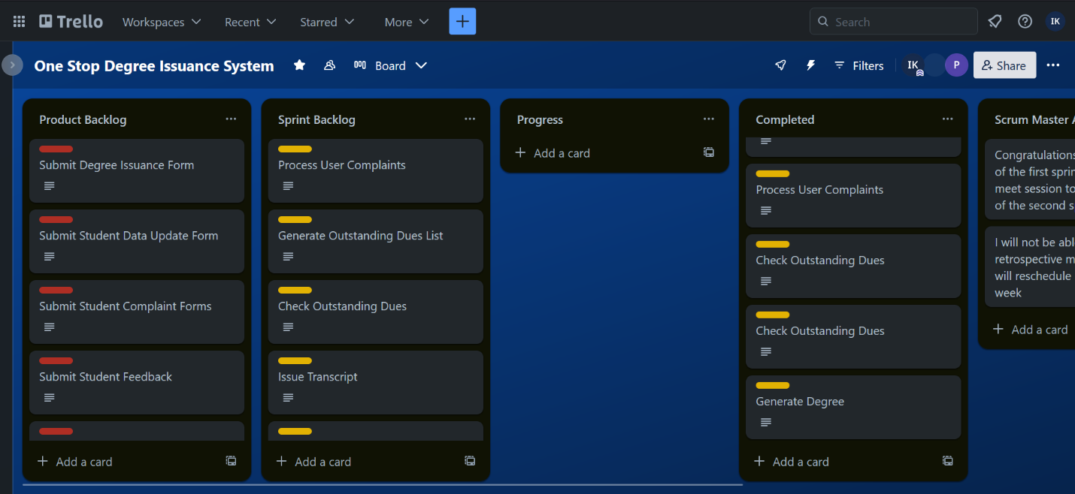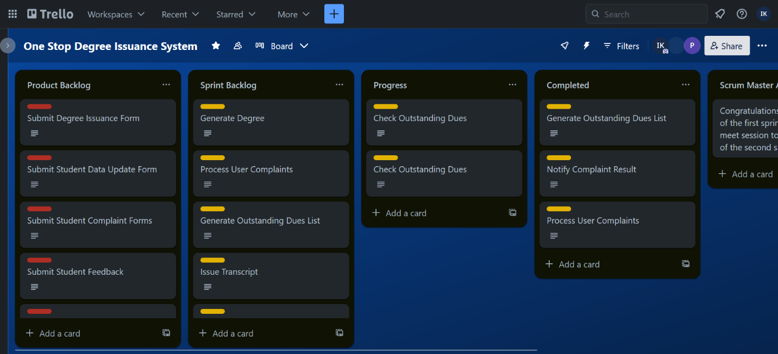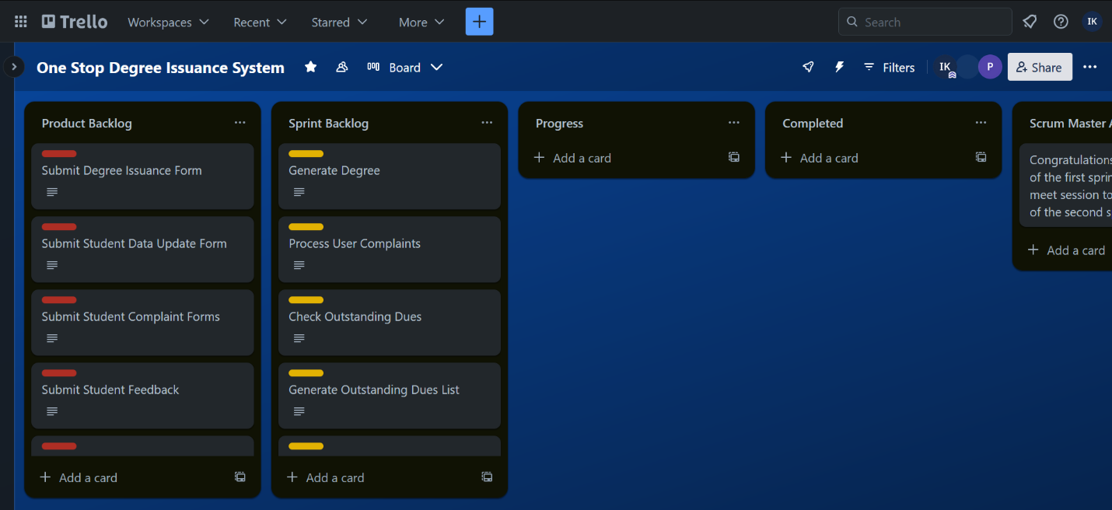

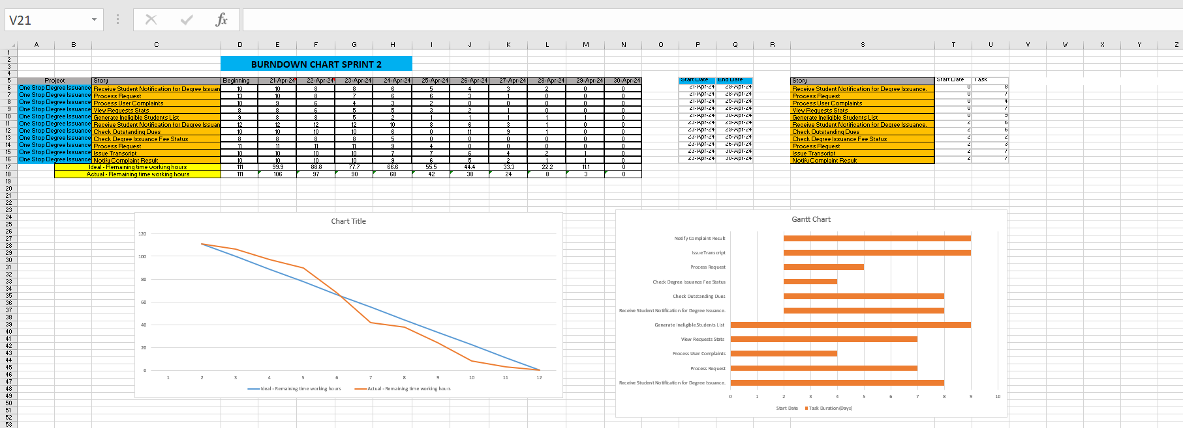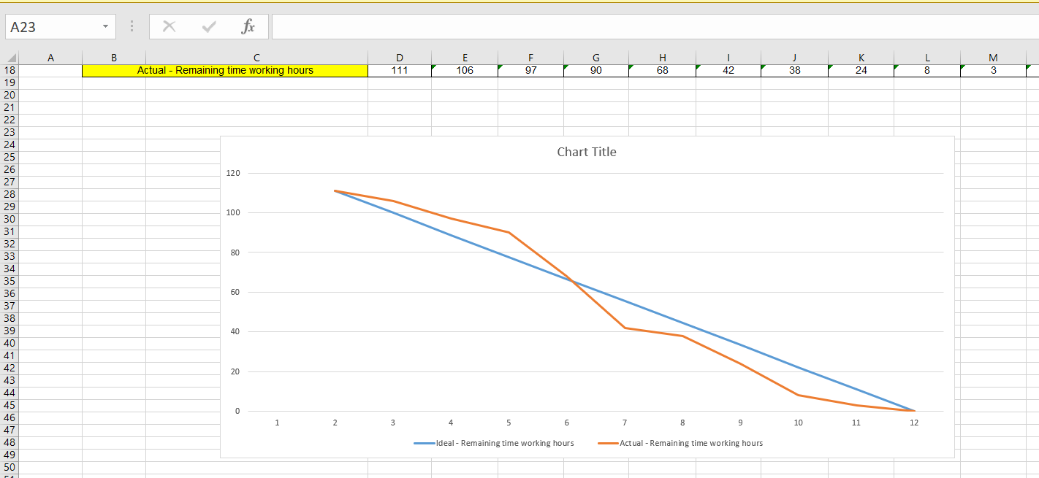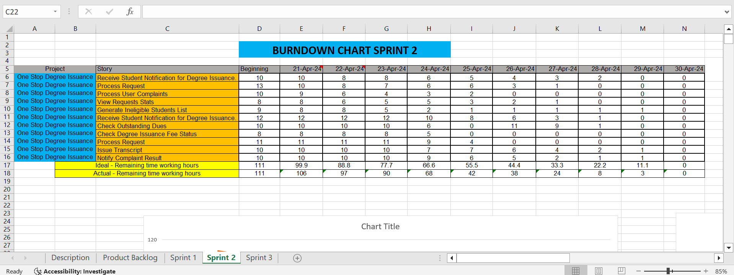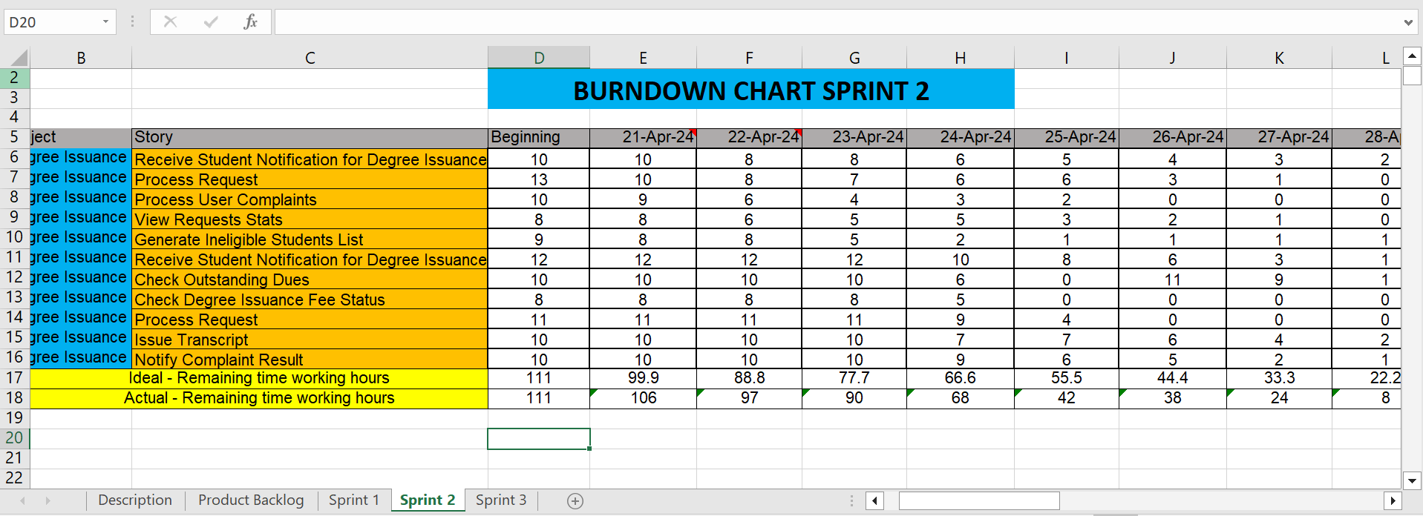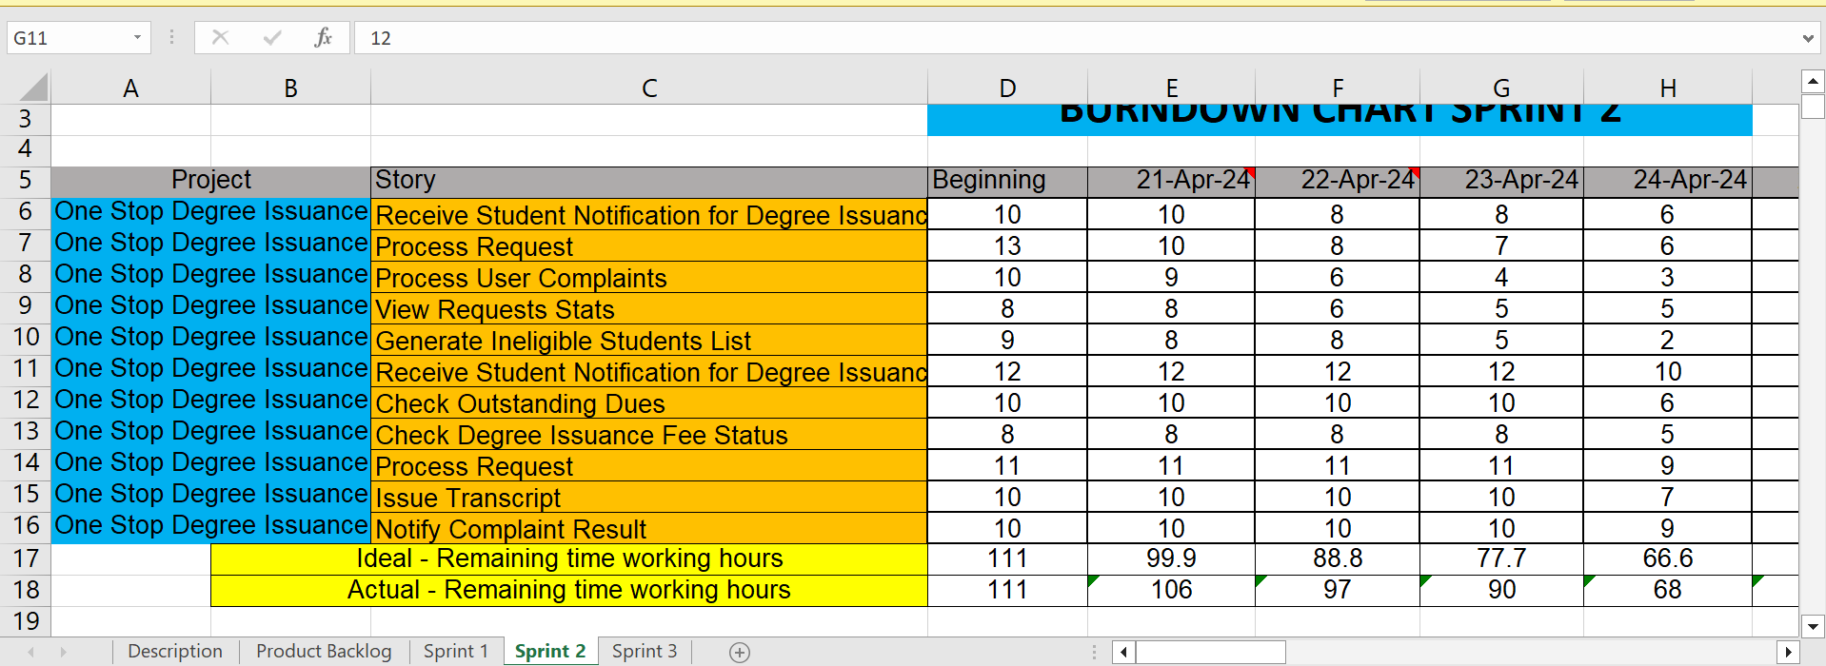

**Sprint # 3**

**Modules to be Developed**

**Feature Name:** *View Requests Log*

**Story ID: 025**

**User Story:** As a Director, I want to view the Requests Log, so that I can view all the requests that were generated on a certain day.

Respected tasks:

1. Create a dashboard for Director members to view statistics on request processing times.

**Feature Name:** *Pending requests*

**Story ID: 026**

**User Story:** As a Director, I want to view the Requests Log, so that I can view all the students’ requests that are in the pending state.

Respected tasks:

1. Update the requests log interface to include a filter or sorting feature that allows the Director to specifically view all student requests that are currently in a pending state.

**Feature Name:** *Processed request*

**Story ID: 027**

**User Story:** As a Director, I want to view the Requests Log, so that I can view all the students’ requests that are in processed state.

Respected tasks:

1. Update the requests log interface to include a filter or sorting feature that allows the Director to specifically view all student requests that are processed.

**Feature Name:** *Track Activity*

**Story ID: 028**

**User Story:** As a Director, I want to track a certain request, so that I can view the status of that request and check in which department the current request is being processed.

Respected tasks:

1. Create a system that allows the Director to input a request identifier and retrieve detailed information on the request, including its current status and the department currently handling it.

**Feature Name:** *View Department Stats*

**Story ID: 029**

**User Story:** As a Director, I want to View the Request Stats, so that I can analyze the time taken by each department to process the requests.

Respected tasks:

1. Create a dashboard within the system that allows the Director to view statistical data on the time each department takes to process requests. This dashboard should include filters to select specific time frames or types of requests.

**Feature Name:** *View Feedback*

**Story ID: 030**

**User Story:** As a Director, I want to view the submitted feedbacks, so that I check what are the views of students regarding the usability of this system.

Respected tasks:

1. Create a dashboard within the system that allows the Director to view feedback and students view.

**Feature Name:** *View Complaint Forms*

**Story ID: 031**

**User Story:** As a Director, I want to View all the submitted Complaint Forms, so that I analyze what are the issues that students are currently facing regarding their degree issuance process.

Respected tasks:

1. Create an interface within the system that allows the Director to access and review all submitted complaint forms. This interface should include search and filter capabilities to sort complaints by date, department, or specific issues.
2. Ensure the system is capable of retrieving detailed information from the database regarding complaints, including the nature of each complaint, the department it is associated with, and the status of the complaint resolution.

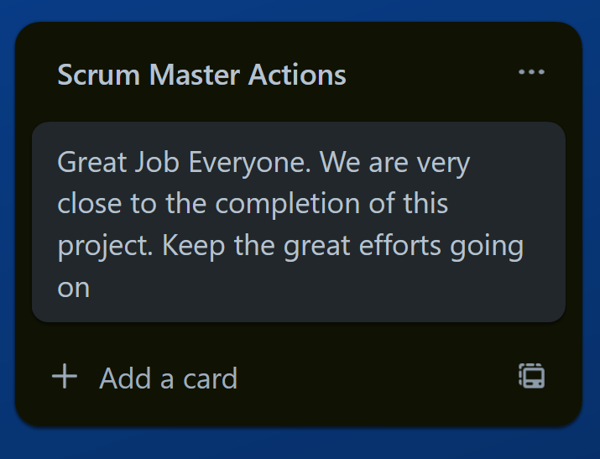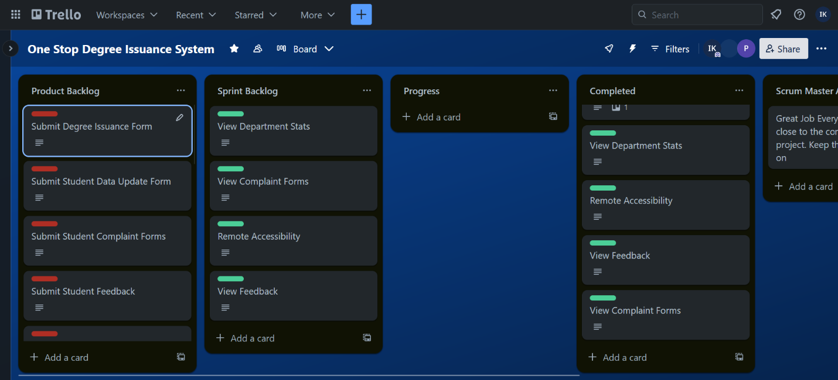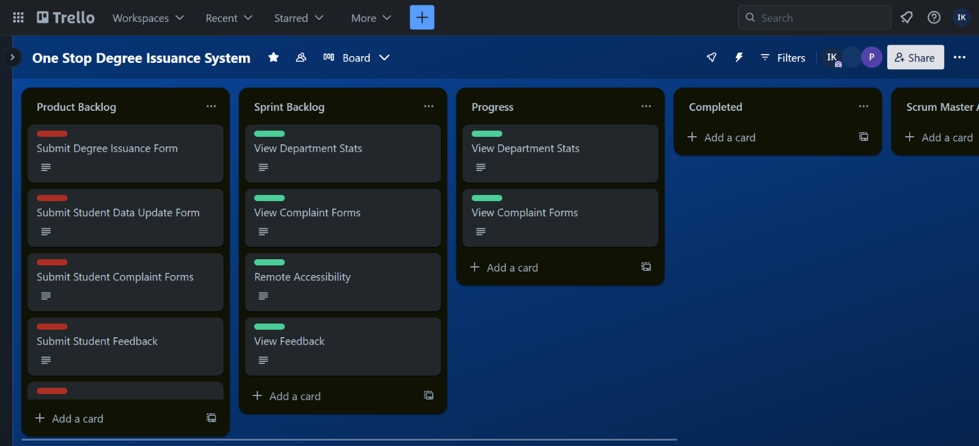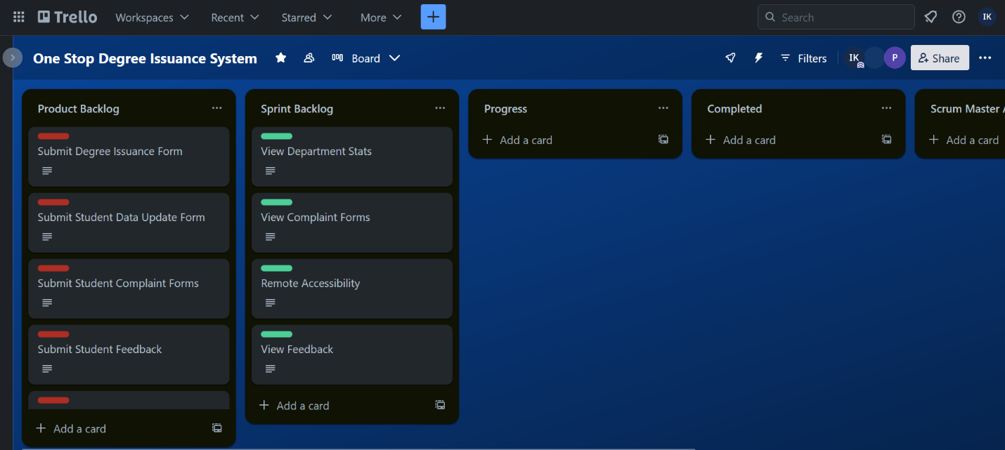

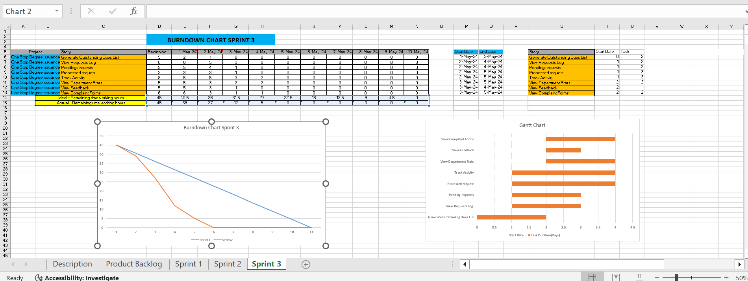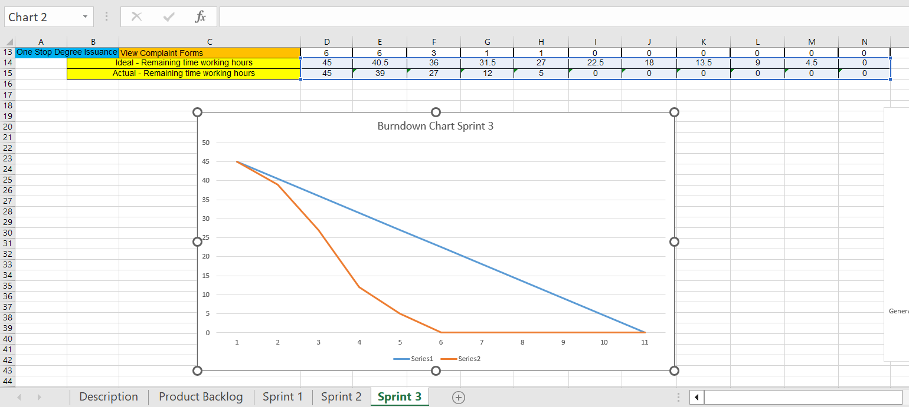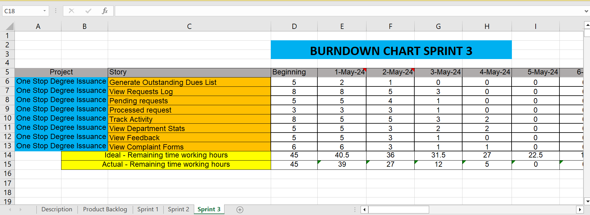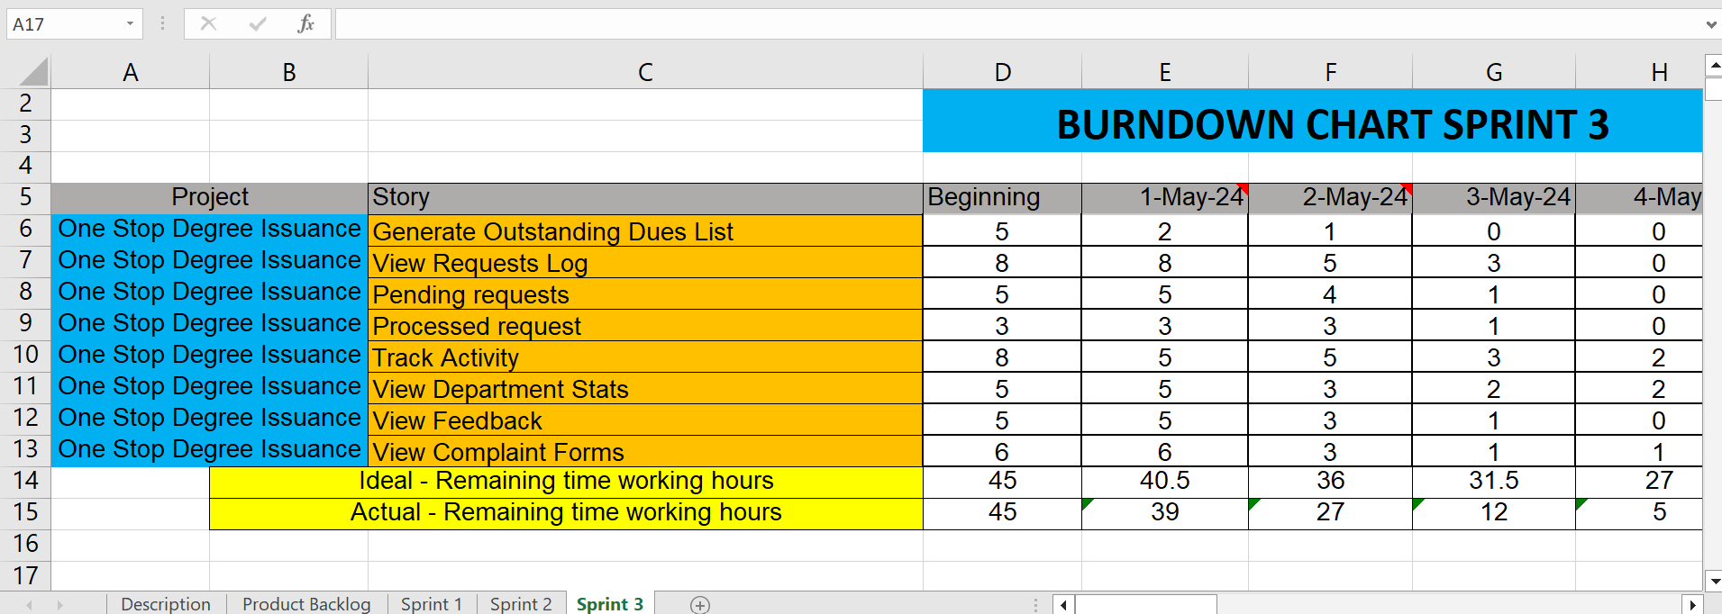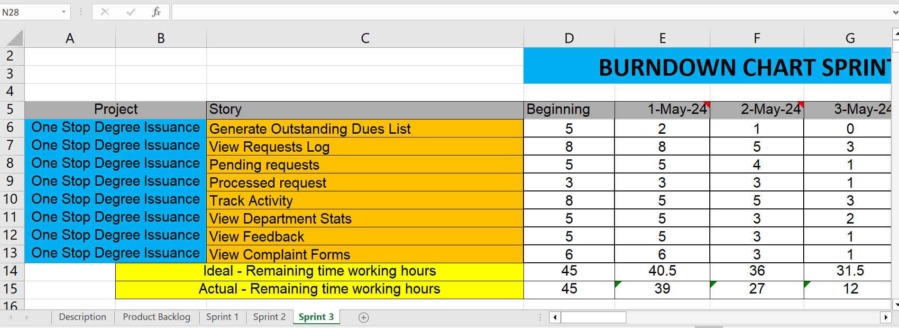**Test Cases for Sprint 1**

**User Story Name:** *Submit Degree Issuance Form*

Inputs:

**Username:** Text Input

**Student Roll Number:** Text Input

**Batch:** Text Input

**Equivalent Class Partitions:**

|  |  |  |
| --- | --- | --- |
| **Field Name** | **Valid Classes** | **Invalid classes** |
| **Username** | Alphabets, Length greater than 3 and less than 20 | Empty Input, Special characters, Length less than 3 |
| **Student Roll Number** | Begins with "21I-", Followed by four digits (0000 to 9999) | Empty, Missing "21I-", non-numeric characters in the digits section, Digits outside the range 0000 to 9999. |
| **Batch** | 4 Digit Number, Ranges From 2016-2021 | Empty, non-numeric, out of range 2016-2024 |

**Boundary Values**:

|  |  |
| --- | --- |
| **Field Name** | Boundary Values |
| **Username** | Valid: 3<=Alphabet>=20, Invalid: Alphabet<3, Alphabet>20 |
| **Student Roll Number** | Valid: 21I-0000,21I-9999, Invalid: 21L-0455,21I-00001 |
| **Batch** | Valid: 2016-2021, Invalid:2015,2024 |

**Test Cases:**

**Weak Equivalence Testing: 3**

**Strong Equivalence Testing: 27**

**User Story Name:** *Submit Student Complaint Form*

Inputs:

**Department:** Dropdown

**Description:** Text Input

**Equivalent Class Partitions:**

|  |  |  |
| --- | --- | --- |
| **Field Name** | **Valid Classes** | **Invalid classes** |
| **Department** | One Stop Admin, FYP Department, Finance Department. | Empty Input |
| **Description** | Alphabets, Alphanumeric and Special Characters. | Empty Input |

**Boundary Values**:

|  |  |
| --- | --- |
| **Field Name** | Boundary Values |
| **Department** | Valid: One Stop Admin, FYP Department, Invalid: Empty Input |
| **Description** | Valid: Alphabets, Alphanumeric Characters, Invalid: Empty Input |

**Test Cases:**

**Weak Equivalence Testing: 2**

**Strong Equivalence Testing: 8**

**User Story Name:** *Submit Data Change Form*

Inputs:

**Category:** Dropdown

**Updated Value:** Text Input

**Equivalent Class Partitions:**

|  |  |  |
| --- | --- | --- |
| **Field Name** | **Valid Classes** | **Invalid classes** |
| **Department** | Name, Batch, Father Name | Empty Input |
| **Description** | Alphabets, Alphanumeric, Alphabets>=3 | Empty Input, Special Characters, Alphabets>3 |

**Boundary Values**:

|  |  |
| --- | --- |
| **Field Name** | Boundary Values |
| **Department** | Valid: Name, Father Name, Invalid: Empty Input |
| **Description** | Valid: Alphabets>=3, Invalid: Empty Input, Special Character |

**Test Cases:**

**Weak Equivalence Testing: 2**

**Strong Equivalence Testing: 8**

**User Story Name:** *Submit Feedback Form*

Inputs:

**Feedback:** Text Input

**Equivalent Class Partitions:**

|  |  |  |
| --- | --- | --- |
| **Field Name** | **Valid Classes** | **Invalid classes** |
| **Feedback** | Alphabets, Alphanumeric | Empty Input, Special Characters |

**Boundary Values**:

|  |  |
| --- | --- |
| **Field Name** | Boundary Values |
| **Feedback** | Valid: Alphabets, Invalid: Empty Input, Special Character |

**Test Cases:**

**Weak Equivalence Testing: 2**

**Strong Equivalence Testing: 8**

**Links:**

**Trello:** https://trello.com/b/fq1hALcF/one-stop-degree-issuance-system

**GitHub:** <https://github.com/umairkhalidx/One-Stop-Degree-Issuance-System>

**Videos:**