***Data Warehouse & Data Mining Final Lab***



***Final Lab***

***Submitted by:*** *M.Umair Khan (FA21-BSE-070)*

***Submission Date***

*|1 January, 2025|*

**DWH Final Lab Tasks**

**Lab Task 1:**

Implement 3 classifiers on any dataset in python and compare their performance.

**File Structure:**

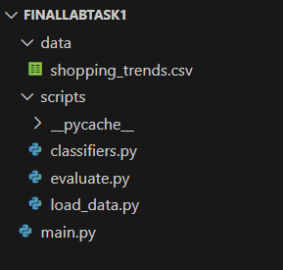

**Dataset Link from Kaggle:**

**Customer Shopping (Latest Trends) Dataset**

<https://www.kaggle.com/datasets/bhadramohit/customer-shopping-latest-trends-dataset>

**Code:**

**classifires.py:**

from sklearn.model_selection import train_test_split

from sklearn.preprocessing import StandardScaler

from sklearn.svm import SVC

from sklearn.model_selection import train_test_split

from sklearn.preprocessing import StandardScaler

import pandas as pd

from sklearn.ensemble import RandomForestClassifier

from sklearn.linear_model import LogisticRegression

def prepare_data(data):

    """Prepare data for training and testing."""

    # Replace 'target' with your actual target column name

    X = data.drop('Item Purchased', axis=1)

    y = data['Item Purchased']

  # Convert categorical columns to numerical

    X = pd.get_dummies(X)  # This will one-hot encode categorical columns

    X_train, X_test, y_train, y_test = train_test_split(X, y, test_size=0.2, random_state=42)

    scaler = StandardScaler()

    X_train = scaler.fit_transform(X_train)

    X_test = scaler.transform(X_test)

    return X_train, X_test, y_train, y_test

def train_classifiers(X_train, y_train):

    """Train three different classifiers."""

    classifiers = {

        'SVM': SVC(),

        'Random Forest': RandomForestClassifier(),

        'Logistic Regression': LogisticRegression()

    }

    for name, clf in classifiers.items():

        clf.fit(X_train, y_train)

    return classifiers

**evaluate.py:**

from sklearn.metrics import accuracy_score, precision_score, recall_score, f1_score

def evaluate_classifiers(classifiers, X_test, y_test):

    """Evaluate classifiers and print their performance."""

    for name, clf in classifiers.items():

        y_pred = clf.predict(X_test)

        print(f"Performance of {name}:")

        print(f"Accuracy: {accuracy_score(y_test, y_pred):.2f}")

        print(f"Precision: {precision_score(y_test, y_pred, average='weighted'):.2f}")

        print(f"Recall: {recall_score(y_test, y_pred, average='weighted'):.2f}")

        print(f"F1 Score: {f1_score(y_test, y_pred, average='weighted'):.2f}")

        print("-" * 30)

**Load.py:**

import pandas as pd

def load_hiv_data(file_path):

    """Load the HIV dataset from a CSV file."""

    return pd.read_csv(file_path, encoding='latin1')  # or 'ISO-8859-1', depending on your file's encoding

if __name__ == "__main__":

    data = load_hiv_data('data/shopping_trends.csv')

    print(data.head())

**main.py:**

from scripts.load_data import load_hiv_data

from scripts.classifiers import prepare_data, train_classifiers

from scripts.evaluate import evaluate_classifiers

def main():

    # Load data

    data = load_hiv_data('data/shopping_trends.csv')

    # Prepare data

    X_train, X_test, y_train, y_test = prepare_data(data)

    # Train classifiers

    classifiers = train_classifiers(X_train, y_train)

    # Evaluate classifiers

    evaluate_classifiers(classifiers, X_test, y_test)

if __name__ == "__main__":

    main()

**Output:**

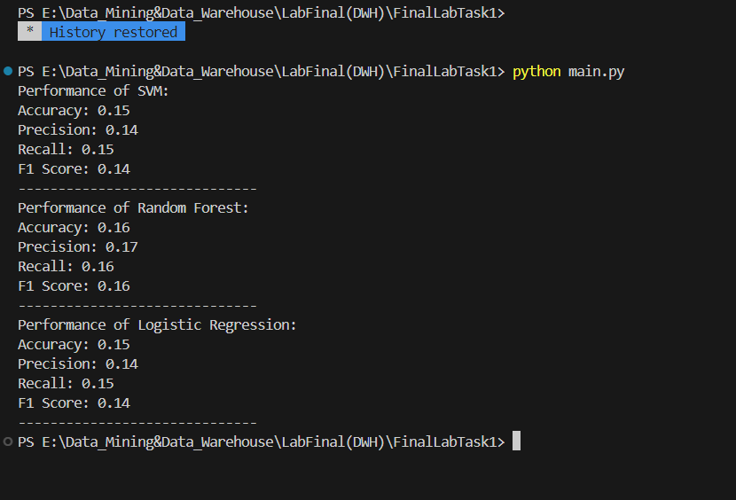

**Lab Task 2:**

Implement 3 classifiers on any dataset in weka and compare their performance.

**Dataset Link from Kaggle:**

**Customer Shopping (Latest Trends) Dataset**

<https://www.kaggle.com/datasets/bhadramohit/customer-shopping-latest-trends-dataset>

**Screenshots of Weka:**

1. **Launch the Weka application on your computer.**

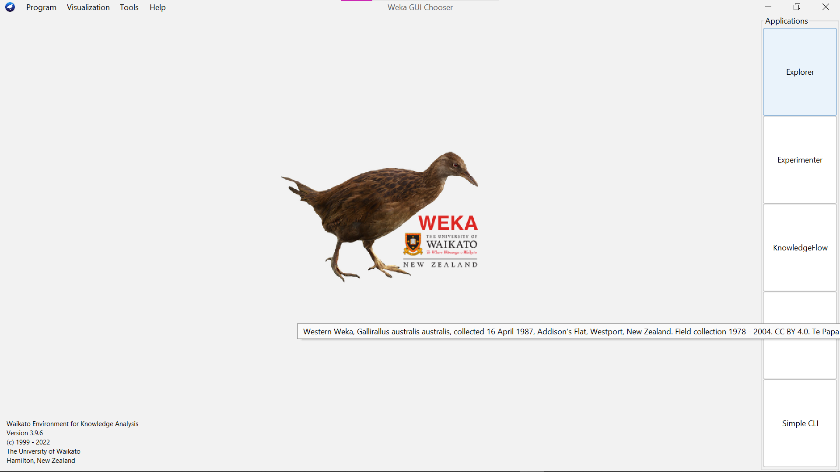

1. **Click on the "Explorer" button to open the Weka Explorer interface.**

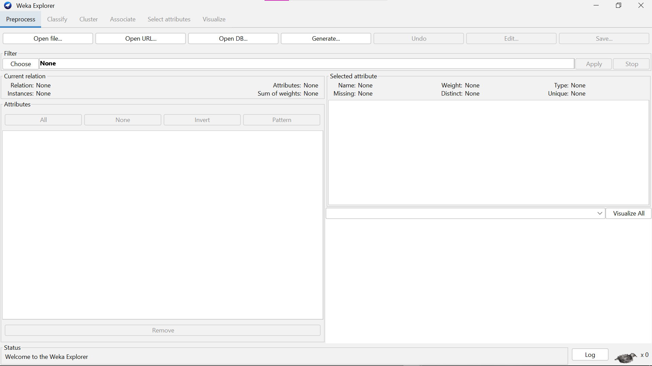

1. **In the "Pre-process" tab, click on "Open file...".**
2. **In the file dialog, change the file type to "CSV data files (*.csv)".**
3. **Navigate to the location of your CSV file and select it to open.**

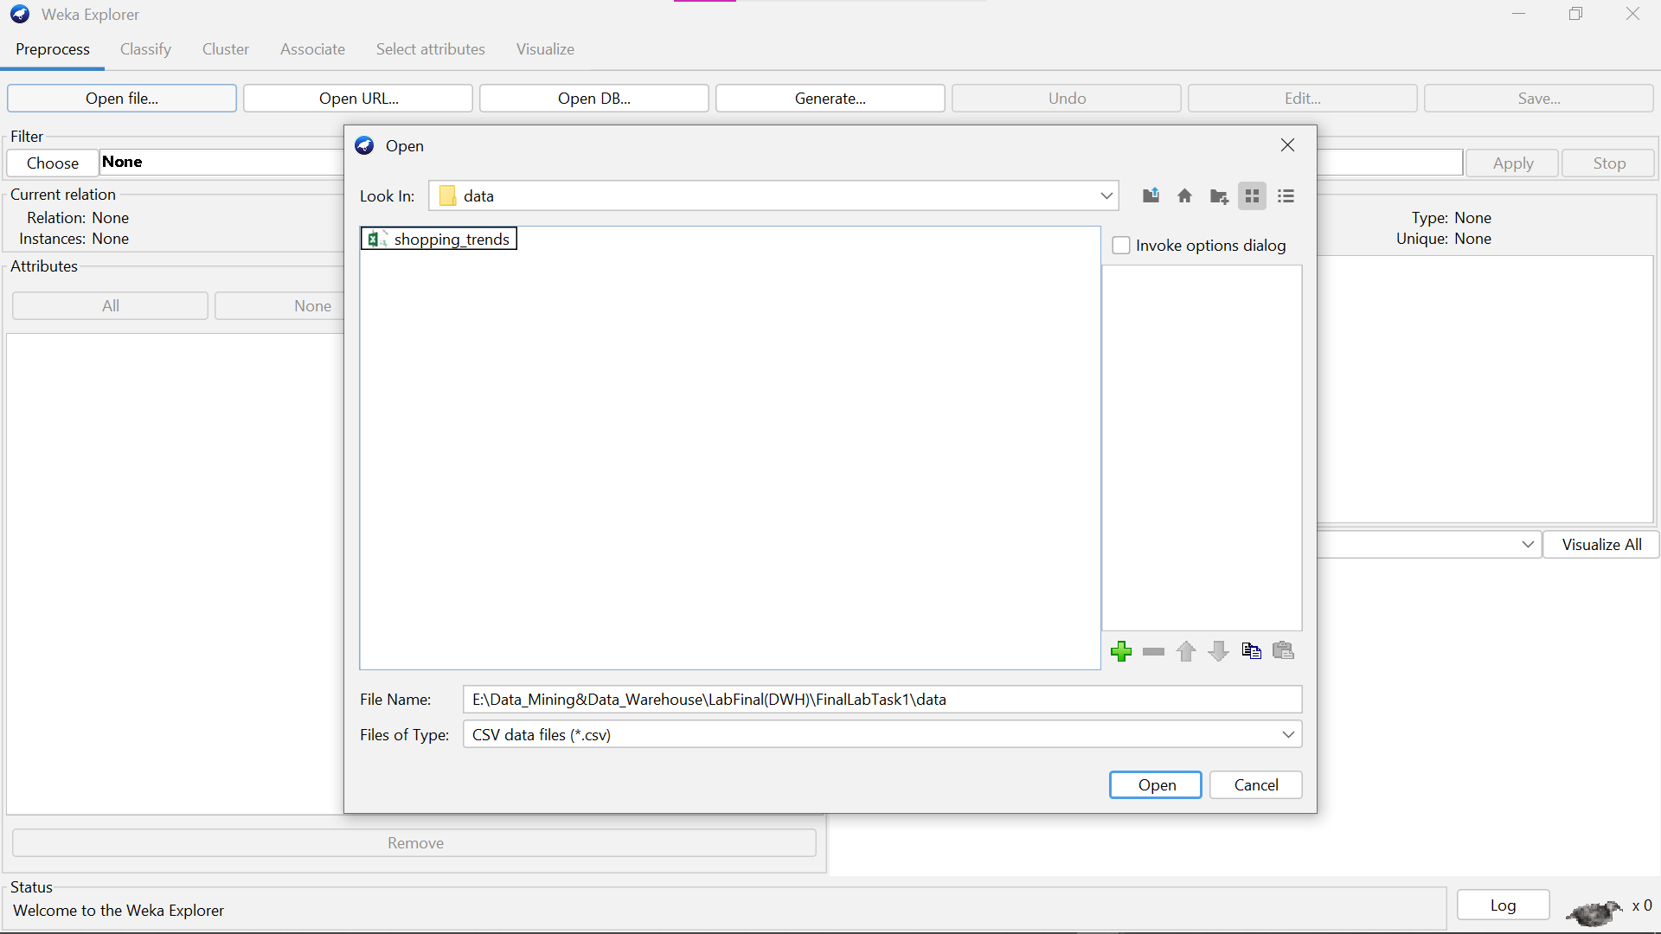

1. **Once your CSV file is loaded, you can proceed to the "Classify" tab to select and run classifiers**

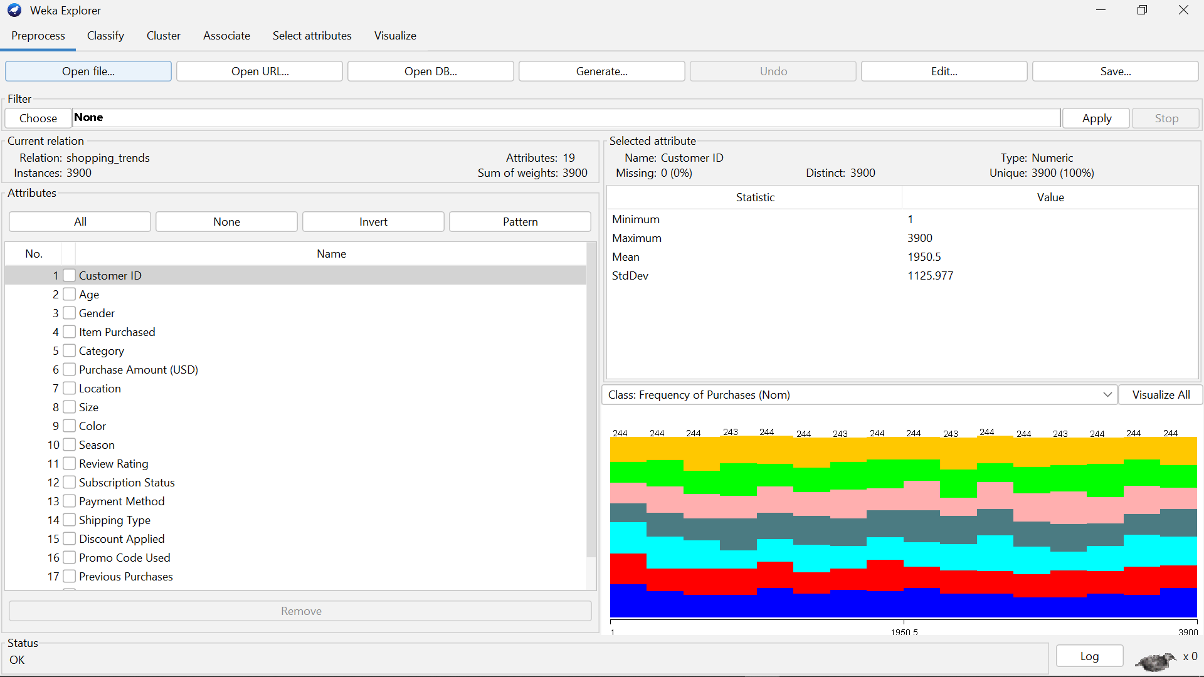

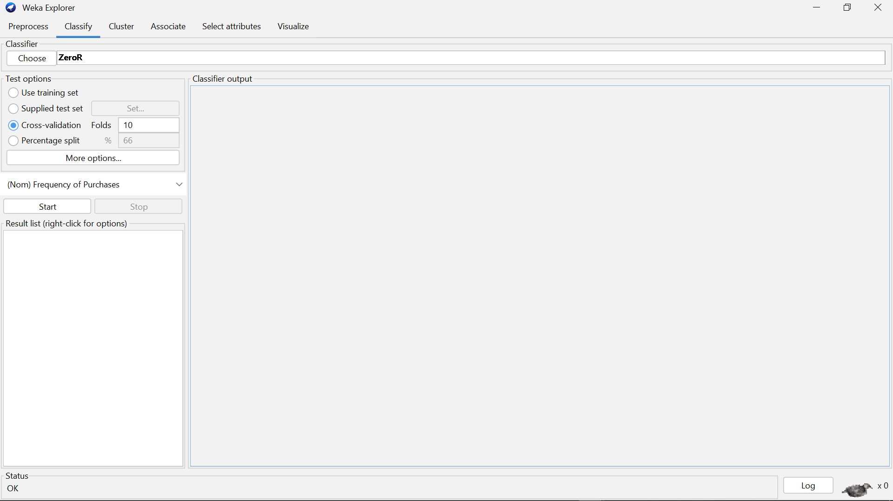

1. **Choose the classifiers you want to use (e.g., J48, RandomForest, NaiveBayes) and run them on your dataset.**

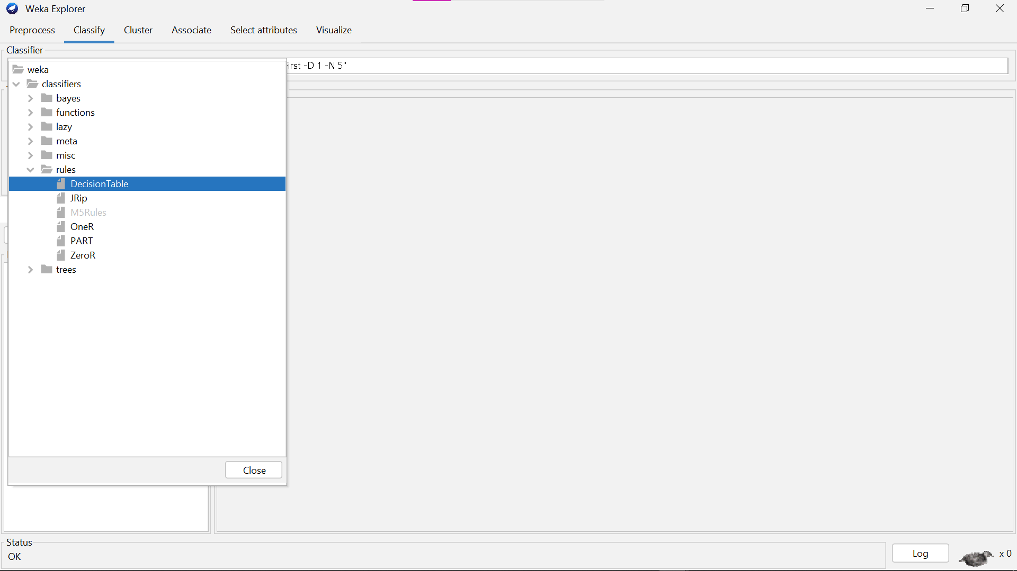

1. **Compare their performance using the metrics provided in the "Classifier output" section.**

**Decision Tree Classify Output:**

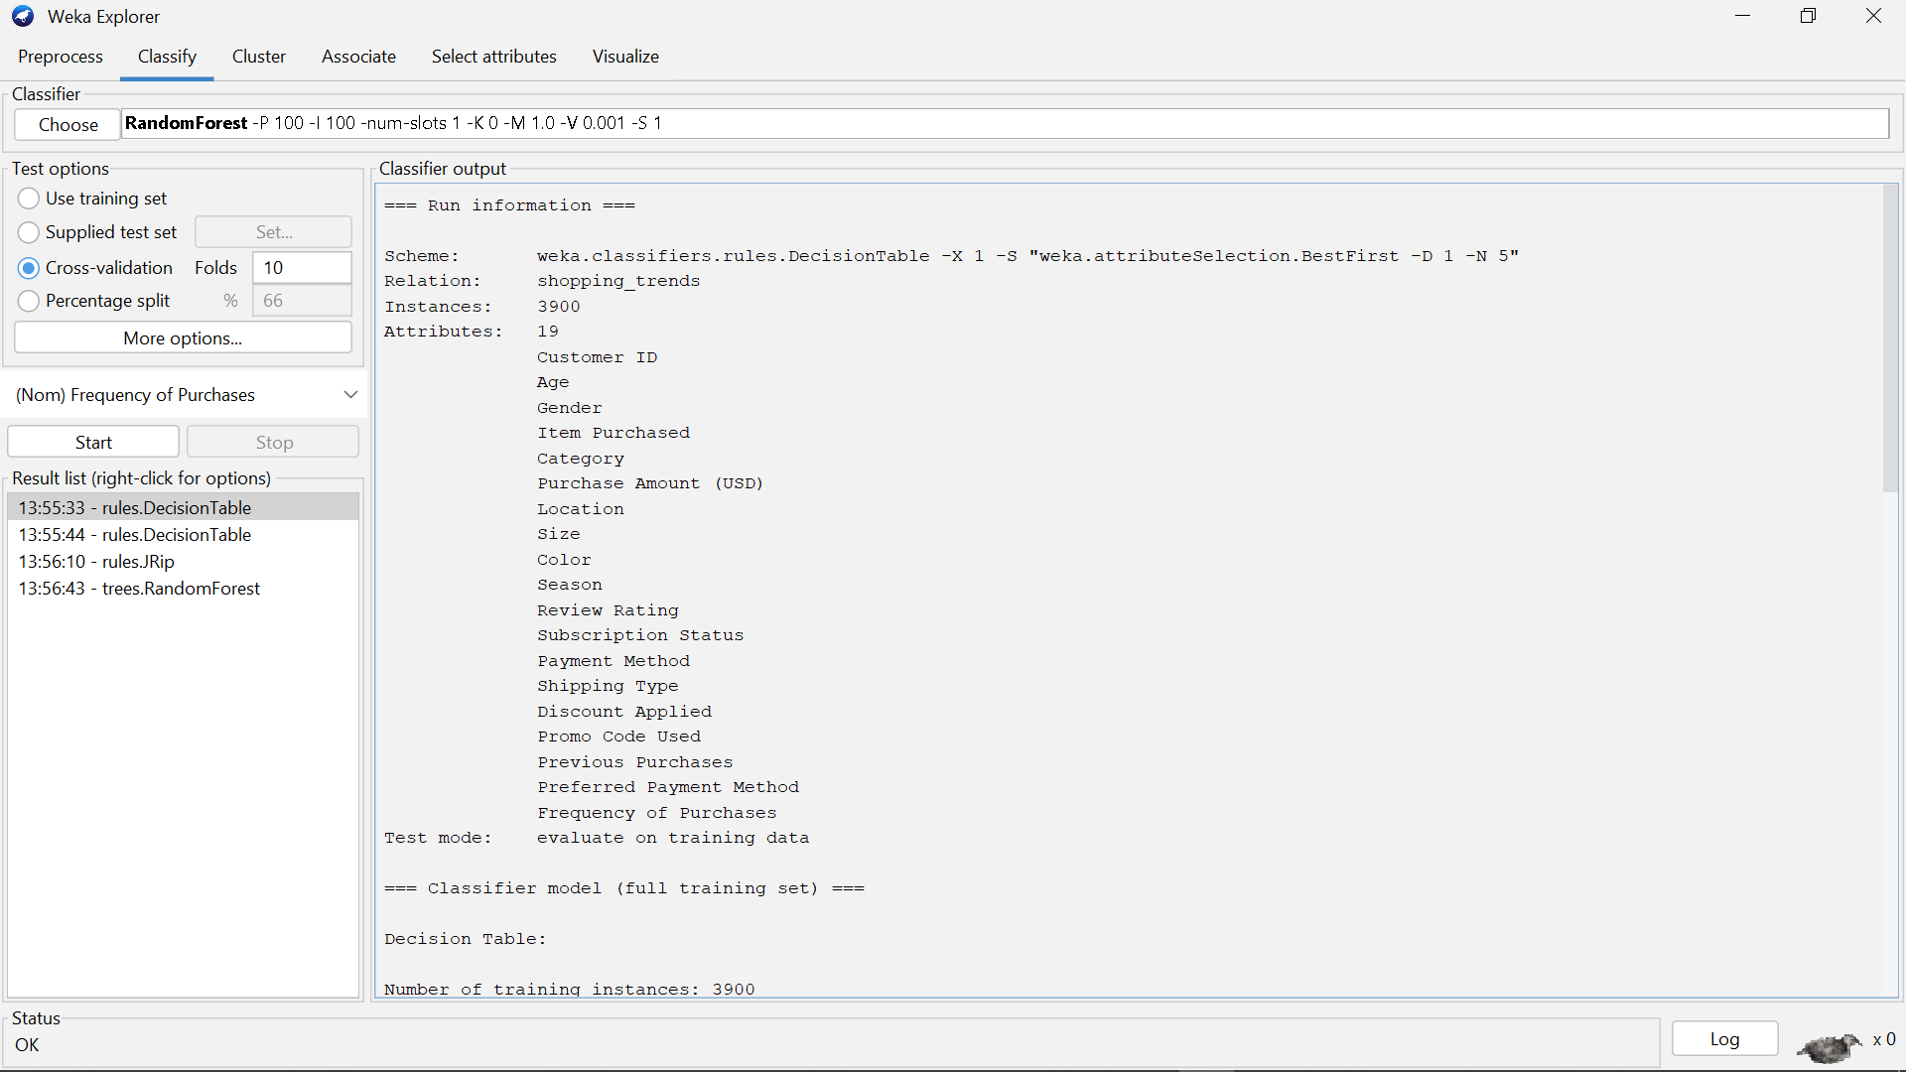

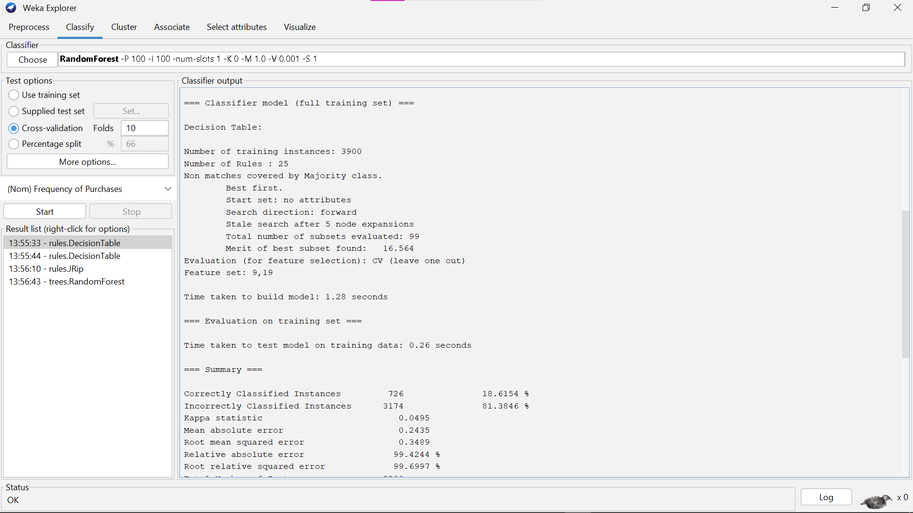

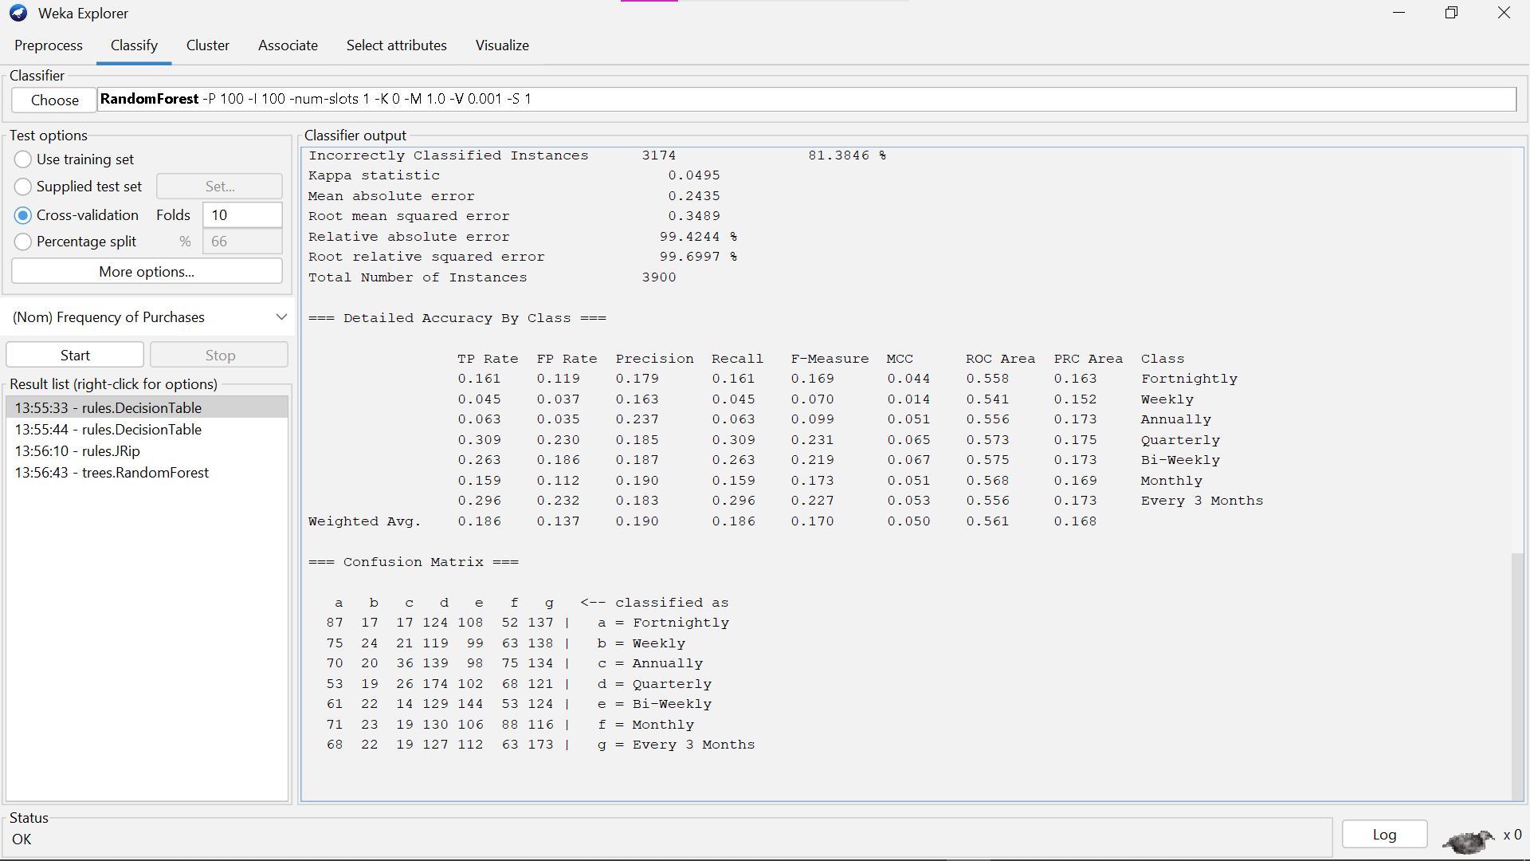

**JRip Classify Output:**

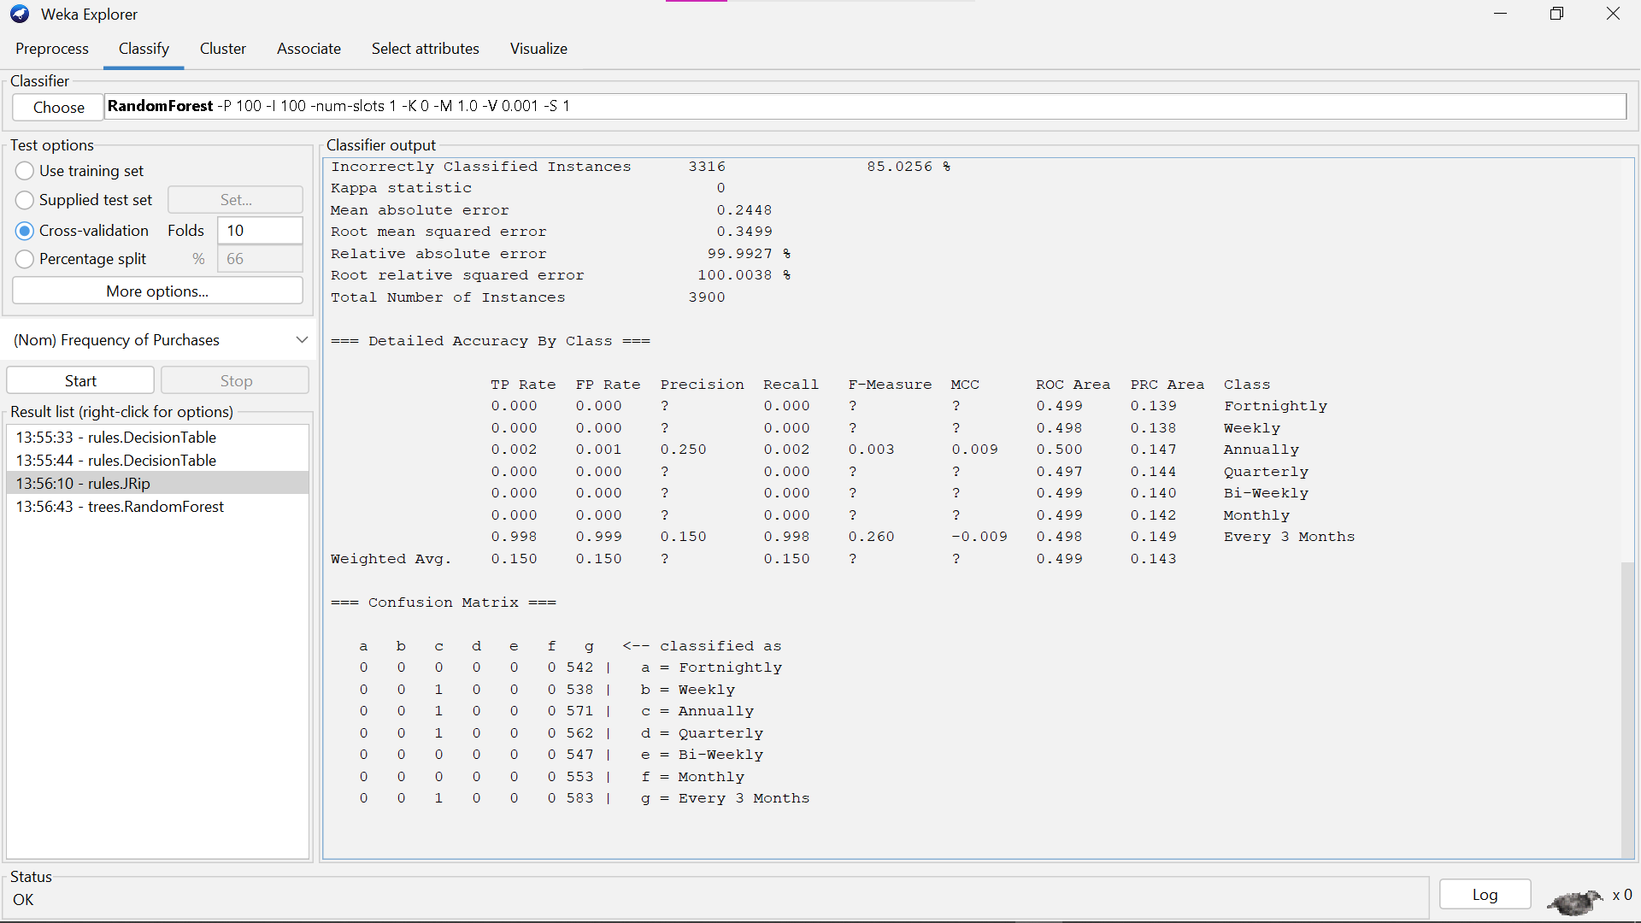



**RandomForest Tree Classify Output:**

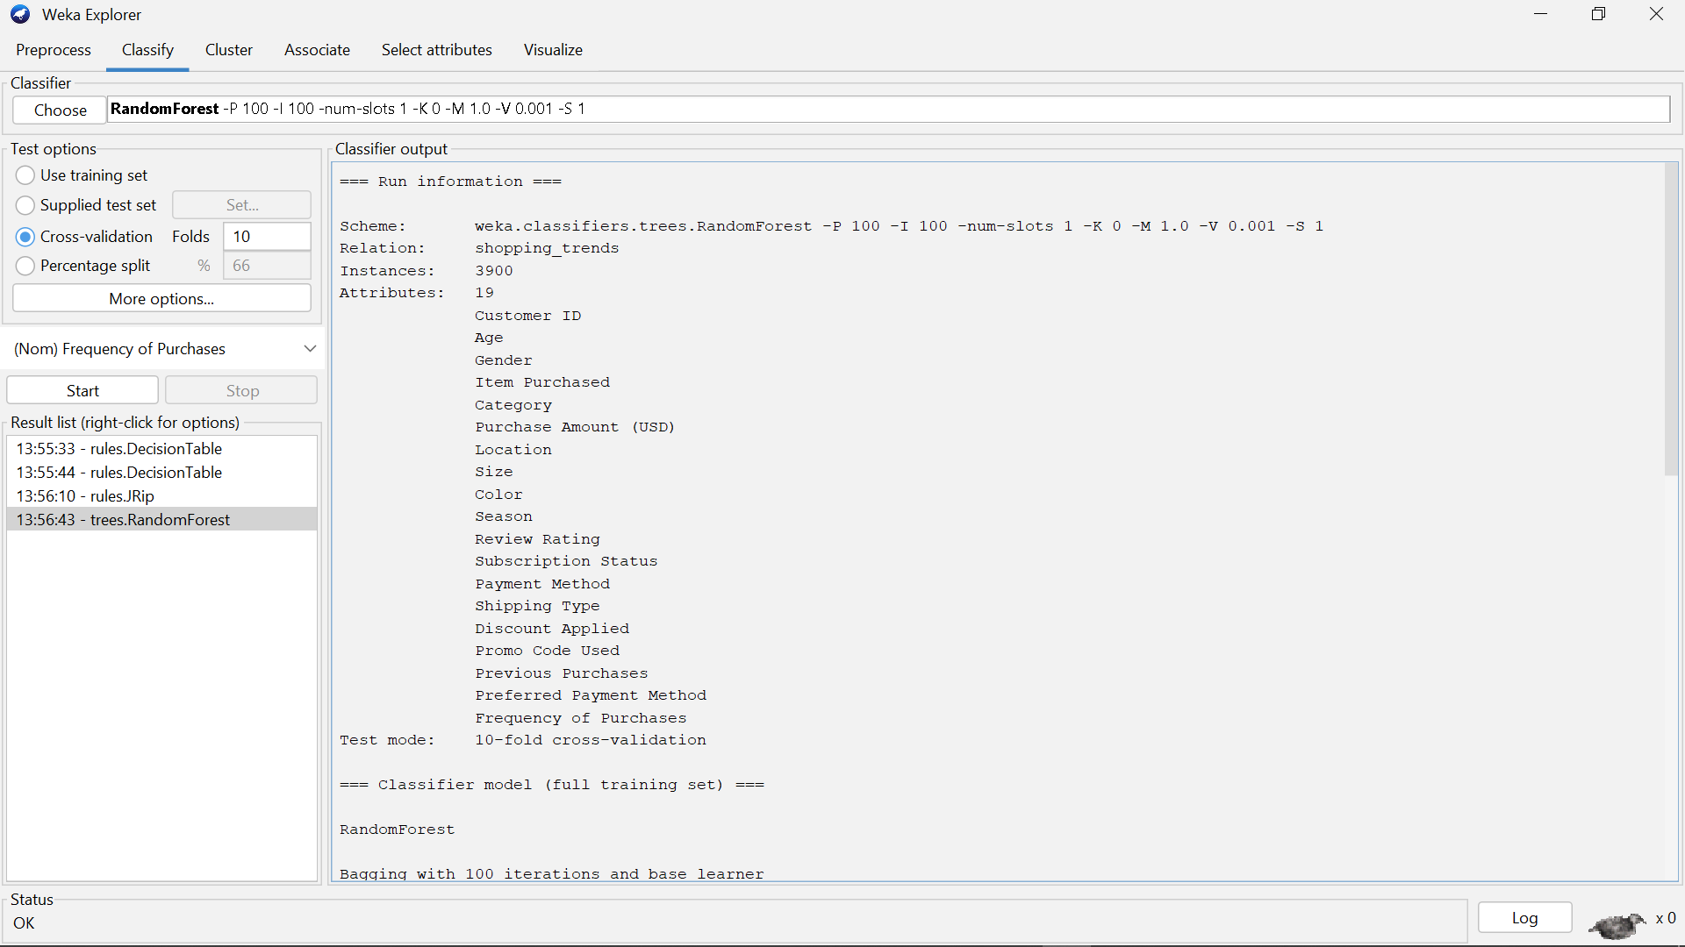

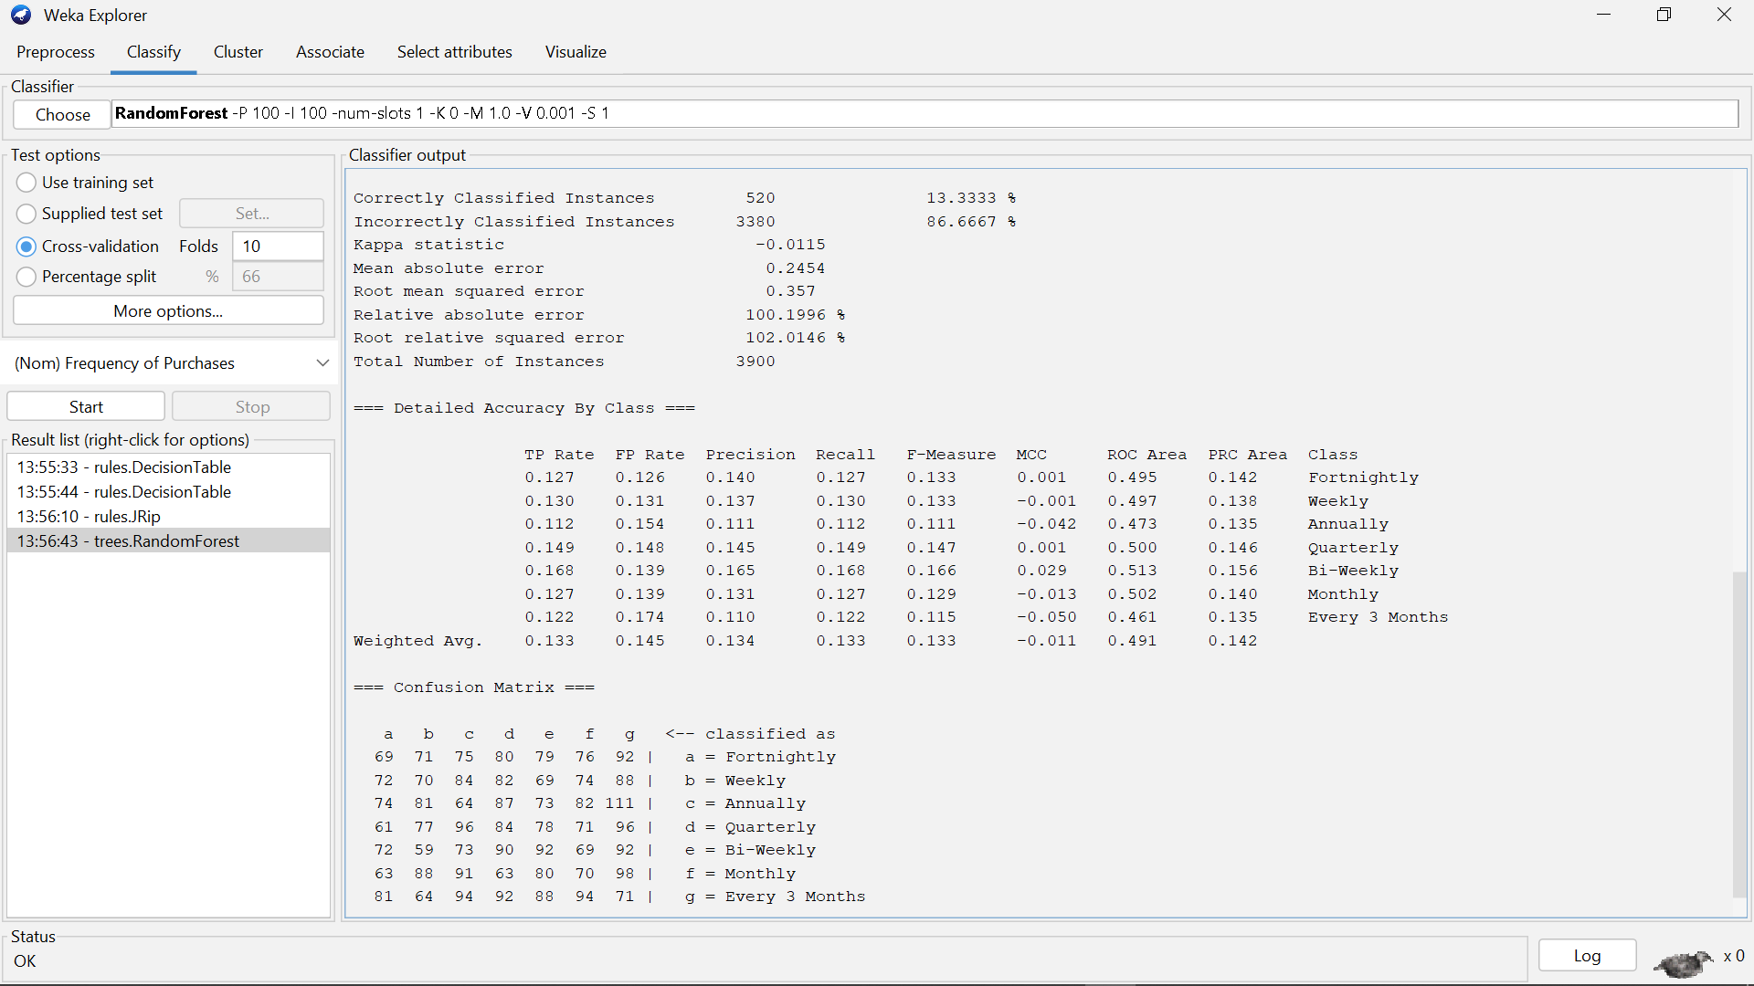

**Lab Task 3:**

Understand working of CNN architecture and implement CNN on any dataset using different hyper parameter settings.

**Dataset Link from Kaggle:**

**CIFAR-10 - Object Recognition in Images**

<https://www.kaggle.com/c/cifar-10/>

**Code:**

import tensorflow as tf

from tensorflow.keras.models import Sequential

from tensorflow.keras.layers import Conv2D, MaxPooling2D, Flatten, Dense, Dropout

from tensorflow.keras.preprocessing.image import ImageDataGenerator

from sklearn.model_selection import train_test_split

import os

import numpy as np

from tensorflow.keras.utils import to_categorical

import matplotlib.pyplot as plt

# 1. Load and Prepare Dataset

# Example: CIFAR-10 dataset

(X_train, y_train), (X_test, y_test) = tf.keras.datasets.cifar10.load_data()

# Normalize pixel values (0-255 to 0-1)

X_train, X_test = X_train / 255.0, X_test / 255.0

# Convert labels to one-hot encoding

y_train = to_categorical(y_train, 10)

y_test = to_categorical(y_test, 10)

# Split the training set into training and validation

X_train, X_val, y_train, y_val = train_test_split(X_train, y_train, test_size=0.2, random_state=42)

# 2. Data Augmentation (Optional)

datagen = ImageDataGenerator(

    rotation_range=15,

    width_shift_range=0.1,

    height_shift_range=0.1,

    horizontal_flip=True

)

datagen.fit(X_train)

# 3. Build the CNN Model

model = Sequential([

    Conv2D(32, (3, 3), activation='relu', input_shape=(32, 32, 3)),

    MaxPooling2D((2, 2)),

    Conv2D(64, (3, 3), activation='relu'),

    MaxPooling2D((2, 2)),

    Conv2D(128, (3, 3), activation='relu'),

    Flatten(),

    Dense(128, activation='relu'),

    Dropout(0.5),

    Dense(10, activation='softmax')  # 10 classes for CIFAR-10

])

# 4. Compile the Model

model.compile(optimizer='adam',

              loss='categorical_crossentropy',

              metrics=['accuracy'])

# 5. Train the Model

history = model.fit(

    datagen.flow(X_train, y_train, batch_size=64),

    validation_data=(X_val, y_val),

    epochs=10

)

# 6. Evaluate the Model

test_loss, test_acc = model.evaluate(X_test, y_test, verbose=2)

print(f"Test Accuracy: {test_acc}")

# 7. Visualize Training Performance

plt.plot(history.history['accuracy'], label='Train Accuracy')

plt.plot(history.history['val_accuracy'], label='Validation Accuracy')

plt.xlabel('Epochs')

plt.ylabel('Accuracy')

plt.legend()

plt.show()

**Output:**

