# Market place Technical foundation Flow Chart Furniture Ecommerce

Front End Requirement

f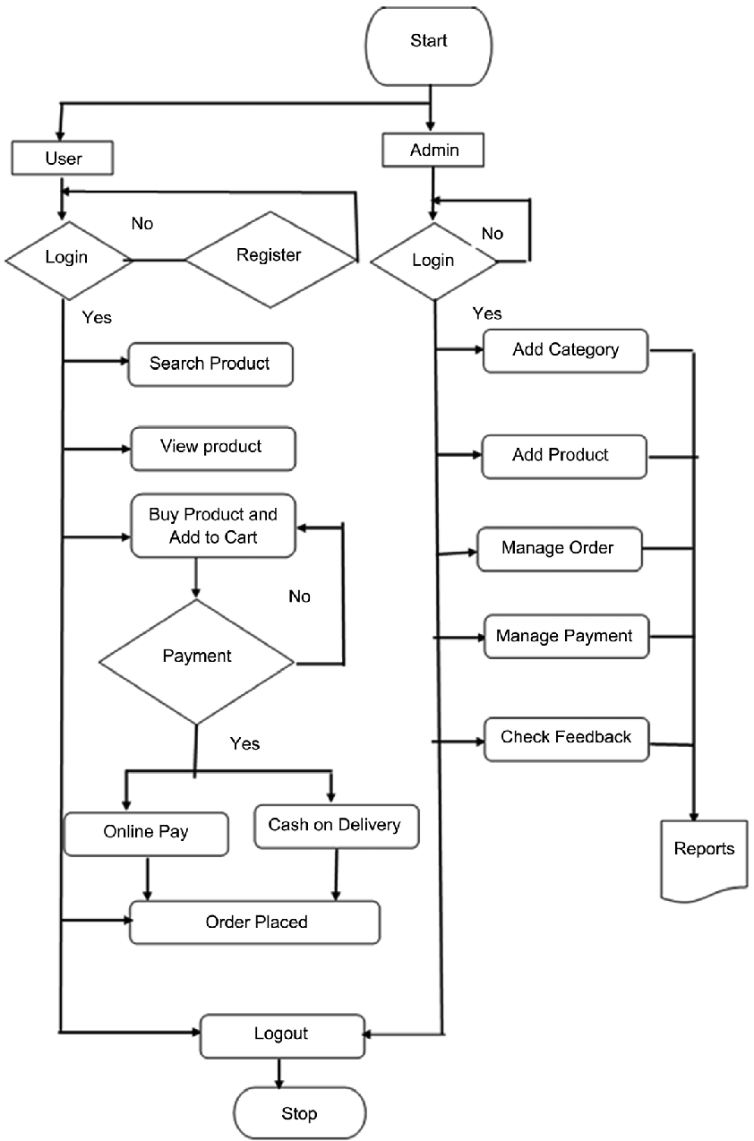

System Architecture

