# **ASSIGNMENT 1**

**Question 1: Produce a line plot showing multiple lines with proper labels and legend. Describe what conclusions you can draw from this plot.**

**Solution:**

**Line Graph:**

**Description:**

The line graph visualizes the fluctuation of different entities in a data set.

**Reason of selection:**

The reason of selecting a line graph is that it can easily handle huge amount of data in an easy way. The user can easily visualize the data and can easily track changes in its dataset time to time.

**Output:**

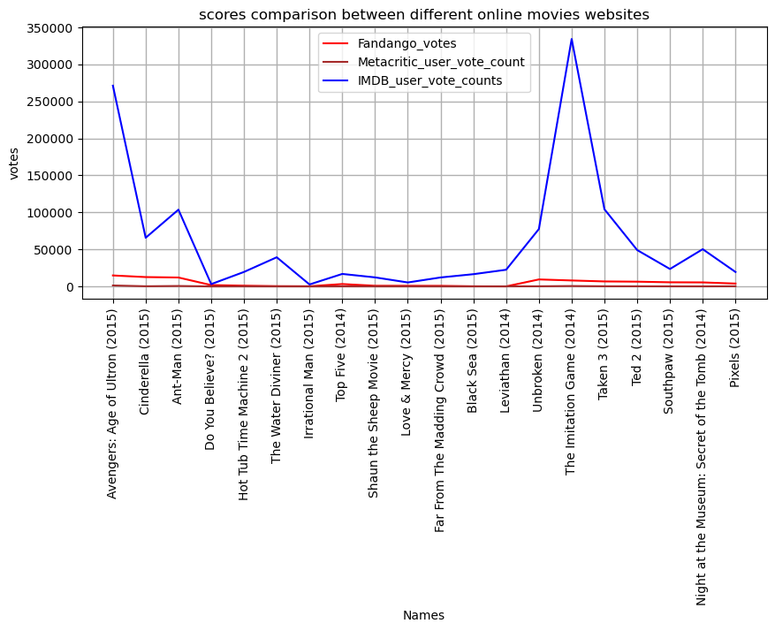

**Link:** [Our Data | FiveThirtyEight](https://data.fivethirtyeight.com/)

**Conclusion:**

When a user takes a good look in to the graph he can clearly analyze the votes given by the people to the following online movie websites. On x-axis we can see the name of different movies, and on y-axis we are calculating the no of votes. The blue line on the graph visualizes the IMDB votes, the red line visualizes the Fandango votes and the brown line indicates the metacritic user votes. We can clearly visualize the competition between these websites.

**Question 2: Produce graphs using two other visualisation methods. Explain why you picked this type of graph and describe what conclusions you can draw.**

**Solution:**

**Part A:**

**Scatter plot:**

**Description:**

A scatter plot shows the correlation between two related entities thus forming a group of dots.

The group of dots are usually known as clusters.

**Reason of selection:**

The reason I selected this graph is because it really help us to analyze the relation between two entities likewise if we combine the two entities would that be a possible if we get another result.

**Output:**

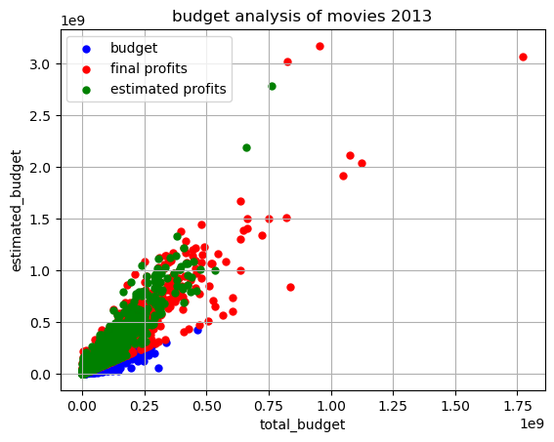

**link:** [Our Data | FiveThirtyEight](https://data.fivethirtyeight.com/)

**Conclusion:**

When a user takes an analysis of this graph the user can easily understand the correlation between different entities. Such as, we can clearly visualize the relation between the total budget and the estimated budget of the films shown as the blue dots, whereas the red dots visualizes the final profits of the movies by calculating the final domgross and the final intgross and the red dots are shown to be the estimated profits by calculating the estimated domgross and the estimated intgross. On x-axis we can see the total budget and on y-axis we can see the estimated budget of the movie. We can clearly visualize our profits ratios just by looking in to the graph.

**Part B:**

**Pie Chart:**

**Description:**

A pie chart is the circular statistical plot that can display series of one data. The area of the chart displays the percentage of the given data. The area of slices of the pie represents the percentage of the parts of data.

**Reason of selection:**

The reason of using the pie charts is that it helps us to understand the whole relation in an organization like the total expense of the firm, total no of departments and almost all the relations within the firm.

**Output:**

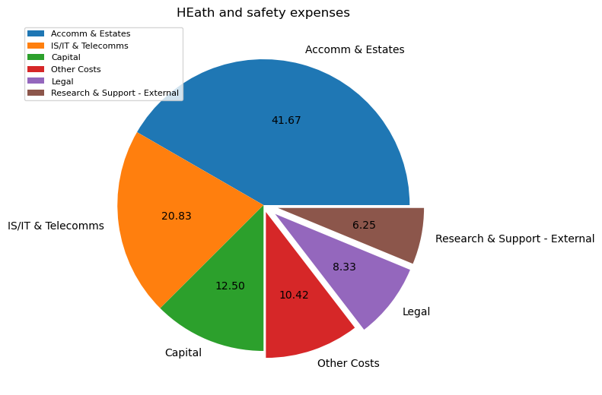

**link:** [Our Data | FiveThirtyEight](https://data.fivethirtyeight.com/)

**Conclusion:**

When a user takes an analysis of this graph the user can easily differentiate between different departments in an organization and their expenditure of the firm. The user can easily analyze the different departments of the firm and the total percentage of the expense caused by each department.