**Elock**

Developing a pattern lock for android by eye tracking means pattern lock depend on of eye. Using opencv eye detection methods.

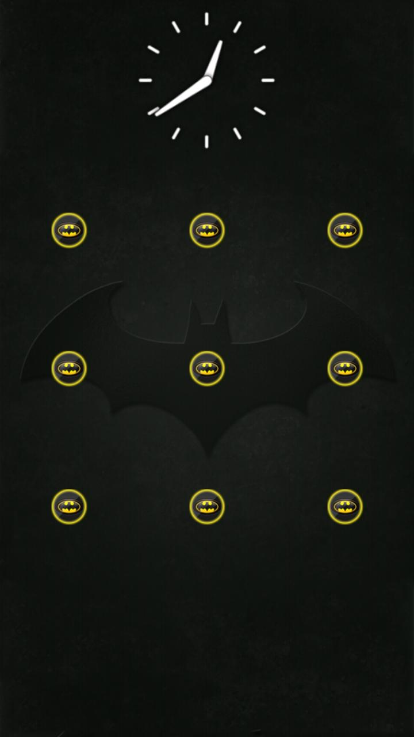

Just like simple pattern lock but when pattern drawn by eye lines drawn at the backend in front looks the same until pattern matched and then lock disappear.