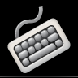Sd

*Lesson 1: The Home* Key’s

* ***Key Drill***
* ***Word Drill***
* ***Tip: Typing Test***
* ***Paragraph Drill***

**1 2 3**

Typing Master

X

About

Setting

Typing Test

Touch Typing Course

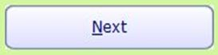cancel.JPG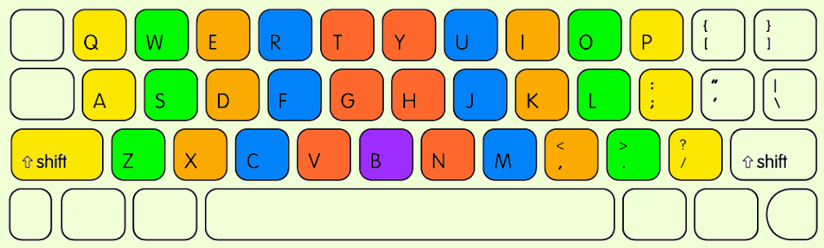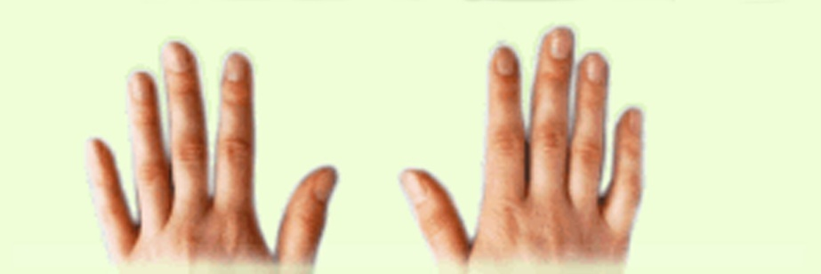

**Studying**

**Your Progress**

cnasal.JPG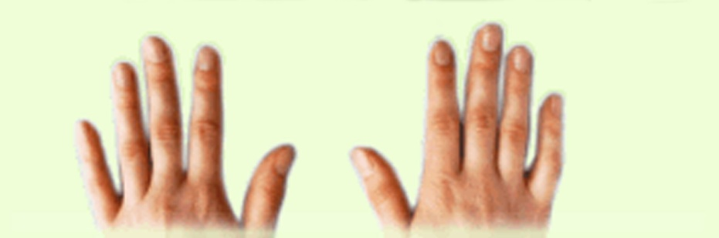

**Studying**

*Lesson 1: The Home* Key’s

* ***1.1 Key Drill***
* ***1.2 Word Drill***
* ***1.3 Tip: Typing Test***
* ***1.4 Paragraph Drill***

**1 2 3**

X

Touch Typing Course

Typing Test

Setting

About

***Paragraph 1***

***Paragraph 2***

***Paragraph 3***

***Paragraph 4***

***Paragraph 5***

*Test Text*

**Typing Text**

Studying

Typing Master

X

About

Setting

Typing Test

**Your Progress**

**Time**

first set all box color is white

and

press ctrl and click on the box

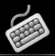

About

**Studying**

* ***Key Drill***
* ***Word Drill***
* ***Tip: Typing Test***
* ***Paragraph Drill***

***Lesson 1: The Home Row***

**1 2 3**

Typing Test

Typing Master

Setting

Touch Typing Course