**UmairSolangi  
2112203  
OS Lab (C)  
Quiz 02**

**Question No 01:**

sudo apt update

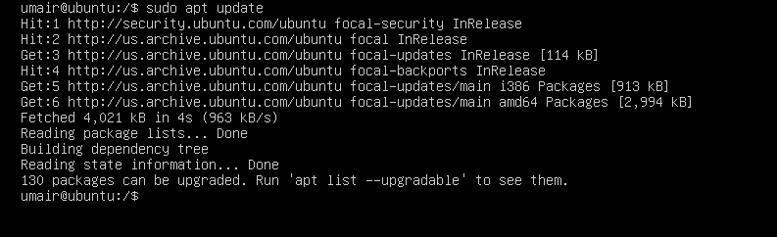

sudo apt install cron



sudo systemctl enable cron

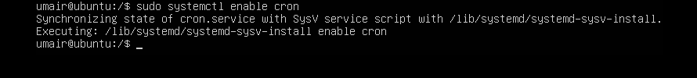

crontab -e

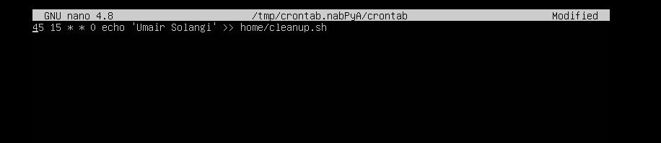

**Question No 02:**

**1: systemctl restart apache2  
2: chmod +x script.sh  
3: To manage server logs**

**Question No 03:**

./list_permissions.sh/home/Desktop/umair

