Umair Solangi  
2112203  
Section C  
Quiz 1  
Os Lab

**Question No 01:**  
Create user named umair and a group named 5c-2112203 the perfume following task:

1. Add the created user to the created group:

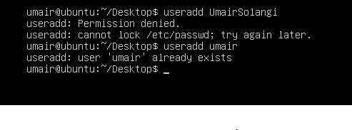

b)Ensure that the created user can execute a command with superuser privileges using sudo without a password prompt:

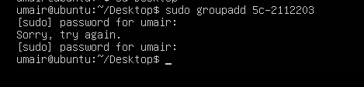

**Question No 02:**

1. List all files and directories in the /etc directory

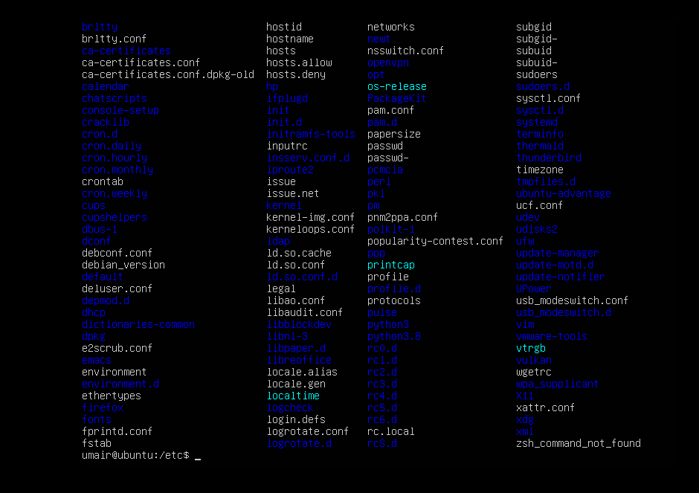

1. Create a new directory named “bingo” in your home directory



1. Move a file named “hello.sh” from you home directory to the “bingo” directory

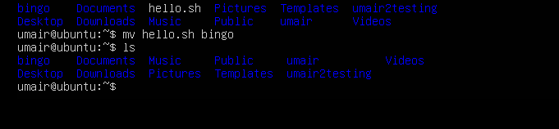

**Question No 05:**

1. List all files in the /home directory



1. Display the contents of the first 10 lines of listing.txt

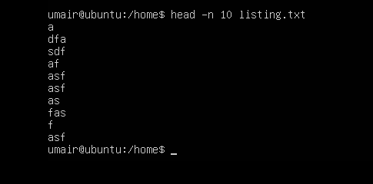

**Question No 04:**

Create a directory named oslab with the following permissions: drwxr’xr’x with sudo then perfume following task:  
a) change the group owner of the oslab directory to users

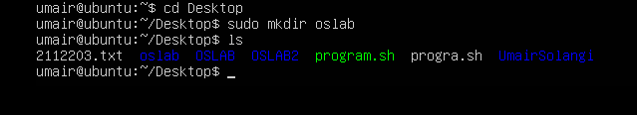

1. Allow member of the users group to write to the oslab directory

