# Laravel Translation Management Service

## Objective

Build a Translation Management Service to evaluate your ability to write clean, scalable, and secure code, with a focus on performance. This is a test task and does not need to be a production-grade application. The expected completion time is 2 hours, but feel free to complete as much as possible if you have additional time available.

## Installation & Setup

### Prerequisites

- PHP 8.2+

- Laravel 11+

- MySQL or PostgreSQL

- Composer

- Docker (optional)

### Steps

- Clone the repository: git clone https://github.com/your-repo/translation-management.git

- Navigate to the project directory: cd translation-management

- Install dependencies: composer install

- Generate application key: php artisan key:generate

- Set up the database: php artisan migrate –seed

💡 **This will create necessary tables and seed initial translations and tags**

✅ **This will populate the database with 100,000 random translations.**

- Run the application: php artisan serve

## API Endpoints

# ****Translation Management API Endpoints****

### ****Authentication****

* **POST /api/register** → Register a new user
* **POST /api/login** → Log in and obtain an authentication token
* **POST /api/logout** → Log out (requires authentication)
* **GET /api/user** → Retrieve authenticated user details

### ****Translation Management****

* **POST /api/translations** → Create a new translation
* **GET /api/translations** → Get all translations
* **GET /api/translations/{id}** → Retrieve a specific translation by ID
* **PUT /api/translations/{id}** → Update an existing translation
* **DELETE /api/translations/{id}** → Delete a translation

### ****Tag Management****

* **GET /api/tags** → Retrieve all available tags
* **GET /api/translations/search?tag=mobile** → Search translations by tag

### ****Export****

* **GET /api/translations-tags/export** → Export translations as JSON

## register

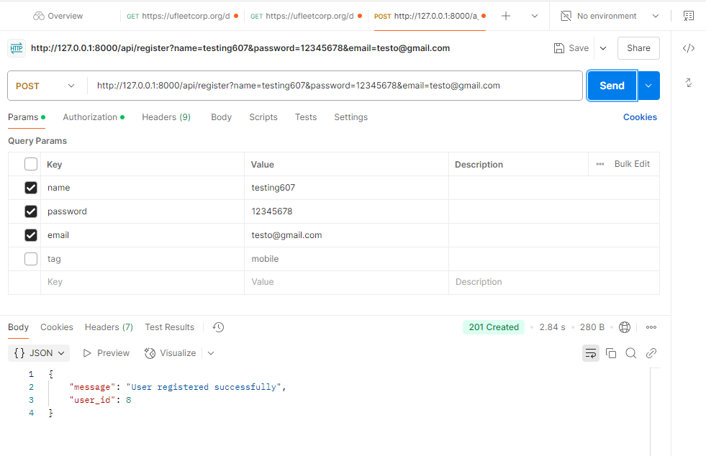

## Login

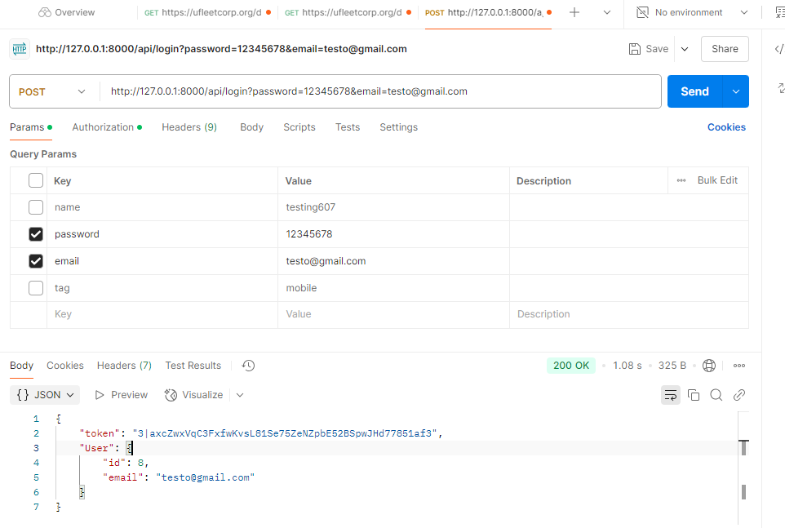

## Translations

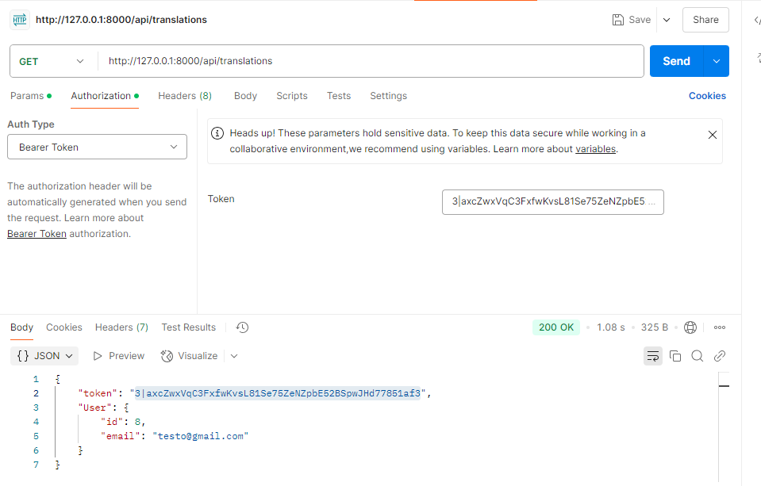

## Tags

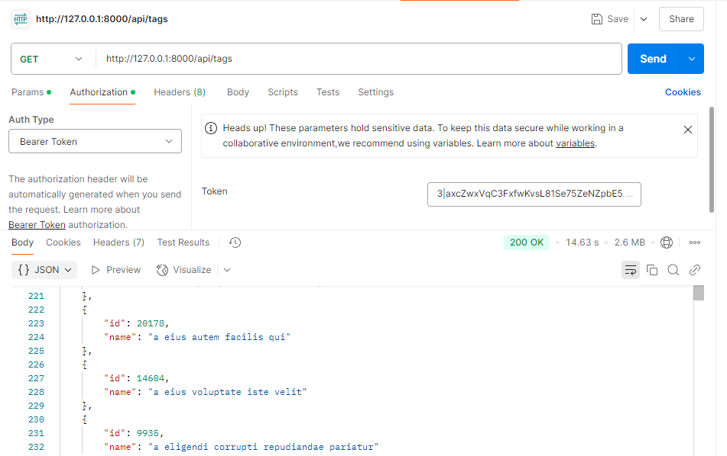

## Search

