**ENDPOINTS:**

* GET /movie-list/fetch
* GET /movie-list/fetch/{id}
* POST /movie-list/add

The above are 3 endpoints and there name is suggesting the purpose of every endpoint.

I have pushed the code in the git repository . You just pull it and install dependencies through composer and use the **movies.sql** as your database.

I have implemented validations for post api.

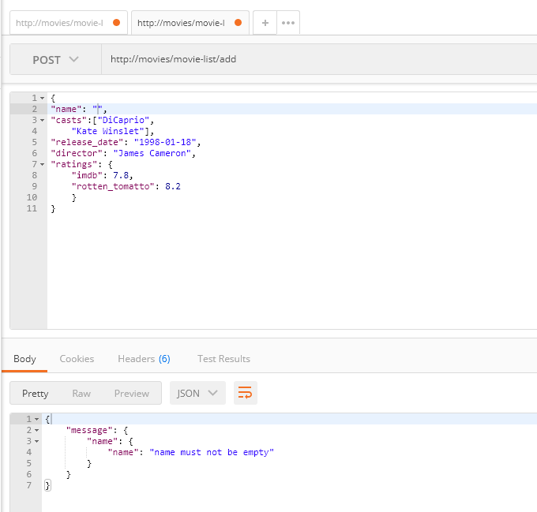

**I have applied authentication assuming there is a table in database that stores session values and I am taking the token from user in headers of API**

(hellouser) is the token that I used in the database that I provided.

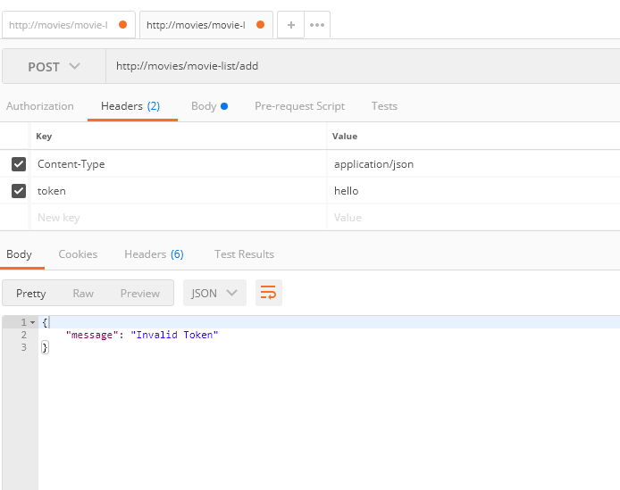

Here is the result  
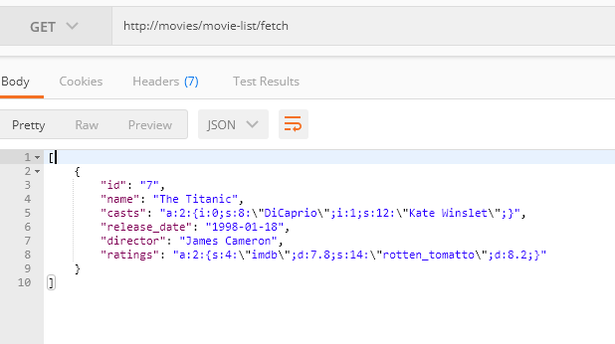

On code point of view I have used slim framework version 4.

I tried to meet all the core requirements , There may be need of improvement in the coding technique, but due to new framework and less time I had to complete the functionality rather focusing on deep concepts that are used by slim framework.  
I understood those concepts but implementing those without a lot of practice just required more time.  
So I have completed funcationality