**Foot Api**

1. Send request using post man and type POST
2. url: http://0.0.0.0:8000/
3. Two perimeter set

* 1fst ‘image’ and type file ( Note: send image on both foot)

* 2nd ‘foot_length’ and type text (Note: give int value in 5 to 15)

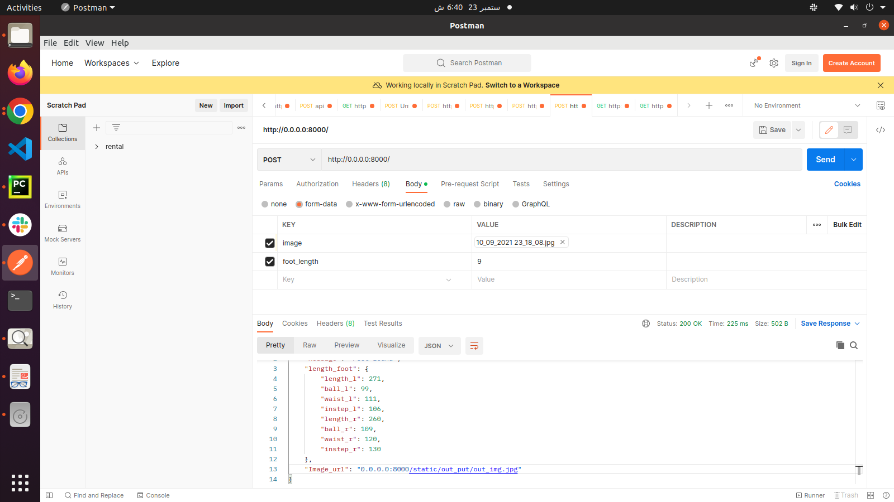  
Result:  
{

"Message": "Feet found",

"length_foot": {

"length_l": 271,

"ball_l": 99,

"waist_l": 111,

"instep_l": 106,

"length_r": 260,

"ball_r": 109,

"waist_r": 120,

"instep_r": 130

},

"Image_url": "0.0.0.0:8000/static/out_put/out_img.jpg"

}