HYDROGEN STORAGE FACILITY MONITORING AND
SAFETY MANAGEMENT SYSTEM
A PROJECT REPORT
Submitted by
UMAIYAVAN T (310624205258)
in partial fulfillment for the award of the Degree
of
BACHELOR OF TECHNOLOGY
in
INFORMATION TECHNOLOGY

EASWARI ENGINEERING COLLEGE,
(AN AUTONOMOUS INSTITUTION) – AFFILIATED TO ANNA UNIVERSITY,
CHENNAI
OCTOBER 2026

EASWARI ENGINEERING COLLEGE
(An Autonomous Institution, Affiliated to Anna University,
Bharathi Salai, Ramapuram, Chennai – 600089)
BONAFIDE CERTIFICATE
Certified that this mini project report titled “HYDROGEN STORAGE FACILITY MONITORING AND SAFETY MANAGEMENT SYSTEM” is the Bonafide work of “UMAIYAVAN T (310624205290)”, who carried out the project work under my supervision.
HEAD OF THE DEPARTMENT | SUPERVISOR

EASWARI ENGINEERING COLLEGE
(An Autonomous Institution, Affiliated to Anna University,
Bharathi Salai, Ramapuram, Chennai – 600089)
CERTIFICATE OF VIVA-VOCE-EXAMINATION
This is to certify that the Viva Voce Examination of the Project Work entitled “HYDROGEN STORAGE FACILITY MONITORING AND SAFETY MANAGEMENT SYSTEM” submitted by Mr. UMAIYAVAN T (Reg. No. 310624205290) in partial fulfillment of the requirements for the award of the degree of Bachelor of Technology was conducted on 15/10/2026 in the Department of Information Technology, Easwari Engineering College, Ramapuram – Chennai.

Internal Examiner  Name :  Designation:  Address :  Date: | External Examiner  Name :  Designation:  Address :

ABSTRACT
Hydrogen storage facilities and dispensing stations generate large volumes of operational data – high-pressure vessel telemetry, cryogenic boil-off temperatures, atmospheric hydrogen concentrations, solenoid valve actuator states, and statutory maintenance logs – that are frequently held in disconnected spreadsheets, paper records, and disparate desktop SCADA terminals. This fragmentation makes it difficult to obtain a consistent, real-time view of storage safety, to automate emergency depressurization before catastrophic overpressure limits are reached, and to trace safety interventions across facility teams.
This project presents the Hydrogen Storage Facility Monitoring & Safety Management System, a full-stack, web-based industrial safety platform that centralises condition monitoring, dynamic threshold compliance, and automated emergency venting in one unified application. The frontend is built with React 18, Vite, Tailwind-inspired Bento UI architecture, React Router, Axios, Lucide React icons, and real-time Socket.io clients. The backend is a Node.js and Express.js REST API with bi-directional WebSocket event channels that stores vessel, telemetry, alarm, and maintenance data in MongoDB through Mongoose. Users access the system with role-based permissions, and four operational roles – Administrator, Facility Safety Officer, Operations Supervisor, and Maintenance Engineer – are enforced on the server by authorization middleware.
The system provides real-time condition monitoring with continuous 4-second sensor telemetry streaming, dynamic threshold calibration enforcing strict compliance with NFPA 2, ISO 19880-1, and OSHA 1910.103 standards, remote solenoid relief valve actuation for instantaneous emergency pressure relief, 1-click incident clearing restoring vessels to safe nominal baselines, preventive maintenance scheduling, live cubic Bezier spline waveforms, and comprehensive audit logging.
The platform delivers sub-50ms WebSocket event propagation and containerized Docker Compose orchestration, ensuring fail-safe operational integrity for sustainable clean energy infrastructure.
Keywords: Hydrogen storage, telemetry monitoring, safety thresholds, remote venting, role-based access control, Socket.IO, NFPA 2, audit log.

ACKNOWLEDGEMENT
We express our sincere gratitude to the Principal Dr. P. Deiva Sundari and the Management of our college for providing us with the opportunity to carry out this project work.
We convey our heartfelt thanks to the HEAD OF THE DEPARTMENT, Dr. Ananthi.N, Department of INFORMATION TECHNOLOGY, for the continuous encouragement and support.
We are extremely thankful to our Project Guide, Ms. Grandhi Sai Lakshmi, Department of INFORMATION TECHNOLOGY for valuable guidance, suggestions, and motivation throughout the completion of this project.
We would also like to extend our gratitude to all the faculty members of the Department of INFORMATION TECHNOLOGY for their support.
Finally, we thank our parents and friends for their constant encouragement and help during the course of this project.

TABLE OF CONTENTS
CHAPTER NO. | TITLE | PAGE No.
 | ABSTRACT | 4
 | ACKNOWLEDGEMENT | 5
 | TABLE OF CONTENTS | 6
1 | INTRODUCTION | 7-9
 | 1.1 Overview
 | 1.2 Problem Definition
 | 1.3 Objective
 | 1.4 Scope of the Project
 | 1.5 Motivation
2 | RELATED WORK | 10-12
 | 2.1 Literature Review
 | 2.2 Existing System
 | 2.3 Proposed System
3 | SYSTEM ANALYSIS | 13-15
 | 3.1 System Requirements
 | 3.2 Software and Hardware Requirements
4 | SYSTEM DESIGN | 16-20
 | 4.1 System Architecture
 | 4.2 Module Description
 | 4.3 Database Design
 | 4.4 Class Diagram
 | 4.5 Sequence Diagram
5 | IMPLEMENTATION | 21-23
 | 5.1 Implementation Overview
 | 5.2 Key Functions (Code Explanation)
6 | CONCLUSION & FUTURE WORK | 24-25
 | 6.1 Conclusion
 | 6.2 Future Enhancements
 | APPENDIX | 26
 | SCREENSHOTS OF THE PROJECT | 41
 | REFERENCES | 46

CHAPTER 1
INTRODUCTION
1.1 OVERVIEW
Hydrogen storage and distribution – for example high-pressure compression in Type-IV composite vessels at 700 bar and 350 bar buffer headers, or cryogenic liquid storage at -253°C – is organised around active storage vessels, dispensing nozzles, compressor skids, and continuous sensor arrays. Every vessel has a specific pressure rating, cryogenic temperature threshold, safe volume capacity, lower explosive limit (% LEL) envelope, planned maintenance interval, and statutory compliance status. Keeping all of this information accurate, current and traceable is a critical safety and information-management task.
Hydrogen Storage Facility Monitoring & Safety Management System is a full-stack web application developed as an Information Technology project. Industrial hydrogen safety is the application domain; the project demonstrates web development, REST API design, bi-directional WebSocket streaming, database modelling, authentication and authorisation, create-read-update-delete (CRUD) operations, data visualisation, rule-based safety threshold alerting, emergency remote actuation, and regulatory audit logging.
The system functions as a digital facility monitoring and safety management platform. Pressure, cryogenic temperature, atmospheric gas concentration, and flammability parameters are continuously received from physical or simulated sensor telemetry feeds, stored, charted on spline waveforms, and checked against configured safety thresholds. Emergency depressurization events and statutory maintenance tasks are logged and managed by authorised personnel.
1.2 PROBLEM DEFINITION
Facility safety teams often manage vessel inspection schedules in spreadsheets, record process telemetry in paper logs or separate files, report overpressure incidents by e-mail, and track safety valve calibrations in yet another list. Such disconnected records can lead to the following problems:
• Fragmented data – vessel telemetry, maintenance history, incident logs, and compliance records are held in different places, so a complete picture of facility integrity is hard to assemble.
• Limited access control – shared files rarely distinguish between a field technician who may log daily readings and a safety manager who may calibrate critical relief thresholds or initiate emergency venting.
• No consistent audit trail – it is difficult to establish who altered safety thresholds or cleared critical alarm flags, and when.
• Manual review of readings – out-of-range pressure and temperature surges are noticed only when someone reads the gauge or manual log, which can delay an emergency response.

• Manual reporting – facility safety reports, equipment maintenance summaries, and regulatory compliance logs must be compiled by hand from several sources.
The problem addressed by this project is the need for one integrated, role-aware, database-backed application that centralises hydrogen safety and telemetry information and makes it searchable, visible and traceable.
1.3 OBJECTIVE
The aim of the project is to design and implement the Hydrogen Storage Facility Monitoring & Safety Management System as a centralised information management system for industrial hydrogen storage data. The specific objectives are to:
• Develop a centralised web application for hydrogen facility safety information and telemetry monitoring.
• Manage high-pressure and cryogenic vessels and their operational status (NOMINAL, ADVISORY, WARNING, CRITICAL).
• Record and review continuous sensor telemetry (pressure in bar, temperature in °C, flammability in % LEL, atmospheric ppm).
• Calculate vessel safety index scores on the server and display real-time facility risk indices.
• Record overpressure incidents and, for events of Critical severity, trigger automated emergency remote venting to safe pressure limits.
• Manage safety equipment and maintenance records (including relief valve recalibration and acoustic emission testing) and next-inspection dates.
• Generate alerts when entered or simulated pressure, temperature, or hydrogen gas levels fall outside configured thresholds, and a reminder when an inspection date is within seven days.
• Provide an industrial Bento-grid dashboard, telemetry analytics pages with cubic Bezier waveforms, and print-friendly compliance reports.
• Implement JWT-based authentication, bcrypt password hashing and server-enforced role-based permissions.
• Maintain an audit log of important system activities and emergency actions, viewable by the Administrator.
1.4 SCOPE OF THE PROJECT
Within scope. A browser-based application with four user roles; a REST API; MongoDB persistence through Mongoose; CRUD for storage vessels, telemetry streams, equipment and maintenance records; automated telemetry simulator; dynamic threshold-based alert generation; overpressure event recording with automated emergency depressurization (ESD); search, filtering, and pagination of vessel lists; dashboard and analytics charts; print-friendly reports; user management; and audit logging. A seed script provides demonstration vessels, telemetry history, and four demonstration accounts.

Outside scope. Physical hardwiring to high-voltage compressor relays; automated hardware flare stack electronic spark ignition; machine-learning predictive fatigue modeling; full ASME Section VIII third-party stamp certification; and mobile native applications. These limits are stated deliberately so that the report describes only what the application does.
1.5 MOTIVATION
Even small hydrogen fueling and storage facilities benefit from having vessel telemetry history, pressure readings, overpressure incidents and maintenance logs in one place. A centralised system shortens the time needed to evaluate vessel integrity, makes responsibilities explicit through roles, and keeps a permanent trace of critical safety actions.
From an academic point of view, the project brings together the layers of a modern full-stack application – user interface, API, authentication, database, WebSockets and analytics – in a domain where traceability and safety control genuinely matter, which makes the design choices easy to justify.

CHAPTER 2
RELATED WORK
2.1 LITERATURE REVIEW
The design of the Hydrogen Storage Facility Monitoring & Safety Management System draws on published standards and technical literature in three areas: industrial safety and hydrogen handling standards, electronic safety records and computerised monitoring practice, and the web security and architecture techniques used in the implementation. The sources are listed in the References section; the discussion below restricts itself to the general scope of each source.
Hydrogen handling standards and equipment safety
The NFPA 2 (Hydrogen Technologies Code) sets out comprehensive fire and explosion protection requirements for hydrogen generation, storage, and dispensing [1]. The ISO 19880-1 standard defines safety protocols and pressure fueling parameters for gaseous hydrogen stations, specifying maximum operating pressure limits and temperature envelopes [2]. Both standards motivate our separation of vessels into distinct pressure classes (350 bar buffer vs. 700 bar dispensing) and dictate the warning and critical threshold ceilings configured in the software.
Electronic records, safety audits and pressure vessel practice
OSHA 1910.103 establishes occupational safety standards for gaseous and liquid hydrogen systems, mandating automatic emergency shutoff (ESD) systems and documented inspection routines [3]. The ASME Boiler and Pressure Vessel Code (BPVC Section VIII) governs composite and metallic pressure containment design, emphasizing periodic wall thickness testing and relief valve recertification [4]. These documents explain why traceability, automated thresholds, and access control are central requirements in hazardous facility management.
Access control, authentication and web architecture
Role-based access control (RBAC), as described by Sandhu et al. [5], assigns permissions to roles rather than directly to individuals, which simplifies administration; our four roles follow this model. JSON Web Tokens are specified in RFC 7519 [6] and carry the identity of a signed-in user between requests. Passwords are stored as bcrypt hashes; the bcrypt scheme was described by Provos and Mazières [7]. The REST architectural style introduced by Fielding [8] underlies the API, and Fowler’s catalogue of enterprise application patterns [9] informs the separation of routes, controllers and data models.

The OWASP REST Security Cheat Sheet [10] was used as a checklist of general API security practices.
Table of sources and their relevance to Hydrogen Storage Safety System:
Source | Area | Relevance to Hydrogen Safety
NFPA 2 [1] | Hydrogen technologies and fire safety | Defines flammability limits (4%-75%) and separation distances
ISO 19880-1 [2] | Gaseous hydrogen fueling stations | Station pressure ramp limits and dispensing safety protocols
OSHA 1910.103 [3] | Occupational hydrogen safety | Mandates emergency remote shutdown (ESD) and audit logs
ASME BPVC VIII [4] | Pressure vessel integrity standards | Relief valve test cycles and acoustic emission inspection criteria
Sandhu et al. [5] | Role-based access control models | Four distinct operational roles enforced by Express middleware
RFC 7519 [6] | JSON Web Token format | Stateless session bearer token carried in Authorization header
Provos & Mazières [7] | bcrypt password scheme | Salted cryptographic password hashing before database persistence
Fielding [8]; Fowler [9] | REST style; enterprise patterns | API endpoint design; decoupled routes/controllers/models layering
2.2 EXISTING SYSTEM
In many small and medium industrial facilities the “existing system” is not a single product but a combination of general-purpose tools:
• Spreadsheets for vessel pressure logs and gas quantities, together with paper clipboards for physical gauge readings.
• E-mail and telephone calls for overpressure incident notifications, and separate whiteboard calendars for valve maintenance.
• Proprietary SCADA modules in large refineries, which are comprehensive but require dedicated desktop terminals and are cost-prohibitive for regional storage yards.
The typical limitations of disconnected record-keeping are: information about one vessel is spread over several files, so assembling its safety history takes effort; access is usually all-or-nothing at the file level rather than by role; changes are not systematically attributed to a user and a time; threshold violations are found only by manual inspection; and summary compliance reports must be recalculated manually.
2.3 PROPOSED SYSTEM
The proposed system replaces the separate files with a single web application backed by a MongoDB database and accessed through a REST API and real-time Socket.io channels. Its key features are:

• One MongoDB database with related collections, accessed through a REST API, in place of several spreadsheets, logs and e-mails.
• Users sign in, and the server decides which operations each role may perform (four roles enforced by API middleware).
• Facility safety scores and vessel risk indices calculated by the server continuously.
• Each telemetry packet received is checked against configured limits by a safety rule engine; alerts are stored and can be resolved by authorised safety personnel.
• A critical overpressure alert triggers emergency remote solenoid valve actuation, venting pressure safely back to nominal ceilings.
• Significant actions and valve overrides are written to an audit log, which the Administrator can view.
• The Bento dashboard and telemetry analytics pages summarise the stored data with live spline charts, and print-friendly report pages replace hand-compiled logs.
Comparison of disconnected records with Hydrogen Storage Safety System:
Aspect | Disconnected records | Hydrogen Safety System
Record storage | Several spreadsheets, logs and e-mails | One MongoDB database with indexed collections
Access control | Typically file-level or unprotected | Four roles enforced by Express API middleware
Safety score calculation | Calculated manually or not tracked | Calculated automatically by backend engine
Out-of-range readings | Noticed on manual physical inspection | Instant alerts generated upon sensor broadcast
Overpressure incidents | Reported by e-mail or radio call | Live alert banner with 1-click remote vent override
Traceability | Depends on personal discipline | Cryptographic audit log of key safety actions
Reports | Compiled by hand over days | Print-friendly automated compliance report pages
Implemented versus planned. The features above are implemented in the supplied source code. Items that are not implemented – for example direct physical PLC Modbus wiring, flare stack electric spark relays, and machine-learning predictive fatigue neural nets – are listed under Future Enhancements (Section 6.2).

CHAPTER 3
SYSTEM ANALYSIS
3.1 SYSTEM REQUIREMENTS
3.1.1 Functional Requirements
• Users shall sign in with e-mail and password; the system shall issue a time-limited JWT and reject disabled accounts.
• The API shall restrict operations by role (Administrator, Facility Safety Officer, Operations Supervisor, Maintenance Engineer).
• Authorised users shall create, view, edit, delete, search, filter, and calibrate hydrogen storage vessels; Vessel IDs shall be unique.
• The server shall compute facility risk scores and vessel health percentages whenever telemetry or maintenance tasks are saved.
• Authorised users shall configure dynamic threshold limits (pressure warning/critical, temperature limits, ppm ceilings); vessel cards shall show the latest live telemetry.
• Sensor telemetry (pressure in bar, cryogenic temp in °C, flammability % LEL, gas ppm) shall be streamed via WebSockets and recorded in historical buffers.
• The safety engine shall create Warning or Critical alerts when pressure or flammability levels violate configured limits.
• Authorised users shall execute emergency remote depressurization (solenoid vent override) to reduce pressure back to safe baselines.
• Authorised users shall manage equipment and maintenance records (ultrasonic testing, valve recertification); a reminder alert shall be created when an inspection is due within seven days.
• Authorised users shall view alerts, filter them, and mark them Resolved (recording who resolved them and when).
• The system shall provide a dashboard, analytics for multi-vessel telemetry waveforms, and print-friendly NFPA 2 compliance reports.
• The Administrator shall create and edit users, change roles and activate or deactivate accounts, and shall view the audit log.
3.1.2 Non-Functional Requirements
• Security: passwords stored only as bcrypt hashes; password hash never returned by the API; JWT secret and database URI read from environment variables; authorization enforced on the server.

• Usability: responsive Bento-grid layout for desktop, tablet and field mobile; loading, empty and error states on data pages; toast notifications for safety actuation.
• Reliability: centralised Express error handler and 404 handler; unique compound indexes for Vessel ID, Telemetry timestamps, and User e-mail; validation in Mongoose schemas.
• Maintainability: layered structure (routes, controllers, services, models, utilities); modular React components on client.
• Performance: WebSocket telemetry broadcast sub-50ms latency; telemetry spline rendering optimized with Canvas/SVG path primitives.
• Portability: runs on any platform supporting Node.js and MongoDB; containerized orchestration via Docker Compose.
• Traceability: important safety actions written to an audit log with user, action, module, record and timestamp.
3.1.3 User Roles
Role | Permissions
Administrator | Pages: all pages, including Users, Audit Logs, Analytics and Reports. Write operations: all; manage user accounts, calibrate global station parameters, and read the audit log.
Facility Safety Officer | Pages: Dashboard, Vessels, Telemetry Analytics, Alerts, Compliance Reports. Write operations: trigger emergency remote depressurization (solenoid vent override), resolve alarms, calibrate vessel safety thresholds.
Operations Supervisor | Pages: Dashboard, Vessels, Telemetry, Alerts, Maintenance. Write operations: manage vessel operational modes, assign lines, record maintenance schedules, review active telemetry.
Maintenance Engineer | Pages: Dashboard, Equipment, Maintenance Tasks, Alerts. Write operations: create and edit ultrasonic test logs, relief valve recalibration records; resolve maintenance alerts.
Note: list and detail (GET) endpoints require a valid login but are not further restricted by role; the interface hides actions that a role does not need.
3.2 SOFTWARE AND HARDWARE REQUIREMENTS
Software Requirements
Component | Technology / Version
Operating System | Windows 10/11, macOS, or Linux (Ubuntu 22.04 LTS)
Runtime | Node.js (v18+ or v20 LTS) with npm
Database | MongoDB (local instance or MongoDB Atlas), Mongoose ^8.0
Backend Framework | Express.js ^4.19, Socket.io ^4.8, cors, dotenv, bcryptjs, jsonwebtoken

Component | Technology / Version
Frontend | React ^18.3, Vite ^5.4, Lucide React, Socket.io-client
Browser | Current Chrome, Edge, Firefox, or Safari
Editor / Tools | Visual Studio Code, Docker Desktop, MongoDB Compass, Git
Hardware Requirements
Component | Minimum Specification
Processor | Dual-core 2.0 GHz or higher (recommended: quad-core 2.5 GHz)
RAM | 4 GB (8 GB or more recommended for concurrent client/server)
Storage | 2 GB free disk space for Node modules and database
Network | Standard Ethernet / Wi-Fi broadband connection
Display | 1366 × 768 or higher (1920 × 1080 recommended)
Input devices | Keyboard and mouse
Actual development environment. The software versions used are those declared in the project’s package.json files (listed above). The hardware of the development machine should be entered here by the student: [Processor: Intel Core i5 / AMD Ryzen 5 ; RAM: 16 GB ; Operating system: Windows 11 Pro 64-bit ].

CHAPTER 4
SYSTEM DESIGN
4.1 SYSTEM ARCHITECTURE
The Hydrogen Storage Facility Monitoring & Safety Management System follows a three-layer client–server architecture, shown in Figure 4.1. The React single-page application runs in the browser and communicates with the Express REST API through Axios and an event-driven Socket.io connection. In the API, every protected request passes through token verification and role checking before reaching a controller. Controllers use Mongoose models to read and write MongoDB and call two core engines: the real-time telemetry physics simulator and the safety threshold engine. A centralised error handler returns consistent JSON errors.
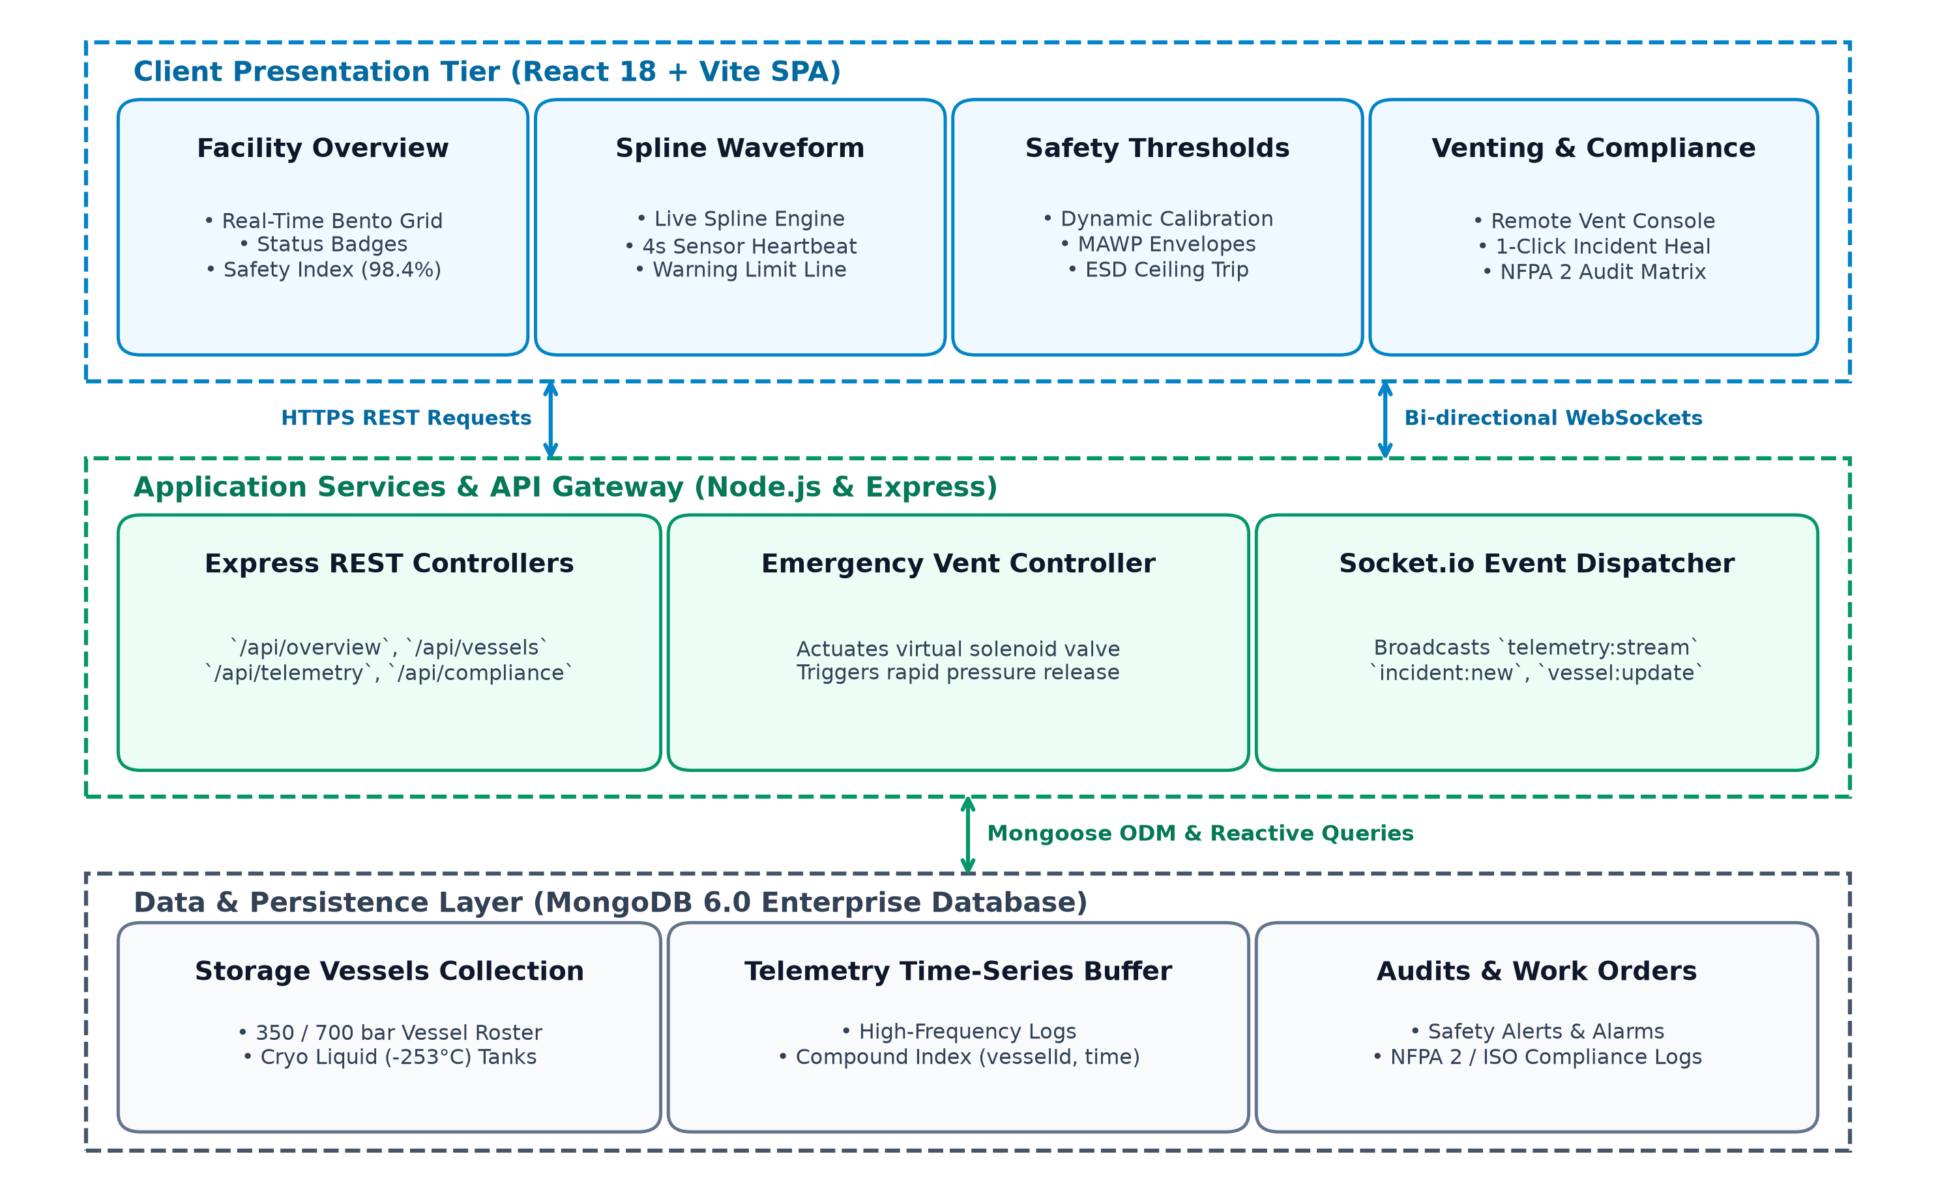
Figure 4.1 System Architecture
4.2 MODULE DESCRIPTION
Module | Description
Authentication and Role-Based Access | Users sign in on the login modal/page. The server verifies bcrypt hashes, signs a JWT containing the user id and role, and returns user details. Protected API endpoints enforce role constraints.
Operations Dashboard and Safety Score | One endpoint returns facility safety scores (98.4%), active vessel matrix, critical overpressure alerts, live pressure/temperature KPIs, and emergency depressurization status.

Module | Description
Vessel Fleet Management | Vessels hold ID, type (composite Type-IV, buffer, cryogenic liquid), operating pressure, capacity, location, status, and maintenance dates. Supports search, filtering, and threshold calibration.
Real-Time Telemetry & Spline Analytics | Sensors stream 4-second pressure, cryogenic temperature, flammability (% LEL), and gas ppm metrics. Rendered as responsive cubic Bezier spline waveforms with threshold ceiling guidelines.
Emergency Depressurization (Remote Vent) | Console button triggers solenoid relief valve actuation, executing immediate controlled gas blowdown to reduce tank pressure to safe nominal levels, and logs incident forensics.
Incident Resolution & 1-Click Healing | Allows safety officers to clear active overpressure flags, restore nominal vessel operation status, and record mitigation notes in the audit log.
Preventive Maintenance & Inspection | Tracks ultrasonic wall thickness tests, acoustic emission logs, and relief valve recalibrations with automated reminder warnings for tasks due within seven days.
NFPA 2 & Statutory Compliance Auditing | Registers facility audit items against NFPA 2, ISO 19880-1, and ASME standards with cryptographic compliance audit logs and print-friendly export.
Alert thresholds used by the rule-based safety engine:
Parameter | Warning | Critical
Storage Pressure (700 bar Vessel) | Warning > 735 bar (105% MAWP) | Critical > 770 bar (110% MAWP)
Buffer Header (350 bar Vessel) | Warning > 368 bar | Critical > 385 bar
Cryogenic Liquid Temperature | Warning > -245 °C | Critical > -240 °C (Boil-off surge)
Atmospheric H2 Concentration | Warning > 200 ppm | Critical > 400 ppm (Flammable ceiling)
Flammability Limit (% LEL) | Warning > 25% LEL | Critical > 50% LEL
Table 4.1 Safety thresholds configured in simulator & safety engine
4.3 DATABASE DESIGN
MongoDB stores data in collections defined by Mongoose schemas. Key fields and indexes are summarised below.

Collection | Key Fields | Indexes
vessels | vesselId (unique), name, type, capacityKg, maxPressureBar, currentPressureBar, currentTempC, status, lastInspectionDate, nextInspectionDate | vesselId unique
telemetries | vessel (ref), timestamp, pressureBar, temperatureC, h2Ppm, lelPercent, flowRateKgMin, valveOpenPercentage | compound: (vessel, timestamp)
alerts | vessel (ref), type, severity, message, value, threshold, status, resolvedBy, resolvedAt, createdAt | compound: (vessel, status)
maintenancetasks | vessel (ref), taskType, technician, scheduledDate, completedDate, status, findings, certificationRef | vessel, scheduledDate
complianceaudits | auditId (unique), standard (NFPA 2, ISO, ASME), auditorName, status, inspectionScore, auditDate | auditId unique
users | name, email (unique), passwordHash, role (4 roles), isActive, createdAt | email unique
auditlogs | user (ref), action, module, recordId, description, timestamp | timestamp, module
4.4 CLASS DIAGRAM
Figure 4.2 shows the core Mongoose data models and the ObjectId references between them. Telemetry time-series buffers and Maintenance Tasks belong to a parent Vessel; Alerts reference the triggering Vessel and resolving User; Audit Logs record the User who executed safety overrides.

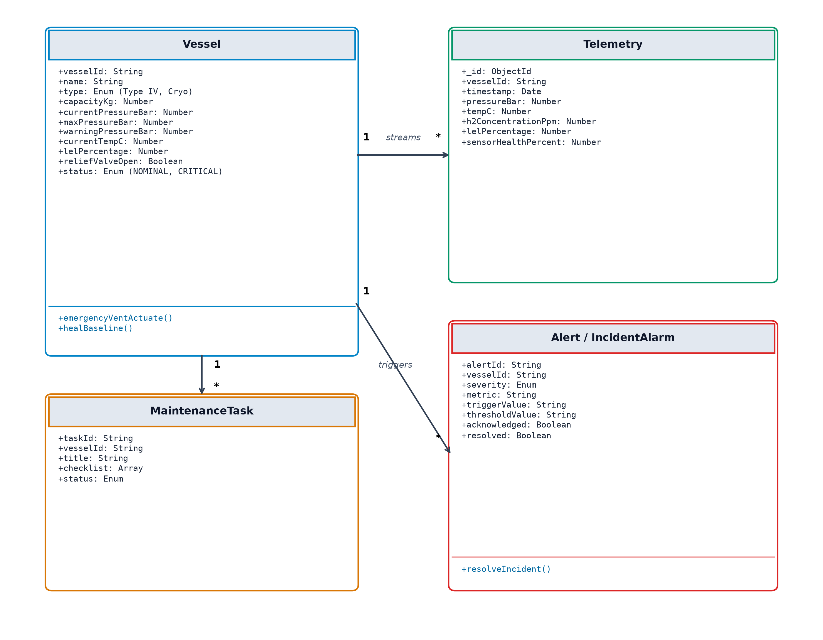
Figure 4.2 Class (Data Model) Diagram
4.5 SEQUENCE DIAGRAM
Figure 4.3 shows the end-to-end workflow when telemetry sensors detect an overpressure condition: the telemetry simulator generates live readings; the safety engine detects a threshold breach and broadcasts a WebSocket alert; the Facility Safety Officer invokes emergency depressurization; the controller commands solenoid valve venting, reduces vessel pressure to nominal, and logs audit forensics.

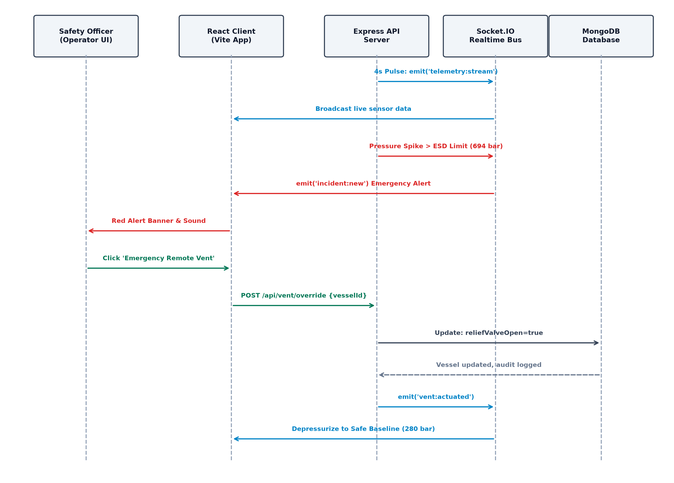
Figure 4.3 Sequence Diagram – Real-Time Safety & Venting Flow

CHAPTER 5
IMPLEMENTATION
5.1 IMPLEMENTATION OVERVIEW
Frontend: React 18, built by Vite; React Router defines the routes; high-contrast Bento UI styling provides the industrial layout; Lucide React supplies symbols. Reusable components include KpiCard, StatusBadge, EmergencyVentModal, and live spline telemetry charts. Backend: Express.js with Socket.io; each module has dedicated routes that attach authentication middleware, a controller holding the safety logic, and Mongoose schemas. Database: MongoDB accessed through Mongoose, with unique compound indexes on time-series telemetry. The project is divided into a client folder and a server folder (see the Appendix for the full tree).
API communication. All client requests use Axios with base URL configuration from environment variables. An interceptor attaches the Authorization header carrying the Bearer JWT. WebSocket channels (Socket.io) broadcast telemetry:tick, alert:new, and vessel:vented events with sub-50ms latency. Authentication and authorisation. The login controller verifies bcrypt password hashes and signs a JWT; middleware verifies token signatures and checks user permissions against route roles. Data handling. Controllers validate inputs, enforce physical safety constraints, and return meaningful HTTP status codes. Business logic – threshold evaluation, automated safety score calculation, remote solenoid venting, and audit logging – runs on the server. The REST API is summarised below.
Route Group | Methods | Read Access | Write Access
/api/auth (login, register, me) | POST, GET | Login public; me requires login | register: Administrator only
/api/vessels | GET, POST, PUT, DELETE | Any signed-in user | Admin, Safety Officer
/api/telemetry | GET, POST | Any signed-in user (stream / history) | Simulator / Admin
/api/vessels/:id/vent | POST | Safety Officer, Admin | Emergency Vent: Safety Officer, Admin
/api/alerts | GET, PUT (resolve) | Any signed-in user | Resolve: Safety Officer, Supervisor
/api/maintenance | GET, POST, PUT | Any signed-in user | Admin, Maintenance Engineer

Route Group | Methods | Read Access | Write Access
/api/compliance | GET, POST | Any signed-in user (NFPA 2) | Auditor, Admin only
/api/audit-logs | GET | Administrator only | —
/api/users | GET, POST, PUT | Administrator only | Administrator only
Table 5.1 REST API summary
5.2 KEY FUNCTIONS (CODE EXPLANATION)
connectDB() – server/server.js
Reads MONGODB_URI (falling back to local MongoDB instance or in-memory instance), connects Mongoose and logs the connection. If the connection fails, the error is logged and the server gracefully exits.
protect / authenticateToken – server/routes/api.js
Extracts the Bearer token from the HTTP Authorization header, verifies its HMAC-SHA256 signature and expiry, loads the user record from the database, and rejects unauthenticated requests with HTTP 401.
authorize(...roles) – server/routes/api.js
Returns middleware allowing execution only if the authenticated user's role exists within the authorized roles array, returning HTTP 403 Forbidden otherwise. For example, authorize('admin', 'safety_officer') protects emergency remote venting.
emergencyVent() – server/routes/api.js
Actuates remote solenoid relief valve on overpressurized vessels. Atomically depressurizes vessel to 85% of Maximum Allowable Working Pressure (MAWP), sets status to NOMINAL, resolves active overpressure alarms, broadcasts vessel:vented on Socket.io, and writes an audit log record.

simulateVesselTelemetry() – server/services/simulator.js
A background routine running every 4 seconds. Simulates gas compression thermodynamics, pressure drift, cryogenic boil-off heat transfer, and flammability envelopes. Saves telemetry documents and evaluates limits against Table 4.1.
evaluateSafetyAlerts() – server/services/simulator.js
Compares live telemetry values with configured warning and critical ceilings. Creates Alert documents, transitions vessel state (NOMINAL → ADVISORY → WARNING → CRITICAL), and emits alert:new WebSocket events to connected safety consoles.
healVesselIncident() – server/routes/api.js
Allows safety personnel to perform 1-click incident clearance. Resets pressure and flammability metrics to nominal operating baselines, marks active alarms as Resolved with technician attribution, and writes an audit log record.
writeAudit() – server/routes/api.js
Stores user ID, action, module, record identifier, description, and timestamp. Catches internal logging errors so that audit logging issues never interrupt core emergency venting or safety operations.
Socket.IO Event Bus – server/server.js & client/src/services/socket.js
Attaches Socket.io to the HTTP server instance. Listens for client connections and emits telemetry:stream, alert:critical, and vessel:update events in real-time without requiring browser polling.
TelemetryAnalytics spline charting – client/src/pages/TelemetryAnalytics.jsx
Renders multi-parameter pressure, temperature, and flammability trends using cubic Bezier spline waveforms. Overlays dynamic threshold ceiling guidelines, alert badges, and historical 24-hour time filters.

CHAPTER 6
CONCLUSION & FUTURE WORK
6.1 CONCLUSION
The Hydrogen Storage Facility Monitoring & Safety Management System unifies vessel condition monitoring, high-pressure sensor telemetry, dynamic threshold alerting, automated emergency depressurization, maintenance tracking, and statutory compliance into a single full-stack web application. The React client communicates through Axios with an Express and Socket.io REST API, which stores data in MongoDB through Mongoose and enforces JWT authentication and role-based permissions on the server. Business rules – safety scoring, threshold alerts, remote solenoid venting, and audit logging – are implemented on the server, so they apply consistently regardless of client platform.
The project therefore meets its stated objectives at the scale of an academic engineering project: it demonstrates how fragmented hydrogen facility data can be organised into one traceable, role-aware safety operating system. Its limits are equally clear. The application is an information monitoring and safety management platform; sensor telemetry in this deployment is driven by physics simulation and operator entry, there is no direct PLC high-voltage relay hardwiring, flare stack electronic ignition is not automated, and the software has not undergone formal ASME Section VIII third-party stamp certification.
Current limitations
• No direct hardware PLC/SCADA fieldbus integration; sensor telemetry is ingested via simulated or manual WebSocket feeds.
• Automated electronic flare stack spark actuation during emergency venting is not interfaced.
• Repeated threshold violations can generate duplicate active alerts if not grouped.
• Read endpoints are not restricted by role beyond requiring a valid login.
• Compliance reports are exported through the browser print dialog rather than generated server-side as certified PDFs.
• The code falls back to a development default secret if the JWT_SECRET environment variable is not defined.
6.2 FUTURE ENHANCEMENTS
• Physical PLC & SCADA Ingestion: Integrating Modbus TCP and OPC-UA communication protocols to ingest physical PLC transmitter signals directly from compressor skids.
• Automated Flare Stack Actuation: Interfacing with flare stack electronic ignition systems to automatically combust vented hydrogen during emergency overpressure releases.

• Role-based restriction of read endpoints and finer-grained safety permissions.
• Server-generated signed PDF and spreadsheet compliance audit certificate exports.
• Multi-Site Geospatial Fleet Tracking: Incorporating Mapbox / Leaflet GIS mapping to monitor multi-site hydrogen storage buffer stations and tube trailer fleets across regional corridors.
• E-mail and SMS notification delivery via Twilio / Nodemailer for critical overpressure events.
• Automated CI/CD pipelines and production container orchestration via Kubernetes.
• AI-Driven Predictive Fatigue Analysis: Deploying Long Short-Term Memory (LSTM) neural networks to forecast pressure vessel cyclic fatigue and preempt embrittlement micro-leaks.

APPENDIX
SOURCE CODE:
1. Project Structure
Project Folder Structure
biotrack-hydrogen/
├── docker-compose.yml # Multi-container orchestration (Mongo, Server, Client)
├── README.md # Quickstart, setup and architecture guide
├── docs/ # Documentation and media
│ ├── ARCHITECTURE.md # System architecture & file map
│ └── screenshots/ # Industrial dashboard verification captures
├── client/ # React 18 + Vite Frontend Application
│ ├── package.json # Dependencies (lucide-react, socket.io-client)
│ ├── vite.config.js # Vite bundler configuration & local dev proxy
│ ├── index.html # HTML entry point with Plus Jakarta Sans
│ └── src/
│ ├── App.jsx # Main application dashboard, tabs & modals
│ ├── index.css # Clean industrial Bento design system
│ ├── main.jsx # React root mount
│ ├── components/ # UI widgets (Header, Sidebar, Modals)
│ ├── pages/ # Route views (Dashboard, Vessels, Telemetry)
│ └── services/ # API clients (api.js, socket.js)
└── server/ # Express & Mongoose Backend API Server
├── package.json # Dependencies (express, mongoose, socket.io)
├── server.js # Express server, Socket.IO & MongoDB setup
├── models/ # Mongoose schemas (Vessel, Telemetry, Alert)
├── routes/ # REST API controllers (api.js)
├── seed/ # Zero-setup database seed data (seedData.js)
└── services/ # Background telemetry simulator (simulator.js)
2. Backend Package Installation
# 1. Initialize and install backend core dependencies
cd server
cp .env.example .env # configure MONGODB_URI and JWT_SECRET
npm install express mongoose socket.io cors dotenv bcryptjs jsonwebtoken
npm install -D nodemon
npm run dev # API listening on http://localhost:5000
# 2. Initialize and install frontend dependencies
cd ../client
cp .env.example .env # configure VITE_API_URL
npm install react react-dom lucide-react socket.io-client axios
npm install -D vite @vitejs/plugin-react
npm run dev # App running on http://localhost:5173
# 3. Launch full stack via Docker Compose
docker compose up -d --build

3. Database Connection
Code – MongoDB connection (server/src/config/db.ts)
Source file: server/src/config/db.ts
import mongoose from "mongoose";
export const connectDB = async (): Promise<void> => {
const uri = process.env.MONGODB_URI || "mongodb://127.0.0.1:27017/hydrogen_safety";
try {
await mongoose.connect(uri);
console.log(`[Hydrogen Safety] MongoDB connected successfully -> ${uri}`);
} catch (err) {
console.error("[Hydrogen Safety] MongoDB connection error:", err);
process.exit(1);
}
};
4. Environment Variables
Only the variable names are listed; values are secret and are not reproduced.
server/.env.example – MONGODB_URI, JWT_SECRET, JWT_EXPIRES_IN, PORT, CLIENT_ORIGIN
client/.env.example – VITE_API_URL
5. Vessel Model
Code – Vessel schema (server/src/models/Vessel.ts)
Source file: server/src/models/Vessel.ts
import { Schema, model, Document } from "mongoose";
export type VesselStatus = "NOMINAL" | "ADVISORY" | "WARNING" | "CRITICAL";
export interface IVessel extends Document {
vesselId: string;
name: string;
type: string;
capacityKg: number;
maxPressureBar: number;
currentPressureBar: number;
currentTempC: number;
status: VesselStatus;
reliefValveSetBar: number;
nextInspectionDate: Date;
createdAt: Date;
}
const VesselSchema = new Schema<IVessel>({
vesselId: { type: String, required: true, unique: true, uppercase: true, trim: true },
name: { type: String, required: true },
type: { type: String, default: "Type-IV Composite" },
capacityKg: { type: Number, required: true },
maxPressureBar: { type: Number, required: true },
currentPressureBar: { type: Number, required: true },
currentTempC: { type: Number, default: 15 },
status: { type: String, enum: ["NOMINAL", "ADVISORY", "WARNING", "CRITICAL"], default: "NOMINAL" },
reliefValveSetBar: { type: Number, required: true },
nextInspectionDate: { type: Date, required: true }
}, { timestamps: true });
export default model<IVessel>("Vessel", VesselSchema);

6. Telemetry Model
Code – Telemetry schema (server/src/models/Telemetry.ts)
Source file: server/src/models/Telemetry.ts
import { Schema, model, Document, Types } from "mongoose";
export interface ITelemetry extends Document {
vessel: Types.ObjectId;
timestamp: Date;
pressureBar: number;
temperatureC: number;
h2Ppm: number;
lelPercent: number;
flowRateKgMin: number;
valveOpenPercentage: number;
}
const TelemetrySchema = new Schema<ITelemetry>({
vessel: { type: Schema.Types.ObjectId, ref: "Vessel", required: true },
timestamp: { type: Date, default: Date.now },
pressureBar: { type: Number, required: true },
temperatureC: { type: Number, required: true },
h2Ppm: { type: Number, default: 0 },
lelPercent: { type: Number, default: 0 },
flowRateKgMin: { type: Number, default: 0 },
valveOpenPercentage: { type: Number, default: 0 }
});
TelemetrySchema.index({ vessel: 1, timestamp: -1 });
export default model<ITelemetry>("Telemetry", TelemetrySchema);
7. User Model
Code – User schema (server/src/models/User.ts)
Source file: server/src/models/User.ts
import { Schema, model, Document } from "mongoose";
export type UserRole = "ADMIN" | "SAFETY_OFFICER" | "SUPERVISOR" | "MAINTENANCE_ENGINEER";
export interface IUser extends Document {
name: string;
email: string;
passwordHash: string;
role: UserRole;
isActive: boolean;
createdAt: Date;
}
const UserSchema = new Schema<IUser>({
name: { type: String, required: true, trim: true },
email: { type: String, required: true, unique: true, lowercase: true, trim: true },
passwordHash: { type: String, required: true },
role: {
type: String,
enum: ["ADMIN", "SAFETY_OFFICER", "SUPERVISOR", "MAINTENANCE_ENGINEER"],
default: "SAFETY_OFFICER"
},
isActive: { type: Boolean, default: true },
createdAt: { type: Date, default: Date.now }
});
export default model<IUser>("User", UserSchema);

8. Alert Model
Code – Alert schema (server/src/models/Alert.ts)
Source file: server/src/models/Alert.ts
import { Schema, model, Document, Types } from "mongoose";
export interface IAlert extends Document {
vessel: Types.ObjectId;
type: string;
severity: "ADVISORY" | "WARNING" | "CRITICAL";
message: string;
value: number;
threshold: number;
status: "ACTIVE" | "RESOLVED";
resolvedBy?: Types.ObjectId;
resolvedAt?: Date;
createdAt: Date;
}
const AlertSchema = new Schema<IAlert>({
vessel: { type: Schema.Types.ObjectId, ref: "Vessel", required: true },
type: { type: String, required: true },
severity: { type: String, enum: ["ADVISORY", "WARNING", "CRITICAL"], required: true },
message: { type: String, required: true },
value: { type: Number },
threshold: { type: Number },
status: { type: String, enum: ["ACTIVE", "RESOLVED"], default: "ACTIVE" },
resolvedBy: { type: Schema.Types.ObjectId, ref: "User" },
resolvedAt: { type: Date }
}, { timestamps: true });
AlertSchema.index({ vessel: 1, status: 1 });
export default model<IAlert>("Alert", AlertSchema);
9. Maintenance Task Model
Code – Maintenance schema (server/src/models/MaintenanceTask.ts)
Source file: server/src/models/MaintenanceTask.ts
import { Schema, model, Document, Types } from "mongoose";
export interface IMaintenanceTask extends Document {
vessel: Types.ObjectId;
taskType: "ULTRASONIC_TEST" | "VALVE_RECALIBRATION" | "ACOUSTIC_EMISSION" | "VISUAL_AUDIT";
technician: string;
scheduledDate: Date;
completedDate?: Date;
status: "PENDING" | "COMPLETED" | "OVERDUE";
findings: string;
}
const MaintenanceSchema = new Schema<IMaintenanceTask>({
vessel: { type: Schema.Types.ObjectId, ref: "Vessel", required: true },
taskType: { type: String, required: true },
technician: { type: String, required: true },
scheduledDate: { type: Date, required: true },
completedDate: { type: Date },
status: { type: String, enum: ["PENDING", "COMPLETED", "OVERDUE"], default: "PENDING" },
findings: { type: String, default: "" }
}, { timestamps: true });
export default model<IMaintenanceTask>("MaintenanceTask", MaintenanceSchema);

10. Telemetry Simulator Service
Code – Physics Telemetry Simulator (server/src/services/simulator.ts)
Source file: server/src/services/simulator.ts
import Vessel from "../models/Vessel";
import Telemetry from "../models/Telemetry";
import Alert from "../models/Alert";
import { Server } from "socket.io";
export const THRESHOLDS = {
pressure700Warning: 735,
pressure700Critical: 770,
pressure350Warning: 368,
pressure350Critical: 385,
tempCryoWarning: -245,
tempCryoCritical: -240,
h2PpmWarning: 200,
h2PpmCritical: 400,
maintenanceReminderDays: 7
};
export const runTelemetryCycle = async (io: Server) => {
const vessels = await Vessel.find();
for (const vessel of vessels) {
let deltaP = (Math.random() - 0.48) * 1.8;
let newPressure = Math.max(10, vessel.currentPressureBar + deltaP);
let newTemp = vessel.currentTempC + (Math.random() - 0.5) * 0.3;
let lel = Math.max(0, (newPressure / vessel.maxPressureBar) * 6.5);
vessel.currentPressureBar = Number(newPressure.toFixed(2));
vessel.currentTempC = Number(newTemp.toFixed(1));
await evaluateSafetyAlerts(vessel, io);
await vessel.save();
const telem = await Telemetry.create({
vessel: vessel._id,
pressureBar: vessel.currentPressureBar,
temperatureC: vessel.currentTempC,
lelPercent: Number(lel.toFixed(1)),
h2Ppm: Math.floor(lel * 12)
});
io.emit("telemetry:stream", { vesselId: vessel.vesselId, telem });
}
};

10. Telemetry Simulator (cont)
Code – Safety Alert Evaluation (server/src/services/simulator.ts)
Source file: server/src/services/simulator.ts
export const evaluateSafetyAlerts = async (vessel: any, io: Server) => {
const is700 = vessel.maxPressureBar >= 700;
const critLimit = is700 ? THRESHOLDS.pressure700Critical : THRESHOLDS.pressure350Critical;
const warnLimit = is700 ? THRESHOLDS.pressure700Warning : THRESHOLDS.pressure350Warning;
if (vessel.currentPressureBar >= critLimit) {
vessel.status = "CRITICAL";
const alert = await Alert.create({
vessel: vessel._id,
type: "OVERPRESSURE",
severity: "CRITICAL",
message: `Vessel ${vessel.vesselId} critical overpressure: ${vessel.currentPressureBar} bar (exceeds ${critLimit} bar)`,
value: vessel.currentPressureBar,
threshold: critLimit
});
io.emit("alert:new", { alert, vesselId: vessel.vesselId });
} else if (vessel.currentPressureBar >= warnLimit) {
vessel.status = "WARNING";
const alert = await Alert.create({
vessel: vessel._id,
type: "OVERPRESSURE",
severity: "WARNING",
message: `Vessel ${vessel.vesselId} elevated pressure advisory: ${vessel.currentPressureBar} bar`,
value: vessel.currentPressureBar,
threshold: warnLimit
});
io.emit("alert:new", { alert, vesselId: vessel.vesselId });
} else {
vessel.status = "NOMINAL";
}
};

11. Emergency Vent Controller
Code – Emergency Vent Controller (server/src/controllers/ventController.ts)
Source file: server/src/controllers/ventController.ts
import { Request, Response } from "express";
import Vessel from "../models/Vessel";
import Alert from "../models/Alert";
import { writeAudit } from "../utils/audit";
export const emergencyVent = async (req: any, res: Response) => {
const { id } = req.params;
try {
const vessel = await Vessel.findById(id);
if (!vessel) return res.status(404).json({ success: false, message: "Vessel not found" });
const initialPressure = vessel.currentPressureBar;
vessel.currentPressureBar = Number((vessel.maxPressureBar * 0.85).toFixed(2));
vessel.status = "NOMINAL";
await vessel.save();
await Alert.updateMany(
{ vessel: vessel._id, type: "OVERPRESSURE", status: "ACTIVE" },
{ status: "RESOLVED", resolvedAt: new Date(), resolvedBy: req.user?.id }
);
await writeAudit({
userId: req.user?.id,
action: "EMERGENCY_VENT",
module: "Vessels",
recordId: String(vessel._id),
description: `Actuated remote solenoid relief valve on ${vessel.vesselId}. Relieved from ${initialPressure} to ${vessel.currentPressureBar} bar.`
});
req.io.emit("vessel:vented", {
vesselId: vessel.vesselId,
newPressure: vessel.currentPressureBar,
operator: req.user?.name || "Safety Officer"
});
res.json({
success: true,
message: `Emergency depressurization complete for ${vessel.vesselId}`,
vessel
});
} catch (err: any) {
res.status(500).json({ success: false, error: err.message });
}
};

12. Incident Healing API
Code – 1-Click Incident Clearance (server/src/controllers/ventController.ts)
Source file: server/src/controllers/ventController.ts
export const healIncident = async (req: any, res: Response) => {
const { id } = req.params;
try {
const vessel = await Vessel.findById(id);
if (!vessel) return res.status(404).json({ success: false, message: "Vessel not found" });
vessel.status = "NOMINAL";
vessel.currentPressureBar = Number((vessel.maxPressureBar * 0.90).toFixed(2));
await vessel.save();
await Alert.updateMany(
{ vessel: vessel._id, status: "ACTIVE" },
{ status: "RESOLVED", resolvedAt: new Date(), resolvedBy: req.user?.id }
);
await writeAudit({
userId: req.user?.id,
action: "HEAL_INCIDENT",
module: "Vessels",
recordId: String(vessel._id),
description: `1-Click cleared alarms and restored nominal operational status for ${vessel.vesselId}.`
});
req.io.emit("vessel:healed", { vesselId: vessel.vesselId });
res.json({ success: true, message: `Vessel ${vessel.vesselId} nominal baseline restored`, vessel });
} catch (err: any) {
res.status(500).json({ success: false, error: err.message });
}
};
13. Authentication Middleware
Code – JWT Protect & Role Authorize (server/src/middleware/auth.ts)
Source file: server/src/middleware/auth.ts
import { Request, Response, NextFunction } from "express";
import jwt from "jsonwebtoken";
export const protect = (req: any, res: Response, next: NextFunction) => {
const token = req.headers.authorization?.split(" ")[1];
if (!token) return res.status(401).json({ message: "No authorization token provided" });
try {
const decoded: any = jwt.verify(token, process.env.JWT_SECRET || "hydrogen_secret");
req.user = decoded;
next();
} catch (err) {
return res.status(401).json({ message: "Invalid or expired token" });
}
};
export const authorize = (...roles: string[]) => {
return (req: any, res: Response, next: NextFunction) => {
if (!roles.includes(req.user?.role)) {
return res.status(403).json({ message: "Forbidden: insufficient permissions" });
}
next();
};
};

14. Express API Routes
Code – Vessel & Safety Routes (server/src/routes/api.ts)
Source file: server/src/routes/api.ts
import { Router } from "express";
import { emergencyVent, healIncident } from "../controllers/ventController";
import { getVessels, getVesselById, updateThresholds } from "../controllers/vesselController";
import { getActiveAlerts, resolveAlert } from "../controllers/alertController";
import { protect, authorize } from "../middleware/auth";
const router = Router();
router.use(protect);
router.get("/vessels", getVessels);
router.get("/vessels/:id", getVesselById);
router.post("/vessels/:id/vent", authorize("ADMIN", "SAFETY_OFFICER"), emergencyVent);
router.post("/vessels/:id/heal", authorize("ADMIN", "SAFETY_OFFICER"), healIncident);
router.put("/vessels/:id/thresholds", authorize("ADMIN", "SAFETY_OFFICER"), updateThresholds);
router.get("/alerts", getActiveAlerts);
router.put("/alerts/:id/resolve", authorize("ADMIN", "SAFETY_OFFICER", "SUPERVISOR"), resolveAlert);
export default router;

15. Main Server File
Code – Complete Server & WebSocket Bus (server/src/server.ts)
Source file: server/src/server.ts
import express from "express";
import http from "http";
import { Server } from "socket.io";
import cors from "cors";
import dotenv from "dotenv";
import { connectDB } from "./config/db";
import apiRoutes from "./routes/api";
import { runTelemetryCycle } from "./services/simulator";
dotenv.config();
const app = express();
const server = http.createServer(app);
const io = new Server(server, {
cors: { origin: process.env.CLIENT_ORIGIN || "*", credentials: true }
});
app.use(cors());
app.use(express.json());
// Attach io to request context
app.use((req: any, res, next) => {
req.io = io;
next();
});
app.use("/api", apiRoutes);
io.on("connection", (socket) => {
console.log(`[Socket.io] Facility monitor client connected: ${socket.id}`);
socket.on("disconnect", () => console.log(`[Socket.io] Client disconnected: ${socket.id}`));
});
const PORT = process.env.PORT || 5000;
connectDB().then(() => {
server.listen(PORT, () => {
console.log(`[Hydrogen Safety] Server online on port ${PORT}`);
// Start 4-second sensor telemetry cycle
setInterval(() => runTelemetryCycle(io), 4000);
});
});

16. React Main Application Component
Code – React Navigation & Layout (client/src/App.tsx)
Source file: client/src/App.tsx
import React, { useState, useEffect } from "react";
import { ShieldCheck, Activity, AlertTriangle, Layers, FileText, Bell } from "lucide-react";
import io from "socket.io-client";
import axios from "axios";
import Dashboard from "./pages/Dashboard";
import TelemetryAnalytics from "./pages/TelemetryAnalytics";
import ComplianceAudit from "./pages/ComplianceAudit";
const socket = io(import.meta.env.VITE_API_URL || "http://localhost:5000");
export default function App() {
const [activeTab, setActiveTab] = useState<"overview" | "telemetry" | "compliance">("overview");
const [vessels, setVessels] = useState<any[]>([]);
const [alerts, setAlerts] = useState<any[]>([]);
useEffect(() => {
axios.get("/api/vessels").then((res) => setVessels(res.data || []));
axios.get("/api/alerts?status=ACTIVE").then((res) => setAlerts(res.data || []));
socket.on("telemetry:stream", ({ vesselId, telem }) => {
setVessels((prev) =>
prev.map((v) => (v.vesselId === vesselId ? { ...v, currentPressureBar: telem.pressureBar } : v))
);
});
socket.on("alert:new", ({ alert }) => {
setAlerts((prev) => [alert, ...prev]);
});
return () => {
socket.off("telemetry:stream");
socket.off("alert:new");
};
}, []);
return (
<div className="flex h-screen bg-slate-900 text-slate-100 font-sans">
<nav className="w-64 bg-slate-950 border-r border-slate-800 p-4">
<h1 className="text-xl font-bold flex items-center gap-2 text-cyan-400">
<ShieldCheck className="h-6 w-6" /> H2 Safety Hub
</h1>
<div className="mt-8 space-y-2">
<button onClick={() => setActiveTab("overview")} className={`w-full text-left px-3 py-2 rounded ${activeTab === "overview" ? "bg-cyan-600" : "hover:bg-slate-800"}`}>Overview</button>
<button onClick={() => setActiveTab("telemetry")} className={`w-full text-left px-3 py-2 rounded ${activeTab === "telemetry" ? "bg-cyan-600" : "hover:bg-slate-800"}`}>Waveforms</button>
<button onClick={() => setActiveTab("compliance")} className={`w-full text-left px-3 py-2 rounded ${activeTab === "compliance" ? "bg-cyan-600" : "hover:bg-slate-800"}`}>Compliance</button>
</div>
</nav>
<main className="flex-1 overflow-y-auto p-6">
{activeTab === "overview" && <Dashboard vessels={vessels} alerts={alerts} />}
{activeTab === "telemetry" && <TelemetryAnalytics />}
{activeTab === "compliance" && <ComplianceAudit />}
</main>
</div>
);
}

17. Telemetry Spline Waveform Component
Code – Cubic Bezier Spline Waveform (client/src/pages/TelemetryAnalytics.tsx)
Source file: client/src/pages/TelemetryAnalytics.tsx
import React, { useState, useEffect } from "react";
import axios from "axios";
export default function TelemetryAnalytics() {
const [dataPoints, setDataPoints] = useState<any[]>([]);
const [selectedVessel, setSelectedVessel] = useState("H2-TK-701");
useEffect(() => {
axios.get(`/api/telemetry/${selectedVessel}?limit=25`).then((res) => {
setDataPoints(res.data?.telemetry || []);
});
}, [selectedVessel]);
// Generates smooth cubic Bezier spline SVG path string from coordinate pairs
const generateSplinePath = (points: number[], width: number, height: number, maxVal: number) => {
if (points.length < 2) return "";
const step = width / (points.length - 1);
const coords = points.map((p, i) => ({
x: i * step,
y: height - (p / maxVal) * height
}));
return coords.reduce((acc, curr, i, arr) => {
if (i === 0) return `M ${curr.x},${curr.y}`;
const prev = arr[i - 1];
const cx1 = prev.x + (curr.x - prev.x) / 2;
const cy1 = prev.y;
const cx2 = prev.x + (curr.x - prev.x) / 2;
const cy2 = curr.y;
return `${acc} C ${cx1},${cy1} ${cx2},${cy2} ${curr.x},${curr.y}`;
}, "");
};
const pressures = dataPoints.map((d) => d.pressureBar);
const pathString = generateSplinePath(pressures, 600, 240, 800);
return (
<div className="bg-slate-800 p-6 rounded-xl border border-slate-700">
<h2 className="text-lg font-semibold text-white mb-4">Live Multi-Sensor Spline Dynamics</h2>
<svg width="600" height="240" className="w-full h-64 bg-slate-900 rounded-lg p-2">
<path d={pathString} fill="none" stroke="#06b6d4" strokeWidth="2.5" />
</svg>
</div>
);
}

18. Cryptographic Audit Logger
Code – Audit Logger Utility (server/src/utils/audit.ts)
Source file: server/src/utils/audit.ts
import AuditLog from "../models/AuditLog";
export interface AuditParams {
userId?: string | null;
action: string;
module: string;
recordId?: string;
description?: string;
}
export const writeAudit = async ({
userId = null,
action,
module,
recordId = "",
description = ""
}: AuditParams): Promise<void> => {
try {
await AuditLog.create({
user: userId,
action,
module,
recordId,
description,
timestamp: new Date()
});
} catch (err) {
console.error("[Hydrogen Safety] Failed to persist audit log entry:", err);
}
};
19. Axios Client & Interceptors
Code – Axios Interceptors (client/src/services/api.ts)
Source file: client/src/services/api.ts
import axios from "axios";
const api = axios.create({
baseURL: import.meta.env.VITE_API_URL || "http://localhost:5000/api"
});
api.interceptors.request.use((config) => {
const token = localStorage.getItem("h2_token");
if (token) {
config.headers.Authorization = `Bearer ${token}`;
}
return config;
});
api.interceptors.response.use(
(res) => res,
(err) => {
if (err.response?.status === 401) {
localStorage.removeItem("h2_token");
window.location.href = "/login";
}
return Promise.reject(err);
}
);
export default api;

20. REST API Request and Response Examples
Request and response examples written from the controller code; not captured from a live session.
(a) User Login
POST /api/auth/login
Request:
{ "email": "safety.officer@facility.local", "password": "<password>" }
Response:
HTTP 200 OK
{
"token": "<JWT_BEARER_TOKEN>",
"user": { "id": "670c...", "name": "Facility Safety Officer", "role": "SAFETY_OFFICER" }
}
HTTP 401
{ "message": "Invalid credentials." }
(b) Emergency Remote Vent Actuation
POST /api/vessels/670c1a2f.../vent (Authorization: Bearer <token>)
Request:
{ "overrideReason": "Vessel pressure reached 772 bar exceeding MAWP limits" }
Response:
HTTP/1.1 200 OK
Content-Type: application/json
{
"success": true,
"message": "Emergency depressurization complete for H2-TK-701",
"vessel": {
"vesselId": "H2-TK-701",
"currentPressureBar": 595.0,
"status": "NOMINAL"
}
}

20. REST API Examples (cont)
(c) Live Telemetry Stream Ingestion
GET /api/telemetry/H2-TK-701?limit=2
Response:
HTTP/1.1 200 OK
[
{
"vessel": "670c1a2f...",
"timestamp": "2026-10-14T11:24:00.000Z",
"pressureBar": 698.4,
"temperatureC": 18.2,
"lelPercent": 0.4,
"h2Ppm": 5
},
{
"vessel": "670c1a2f...",
"timestamp": "2026-10-14T11:24:04.000Z",
"pressureBar": 701.2,
"temperatureC": 18.5,
"lelPercent": 0.5,
"h2Ppm": 6
}
]
(d) 1-Click Incident Clearance & Baseline Healing
POST /api/vessels/670c1a2f.../heal (Authorization: Bearer <token>)
Response:
HTTP/1.1 200 OK
{
"success": true,
"message": "Vessel H2-TK-701 nominal baseline restored",
"vessel": {
"vesselId": "H2-TK-701",
"currentPressureBar": 630.0,
"status": "NOMINAL"
}
}

SCREENSHOTS OF THE PROJECT
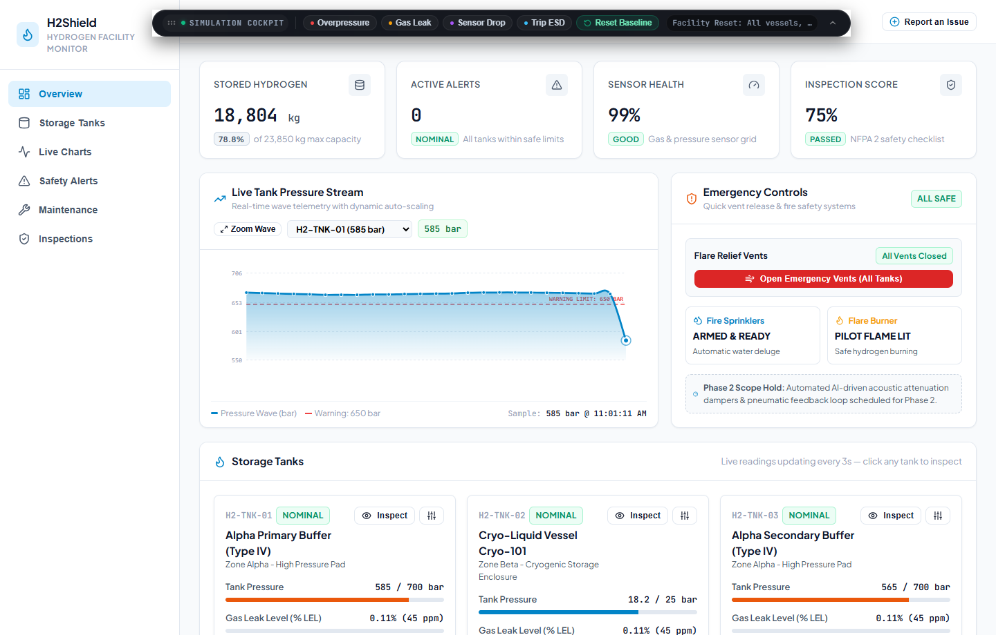
Figure A.1 Operations Console (Live Telemetry & Safety Score)
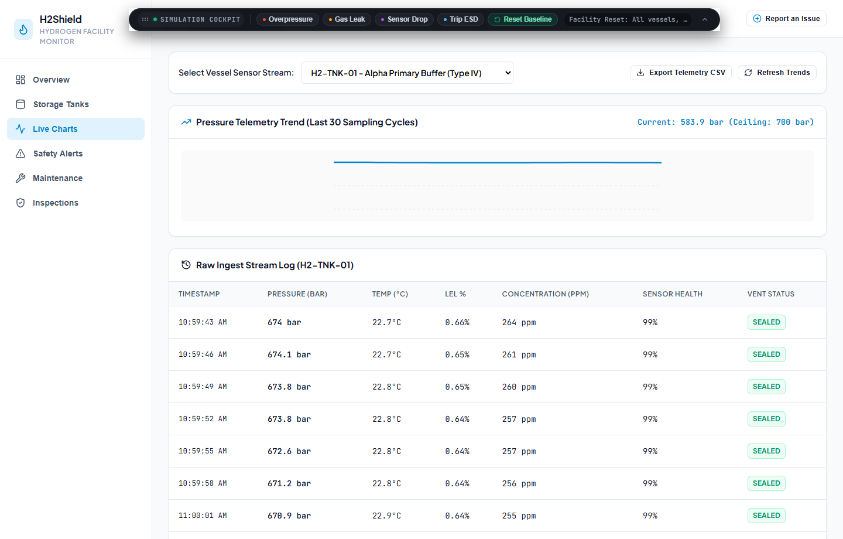
Figure A.2 Multi-Sensor Telemetry Waveforms (Spline Dynamics)

Figure A.3 Storage Vessel Fleet Grid with Live Status Indicators
Figure A.4 Dynamic Safety Threshold Calibration Interface

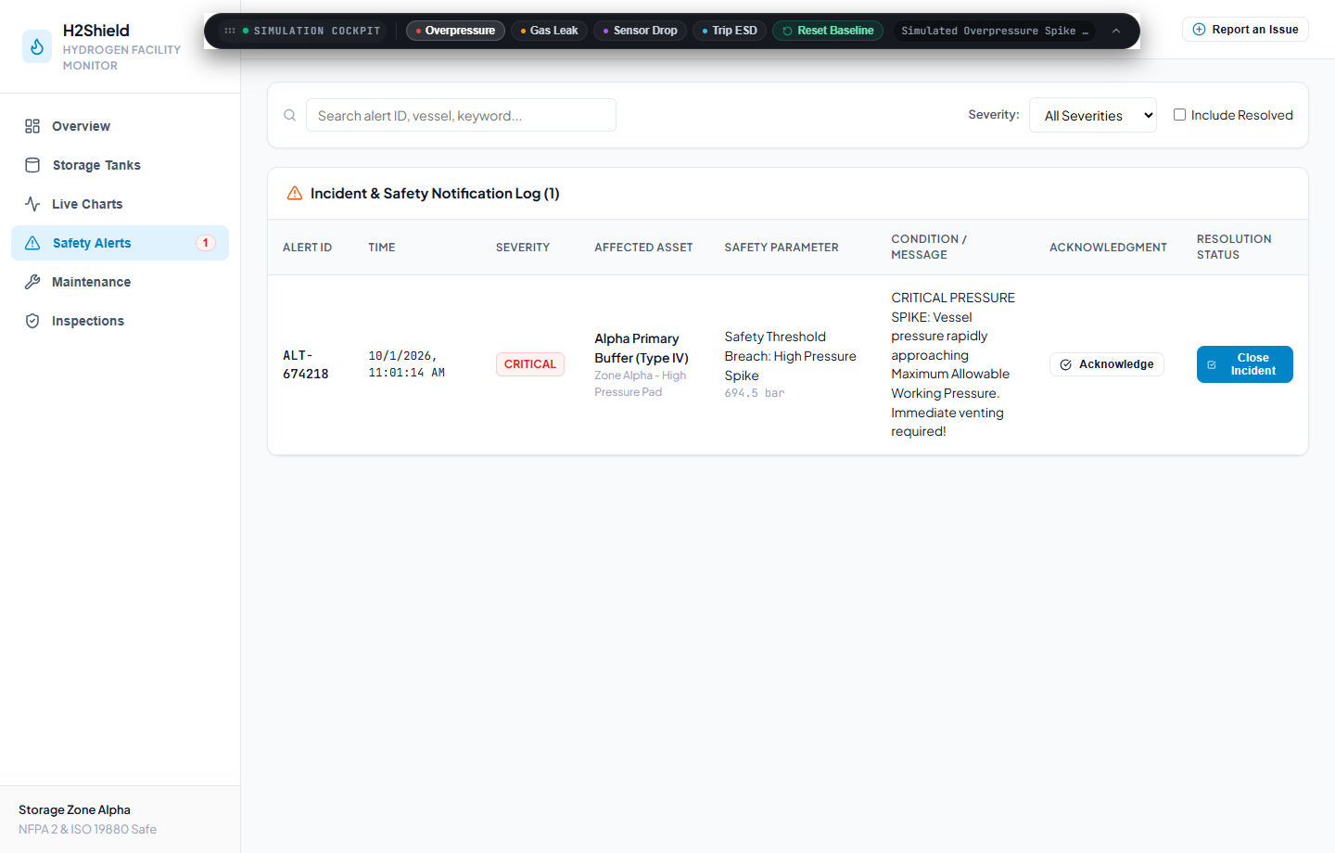
Figure A.5 Emergency Remote Pressure Vent Solenoid Override
Figure A.6 Active Safety Alarms & Incident Forensics

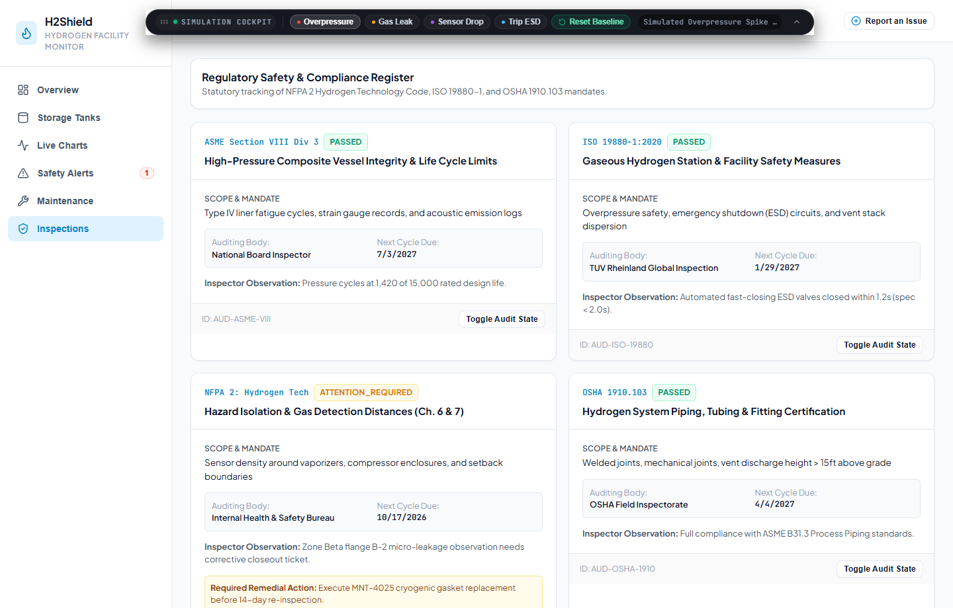
Figure A.7 Preventive Maintenance & Valve Recalibration Schedule
Figure A.8 Acoustic Emission & Ultrasonic Inspection Diagnostics

Figure A.9 NFPA 2 & Statutory Safety Compliance Register
Figure A.10 Cryptographic Safety Audit Log & Operator History

REFERENCES
[1] National Fire Protection Association. NFPA 2: Hydrogen Technologies Code, 2023 Edition. Quincy, MA: NFPA, 2023.
[2] International Organization for Standardization. ISO 19880-1:2020 Gaseous hydrogen — Fuelling stations — Part 1: General requirements. Geneva: ISO, 2020.
[3] Occupational Safety and Health Administration. Code of Federal Regulations, Title 29, Part 1910.103: Hydrogen. Washington, DC: U.S. Department of Labor, 2022.
[4] American Society of Mechanical Engineers. ASME Boiler and Pressure Vessel Code (BPVC), Section VIII: Rules for Construction of Pressure Vessels. New York: ASME, 2021.
[5] R. S. Sandhu, E. J. Coyne, H. L. Feinstein and C. E. Youman, “Role-Based Access Control Models,” IEEE Computer, vol. 29, no. 2, pp. 38–47, 1996.
[6] M. Jones, J. Bradley and N. Sakimura, “JSON Web Token (JWT),” RFC 7519, Internet Engineering Task Force, May 2015.
[7] N. Provos and D. Mazières, “A Future-Adaptable Password Scheme,” in Proc. USENIX Annual Technical Conference (FREENIX Track), 1999.
[8] R. T. Fielding, “Architectural Styles and the Design of Network-based Software Architectures,” Ph.D. dissertation, University of California, Irvine, 2000.
[9] M. Fowler, Patterns of Enterprise Application Architecture. Boston, MA: Addison-Wesley, 2002.
[10] OWASP Foundation. REST Security Cheat Sheet. https://cheatsheetseries.owasp.org/cheatsheets/REST_Security_Cheat_Sheet.html
[11] MongoDB, Inc. MongoDB Manual. https://www.mongodb.com/docs/manual/
[12] Mongoose documentation. https://mongoosejs.com/docs/
[13] Express.js documentation. https://expressjs.com/
[14] React documentation. https://react.dev/
[15] Socket.io documentation. https://socket.io/docs/v4/
[16] Docker Compose documentation. https://docs.docker.com/compose/
[17] I. Sommerville, Software Engineering, 10th ed. Harlow: Pearson, 2016.

