UMAIZA WASEEM
BSSE-5A
FA24B1-SE-083

Task 1: Install Gitea and Push a Repository from the Ubuntu Server
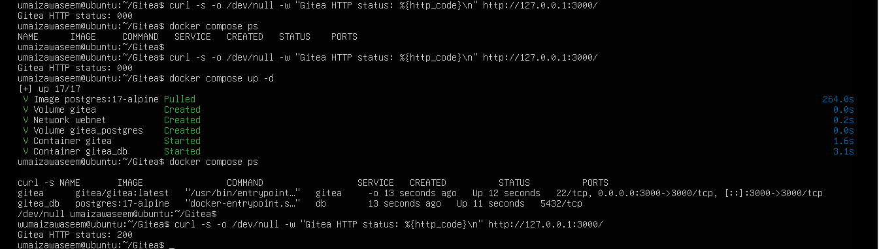
task1_gitea_running.png

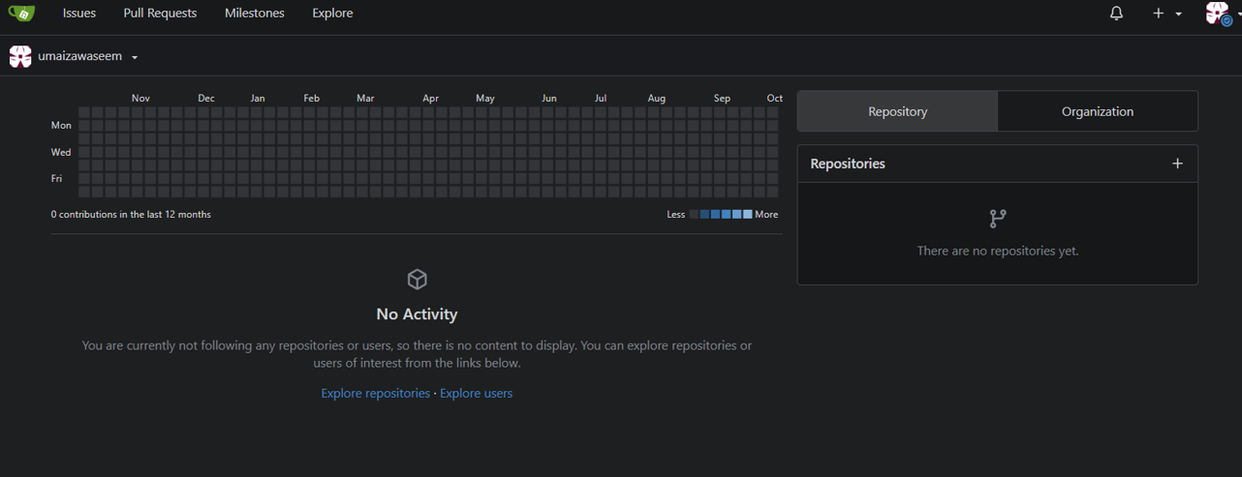

task1_gitea_installed.png

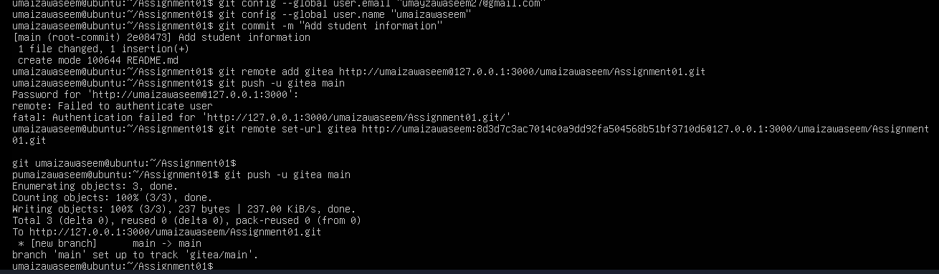
task1_gitea_push.png

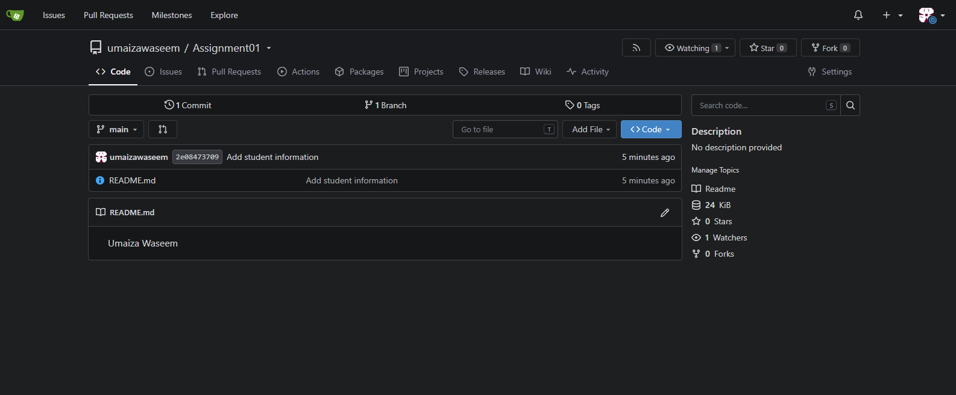
task1_gitea_repository.png

Task 2: Push the Same Repository to GitHub
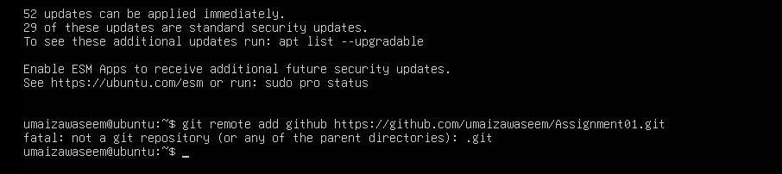
task2_remotes.png

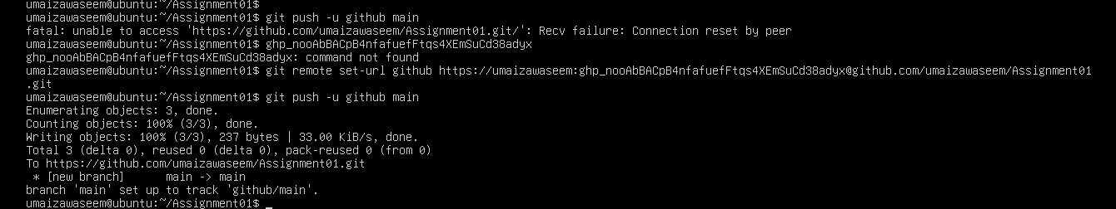
task2_github_push.png

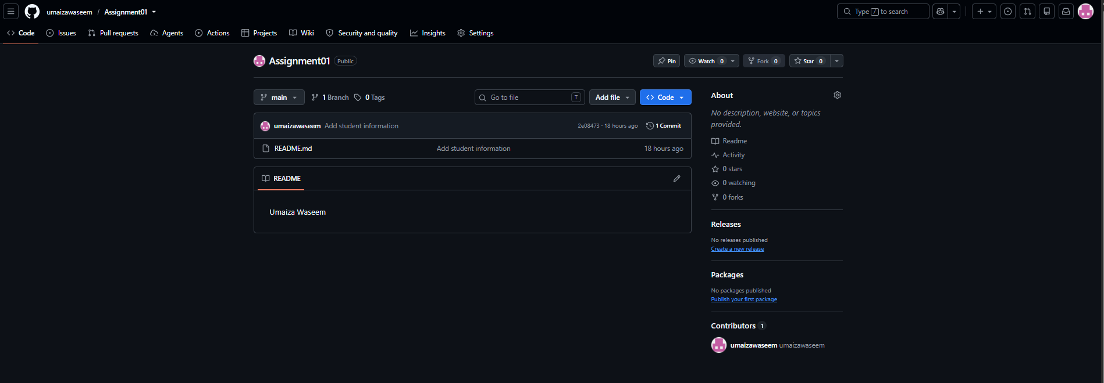
task2_github_repository.png

Task 3: Track Three Large Files with Git LFS
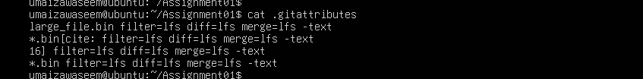
task3_lfs_setup.png

task3_lfs_files.png
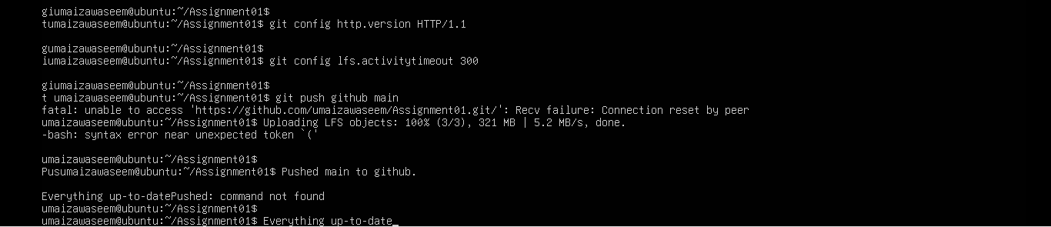
task3_lfs_push.png

Task 4: Create a Portfolio or CV with GitHub Pages
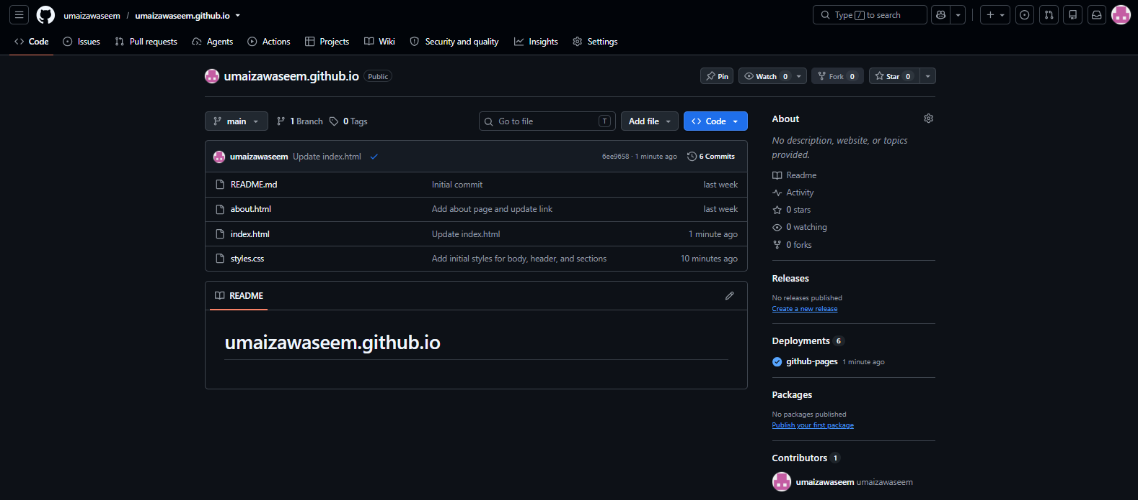
task4_pages_repository.png

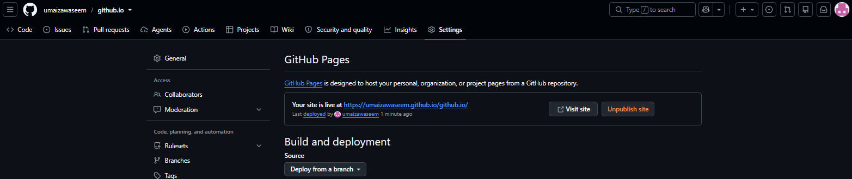
task4_pages_deployment.png

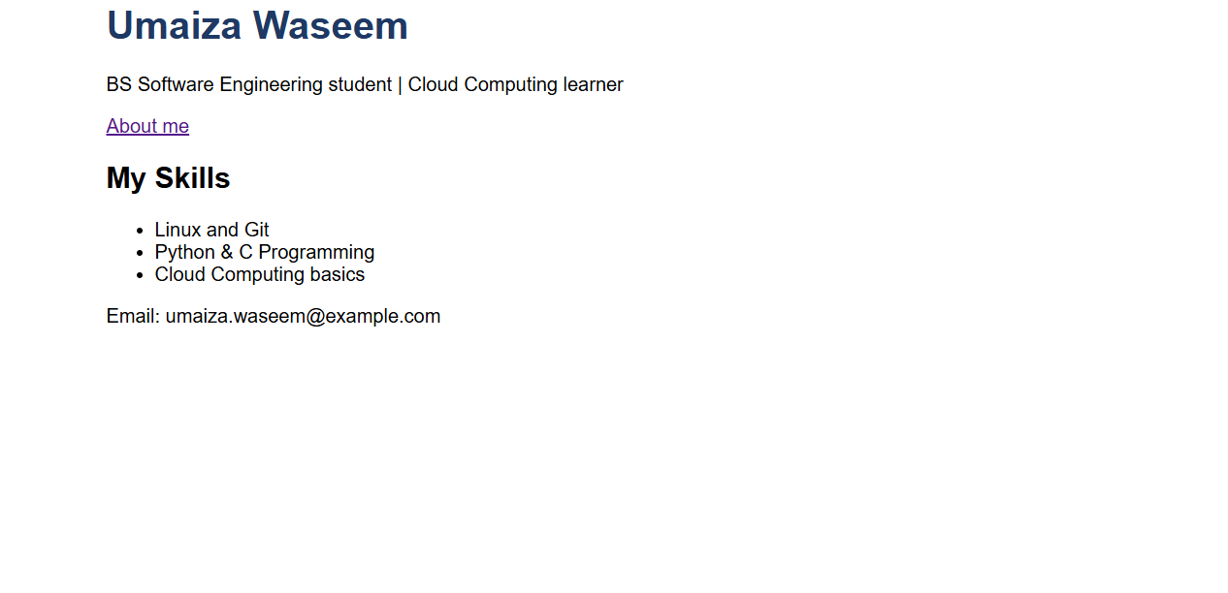
task4_portfolio_live.png

