Free Your Fire Image Assets

The images below represent the original, unedited photos.

All local images (freeyourfire/public/images) are by Aubrie Atamanuik, website co-owner.

Others are available under the Creative Commons license (with no attribution required) and can be accessed by the links below the photos.

Product images are not included. They will change frequently because currently there is only one of each product, and new products will be added regularly.

# **Banner Images**

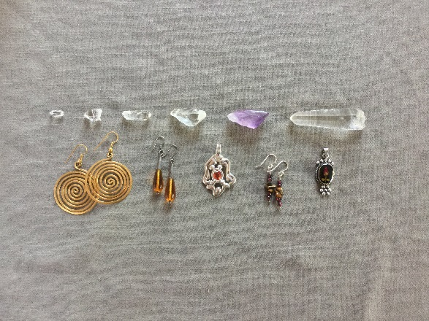

freeyourfire/public/images/home-photo-orig.jpg

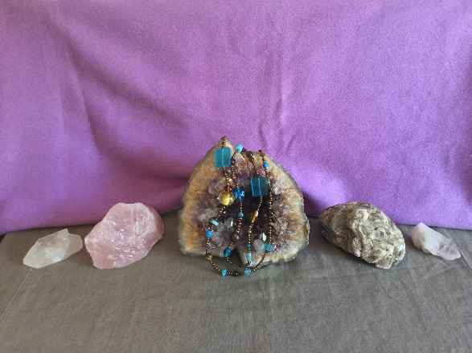

freeyourfire/public/images/about-photo-orig.jpg

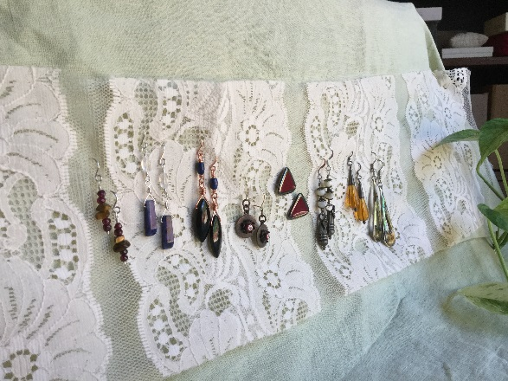

freeyourfire/public/images/earrings-orig.jpg

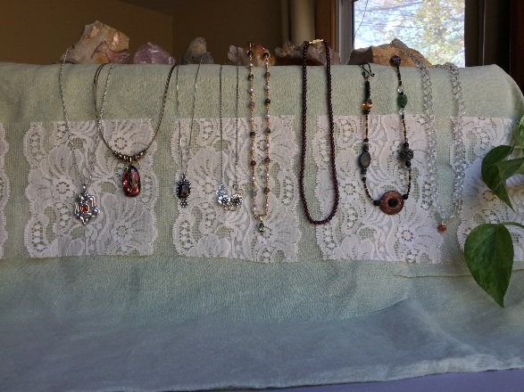

freeyourfire/public/images/necklaces-orig.jpg

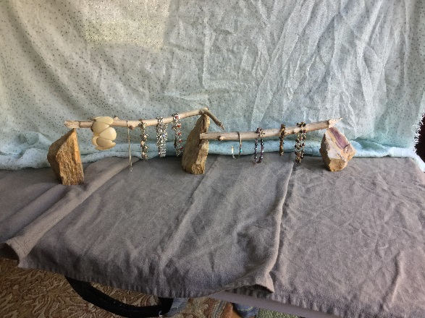

freeyourfire/public/images/bracelets-orig.jpg

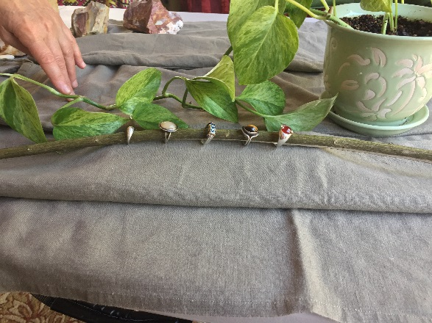

freeyourfire/public/images/rings-orig.jpg

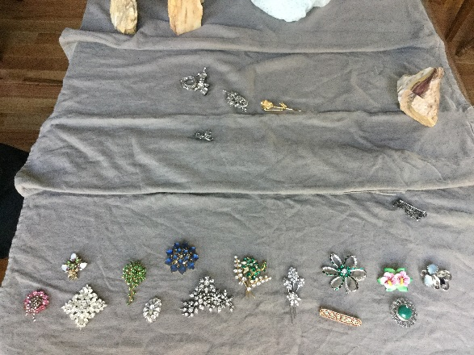

freeyourfire/public/images/brooches-orig.jpg

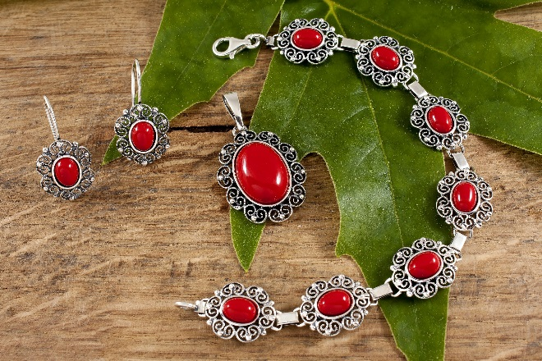

<https://pixabay.com/en/jewelry-coral-woman-gemstones-neck-2847394/>

# **Shop Jewelry Page**

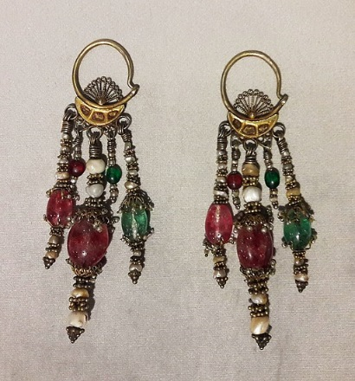

<https://commons.wikimedia.org/wiki/File:Tashkent_Panchpoya_earrings.jpg>

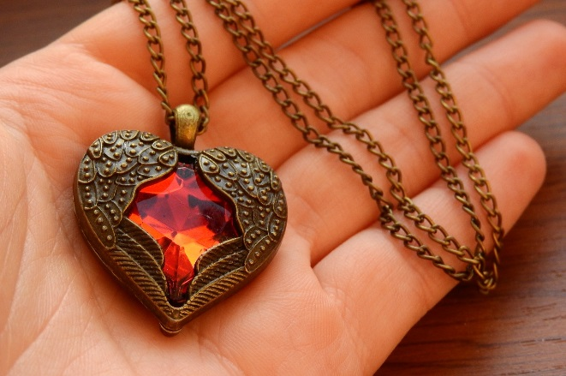

<https://pixabay.com/en/necklace-with-winged-heart-2900736/>

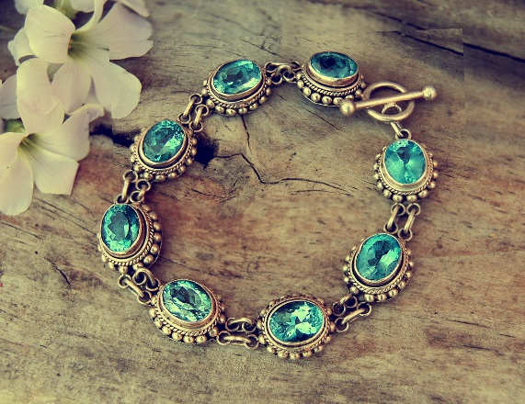

<https://pixabay.com/en/bracelet-silver-gemstones-jeweller-1198740/>



freeyourfire/public/images/rings-orig.jpg

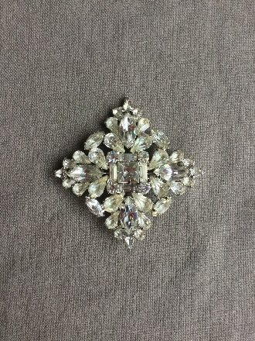

freeyourfire/public/images/silver-rhinestone-brooch-orig.jpg



<https://pixabay.com/en/jewelry-coral-woman-gemstones-neck-2847394/>

# **Icons**



<https://www.iconfinder.com/icons/107153/circle_facebook_icon#size=128>



<https://www.iconfinder.com/icons/104461/twitter_icon#size=16>



<https://www.iconfinder.com/icons/2914532/loupe_icon#size=32>

# **Paypal Buttons**



freeyourfire/public/images/view-cart-button.png



freeyourfire/public/images/add-to-cart-button.png