Web Technologies

Lab Experiment - 1

Name: Pendyala Umakanth

Roll: 221810305050

Class: B5

Branch: CSE

Date of Submission: 19-02-2021

Question:

1) HOME PAGE: The static home page must contain three frames. Top frame: Logo and the college name and links to Home page, Login page, Registration page, Catalogue Page, Cart Page etc. Left frame - Right frame

2) LOGIN PAGE

3) REGISTRATION PAGE

4) CATALOGUE PAGE.

5) CART PAGE

HTML CODE ALOUNG WITH CSS

The Frame file code (home file)

<!DOCTYPE html>

<html lang="en">

<head>

    <title>Collage Forms</title>

</head>

<frameset rows = "15%, *" border = "5">

    <frame name = "top" src = "./logo_file.html">

    <frameset cols = "25%, *" border = "5">

        <frame name = "left" src = "./control_pannel.html">

        <frame name = "right" src = "./description.html">

    </frameset>

</frameset>

</html>

Top Frame Code (logo_file.html)

<!DOCTYPE html>

<html lang="en">

<head>

    <meta charset="UTF-8">

    <meta name="viewport" content="width=device-width, initial-scale=1.0">

    <title>HTML LOGO</title>

    <style>

    </style>

</head>

<body>

    <table style="margin: auto;">

        <tr>

            <td>

                <img  style = "height: 50px;" src="https://upload.wikimedia.org/wikipedia/en/thumb/a/a6/Gandhi_Institute_of_Technology_and_Management_logo.jpg/220px-Gandhi_Institute_of_Technology_and_Management_logo.jpg" alt="image not found">

            </td>

            <td rowspan="5">

                <h1 style="display: inline-block; text-align: center;">GITAM UNIVERSITY</h1>

            </td>

        </tr>

    </table>

    <table style="margin: auto; max-width: 1100px; overflow: hidden;" >

        <th style="width: 500px; text-align: left;"><a href="./description.html" target="right">HOME PAGE</a></th>

        <th style = "width: 150px;"><a href="./cart.html" target = "right">CART</a></th>

        <th style = "width: 150px;"><a href="./catalogue.html" target = "right">CATALOGUE</a></th>

        <th style = "width: 150px;"><a href="./lab_registration_form_03_02_2021.html" target="right">REGISTRATION FORM</a></th>

        <th style = "width: 150px;"><a href="./login_form.html" target="right">LOGIN FORM</a></th>

    </table>

</body>

</html>

Left Frame (control_pannel.html)

<!DOCTYPE html>

<html lang="en">

<head>

    <meta charset="UTF-8">

    <meta name="viewport" content="width=device-width, initial-scale=1.0">

    <title>Control Pannel</title>

    <style>

        a {

            display: block;

            margin: 1rem;

            text-transform: uppercase;

        }

        ul a {

            margin: 0;

        }

    </style>

</head>

<body>

    <h1>MENU ITEMS</h1>

    <h3>CATALOGUE</h3>

    <ul>

        <li><a href="./python_file.html" target="right">PYTHON</a></li>

        <li><a href="./html_file.html" target="right">HTML</a></li>

        <li><a href="./css_file.html" target="right">CSS</a></li>

        <li><a href="./javascript_file.html" target = "right">JAVASCRIPT</a></li>

    </ul>

    <hr>

    <a href="./description.html" target="right">HOME</a>

    <a href="./cart.html" target = "right">CART</a>

    <a href="./catalogue.html" target = "right">Catalogue</a>

    <a href="./lab_registration_form_03_02_2021.html" target = "right">Registration Form</a>

    <a href="./login_form.html" target = "right">Login Form</a>

</body>

</html>

Right Frame(description.html -> default page loading)

<!DOCTYPE html>

<html lang="en">

<head>

    <meta charset="UTF-8">

    <meta http-equiv="X-UA-Compatible" content="IE=edge">

    <meta name="viewport" content="width=device-width, initial-scale=1.0">

    <title>Description Page</title>

</head>

<body>

    <h2>Description Of the page</h2>

    <p>This page is designend for the student login</p>

    <p>It gives information according to various subjects the students can access and the books related to them</p>

</body>

</html>

CART PAGE(cart.html)

<!DOCTYPE html>

<html lang="en">

<head>

    <meta charset="UTF-8">

    <meta http-equiv="X-UA-Compatible" content="IE=edge">

    <meta name="viewport" content="width=device-width, initial-scale=1.0">

    <title>Cart Page</title>

    <style>

        th, td {

            height: 30px;

        }

    </style>

</head>

<body>

    <main>

        <table border="1px" style="width: 70%; text-align: center;" align="center">

            <tr style="background-color: aquamarine; text-align: center;">

                <th>Book Name</th>

                <th>Quantity</th>

                <th>Price</th>

                <th>Total</th>

            </tr>

            <tr>

                <td>Javascript</td>

                <td>1</td>

                <td>200</td>

                <td>200</td>

            </tr>

            <tr>

                <td>Python</td>

                <td>2</td>

                <td>200</td>

                <td>400</td>

            </tr>

            <tr>

                <td>HTML</td>

                <td>1</td>

                <td>250</td>

                <td>250</td>

            </tr>

            <tr>

                <td></td>

                <td></td>

                <td></td>

                <td>Total Amount = 850</td>

            </tr>

        </table>

    </main>

</body>

</html>

Catalogue Page(Catalogue.html)

<!DOCTYPE html>

<html lang="en">

<head>

    <meta charset="UTF-8">

    <meta http-equiv="X-UA-Compatible" content="IE=edge">

    <meta name="viewport" content="width=device-width, initial-scale=1.0">

    <title>Catalogue Page</title>

    <style>

        img {

            height: 100px;

            width: 200px;

            text-align: center;

            margin: auto;

            display: block;

        }

        .a {

            width: 120px;

        }

    </style>

</head>

<body>

    <main>

        <table border="1px" style="width: 70%;" align="center">

            <tr>

                <th>IMAGE</th>

                <th>Description</th>

                <th>Prise</th>

                <th>Add to cart image</th>

            </tr>

            <tr>

                <td><img class = "a" src="./Javascript.jfif" alt=""></td>

                <td><p>Book Name: Master Javascript edition 2000<br>Author: Mikhel William<br>Publication: Person Education</p></td>

                <td><p>200 RS/-</p></td>

                <td><img src="./cart_image.jpg" alt=""></td>

            </tr>

            <tr>

                <td><img class = "a" src="./python.jpg" alt=""></td>

                <td><p>Book Name: Automate the booring stuff edition 2nd<br>Author: AL Sweigart<br>Publication: Pearson Education</p></td>

                <td><p>399 RS/-</p></td>

                <td><img src="./cart_image.jpg" alt=""></td>

            </tr>

            <tr>

                <td><img class = "a" src="./CSS.jpg" alt=""></td>

                <td><p>Book Name: Master CSS edition 2000<br>Author: Mikhel William<br>Publication: Person Education</p></td>

                <td><p>169 RS/-</p></td>

                <td><img src="./cart_image.jpg" alt=""></td>

            </tr>

            <tr>

                <td><img class = "a" src="./HTML.jfif" alt=""></td>

                <td><p>Book Name: Master HTML edition 2000<br>Author: Mikhel William<br>Publication: Person Education</p></td>

                <td><p>500 RS/-</p></td>

                <td><img src="./cart_image.jpg" alt=""></td>

            </tr>

            <tr>

                <td><img class = "a" src="./HTML_1.jfif" alt=""></td>

                <td><p>Book Name: Master HTML  edition 2006<br>Author: Mikhel William<br>Publication: Person Education</p></td>

                <td><p>999 RS/-</p></td>

                <td><img src="./cart_image.jpg" alt=""></td>

            </tr>

        </table>

    </main>

</body>

</html>

Registration Form Page(Register.html)

<!DOCTYPE html>

<html>

    <head>

        <title>Registration Form</title>

        <style>

            .pd {

                padding: 5px;

                width: 100%;

                margin-bottom: 5px;

            }

            body {

                background-color: #FFE5EA;

            }

        </style>

    </head>

    <body>

        <h1 align= "center">Registration Form</h1>

        <div align = "center">

            <form action="" method="" style="width: 480px;">

                <input maxlength="100" class = "pd" style = "width: 100%;" type="text" name="username" id="" placeholder="Enter your name">

                <input type="number" class = "pd" placeholder="Enter your pin number" >

                <input type="date" class = "pd" placeholder="Date of BIrth" >

                <br>

                <br>

                <input type="password" class = "pd" placeholder="Enter password" minlength="10" maxlength="20">

                <input type="password" class = "pd" placeholder="Re- Enter password" minlength="10" maxlength="20">

                <label for="">Gender</label>

                <input  type="radio" style = "display: inline;" >

                <label for="male">Male</label>

                <input  type="radio">

                <label for="male">Female</label>

                <br>

                <br>

                <label style = "margin-top: 2rem;" for="Department">Choose a department:</label>

                <select name="departments" id="departments" class = "pd">

                  <option value="volvo">CSE</option>

                  <option value="saab">ECE</option>

                  <option value="mercedes">Aero</option>

                  <option value="audi">Electrical</option>

                </select>

                <br>

                <br>

                <input type="email" placeholder="enter email" class = "pd">

                <input type="number" placeholder="enter mobile number" class = "pd">

                <br>

                <br>

                <label for="address">Address</label>

                <input type="text" placeholder="Enter house number" class = "pd">

                <input type="text" placeholder="Enter street or location" class = "pd">

                <input type="text" placeholder="Enter village or city" class = "pd">

                <input type="text" placeholder="Enter District" class = "pd">

                <input type="text" placeholder="Enter State" class = "pd">

                <input type="number" placeholder="Enter Pin code" class = "pd">

                <br>

                <br>

                <label for="Enter hobbies" class = "pd">Hobbies</label><br>

                <input type="checkbox" id="1" name="1" value="">

                <label for="vehicle1"> Batminton</label>

                <input type="checkbox" id="2" name="2" value="">

                <label for="vehicle2"> Cricket</label>

                <input type="checkbox" id="3" name="3" value="">

                <label for="vehicle3"> Reading Books</label>

                <br>

                <br>

                <label for=""> Enter Comments</label>

                <textarea name="comments" placeholder="Enter Comments" id="comments" cols="30" rows="10" class = "pd"></textarea>

                <input type="file">

                <br>

                <br>

                <button type="submit" class = "pd">Submit</button>

                <button type="reset" class = "pd">Clear</button>

            </form>

        </div>

    </body>

</html>

Login Form(login.html)

<!DOCTYPE html>

<html lang="en">

<head>

    <meta charset="UTF-8">

    <meta http-equiv="X-UA-Compatible" content="IE=edge">

    <meta name="viewport" content="width=device-width, initial-scale=1.0">

    <title>Login Form</title>

    <style>

        * {

            margin: 0;

            padding: 0;

            box-sizing: border-box;

        }

        html, body {

            height: 100%;

            overflow: auto;

        }

        .input {

            margin: auto;

            overflow: hidden;

            max-width: 600px;

        }

        form {

            display: flex;

            flex-direction: column;

            width: 450px;

        }

        main {

            height: 100%;

            display: flex;

            justify-content: center;

            align-items: center;

        }

        input {

            margin: .2rem 0 .2rem 0;

            font-size: 1.2rem;

            line-height: 2rem;

        }

        button {

            padding: .3rem;

        }

        h1 {

            text-align: center;

        }

        .mar-1 {

            margin: 5px 0 5px 0;

        }

    </style>

</head>

<body>

    <main>

        <div class="input">

            <form action="">

                <h1>Login Form</h1>

                <input type="text" placeholder="username">

                <input type="password" placeholder="Enter password">

                <button type="submit">Submit</button>

                <button type="reset" class = 'mar-1'>Forget Password</button>

                <a href="./lab_registration_form_03_02_2021.html" target="right" style="margin: 10px 0 10px 0;">New User! Register Here</a>

            </form>

        </div>

    </main>

</body>

</html>

Description_about_python file(python_file.html)

<!DOCTYPE html>

<html lang="en">

<head>

    <meta charset="UTF-8">

    <meta http-equiv="X-UA-Compatible" content="IE=edge">

    <meta name="viewport" content="width=device-width, initial-scale=1.0">

    <title>Python File</title>

    <style>

        img {

            height: 100px;

            width: 200px;

            text-align: center;

            margin: auto;

            display: block;

        }

        .a {

            width: 120px;

        }

    </style>

</head>

<body>

    <h3>About Python</h3>

    <p>Python is an interpreted, object-oriented, high-level programming language with dynamic semantics. Its high-level built in data structures, combined with dynamic typing and dynamic binding, make it very attractive for Rapid Application Development, as well as for use as a scripting or glue language to connect existing components together. Python's simple, easy to learn syntax emphasizes readability and therefore reduces the cost of program maintenance. Python supports modules and packages, which encourages program modularity and code reuse. The Python interpreter and the extensive standard library are available in source or binary form without charge for all major platforms, and can be freely distributed.</p>

    <h3>Books Availible with us</h3>

    <table border="1px" style="width: 70%;" align="center">

        <tr>

            <th>IMAGE</th>

            <th>Description</th>

            <th>Prise</th>

            <th>Add to cart image</th>

        </tr>

        <tr>

            <td><img class = "a" src="./python.jpg" alt=""></td>

            <td><p>Book Name: Automate the booring stuff edition 2nd<br>Author: AL Sweigart<br>Publication: Pearson Education</p></td>

            <td><p>399 RS/-</p></td>

            <td><img src="./cart_image.jpg" alt=""></td>

        </tr>

    </table>

</body>

</html>

Description -> HTML file

<!DOCTYPE html>

<html lang="en">

<head>

    <meta charset="UTF-8">

    <meta http-equiv="X-UA-Compatible" content="IE=edge">

    <meta name="viewport" content="width=device-width, initial-scale=1.0">

    <title>Python File</title>

    <style>

        img {

            height: 100px;

            width: 200px;

            text-align: center;

            margin: auto;

            display: block;

        }

        .a {

            width: 120px;

        }

    </style>

</head>

<body>

    <h3>About HTML</h3>

    <p>n 1980, physicist Tim Berners-Lee, a contractor at CERN, proposed and prototyped ENQUIRE, a system for CERN researchers to use and share documents. In 1989, Berners-Lee wrote a memo proposing an Internet-based hypertext system.[3] Berners-Lee specified HTML and wrote the browser and server software in late 1990. That year, Berners-Lee and CERN data systems engineer Robert Cailliau collaborated on a joint request for funding, but the project was not formally adopted by CERN. In his personal notes[4] from 1990 he listed[5] "some of the many areas in which hypertext is used" and put an encyclopedia first.

        The first publicly available description of HTML was a document called "HTML Tags", first mentioned on the Internet by Tim Berners-Lee in late 1991.[6][7] It describes 18 elements comprising the initial, relatively simple design of HTML. Except for the hyperlink tag, these were strongly influenced by SGMLguid, an in-house Standard Generalized Markup Language (SGML)-based documentation format at CERN. Eleven of these elements still exist in HTML 4.[8]

   .</h3>

    <table border="1px" style="width: 70%;" align="center">

        <tr>

            <th>IMAGE</th>

            <th>Description</th>

            <th>Prise</th>

            <th>Add to cart image</th>

        </tr>

        <tr>

            <td><img class = "a" src="./HTML.jfif" alt=""></td>

            <td><p>Book Name: Master HTML edition 2000<br>Author: Mikhel William<br>Publication: Person Education</p></td>

            <td><p>500 RS/-</p></td>

            <td><img src="./cart_image.jpg" alt=""></td>

        </tr>

        <tr>

            <td><img class = "a" src="./HTML_1.jfif" alt=""></td>

            <td><p>Book Name: Master HTML  edition 2006<br>Author: Mikhel William<br>Publication: Person Education</p></td>

            <td><p>999 RS/-</p></td>

            <td><img src="./cart_image.jpg" alt=""></td>

        </tr>

    </table>

</body>

</html>

Description -> CSS file

<!DOCTYPE html>

<html lang="en">

<head>

    <meta charset="UTF-8">

    <meta http-equiv="X-UA-Compatible" content="IE=edge">

    <meta name="viewport" content="width=device-width, initial-scale=1.0">

    <title>Python File</title>

    <style>

        img {

            height: 100px;

            width: 200px;

            text-align: center;

            margin: auto;

            display: block;

        }

        .a {

            width: 120px;

        }

    </style>

</head>

<body>

    <h3>About Css</h3>

    <p>CSS is designed to enable the separation of presentation and content, including layout, colors, and fonts.[3] This separation can improve content accessibility, provide more flexibility and control in the specification of presentation characteristics, enable multiple web pages to share formatting

        The name cascading comes from the specified priority scheme to determine which style rule applies if more than one rule matches a particular element. This cascading priority scheme is predictable.</p>

    <h3>Books Availible with us</h3>

    <table border="1px" style="width: 70%;" align="center">

        <tr>

            <th>IMAGE</th>

            <th>Description</th>

            <th>Prise</th>

            <th>Add to cart image</th>

        </tr>

        <tr>

            <td><img class = "a" src="./CSS.jpg" alt=""></td>

            <td><p>Book Name: Master CSS edition 2000<br>Author: Mikhel William<br>Publication: Person Education</p></td>

            <td><p>169 RS/-</p></td>

            <td><img src="./cart_image.jpg" alt=""></td>

        </tr>

    </table>

</body>

</html>

Description -> Javascript File

<!DOCTYPE html>

<html lang="en">

<head>

    <meta charset="UTF-8">

    <meta http-equiv="X-UA-Compatible" content="IE=edge">

    <meta name="viewport" content="width=device-width, initial-scale=1.0">

    <title>Python File</title>

    <style>

        img {

            height: 100px;

            width: 200px;

            text-align: center;

            margin: auto;

            display: block;

        }

        .a {

            width: 120px;

        }

    </style>

</head>

<body>

    <h3>About Javascript</h3>

    <p>The Mozilla project provides two JavaScript implementations. The first ever JavaScript was created by Brendan Eich at Netscape, and has since been updated to conform to ECMA-262 Edition 5 and later versions. This engine, code named SpiderMonkey, is implemented in C/C++. The Rhino engine, created primarily by Norris Boyd (also at Netscape) is a JavaScript implementation written in Java. Like SpiderMonkey, Rhino is ECMA-262 Edition 5 compliant.

        Several major runtime optimizations such as TraceMonkey (Firefox 3.5), JägerMonkey (Firefox 4) and IonMonkey were added to the SpiderMonkey JavaScript engine over time. Work is always ongoing to improve JavaScript execution performance.</p>

    <h3>Books Availible with us</h3>

    <table border="1px" style="width: 70%;" align="center">

        <tr>

            <th>IMAGE</th>

            <th>Description</th>

            <th>Prise</th>

            <th>Add to cart image</th>

        </tr>

        <tr>

            <td><img class = "a" src="./Javascript.jfif" alt=""></td>

            <td><p>Book Name: Master Javascript edition 2000<br>Author: Mikhel William<br>Publication: Person Education</p></td>

            <td><p>200 RS/-</p></td>

            <td><img src="./cart_image.jpg" alt=""></td>

        </tr>

    </table>

</body>

</html>

Outputs Recorded

1.Description File (Home.html)

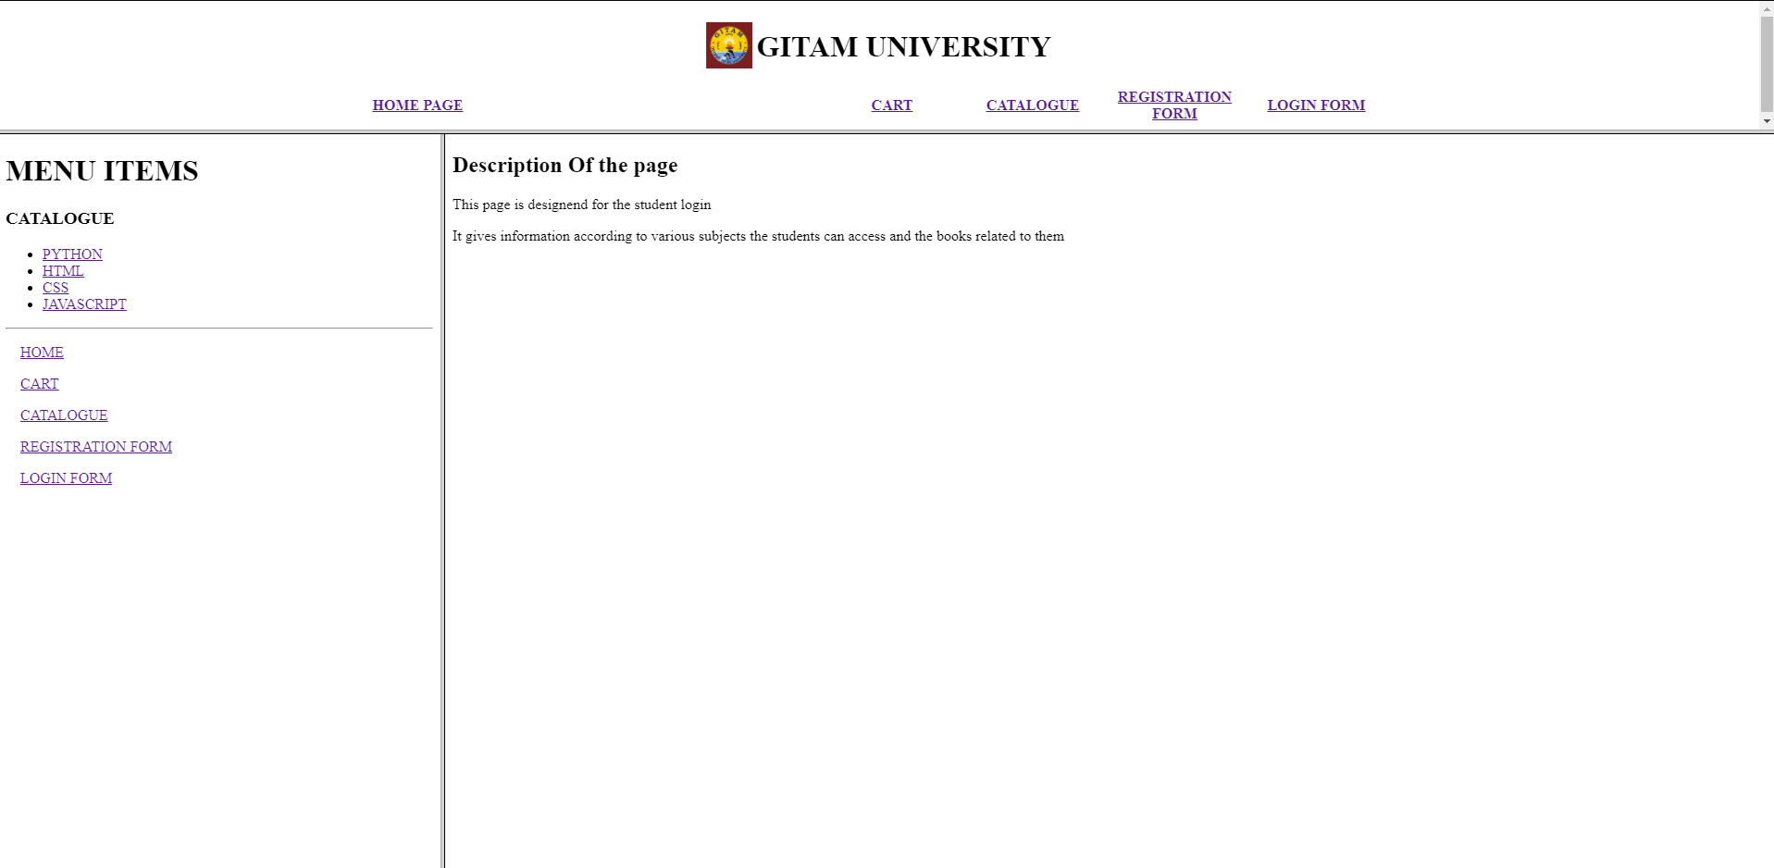

2.CART.HTML on Right Frame

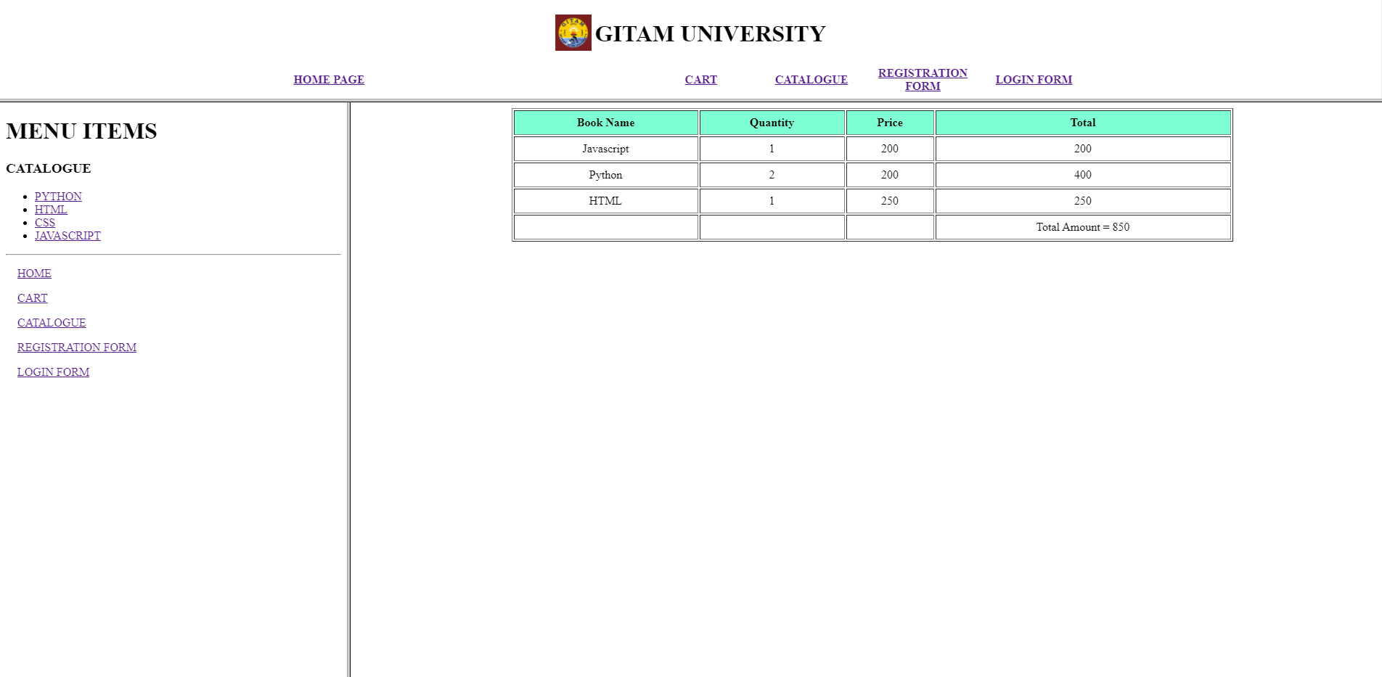

3.Catalogue.Html on Right Frame

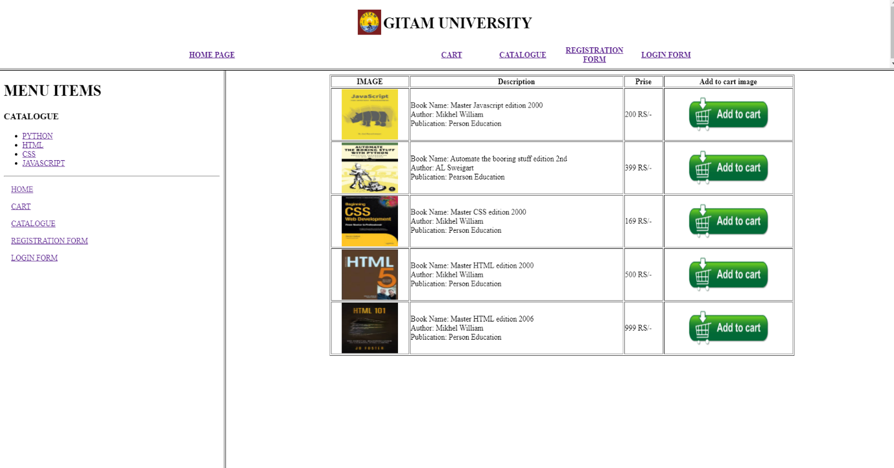

4.Registration From (Register.html) on the right frame

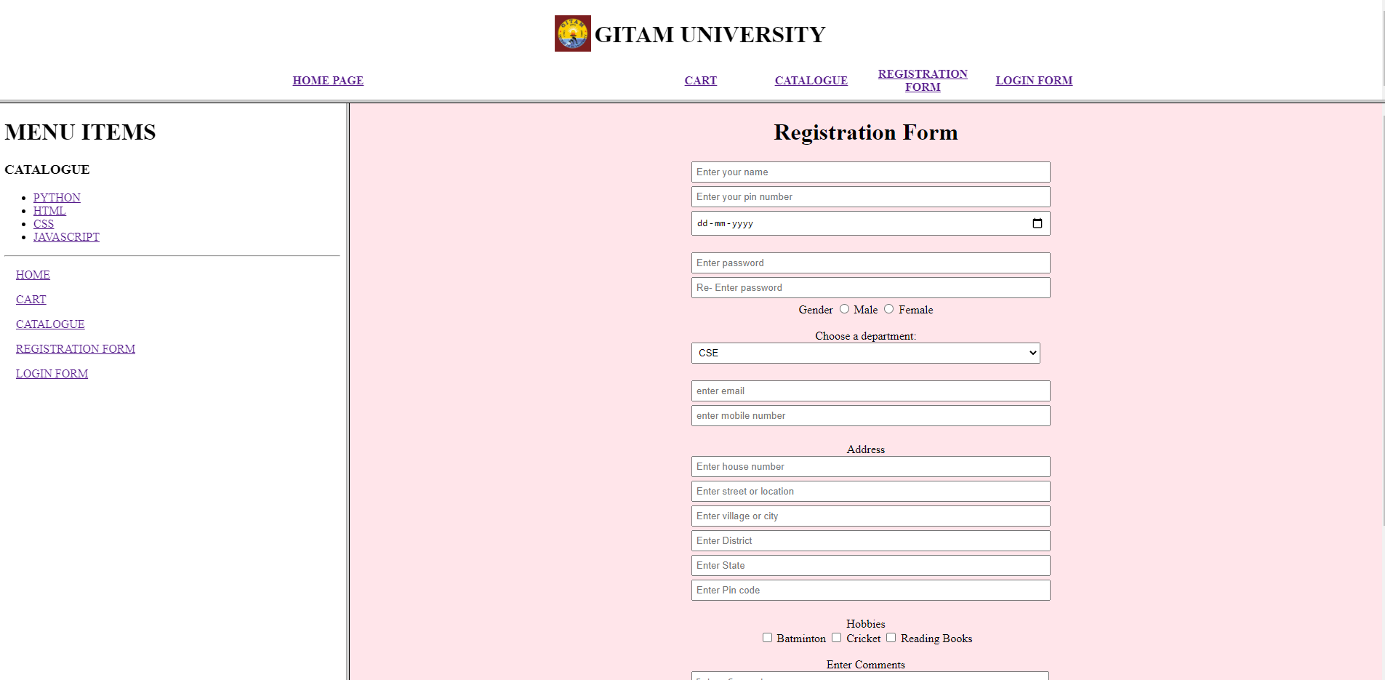

5.Login From on right frame

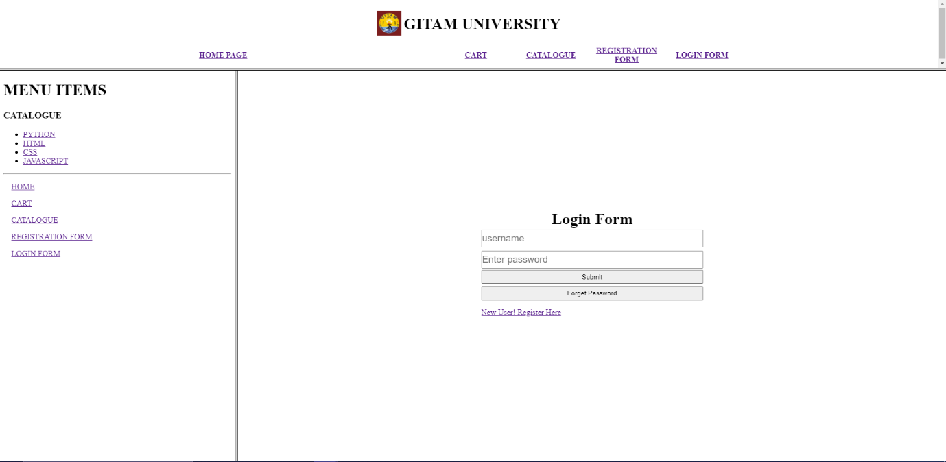

6.Python Link output on Right Frame

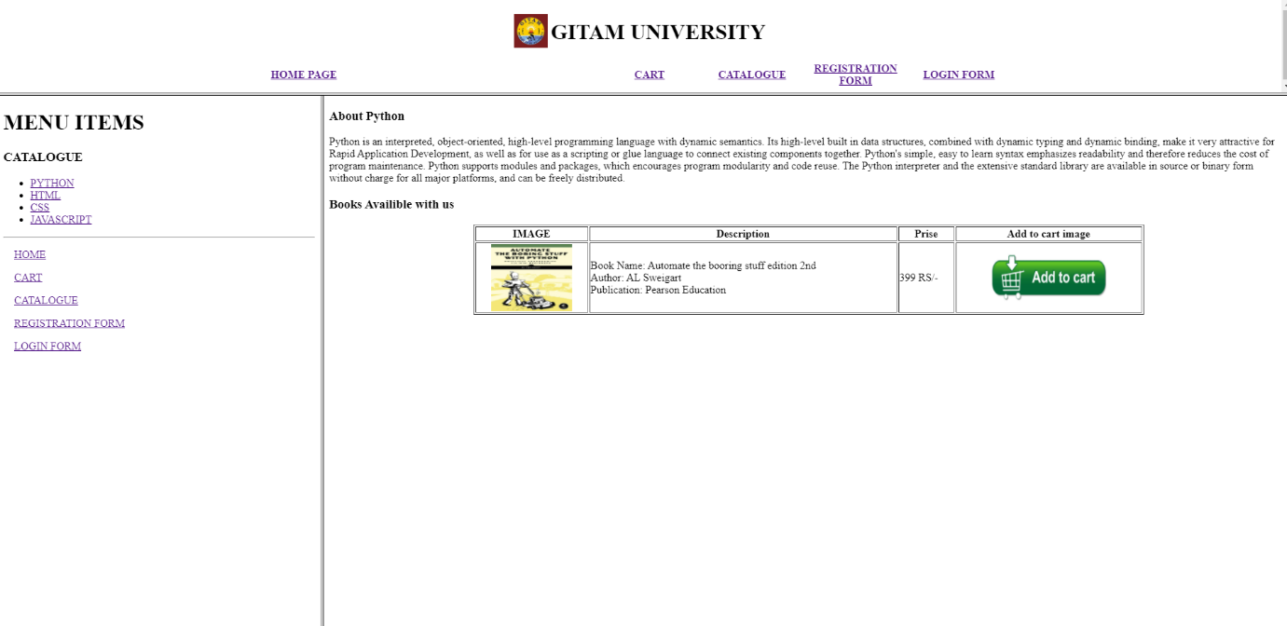

7. HTML link output on Right Frame

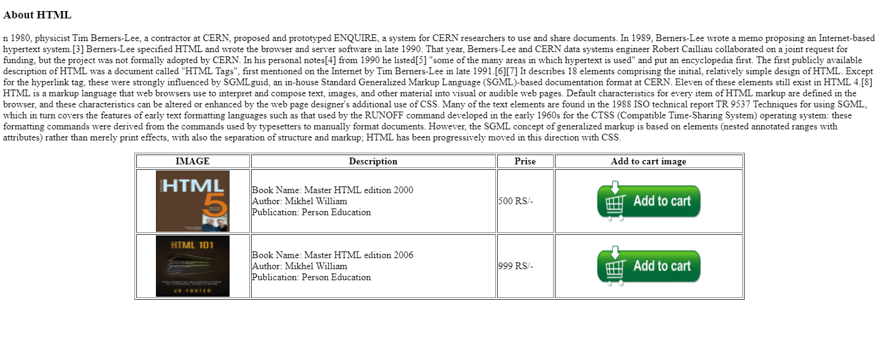

8. CSS link output on right frame

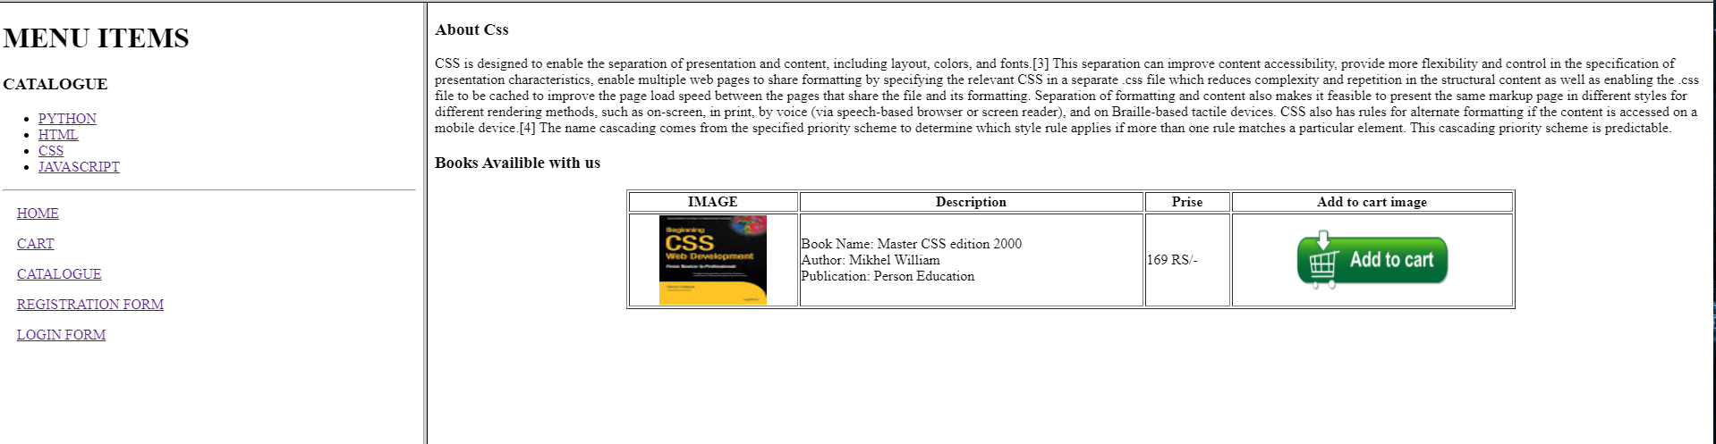

9. JavaScript Link output on the right frame

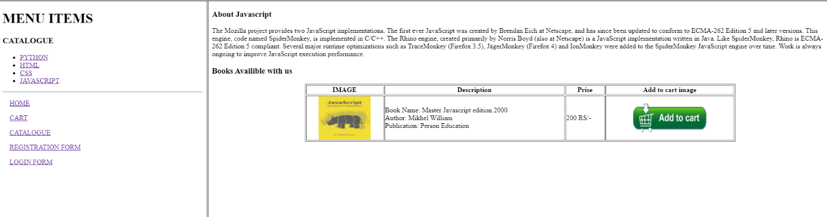

THE END