Promo Finder for AI Microdramas
Problem 1 · Mohammad Umam Ali · Roll No. 230122030 · Branch Chemical Science and Technology | Code: https://github.com/umam-ali/KUKU | Website: https://dwi8otmt9ftawnkfbjcrgh.streamlit.app/

What I built and why
Today an editor watches every episode to pick promo moments, and new shows ship every week. I built a tool that reads a show’s screenplays and returns a ranked shortlist of 20–60 s promo clips: episode, start and end time, the hook, the cliffhanger and why it works. An editor approves the final picks. I ran it on all 50 episodes of I Married a Broken Soldier. He Was a Duke. I chose this problem because it is a real, repeated step at Kuku, the input is real, and the output can be measured.

Assumptions
- A promo is one continuous 20–60 s clip from one episode. The brief allows stitching moments together; I left that out so every promo is easy to verify and cut.
- The screenplay is the edit timeline. I trust its timestamps, and treat camera and action lines as what is on screen (they describe intended shots, not the final video).
- Hook = the first 3 seconds. Cliffhanger = the clip stops before the answer or the consequence.
- The viewer is a stranger scrolling past. The show’s premise (the twist in its title) is fair to show; later twists are spoilers.
- The tool shortlists; a human decides. It never posts anything itself.
- Free model tiers only, and the screenplays stay private (they are not in the public repo).

How it works
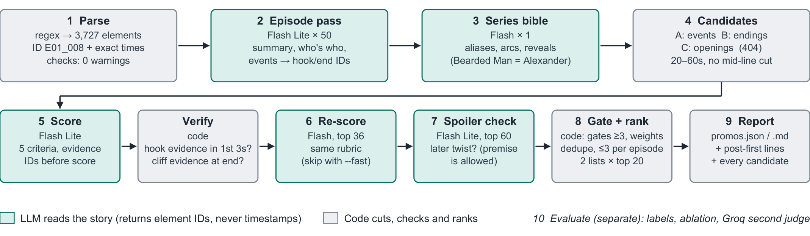
- AI reads the story, code makes the cuts. The model only points to screenplay lines by ID. Code turns those into timestamps, keeps clips at 20–60 s and never cuts mid-sentence, so a promo can never point at a moment that doesn’t exist.
- Three places to look: around key events, at each episode’s ending (written as a cliffhanger), and at each episode’s opening (written to grab).
- Scores need proof. A judge model scores hook, cliffhanger, standalone, coherence and emotion, and must quote the lines behind each score. It also sees the 8 s after the cut, to tell real suspense from a random cut. Code rejects a claim if its evidence is in the wrong place (e.g. a “hook” that isn’t in the first 3 s).
- Ranking: a clip must score at least 3/5 on hook, cliffhanger, standalone and coherence, then is ranked by a weighted score, with at most 3 per episode. I produce two lists: one for new viewers and one to win back viewers who dropped off.
- Easy to re-run and swap: one command (run.py <folder>) on any show, one line in a config file to change a model, and every response is cached.

Sample output: top 3 of 20
# | Episode | Clip | Hook (first 3 s) | Cliffhanger
1 | 15 | 0:44 – 1:26 | A thug orders Juliana to move. She refuses. | Her husband steps in; the thug challenges him to a fight.
2 | 32 | 1:57 – 2:34 | The villain raises a red-hot branding iron. | Will she blind Juliana?
3 | 5 | 0:56 – 1:41 | A cruel matriarch hurls Juliana’s ledger into the mud. | What will the scarred husband do to her ex-fiancé?

All three open on a threat or a humiliation, need no backstory, and cut before the consequence.

How I checked quality
I labelled 14 episodes blind from the screenplays (AI-assisted drafts), before looking at any output for them. I used 10 to find failures and fix them (v1 → v2), and kept 4 aside to test the fixes honestly. A “match” means the clip overlaps my label by at least 50 %.
Check | v1 | v2
My promo was among the tool’s candidates (tuning episodes that have a promo) | 6 / 8 | 7 / 8
My promo was in that episode’s top 3 | 5 / 8 | 7 / 8
Average gap between my start/end and the tool’s | 4.9 s | 2.1 s
My promo was found (held-out episodes that have a promo) | 1 / 3 | 1 / 3
Episodes with nothing worth posting were left empty | 3 / 3 | 3 / 3

- The cliffhanger score agrees with the writers. Endings of episodes that the next episode describes as a cliffhanger score 4.31/5, against 2.80 for other endings.
- A second model (Groq) agrees on hook and cliffhanger (within 0.3 points) but not on “standalone” (1.2 points apart). That is the weakest judgement in the system.
- Honest result: the fixes worked on the episodes I tuned on, but not yet on the 4 held-out ones. Too few to claim a general gain.

Where it struggles
Problem | Example | Next step
Misses climaxes in the middle of an episode | Ep 33: the line “That is witchcraft” (2:06) was never tried as an ending | Also try endings at the most intense lines
“Standalone” is hard to judge | Late-series scenes almost always fail it; the two models disagree | Calibrate with real data: 3-second hold rate, completion
The same idea twice | Ranks 2 and 4 (Ep 32 and Ep 31) use the same branding-iron threat | Remove near-duplicates across episodes
Reads text, not video | A hook may look different on screen than on paper | Check the actual frames with a vision model

Scale and cost
- One 50-episode show takes about 220 calls to a cheap model and 8 to a stronger one (about 1 M tokens). On free tiers that is about 15–25 minutes, because the free tier allows only 15 calls a minute. With paid keys and parallel calls it would take a few minutes. Re-runs come from the cache in about a minute.
- The stronger model only sees the top ~10 % of clips. Shows are independent, so they can run in parallel; cost grows in step with episode count.
- The editor reviews about 20 clips per show instead of watching about 100 minutes.

AI tools
I used Claude Code to implement and run the pipeline, under my design decisions and review. Gemini Flash / Flash Lite and Groq gpt-oss-120b run inside the tool. Where AI got it wrong: the first version made short clips longer by moving their start earlier, and 131 of 204 clips silently lost their hook. I caught it by inspecting the output and changed it to extend the clip forward to the next cliffhanger instead.

