***EXP 11 AND 12***

**First workflow : ANDROID CI WORKFLOW**

Code :

Github action:

Workflow that invokes success and failure:



Git commands for success and failure for workflow :

**Second workflow : CI-ANDROID-BUILD**

CODE:

Github action:

Second workflow running after first successful workflow:



Git commands for the following on ci-tests branch ,

On push to ci-tests branch, we see the first workflow triggered followed by second:

**Third workflow**

code:

Github action :

Git commands for push to “feature/my-feature” branch which triggers the workflow :

Running of workflow :

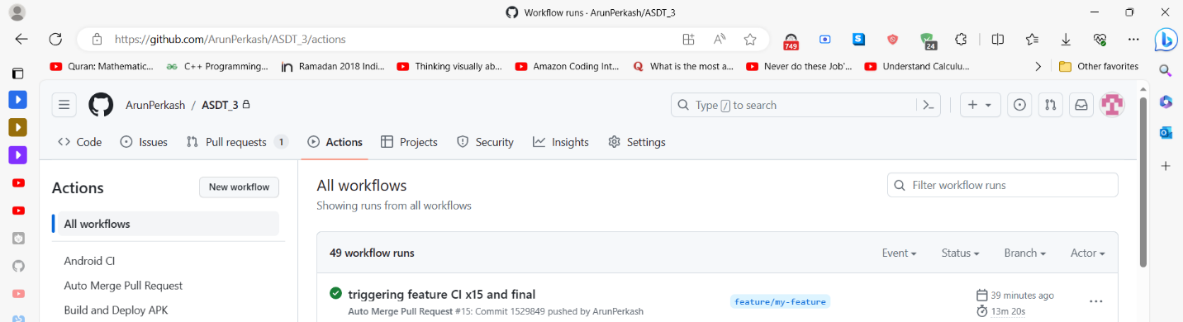

**Assignment Completion Report :**

1. **Android CI Workflow:**
   * **Triggered on pushes to the ci-tests branch.**
   * **Builds and tests an Android app using Gradle.**
   * **Runs unit tests and uploads the test reports.**
   * **Utilizes GitHub Actions and Gradle for continuous integration.**
2. **Build and Deploy APK Workflow:**
   * **Triggered on successful completion of the Android CI Workflow.**
   * **Runs on the latest version of Ubuntu.**
   * **Sets up JDK 17, builds the Android APK in debug mode, and renames it with a timestamp.**
   * **Adds the APK to a repository folder called "testBuilds".**
   * **Commits and pushes changes to the repository.**
3. **Auto Merge Pull Request Workflow:**
   * **Triggered on pushes to branches starting with "feature" or "fix".**
   * **Creates a pull request to the main branch with all repository members as reviewers.**
   * **Automatically merges the pull request using squash merge when all reviewers approve.**

**These workflows automate various tasks in your repository, such as building and testing your Android app, deploying APKs, and automating the pull request and approval process.**