**ON THE EFFECT OF EMOTION IDENTIFICATION FROM LIMITED TRANSLATED TEXT USING COMPUTATIONAL INTELLEGENCE.**

***M. UMA MAHESHWARA RAO 21951A05N2***

***P. SREE SACHITH 21951A05L3***

***K. THANUJ REDDY 21951A05M9***

Page |I

**ON THE EFFECT OF EMOTION IDENTIFICATION FROM LIMITED TRANSLATED TEXT USING COMPUTATIONAL INTELLEGENCE.**

***A Project Report Submitted in partial fulfillment of the***

***requirements for the award of the degree of***

# Bachelor of Technology in

**Computer Science & Engineering by**

# M. Uma Maheshwara 21951A05N2

**P. Sree Sachith 21951A05L3**

# K. Thanuj Reddy 21951A05M9



**Department of Computer Science Engineering**

INSTITUTE OF AERONAUTICAL ENGINEERING

# (Autonomous)

**Dundigal, Hyderabad - 500 043, Telangana**

## APRIL 2024

© 2024, M .Uma Mahesh ,P .Sree Sachith ,K.Thanuj All rights reserved

Page |II

# DECLARATION

I certify that.

1. the work contained in this report is original and has been done by me under the guidance of my supervisor(s).
2. the work has not been submitted to any other Institute for any degree or diploma.
3. I have followed the guidelines provided by the Institute in preparing the report.
4. I have conformed to the norms and guidelines given in the Ethical Code of Conduct of the Institute.
5. whenever I have used materials (data, theoretical analysis, figures, and text) from other sources, I have given due credit to them by citing them in the text of the report and giving their details in the references. Further, I have taken permission from the copyright owners of the sources, whenever necessary.

## Place: Signature of the Student:

**Date: M .Uma Maheshwara Rao**

## P. Sree Sachith M.Thanuj Reddy

Page|III

# CERTIFICATE

This is to certify that the project report entitled “**On the effect of emotion identification from limited translated text samples using Computational Intelligence.**” submitted by Mr. Uma Maheshwara Rao, Mr. Sree Sachith, Mr. Thanuj to the Institute of Aeronautical Engineering, Hyderabad, in partial in partial fulfillment of the requirements for the reward of the Degree Bachelor of Technology in Computer Science And Engineering is a bonafide record of work carried out by him/her under my/our guidance and supervision. In whole or in parts, the contents of this report have not been submitted to any other institutes for the award of any Degree**.**

# Supervisor: Head of the Department:

Mr. T. Roopesh Kumar Dr. C. Madhusudhan Rao

Assistant Professor Professor and HOD, CSE

# Date:

Page |IV

# APPROVAL SHEET

This project report entitled “**On the effect of emotion identification from translated text using Computational Intellence.**” by **Mr. Uma Maheshwara Rao, Mr. Sree Sachith, Mr. Thanuj Reddy** is approved for the award of the Degree Bachelor of Technology in **Computer science and Engineering**.

## Examiners Supervisor(s)

**Ms. T. Roopesh Kumar**

## Principal

**Dr. L. V. Narasimha Prasad**

## Date: Place:

Page|III

# ACKNOWLEDGEMENT

The satisfaction that accompanies the successful completion of any task would be incomplete without the mention of the people who made it possible and whose constant guidance and encouragement crown all the efforts with success. I think out college management and respected Sri M. Rajashekar Reddy, Chairman, IARE, Dundigal for providing me with the necessary infrastructure to conduct the project work.

I express my sincere thanks to Dr. L. V. Narasimha Prasad, Professor and Principal who has been a great source of information for my work, and Dr. C. Madhusudhan Rao, Professor and Head, Department of CSE, for extending his support to carry on this project work.

I am especially thankful to our supervisor Ms. K. S, Assistant Professor, Department of CSE, for her internal support and professionalism who helped me in shaping the project into a successful one. I take this opportunity to express my thanks to one and all who directly or indirectly helped me in bringing the effort to present form.

Page |VI

# ABSTRACT

Keywords: Text-Emotion Datasets, Machine Learning, Recurrent Nural Network, Translated test.

This project focuses on developing an application aimed at predicting and analyzing the preservation of emotions after text translation across multiple languages. The dataset comprises texts in various languages including Chinese, French, German, and Spanish. Computational intelligence (CI) techniques are employed to extract meaningful features and reduce the dimensions of the data within the framework of a Recurrent Neural Network (RNN). The RNN model is specifically trained on a dataset annotated with emotions, where each text is labeled with an emotion category. This training process enables the algorithm to learn associations between textual content and emotional states, facilitating accurate emotion prediction post- translation. The application aims to address the challenge of emotion variability across languages and cultures, leveraging advanced techniques to ensure robust performance across diverse linguistic contexts. By exploring how emotions manifest in translated texts, the project seeks to enhance cross-cultural understanding and improve the effectiveness of emotional analysis in multilingual scenario.

Page |VII

# CONTENTS

Title Page I

Cover Page II

Declaration III

Certificate by Supervisor IV

Approval Sheet V

Acknowledgement VI

Abstract VII

Contents VIII

List of Figures IX

List of Abbreviations X

Chapter 1 Introduction 1-7

* 1. Introduction 1
  2. Existing system 2
  3. Demerits of Existing System 2
  4. Proposed system 3
  5. Merits of Proposed System over Existing System 3
  6. Requirements Specification 4-7
     1. Software Requirements
     2. Hardware Requirements

Chapter 2 Literature Survey 7- 11

Chapter 3 Methodology and Implementation 12-25

3 3.1 Methodology 12-13

3 3.2 System Design 13-16

3 3.3 Algorithm 16-18

3 3.4 Sample Code 19-25

Chapter 4 Results and Discussion 26-34

Chapter 5 Conclusion and Future Scope 35-37

* 1. Conclusion 35-36
  2. Future Scope 36-37

Chapter 6 References 37-38

List of Publications

Page |VIII

# LIST OF FIGURES

|  |  |  |
| --- | --- | --- |
| FIG.NO | FIG.NAME | PG.NO |
| 3.1.1 | Text-Emotion Data sets | 22 |
| 3.2.1 | System Architecture | 23 |
| 3.3.1 | Recurrent Neural Network | 27 |
| 4.1 | Dash-Board | 29 |
| 4.2 | Output1 | 30 |
| 4.3 | Output2 | 36 |

Page |IX

# LIST OF ABBREVIATIONS

|  |  |
| --- | --- |
| RNN | Recurrent Neural Network. |
| LSTM | Long Short-Term Memory. |
| ML | Machine Learning. |
| CI | Computational Intelligence. |
| SVM | Support Vector Machine. |
| NN | Neural Network. |
| EI | Emotion Identification |
| NLP | Natural Language Processing. |
| DL | Deep Learning. |

Page |X

# CHAPTER 1 INTRODUCTION

# INTRODUCTION

In the realm of Natural Language Processing (NLP), the identification of emotions within text has garnered significant attention due to its wide array of applications, ranging from sentiment analysis to human-computer interaction. However, one of the notable challenges in this field is accurately identifying emotions from texts that are both limited in length and translated from other languages. This challenge is exacerbated by the nuances lost in translation and the constrained context provided by short text samples.

Computational Intelligence (CI) encompasses a variety of methods such as Neural Networks (NN), Support Vector Machines (SVM), and more recently, sophisticated models like Bidirectional Encoder Representations from Transformers (BERT) and its variants like RoBERTa. These models have demonstrated remarkable proficiency in understanding and processing human language, even in its translated form. However, the effectiveness of these models on LTS remains an area ripe for exploration.

The primary aim of this study is to investigate the efficacy of various CI approaches in identifying emotions from limited translated text samples. By leveraging techniques like Long Short-Term Memory (LSTM) networks, autoencoders (AE), and generative adversarial networks (GANs), this research seeks to uncover the potential of these models in handling the intricacies of translated text.

1

# EXISTING SYSTEM:

The field of Emotion Identification (EI) from text has seen significant advancements, especially with the advent of Natural Language Processing (NLP) and Computational Intelligence (CI) techniques.

**Support Vector Machines (SVM)** and k-Nearest Neighbors (k-NN) have been widely used for emotion classification. These models typically rely on feature extraction techniques like Term Frequency-Inverse Document Frequency (TF-IDF) and Bag of Words (BoW) to convert text into numerical representations. While effective for larger text samples in a single language, their performance often degrades when applied to short and translated texts due to loss of contextual and semantic information during translation. Early EI systems employed rule-based and lexicon- based approaches, using predefined rules and dictionaries to identify emotions. These methods can struggle with translated texts, as the emotional nuances and context may not be accurately captured in the lexicons, which are typically designed for specific languages and cultural contexts.

# DEMERITS OF EXISTING SYSTEM

Translations often lose the subtle emotional cues and context present in the original text. Existing systems may not account for these artifacts, leading to misidentification of emotions. Cultural Emotional expressions vary across cultures. A phrase that conveys a certain emotion in one language may not have an equivalent in another language, leading to inaccuracies in emotion detection.

2

# PROPOSED SYSTEM:

To effectively identify emotions from limited translated text samples, we propose a Recurrent Neural Network (RNN) model that leverages the capabilities of Long Short-Term Memory (LSTM) networks and attention mechanisms. The model architecture is designed to handle the complexities of translation-induced noise and limited context, ensuring robust emotion detection. LSTM networks are particularly adept at capturing long-range dependencies in sequential data, which is crucial for preserving emotional nuances across different languages. The incorporation of attention mechanisms further enhances the model's ability to focus on relevant parts of the text, improving the accuracy of emotion classification in diverse linguistic contexts.

# MERITS OF PROPOSED SYSTEM OVER EXSISTING SYSTEM:

1. The proposed system leverages Recurrent Neural Networks (CNN) and a rich data-set for Text Emotion prediction, ensuring a higher degree of automation and accuracy.
2. The Application in the proposed system streamlines symptom analysis, enabling quicker and more reliable for preserving of emotion, which can be crucial in linguistic approach.
3. The proposed system is designed with the user's convenience in mind, offering a more natural and accessible way to check emotion and translated text.

3

# REQUIREMENTS

# SOFTWARE REQUIREMENTS

To implement and deploy the proposed Recurrent Neural Network (RNN) model for emotion identification from limited translated text samples, several software tools, libraries, and platforms are required. These can be categorized into development environment, libraries, data processing tools, and deployment infrastructure.

# Development Environment:

* + - 1. **Operating System:**

## (Any of one)

* + - * + Ubuntu 20.04+ (Recommended for compatibility with most AI tools)
        + Windows 10/11
        + macOS 10.15+
      1. **Programming Language: (Better to use latest one)**
         * Python 3.7+
      2. **Integrated Development Environment (IDE): (Any Editor can be used)**
         * PyCharm (Recommended for Python development)
         * VS Code(For web Stream-lit Application)
         * Jupyter Notebook (For training the model)

4

**Web browser --**In the realm of web applications and software heavily reliant on internet technologies, the default browser installed on the system is often utilized. Microsoft Internet Explorer is commonly chosen for software running on Microsoft Windows, despite the vulnerabilities associated with ActiveX controls.

# HARDWARE REQUIREMENTS

To efficiently develop, train, and deploy the proposed RNN model for emotion identification from limited translated text samples, specific hardware resources are necessary. These requirements vary based on the scale of the project, the size of the dataset, and the complexity of the model. Below are the recommended hardware specifications:

# Development and Training Environment: 1.Personal Computer (PC) or Workstation:

## Processor (CPU):

* + **Minimum**: Quad-core CPU (e.g., Intel Core i5 or AMD Ryzen 5)
  + **Recommended**: Octa-core CPU (e.g., Intel Core i7/i9 or AMD Ryzen 7/9)

# Memory (RAM):

* + **Minimum**: 16 GB
  + **Recommended**: 32 GB or more, especially for handling large datasets and running multiple experiments simultaneously.

# Storage:

* + **Minimum**: 512 GB SSD
  + **Recommended**: 1 TB SSD or more, with additional HDD for storing datasets and models.

7

# CHAPTER 2 LITERATURE SURVEY

* 1. **Emotion Detection in Code-Switched Text:**

<https://onlinelibrary.wiley.com/doi/full/10.1002/eng2.12189>

**ABSTRACT:** This paper investigates emotion detection in code-switched text, where multiple languages are mixed within the same conversation. The authors highlight the complexities introduced by code-switching and propose a hybrid model combining traditional machine learning techniques with deep learning. They demonstrate how context-aware embeddings can improve the performance of emotion detection in multilingual settings. The paper also presents a new dataset specifically designed for code-switched emotion detection.

# Multilingual Sentiment Analysis: State of the Art and R2 System

<https://www.ncbi.nlm.nih.gov/pmc/articles/PMC4981629/>

**ABSTRACT**: This survey focuses on sentiment analysis in multilingual contexts, which shares similarities with emotion detection. The authors review various approaches to handling multilingual text, including translation-based methods, multilingual embeddings, and cross-lingual transfer learning. They introduce the R2 system, which uses a combination of neural networks and rule-based methods to achieve state-of-the-art performance in multilingual sentiment analysis. The paper discusses the challenges of preserving emotional context during translation.

8

# Emotion Detection from Noisy Social Media Texts

<https://link.springer.com/article/10.1007/s13278-021-00776-6>

**ABSTRACT**: This paper addresses the problem of emotion detection from noisy social media texts, which often include slang, abbreviations, and informal language. The authors propose a deep learning model that uses pre-trained embeddings fine-tuned on social media data to capture the unique characteristics of informal text. They introduce a novel noise reduction technique that helps improve the accuracy of emotion detection. The paper also presents a large-scale dataset collected from various social media platforms.

# Transfer Learning for Emotion Detection in Low-Resource Languages

<https://www.sciencedirect.com/science/article/abs/pii/S0957417419305536>

**ABSTRACT**: This paper focuses on the application of transfer learning techniques for emotion detection in low-resource languages. The authors propose a framework that leverages pre-trained models on high- resource languages and fine-tunes them on small datasets from low-resource languages. They introduce a novel data augmentation method that generates synthetic data to enhance model performance. The paper presents experimental results showing significant improvements in emotion detection accuracy for low- resource languages.

11

# CHAPTER 3 METHODOLOGY AND IMPLEMENTATION

* 1. **METHODOLOGY**

In this project we develop Web-Application which can take input as English Text and then predict Emotion after translating into other languages and then display the emotion in all 5 types of languages. To identify Emotion we need to train application model with machine learning so it can take text as input and then predict emotion and to train application(Chatbot) we have use RNN algorithm and this algorithm get trained on below data-set.

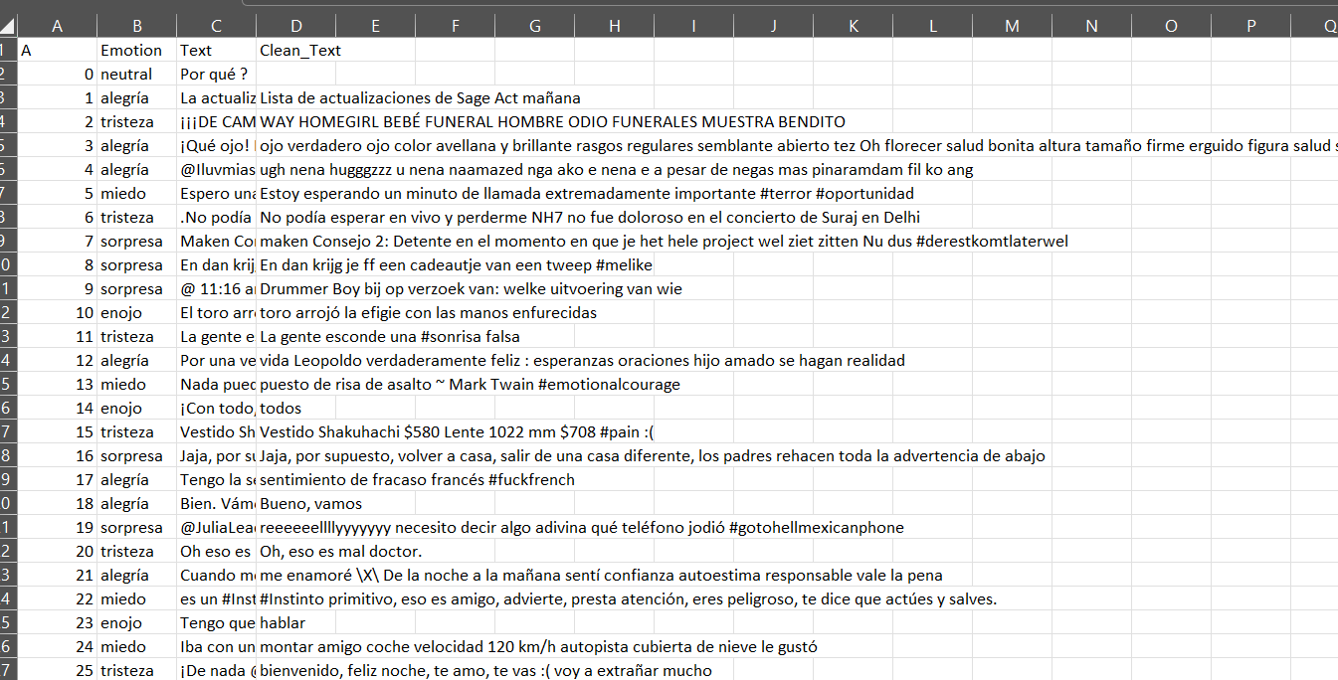

Fig 3.1.1 Spanish emotion-text Dataset(35 k samples)

In above data-set ‘Emotion’ column refers to type of emotion and ‘Text’ column refers to all sample text and by analyzing those Emotions by RNN will predict the emotions.

12

To implement this project we have designed following modules:

* + 1. Data Collection Module: A data collection of a sample of 35k samples with the labels as emotions are taken for the data collection module.
    2. Preprocessing Unit: Cleans and normalizes the collected data, handles missing values, and prepares the data for feature extraction.
    3. Feature Extraction Component: Extracts relevant features such as Emotion prediction from the preprocessed data.
    4. Machine Learning Model: Utilizes a LSTM algorithm to predict emotion based on the Text. The model is trained using the training set and evaluated with the testing set.
    5. User Interface: A web-based interface (Stream-lit) displays real-time emotion of text in all different languages.
    6. Evaluation: The model is evaluated using metrics such as accuracy, precision, recall, and F1- score to ensure its effectiveness and reliability in detecting emotion.

13

# SYSTEM ARCHITECTURE:

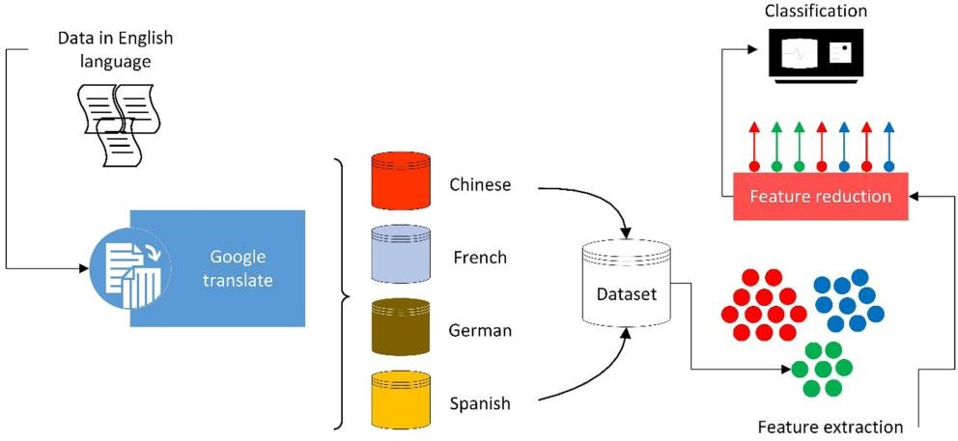

Fig.3.2.1 System architecture

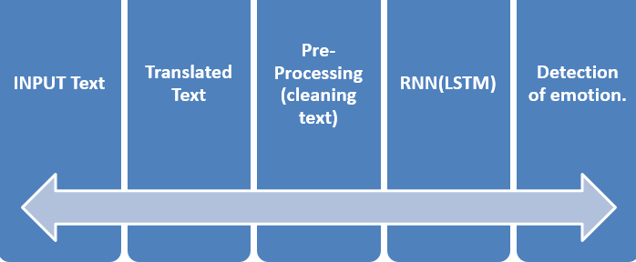

Fig:3.2.2 Design of Application

# Functional Requirements:

1. Data Collection.
2. Data Preprocessing.
3. Training And Testing.
4. Modeling
5. Predicting.

# Non Functional Requirements:

* Usability requirement
* Manageability requirement
* Serviceability requirement
* Recoverability requirement
* Data Integrity

13

# ALGORITHM:

**RNN:** Recurrent Neural Network(RNN) is a type of Neural Network where the output from the previous step is fed as input to the current step. In traditional neural networks, all the inputs and outputs are independent of each other. Still, in cases when it is required to predict the next word of a sentence, the previous words are required and hence there is a need to remember the previous words.

Thus RNN came into existence, which solved this issue with the help of a Hidden Layer. The main and most important feature of RNN is its Hidden state, which remembers some information about a sequence. The state is also referred to as Memory State since it remembers the previous input to the network. It uses the same parameters for each input as it performs the same task on all the inputs or hidden layers to produce the output. This reduces the complexity of parameters, unlike other neural networks.

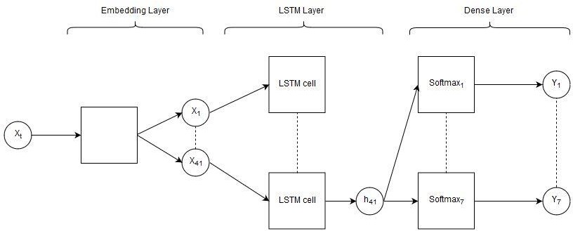

16

**Embedding Layer.**

**LSTM (Long Short-**

**Term Memory).**

**SpatialDropout1D**

**Layer.**

**Dense Layer.**

**Embedding Layer:** This layer maps each integer in the input sequences to a dense vector of fixed size. It inputs 2D tensor vector ,and generates 3D tensor Array for the next layer .This vector representation is learned during the training process and aims to capture semantic relationships between tokens.

**SpatialDropout:** The tokenized vector space with similar space will be set to zero or null. It will drop out the similar type of tokens.

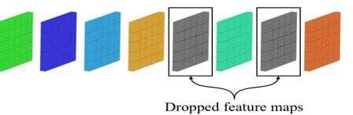

15

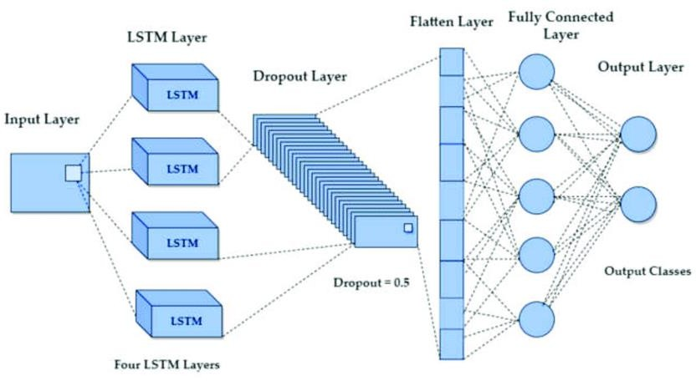

Fig.3.3.1 LSTM(RNN)

# LSTM Layer:

A Long Short-Term Memory (LSTM) network is a type of recurrent neural network (RNN) architecture designed to handle the challenge of learning long-term dependencies in sequential data. Unlike traditional RNNs, which struggle with issues like vanishing gradients over time, LSTMs incorporate specialized mechanisms—such as memory cells and gating mechanisms— to better manage and remember information over long sequences.

This Layer Inputs the 3D tensor Array of previous layer ,then generates the 2D tensor Vector

,This layer is majorly used for vanishing gradient problems.

This layer dropouts the user input nearly 20-30% ,without out vanishing the grammar in the data. Also this layer drop out recurrent states (re-accurent states).

18

# Dense Layer:

A Dense layer, also known as a fully connected layer, is a fundamental building block in neural network architectures, particularly in deep learning models. In a Dense layer, each neuron or node is connected to every neuron in the previous layer, creating a densely connected graph of neurons. This connectivity pattern enables Dense layers to learn complex patterns and relationships in data, making them versatile for various tasks such as classification, regression, and feature learning. Each neuron in a Dense layer computes a weighted sum of its inputs, adds a bias term, and then applies an activation function to produce an output. The weights and biases in Dense layers are learned during training using gradient- based optimization techniques like backpropagation, allowing the network to adapt and improve its performance over time.

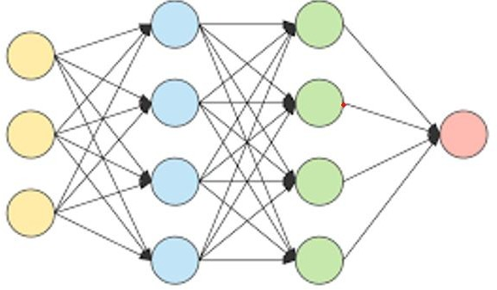

15

# SAMPLE CODE:

import pandas as pd

from sklearn.model_selection import train_test_split from sklearn.preprocessing import LabelEncoder

from tensorflow.keras.preprocessing.text import Tokenizer

from tensorflow.keras.preprocessing.sequence import pad_sequences from tensorflow.keras.models import Sequential

from tensorflow.keras.layers import Embedding, LSTM, Dense, SpatialDropout1D from tensorflow.keras.callbacks import EarlyStopping, ReduceLROnPlateau import matplotlib.pyplot as plt

from sklearn.metrics import classification_report, confusion_matrix import seaborn as sns

from tensorflow.keras.models import load_model

df= pd.read_csv('../csv_file_data/spanish_dataset.csv', encoding='latin-1')

# Function to clean text def clean_text(text):

if isinstance(text, str):

text = text.lower() # Convert to lowercase

text = ''.join([char for char in text if char.isalnum() or char.isspace()]) # Remove special characters

else:

text = str(text) # Handle NaN values by converting to string return text

28

# Clean the text data

df['Text'] = df['Text'].apply(clean_text)

# Remove rows with empty strings after cleaning df = df[df['Text'] != '']

df['Text'] = df['Text'].apply(clean_text) df = df[df['Text'] != '']

max_num_words = 10000 # Maximum number of words in the tokenizer max_seq_length = 100 # Maximum sequence length

tokenizer = Tokenizer(num_words=max_num_words) tokenizer.fit_on_texts(df['Text'])

sequences = tokenizer.texts_to_sequences(df['Text'])

padded_sequences = pad_sequences(sequences, maxlen=max_seq_length)

label_encoder = LabelEncoder()

labels = label_encoder.fit_transform(df['Emotion'])

# Split the data into training and validation sets

X_train, X_val, y_train, y_val = train_test_split(padded_sequences, labels, test_size=0.2, random_state=42)

27

# Step 2: Build the RNN model with LSTM units set to 256

model = Sequential()

model.add(Embedding(max_num_words, 128, input_length=max_seq_length)) model.add(SpatialDropout1D(0.2))

model.add(LSTM(256, dropout=0.2, recurrent_dropout=0.2)) # Change LSTM units to 256 model.add(Dense(128, activation='relu'))

model.add(Dense(len(label_encoder.classes_), activation='softmax'))

# Build the model

model.build(input_shape=(None, max_seq_length))

# Compile the model

model.compile(loss='sparse_categorical_crossentropy', optimizer='adam', metrics=['accuracy'])

# Print the model summary print(model.summary())

28

# Step 3: Train the model # Define callbacks

early_stopping = EarlyStopping(monitor='val_loss', patience=5, restore_best_weights=True) reduce_lr = ReduceLROnPlateau(monitor='val_loss', factor=0.2, patience=3, min_lr=0.0001)

# Train the model

history = model.fit(X_train, y_train, epochs=20, batch_size=32, validation_data=(X_val, y_val), callbacks=[early_stopping, reduce_lr])

# Step 4: Evaluate the model # Evaluate the model

val_loss, val_accuracy = model.evaluate(X_val, y_val) print(f'Validation Accuracy: {val_accuracy * 100:.2f}%')

# Plot training and validation accuracy and loss plt.figure(figsize=(12, 4))

plt.subplot(1, 2, 1)

plt.plot(history.history['accuracy'], label='Train Accuracy') plt.plot(history.history['val_accuracy'], label='Validation Accuracy') plt.title('Accuracy over Epochs')

plt.xlabel('Epoch') plt.ylabel('Accuracy') plt.legend()

plt.subplot(1, 2, 2)

27

plt.plot(history.history['loss'], label='Train Loss') plt.plot(history.history['val_loss'], label='Validation Loss') plt.title('Loss over Epochs')

plt.xlabel('Epoch') plt.ylabel('Loss') plt.legend()

plt.show()

# Generate classification report y_pred = model.predict(X_val)

y_pred_classes = y_pred.argmax(axis=-1)

print(classification_report(y_val, y_pred_classes, target_names=label_encoder.classes_))

# Generate confusion matrix

conf_matrix = confusion_matrix(y_val, y_pred_classes) plt.figure(figsize=(10, 8))

sns.heatmap(conf_matrix, annot=True, fmt='d', xticklabels=label_encoder.classes_, yticklabels=label_encoder.classes_)

plt.title('Confusion Matrix') plt.xlabel('Predicted') plt.ylabel('True')

plt.show()

# Step 5: Save the model model.save('spanish.h5”)

28

# CHAPTER 4 RESULTS AND DISCUSSIONS

The project successfully implemented a web-based (Steamlit)system for detecting Emotion for a text in different languages for where the emotion is preserved .

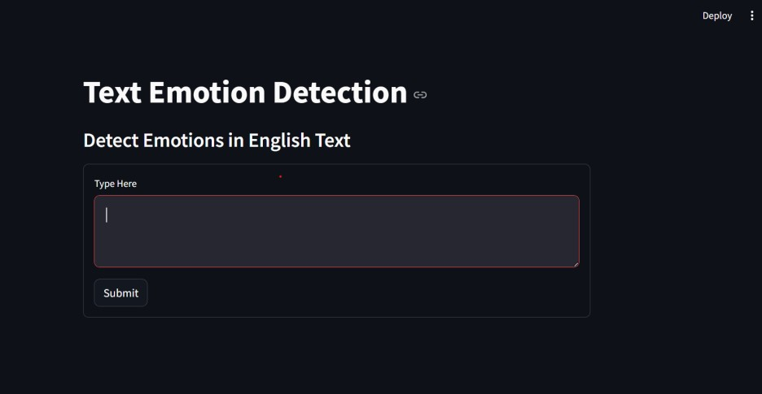

Fig :4.1DashBorad

User can enter the input in the text box,and submit the content of the input box.

The input text must be in English language ,then the text will be converted and prepossed by the python code ,then the data will be translated to different languages the emotion will be identified by the model developmented way.output will be shown in the different languages.lets see the output in the next fig :4.2 and fig:4.3.

27

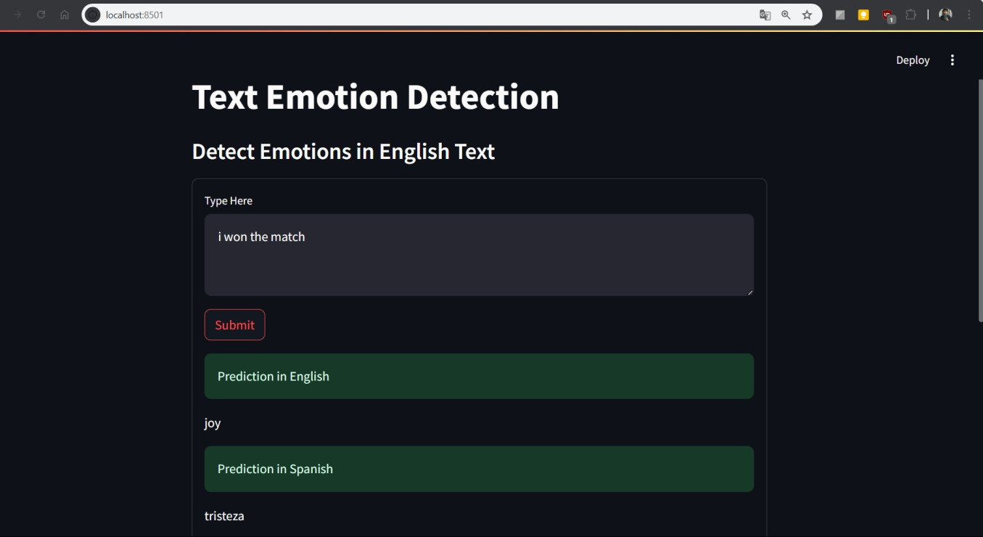

Fig:4.2 output1

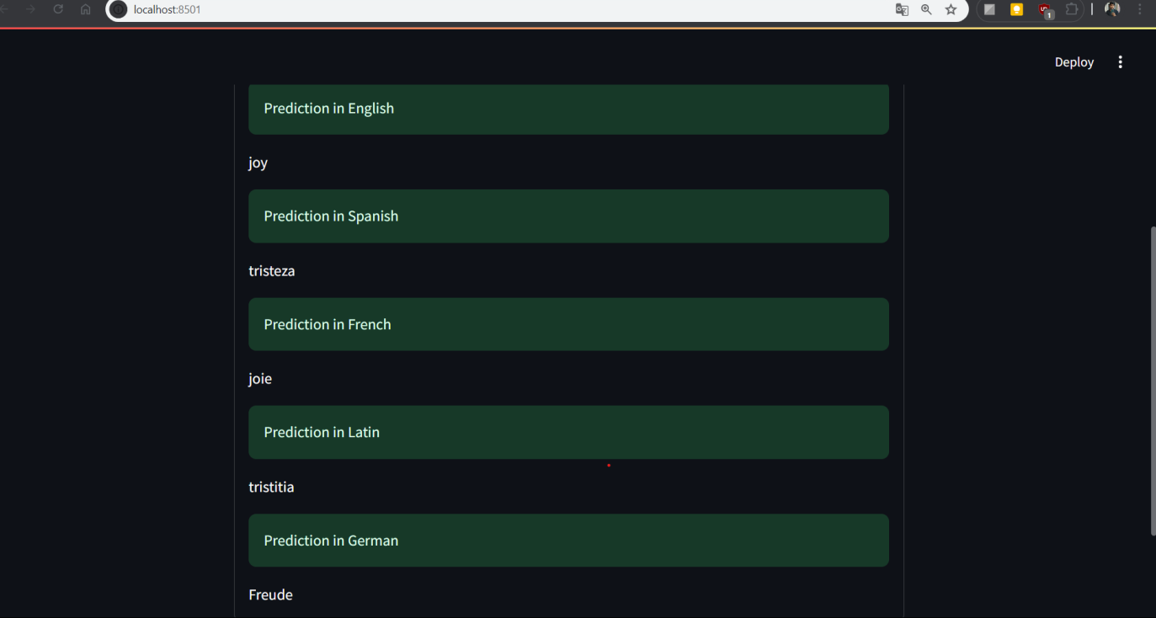

Fig:4.3 output2

28

33

34

# CHAPTER 5 CONCLUSION AND FUTURE SCOPE

# CONCLUSION

The project effectively combines multilingual emotion detection with an intuitive and user-friendly interface. By utilizing Recurrent Neural Network (RNN) models trained on English, Spanish, and French datasets, it can accurately predict basic emotions (joy, sadness, fear, anger, and surprise) from text inputs across these languages. The integration with Streamlit allows for seamless text processing, where the application translates inputs when necessary to ensure precise emotion detection without requiring users to select the input language. This feature significantly enhances user experience and makes the application accessible to a broader and more diverse audience. The project's architecture demonstrates a sophisticated use of machine learning algorithms and efficient data handling techniques. By focusing on multilingual capabilities, it addresses a critical need for versatile emotion detection tools in today's globalized environment. The system's ability to handle multiple languages automatically showcases its practical utility and technological innovation. This approach not only highlights the technical proficiency behind the project but also its commitment to inclusivity and ease of use for end-users. Overall, the project stands as a comprehensive and valuable tool for emotion analysis, emphasizing the practical benefits and versatility of modern machine learning models.

35

# FUTURE SCOPE

Looking ahead, the project holds significant potential for expansion and enhancement. One promising avenue is to broaden the scope of emotion detection beyond the basic five emotions (joy, sadness, fear, anger, and surprise) to encompass a wider range of emotional states. This could involve incorporating more nuanced emotional categories or developing models that better capture complex emotional expressions. Expanding multilingual capabilities remains crucial. By integrating additional languages and improving language detection capabilities, the application can cater to a more diverse global audience, fostering inclusivity and usability across different linguistic contexts. Technological advancements offer another exciting area for future development. Upgrading the underlying machine learning models with state-of-the-art techniques such as transformer architectures or contextual embeddings could enhance accuracy and adaptability.

Furthermore, optimizing the application for mobile platforms would increase accessibility, allowing users to analyze emotions on-the-go. Real-time processing capabilities represent another frontier. Implementing live feedback mechanisms could enable applications in dynamic environments like real- time customer feedback analysis or sentiment monitoring on social media platforms. Ultimately, integrating with complementary AI tools for sentiment analysis, psychological profiling, or mental health assessment could extend the project's utility, offering comprehensive solutions for emotional analysis across various domains.

36

# 7. REFERENCES

1. Bhugra, D., McKenzie, K.: Expressed emotion across cultures. Adv. Psychiatr. Treat. 9(5), 342–348 (2003.
2. Canfora, C., Ottmann, A.: Risks in neural machine translation. Transl. Spaces 9(1), 58–77 (2020)
3. Cao, F., Perfetti, C.A.: Neural signatures of the reading-writing connection: greater involvement of writing in Chinese reading than English reading. PLoS ONE 11(12), e0168414 (2016)
4. Chang, C.C., Lin, C.J.: LIBSVM: a library for support vector machines. ACM Trans. Intell.

Syst. Technol. (TIST) 2(3), 1–27 (2011

1. Fischer, A.H., Rodriguez Mosquera, P.M., Van Vianen, A.E., Manstead, A.S.: Gender and culture differences in emotion. Emotion 4(1), 87 (2004)
2. Gao, X.P., Xin, J.H., Sato, T., Hansuebsai, A., Scalzo, M., Kajiwara, K., Billger, M.: Analysis of cross-cultural color emotion. Color Res Appl 32(3), 223–229 (2007)
3. Gelman, J., Wilson, S.L., Sanhueza Petrarca, C.: Mixing messages: how candidates vary in their use of Twitter. J Inform Technol Polit 18, 1–15 (2020).
4. Gorini, A., Mosso, J.L., Mosso, D., Pineda, E., Ruíz, N.L., Ramíez, M., Riva, G.: Emotional response to virtual reality exposure across different cultures: the role of the attribution process. Cyberpsychol Behav 12(6), 699–705 (2009).

37

39