A Mini Project Report
On
GARBAGE SEGREGATION USING DL
Submitted to JNTU HYDERABAD
In Partial Fulfillment of the requirements for the Award of Degree of

BACHELOR OF TECHNOLOGY
IN
COMPUTER SCIENCE AND ENGINEERING

Submitted
By

V.Uma Maheshwari (218R1A05J4)
T.Vinod Goud (218R1A05F6)
G.Sahana (218R1A05F5)
V.Balaram Prasad (218R1A05J5)

Under the Esteemed guidance of
Dr.K.Vijaya Babu
Assistant Professor, Department of CSE



Department of Computer Science & Engineering
CMR ENGINEERING COLLEGE
(UGC AUTUNOMOUS)
(Approved by AICTE, NEW DELHI, Affiliated to JNTU, Hyderabad)
Kandlakoya, Medchal Road, R.R. Dist. Hyderabad-501 401)
2024-2025
CMR ENGINEERING COLLEGE
(Accredited by NBA,Approved by AICTE NEW DELHI, Affiliated to JNTU, Hyderabad)
Kandlakoya, Medchal Road, Hyderabad-501 401

Department of Computer Science & Engineering
CERTIFICATE
This is to certify that the project entitled “GARBAGE SEGREGATION USING DL” is a bonafide work carried out by
V.Uma Maheshwari (218R1A05J4)
T.Vinod (218R1A05F6)
G.Sahana (218R1A05F5)
V.Balaram Prasad (218R1A05J5)
in partial fulfillment of the requirement for the award of the degree of BACHELOR OF TECHNOLOGY in COMPUTER SCIENCE AND ENGINEERING from CMR Engineering College, affiliated to JNTU, Hyderabad, under our guidance and supervision.

The results presented in this project have been verified and are found to be satisfactory. The results embodied in this project have not been submitted to any other university for the award of any other degree or diploma.

Internal Guide | Mini Project Coordinator | Head of the Department | External Examiner
Dr.K.Vijaya Babu | Mr. S. Kiran Kumar | Dr. Sheo Kumar
Assistant Professor | Assistant Professor | Professor & H.O.D
CSE, CMREC | CSE, CMREC | CSE, CMREC

DECLARATION

This is to certify that the work reported in the present project entitled "GARBAGE SEGREGATION USING DL” is a record of bonafide work done by us in the Department of Computer Science and Engineering, CMR Engineering College, JNTU Hyderabad. The reports are based on the project work done entirely by us and not copied from any other source. We submit our project for further development by any interested students who share similar interests to improve the project in the future.
The results embodied in this project report have not been submitted to any other University or Institute for the award of any degree or diploma to the best of our knowledge and belief.

V.Uma Maheshwari (218R1A05J4)
T.Vinod Goud (218R1A05F6)
G.Sahana (218R1A05F5)
V.Balaram Prasad (218R1A05J5)

ACKNOWLEDGMENT

We are extremely grateful to Dr. A. Srinivasula Reddy, Principal and Dr.Sheo Kumar, HOD, Department of CSE, CMR Engineering College for their constant support.

I am extremely thankful to Dr.K.Vijaya Babu, Assistant Professor, Internal Guide, Department of CSE, for his/ her constant guidance, encouragement and moral support throughout the project.

I will be failing in duty if I do not acknowledge with grateful thanks to the authors of the references and other literatures referred in this Project.

I thank S.Kiran Kumar Mini Project Coordinator for his constant support in carrying out the project activities and reviews.

I express my thanks to all staff members and friends for all the help and co-ordination extended in bringing out this project successfully in time.

Finally, I am very much thankful to my parents who guided me for every step.

V.Uma Maheshwari (218R1A05J4)
T.Vinod Goud (218R1A05F6)
G.Sahana (218R1A05F5)
V.Balaram Prasad (218R1A05J5)

ABSTRACT

Waste Segregation means to group Waste into different Categories. Each waste goes into its category at the point of dumping or collection. Under the Waste Regulations 2011, you must segregate cardboard, glass, metal, paper, plastic, trash and at source unless it is technically or economically unfeasible. Under the same regulations, you should implement the waste hierarchy; reduce, reuse, recycle, other recovery and disposal. By law, you should implement this hierarchy and segregation helps with recycling in particular. Waste segregation is included in law because it is much easier to recycle. Effective segregation of wastes means that less waste goes to landfill which makes it cheaper and better for people and the environment. It is important to segregate for public health. In particular, hazardous wastes can cause long term health problems, so it is very important that they are disposed of correctly and safely and not mixed in with the normal waste coming out of your home or office. In this project, we have tried to classify garbage under the same categories as provided by the Waste Regulations 2011.Those are cardboard, glass, metal, paper, plastic, trash.

LIST OF FIGURES

s.no | Fig.no | Name | Pg.no
1 | 1.1 | Deep Learning workflow | 2
2 | 2.2.6 | Agile Model lifecycle | 7
3 | 4.1.1 | System Design | 13
4 | 4.2.1 | Data flow Diagram | 15
5 | 4.2.2 | Use-Case Diagram | 16
6 | 4.2.3 | Sequence Diagram | 17

LIST OF ABBREVIATIONS

s.no | Abbreviation | Full Form
1 | UML | Unified Modeling Language
2 | HTML | Hyper Text Markup Language
3 | AWS | Amazon Web  Service

LIST OF SCREENSHOTS

s.no | Fig.no | Name | Page.no
1 | 7.1 | Web Page | 17
2 | 7.2 | Classified as metal | 32
3 | 7.3 | Classified as organic | 33
4 | 7.4 | Classified as glass | 34
5 | 7.5 | Classified as plastic | 36
6 | 7.6 | Related videos | 37

TABLE OF CONTENTS

ABSTRACT 1
LIST OF FIGURES 2
LIST OF 3
SCREENSHOTS

- INTRODUCTION 1
  - About the project 1
  - Objective 1
- SYSTEM ANALYSIS 2
  - Existing System 2
  - Proposed System 2
  - Scope of the Project 4
  - Module Description 4
  - System Configuration 5
2.5.1 Software requirements 5
2.5.2 Hardware requirements 5
- LITERATURE OVERVIEW 6
- SYSTEM DESIGN 8
  - System Architecture 8
  - UML Diagrams 9
  - System Design 11
5.CODING AND IMPLEMENTATION 13
5.1 Sample code 13
6.TESTING 33
6.1 Testing 33
6.1.1 Unit Testing 33
6.1.2 Integration Testing 33
6.1.3 System Testing 33

7.OUTPUT SCREENS 34
8.CONCLUSION 36

8.1 Conclusion 36
8.2 Future Enhancement 36

9.REFERENCES 37

1.INTRODUCTION
1.1 ABOUT THE PROJECT

The garbage and recycling businesses are being overwhelmed by the ever-increasing volume of global garbage. As a result, the demand for smart solutions for environmental monitoring and recycling process improvement is stronger than ever. Human life and the environment are both affected by waste disposal, whether directly or indirectly. The negative consequences of waste materials can be mitigated with the use of a competent waste management system
Our project Garbage Segregation Using DL is an application built using aws platform so that we can use in phones or desktops. In this project client uploads a photo and he gets the knowledge about the garbage. According to the description given it is classified as recyclable or non-recyclable so that the segregation of waste is done properly.

1.2 OBJECTIVE
In this project we aim that the client will be having enough knowledge about the objects they are segregating. Waste segregation is included in law because it is much easier to recycle. Effective segregation of wastes means that less waste goes to landfill which makes it cheaper and better for people and the environment.

2. SYSTEM ANALYSIS

2.1 EXISTING SYSTEM
Our application is unique of its kind, but however there are few systems similar to our project that are already in use. Few of them involve iot applications. Not all of them can afford the entire system.

2.2PROPOSED SYSTEM
Our project only needs internet connection and a device which has camera. So that it is easy to take a snap of object and upload it.
Our project only needs internet connection and a device which has camera.So that it is easy to take a snap of object and upload it.
Convolutional Neural Network Convolutional Neural Network (CNN) is prominently used for image analysis. Its hidden layers called convolutional layers to make it more special. Each convolutional layer contains a set of filters. These filters detect patterns or features in the images. A simplest CNN has the following layers:
Convolutional layer: A convolutional layer extracts features of images by using filters. Filters are small matrices of dimensions of our wish filled with random values. These filters detect patterns by striding over the input images after which we get the resultant feature map which is passed to the next layer.
Pooling layer: In this layer, a window normally a size of 2x2 is placed over the feature map and the maximum value is selected in the window neglecting all other values. It results in a decreased picture scale.
Fully connected layer: The actual image recognition and classification happens in this sheet. The shrink images are taken and inserted into a single vector. This vector is compared and the image is classified with the vectors obtained from the trained images.

2.2.1Details
Here the client just needs to open the link and upload photo. Uploading photo can be from the device or can be capturing the picture can uploading directly. After that they need to click a button to classify.

2.2.2 Impact on Environment
Our project has no negative impact on Environment, it helps the user to know about the object. Having some knowledge on waste object helps us to improve our environment.

2.2.3 Safety
Our project is highly secured since it uses client server architecture. As the data is centralized this system is more secure and serves added security to the data.

2.2.4 Ethics

The solution we are implementing doesn’t cause harm to any people either physically or virtually. It is quite safe for execution. This makes our project more robust and secure.

2.2.5 Cost
There will be very minute requirement for cost maintenance and usage as the data is given by user, no extra effort is required to maintain. All it requires is a PC/laptop/mobile with good internet connection.

2.2.6 Type

Our solution comes under the category of standalone product as it just requires a picture of the photo and good internet connection.

2.2.7 Standards
We have followed the Agile Methodology to create our project. Initially, we gathered all the requirements that are necessary for the project. We have specifically defined the purpose of the software and have divided the entire project into small builds. These builds were worked on for days together to produce an efficient solution for each stage.
Both the design and the testing processes were simultaneous so that it would be easier for use to identify if there was any problem with the code. As soon as there were any changes, we would implement the idea and then repeat the process. This proved out to be an efficient solution that not only made the project execution faster but also easier.

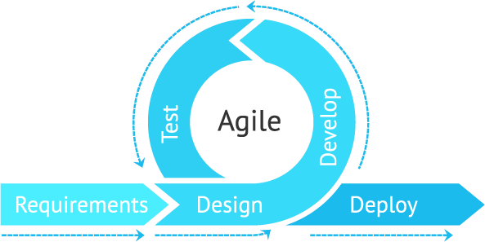

Figure 2.2.7: Agile Model

2.3SCOPE OF THE PROJECT
The main scope of the project is to provide a platform for user who wants to keep our environment ecofriendly and balanced. When the garbage is segregated at our homes the burden and responsibility of workers will become less and more plans will be implemented for non-recyclable objects.

2.4 MODULES DESCRIPTION
Object Identification
The duty of model is to identify the object. Object identification is easy using tensor flow and keras. Here we have taken vgg16 a convolutional neural network (CNN) which is great model.
Categorizing
After identifying the object, it checks what category it comes under like paper, metal, glass. etc. And provides sufficient description about the object.

2.5 SYSTEM CONFIGURATION
System analysis is done to know about the requirements in both functional and non- functional perspective. It gives software requirement specification that gives an overview of the system.

Software Requirements
Framework: aws elastic beanstalk
Programming Language: Python 3+
Code Editor: jupyter notebook

Hardware Requirements
Operating System: Windows
RAM: 4GB or more
Processor: 2 GHz or more
Disk Space: 200GB or more

3. LITERATURE OVERVIEW

AWS Elastic Beanstalk
AWS Elastic Beanstalk is an easy-to-use service for deploying and scaling web applications and services developed with Java, .NET, PHP, Node.js, Python, Ruby, Go, and Docker on familiar servers such as Apache, Nginx, Passenger, and IIS. You can simply upload your code and Elastic Beanstalk automatically handles the deployment, from capacity provisioning, load balancing, auto-scaling to application health monitoring. At the same time, you retain full control over the AWS resources powering your application and can access the underlying resources at any time.
There is no additional charge for Elastic Beanstalk - you pay only for the AWS resources needed to store and run your applications.

Features of AWS Elastic Beanstalk:
- Fast and simple to begin
- Developer productivity
- Impossible to outgrow

Python:
Python is an interpreted high-level general-purpose programming language. Its design philosophy emphasizes code readability with its use of significant indentation. Its language constructs as well as its object-oriented approach aim to help programmers write clear, logical code for small and large-scale projects.

Python is dynamically-typed and garbage-collected. It supports multiple programming paradigms, including structured (particularly, procedural), objectoriented and functional programming. It is often described as a "batteries included" language due to its comprehensive standard library.

Guido van Rossum began working on Python in the late 1980s, as a successor to the ABC programming language, and first released it in 1991 as Python 0.9. Python 2.0 was released in 2000 and introduced new features, such as list comprehensions and a cycle-detecting garbage collection system (in addition to reference counting). Python 3.0 was released in 2008 and was a major revision of the language that is not completely backward-compatible. Python 2 was discontinued with version 2.7.18 in 2020.

Features of Python:
- Easy to code:
- Free and Open Source:
- Object-Oriented Language:
- GUI Programming Support:
- High-Level Language:
- Extensible feature:
- Python is Portable language:
- Python is Integrated language:
- Interpreted Language:
- Large Standard Library

4. SYSTEM DESIGN

4.1 SYSTEM ARCHITECTURE

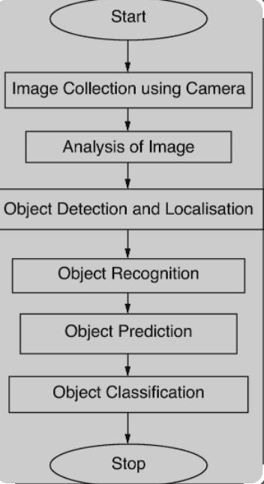
Fig:4.1: System Architecture

Image Collection Using Camera
Inorder to detect the image we need to upload the image.When the user is using the application through phone ,user uploads it through camera.While through others they can simply upload it.

Analysis of Image
After uploading the image,analysis of image is done.Here we are going to take that image and change its dimensions using image data generator.

Object Detection and localization
Object localization refers to identifying the location of one or more objects in an image and drawing abounding box around their extent. Object detection combines these two tasks and localizes and classifies one or more objects in an image.

Object Recognition
The duty of model is to identify the object. Object identification is easy using tensor flow and keras. Here we have taken vgg16 a convolutional neural network (CNN) which is great model.
Object Prediction
According to the object classification given in data,prediction is done.

Object Classification
To classify the object we use vgg16.

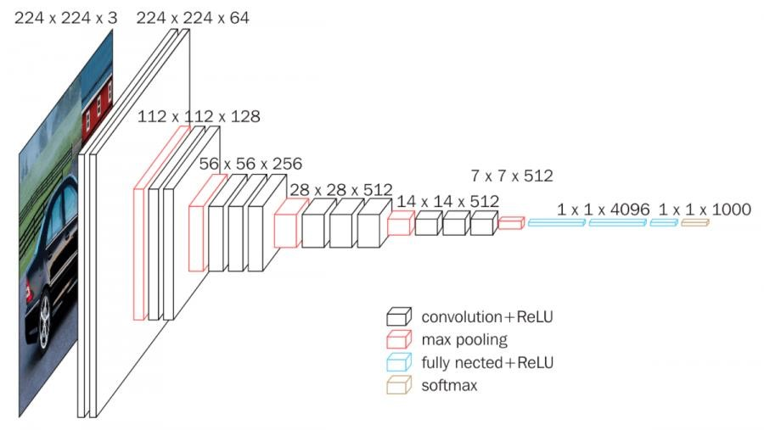

4.2 UML DIAGRAM

4.2.1 Sequence Diagram

A sequence diagram is a type of interaction diagram because it describes how—and in what order—a group of objects works together. These diagrams are used by software developers and business professionals to understand requirements for a new system or to document an existing process.

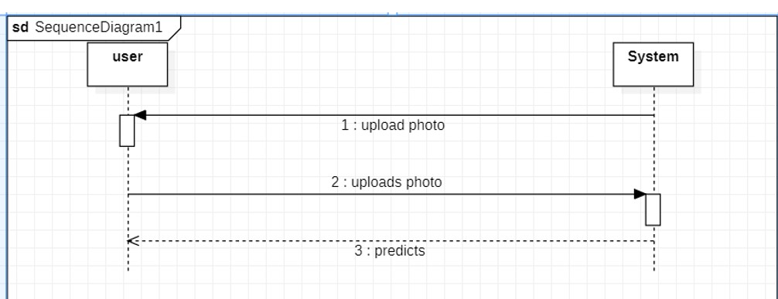

Fig 4.2 Sequence diagram

4.2.2 Class Diagram

Class diagram consists of classes, interfaces, associations, and collaboration. Class diagrams basically represent the object-oriented view of a system, which is static in nature.

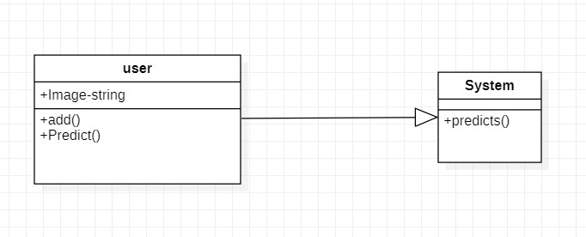
Fig 4.4 Class diagram

4.2.3 Use case Diagram

Use case diagrams are a set of use cases, actors, and their relationships. They represent the use case view of a system.

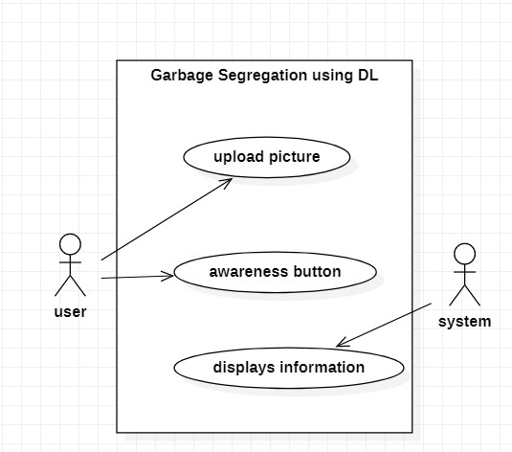

Fig 4.5 Use case diagram

4.3 System Design
Pre-processing and data augmentation
The dataset is relatively small for pre-trained models to handle. Overfitting can be a concern. Therefore, some steps must be taken before the training model. Dataset size is doubled by adding images from the Google images. Additionally, certain techniques of augmentation such as Random Re-sized Crop, Random Horizontal Flip, are used.

Network Training
The dataset is split into 80% training set and 20% testing set. Google Colab is used for this project as it provides GPU free of cost. Google Colab has 1000s of cores running simultaneously. It provides with 12.72 GB RAM and 358.27 hard disk spaces in one run time. We took advantage of Fastai library to train CNN models.

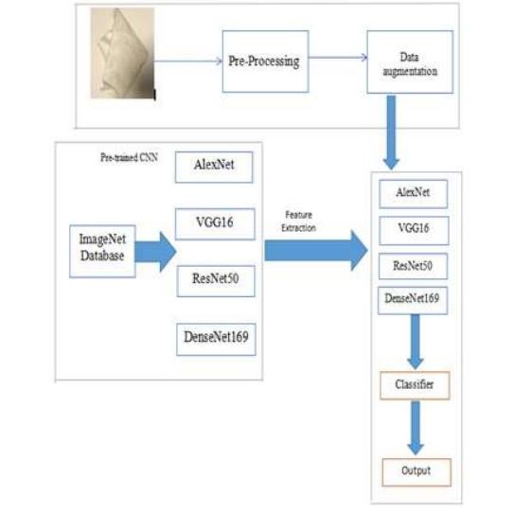

Fig:4.5:System Design

5.CODING AND IMPLEMENTATION

5.1.Sample code
import os
import torch
import torchvision
from torch.utils.data import random_split
import torchvision.models as models
import torch.nn as nn
import torch.nn.functional as F
data_dir = r'.\archive\TrashType_Image_Dataset';

classes = os.listdir(data_dir)
print(classes)
['cardboard', 'glass', 'metal', 'paper', 'plastic', 'trash']
from torchvision.datasets import ImageFolder
import torchvision.transforms as transforms

transformations = transforms.Compose([transforms.Resize((256, 256)), transforms.ToTensor()])

dataset = ImageFolder(data_dir, transform = transformations)
import matplotlib.pyplot as plt
%matplotlib inline

def show_sample(img, label):
print("Label:", dataset.classes[label], "(Class No: "+ str(label) + ")")
plt.imshow(img.permute(1, 2, 0))
random_seed = 42
torch.manual_seed(random_seed)
<torch._C.Generator at 0x15063007d70>
len(dataset)
2528
from torch.utils.data.dataloader import DataLoader
batch_size = 32
def get_default_device():
"""Pick GPU if available, else CPU"""
if torch.cuda.is_available():
return torch.device('cuda')
else:
return torch.device('cpu')

def to_device(data, device):
"""Move tensor(s) to chosen device"""
if isinstance(data, (list,tuple)):
return [to_device(x, device) for x in data]
return data.to(device, non_blocking=True)

class DeviceDataLoader():
"""Wrap a dataloader to move data to a device"""
def _init_(self, dl, device):
self.dl = dl
self.device = device

def _iter_(self):
"""Yield a batch of data after moving it to device"""
for b in self.dl:
yield to_device(b, self.device)

def _len_(self):
"""Number of batches"""
return len(self.dl)
device = get_default_device()
device
device(type='cpu')
class ImageClassificationBase(nn.Module):
def training_step(self, batch):
images, labels = batch
out = self(images) # Generate predictions
loss = F.cross_entropy(out, labels) # Calculate loss
return loss

def validation_step(self, batch):
images, labels = batch
out = self(images) # Generate predictions
loss = F.cross_entropy(out, labels) # Calculate loss
acc = accuracy(out, labels) # Calculate accuracy
return {'val_loss': loss.detach(), 'val_acc': acc}
def validation_epoch_end(self, outputs):
batch_losses = [x['val_loss'] for x in outputs]
epoch_loss = torch.stack(batch_losses).mean() # Combine losses
batch_accs = [x['val_acc'] for x in outputs]
epoch_acc = torch.stack(batch_accs).mean() # Combine accuracies
return {'val_loss': epoch_loss.item(), 'val_acc': epoch_acc.item()}

def epoch_end(self, epoch, result):
print("Epoch {}: train_loss: {:.4f}, val_loss: {:.4f}, val_acc: {:.4f}".format(
epoch+1, result['train_loss'], result['val_loss'], result['val_acc']))
class ResNet(ImageClassificationBase):
def _init_(self):
super()._init_()
# Use a pretrained model
self.network = models.resnet50(pretrained=True)
# Replace last layer
num_ftrs = self.network.fc.in_features
self.network.fc = nn.Linear(num_ftrs, len(dataset.classes))

def forward(self, xb):
return torch.sigmoid(self.network(xb))

model = torch.load("GarbageClassifier.pth")
to_device(model, device)
ResNet(
(network): ResNet(
(conv1): Conv2d(3, 64, kernel_size=(7, 7), stride=(2, 2), padding=(3, 3), bias=False)
(bn1): BatchNorm2d(64, eps=1e-05, momentum=0.1, affine=True, track_running_stats=True)
(relu): ReLU(inplace=True)
(maxpool): MaxPool2d(kernel_size=3, stride=2, padding=1, dilation=1, ceil_mode=False)
(layer1): Sequential(
(0): Bottleneck(
(conv1): Conv2d(64, 64, kernel_size=(1, 1), stride=(1, 1), bias=False)
(bn1): BatchNorm2d(64, eps=1e-05, momentum=0.1, affine=True, track_running_stats=True)
(conv2): Conv2d(64, 64, kernel_size=(3, 3), stride=(1, 1), padding=(1, 1), bias=False)
(bn2): BatchNorm2d(64, eps=1e-05, momentum=0.1, affine=True, track_running_stats=True)
(conv3): Conv2d(64, 256, kernel_size=(1, 1), stride=(1, 1), bias=False)
(bn3): BatchNorm2d(256, eps=1e-05, momentum=0.1, affine=True, track_running_stats=True)
(relu): ReLU(inplace=True)
(downsample): Sequential(
(0): Conv2d(64, 256, kernel_size=(1, 1), stride=(1, 1), bias=False)
(1): BatchNorm2d(256, eps=1e-05, momentum=0.1, affine=True, track_running_stats=True)
)
)
(1): Bottleneck(
(conv1): Conv2d(256, 64, kernel_size=(1, 1), stride=(1, 1), bias=False)
(bn1): BatchNorm2d(64, eps=1e-05, momentum=0.1, affine=True, track_running_stats=True)
(conv2): Conv2d(64, 64, kernel_size=(3, 3), stride=(1, 1), padding=(1, 1), bias=False)
(bn2): BatchNorm2d(64, eps=1e-05, momentum=0.1, affine=True, track_running_stats=True)
(conv3): Conv2d(64, 256, kernel_size=(1, 1), stride=(1, 1), bias=False)
(bn3): BatchNorm2d(256, eps=1e-05, momentum=0.1, affine=True, track_running_stats=True)
(relu): ReLU(inplace=True)
)
(2): Bottleneck(
(conv1): Conv2d(256, 64, kernel_size=(1, 1), stride=(1, 1), bias=False)
(bn1): BatchNorm2d(64, eps=1e-05, momentum=0.1, affine=True, track_running_stats=True)
(conv2): Conv2d(64, 64, kernel_size=(3, 3), stride=(1, 1), padding=(1, 1), bias=False)
(bn2): BatchNorm2d(64, eps=1e-05, momentum=0.1, affine=True, track_running_stats=True)
(conv3): Conv2d(64, 256, kernel_size=(1, 1), stride=(1, 1), bias=False)
(bn3): BatchNorm2d(256, eps=1e-05, momentum=0.1, affine=True, track_running_stats=True)
(relu): ReLU(inplace=True)
)
)
(layer2): Sequential(
(0): Bottleneck(
(conv1): Conv2d(256, 128, kernel_size=(1, 1), stride=(1, 1), bias=False)
(bn1): BatchNorm2d(128, eps=1e-05, momentum=0.1, affine=True, track_running_stats=True)
(conv2): Conv2d(128, 128, kernel_size=(3, 3), stride=(2, 2), padding=(1, 1), bias=False)
(bn2): BatchNorm2d(128, eps=1e-05, momentum=0.1, affine=True, track_running_stats=True)
(conv3): Conv2d(128, 512, kernel_size=(1, 1), stride=(1, 1), bias=False)
(bn3): BatchNorm2d(512, eps=1e-05, momentum=0.1, affine=True, track_running_stats=True)
(relu): ReLU(inplace=True)
(downsample): Sequential(
(0): Conv2d(256, 512, kernel_size=(1, 1), stride=(2, 2), bias=False)
(1): BatchNorm2d(512, eps=1e-05, momentum=0.1, affine=True, track_running_stats=True)
)
)
(1): Bottleneck(
(conv1): Conv2d(512, 128, kernel_size=(1, 1), stride=(1, 1), bias=False)
(bn1): BatchNorm2d(128, eps=1e-05, momentum=0.1, affine=True, track_running_stats=True)
(conv2): Conv2d(128, 128, kernel_size=(3, 3), stride=(1, 1), padding=(1, 1), bias=False)
(bn2): BatchNorm2d(128, eps=1e-05, momentum=0.1, affine=True, track_running_stats=True)
(conv3): Conv2d(128, 512, kernel_size=(1, 1), stride=(1, 1), bias=False)
(bn3): BatchNorm2d(512, eps=1e-05, momentum=0.1, affine=True, track_running_stats=True)
(relu): ReLU(inplace=True)
)
(2): Bottleneck(
(conv1): Conv2d(512, 128, kernel_size=(1, 1), stride=(1, 1), bias=False)
(bn1): BatchNorm2d(128, eps=1e-05, momentum=0.1, affine=True, track_running_stats=True)
(conv2): Conv2d(128, 128, kernel_size=(3, 3), stride=(1, 1), padding=(1, 1), bias=False)
(bn2): BatchNorm2d(128, eps=1e-05, momentum=0.1, affine=True, track_running_stats=True)
(conv3): Conv2d(128, 512, kernel_size=(1, 1), stride=(1, 1), bias=False)
(bn3): BatchNorm2d(512, eps=1e-05, momentum=0.1, affine=True, track_running_stats=True)
(relu): ReLU(inplace=True)
)
(3): Bottleneck(
(conv1): Conv2d(512, 128, kernel_size=(1, 1), stride=(1, 1), bias=False)
(bn1): BatchNorm2d(128, eps=1e-05, momentum=0.1, affine=True, track_running_stats=True)
(conv2): Conv2d(128, 128, kernel_size=(3, 3), stride=(1, 1), padding=(1, 1), bias=False)
(bn2): BatchNorm2d(128, eps=1e-05, momentum=0.1, affine=True, track_running_stats=True)
(conv3): Conv2d(128, 512, kernel_size=(1, 1), stride=(1, 1), bias=False)
(bn3): BatchNorm2d(512, eps=1e-05, momentum=0.1, affine=True, track_running_stats=True)
(relu): ReLU(inplace=True)
)
)
(layer3): Sequential(
(0): Bottleneck(
(conv1): Conv2d(512, 256, kernel_size=(1, 1), stride=(1, 1), bias=False)
(bn1): BatchNorm2d(256, eps=1e-05, momentum=0.1, affine=True, track_running_stats=True)
(conv2): Conv2d(256, 256, kernel_size=(3, 3), stride=(2, 2), padding=(1, 1), bias=False)
(bn2): BatchNorm2d(256, eps=1e-05, momentum=0.1, affine=True, track_running_stats=True)
(conv3): Conv2d(256, 1024, kernel_size=(1, 1), stride=(1, 1), bias=False)
(bn3): BatchNorm2d(1024, eps=1e-05, momentum=0.1, affine=True, track_running_stats=True)
(relu): ReLU(inplace=True)
(downsample): Sequential(
(0): Conv2d(512, 1024, kernel_size=(1, 1), stride=(2, 2), bias=False)
(1): BatchNorm2d(1024, eps=1e-05, momentum=0.1, affine=True, track_running_stats=True)
)
)
(1): Bottleneck(
(conv1): Conv2d(1024, 256, kernel_size=(1, 1), stride=(1, 1), bias=False)
(bn1): BatchNorm2d(256, eps=1e-05, momentum=0.1, affine=True, track_running_stats=True)
(conv2): Conv2d(256, 256, kernel_size=(3, 3), stride=(1, 1), padding=(1, 1), bias=False)
(bn2): BatchNorm2d(256, eps=1e-05, momentum=0.1, affine=True, track_running_stats=True)
(conv3): Conv2d(256, 1024, kernel_size=(1, 1), stride=(1, 1), bias=False)
(bn3): BatchNorm2d(1024, eps=1e-05, momentum=0.1, affine=True, track_running_stats=True)
(relu): ReLU(inplace=True)
)
(2): Bottleneck(
(conv1): Conv2d(1024, 256, kernel_size=(1, 1), stride=(1, 1), bias=False)
(bn1): BatchNorm2d(256, eps=1e-05, momentum=0.1, affine=True, track_running_stats=True)
(conv2): Conv2d(256, 256, kernel_size=(3, 3), stride=(1, 1), padding=(1, 1), bias=False)
(bn2): BatchNorm2d(256, eps=1e-05, momentum=0.1, affine=True, track_running_stats=True)
(conv3): Conv2d(256, 1024, kernel_size=(1, 1), stride=(1, 1), bias=False)
(bn3): BatchNorm2d(1024, eps=1e-05, momentum=0.1, affine=True, track_running_stats=True)
(relu): ReLU(inplace=True)
)
(3): Bottleneck(
(conv1): Conv2d(1024, 256, kernel_size=(1, 1), stride=(1, 1), bias=False)
(bn1): BatchNorm2d(256, eps=1e-05, momentum=0.1, affine=True, track_running_stats=True)
(conv2): Conv2d(256, 256, kernel_size=(3, 3), stride=(1, 1), padding=(1, 1), bias=False)
(bn2): BatchNorm2d(256, eps=1e-05, momentum=0.1, affine=True, track_running_stats=True)
(conv3): Conv2d(256, 1024, kernel_size=(1, 1), stride=(1, 1), bias=False)
(bn3): BatchNorm2d(1024, eps=1e-05, momentum=0.1, affine=True, track_running_stats=True)
(relu): ReLU(inplace=True)
)
(4): Bottleneck(
(conv1): Conv2d(1024, 256, kernel_size=(1, 1), stride=(1, 1), bias=False)
(bn1): BatchNorm2d(256, eps=1e-05, momentum=0.1, affine=True, track_running_stats=True)
(conv2): Conv2d(256, 256, kernel_size=(3, 3), stride=(1, 1), padding=(1, 1), bias=False)
(bn2): BatchNorm2d(256, eps=1e-05, momentum=0.1, affine=True, track_running_stats=True)
(conv3): Conv2d(256, 1024, kernel_size=(1, 1), stride=(1, 1), bias=False)
(bn3): BatchNorm2d(1024, eps=1e-05, momentum=0.1, affine=True, track_running_stats=True)
(relu): ReLU(inplace=True)
)
(5): Bottleneck(
(conv1): Conv2d(1024, 256, kernel_size=(1, 1), stride=(1, 1), bias=False)
(bn1): BatchNorm2d(256, eps=1e-05, momentum=0.1, affine=True, track_running_stats=True)
(conv2): Conv2d(256, 256, kernel_size=(3, 3), stride=(1, 1), padding=(1, 1), bias=False)
(bn2): BatchNorm2d(256, eps=1e-05, momentum=0.1, affine=True, track_running_stats=True)
(conv3): Conv2d(256, 1024, kernel_size=(1, 1), stride=(1, 1), bias=False)
(bn3): BatchNorm2d(1024, eps=1e-05, momentum=0.1, affine=True, track_running_stats=True)
(relu): ReLU(inplace=True)
)
)
(layer4): Sequential(
(0): Bottleneck(
(conv1): Conv2d(1024, 512, kernel_size=(1, 1), stride=(1, 1), bias=False)
(bn1): BatchNorm2d(512, eps=1e-05, momentum=0.1, affine=True, track_running_stats=True)
(conv2): Conv2d(512, 512, kernel_size=(3, 3), stride=(2, 2), padding=(1, 1), bias=False)
(bn2): BatchNorm2d(512, eps=1e-05, momentum=0.1, affine=True, track_running_stats=True)
(conv3): Conv2d(512, 2048, kernel_size=(1, 1), stride=(1, 1), bias=False)
(bn3): BatchNorm2d(2048, eps=1e-05, momentum=0.1, affine=True, track_running_stats=True)
(relu): ReLU(inplace=True)
(downsample): Sequential(
(0): Conv2d(1024, 2048, kernel_size=(1, 1), stride=(2, 2), bias=False)
(1): BatchNorm2d(2048, eps=1e-05, momentum=0.1, affine=True, track_running_stats=True)
)
)
(1): Bottleneck(
(conv1): Conv2d(2048, 512, kernel_size=(1, 1), stride=(1, 1), bias=False)
(bn1): BatchNorm2d(512, eps=1e-05, momentum=0.1, affine=True, track_running_stats=True)
(conv2): Conv2d(512, 512, kernel_size=(3, 3), stride=(1, 1), padding=(1, 1), bias=False)
(bn2): BatchNorm2d(512, eps=1e-05, momentum=0.1, affine=True, track_running_stats=True)
(conv3): Conv2d(512, 2048, kernel_size=(1, 1), stride=(1, 1), bias=False)
(bn3): BatchNorm2d(2048, eps=1e-05, momentum=0.1, affine=True, track_running_stats=True)
(relu): ReLU(inplace=True)
)
(2): Bottleneck(
(conv1): Conv2d(2048, 512, kernel_size=(1, 1), stride=(1, 1), bias=False)
(bn1): BatchNorm2d(512, eps=1e-05, momentum=0.1, affine=True, track_running_stats=True)
(conv2): Conv2d(512, 512, kernel_size=(3, 3), stride=(1, 1), padding=(1, 1), bias=False)
(bn2): BatchNorm2d(512, eps=1e-05, momentum=0.1, affine=True, track_running_stats=True)
(conv3): Conv2d(512, 2048, kernel_size=(1, 1), stride=(1, 1), bias=False)
(bn3): BatchNorm2d(2048, eps=1e-05, momentum=0.1, affine=True, track_running_stats=True)
(relu): ReLU(inplace=True)
)
)
(avgpool): AdaptiveAvgPool2d(output_size=(1, 1))
(fc): Linear(in_features=2048, out_features=6, bias=True)
)
)
def predict_image(img, model):
# Convert to a batch of 1
xb = to_device(img.unsqueeze(0), device)
# Get predictions from model
yb = model(xb)
# Pick index with highest probability
prob, preds = torch.max(yb, dim=1)
# Retrieve the class label
return dataset.classes[preds[0].item()]
loaded_model = model
from PIL import Image
from pathlib import Path

def predict_external_image(image_name):
image = Image.open(Path(image_name))

example_image = transformations(image)
plt.imshow(example_image.permute(1, 2, 0))
return predict_image(example_image, loaded_model);
classes
['cardboard', 'glass', 'metal', 'paper', 'plastic', 'trash']
classesData = {
'cardboard':"",
'glass': "Glass recycling is the processing of waste glass into usable products. Glass that is crushed and ready to be remelted is called cullet. There are two types of cullet: internal and external. Internal cullet is composed of defective products detected and rejected by a quality control process during the industrial process of glass manufacturing, transition phases of product changes (such as thickness and colour changes) and production offcuts. External cullet is waste glass that has been collected or reprocessed with the purpose of recycling. External cullet (which can be pre- or post-consumer) is classified as waste. The word cullet, when used in the context of end-of-waste, will always refer to external cullet. To be recycled, glass waste needs to be purified and cleaned of contamination. Then, depending on the end use and local processing capabilities, it might also have to be separated into different colors. Many recyclers collect different colors of glass separately since glass retains its color after recycling.",
'metal':"",
'paper':"The recycling of paper is the process by which waste paper is turned into new paper products. It has a number of important benefits: It saves waste paper from occupying homes of people and producing methane as it breaks down. Because paper fibre contains carbon (originally absorbed by the tree from which it was produced), recycling keeps the carbon locked up for longer and out of the atmosphere. Around two-thirds of all paper products in the US are now recovered and recycled, although it does not all become new paper. After repeated processing, the fibres become too short for the production of new paper - this is why virgin fibre (from sustainably farmed trees) is frequently added to the pulp recipe. Paper recycling pertains to the processes of reprocessing waste paper for reuse. Waste papers are either obtained from paper mill paper scraps, discarded paper materials, and waste paper material discarded after consumer use. Examples of the commonly known papers recycled are old newspapers and magazines.",
'plastic':"Plastic recycling is the process of recovering scrap or waste plastic and reprocessing the material into useful products. Due to purposefully misleading symbols on plastic packaging and numerous technical hurdles, less than 10% of plastic has ever been recycled. Compared with the lucrative recycling of metal, and similar to the low value of glass recycling, plastic polymers recycling is often more challenging because of low density and low value. Materials recovery facilities are responsible for sorting and processing plastics. As of 2019, due to limitations in their economic viability, these facilities have struggled to make a meaningful contribution to the plastic supply chain. The plastics industry has known since at least the 1970s that recycling of most plastics is unlikely because of these limitations. However, the industry has lobbied for the expansion of recycling while these companies have continued to increase the amount of virgin plastic being produced.",
'trash':"",
}
import tkinter as tk
from tkinter import filedialog
from PIL import Image, ImageTk
import os

def create_app():
def load_image():
# Open a file dialog to select an image file
file_path = filedialog.askopenfilename(
title="Select an Image",
filetypes=[("Image Files", ".png;.jpg;.jpeg;.bmp;*.gif")]
)
if file_path:
try:
# Load the selected image
img = Image.open(file_path)
photo = ImageTk.PhotoImage(img)

# Update the label with the new image
image_label.config(image=photo)
image_label.image = photo # Keep a reference to avoid garbage collection

# Pack the image label
image_label.pack(pady=(0, 5))

imgtype = predict_external_image(file_path)

# Update the text label
text_label.config(text="Waste Classified as \"" + imgtype + "\" Material")
text_label.pack(pady=(0, 10)) # Add some padding around the text

# Update the data label to display the string stored in 'data'
# Example string in 'data'
data = classesData[imgtype]
data_label.config(text=data)
data_label.pack(pady=(0, 10)) # Add some padding around the data label
except Exception as e:
print(f"An error occurred: {e}")

# Create the main window
root = tk.Tk()
root.title("Image Display")

# Create a button to load the image
load_button = tk.Button(root, text="Load Image", command=load_image)
load_button.pack(pady=10) # Add some padding around the button

# Create a label to display the image
image_label = tk.Label(root)
image_label.pack(pady=(0, 5)) # Add 5 lines of space below the image

# Create a label to display the text "This image is:"
text_label = tk.Label(root, text="", font=("Helvetica", 16, "bold"))
text_label.pack(pady=(0, 10)) # Add some padding around the text

# Create a label to display the string stored in 'data' with word wrapping
data_label = tk.Label(root, text="", font=("Helvetica", 14), wraplength=1000, justify="left")
data_label.pack(pady=(0, 10)) # Add some padding around the data label

# Run the Tkinter event loop
root.mainloop()

# Call the function to create the app
create_app()
import torch
import numpy as np
from PIL import Image, ImageDraw, ImageFont
import torchvision.transforms as T

def preprocess(image_path):
transform = T.Compose([
T.Resize((256, 256)), # Resize to match your model input size
T.ToTensor(), # Convert to tensor
])
image = Image.open(image_path).convert("RGB")
return transform(image).unsqueeze(0) # Add batch dimension

def segment_objects(image_path):
image_tensor = preprocess(image_path)

with torch.no_grad():
output = model(image_tensor)

output = output.squeeze().cpu().numpy() # Remove batch dimension
if len(output.shape) == 3: # Handle multi-class output
segmentation_mask = np.argmax(output, axis=0) # Get the class with highest probability for each pixel
else:
segmentation_mask = (output > 0.5).astype(int) # For binary output

return segmentation_mask

def get_color_map():
# Define a color map for each class
return np.array([
[0, 0, 0], # black for 'cardboard'
[0, 255, 0], # green for 'glass'
[255, 0, 0], # red for 'metal'
[0, 0, 255], # blue for 'paper'
[255, 255, 0], # yellow for 'plastic'
[255, 0, 255] # magenta for 'trash'
], dtype=np.uint8) # Ensure colors are in uint8 format

def get_labels():
return ['cardboard', 'glass', 'metal', 'paper', 'plastic', 'trash']

def overlay_labels(image_path, mask):
image = Image.open(image_path).convert("RGB")
draw = ImageDraw.Draw(image)
color_map = get_color_map()
labels = get_labels()

try:
font = ImageFont.truetype("arial.ttf", 15)
except IOError:
font = ImageFont.load_default()

for i in range(6): # Assuming 6 classes
mask_class = mask == i
if np.any(mask_class):
coords = np.argwhere(mask_class)
print(f"Coordinates for class {i}: {coords}") # Debug output

if coords.shape[0] == 0:
print(f"No coordinates found for class {i}")
continue

# Ensure coords is in expected format
if coords.shape[1] != 2:
coords = coords.reshape(-1, 2) # Ensure 2D shape if possible

min_x, min_y = coords.min(axis=0)
max_x, max_y = coords.max(axis=0)

# Ensure valid coordinates
min_x, min_y, max_x, max_y = int(min_x), int(min_y), int(max_x), int(max_y)

# Draw bounding box and text
draw.rectangle([min_y, min_x, max_y, max_x], outline=tuple(color_map[i]), width=2)
draw.text((min_y, min_x), labels[i], fill=tuple(color_map[i]), font=font)

return image

# Example usage
image_path = '.\\test.jpg'
segmentation_mask = segment_objects(image_path)
annotated_image = overlay_labels(image_path, segmentation_mask)
annotated_image.show() # Show the annotated image
Coordinates for class 0: [[0]
[1]
[2]
[4]
[5]]
import torch
import torchvision.transforms as T
from torchvision.models.detection import fasterrcnn_resnet50_fpn
from PIL import Image, ImageDraw, ImageFont
import numpy as np

# Load your GarbageClassifier model
model = torch.load('GarbageClassifier.pth')
model.eval()
device = torch.device('cuda' if torch.cuda.is_available() else 'cpu')
model.to(device)

# Define classes for your GarbageClassifier
classes = ['cardboard', 'glass', 'metal', 'paper', 'plastic', 'trash']

# Load pre-trained Faster R-CNN model for object detection
detection_model = fasterrcnn_resnet50_fpn(pretrained=True)
detection_model.eval()
detection_model.to(device)

# Define preprocessing for GarbageClassifier
def preprocess(image):
transform = T.Compose([
T.Resize((256, 256)),
T.ToTensor(),
])
return transform(image)

# Function to classify objects
def predict_image(img, model):
xb = img.unsqueeze(0).to(device) # Convert to batch of 1 and move to device
with torch.no_grad():
yb = model(xb)
prob, preds = torch.max(yb[0], dim=1) # Get the predicted class
return classes[preds[0].item()]

# Process image using Faster R-CNN and GarbageClassifier
def process_image(image_path):
image = Image.open(image_path).convert("RGB")
draw = ImageDraw.Draw(image)
color_map = np.array([
[0, 0, 0], # black for 'cardboard'
[0, 255, 0], # green for 'glass'
[255, 0, 0], # red for 'metal'
[0, 0, 255], # blue for 'paper'
[255, 255, 0], # yellow for 'plastic'
[255, 0, 255] # magenta for 'trash'
], dtype=np.uint8)

font = ImageFont.load_default()

# Preprocess image for object detection
transform = T.Compose([
T.ToTensor(),
])
image_tensor = transform(image).unsqueeze(0).to(device)

with torch.no_grad():
detections = detection_model(image_tensor)[0]

# Draw bounding boxes and labels
for i, (box, label, score) in enumerate(zip(detections['boxes'], detections['labels'], detections['scores'])):
if score > 0.5: # Confidence threshold
min_x, min_y, max_x, max_y = box.int().cpu().numpy()

# Debugging: Print the coordinates and class
print(f"Object {i}: Bounding box: ({min_x}, {min_y}), ({max_x}, {max_y})")

# Extract the object region
obj_region = image_tensor[:, min_y:max_y, min_x:max_x]
if obj_region.shape[1] == 0 or obj_region.shape[2] == 0:
continue # Skip empty regions

# Classify the object
obj_label = predict_image(obj_region.squeeze(0), model)
print(f"Object {i}: Classified as {obj_label}")

# Draw bounding box and label
draw.rectangle([min_x, min_y, max_x, max_y], outline=tuple(color_map[classes.index(obj_label)]), width=2)
draw.text((min_x, min_y), obj_label, fill=tuple(color_map[classes.index(obj_label)]), font=font)

return image

# Example usage
image_path = '.\\test.jpg'
annotated_image = process_image(image_path)
annotated_image.show() # Show the annotated image
Object 0: Bounding box: (721, 309), (811, 658)
Object 1: Bounding box: (837, 338), (907, 656)
Object 2: Bounding box: (438, 328), (548, 684)
Object 3: Bounding box: (766, 335), (860, 675)
Object 4: Bounding box: (65, 451), (354, 644)
Object 5: Bounding box: (842, 339), (902, 494)
Object 6: Bounding box: (930, 550), (1136, 677)
Object 7: Bounding box: (806, 335), (876, 666)
Object 8: Bounding box: (0, 475), (1187, 755)
Object 9: Bounding box: (56, 525), (341, 617)
Object 10: Bounding box: (53, 592), (321, 649)
Object 11: Bounding box: (61, 575), (345, 631)
Object 12: Bounding box: (771, 555), (861, 678)
Object 13: Bounding box: (56, 558), (354, 678)
import torch
import torchvision.transforms as T
from torchvision.models.detection import fasterrcnn_resnet50_fpn
from PIL import Image, ImageDraw, ImageFont
import numpy as np

# Load your GarbageClassifier model
model = torch.load('GarbageClassifier.pth')
model.eval()
device = torch.device('cuda' if torch.cuda.is_available() else 'cpu')
model.to(device)

# Define classes for your GarbageClassifier
classes = ['cardboard', 'glass', 'metal', 'paper', 'plastic', 'trash']

# Load pre-trained Faster R-CNN model for object detection
detection_model = fasterrcnn_resnet50_fpn(pretrained=True)
detection_model.eval()
detection_model.to(device)

# Define preprocessing for GarbageClassifier
def preprocess(image):
transform = T.Compose([
T.Resize((256, 256)),
T.ToTensor(),
])
return transform(image)

# Function to classify objects
def predict_image(img, model):
xb = img.unsqueeze(0).to(device) # Convert to batch of 1 and move to device
with torch.no_grad():
yb = model(xb)
prob, preds = torch.max(yb[0], dim=1) # Get the predicted class
return classes[preds[0].item()]

# Process image using Faster R-CNN and GarbageClassifier
def process_image(image_path):
image = Image.open(image_path).convert("RGB")
draw = ImageDraw.Draw(image)
color_map = np.array([
[0, 0, 0], # black for 'cardboard'
[0, 255, 0], # green for 'glass'
[255, 0, 0], # red for 'metal'
[0, 0, 255], # blue for 'paper'
[255, 255, 0], # yellow for 'plastic'
[255, 0, 255] # magenta for 'trash'
], dtype=np.uint8)

font = ImageFont.load_default()

# Preprocess image for object detection
transform = T.Compose([
T.ToTensor(),
])
image_tensor = transform(image).unsqueeze(0).to(device)

with torch.no_grad():
detections = detection_model(image_tensor)[0]

# Debugging: Print total detected objects and their scores
print(f"Detected objects: {len(detections['boxes'])}")
for i, (box, label, score) in enumerate(zip(detections['boxes'], detections['labels'], detections['scores'])):
print(f"Object {i}: Bounding box: {box}, Score: {score}")

# Draw bounding boxes and labels
for i, (box, label, score) in enumerate(zip(detections['boxes'], detections['labels'], detections['scores'])):
if score > 0.5: # Confidence threshold
min_x, min_y, max_x, max_y = box.int().cpu().numpy()

# Debugging: Print bounding box details
print(f"Drawing bounding box: ({min_x}, {min_y}), ({max_x}, {max_y})")

# Extract the object region
obj_region = image_tensor[:, min_y:max_y, min_x:max_x]
if obj_region.shape[1] == 0 or obj_region.shape[2] == 0:
continue # Skip empty regions

# Resize object region to match classifier input size
obj_region = T.Resize((256, 256))(obj_region.squeeze(0)) # Resize to classifier input size

# Classify the object
obj_label = predict_image(obj_region.unsqueeze(0), model)
print(f"Object {i}: Classified as {obj_label}")

# Draw bounding box and label
draw.rectangle([min_x, min_y, max_x, max_y], outline=tuple(color_map[classes.index(obj_label)]), width=2)
draw.text((min_x, min_y - 10), obj_label, fill=tuple(color_map[classes.index(obj_label)]), font=font)

return image

# Example usage
image_path = '.\\test.jpg'
annotated_image = process_image(image_path)
annotated_image.show() # Show the annotated image
annotated_image.save('annotated_image_with_labels.jpg') # Save the annotated image
Detected objects: 45
Object 0: Bounding box: tensor([721.3423, 309.4503, 812.0912, 658.3715]), Score: 0.9944170713424683
Object 1: Bounding box: tensor([837.5850, 338.4106, 907.4632, 657.1381]), Score: 0.9919330477714539
Object 2: Bounding box: tensor([439.0090, 328.3222, 549.0280, 683.6404]), Score: 0.977828860282898
Object 3: Bounding box: tensor([766.8976, 337.0799, 860.4631, 675.6911]), Score: 0.961835503578186
Object 4: Bounding box: tensor([ 64.9997, 451.3032, 354.7159, 643.7771]), Score: 0.9197129607200623
Object 5: Bounding box: tensor([842.0444, 339.2059, 902.1689, 494.5328]), Score: 0.9180073738098145
Object 6: Bounding box: tensor([ 930.7585, 548.6348, 1136.9679, 677.1661]), Score: 0.8908308744430542
Object 7: Bounding box: tensor([806.6801, 335.7841, 876.8629, 666.4393]), Score: 0.8302330374717712
Object 8: Bounding box: tensor([ 0.0000, 475.5961, 1187.0000, 755.3837]), Score: 0.7574615478515625
Object 9: Bounding box: tensor([ 56.7125, 525.4404, 341.2184, 617.7027]), Score: 0.6521540880203247
Object 10: Bounding box: tensor([ 53.2899, 591.7515, 323.8679, 651.3610]), Score: 0.6343586444854736
Object 11: Bounding box: tensor([771.1795, 556.0899, 861.4122, 678.5583]), Score: 0.6018356680870056
Object 12: Bounding box: tensor([ 61.8180, 575.3846, 345.1274, 631.7604]), Score: 0.601249635219574
Object 13: Bounding box: tensor([ 56.9022, 558.4006, 354.5809, 678.8892]), Score: 0.5456209778785706
Object 14: Bounding box: tensor([603.0496, 505.6650, 706.6281, 662.4071]), Score: 0.45380669832229614
Object 15: Bounding box: tensor([ 925.2892, 441.0134, 1153.4531, 631.6669]), Score: 0.4306621849536896
Object 16: Bounding box: tensor([ 64.2232, 592.7491, 286.7673, 627.3453]), Score: 0.40089860558509827
Object 17: Bounding box: tensor([587.5477, 426.7991, 671.9947, 519.8320]), Score: 0.39932313561439514
Object 18: Bounding box: tensor([376.2409, 558.5298, 540.6283, 681.5814]), Score: 0.3493914306163788
Object 19: Bounding box: tensor([367.4950, 580.0046, 429.0876, 642.0156]), Score: 0.33269065618515015
Object 20: Bounding box: tensor([ 225.0721, 223.4562, 1185.7213, 775.7329]), Score: 0.28114262223243713
Object 21: Bounding box: tensor([372.6181, 547.9832, 546.3412, 680.3394]), Score: 0.26077133417129517
Object 22: Bounding box: tensor([365.8888, 583.5187, 431.8119, 643.6121]), Score: 0.221834197640419
Object 23: Bounding box: tensor([ 928.7391, 449.9987, 1145.8500, 667.2585]), Score: 0.2137637585401535
Object 24: Bounding box: tensor([ 88.0030, 652.6198, 319.1146, 684.1154]), Score: 0.20772457122802734
Object 25: Bounding box: tensor([ 965.3398, 491.9022, 1008.7709, 530.8095]), Score: 0.20610107481479645
Object 26: Bounding box: tensor([859.7021, 548.9821, 902.5892, 657.7807]), Score: 0.202586829662323
Object 27: Bounding box: tensor([ 51.0016, 631.9736, 328.6101, 676.9243]), Score: 0.18747027218341827
Object 28: Bounding box: tensor([556.7895, 539.6857, 656.2094, 691.7179]), Score: 0.1813974529504776
Object 29: Bounding box: tensor([ 3.5048, 378.7570, 684.1477, 755.8710]), Score: 0.1636641025543213
Object 30: Bounding box: tensor([796.6388, 323.6402, 843.7454, 498.3707]), Score: 0.14628472924232483
Object 31: Bounding box: tensor([ 219.8100, 584.4963, 1180.2949, 759.6064]), Score: 0.12902188301086426
Object 32: Bounding box: tensor([ 927.4880, 446.6630, 1115.2621, 496.9533]), Score: 0.12263858318328857
Object 33: Bounding box: tensor([ 933.2725, 439.0683, 1129.9142, 552.7771]), Score: 0.12182825058698654
Object 34: Bounding box: tensor([737.3575, 318.5610, 915.3529, 674.8090]), Score: 0.10429815948009491
Object 35: Bounding box: tensor([757.4262, 298.2663, 796.5564, 434.3524]), Score: 0.0891033187508583
Object 36: Bounding box: tensor([ 942.9377, 462.7369, 1143.9874, 603.0914]), Score: 0.07321678102016449
Object 37: Bounding box: tensor([ 58.8430, 627.0533, 304.1866, 659.2194]), Score: 0.07013126462697983
Object 38: Bounding box: tensor([376.7343, 563.3813, 546.8046, 683.8051]), Score: 0.06965142488479614
Object 39: Bounding box: tensor([ 66.1283, 649.0449, 327.4446, 687.7984]), Score: 0.06515665352344513
Object 40: Bounding box: tensor([858.6315, 560.6264, 902.9728, 657.1262]), Score: 0.06291745603084564
Object 41: Bounding box: tensor([584.2639, 424.8390, 678.0756, 533.1078]), Score: 0.06279133260250092
Object 42: Bounding box: tensor([651.2177, 619.8378, 705.7811, 631.4406]), Score: 0.060036566108465195
Object 43: Bounding box: tensor([373.2005, 568.5016, 466.5459, 650.7392]), Score: 0.056788183748722076
Object 44: Bounding box: tensor([651.5035, 623.7996, 704.8994, 637.4756]), Score: 0.050665732473134995
Drawing bounding box: (721, 309), (812, 658)
Drawing bounding box: (837, 338), (907, 657)
Drawing bounding box: (439, 328), (549, 683)
Drawing bounding box: (766, 337), (860, 675)
Drawing bounding box: (64, 451), (354, 643)
Drawing bounding box: (842, 339), (902, 494)
Drawing bounding box: (930, 548), (1136, 677)
Drawing bounding box: (806, 335), (876, 666)
Drawing bounding box: (0, 475), (1187, 755)
Drawing bounding box: (56, 525), (341, 617)
Drawing bounding box: (53, 591), (323, 651)
Drawing bounding box: (771, 556), (861, 678)
Drawing bounding box: (61, 575), (345, 631)
Drawing bounding box: (56, 558), (354, 678)
import torch
from torchvision.models.detection import fasterrcnn_resnet50_fpn
from PIL import Image, ImageDraw
import torchvision.transforms as T

# Load pre-trained Faster R-CNN model for object detection
detection_model = fasterrcnn_resnet50_fpn(pretrained=True)
detection_model.eval()
device = torch.device('cuda' if torch.cuda.is_available() else 'cpu')
detection_model.to(device)

# Function to process image and draw bounding boxes
def process_image(image_path):
# Load and preprocess image
image = Image.open(image_path).convert("RGB")
draw = ImageDraw.Draw(image)

transform = T.Compose([
T.ToTensor(),
])
image_tensor = transform(image).unsqueeze(0).to(device)

# Perform object detection
with torch.no_grad():
detections = detection_model(image_tensor)[0]

# Draw bounding boxes
for i, (box, score) in enumerate(zip(detections['boxes'], detections['scores'])):
if score > 0.5: # Confidence threshold
min_x, min_y, max_x, max_y = box.int().cpu().numpy()

# Draw bounding box
draw.rectangle([min_x, min_y, max_x, max_y], outline="black", width=2)

return image

# Example usage
image_path = '.\\test.jpg'
annotated_image = process_image(image_path)
annotated_image.show() # Show the annotated image
annotated_image.save('gimage.jpg') # Save the annotated image
import torch
from torchvision.models.detection import fasterrcnn_resnet50_fpn
from PIL import Image, ImageDraw, ImageFont
import torchvision.transforms as T
import numpy as np
import cv2
from io import BytesIO

# Load your GarbageClassifier model
garbage_model = torch.load('GarbageClassifier.pth')
garbage_model.eval()
device = torch.device('cuda' if torch.cuda.is_available() else 'cpu')
garbage_model.to(device)

# Define classes for your GarbageClassifier
classes = ['cardboard', 'glass', 'metal', 'paper', 'plastic', 'trash']

# Load pre-trained Faster R-CNN model for object detection
detection_model = fasterrcnn_resnet50_fpn(pretrained=True)
detection_model.eval()
detection_model.to(device)

# Define preprocessing for GarbageClassifier
def preprocess_image(image):
transform = T.Compose([
T.Resize((256, 256)),
T.ToTensor(),
])
return transform(image)

# Function to classify objects
def predict_image(img, model):
xb = img.unsqueeze(0).to(device) # Convert to batch of 1 and move to device
with torch.no_grad():
yb = model(xb)
prob, preds = torch.max(yb[0], dim=1) # Get the predicted class
return classes[preds[0].item()]

# Function to extract and classify object regions
def process_image(image_path, model, classes, device):
# Load and preprocess the image
image = Image.open(image_path).convert("RGB")
width, height = image.size

# Define transforms
preprocess = T.Compose([
T.Resize((256, 256)),
T.ToTensor(),
])

# Dummy function for object detection
def dummy_detect_objects(image):
# Replace this with your actual object detection code
return [(50, 50, 150, 150), (200, 200, 300, 300)] # Example bounding boxes

# Detect objects in the image
detections = dummy_detect_objects(image)

# Prepare to draw bounding boxes and labels
draw = ImageDraw.Draw(image)

# Classification transform
classify_transform = T.Compose([
T.Resize((256, 256)),
T.ToTensor(),
])

for i, (min_x, min_y, max_x, max_y) in enumerate(detections):
# Crop the object region from the image
obj_region = image.crop((min_x, min_y, max_x, max_y))
obj_region = classify_transform(obj_region).unsqueeze(0).to(device)

# Classify the object
model.eval()
with torch.no_grad():
outputs = model(obj_region)
_, preds = torch.max(outputs, 1)
label = classes[preds.item()]

# Draw bounding box and label
draw.rectangle([min_x, min_y, max_x, max_y], outline="black", width=2)
draw.text((min_x, min_y), label, fill="black")

return image

# Example usage
image_path = '.\\test.jpg'
annotated_image = process_image(image_path, garbage_model, classes, device)
annotated_image.show() # Show the annotated image
annotated_image.save('annotated_image_with_labels.jpg') # Save the annotated image
import torch
from torchvision.models.detection import fasterrcnn_resnet50_fpn
from torchvision.transforms import functional as F
from torchvision import transforms as T
from PIL import Image, ImageDraw, ImageFont
import numpy as np

def to_device(tensor, device):
return tensor.to(device)

# Initialize your model and device
device = torch.device("cuda" if torch.cuda.is_available() else "cpu")
garbage_model = torch.load("GarbageClassifier.pth").to(device) # Load your trained model
garbage_model.eval()

# Load a pre-trained Faster R-CNN model for object detection
detection_model = fasterrcnn_resnet50_fpn(pretrained=True)
detection_model.to(device)
detection_model.eval()

def detect_objects(image, model, device):
image_tensor = F.to_tensor(image).unsqueeze(0).to(device)
with torch.no_grad():
predictions = model(image_tensor)
boxes = predictions[0]['boxes'].cpu().numpy()
scores = predictions[0]['scores'].cpu().numpy()
threshold = 0.5
boxes = boxes[scores > threshold]
return [tuple(box) for box in boxes]

def preprocess_image(image):
transform = T.Compose([
T.Resize((256, 256)),
T.ToTensor()
])
return transform(image)

def predict_image(img, model):
xb = to_device(img.unsqueeze(0), device)
with torch.no_grad():
yb = model(xb)
prob, preds = torch.max(yb, dim=1)
return classes[preds[0].item()]

def process_image(image_path, model, classes, device):
image = Image.open(image_path).convert("RGB")
detections = detect_objects(image, detection_model, device)
draw = ImageDraw.Draw(image)

try:
font = ImageFont.truetype("arial.ttf", 20)
except IOError:
font = ImageFont.load_default()

for min_x, min_y, max_x, max_y in detections:
obj_region = image.crop((min_x, min_y, max_x, max_y))
obj_region_preprocessed = preprocess_image(obj_region)
label = predict_image(obj_region_preprocessed, model)

draw.rectangle([min_x, min_y, max_x, max_y], outline="black", width=2)
draw.text((min_x, min_y - 20), label, fill="black", font=font)

return image

# Example usage
classes = ['cardboard', 'glass', 'metal', 'paper', 'plastic', 'trash'] # Define your classes
image_path = '.\\cimage.jpg'
annotated_image = process_image(image_path, garbage_model, classes, device)
annotated_image.show() # Show the annotated image
annotated_image.save('annotated_image_with_labels.jpg') # Save the annotated image

6.Testing
6.1 Testing
Testing is the process where the test data is prepared and is used for testing the modules individually and later the validation given for the fields. Then the system testing takes place which makes sure that all components of the system property functions as a unit. The test data should be chosen such that it passed through all possible condition. Actually, testing is the state of implementation which aimed at ensuring that the system works accurately and efficiently before the actual operation commence. The following is the description of the testing strategies, which were carried out during the testing period.

TYPES OF TESTING

6.1.1 Unit Testing

It focuses on the smallest unit of software design. In this, we test an individual unit or group of interrelated units. It is often done by the programmer by using sample input and observing its corresponding outputs.
6.1.2 Integration Testing

The objective is to take unit tested components and build a program structure that has been dictated by design. Integration testing is testing in which a group of components is combined to produce output.
6.1.3 System Testing
This software is tested such that it works fine for the different operating systems. It is covered under the black box testing technique.

7.Output screens

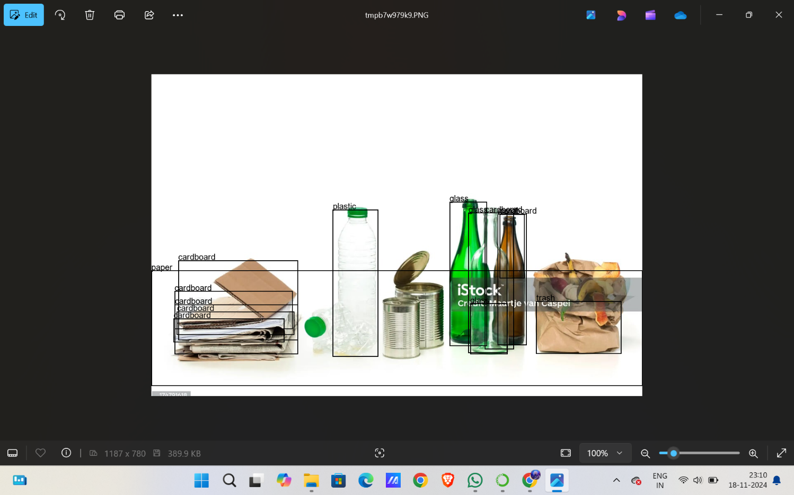

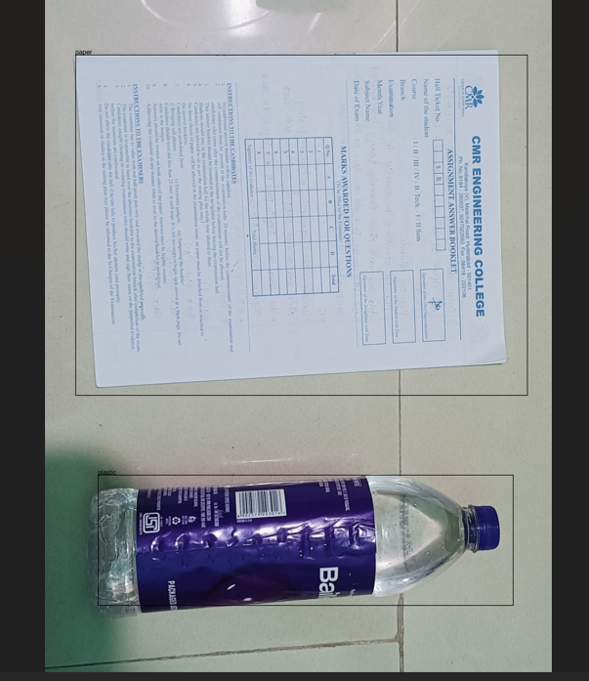

8.CONCLUSION

8.1 Conclusion
In this research, our goal is to segregate the waste materials using machine learning. We made use of the pre-trained architectures and six waste classification categories to accomplish this goal. Web scraping is done for removal of misclassified images and it has been working well in developing low precision models. Compared with other versions DenseNet169 performed better. The output of ResNet50 is likewise closer to DenseNet169.

8.2.Future Enhancement
Further work includes, optimization of the results and prediction accuracies for various discrete inputs in real- time. Thus, this approach, aids in reducing pollution levels and in the long run focuses on the development of universal waste segregation framework. Thus,the work is an important asset to the society

9.REFERENCE
1). Miranda, Ruben, Blanco and Angeles. 2010. “Environmental awareness and paper
recycling”. Cellulose Chemistry and Technology. Vol. 44. pp. 431-449.
2). Chandaluru Priyanka, Sri Ramya P. 2020. Image Based Classification of Waste
Material Using Convolution Neural Network, International Journal of Advanced Science
and Technology Vol. 29, 5, pp. 2967 – 2975
3). Albawi S, Mohammed T A and Al-Zawi S. 2017. "Understanding of a convolutional
neural network,", International Conference on Engineering and Technology (ICET),
Antalya, pp. 1-6
4). Deng J, Dong W, Socher R, L.-J. Li, Li K, and Fei-Fei L. 2009. “ImageNet: A Large
Scale Hierarchical Image Database”, IEEE Conference on Computer Vision and Pattern
Recognition, pp. 248-255.
5). Bakator M, Radosav D. 2018. “Deep Learning and Medical Diagnosis: A Review of
Literature”, Multimodal Technologies and Interaction.Vol. 2, 47, pp. 1-12.
6). Thung, Gary and Ming Xiang Yang. 2016. “Classification of Trash for Recyclability
Status.”, Corpus Id-27517432.
7). Yang, M.; Thung, G. Classification of trash for recyclability status. CS229 Project
Report 2016, 2016.

8). Lowe, D.G. Distinctive image features from scale-invariant keypoints. International
journal of computer vision 2004, 60, 91–110.
9). Krizhevsky, A.; Sutskever, I.; Hinton, G.E. Imagenet classification with deep
convolutional neural networks. Communications of the ACM 2017, 60, 84–90.
10). Sakr, G.E.; Mokbel, M.; Darwich, A.; Khneisser, M.N.; Hadi, A. Comparing deep
41
learning and support vector machines for autonomous waste sorting. 2016 IEEE
International Multidisciplinary Conference on Engineering Technology (IMCET). IEEE,
2016, pp. 207–212.
11). Arebey, M.; Hannan, M.; Begum, R.; Basri, H. Solid waste bin level detection using
gray level co-occurrence matrix feature extraction approach. Journal of environmental
management 2012, 104, 9–18

