**Automated Network Request Management in ServiceNow**

**Project Description:**

This project aims to design and implement a streamlined, automated solution for managing network-related service requests within ServiceNow. It enables end users to submit requests for network services through a user-friendly self-service portal.

The system leverages ServiceNow’s workflow engine, catalog items, and approval processes to ensure requests are properly captured, validated, and routed for fulfillment. Upon submission, requests trigger automated notifications, task assignments, and—where applicable—integration with network automation tools or scripts to fulfill standard requests without manual intervention.

**Key Features:**

1. Custom service catalog for common network requests
2. Dynamic forms to capture relevant request details
3. Automated approval workflows based on request type and sensitivity
4. Integration with infrastructure management or orchestration tools (optional)
5. Real-time status updates and notifications to requesters and technicians
6. Reporting and analytics on request volume, resolution time, and SLA adherence
7. **Access the Developer Site**
8. Go to **https://developer.servicenow.com/** and sign in with your developer account.
9. After a successful sign-in, the landing page shows as below:

**Start Building an Instance**

On the welcome page, click **Start Building**.

Choose an **Instance location** if prompted (for example: Zurich, Yokohama, or the region closest to you).

Click **Request Instance** or **Start Building** again.

Wait while ServiceNow provisions your **personal developer instance** (this may take a minute or two).

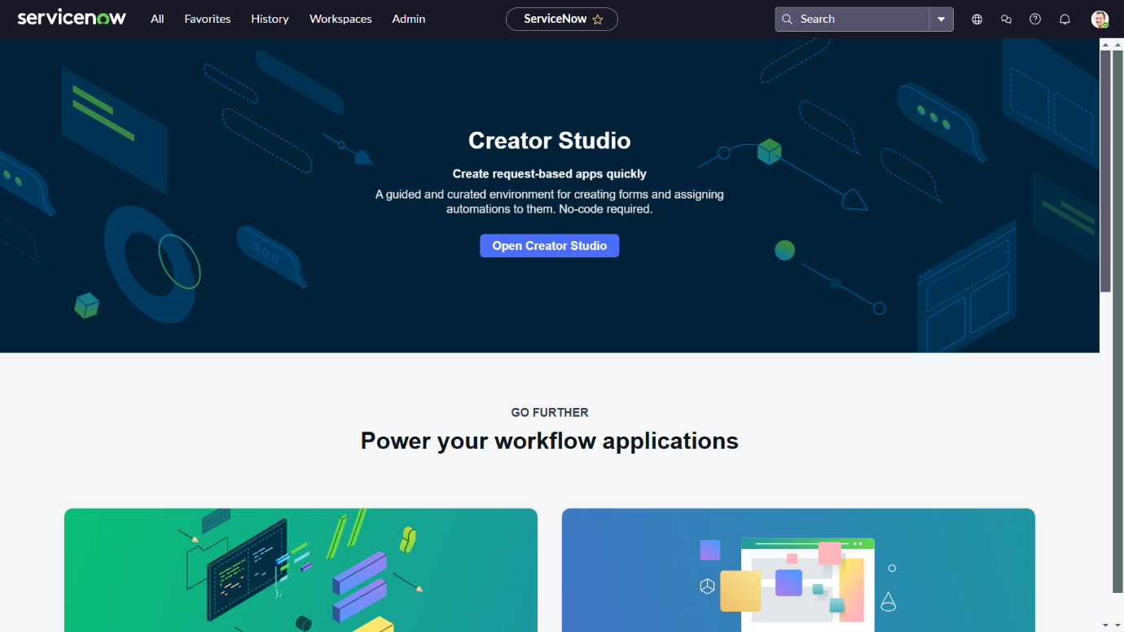

**Service Catalog Creation**

**Creation of service catalog:**

1. Navigate to Application navigator
2. Click on All >> search for Service Catalog
3. Under Service Catalog>> Maintain items
4. Click on New
5. Fill the details >> Name– Network Request
6. Select Catalog>> Service Catalog
7. Select Category>> Network
8. Fill the Short Description as Network request Management
9. Click on Save.

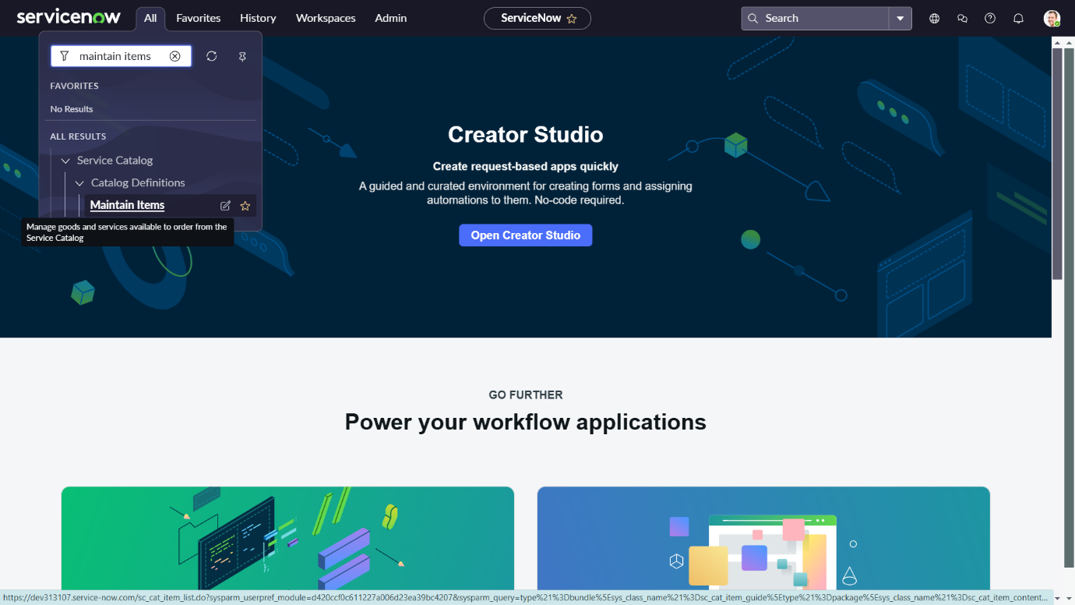

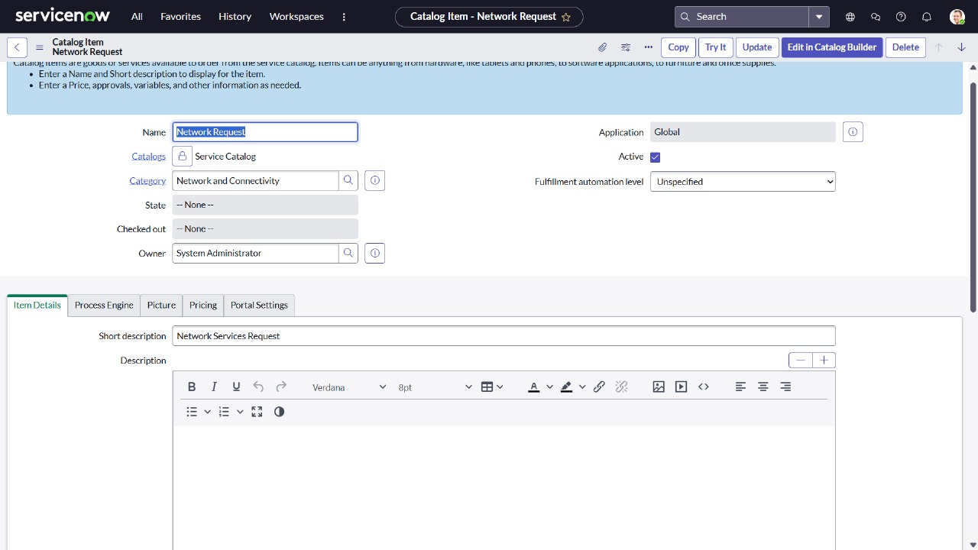

**Variable Configuration:**

**Go to the Variables Tab:**

1. Open the catalog item you just created (Service Catalog → Catalog Definitions → Maintain Items).
2. Click the Variables related list at the bottom of the form.
3. Click New to create a variable.

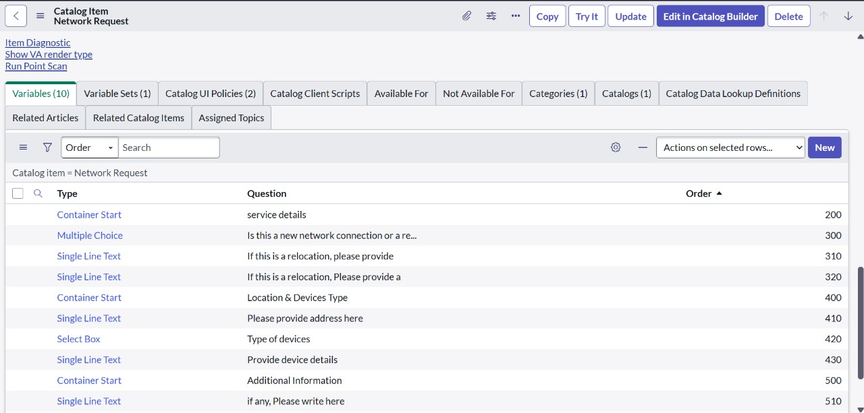

**Variables Types:**

1. Is this a New connection or Relocation? >> Choice >> New/ Relocation/None
2. If this is a relocation, Please provide your relocated address here>>String
3. Types of devices>> Choice>> Laptop/Mobiles/Others
4. Please provide address here>>String
5. Provide device details here>> String
6. If anything else, please specify>> String

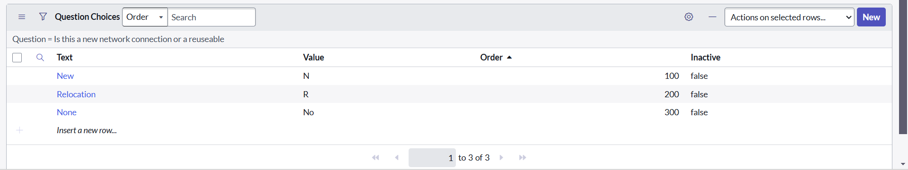

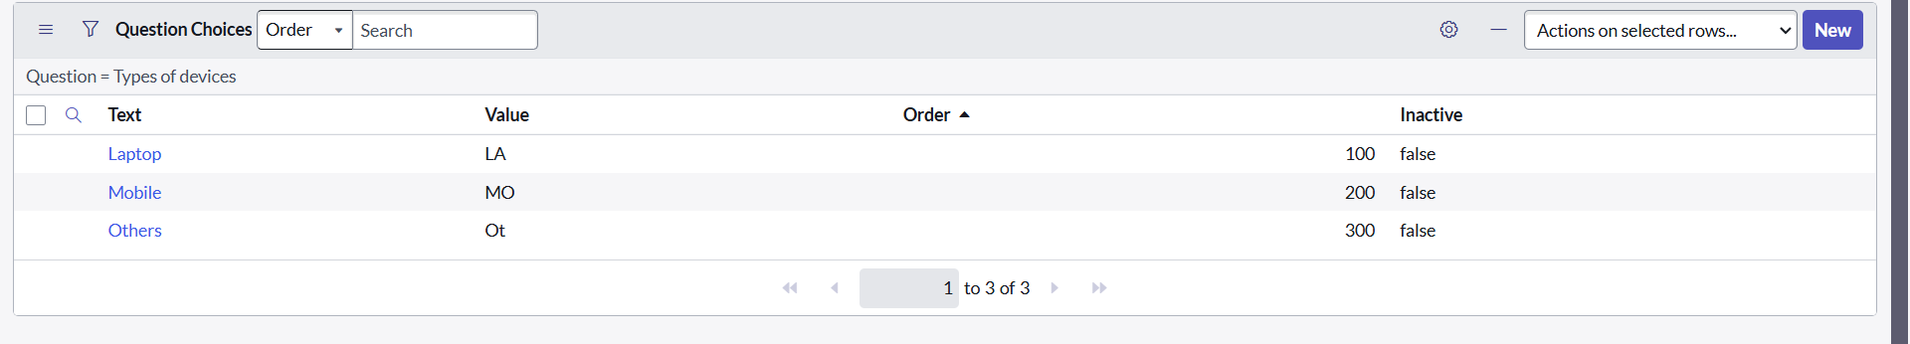

**Variable Set Configuration:**

Variable Sets allow you to reuse common variables across multiple catalog items.

Navigate to Service Catalog → Catalog Variables → Variable Sets.

Create a set, add variables to it, then associate the set with multiple items.

Create Title as Requester Information ,Type as Single Row and Layout as 2 Columns Wide,one side then the other

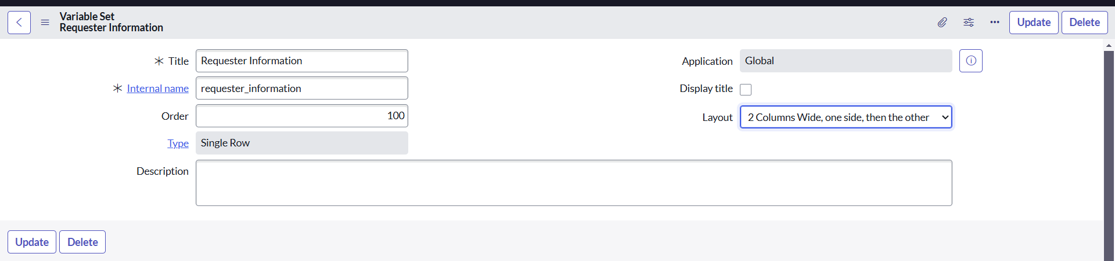

**Variable Types In Variable Set:**

Opened on behalf of >> Reference>> reference to user table

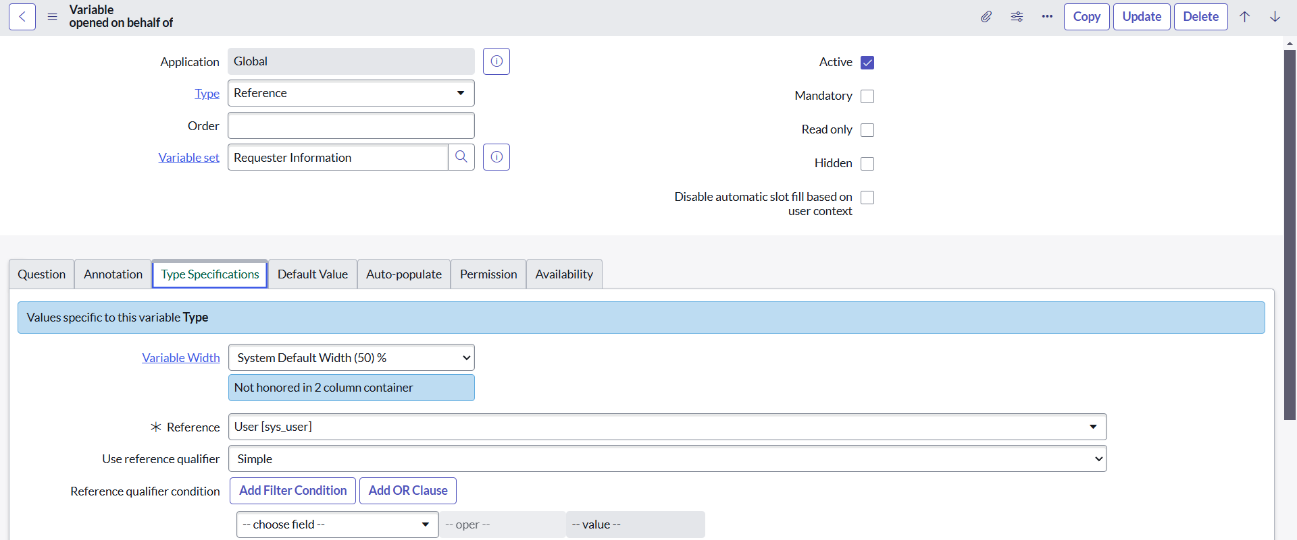

Email Id >> Single line text >> Auto populate by Opened on behalf of variable.

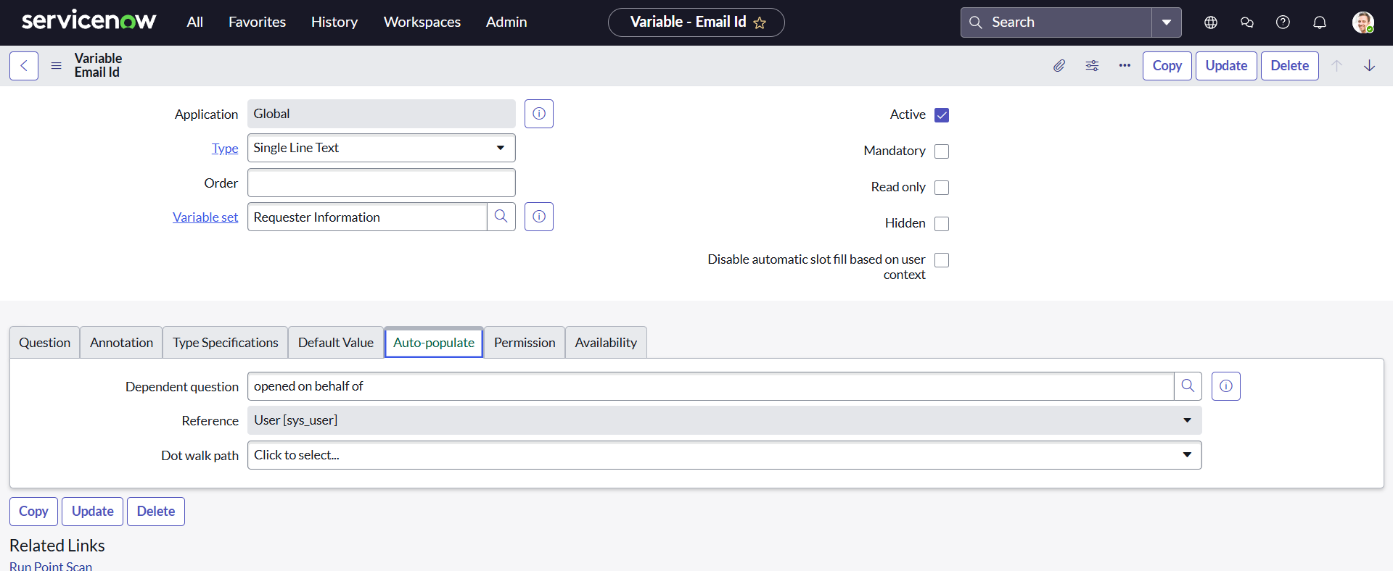

As mentioned in the above figures, all other variables are followed in the same process:

User name >>Single line text >> Auto populate by Opened on behalf of variable.

Phone Number >>Single line text >> Auto populate by Opened on behalf of variable.

Proof of Document >> Attachment

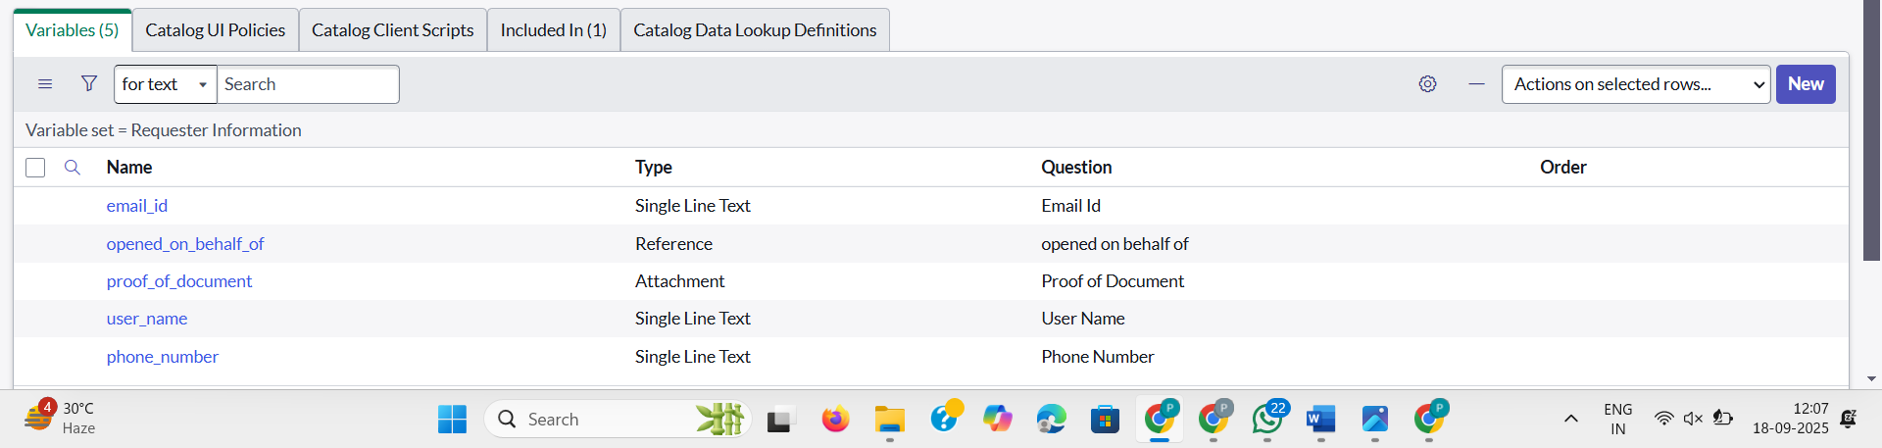

**Catalog UI Policy Configuration**

Scenario: If user selects types of devices is **Others,** then Please specify field should populate.

**Procedure:**

1. Navigate to catalog items
2. Open Network Request item
3. In related list, we have Catalog UI policy
4. Click on New button to configure New UI policy
5. Select Applies to as Catalog item
6. Select catalog item as Network Request
7. Provide short description, if required
8. Apply condition>> **types of devices** is **others**

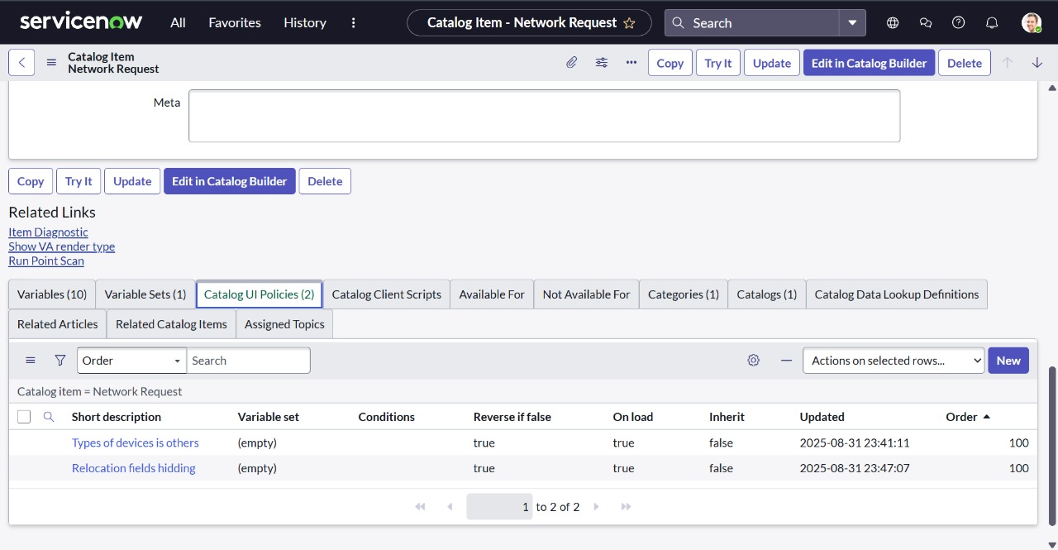

Clickon save, after saving the form will get UI policy actions in the related list

Click on New button to configure new UI Policy action, and Select the variable which we want to display on condition

Make Visible True as per our requirement

Update the UI Policy and Test the same on Catalog form.

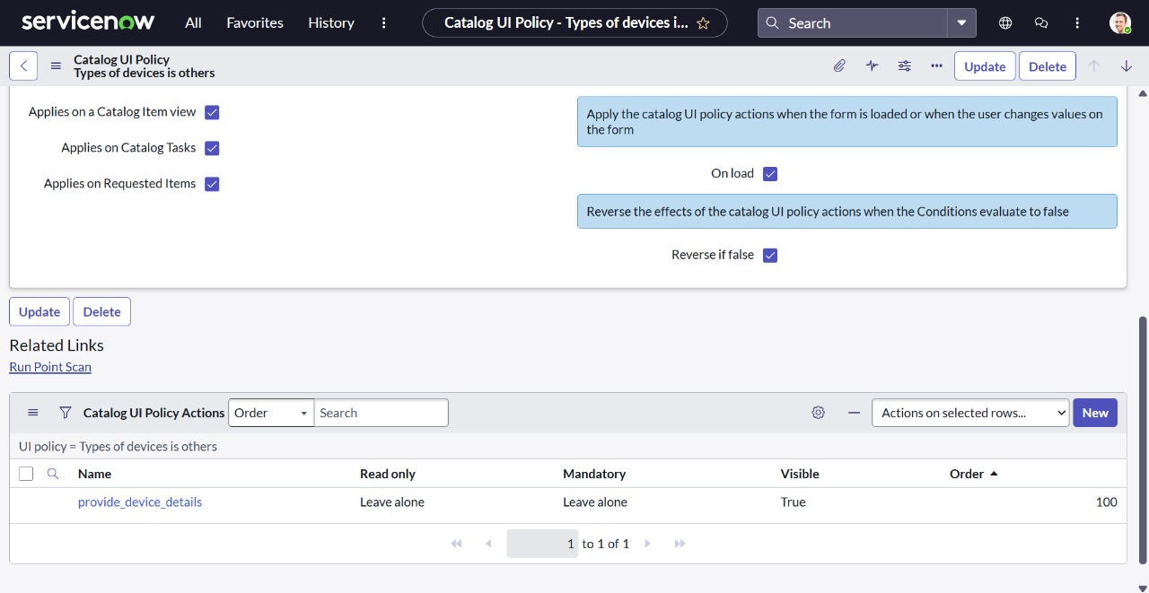

**Creation of Table:**

**Create the Network database Table**

1. Navigate to **System Definition → Tables**.
2. Click **New** to create a new table.
3. Fill in **Table Information**:
   1. **Name**: **Network database**
   2. **Label**: **Network database** (backend name of the table).
   3. **Auto-generate schema**: Leave it checked if you want ServiceNow to auto-generate schema fields.
4. Click **Submit** to create the table.

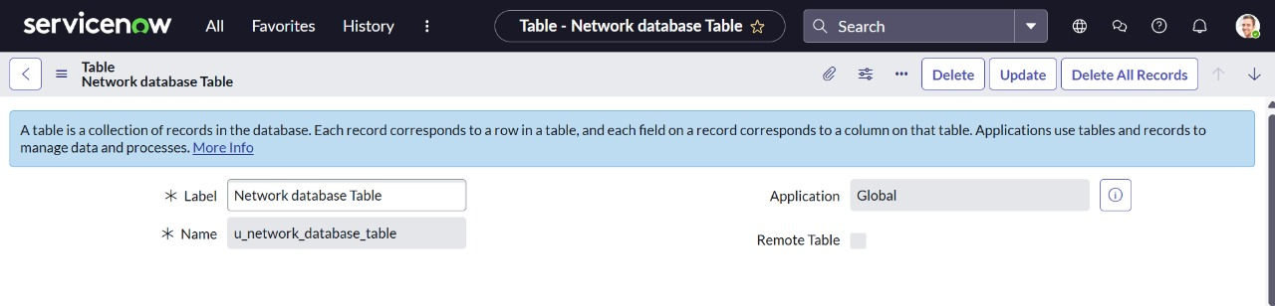

**Creation of Fields:**

**We had created the columns as mentioned in the below figure:**

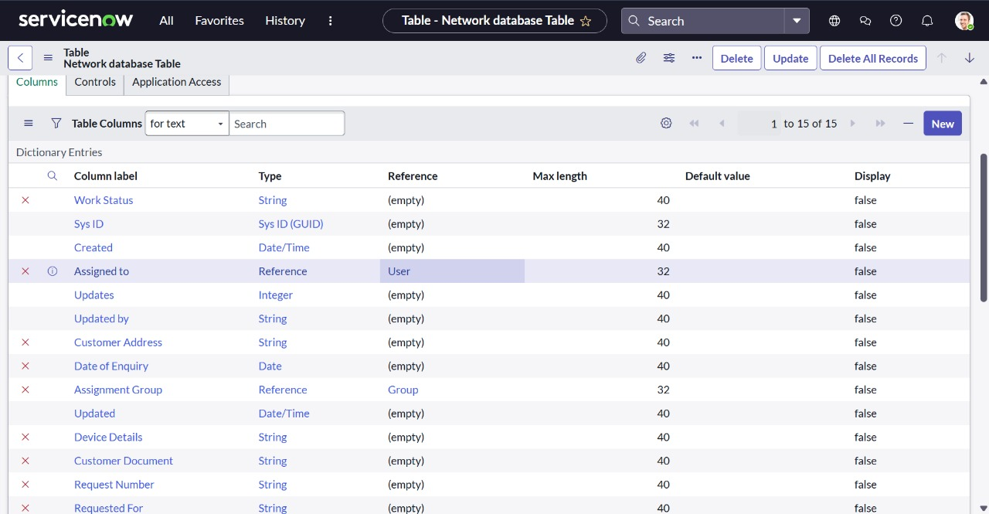

**Navigating to Flow Designer:**

Go to Flow Designer by typing Flow Designer in the left-hand application navigator, or navigate through All > Flow Designer.

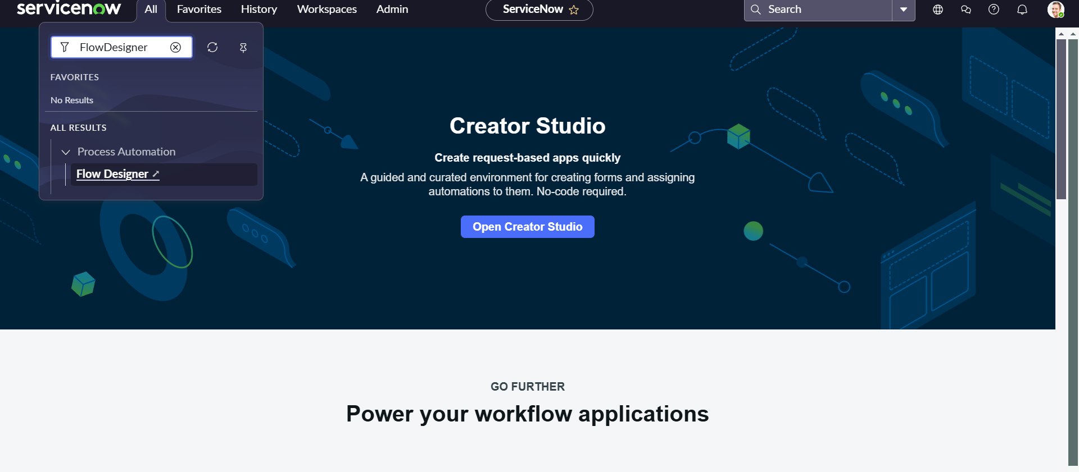

**Creation Of Flow**

After clicking flow designer, it redirects to a new page .

1.Click on New

2.Flow Name >Network Request and give the description

3.Click on Build flow

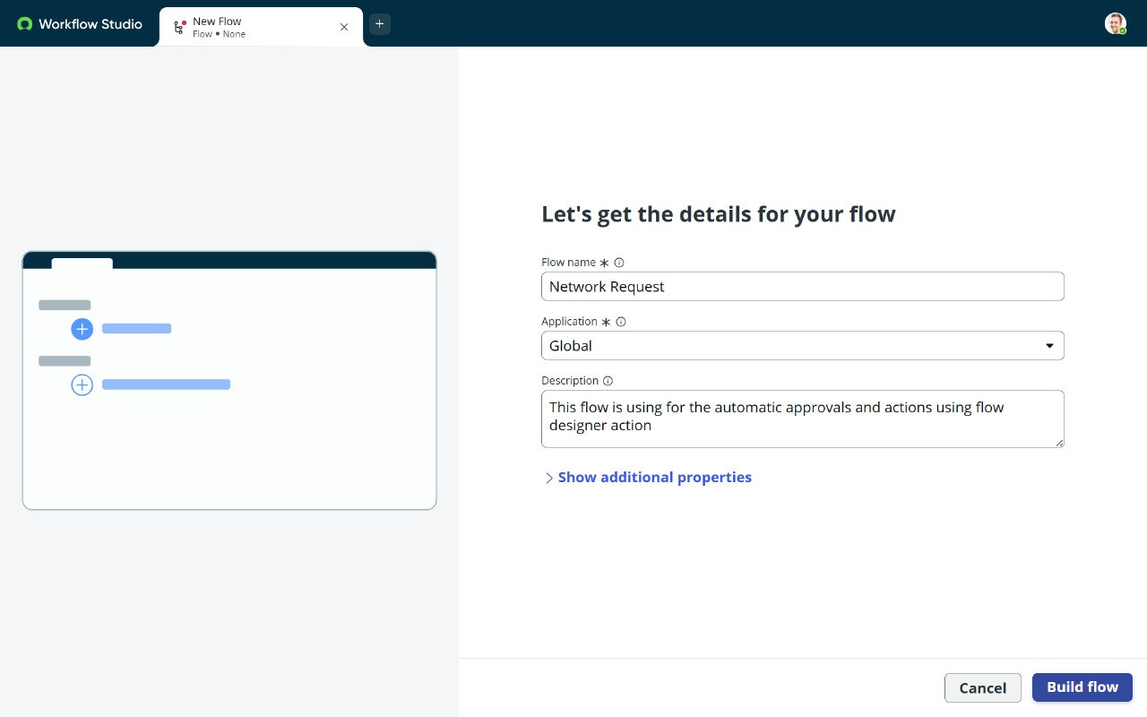

**2.Configuring Trigger**

1.Click on (+) Icon to Configure the Trigger

2.Select Trigger as Application >> Service catalog

3.Click on Done.

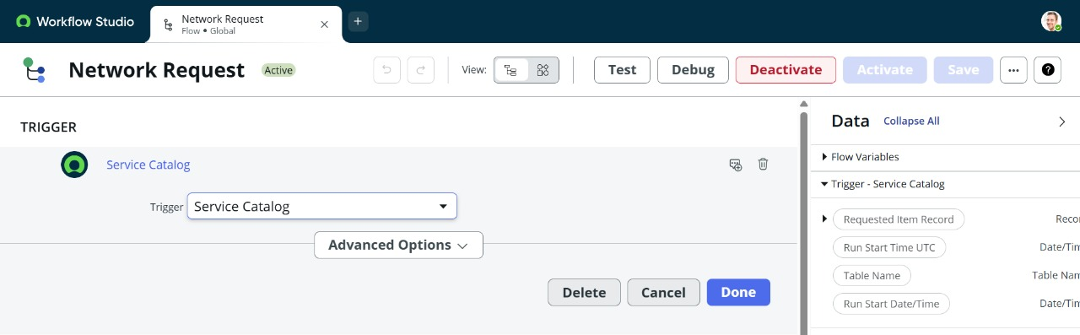

Configuring Action:

We are creating multiple actions to create a Flow.

Step 1:We created an Action :Get catalog Variables with several Action inputs.

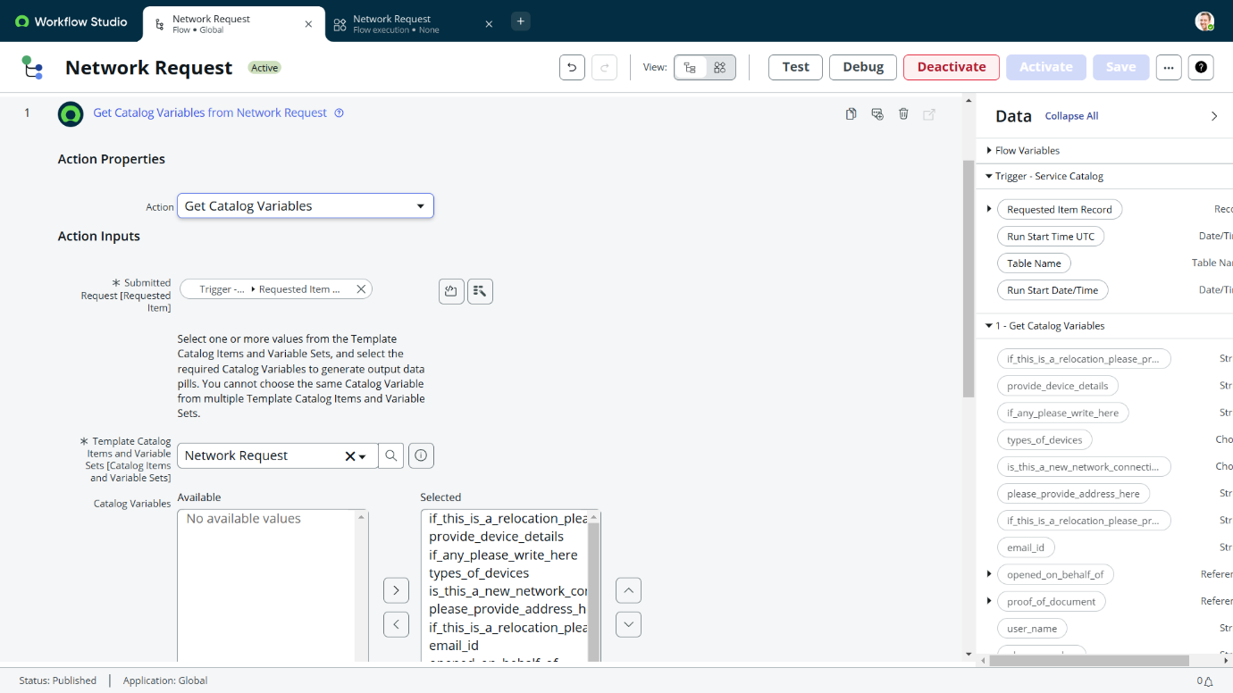

Step 2: We created an Action :Create Record

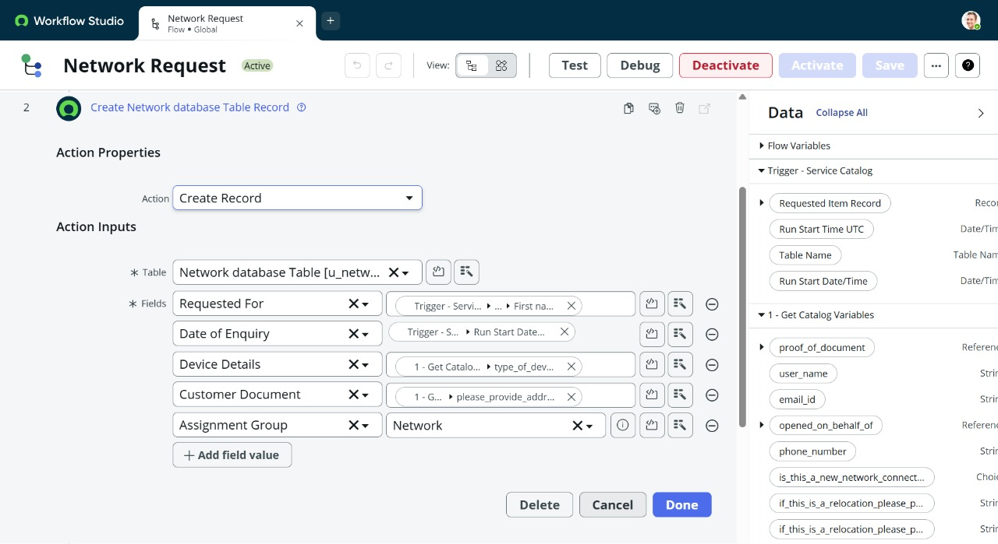

Step 3: We created an Action :Ask For Approval

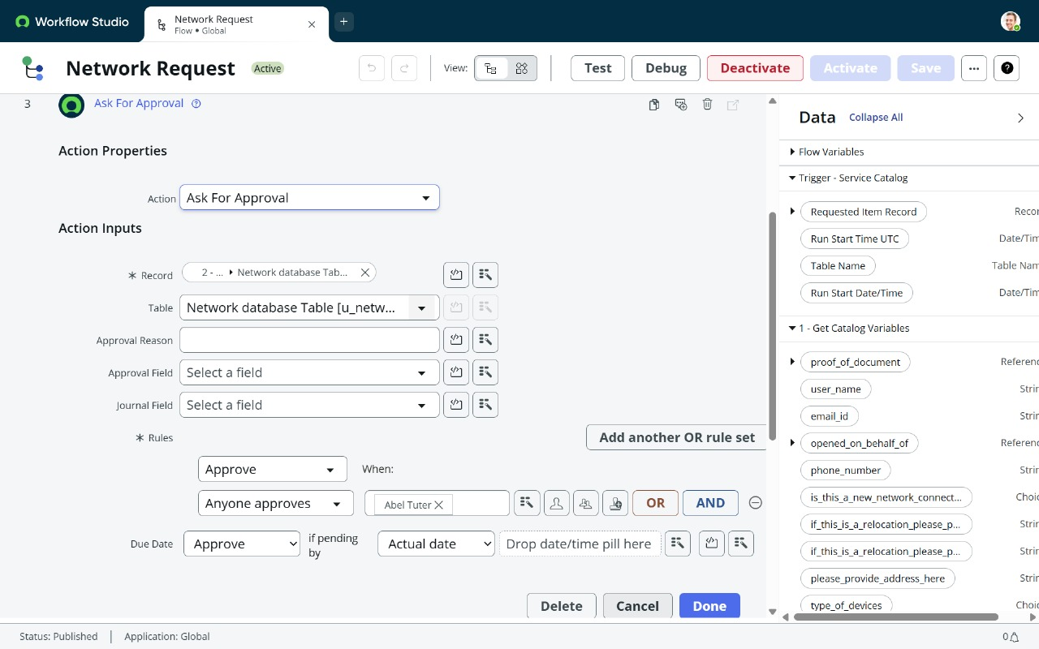

Step 4:We created a Flow Logic

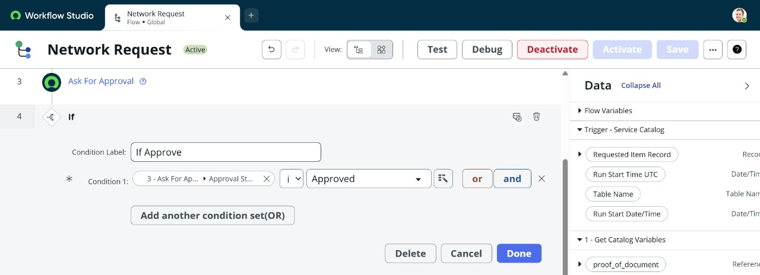

Step 5:We created an action:Send Email

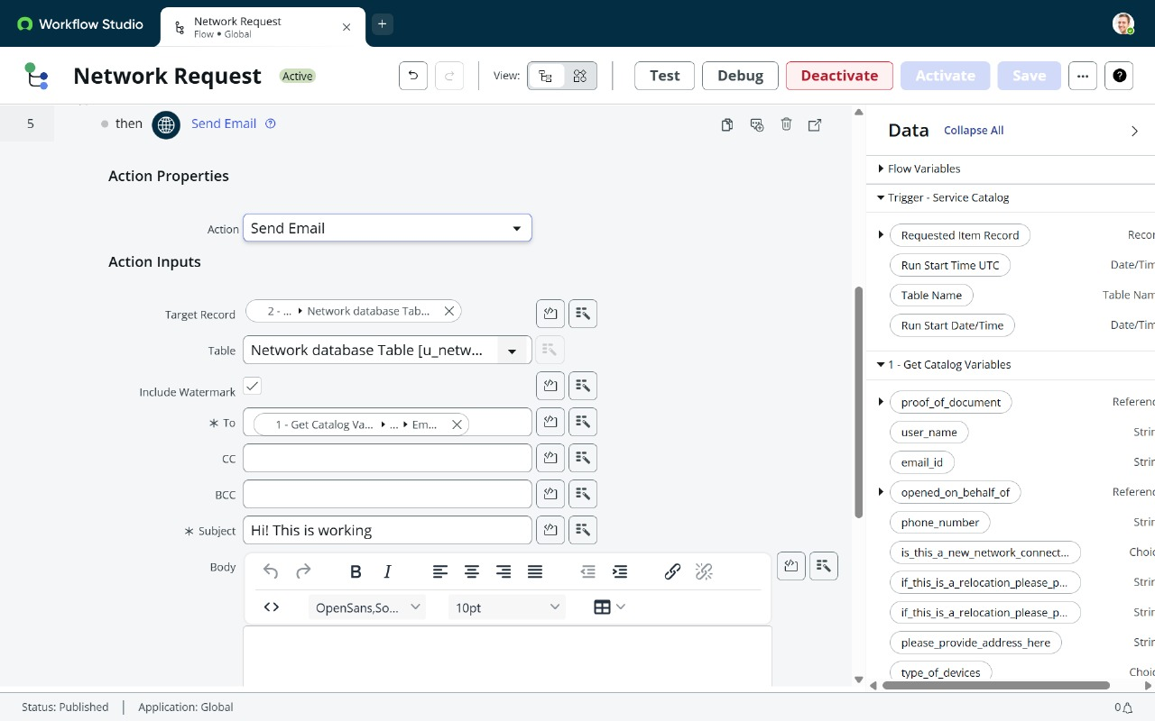

Step 6:we created an action:Update Record

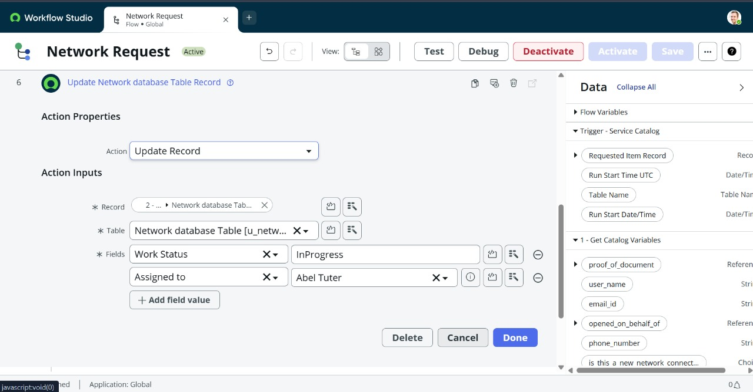

Flow chart:

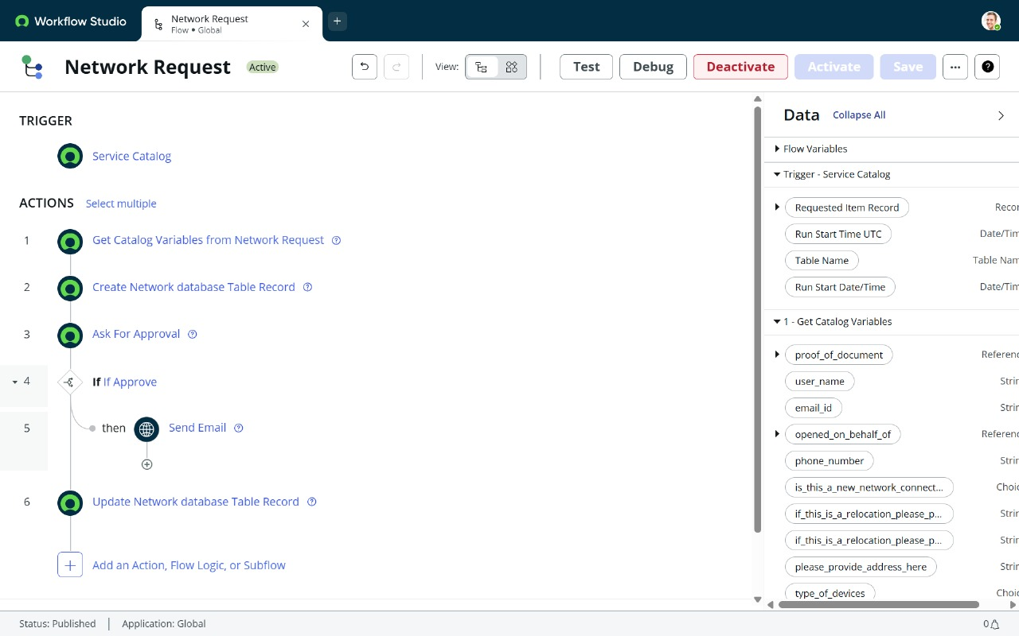

**Final Testing in End User portal & Instance**

In the service catalog->Maintain Items->Network Request->Process Engine->Flow->Network Request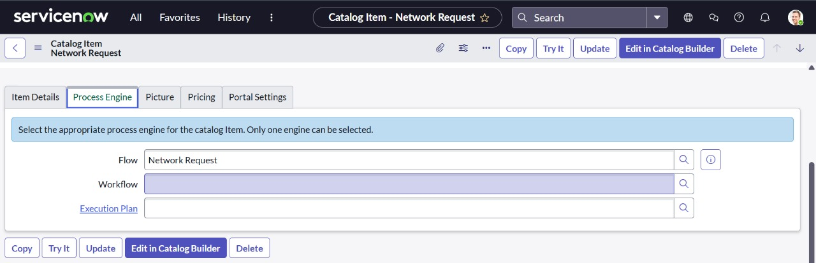

Then click on Try it and choose order now :

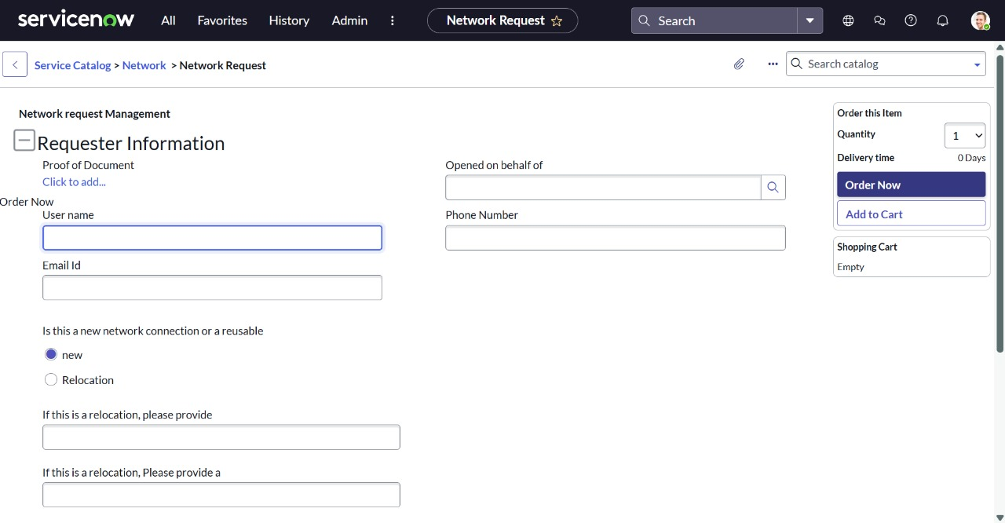Then Request Number can generated after that Request item number can copied and test into flow .

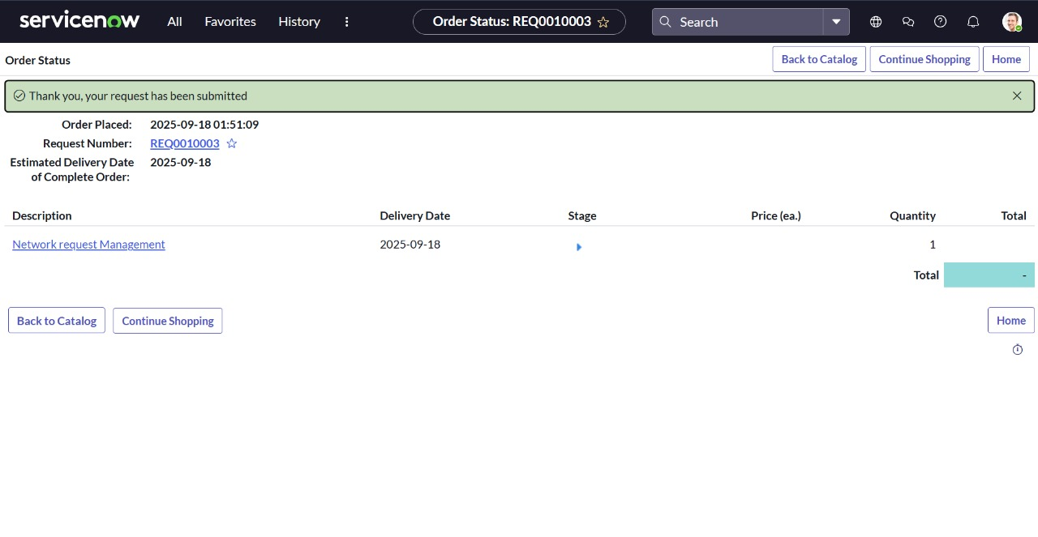

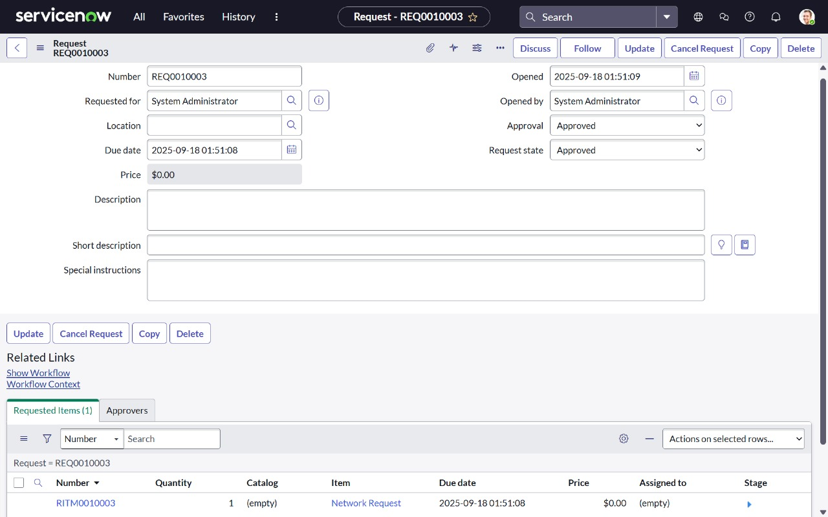

Go to System logs->Email

And we can see our request number is created and got acknowledged as request approved.

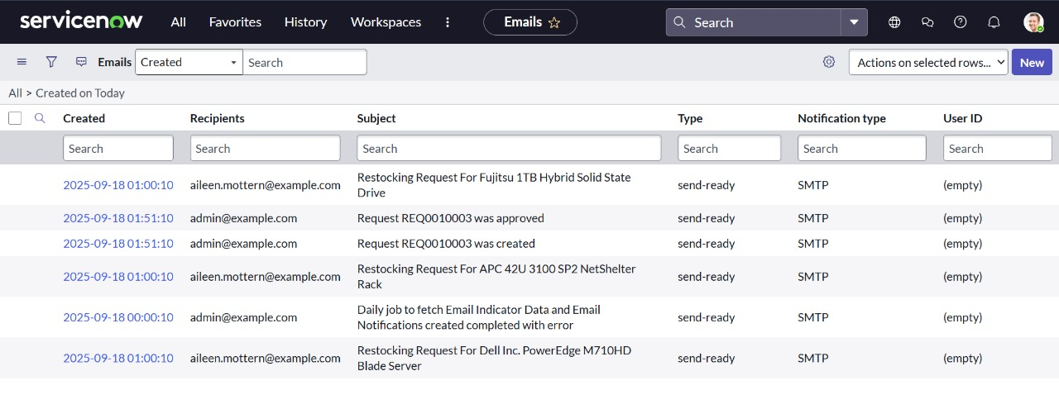

Now click on the Request approved. And choose preview Email. And we can see the request approval for our Order.

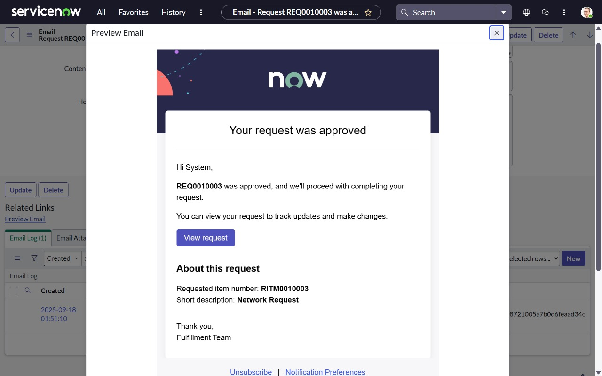

And if we click on view request we can see the summary of the Request.

