19. **CREATE A BOXPLOT GRAPH FOR THE RELATION BETWEEN "MPG"(MILES PER GALLOON) AND "CYL"(NUMBER OF CYLINDERS) FOR THE DATASET "MTCARS" AVAILABLE IN R ENVIRONMENT**

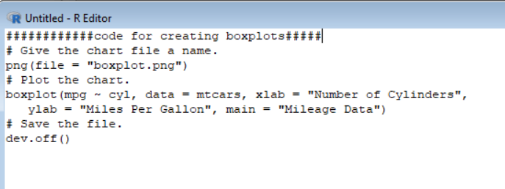

Code for creating boxplots in r programing.

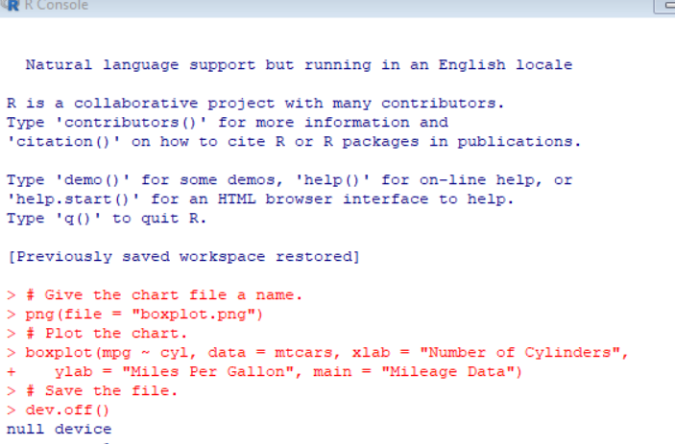

Output result of created boxplot..

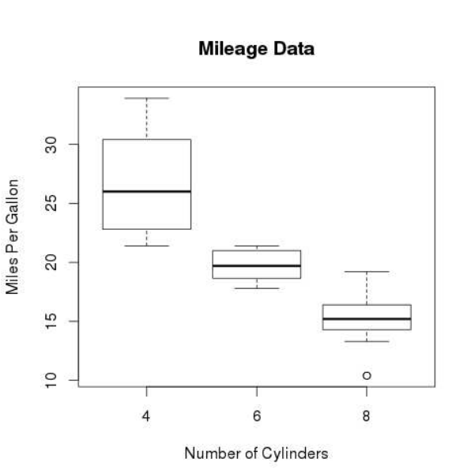

Output graph of boxplot..