**22. USING R PROGRAM MAKE A HISTOGRAM FOR THE “AIRPASSENGERS “DATASET, START AT 100 ON THE X-AXIS, AND FROM VALUES 200 TO 700, MAKE THE BINS 150 WIDE**

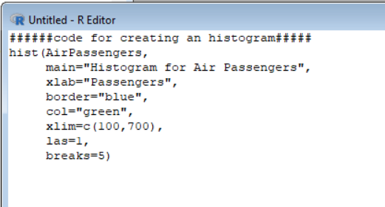

Code for creating an histogram..

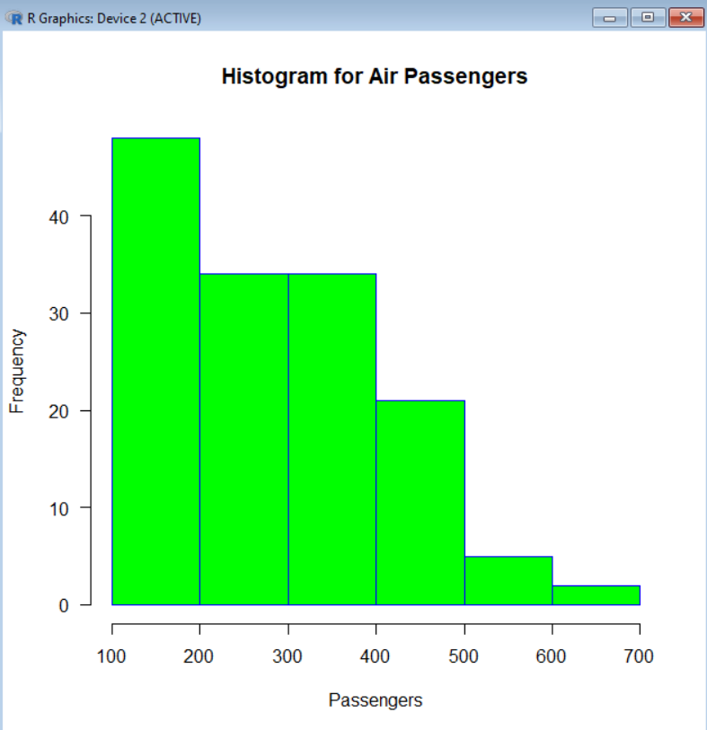

Output of histogram graphical representation..