23. **USING R PROGRAM CREATE A 3D PIE CHART FOR THE DATASET “POLITICAL KNOWLEDGE” WITH SUITABLE LABELS AND COLOURS.**

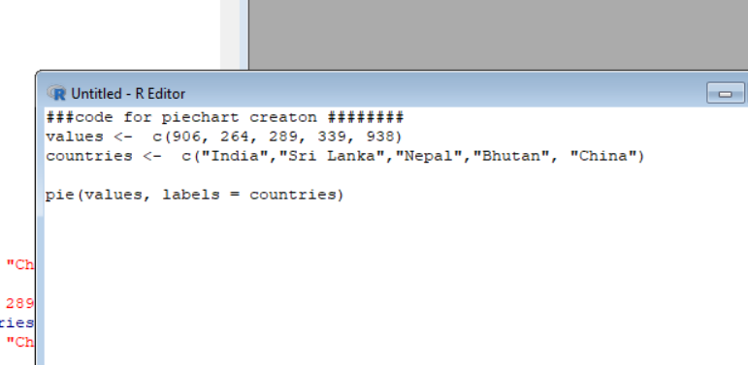

**Code for creating the pie charts**

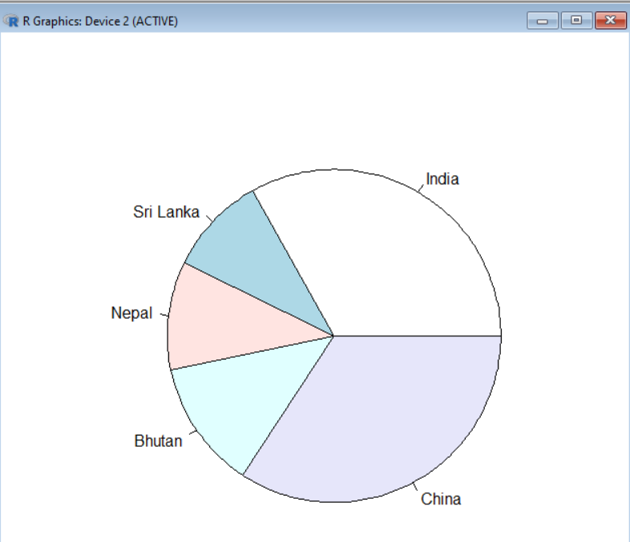

**Output of created pie chart.**