**24. OBTAIN MULTIPLE LINES IN LINE CHART USING A SINGLE PLOT FUNCTION IN R.USE ATTRIBUTES “MPG”AND “QSEC” OF THE DATASET “MTCARS”**

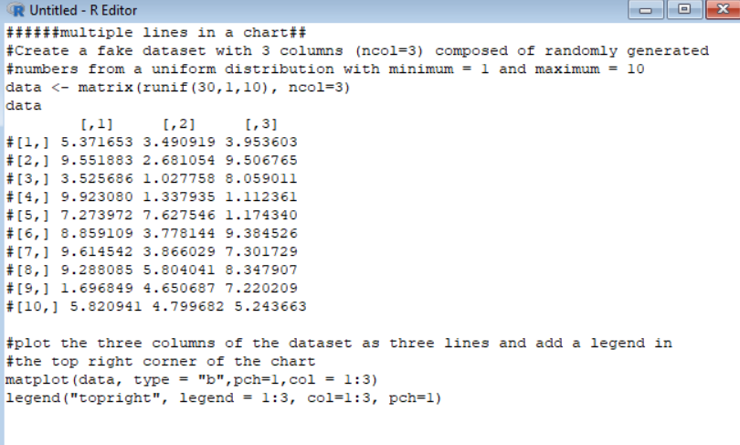**code for getting multiple lines in chart.**

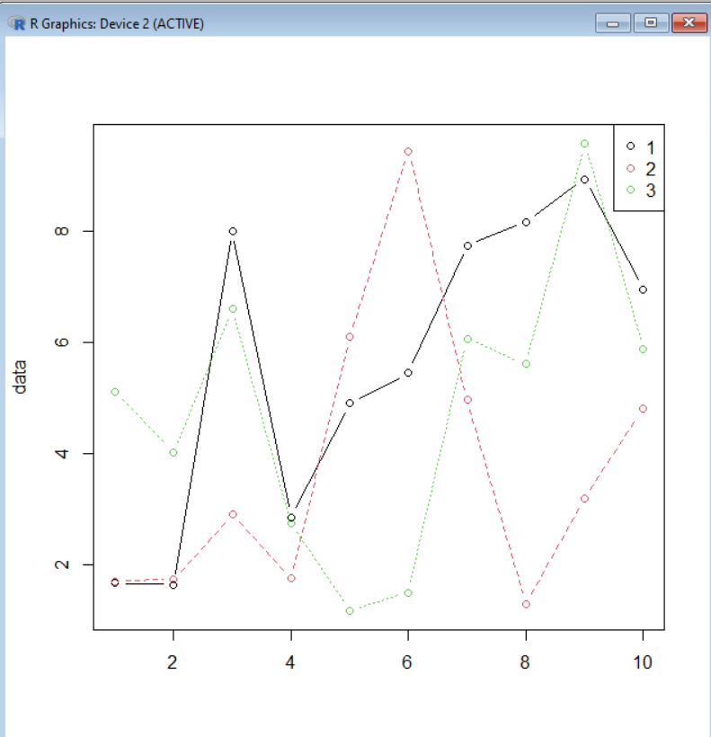

**Output of multiple lines in chart.**