**25. USING R PROGRAM MAKE A HISTOGRAM FOR THE “TOOTHGROWTH” DATASET, START AT 100 ON THE X-AXIS, AND FROM VALUES 200 TO 700, MAKE THE BINS 150 WIDE**

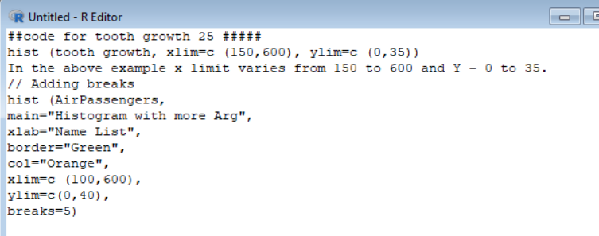

**Code for creating a histogram for tooth growth.**

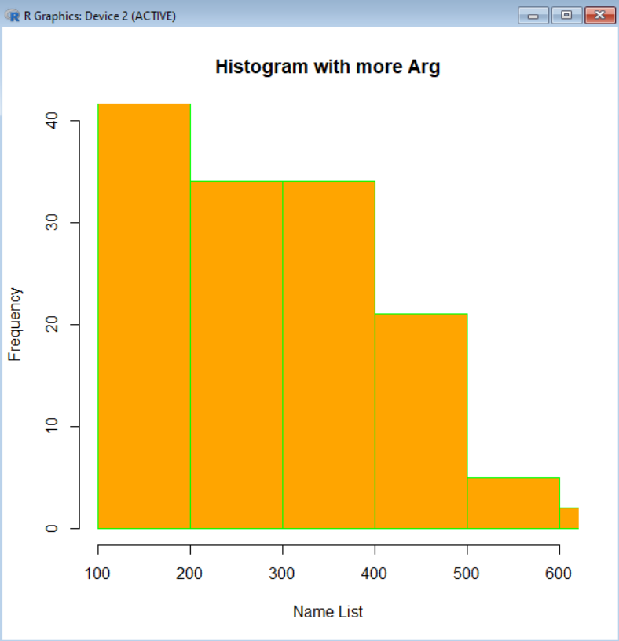

**Output of histogram, for tooth growth.**