DATA DISPERSION(MAX,MIN,RANGE,VAR,STANDARD DEVIATION,MEAN ADSOLUATE DEVIATION)

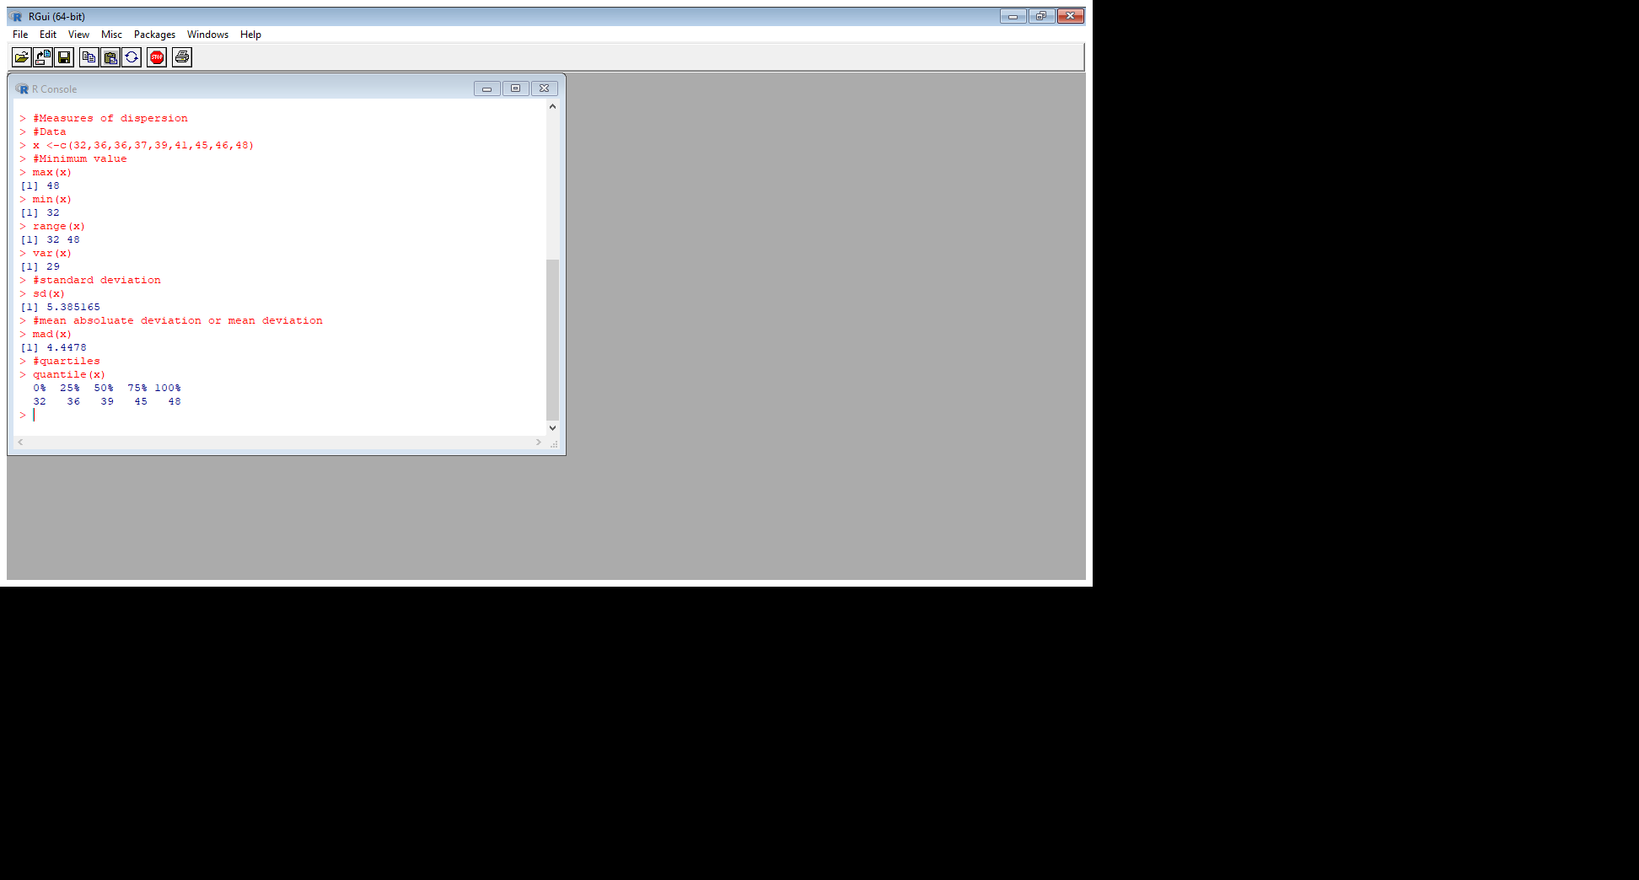

CENTRAL TENDENCY

