Practice Questions(solve exercise questions for practice)

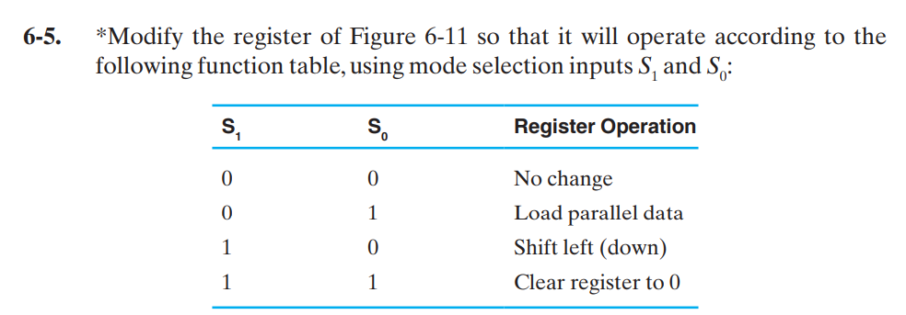

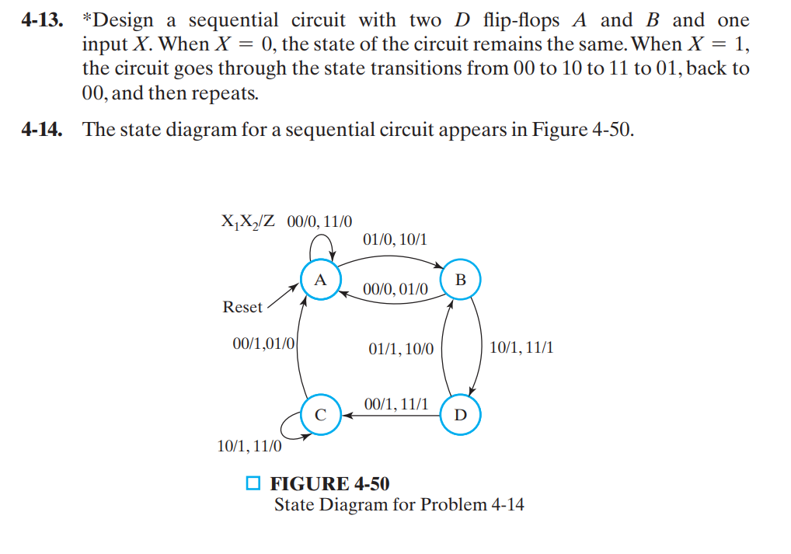

**Problem –** Design Synchronous 3-bit Up/Down Counter

**Problem-** Design 4bit bidirectional shift register.