@deprecated-don’t use the method

@supresswarning(“unchecked”)

@override-to override the class in main method

To create a new annotation

The below annotation has no value it is called marker annotation(without any values)

We have to mention @Target(ElementType.TYPE),@Retention(RetentionPolicy.RUNTIME)

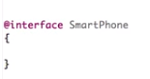

Single value annotation with one field values

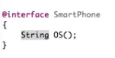

Multivalue annotation

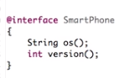

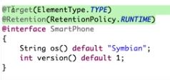

To give values

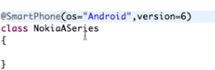

To provide default values:

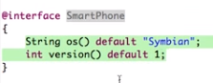

All are subclasses of annotations

For the values to be inherited use @inherited



To fetch the value of annotations

