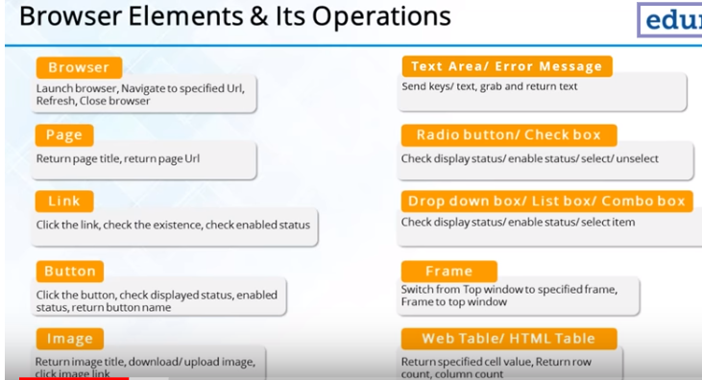

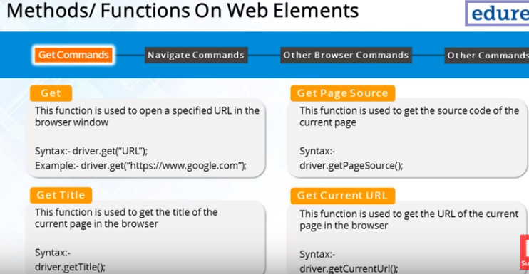

driver.get("https://www.amazon.in/");

Thread.*sleep*(4000);

String titleOfPage=driver.getTitle();

System.***out***.println("Title of page"+titleOfPage);

Thread.*sleep*(4000);

driver.findElement(By.*linkText*("Today's Deals")).click();

String currentURL=driver.getCurrentUrl();

System.***out***.println("CurrentURL:"+currentURL);

System.***out***.println("Page source:"+driver.getPageSource());

Navigation-clicking forward and backward ,refresh in selenium

Get and navigateto are same

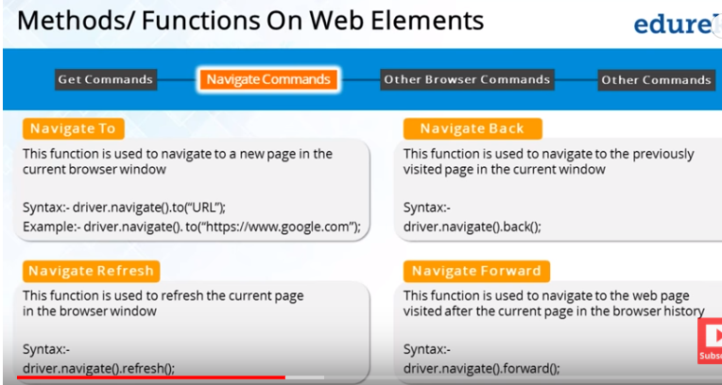

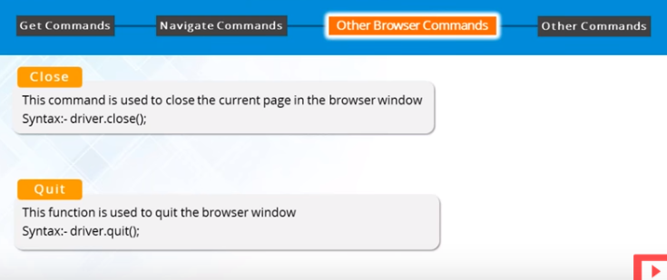

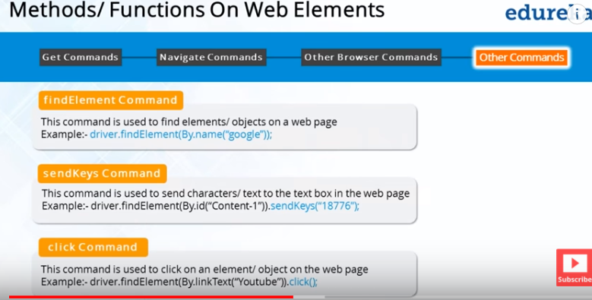

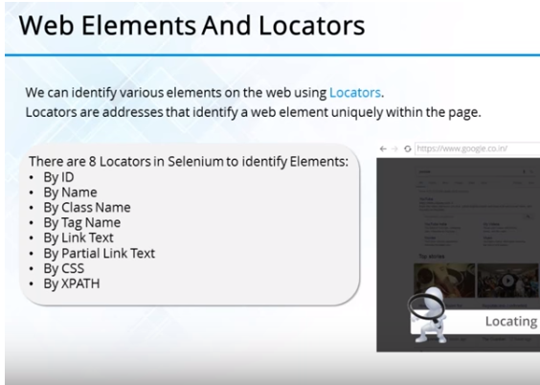

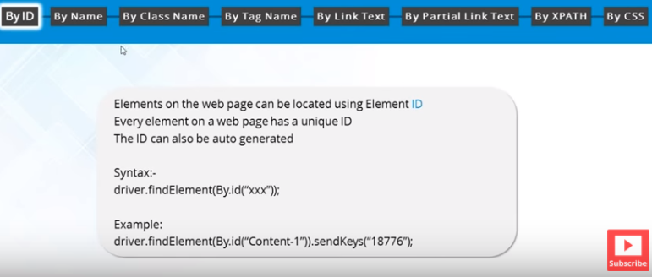

Id is always unique to element

Class—use it when it in unique for entire page in console

Partial linked text-it the linkedtext is long we can use it partially to identify the element

Tag-html tags..if only one tag of that type is present in whole page

For CSS:

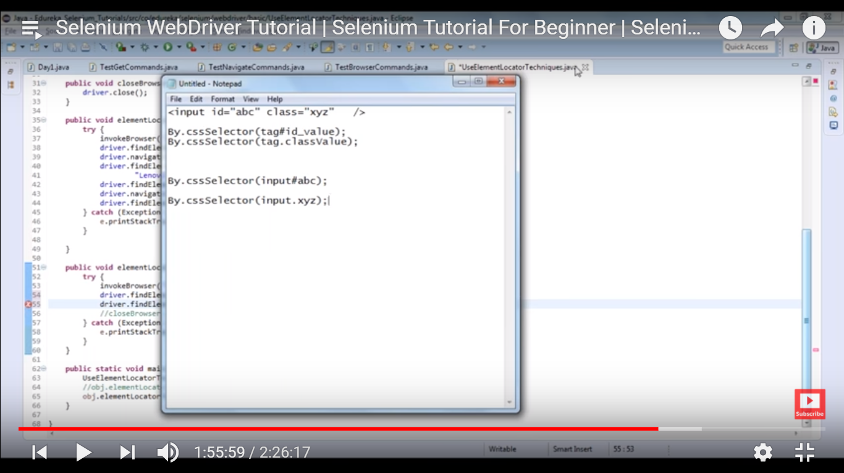

x-path: path Expression to iterate through the document

* absolute-HTML as reference, start with /
* relative-any tag as reference, start with //

The X path for below code=

**Example 1:**

<div id="nav-tools">

<a id="nav-link-yourAccount"  tabindex="25">

<span class="nav-line-1">Hello. Sign in</span>

*Xpath=//div[@id='nav-tools']/a[@id='nav-link-yourAccount']/span[1]*

**Example 2**

<div class="_3ac-" data-reactid="47">Log In/Sign Up</div>

*Xpath://div[@data-reactid='47']*

P.S:

Id- if it contains irrelevant names should not be used(u_0_1)

Class—if contains irreleveant name or with spaces should not be used

Testng-Test next Generation:

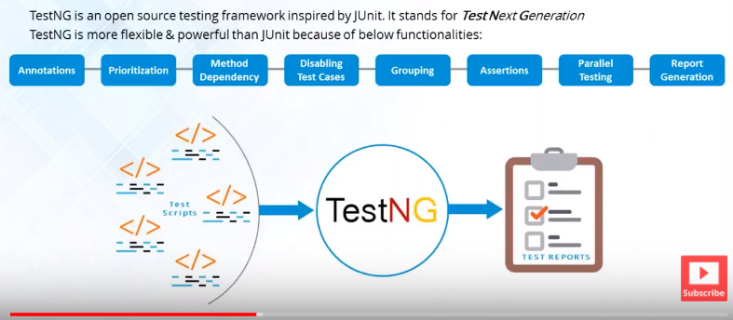

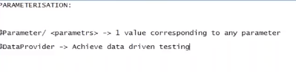

@Test-Before any menthod

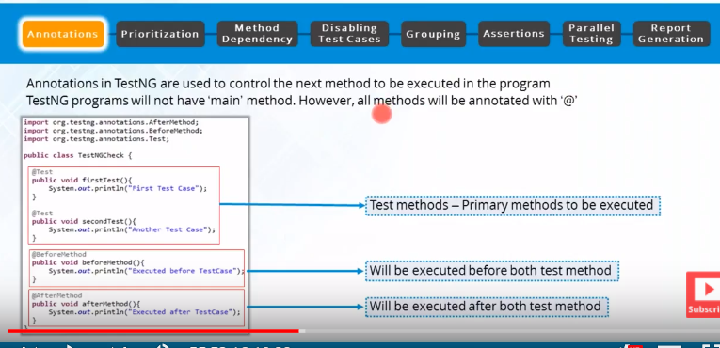

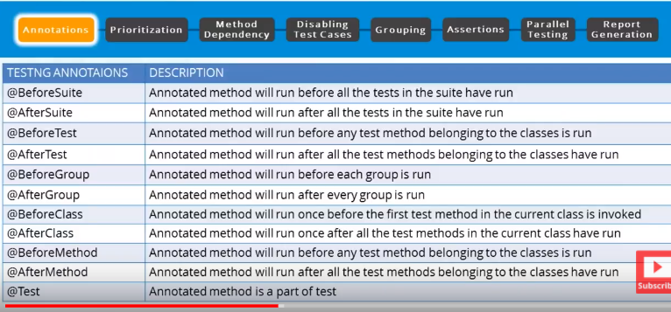

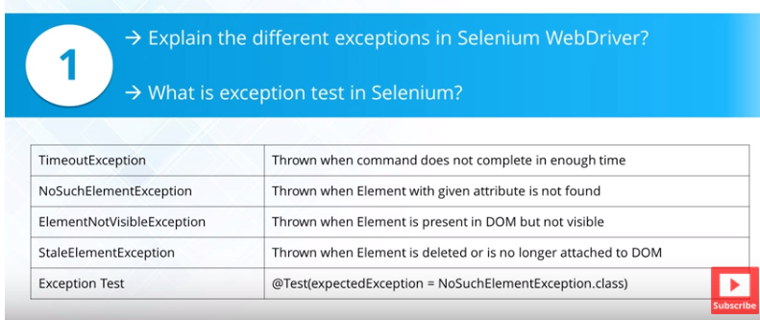

Excepted exception is for negative scenario

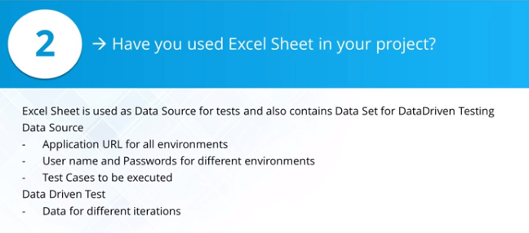

Code is tested for different data-data driven framework

